leoeleandro.pt

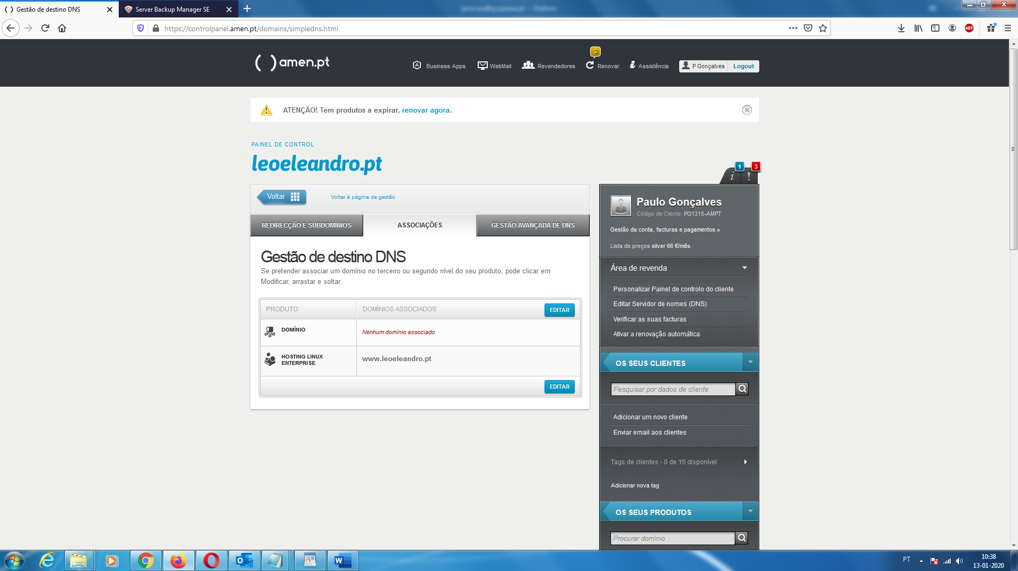

1. Gestao DNS

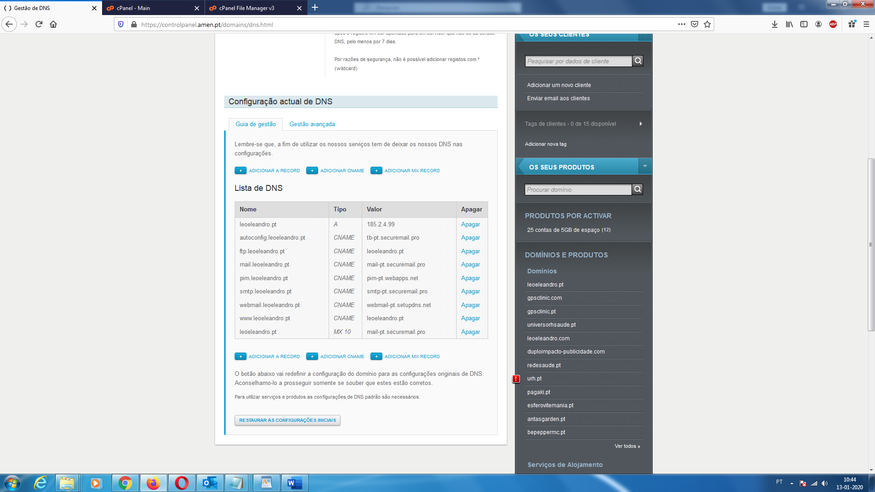

| **Nome** | **Tipo** | **Valor** | **Apagar** |
| --- | --- | --- | --- |
| leoeleandro.pt | *A* | 185.2.4.99 | Apagar |
| autoconfig.leoeleandro.pt | *CNAME* | tb-pt.securemail.pro | Apagar |
| ftp.leoeleandro.pt | *CNAME* | leoeleandro.pt | Apagar |
| mail.leoeleandro.pt | *CNAME* | mail-pt.securemail.pro | Apagar |
| pim.leoeleandro.pt | *CNAME* | pim-pt.webapps.net | Apagar |
| smtp.leoeleandro.pt | *CNAME* | smtp-pt.securemail.pro | Apagar |
| webmail.leoeleandro.pt | *CNAME* | webmail-pt.setupdns.net | Apagar |
| www.leoeleandro.pt | *CNAME* | leoeleandro.pt | Apagar |
| leoeleandro.pt | *MX 10* | mail-pt.securemail.pro | Apagar |

1. Gestao Avançada DNS

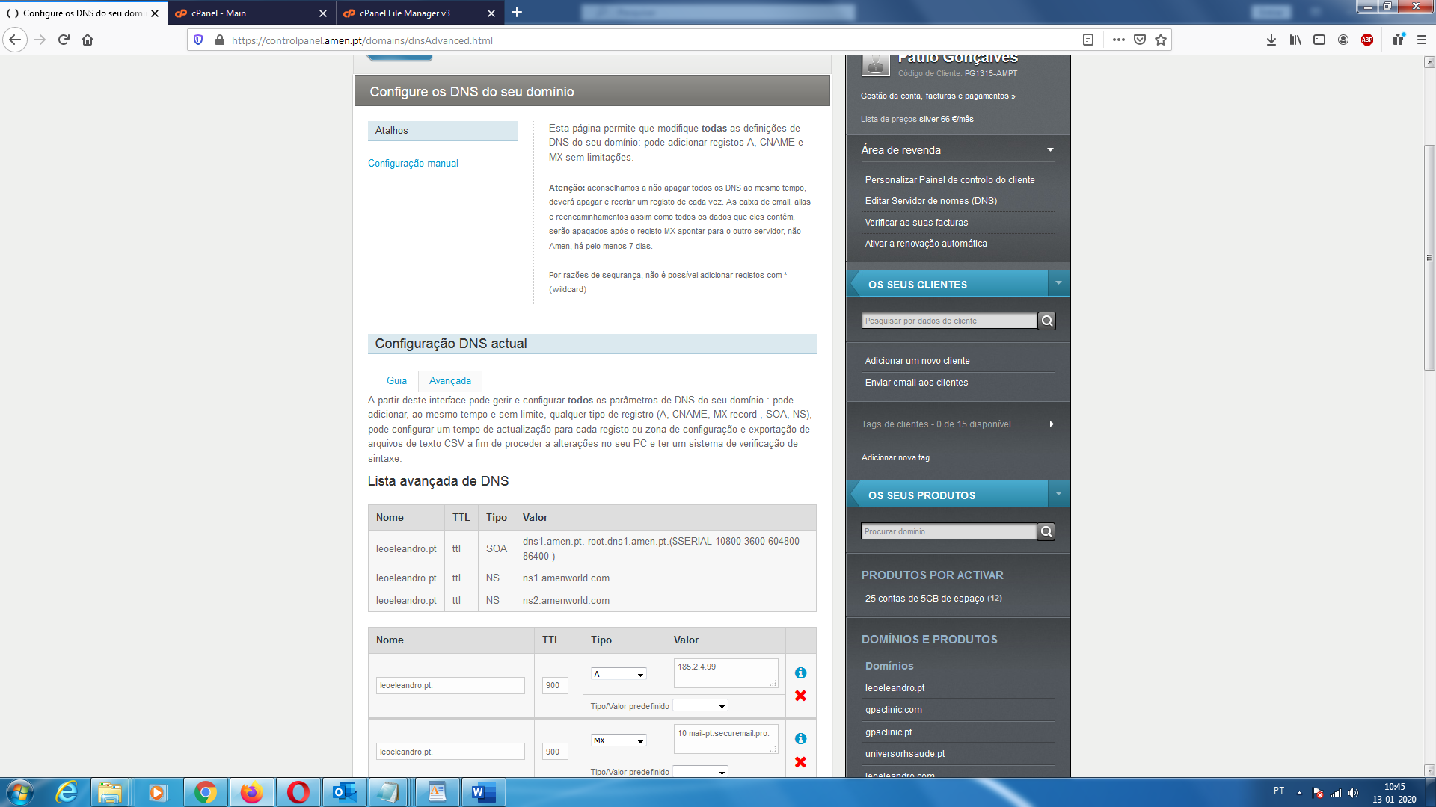

| **Nome** | **TTL** | **Tipo** | **Valor** |
| --- | --- | --- | --- |
| leoeleandro.pt | ttl | SOA | dns1.amen.pt. root.dns1.amen.pt.($SERIAL 10800 3600 604800 86400 ) |
| leoeleandro.pt | ttl | NS | ns1.amenworld.com |
| leoeleandro.pt | ttl | NS | ns2.amenworld.com |

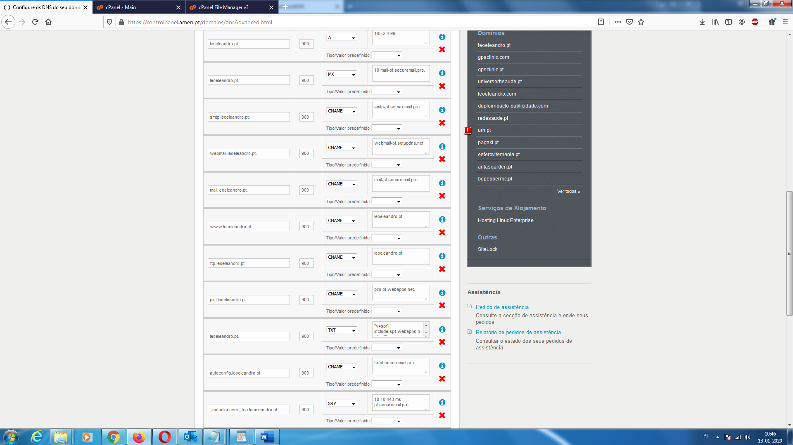

|  |  |  |  |
| --- | --- | --- | --- |
| Nome | TTL | Tipo | Valor |
| leoeleandro.pt. | 900 | A | 185.2.4.99 |
| leoeleandro.pt. | 900 | MX | 10 mail-pt.securemail.pro. |
| smtp.leoeleandro.pt. | 900 | CNAME | smtp-pt.securemail.pro. |
| webmail.leoeleandro.pt. | 900 | CNAME | webmail-pt.setupdns.net. |
| mail.leoeleandro.pt. | 900 | CNAME | mail-pt.securemail.pro. |
| www.leoeleandro.pt. | 900 | CNAME | leoeleandro.pt. |
| ftp.leoeleandro.pt. | 900 | CNAME | leoeleandro.pt. |
| pim.leoeleandro.pt. | 900 | CNAME | pim-pt.webapps.net. |
| leoeleandro.pt. | 900 | TXT | "v=spf1 include:spf.webapps.net ~all" |
| autoconfig.leoeleandro.pt. | 900 | CNAME | tb-pt.securemail.pro. |
| _autodiscover._tcp.leoeleandro.pt. | 900 | SRV | 10 10 443 ms-pt.securemail.pro. |
|  |  |  |  |

1. Email

geral@leoeleandro.pt