Exp#1

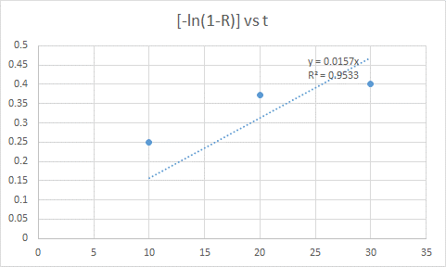

Exp#3

|  |  |  |  |  |
| --- | --- | --- | --- | --- |
| t(in min) | V(ml) | A(1cm^2) | At/V | V/A |
| 10 | 40 | 1 | 0.25 | 40 |
| 20 | 80 | 1 | 0.25 | 80 |
| 30 | 140 | 1 | 0.214286 | 140 |
| 40 | 175 | 1 | 0.228571 | 175 |
| 50 | 200 | 1 | 0.25 | 200 |
| 60 | 230 | 1 | 0.26087 | 230 |
| 70 | 260 | 1 | 0.269231 | 260 |
| 80 | 290 | 1 | 0.275862 | 290 |
| 90 | 310 | 1 | 0.290323 | 310 |

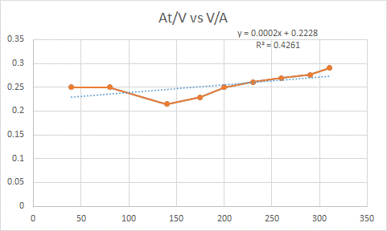

Exp#4

|  |  |  |  |  |  |
| --- | --- | --- | --- | --- | --- |
|  | Volume remaining | Volume elutted V(in ml) |  |  |  |
| t (in min) | A (cm^2) | V/A | At/V |
| 5 | 200 | 50 | 12.56 | 3.980892 | 1.256 |
| 10 | 160 | 90 | 12.56 | 7.165605 | 1.395556 |
| 15 | 130 | 120 | 12.56 | 9.55414 | 1.57 |
| 20 | 100 | 150 | 12.56 | 11.94268 | 1.674667 |
| 25 | 80 | 170 | 12.56 | 13.53503 | 1.847059 |
| 30 | 70 | 180 | 12.56 | 14.33121 | 2.093333 |
| 35 | 60 | 190 | 12.56 | 15.12739 | 2.313684 |
| 40 | 50 | 200 | 12.56 | 15.92357 | 2.512 |
| 45 | 45 | 205 | 12.56 | 16.32166 | 2.757073 |

Exp#7

|  |  |  |  |  |  |  |  |
| --- | --- | --- | --- | --- | --- | --- | --- |
| **Group** | **C** |  |  |  |  |  |  |
| **Time (min)** | **OD1** | **OD 2** | **O.D.** | **k** | **Concentration(mg/L)** | **C\*** | **C/C\*** |
| 10 | 0.004 | 0 | 0.002 | 12.856 | 0.025712 | 20 | 0.001286 |
| 20 | 0.005 | 0.007 | 0.006 | 12.856 | 0.077136 | 20 | 0.003857 |
| 30 | 0.019 | 0.018 | 0.0185 | 12.856 | 0.237836 | 20 | 0.011892 |
| 40 | 0.02 | 0.02 | 0.02 | 12.856 | 0.25712 | 20 | 0.012856 |
| 50 | 0.151 | 0.152 | 0.1515 | 12.856 | 1.947684 | 20 | 0.097384 |
| 55 | 0.094 | 0.094 | 0.094 | 12.856 | 1.208464 | 20 | 0.060423 |
| 60 | 0.362 | 0.362 | 0.362 | 12.856 | 4.653872 | 20 | 0.232694 |
| 65 | 0.412 | 0.412 | 0.412 | 12.856 | 5.296672 | 20 | 0.264834 |
| 70 | 0.632 | 0.634 | 0.633 | 12.856 | 8.137848 | 20 | 0.406892 |
| 75 | 0.64 | 0.644 | 0.642 | 12.856 | 8.253552 | 20 | 0.412678 |
| 80 | 1.032 | 0.988 | 1.01 | 12.856 | 12.98456 | 20 | 0.649228 |

Exp#8

|  |  |  |
| --- | --- | --- |
|  | Area | Conc (g/l) |
| A | 4530885 | 1.359266 |
| 4543808 | 1.363142 |
| 2132206 | 0.639662 |
| 2836711 | 0.851013 |
| 1608085 | 0.482426 |
|  |  |  |
| B | 2876386 | 0.862916 |
| 2843325 | 0.852998 |
| 1396103 | 0.418831 |
| 1801826 | 0.540548 |
| 1169709 | 0.350913 |
|  |  |  |
| C | 14627923 | 4.388377 |
| 6852708 | 2.055812 |
| 5740102 | 1.722031 |
|  |  |  |
| D | 3253468 | 0.97604 |
| 1534366 | 0.46031 |
| 1046590 | 0.313977 |

Exp#9

|  |  |  |  |  |
| --- | --- | --- | --- | --- |
| AS(conc) | O.D. (A) | O.D. (B) | Protein precipitated in A | Protein precipitated in B |
|  |  |  |
| 35% | 2.6 | 1.744 | 0.92 | 0.186 |
| 40% | 1.97 | 1.592 | 1.55 | 0.338 |
| 45% | 1.62 | 1.29 | 1.9 | 0.64 |
| 50% | 0.22 | 1.184 | 3.3 | 0.746 |