# Make OCP / OOXML Files (docx, docm, xlsx, pptx, pptm, xlsm) internal content visible during Beyond Compare Folder compares

## Change the Folder Compare Settings

### Open the “Folder Compare” window …

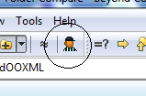

### .. and untick Excel and Word.

### Also, add ‘.rels’ to the list of XML file types

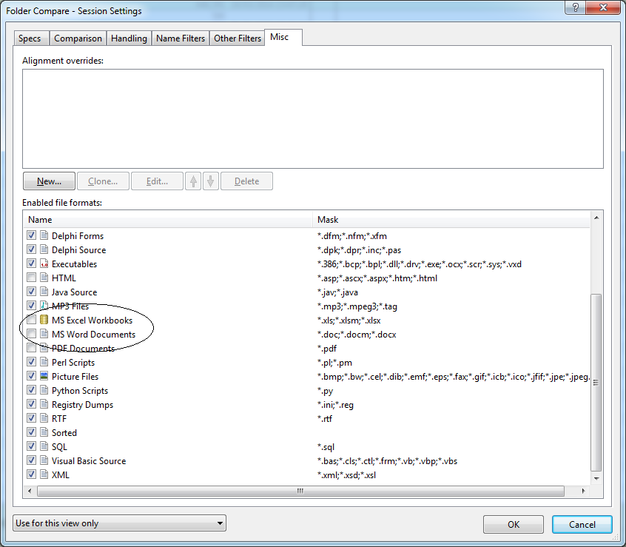

## Change Archive Handling

### Select Options:

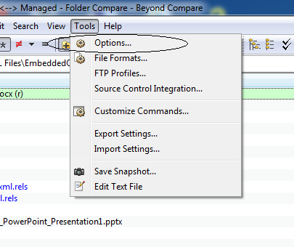

### Then Select Folder Views and change the Mask for Zip file to:

**\*.zip;*.jar;*.ear;*.war;*.bcpkg;*.docx;*.docm;*.xlsx;*.pptx;*.pptm;*.xlsm**

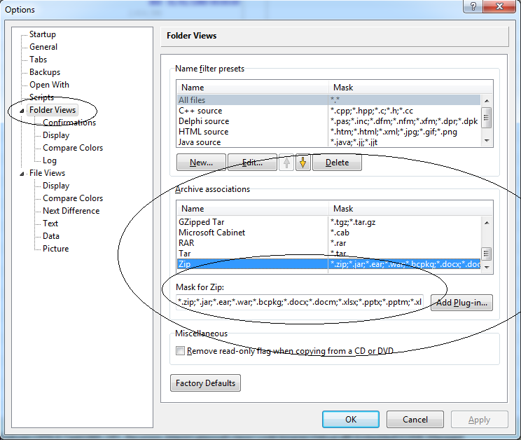

## Change Session Settings to make it easy to expand and see all OCP files fully expanded

### Open Session Settings

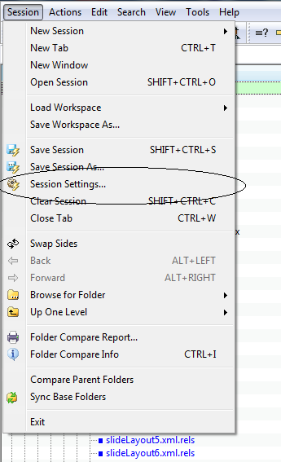

### Tick “Expand Subfolders” and select “As folders always” under Archive Handling.

### Select ‘Also update session defaults” at the bottom.

