Home Owner Homeowner Test
This is a test to check if meow is removed but home owner isn’t and homeowner isn’t
External Link home owner homeowner
Internal Link home owner homeowner
Home owner homeowner

Home owner Homeowner

Comment

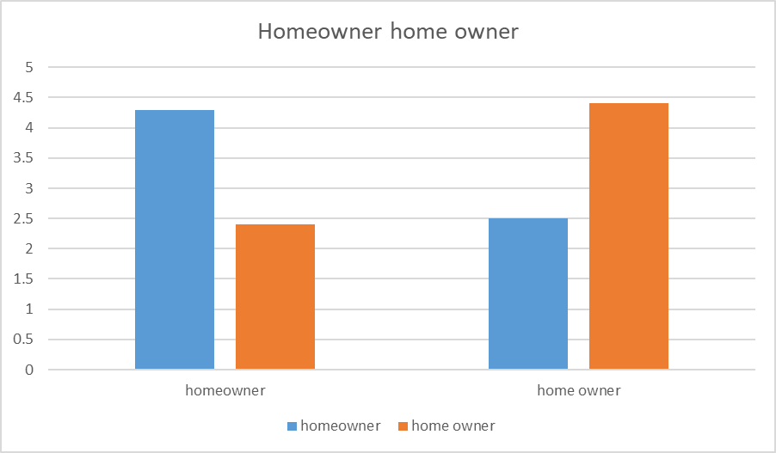

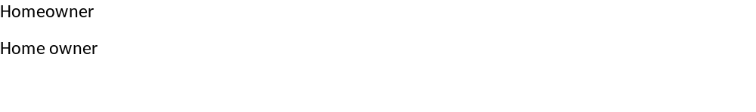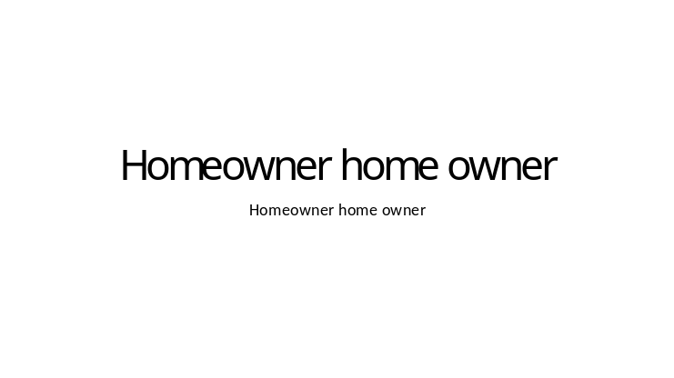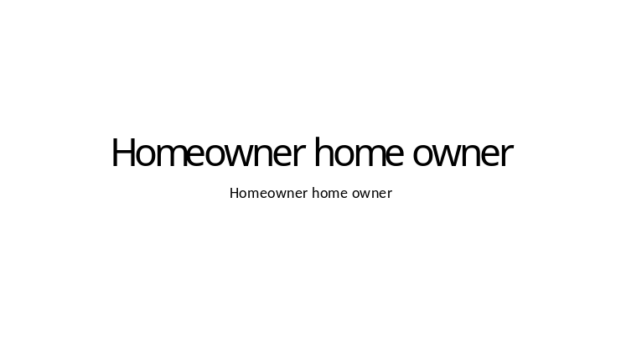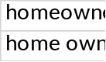

Page 2

