**User app changes:**

1. The ability for the customer to input their delivery address and the app estimates a delivery charge based on the distance the customer is away from the restaurant. With a maximum delivery radius also. This can be put in the place of the “Table number”
2. The ability to order for home delivery or collection with a time slot.
3. Clearly display opening hours on the customer app and web app and do not accept orders outside of these times. Have working hours for delivery and separate hours for collection. Also, there will be different opening times every day.
4. Rebrand. Change name to Mayo Eats and also use new logo for icon and splashscreen and everywhere else it needs to be changed.
5. Remove page to select countries. Only Ireland will be used from now on.
6. When the customer adds an item to the cart. There must be options. An option to select the size, an option for a drink if it is a meal. And a recommended add on item. Something like what I have added below.
7. Add the delivery charge to the receipt, cart and order for the customer.

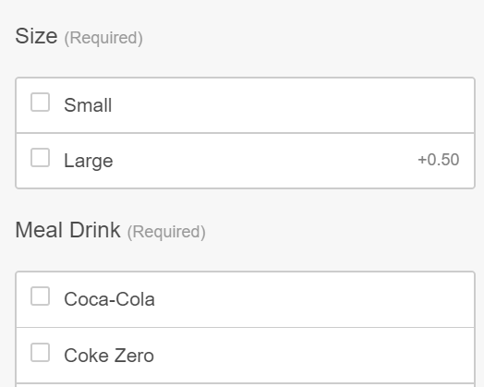

**Business app edits:**

7) Change the ORDR-UP logo to Mayo Eats on the sign in page of the business app.

8) Also add 353 to the start of all phone numbers by default.

9) Integrate sms messages for the customer to receive their order number and delivery time.

10) Change the ESTIMATED DELIVERY TIME to a text box AND the buttons with 15 mins, 30 mins, 45 mins, 60 mins.

**Admin panel edits:**

**11)** Create another admin panel sign in for Mayo Eats

**12)**Add in the drivers page again on the admin panel