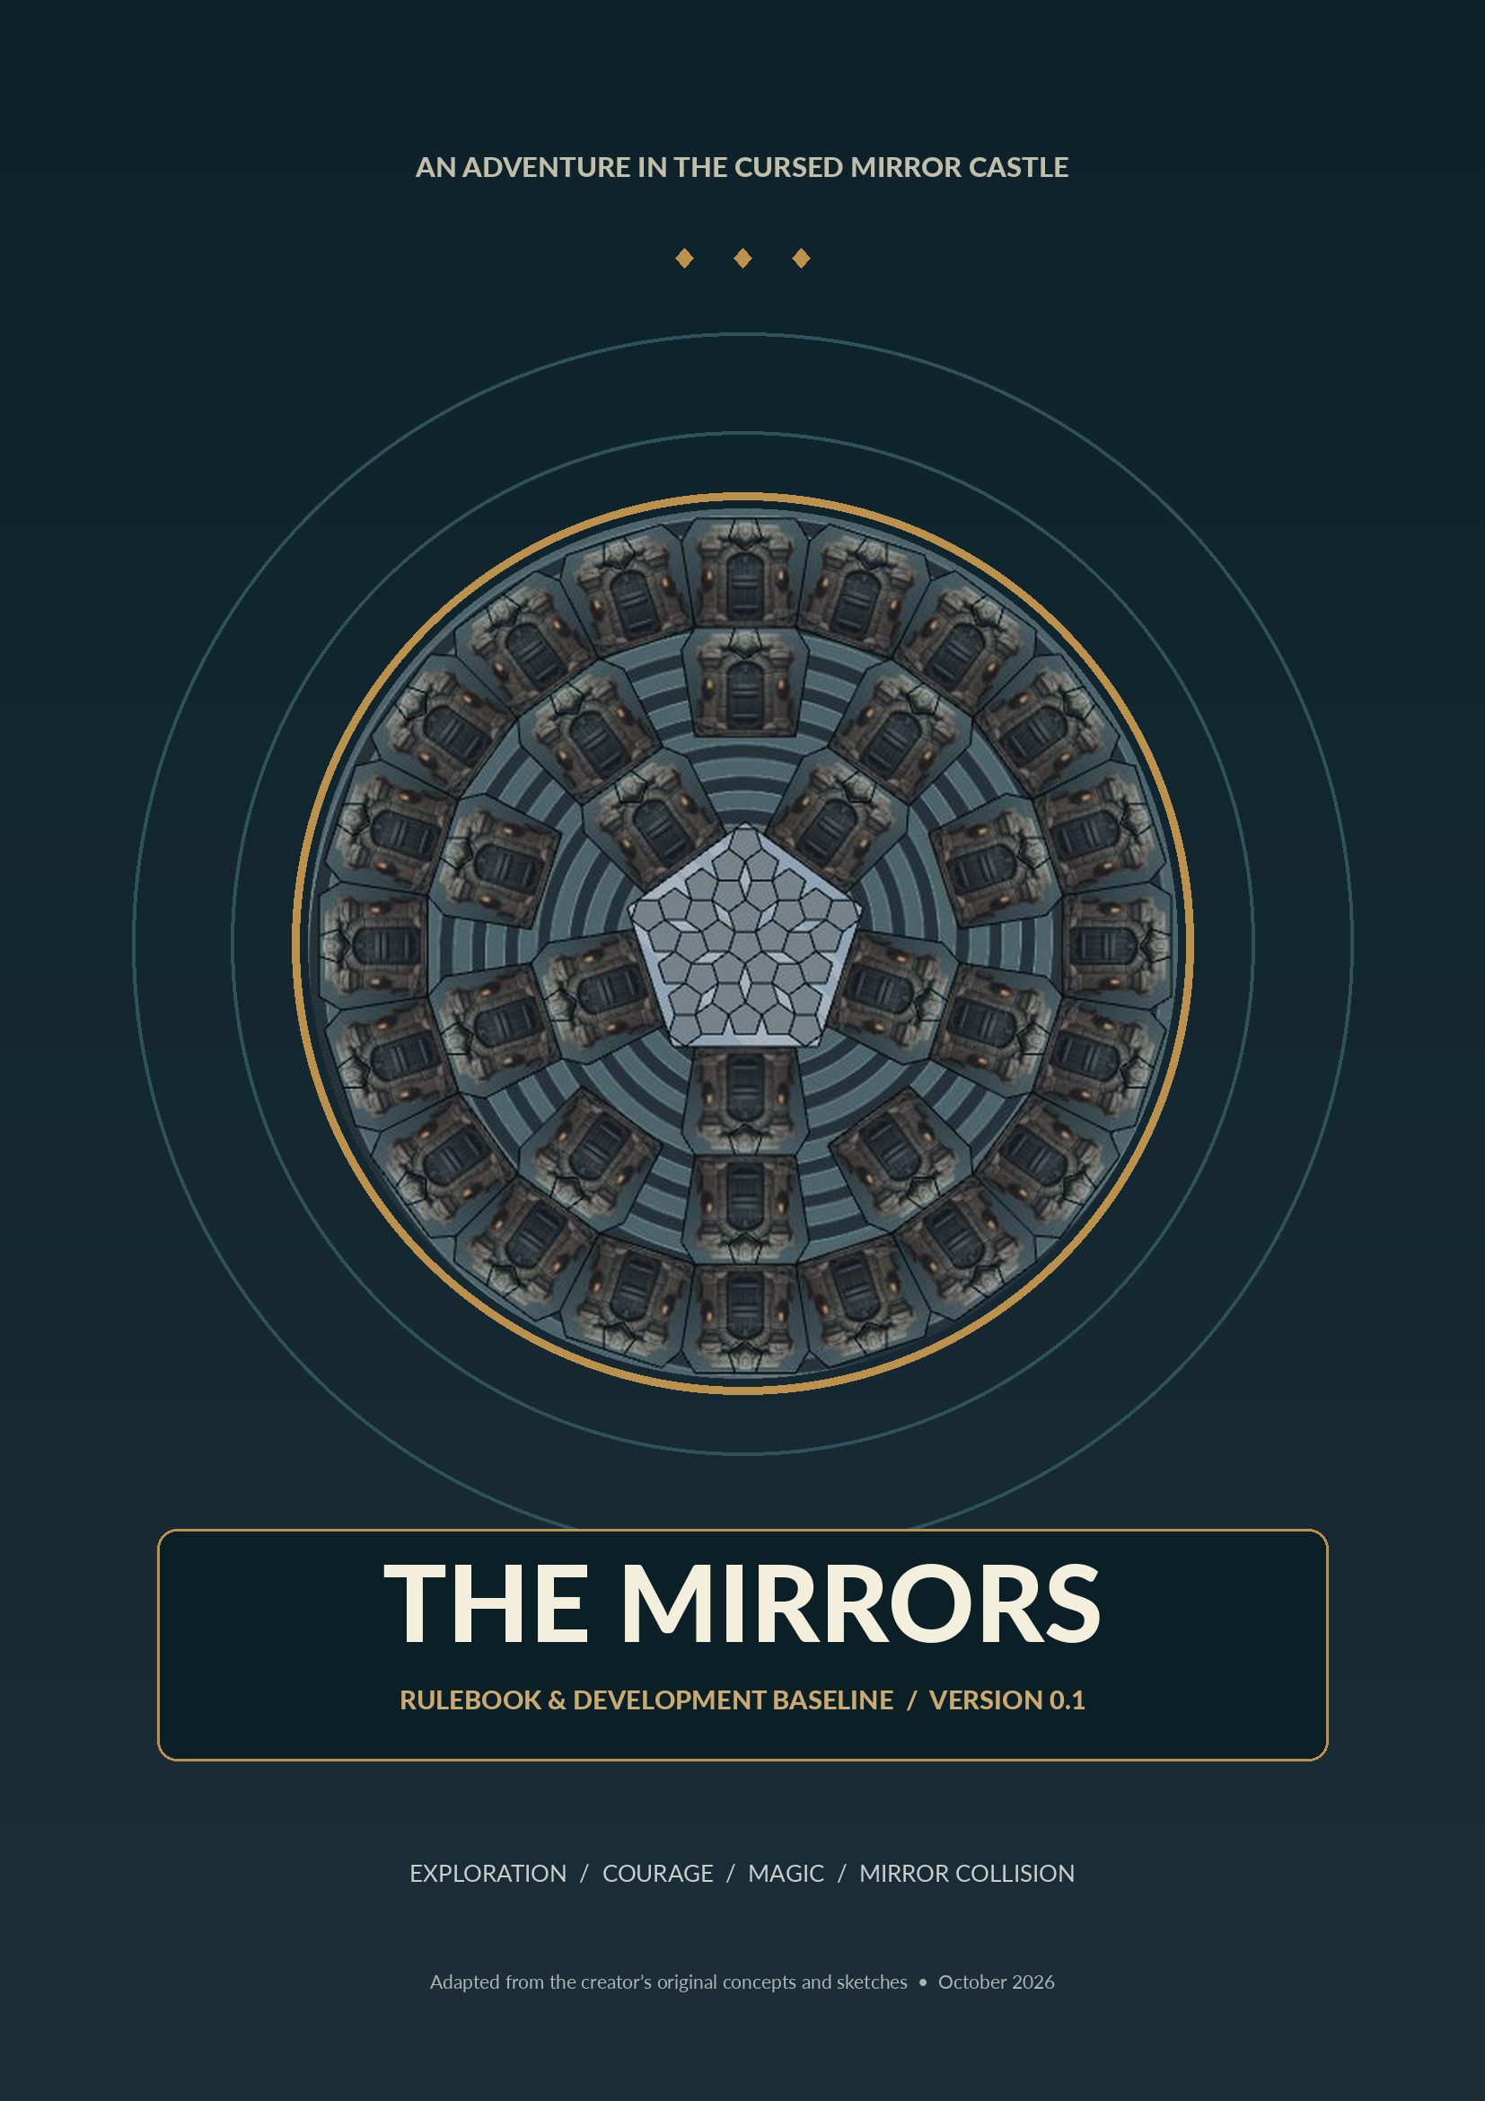

READ THIS FIRST
This document translates the creator’s original story, notes, board sketches, and our design discussion into a coherent development reference for The Mirrors. It is a professional rulebook draft, not a claim that every detail has already been playtested or approved.
CONFIRMED | How to use this rulebook
CONFIRMED = explicitly established by the game creator. PROVISIONAL = a practical playtest default supplied to make a prototype playable. OPEN = needs a designer decision. REFERENCE = background material from earlier sketches.

Development status
Classification | Meaning | Examples
CONFIRMED | Core design to preserve | 35 fragments; mandatory movement; room contents act as local inventory
PROVISIONAL | Testable rule to validate or replace | Movement allowance by Fear tier; one place + one flip per turn
OPEN | Deliberately undecided | Occuldor Rage effects; exact companion behaviors; bonus Courage
REFERENCE | Source material, not necessarily locked | Named magic schools; earlier Fear-track sketch

Contents
01 The legend and objective
02 Components and card anatomy
03 Castle, rooms, and discovery
04 Setup
05 Turn structure and movement
06 Mirrors, Occuldor, and collision
07 Courage, Fear, and Rage
08 Inventory, items, spells, companions, secrets
09 Endgame and scoring
10 Worked example and clarifications
11 Prototype cards and testing
12 Design register and source sketches
OPEN | Rulebook reading convention
If a sentence is not individually tagged, it should be read within the status established by its section title or nearby callout. All numerical values introduced for prototyping are repeated in the design register.

01 THE LEGEND & THE OBJECTIVE

The Drunken Pony
At the Drunken Pony, two to five fearless adventurers are enjoying their green beers when someone suggests an expedition to an abandoned manor outside the city. The manor is known as the Mirror Castle, once home to Occuldor, a wizard who mastered reflections, warped visions, and mirror magic.
Long ago, local witches imprisoned Occuldor beneath a kaleidoscopic mirror in the castle’s central Hall. To guard against his eventual return, they hid White Mirrors throughout the manor. Occuldor had already concealed Black Mirrors that could help restore his power. When White and Black Mirrors are brought face to face, they annihilate and leave behind a magical Mirror Sigil.
The heroes enter the manor, accidentally drop a mug, and shatter the Kaleidoscope that sealed Occuldor away. He is free once more. The only way to imprison him again is to restore every scattered colored fragment of the Kaleidoscope.

The objective
CONFIRMED | A shared survival goal and an individual winner
Restore all 35 colored fragments to the central Kaleidoscope before every hero dies. If Occuldor defeats all heroes, everyone loses. If Occuldor is imprisoned, the most heroic surviving player wins.

Successful mirror collisions automatically return a room’s fragment to the central Hall; players do not physically carry fragments back. Each restoration gives the responsible player Courage. Additional Courage from matching colors is under consideration.

At a glance
Game property | Current design
Player count | 2–5, subject to final map/player-count testing
Genre | Semi-cooperative adventure, room exploration, magical resource management
Victory | Shared seal of 35 fragments; personal competition for Heroism/Courage
Loss | All heroes dead
Core challenge | Acquire and combine mirrors, lure Occuldor, flip unblocked Black Mirrors, endure consequences
Length | Not yet established; 35-room pacing requires dedicated tests

02 COMPONENTS

Physical and card components
Component | Quantity | Status / purpose
Central Castle board | 1 | Contains broken Kaleidoscope and 35 room positions; physical layout OPEN
Room tiles / room boards | 35 | Each carries a unique four-Finding pattern
Colored mirror fragments | 35 | Five colors; provisional distribution 7 of each color
White Mirror cards | 35 | Each has one of 35 four-discovery combinations
Black Mirror cards | 35 | Each carries an Occuldor consequence; effect list OPEN
Element tokens | 70 | 14 each: Air, Earth, Fire, Water, Aether
Item / Spell / Companion / Secret cards | TBD | Finding categories exist; finished card counts and repeats OPEN
Hero figures and boards | 2–5 | Personal inventory, equipped cards, spells, sigils
Occuldor figure / Rage marker | 1 each | Marks his location and escalation
Fear/Courage board and hero markers | 1 board + one per hero | Track from Death through Heroic; see Section 07
Paralysis tokens | As needed | Original rule: arrival of Occuldor affects all heroes
Mirror Sigils | As needed | Magical casting resource gained from collisions; rules provisional

The two sets of 35 combinations
The rooms use every unordered four-slot combination of four types: Black Mirror, White Mirror, Element Slot 1, and Element Slot 2. A room can therefore contain multiple mirrors of the same kind or multiple element slots. The two element slots are distinct at the design-generation level even though they both draw an element from the same five-element bag.
White Mirrors use the same 35-pattern principle, replacing the four room symbols with Item, Spell, Companion, and Secret. This provides balanced discovery counts while varying the mixture on each card.
CONFIRMED | The 35-pattern design
For four slots chosen from four distinct symbol categories with repetition allowed and order ignored, the number of combinations is C(7,4) = 35. Across the full 35-pattern set, each category appears exactly 35 times.

03 THE CASTLE & ITS ROOMS

Original board direction
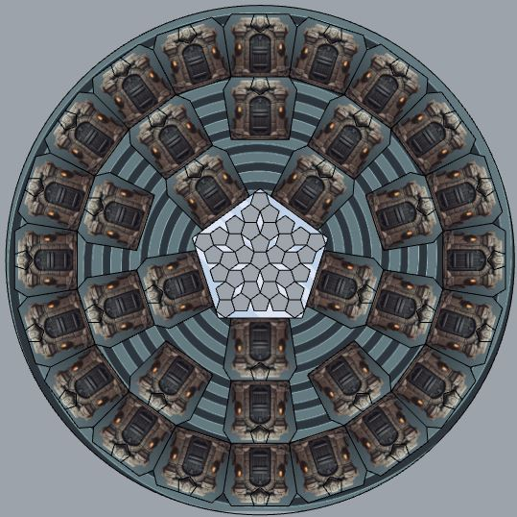
Original circular Castle concept, supplied by the creator. Final connection paths and room positions remain under development.
The core spatial idea is a central Mirror Hall surrounded by 35 undiscovered rooms. Players begin in the Hall and must navigate to rooms, gather and combine findings, and return pieces to the Kaleidoscope remotely through mirror collisions.
PROVISIONAL | Recommended first physical prototype
Use a fixed circular map with 35 marked room slots, placing each room tile face down at setup. Print unambiguous corridors or connections between slots. Later compare this fixed map to a modular-room layout using the same content.

Room discovery
1. When a player finishes movement at an undiscovered room, reveal its room tile.
2. Reveal the room’s randomly preassigned colored fragment. The color is now public information.
3. Resolve its four Finding slots: every Black slot receives a Black Mirror card, every White slot receives a White Mirror card, and each Element slot receives a token drawn from the Element bag.
4. Keep all discovered objects in the room unless a player takes or consumes them. A room remains accessible on future turns.
Discovery reveals the contents of a room; it does not automatically activate Black Mirror curses or White Mirror discovery effects. A White Mirror’s discovery content becomes available when that White Mirror is used or installed, according to Section 06.

Room condition
Condition | Meaning
Undiscovered | Tile and colored fragment are hidden; findings not yet generated
Discovered | Fragment color and room objects visible; items may be exchanged
Mirror pair installed | White Mirror active; Black Mirror is guarded by Occuldor or waiting unblocked
Restored | Room fragment has returned to Hall; it cannot be restored a second time

OPEN | Important room rule
May several mirror pairs coexist in the same room? The initial prototype assumes at most one unresolved pair in a room with an unrestored fragment. A second collision cannot restore another fragment from that room.

04 SETUP

Preparation
1. Place the Castle board and central Kaleidoscope. Put Occuldor in the central Mirror Hall.
2. Randomly assign one colored fragment to each of the 35 room positions, face down. The pool contains all 35 fragments; the prototype uses seven of each of five colors.
3. Shuffle the 35 unique room-Finding patterns and assign one face down to each room position. Room positions and assigned colored fragments are independent.
4. Shuffle the 35 Black Mirror cards and the 35 White Mirror cards into separate decks. Keep both decks accessible.
5. Put 14 tokens each of Air, Earth, Fire, Water, and Aether into an opaque Element bag.
6. Set out the Item, Spell, Companion, and Secret decks, associated character pieces, and any necessary markers. Prototype deck contents remain provisional.
7. Each hero chooses a figure and receives a player board. Set each hero to Calm on the shared Fear/Courage track; use position 18 in the prototype.
8. Place the Occuldor Rage marker at its starting position (prototype: 0). Give all heroes empty inventories and no spells unless the selected scenario explicitly grants starting equipment.
9. All heroes begin in the central Hall. Choose the first player by agreement or randomly; initial playtests use clockwise fixed order.
PROVISIONAL | Startup assumptions
Position 18, Rage 0, empty starting inventories, fixed clockwise order, and a fixed room-slot map are usable defaults—not yet approved original rules.

Public vs. private information
Public | Private
Discovered room colors and objects | Unrevealed Secret text held by a player
Occuldor location, Rage, hero Courage | Undiscovered rooms / face-down cards
Installed White/Black Mirrors, restored fragments | Hidden future cards in decks and Element bag

05 PLAYING A TURN
CONFIRMED | Mandatory movement; optional mirrors
Every non-paralyzed hero must move each turn. Placing a mirror pair and flipping an unblocked Black Mirror are optional. Mirror actions can occur before or after movement.

Turn sequence
1. LOCAL PREPARATION. While in the current room, freely inspect and combine all accessible objects there with your personal belongings. Take, leave, exchange, or arrange resources subject to capacity only when carrying them away.
2. PRE-MOVE ACTIONS. Optionally place a White/Black Mirror pair or flip an unblocked Black Mirror in your current room. Use eligible items and spells if their timing allows.
3. MANDATORY MOVE. Move along connected paths according to your current Fear/Courage state and modifiers. Intermediate rooms are passed, not entered. Movement ends in the destination room.
4. ENTER ROOM. If the destination has not been explored, reveal its room and contents. Resolve entry effects and companion relationships.
5. POST-MOVE ACTIONS. Optionally place mirrors, flip an unblocked Black Mirror, use local resources, and cast eligible spells.
6. END TURN. Settle temporary effects, check Fear/Death conditions and pass to the next player.
PROVISIONAL | Turn-level action limit for early tests
Allow at most one mirror-pair placement and at most one Black Mirror flip per turn, in either order and on either side of movement. The creator has not yet decided between this and unrestricted mirror actions.

Movement without dice
Movement is intended to depend on the hero’s state on the Fear/Courage track, not a random movement die. Companion and spell abilities may modify this allowance.
State | Fear/Courage positions | Prototype movement
Heroic | 29–35 | Up to 3 connected steps
Confident | 22–28 | Up to 3 connected steps
Calm | 15–21 | Up to 2 connected steps
Anxious | 8–14 | Up to 1 connected step
Terrified | 1–7 | Up to 1 connected step
Death | 0 | Cannot act

In this prototype, a non-paralyzed player moves at least one step and must end at a different location, but may choose any legal distance up to their allowance. Passing a room does not trigger exploration, object use, or companion entry effects. The central Hall counts as a location; corridor details remain part of map development.
OPEN | Movement interactions
Exact step allowance, whether a hero may backtrack to their starting space, how dead ends function, and whether fear affects route legality instead of speed require playtesting.

Paralysis overrides mandatory movement
The original design gives all players a paralysis token when Occuldor appears on a newly installed Black Mirror. The token prevents that hero’s next required move; it is an explicit exception to mandatory movement. The hero may still perform local optional actions unless another effect prevents them. Discard the token after the affected movement step is skipped.
OPEN | Pacing hazard
Applying a castle-wide movement skip after every Occuldor relocation may add dozens of inactive player turns across 35 pairs. Test a milder Dread effect or local paralysis as alternatives before production.

06 THE MIRROR SYSTEM
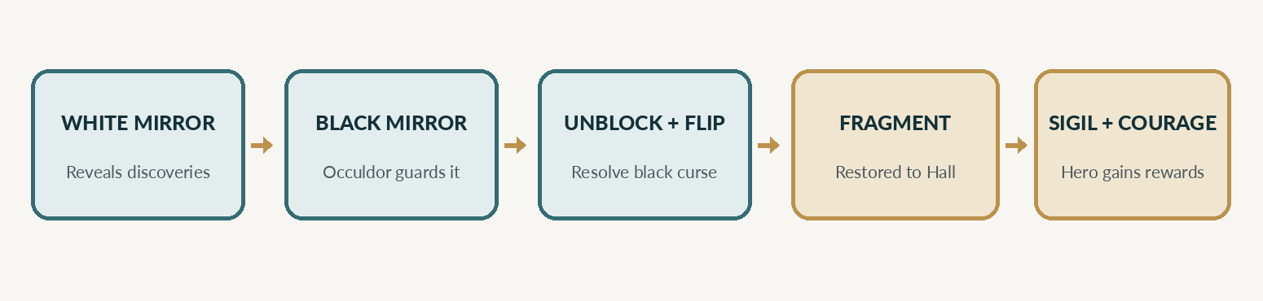
The mirror-pair sequence. White Mirror discovery and Black Mirror danger are separate parts of one restoration process.

6.1 Place a White and Black Mirror pair
1. The hero must be in a discovered room that still holds its colored fragment.
2. Access one White Mirror and one Black Mirror from any combination of personal inventory and objects in the room. No pickup into inventory is required.
3. Install the pair in the room. Place the Black Mirror face down; its harmful effect is not resolved yet.
4. Activate the White Mirror’s beneficial discovery: reveal and make available the Item, Spell, Companion, and Secret discoveries shown on its four-slot card. Discoveries that are not carried remain in the room.
5. Occuldor arrives to guard this Black Mirror, relocating from the Hall or a previously guarded pair. Any previously guarded Black Mirror becomes unblocked. Apply the original paralysis effect to all players.

6.2 Flip an unblocked Black Mirror
1. The hero must currently occupy the room containing the unblocked Black Mirror.
2. Flip the Black Mirror and resolve its printed Occuldor curse, modified by the current Rage state as applicable.
3. The White and Black Mirror cards annihilate. Remove both from the game, or place them in a used-mirror supply for tracking.
4. Restore that room’s colored fragment directly into its corresponding Kaleidoscope position in the Hall. The hero never needs to deliver it physically.
5. Give the hero one Mirror Sigil and a Courage reward. Exact color matching and numeric Courage awards are provisional; see below.
6. Mark the room as restored. It cannot produce an additional central fragment.
PROVISIONAL | Simple first-playtest reward
For an initial playable loop, award +1 Courage per restored fragment and one Sigil matching the restored fragment color. The creator’s idea of extra Courage for matching colors remains OPEN.

6.3 What does placement of the colored piece mean?
The first physical concept shows a five-color Kaleidoscope made of many individual pieces. Every room’s hidden fragment has a fixed destination or matching region in the central puzzle. When a fragment is restored, the player updates the central mirror immediately.
The creator is considering extra Courage for placing a piece of the same color as another restored piece. Whether this means neighboring physical pieces, consecutive restorations, or color-section completion has not yet been decided.

6.4 Scarcity and conservation
There are exactly 35 White Mirror cards, 35 Black Mirror cards, and 35 fragments. Assuming one pair restores one room, all 35 pairs must ultimately resolve to win. Therefore no general effect may permanently destroy or irretrievably discard a required mirror without a replacement rule.
CONFIRMED | Room-bound fragment is the natural collision limiter
A successful collision restores one fragment from that room. Once its fragment has been restored, there is no additional room fragment available to send to the Hall.

07 OCCULDOR, COURAGE & FEAR

Occuldor as a living obstacle
Occuldor starts at the central Hall. A newly placed pair attracts him to the Black Mirror, where he blocks its flip. When a later pair is installed in another room, he moves to guard the new Black Mirror, allowing players to resolve the formerly blocked mirror. Occuldor’s arrival causes paralysis in the original rule set.
Occuldor also has a separate Rage track. Its value changes as pieces are restored, and his curse consequences can become stronger with his Rage, fragment color, or particular puzzle combinations. The scale, thresholds, and event effects remain undeveloped.
OPEN | The final guarded mirror paradox
Once only one unresolved Black Mirror remains, no subsequent placement may be available to lure Occuldor away. The final-seal mechanism must be settled so a theoretically winning game cannot become permanently blocked.

Provisional last-seal safety rule
For prototype testing ONLY: after 34 fragments have been restored, a hero in the final guarded room may attempt a Final Seal. Pay 3 Courage, force Occuldor back to the Hall, then flip the Black Mirror and resolve its curse normally. This is not an approved core rule; it exists to ensure a test session can end.

Fear and Courage
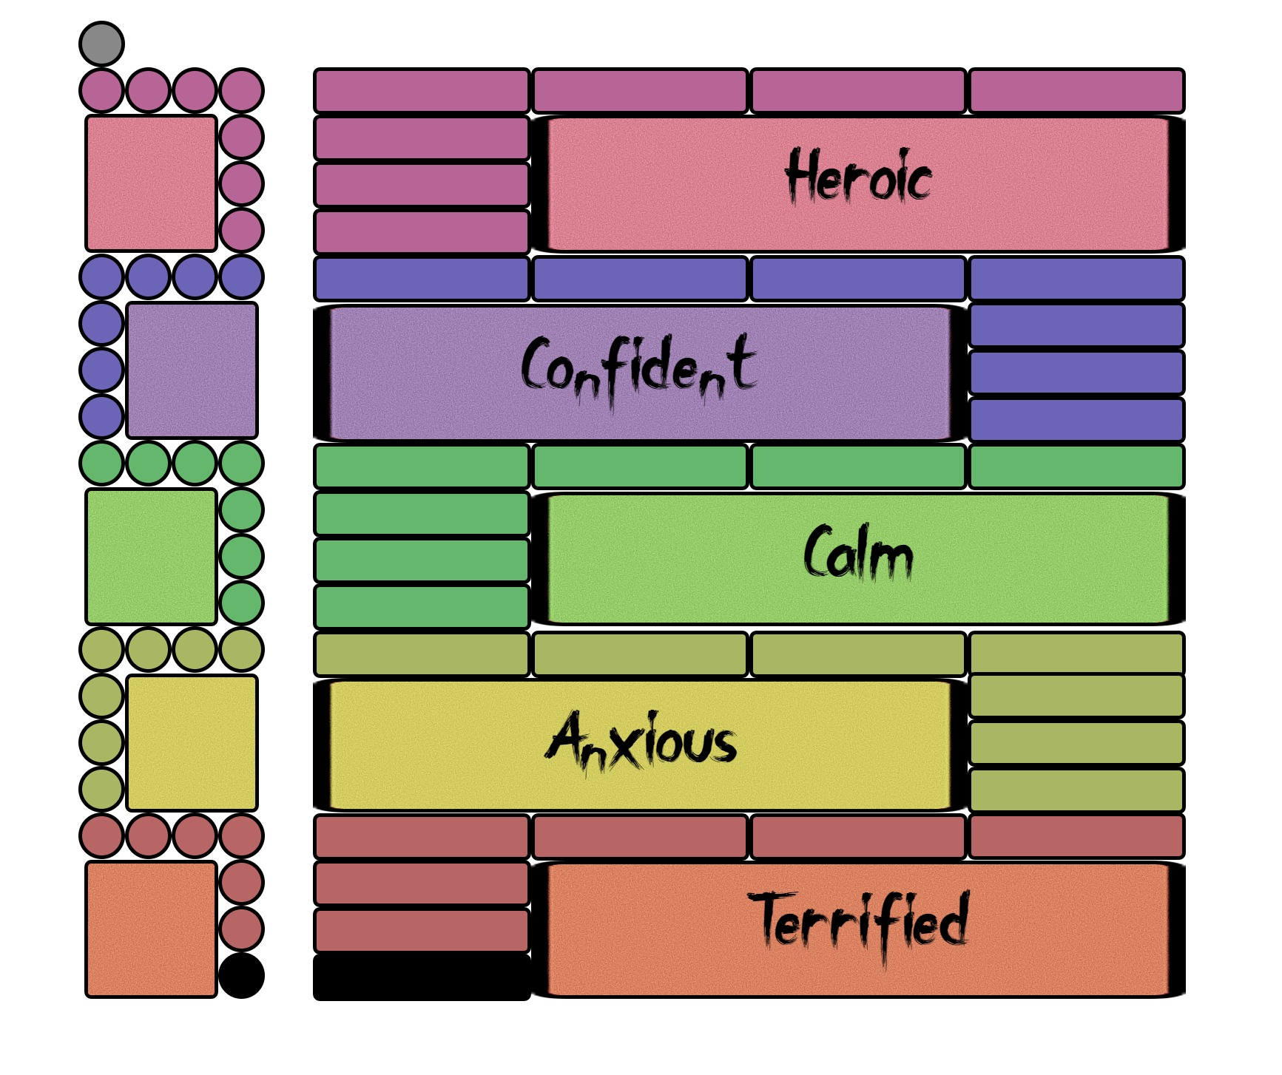
Original five-state Fear track concept, supplied by the creator. Text uses the numeric ranges recorded in the sketches.
State | Positions | Meaning in the original notes
Heroic | 29–35 | Resistant to Occuldor
Confident | 22–28 | Resistant to black magic
Calm | 15–21 | Baseline psychological state
Anxious | 8–14 | Negative effects to be defined
Terrified | 1–7 | Paralysis / severe restriction
Death | 0 | Hero is dead; original victory loss if all die

Restoring a colored fragment raises the responsible hero’s Courage. Black Mirror curses, Occuldor actions, and other effects may lower it. A hero at zero is dead under the original design. If all heroes die before the 35th fragment is restored, Occuldor wins.
OPEN | Two distinct uses for a single track
Courage currently measures both survival psychology and who is “most heroic.” If winning only depends on the final Courage value, Black Mirror risk and accumulated contributions may produce unintuitive winners. Prototype final winner = highest surviving Courage; compare against a separate Heroism score in testing.

08 OBJECTS, MAGIC & COMPANIONS

8.1 The room is an extension of your inventory
CONFIRMED | Literal local access — everything
While physically in a room, a player can use and combine ANYTHING in that room exactly as if it were in their own inventory: mirrors, elements, items, spells, companions, and other accessible objects. No pickup is necessary before using it. Carrying capacity limits what travels with the hero, not what can be used locally.

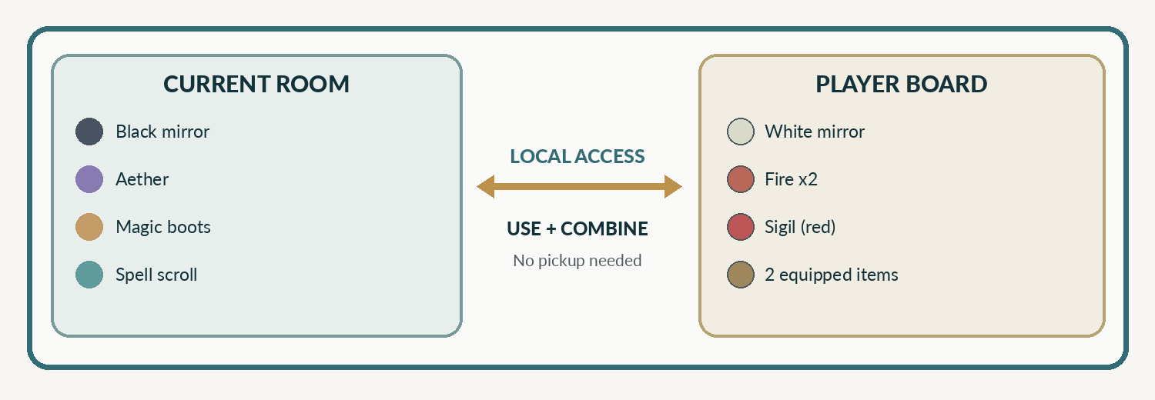
Room contents and carried possessions form a single local pool of usable objects while the hero is present.
Examples: use a White Mirror lying in the room with the Black Mirror in your bag; use Fire tokens on the floor plus your Aether to meet a spell’s learning requirement; benefit from magical boots in the room while taking an action there, even if your equipment slots are full. If the boots improve movement, the effect can be used as the hero leaves that room. Once no longer there, its effect ends unless it was carried or explicitly has a lasting duration.
For card effects that grant a permanent upgrade or require learning, normal card conditions still apply: being in a room gives access to the card, but does not waive a printed cost or prerequisite. A learned spell left in the room may be cast by a player who can legally access its learned effect, subject to future rules for spell ownership.

8.2 Initial carrying capacity
Player-board area | Original initial capacity | Notes
Mirror slots | 2 mirrors | White or Black, in any mixture
Element slots | 5 elements | Any combination of Air / Earth / Fire / Water / Aether
Spell slots | 3 cards | May include learned or unlearned spell cards
Item mounts | 2 items | One at each side; relics may use additional board space
Mirror Sigils | No fixed number yet | Placed on or near board; used to activate spells
Follower companions | Unlimited | Some plants, insects, birds, or animals consume carrying capacity
Secrets | Unlimited | Represent information and private objectives

8.3 Elements and learning magic
The Element bag contains exactly 70 tokens, 14 each of Air, Earth, Fire, Water, and Aether. Elements appear through room Findings and can be carried, left, exchanged, combined, or paid to learn spells. Some spells may additionally require a magical item or another prerequisite. Paying a cost removes the specified elements from local access and returns them to the designated supply (prototype: general Element bag).

8.4 Mirror Sigils and spellcasting
Mirror Sigils are earned from successful collisions and power learned spells. Earlier sketches propose Sigils physically placed onto spell cards, with different behaviors: once-per-round activation, enduring allocation, and combinations of multiple Sigils. Sigil color may matter.
PROVISIONAL | First-playtest casting economy
A hero receives a Sigil matching the restored fragment’s color. To cast a learned spell, allocate one compatible ready Sigil (unless the spell says otherwise); exhaust it until the beginning of the hero’s next turn. Do not consume the Sigil. Test compatibility and refreshing rather than treating them as approved rules.

8.5 Spell categories
Type | Purpose | Design status
Personal | Affects the hero or their belongings | Candidate
Room | Affects objects or mirror interactions in the current room | Candidate
Field / Manor | Affects several rooms or the entire Castle | Mentioned in original concept
Reaction | Intervenes during Occuldor or another player’s action | Candidate
Ongoing | Uses one or more permanently allocated Sigils | Implied by early spell sketches

Earlier notes propose a wide set of magical schools such as Chronomancy, Cryptomancy, Chromomancy, Psychomancy, Numeromancy, Pyromancy, Hydromancy, Aeromancy, Geomancy, Oneiromancy, Zoomancy, and many others. These are a design library, not 20+ required subsystems in the first prototype.

08 OBJECTS, MAGIC & COMPANIONS / CONTINUED

8.6 Items
Items extend capacity, enable actions, protect players, modify movement, or provide special advantages. A player may physically carry up to two attached items at the start, though certain relics or equipment may use dedicated board locations. Room access means an item on the floor may still be used there, even if carrying capacity is full.

8.7 Companions
Companions have card identities and physical figures. They may be animals, birds, insects, plants, or ghosts. Some follow heroes indefinitely; others stay in particular rooms, transfer when another hero passes them, or require inventory capacity because they must be carried. Companions can be helpful or troublesome, and some cannot coexist in the same room.
Example | Early-design inspiration | Development question
Rex the Dog | Loyal follower | How does loyalty interact with Occuldor?
Alexis the Cat | Scout or independent traveler | When may a scout reveal a room?
Poe the Raven | Flying exploration companion | Can it cross blocked rooms?
Madison & Mason | Paired ghost companions | May both be controlled by different players?
Rabbit / Tortoise | Movement modifiers | Do modifications override Fear speed limits?

8.8 Secrets
Secret cards are private information: hidden objectives, achievements, clues, or special narrative knowledge. They require no carrying capacity. A Secret may influence courage rewards, identify a dangerous Black Mirror, or create an additional personal achievement, but must not make sealing the Kaleidoscope impossible.

8.9 Capacity, taking, and leaving objects
1. While in a room, any object there remains locally accessible regardless of carrying capacity.
2. A player may reorganize their carried belongings with objects in the room, following any printed restrictions.
3. When moving away, the hero may retain only what fits in their player-board capacity (modified by carried enhancements). Everything left behind remains in the room.
4. If a hero’s active capacity decreases, excess objects must be left in their current room before that hero moves again (provisional handling rule).
OPEN | Ownership edge cases
Precise treatment of passive items used during a departure, learned spells stored in rooms, automatic companion transfer, and whether visiting heroes can use a rival’s learned spells must be specified in card templating.

09 ENDING THE GAME

Occuldor victory
If every hero has reached Death on the Fear/Courage track before all 35 fragments are restored, Occuldor wins and the heroes lose together.

Heroic victory
After the 35th successful mirror collision, restore the final fragment directly into the Kaleidoscope. Occuldor is imprisoned again, and the surviving heroes compare their achievements to identify the most heroic player.
PROVISIONAL | Prototype winner and tie-break
Highest current Courage among surviving heroes wins. In a tie, the hero who personally restored more fragments wins; if still tied, share victory. The final criteria have not been explicitly decided.

Why shared victory and individual scoring matter
The heroes need one another to draw Occuldor away from guarded mirrors and restore the full Kaleidoscope. Yet every collision can benefit its resolving player personally. This shared-versus-personal incentive is intentional; the game should reward courageous contribution without encouraging players to deliberately prevent the group from finishing.

Possible matching-color reward
Model | Description | Behavior it encourages
Consecutive match | Restore the same color as the most recent fragment | Short-term route planning, timing
Adjacent placement | Touch a restored fragment of the same color in the puzzle | Spatial planning; may be automatic if positions are fixed
Finish a color section | Restore the last fragment of one color | Long-term races; may reward last-hit timing

No matching-color award is active in the baseline rules until a precise trigger and amount have been chosen. The initial prototype uses +1 Courage per restoration only.

10 WORKED EXAMPLE & RULE CLARIFICATIONS

Example: two mirror pairs and a released fragment
1. Mara enters explored Room 11. She carries a White Mirror and finds a Black Mirror among the room’s objects. The room has an unreturned violet fragment.
2. Mara places the White and Black Mirrors together, using the Black Mirror directly from the room. The White Mirror reveals its printed discoveries. Occuldor appears and guards the Black Mirror. All heroes receive the original paralysis effect.
3. On a later turn, Toren installs another pair in Room 17. Occuldor leaves Room 11 and travels to Room 17, guarding Toren’s pair. Room 11’s Black Mirror is now unblocked.
4. Mara returns to Room 11 and chooses to flip its Black Mirror. She resolves the printed curse and any applicable Rage effect. The White and Black Mirrors annihilate.
5. Room 11’s violet fragment automatically returns to its Kaleidoscope position in the Hall. Mara gains one violet Sigil and +1 Courage under prototype rewards. Room 11 is now restored.

Quick rulings
Question | Rule / status
Must I pick up a card or token before using it? | No. All objects in the current room act as your local inventory. CONFIRMED.
May I stay in the same room all turn? | No, unless an effect prevents the mandatory movement. CONFIRMED.
Do I trigger passed rooms during movement? | No; only the destination room is entered. CONFIRMED from original movement vision.
Must I walk back to the Hall with a fragment? | No; the fragment returns automatically after a collision. CONFIRMED.
Can I flip a Black Mirror while Occuldor guards it? | No, not under normal conditions. CONFIRMED.
Can a restored room produce another fragment? | No; each room owns one fragment. CONFIRMED implication.
Can players cast or interact before AND after movement? | Yes for allowed actions; action count remains PROVISIONAL.
What happens when the last mirror is guarded? | A Final Seal fallback is PROVISIONAL pending a proper design.
Does a color matching pattern grant bonus Courage? | Not yet; trigger and reward remain OPEN.

11 EARLY PROTOTYPE CONTENT
The following cards are examples for playtesting the framework, not reconstructions of finalized original cards. Their role is to generate varied actions without requiring all complete decks to be written before the first test.

Sample Black Mirror effects [PROVISIONAL]
Name | Effect to test
The Distorted Self | Lose 2 Courage when flipped.
Hall of Echoes | Lose 1 Courage for each companion following you (maximum 3).
Shattered Reflection | Leave one carried Element token in this room.
Terror Behind Glass | Gain one paralysis token; it applies at your next movement.
The Watching Eye | Increase Occuldor Rage by 1, then lose 1 Courage.
Reflection of Defiance | If Confident or Heroic, lose 1 Courage; otherwise lose 3.

Sample Items / Spells / Companions [PROVISIONAL]
Example | Why test it
Pocket Satchel (Item) | Increase carried Element capacity by two; verify effect when the satchel remains in a room.
Traveler’s Boots (Item) | +1 movement when accessible; test local versus carried effect.
Clear Reflection (Spell) | Spend or exhaust a Sigil to reduce a Black Mirror consequence by one.
Chromatic Echo (Spell) | Use a different compatible Sigil color for one activation.
Rabbit (Companion) | +1 movement; verify whether it overrides the Courage tier.
Tortoise (Companion) | -1 movement, but resist one Courage loss from Occuldor.

Development card anatomy
Item: name • object type • passive or activated effect • carried-size/equipment slot • timing • exceptions. Spell: name • magic school/type • learning cost in elements or items • Sigil requirement • activation timing • duration • quick/ongoing icon. Companion: name • follower/room/baggage type • movement modifier • entry reaction • incompatible companions. Black Mirror: curse • Occuldor Rage interaction • severity • counterplay. White Mirror: four discovery icons in a unique multiset pattern.

First test scenario
For an early mechanics test, use 10–12 rooms, a reduced set of mirror cards, two or three players, and a clear path graph. Do not use the full 35-fragment win condition in the first micro-prototype. The purpose is to observe the mirror/Occuldor movement loop, inventory decisions, paralysis pacing, and restoration rewards.

12 DESIGN REGISTER
The issues below are deliberately unresolved. This register prevents convenient prototype assumptions from being mistaken for the creator’s approved rules.
Priority | Issue / design decision | Current baseline
P0 | Can players place more than one pair or flip more than one mirror per turn? | 1 pair + 1 flip per turn [PROVISIONAL]
P0 | How is the final Black Mirror unblocked? | Final Seal fallback costing 3 Courage [PROVISIONAL]
P0 | Does Occuldor paralyze all players upon every arrival? | Yes in original; pacing-risk playtest required
P0 | What happens at Fear 0 and with a dead hero’s objects? | Death at 0; object-drop rules OPEN
P1 | Fear-dependent movement allowances and navigation paths | 3/3/2/1/1 movement [PROVISIONAL]
P1 | Does the fixed circular or modular castle play better? | Fixed 35 slots [PROVISIONAL]
P1 | What does Rage do at each threshold? | Rage track exists; triggers/events OPEN
P1 | When does matching a piece color grant extra Courage? | Consecutive / adjacent / completed color OPEN
P1 | How are Sigils colored, exhausted, and assigned? | Matching + exhaust until next turn [PROVISIONAL]
P1 | What is the individual victory metric? | Highest Courage [PROVISIONAL]
P2 | How many unique Item, Spell, Companion and Secret cards? | Discovery slots fixed, unique design counts OPEN
P2 | Can a room hold multiple unresolved pairs / companions? | One unresolved pair in first prototype
P2 | How long does the full 35-room game take at 2, 3, 4, 5 players? | Unknown; measure turns, paralysis downtime, decision time

Suggested playtest measurements
- Rounds and minutes per restored fragment; total turns to finish.
- Average turns that a player loses to paralysis and to low movement.
- Number of discovered rooms with unused mirrors or resources.
- How often a player cannot make progress because Occuldor guards the only usable pair.
- Courage distribution and change from Black Mirror curses versus fragment rewards.
- How often players use room-local objects without carrying them; how many objects accumulate in each room.
- How often a player’s personal incentive conflicts with sealing the final Kaleidoscope.

Source sketches and diagrams
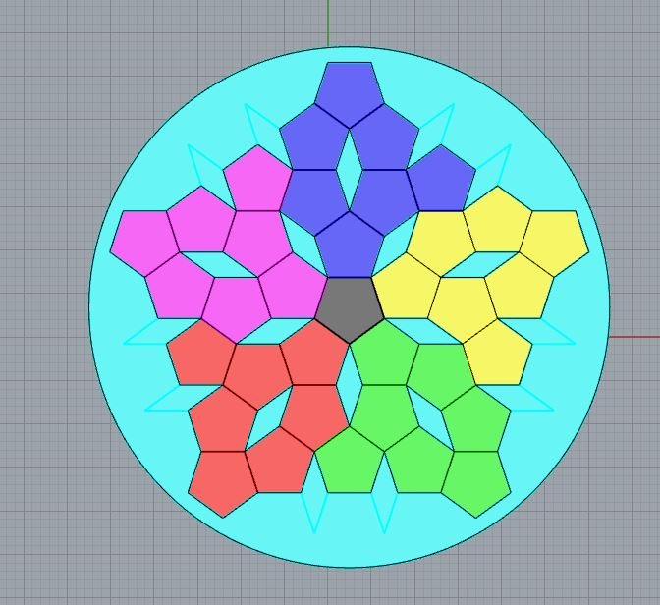
Creator’s five-color Kaleidoscope puzzle sketch. Piece geometry and adjacency incentives are not yet finalized.
Other source notes document magical schools, companions, the fear states, spell card anatomy, and a 35-pattern room-generation method. The source art is retained here as a design reference, rather than asserting that all depicted layouts and labels are finished production rules.
OPEN | Next collaborative design discussion
Choose a precise interaction between Occuldor and an installed pair: number of mirror actions per turn, whether a new pair always pulls him, the cost of resolving his final guarded pair, and the severity/timing of his global paralysis. Those decisions determine pace more strongly than deck size or artwork.

THE MIRRORS • THE CASTLE IS WAITING

