1. Elevate your user access to root;

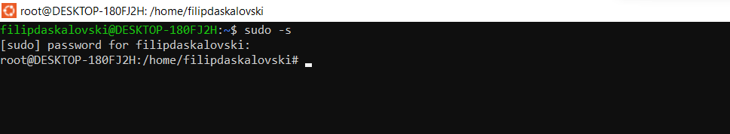

1. add a new user to your Linux OS and set a password for it;

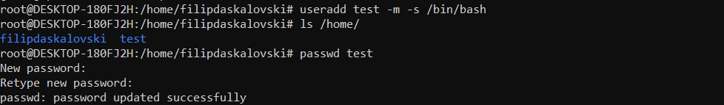

1. Test if you can log in using that user;

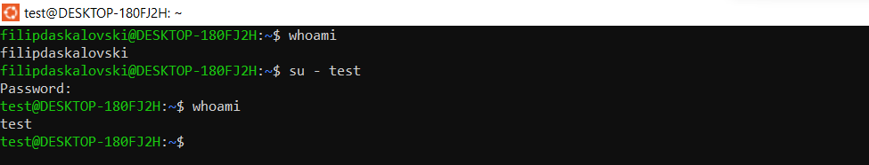

1. Using grep command check if the user is created;

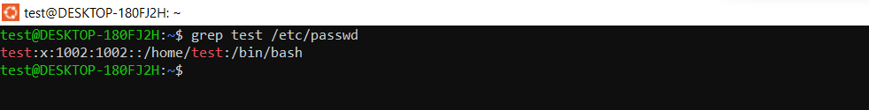

1. grep the UID of each user;

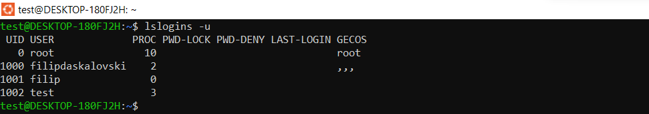

1. Find out the GID of the created user;

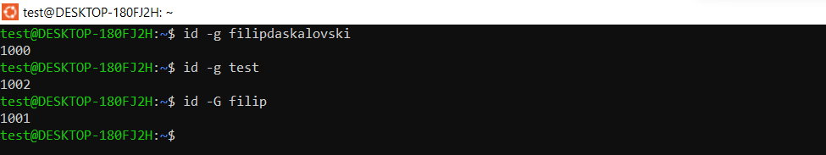

1. Change the password of the user and force it to change the pass on his next login;

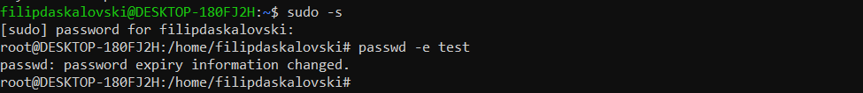

1. Add a new user and set an expiration date for it, with a five-day warning period;

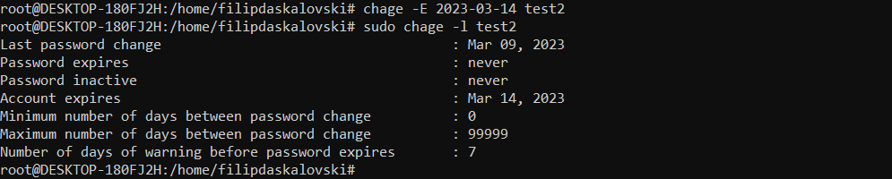



1. Create a new group;

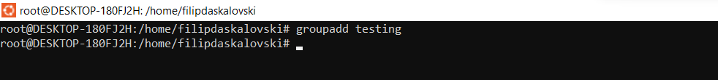

1. Assign the two new users to that group;





1. Lock one of the user accounts;



1. Change the shell of one user to tcsh;

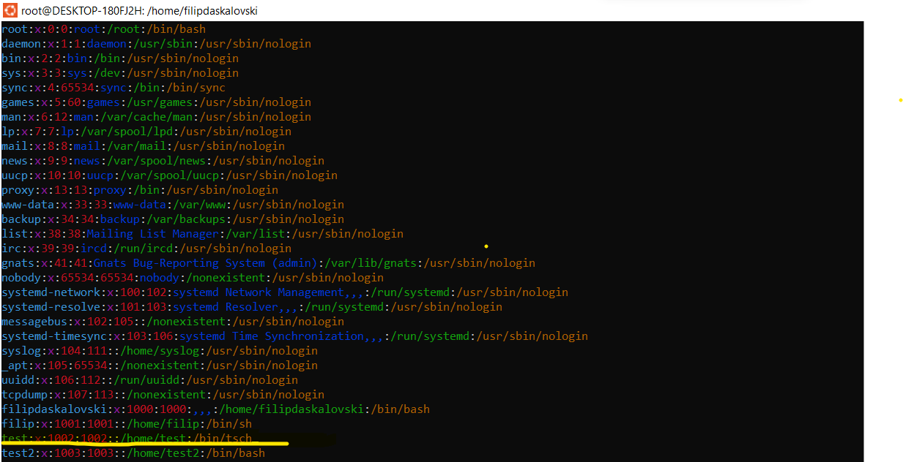

1. Make sure your home directory has “execute” access enabled for group and other.

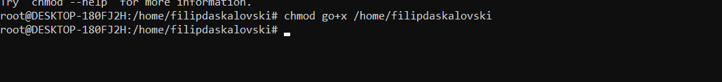

1. Change to your home directory, and create a directory called labs;

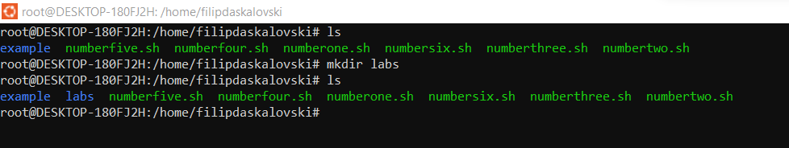

1. Create an empty file in labs directory

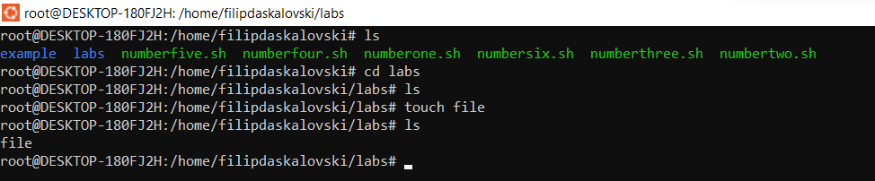

1. Change permissions of file to rwx-rwx-rwx



1. Change the permissions back to rx-rw-rw

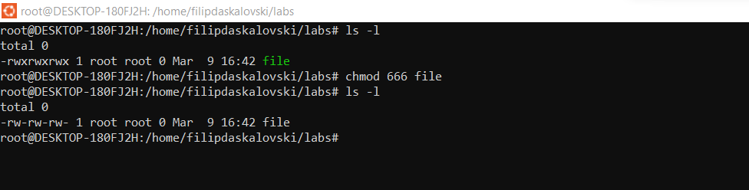

1. Check what owners does the file have.

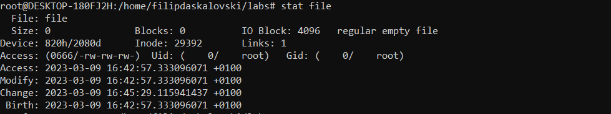

1. Change the user ownership of the file to another user;

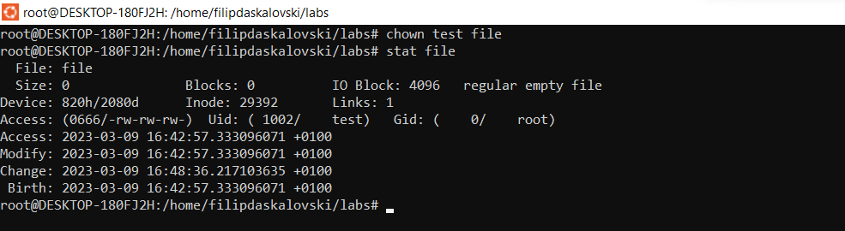

1. Create a group called group1 and assign two users to the group;

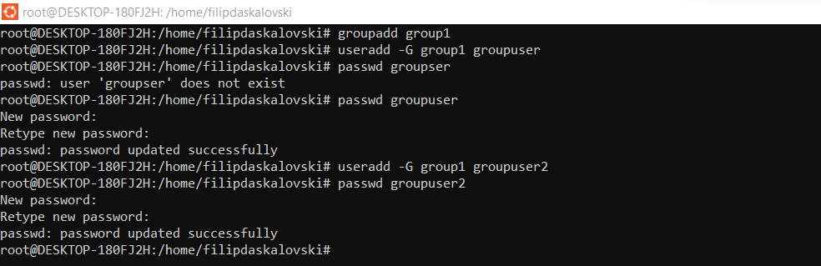

1. Create a file called group1.txt and redirect below input into the file:

“This is our group test file”.



1. Change the group of the file to one of your users;

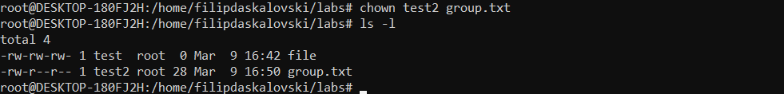

1. Give members of the group group1 read/write access to this file?

