- Elevate your user access to root;
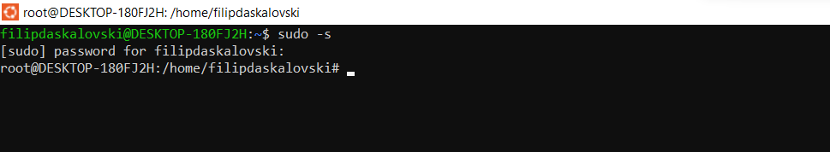
- add a new user to your Linux OS and set a password for it;
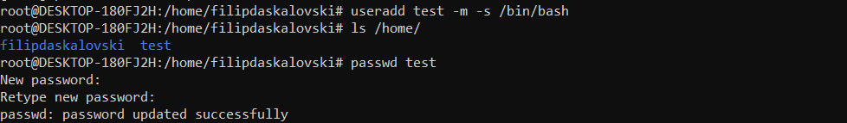
- Test if you can log in using that user;
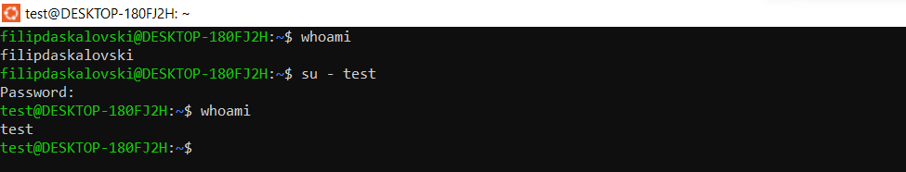
- Using grep command check if the user is created;
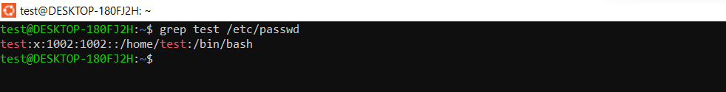
- grep the UID of each user;
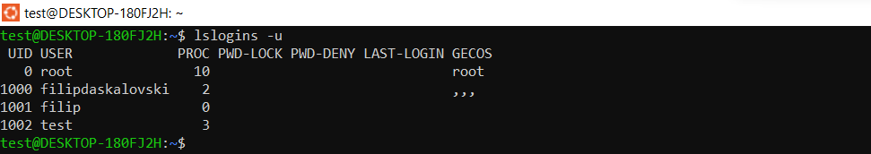
- Find out the GID of the created user;
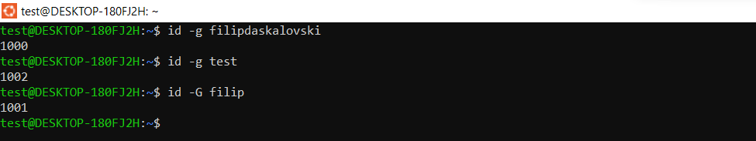
- Change the password of the user and force it to change the pass on his next login;
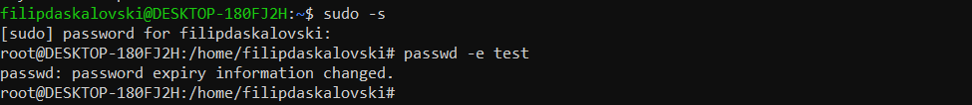
- Add a new user and set an expiration date for it, with a five-day warning period;
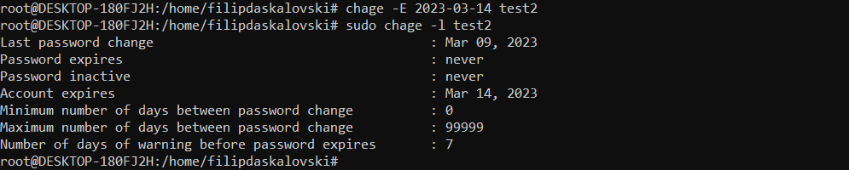
- Create a new group;
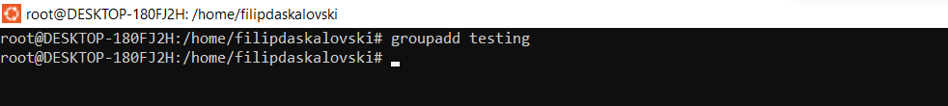
- Assign the two new users to that group;
- Lock one of the user accounts;
- Change the shell of one user to tcsh;
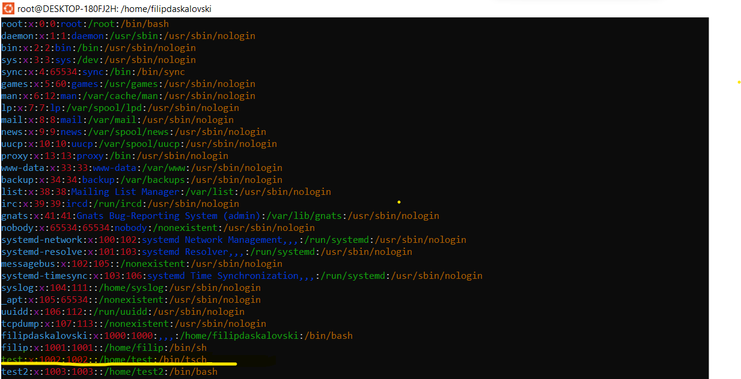
- Make sure your home directory has “execute” access enabled for group and other.
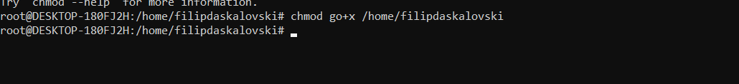
- Change to your home directory, and create a directory called labs;
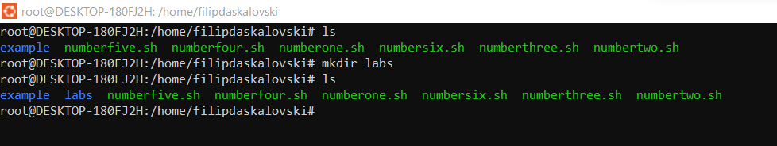

- Create an empty file in labs directory
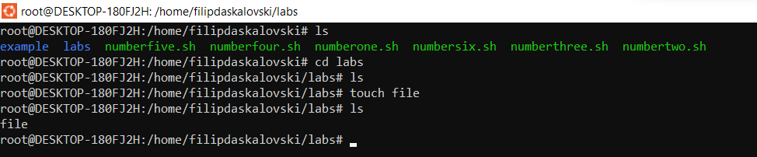
- Change permissions of file to rwx-rwx-rwx
- Change the permissions back to rx-rw-rw
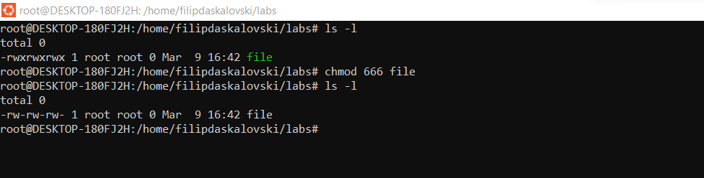
- Check what owners does the file have.
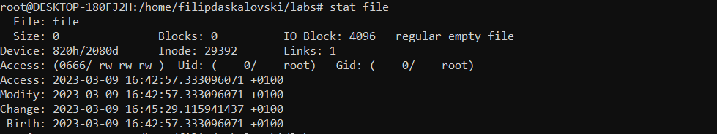

- Change the user ownership of the file to another user;
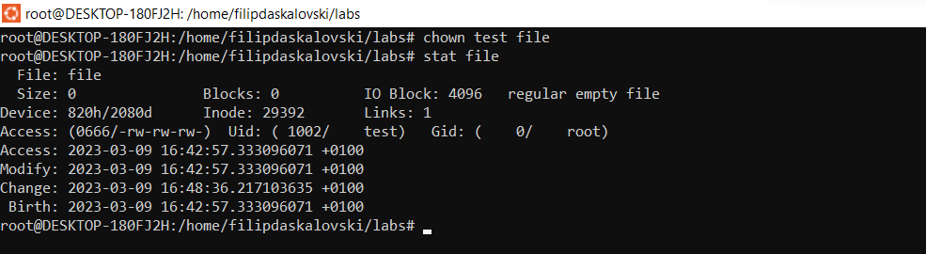

- Create a group called group1 and assign two users to the group;
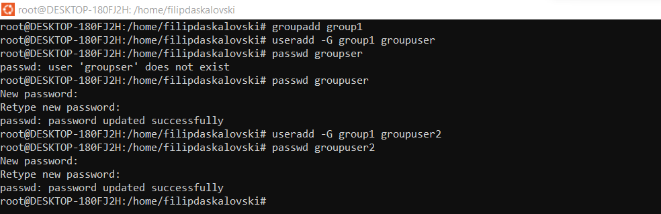
- Create a file called group1.txt and redirect below input into the file:
“This is our group test file”.
- Change the group of the file to one of your users;
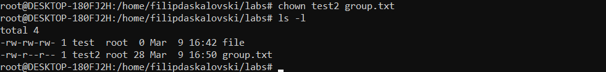

- Give members of the group group1 read/write access to this file?

