


Exercise: Shell scripts

- Write a shell script to get the current date, time, username and current working directory.

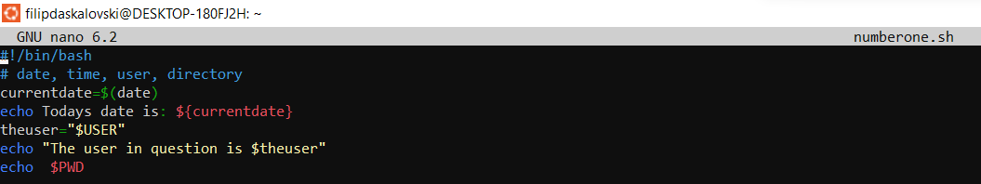
========================================================

- Write a shell script that prints “I love learning about DevOps” on the screen. Message should be a variable.
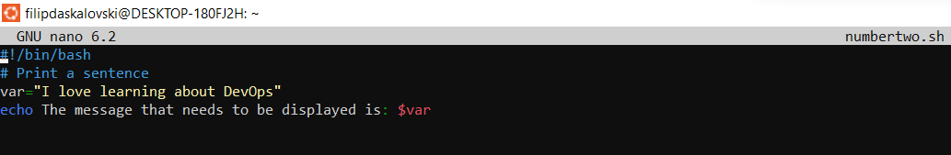

========================================================

- Write a shell script that displays “plan code build test release deploy” on the screen with each appearing on a separate line.
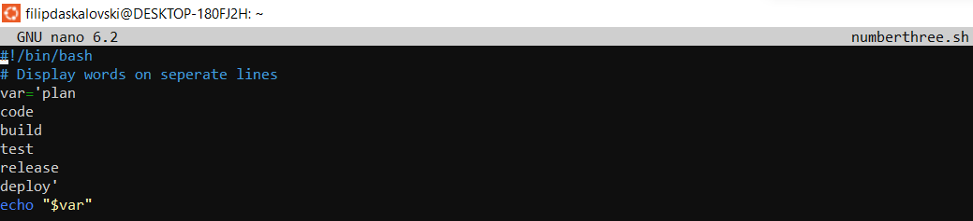
========================================================

- Write a shell script that prompts the user for a name of a file or directory and reports if it is a regular file, a directory, or another type of file. Also perform a ls command against the file or directory with the long listing option.
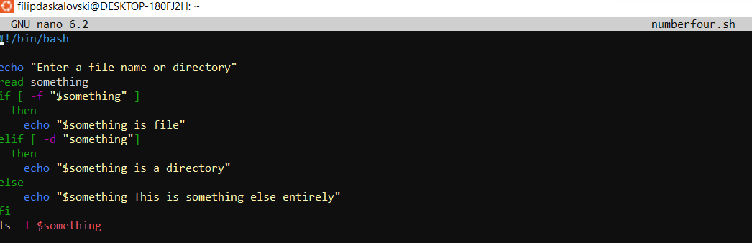

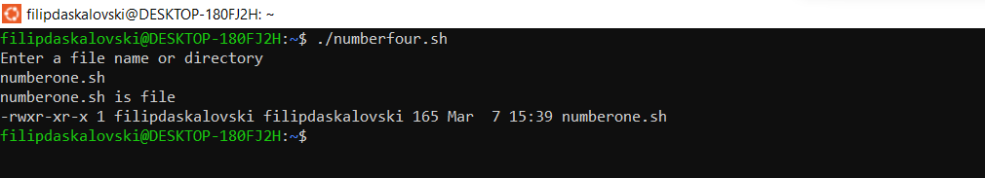

========================================================

- Use arguments in a script. Total number of arguments should be three.

========================================================
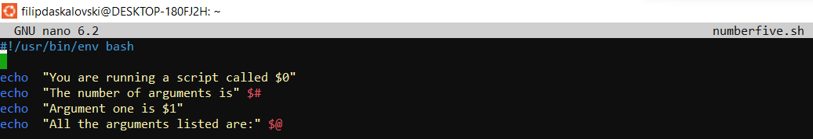

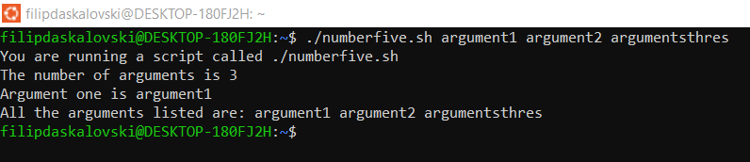

- Write a script that till output your name out of a variable and will display the server uptime
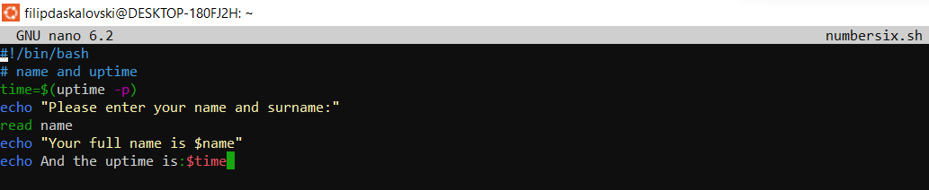

========================================================

69 Bulgaria Blvd., Infinity Tower B, fl. 8, Triaditza district, 1404 Sofia, Bulgaria | +359 2424 6484 | sales@scalefocus.com | www.scalefocus.com

