|  |  |  |
| --- | --- | --- |
| **INFORMATICĂ APLICATĂ** | **FIŞĂ DE LUCRU** | **LAB3** |
| SISTEME DE OPERARE.  INTERCONECTAREA SISTEMELOR DE CALCUL. INSTALARE ȘI CONFIGURARE | | |

1. a) Adresa IPv4

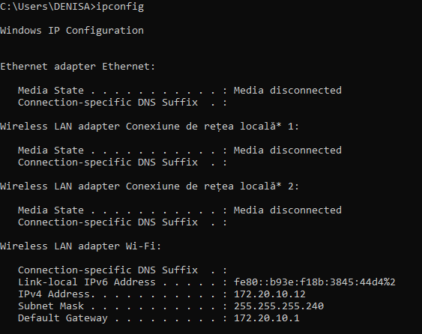

b) Adresa MAC

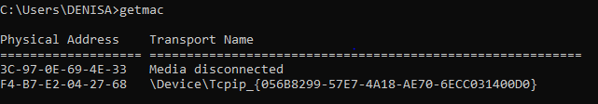

c) Tipuri de interfete de retea

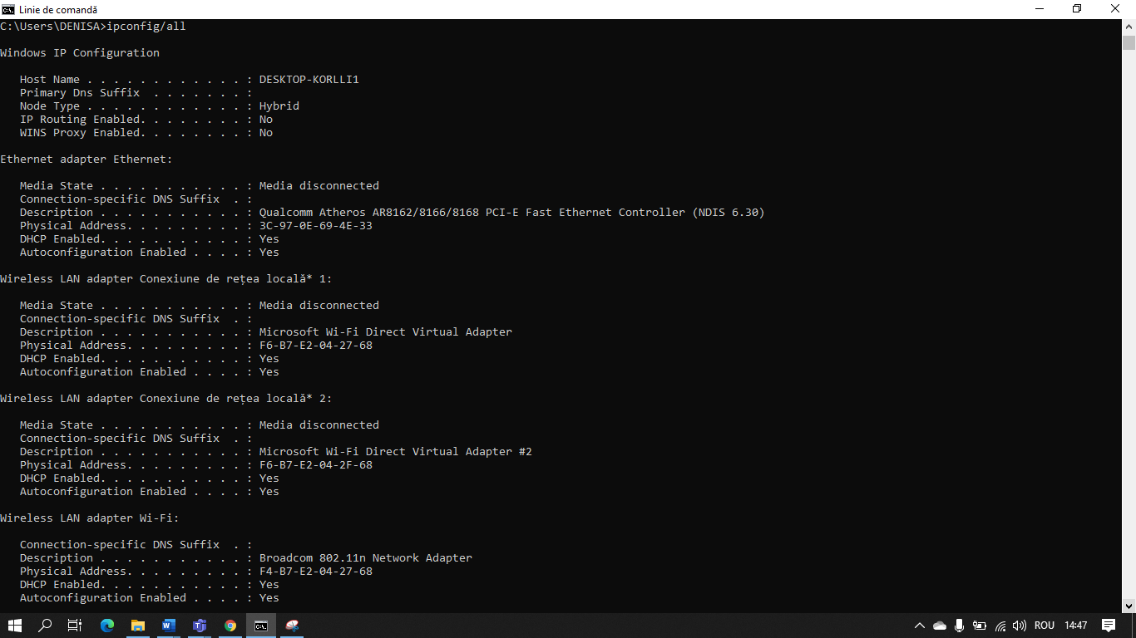

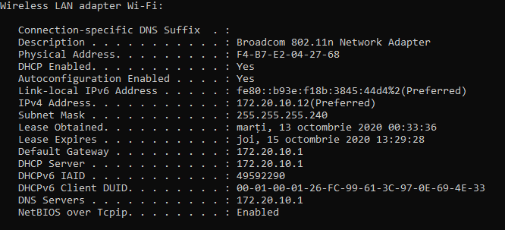

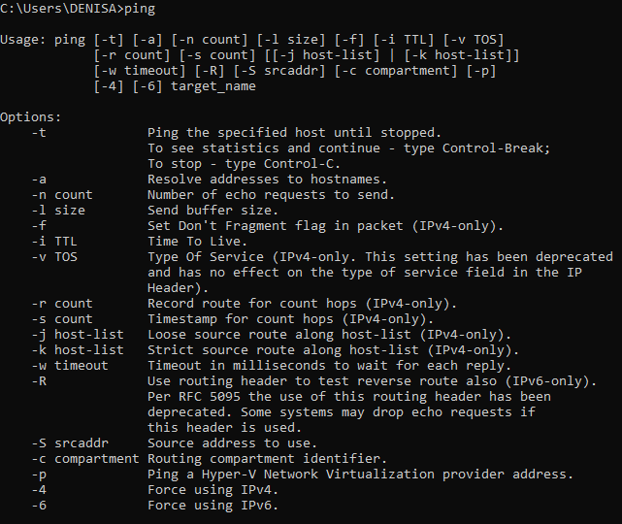d)Numarul de pachete de transmisie

e)Exemplificari de rute de conectivitate

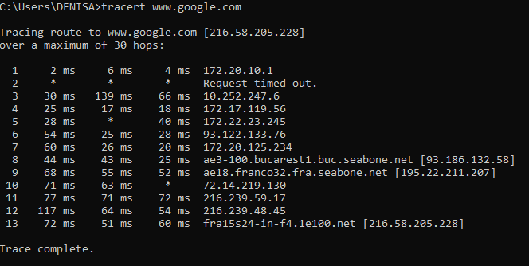

1. a) 3 procese in ordinea consumului de resurse

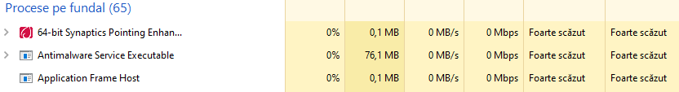

1. The SynTPEnhService.exe process is also known as 64-bit Synaptics Pointing Enhance Service or, as the case may be, 32-bit Synaptics Pointing Enhance Service and is a part of Synaptics Pointing Device Driver. This software is produced by Synaptics ([www.synaptics.com](http://www.synaptics.com)).
2. "MsMpEng.exe" is Microsoft's core antimalware executable. It performs the actual background real-time protective scanning for malware, viruses, and worms of files that it detects as having been created or updated recently. It has been used since Windows XP both in consumer-oriented products, (Windows Defender, Microsoft Security Essentials), and by Microsoft enterprise products designed for managed software or server environments such as Forefront Client Security (FCS), meant only for Windows Server, not endpoint Windows.
3. Application Frame Host is a Windows service that is designed to display certain applications in frames. ApplicationFrameHost.exe is a file associated with the Application Frame Host service and is safe for your PC. Windows represents a range of graphical operating systems by Microsoft.

b) 3 servicii in ordinea consumului de resurse

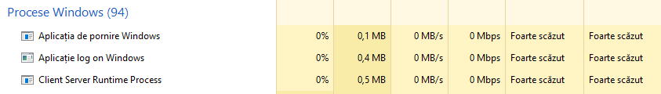

1. Microsoft Windows is an operating system. Windows Initialization is a background application launcher for the Windows OS. Wininit.exe is responsible for running the Windows Initialization process. This is an essential Windows file and should not be removed.
2. The winlogon.exe process is a very important part of the Windows operating system, and Windows will be unusable without it.This process performs a variety of critical tasks related to the Windows sign-in process.
3. Microsoft Windows is an operating system. Client Server Runtime Process is the user-mode portion of the Windows subsystem. Csrss.exe is an essential Windows file and does not pose any threat to your PC.

c) 3 aplicatii in ordinea consumului

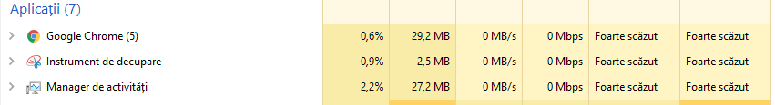

1. Google Chrome is a cross-platform web browser developed by Google. It was first released in 2008 for Microsoft Windows, and was later ported to Linux, macOS, iOS, and Android where it is the default browser built into the OS.[9] The browser is also the main component of Chrome OS, where it serves as the platform for web applications.
2. Snipping Tool is a Microsoft Windows screenshot utility included in Windows Vista and later. It can take still screenshots of an open window, rectangular areas, a free-form area, or the entire screen.
3. Windows is a series of operating systems developed by Microsoft. Taskmgr.exe is responsible for running the Task Manager component of Windows, and is a safe file for your PC.

d) Performanta CPU

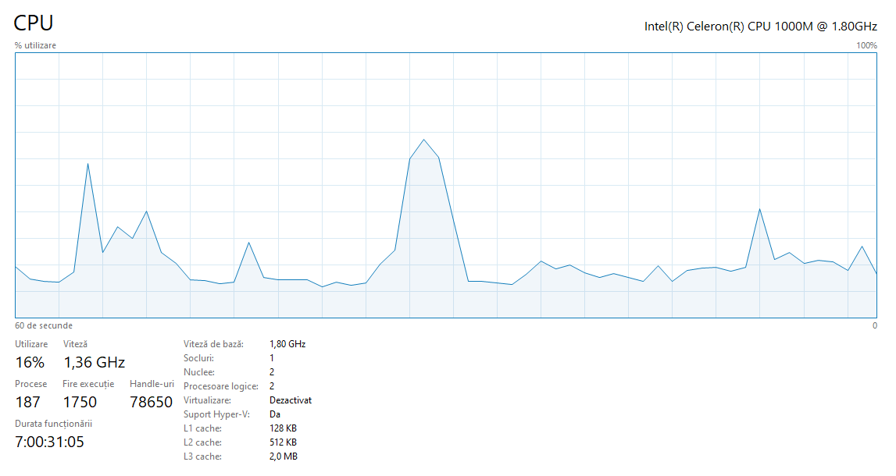

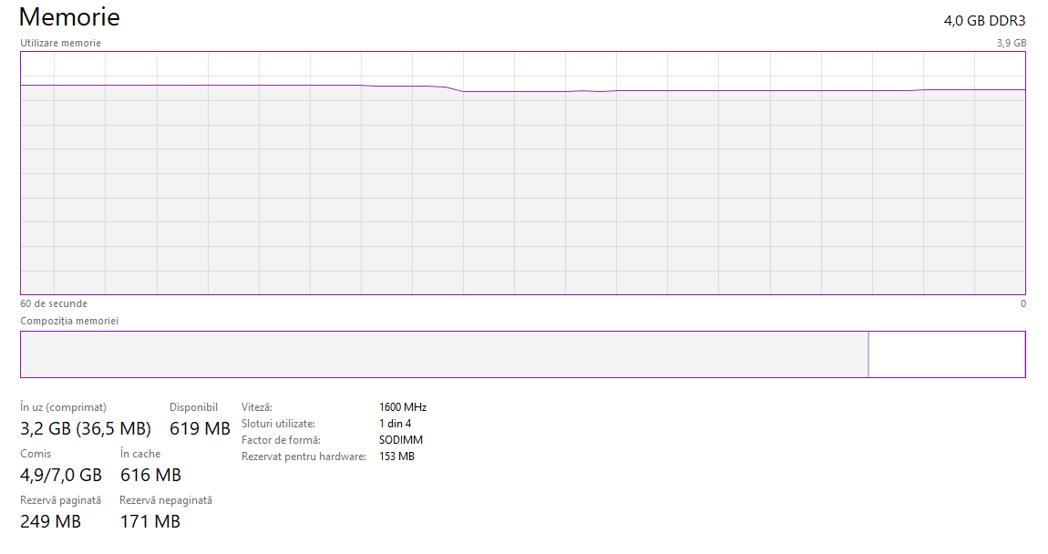

e) Conexiuni in retea si specificati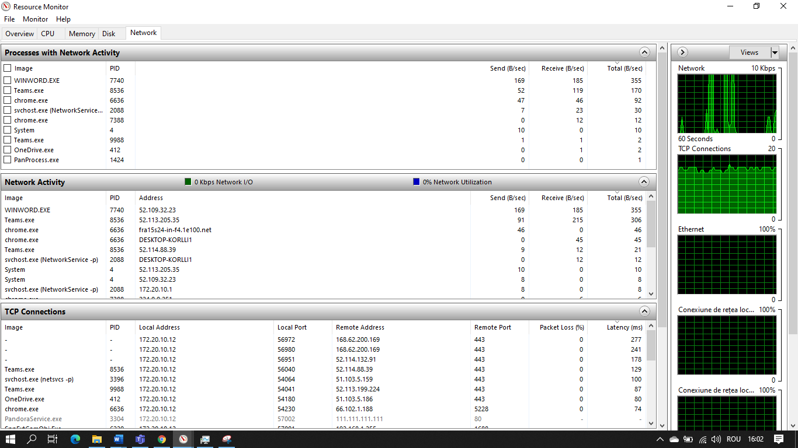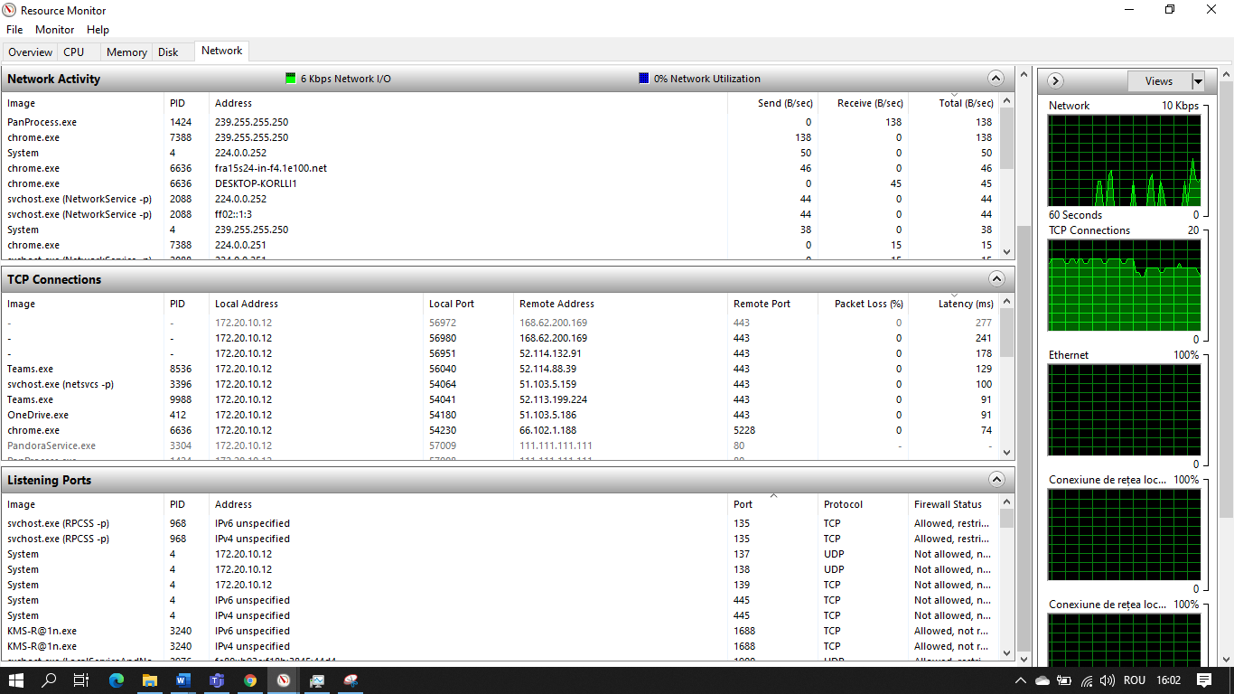i

1. 