UNIVERSIDADE NOVA DE LISBOA
FCT – Departamento de Engenharia Electrotécnica

Secção de Robótica e Manufactura Integrada

Lab work nº 2
Discipline | Real-time Systems
Year | 2015/2016
Goals | Development of real-time applications using high level languages
Labs | 5 Lessons x 3 hours each + 12 Hours outside lab.
Due date | 22/11/2015
Concrete Objectives:
- Java language
  - Characteristics of this programming language
  - The “Java Virtual Machine”(JVM)
  - Object-oriented programming
  - Java training examples

- Real-time features of Java
  - The Thread class and the “Runnable” interface
  - Synchronization and communication between Threads.
  - Interaction with physical systems; The “Java Native Interface” (JNI)

- Develop a practical application of Java real-time as described in annex 1

- Fill the lab work sheet (annex 2), until finish all lab lessons.

Annex 4 – Work lab description

This work is aimed at providing the concepts of Java real-time. For such, it is necessary to develop a real-time solution for a problem described in this annex. The scenario of this problem is about the real-time control of a wharehouse illustrated in Error: Reference source not found.
The adequate solution for this problem requires the utilization of a set of developing technologies based on Java SDK, Java Native interface, and DLL development. A simulator of the wharehouse kit (Error: Reference source not found) is also available, which allows continuing the work outside of the lab. This simulator also allows testing before running the implementation in the real kit, which helps eliminate most of the mistakes that might occur during development. The technical characteristics of the hardware kit can be achieved at http://www.staudinger-est.de/en/simulation/compact-models/documents/226001.pdf. The interface with the kit is done through an input / output digital data acquisition board, the NI USB 6509.

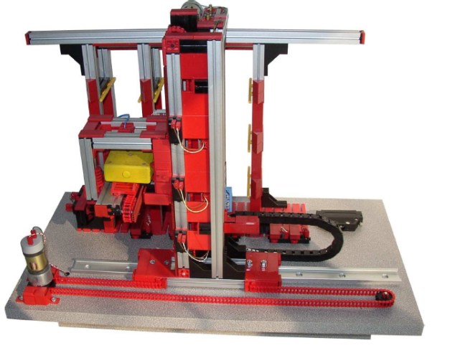
Fig. 1 – Warehouse Kit

Consider that 50 distinct products, identified by the references p1…p50, are to be stored in this warehouse. Note that there are only 9 storage cells available in the warehouse, so only a few can be stored. Each cell can only hold a single product. But the warehouse can hold repeated products. The functional requirements needed to control this system are listed in the following table. They are split into basic or low-level requirements, for direct interaction with sensors and actuators, and high-level requirements, for the storage management.

Req. | Description
 | Low-Level Requirements:
Rb1 | Read the system state (read the sensors)
Rb2 | Activate the actuators
Rb3 | Move in each warehouse axes x, y, z
Rb4 | Move the elevator to a specific x, z position
Rb5 | Put a piece in a specific x, z position
Rb6 | Retrieve a peace from a specific x, z position
Rb7 | Control the system directly through the keyboard (“up”, “down”,”left”,”right”,”inside”, “outside”, …)
Rb8 | Simple data structure (either arrays, lists, files, or …) to store information concerning the products (x, y position; storage date, price, …). Date structure can just be an integer number, e.g. 20140915 which stands for 2014/09/15, allowing simple comparisons between date values.
 | High-Level requirements:
Rh1 | Put product P in the cell (reference, date, x, z) - specified on the keyboard
 | Put product P in a free cell (reference, date) - system selects free (x, z) itself
Rh2 | Retrieve a product from the cell (x, z) – specified on the keyboard
Rh3 | Retrieve a product from a cell given its reference, the oldest one.
Rh4 | Consider a STOP button for emergency situations – at the left side of the warehouse
Rh5 | Consider a RESUME button towards continue the working cycle – at the left side of the warehouse
Rh6 | Manually CALIBRATE the system to an adequate working point. The best point is at cell (2,2). Use rb7 for this process.
 | Information-related requirements:
Rh7 | Show a list with the products that are stored in the warehouse
Rh8 | Show the product stored in a given (x,y) cell
Rh9 | Find and show the (x, y) cells of a product reference; reference provided by keyboard
Rh10 | Calculate the total value (in Euros) of the stored products

Furthermore, while fulfilling these functional requirements, your solution should comply the following non-functional requirements:

NF. req. | Description
NF1 | While the system is making an operation, the User Interface (UI) (e.g. keyboard), can accumulate new next request, for another put/retrieve or for showing information (NF1.1). Information requirements can be executed in parallel with movements (NF1.2).
NF2 | Check for valid movements like put in free cell (NF2.1), retrieve product from the cell containing it (NF2.2) or not going outside limits (NF2.3).
NF3 | Graphical User Interface for enhanced interaction with the system

Given the fact that there is a single and expensive warehouse for the class, a warehouse simulator is also provided, illustrated in fig. 2. This allow sharing the warehouse kit without the annoying waiting queues that used to happen prior the existence of the simulator. Furthermore, the simulator allows the development of your code, testing and error correction, before its use in the real warehouse. These are best practices in industry (like in manufacture, robotics…), so we suggest you get used to it. Stressing again, your code should be firstly tested to exhaustion in the simulator. After a successful assessment, you can test in the real kit.

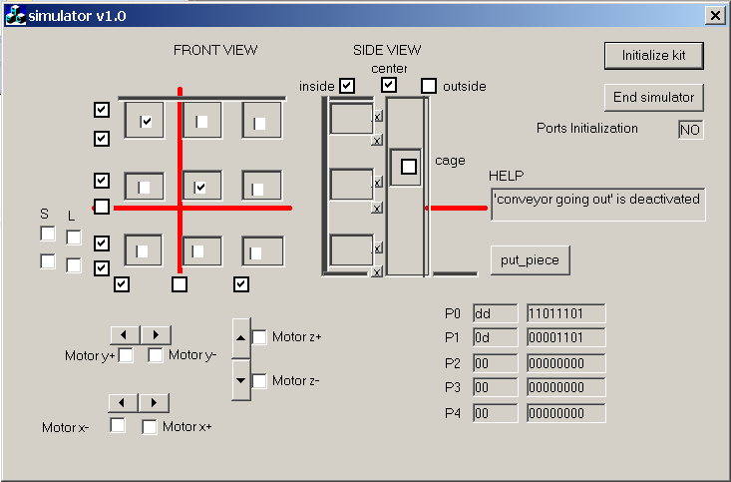
Fig. 2 – Warehouse Simulator

As mentioned before, for a good utilization of the kit that is available in the laboratory, a corresponding simulator is also available, as illustrated in 2. The utilization of the simulator allows fulfill all the functional requirements, without the need of constantly test with the real kit. Furthermore, design and development mistakes can be detected and fixed while the system is operated in simulation model. Before running in the real kit, the implemented solution must be verified and proved that it works well with the simulator in all situations.
As a suggestion, start your work by firstly implementing all the methods necessary for the adequate handling of the sensors and actuators in the distribution line (e.g. readPort, writePort, createDI…). Afterwards, implement low-level requirements. Finally, fulfill the high-level requirements.
As there is plenty of real-time behavior in the warehouse, a real-time approach should be adopted for developing the program that adequately operates the system. The real-time constraints presented in the mentioned warehouse may require the utilization of synchronization and communication between Threads, as well as handling the access to resources in exclusive mode. For an introduction on the utilization of threads, semaphores, communication, deadlock prevention, and so on, we recommend reading the tutorial available at http://download.oracle.com/javase/tutorial/essential/concurrency/index.html.

Another important aspect of this work has to do with the interaction between Java Threads and the assembly line. The kit representing the real system is connected via USB to the operating system (Microsoft Windows). As Java programs run isolated inside a Java Virtual Machine (JVM), the operating system and resource existing at the native machine are out of its reach. In order to obtain access to them, it is necessary to provide Java Native interface (JNI) to the application, as illustrated in Fig. 4. The functions for the direct access to the hardware ports must be implemented inside a Dynamic Link Library (DLL). The construction of a DLL and its access from a Java program is described in annex 2.

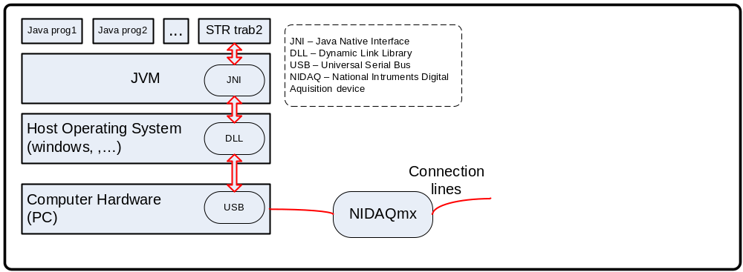
Figure 4 – Architecture of the whole system

The following documents are available for this work:

Annex 1 – First steps in java programming
Annex 2 – Accessing hardware resources through JNI
Annex 3 – Java real-time tutorial
Annex 4 – Work Description (this annex)
Annex 5 – Report of the developed work, to be delivered

This work follows the following plan:

1st lesson:
Introduction to java. Implementation and understanding of the examples presented in annex 1 and 2. Development of the JNI DLL for accessing the hardware layer from JAVA.

2nd lesson:
Interaction between Java and low level resources. Elaboration of both low level and high level routines for coordinating the distribution line.

3rd lesson:
Introduction to Threads; Synchronization and communication. Development of the necessary threads for modeling the concurrent behavior present in the warehouse.
4st lesson:
Fulfillment of each functional requirement towards the solution for the assembly line.
5st lesson:
Finish work.

Annex 5 – Lab Report

Report for Lab work nº 2
Discipline | Real-time systems
Year | 2015/2016
Student Nº____  Student Nº____  Student Nº____ | Name:  Name:  Name:
Duedate:

Add or remove lines as you need during the filling of the following tables.

 | Low-Level Requirements’ answers (check with “X”)
Req. | Success (100%) | Almost done | Unable to finish  with source-code | Unable to do it | Professor’s review  (leave it blank)
Rb1
Rb2
Rb3
Rb4
Rb5
Rb6
Rb7
Rb8
…/…

 | High-level requirements’ answers (check with “X”)
Req. | Success | Almost done | Unable to finish  with source-code | Unable to do it | Professor’s review  (leave it blank)
Rh1
Rh2
Rh3
Rh4
Rh5
Rh6
Rh7
Rh8
Rh9
Rh10

 | Non-functional requirements’ answers (check with “X”)
Req. | Success | Almost done | Unable to finish  with source-code | Unable to do it | Professor’s review  (leave it blank)
NF1.1
NF1.2
NF2.1
NF2.2
NF2.3
NF3

Classes/threads identification
Thread name | Describe its functionality (What is its purpose, what is its behavior)

Used synchronization mechanisms
Name of the mechanism | Type (resource or synch) | Describe its purpose, initialization value and which threads use it

Used communication mechanisms
Name of the mechanism | Describe its purpose and which threads use it

Important Classes/methods (e,g,: cylinder_A.goto(), …)
Class name | Method signature (name and arguments) | Description

Put here facultative information, which may provide more detailed information about your work, namely, diagrams, figures, GUI, results justification, and so on (maximum two sheets).

