TO: Prof. David Green

FROM: Filipe de Andrade Morais – (BlazerID: filipeam)

DATE: 07/08/2019

SUBJECT: HW5 - Data Collection Application

Summary

This assignment goal was to develop an application to store and display log data from students on software project teams. The application runs on a PHP server and stores the data, entered through a HTML form, on a comma-separated file.
To be able to run the application, all the files were located in the XAMPP directory “htdocs”.

Completion of the general requirements

The very most important requirement of the application to store data in a .csv file was accomplished the mechanism that links the form bellow on a HTML file to the PHP commands that write the data on the mentioned file.

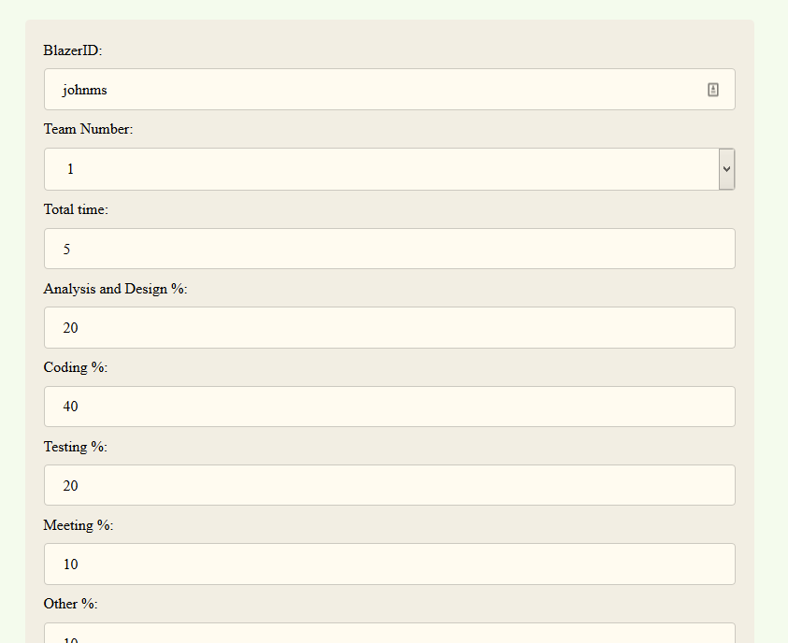
Figure 1-Input data form screenshot
When pressed submit having entered all the expected data the following page will be shown giving the data that was entered by the last and all the records stored in the file, displayed bellow it.
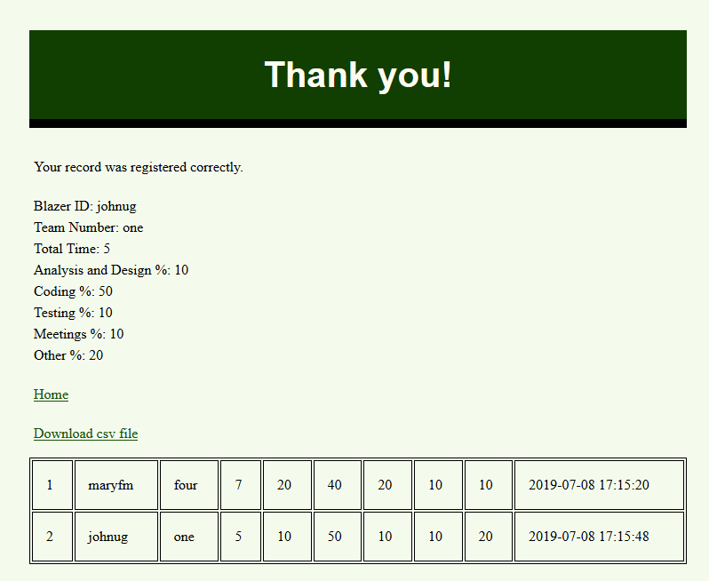
Figure 2-Successful entering of data Screenshot
The label “Download csv file” contains a link that gives the user the choice to download the whole .csv file instead of only displaying on the web browser, as it can be seen on the following picture:
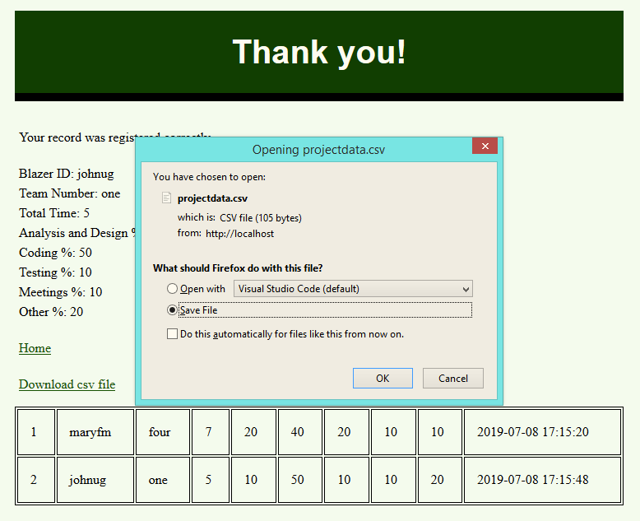
Figure 3-"Save file" dialog box screenshot
The styling of the form and of the whole was developed on the top of the one for the previous assignments. Some changes were made reducing the font and the padding size and changing the color of some of the elements on the page from violet to dark green. That can be seen throughout the page as on the very top of the first which also contains a rubric for the required fields.
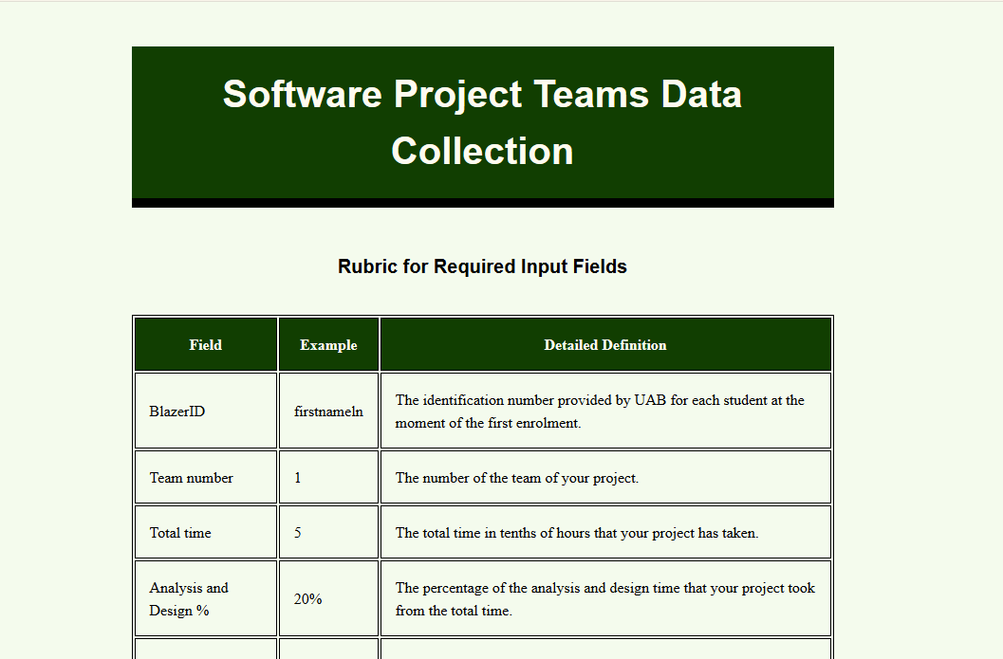
Figure 4-Top part of the first page

Bonus Features - Validate data submitted on server side
Some commands were implemented on the PHP part of the application to validate the input data on the server side. For example, the first field (BlazerId) has to have only letters. The next sequence of pictures show what kind of message it gets in case of typing not as requested to.
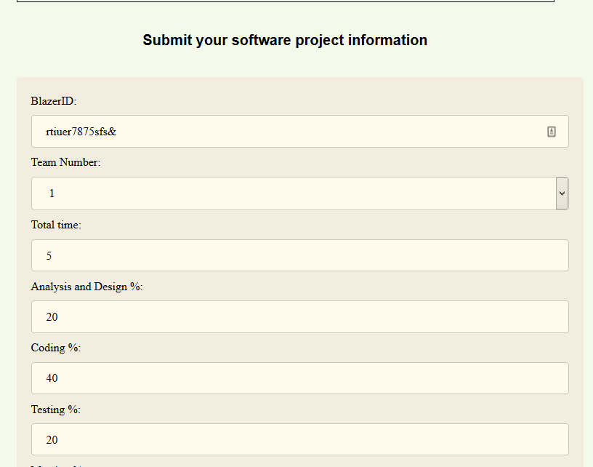
Figure 5-Wrong input data for the BlazerId
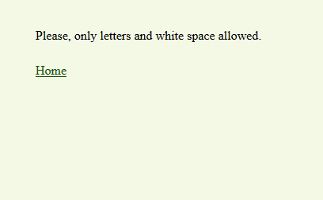
Figure 6-Error message for the BlazerId field

Bonus Features - Produce log information for this student
As mentioned earlier, all the log information highlighting the last and also the whole .csv file is shown when a correct data input is entered.
Figure 7-Log information with the student data

Bonus Features - Provide client side validation of the inputed data
For the client side validation, a specific function for checking if the number entered on the percentage fields were not above 100 was developed. Also, this function validates if it was entered only numbers as the input data. When any of those are wrong, the border is turn to red and when fixed it get back to gray.

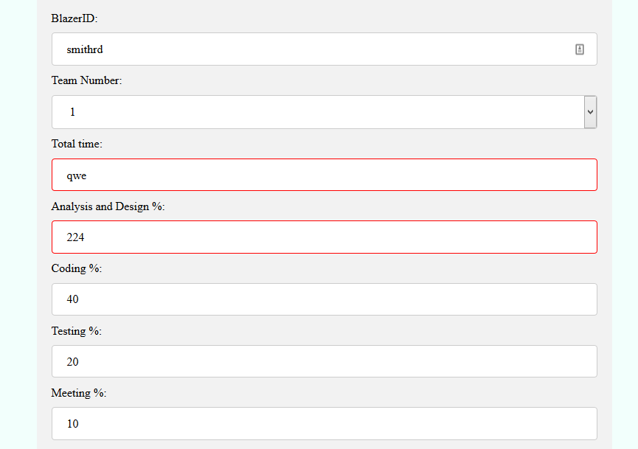
Figure 8-Validation showing wrong input data

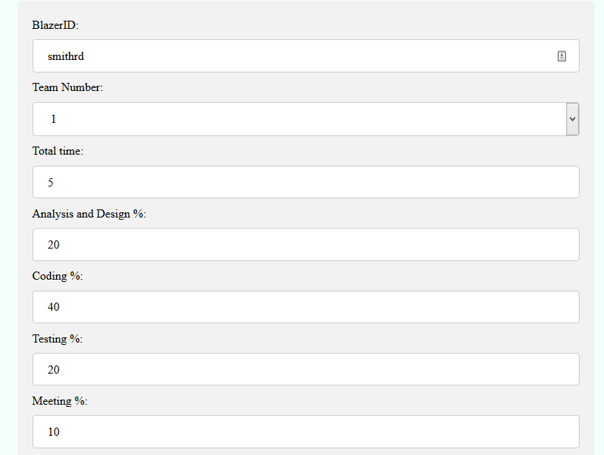
Figure 9-After the data is fixed, the border turned to gray.

References

- H. Harris (2019, july, 07). Dummies: How to Write a Basic Text File in PHP for HTML5 and CSS3 Programming [online webpage]. Available: https://www.dummies.com/programming/php/how-to-write-a-basic-text-file-in-php-for-html5-and-css3-programming

- (2019, july, 07). Webslesson: How to Store Form data in CSV File using PHP [online webpage]. Available: https://www.webslesson.info/2017/09/how-to-store-form-data-in-csv-file-using-php.html

