TO: Prof. David Green

FROM: Filipe de Andrade Morais – (BlazerID: filipeam)

DATE: 07/21/2019

SUBJECT: HW6 - Data Base Application

Summary

This assignment goal was to develop an application that runs in PHP and connects to a MySQL database and uses it to display UAB EE courses history according the user’s choice.
To be able to run the application, all the files were located in the XAMPP directory “htdocs”.

Completion of the general requirements

With the provided database of the courses history from the “demodb” example and having the “eeschedule-db.inc” to be able to access it, the application developed accomplished the requirement to display the course history of the selected course. As also required, it sorts the data by semester or by enrolled number, according to the user’s choice.

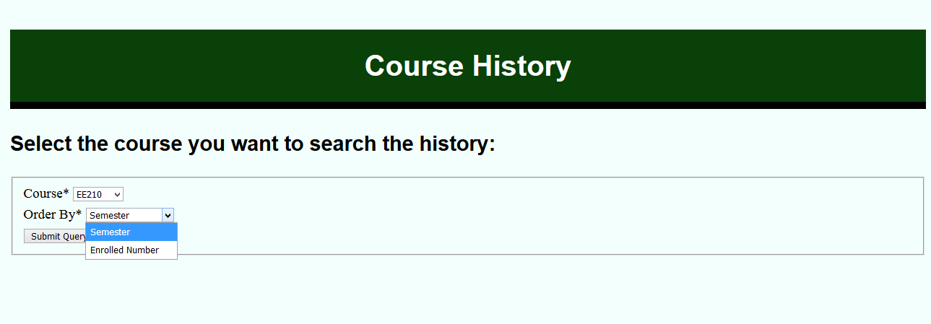
Figure 1-Course and Order selection screen

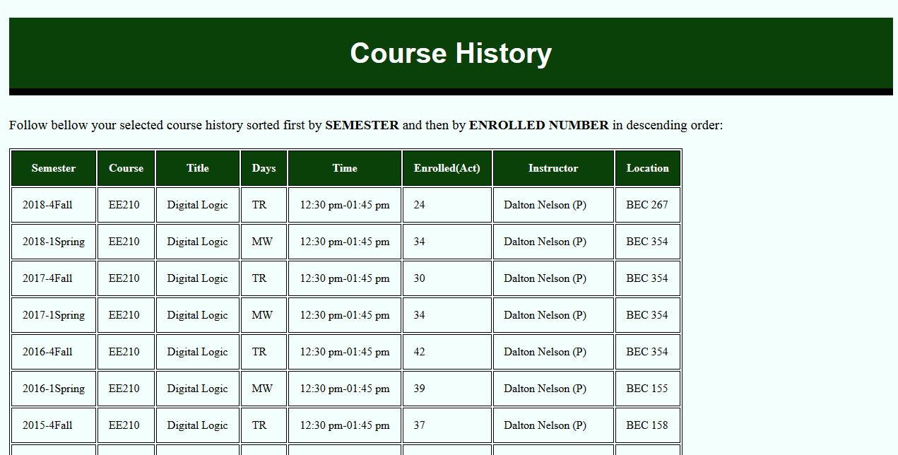
Figure 2-Course history for the one selected sorted by semester

Commentary on the code implemented

First screen
The most developed part of the first screen is the course selection. The code was based on the function “makeDropDown” given by the “demodb” example.

function makeDropDown($name, $sql_rows)
{
if (!$sql_rows) {
return "No Values for Control";
}

$name_id = $name . '_id';
$control = "<select id='$name' name='$name_id'>\n";

while ($row = mysqli_fetch_assoc($sql_rows)) {
$control .= (" <option value =" . $row[$name] . ">" . $row[$name] . "</option>\n");
}
$control .= "</select>\n";
return $control;
}

$sqlListCourses = "SELECT id, course FROM courses ORDER BY course ASC";
$result = mysqli_query($connection, $sqlListCourses);
$courseListDropDown = makeDropDown("course", $result);
mysqli_free_result($result);
mysqli_close($connection);
?>

<h2>Select the course you want to search the history:</h2>
<form action="searchcourse.php" method="get">
<fieldset>
<label for="course_id">Course<span class="required">*</span></label> <?PHP echo $courseListDropDown ?><br />
<label for="order_by">Order By<span class="required">*</span></label>
<select id='order_by' name='order_by'>
<option value="reginfo.semester">Semester</option>
<option value="reginfo.act">Enrolled Number</option>
</select>
<br/>
<input type="submit">
</fieldset>
</form>

MySQL Query for the search function
This part can be considered the most important of the assignment. The greatest learning outcome came from learning first how to create a select MySQL query, which PHP instruction to use for applying that query, how to display its results and finally how to use the inner join MySQL statement.
The final code can be seen above but there were several less efficient versions that were used before this last one:

<?php
echo " <tr>\n";
$sqlSelectDataInnerJoin = "SELECT * FROM courses INNER JOIN reginfo ON courses.id=course_id INNER JOIN instructors ON instructor_id=instructors.id WHERE course='" . $courseId . "' ORDER BY " . $orderBy . " DESC, " . $secondOrderBy . " DESC";
$resultCourseHistory = mysqli_query($connection, $sqlSelectDataInnerJoin);
while ($courseHistoryRow = mysqli_fetch_assoc($resultCourseHistory)) {
echo " <td>" . $courseHistoryRow['semester'] . "</td>";
echo " <td>" . $courseHistoryRow['course'] . "</td>";
echo " <td>" . $courseHistoryRow['title'] . "</td>";
echo " <td>" . $courseHistoryRow['days'] . "</td>";
echo " <td>" . $courseHistoryRow['time'] . "</td>";
echo " <td>" . $courseHistoryRow['act'] . "</td>";
echo " <td>" . $courseHistoryRow['instructor'] . "</td>";
echo " <td>" . $courseHistoryRow['location'] . "</td>";
echo " </tr>\n";
}
?>
</table>

<p>
<a href="coursehistory.php">Make another search</a>
</p>

Css Style
The stylesheet was taken based on the previous assignments. So the background and font colors, the font size, line spacing and padding and also the tables borders were kept the same as mentioned. Here it follows a portion of the css code:
h1,
h2 {
font-family: "Open Sans Condensed", "Arial", sans-serif;
}

body {
font-family: "Crimson Text", "Times New Roman", serif;
background-color: #F2FFFC;
font-size: 120%;
line-height: 1.5;
padding: 10px;
}

main h1 {
font-size: 40px;
color: #FFF;
background-color: #0a4108;
text-align: center;

Bonus 1

A way to re-sort the table was accomplished by adding a new selection on the first screen and then later accessing that element, assigning it to a variable and finally inserting it on the MySQL statement. This implementation can be seen bellow as also the result screen:
$orderBy = $_GET["order_by"];
if ($orderBy == "reginfo.semester") {
$secondOrderBy = "reginfo.act";
$orderByLabel = "SEMESTER";
$secondOrderByLabel = "ENROLLED NUMBER";
} else {
$secondOrderBy = "reginfo.semester";
$orderByLabel = "ENROLLED NUMBER";
$secondOrderByLabel = "SEMESTER";
}
…
$sqlSelectDataInnerJoin = "SELECT * FROM courses INNER JOIN reginfo ON courses.id=course_id INNER JOIN instructors ON instructor_id=instructors.id WHERE course='" . $courseId . "' ORDER BY " . $orderBy . " DESC, " . $secondOrderBy . " DESC";

Bonus 3
The next steps were followed to accomplish the exporting of the database (schema + data) and its following importing into a new database:

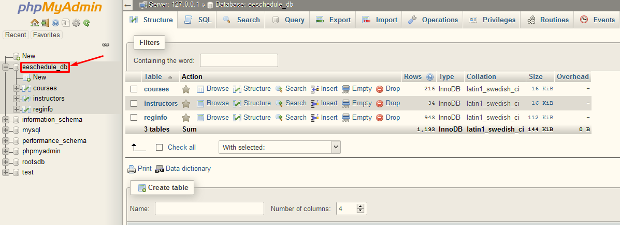
Figure 3-Click on the database to be exported

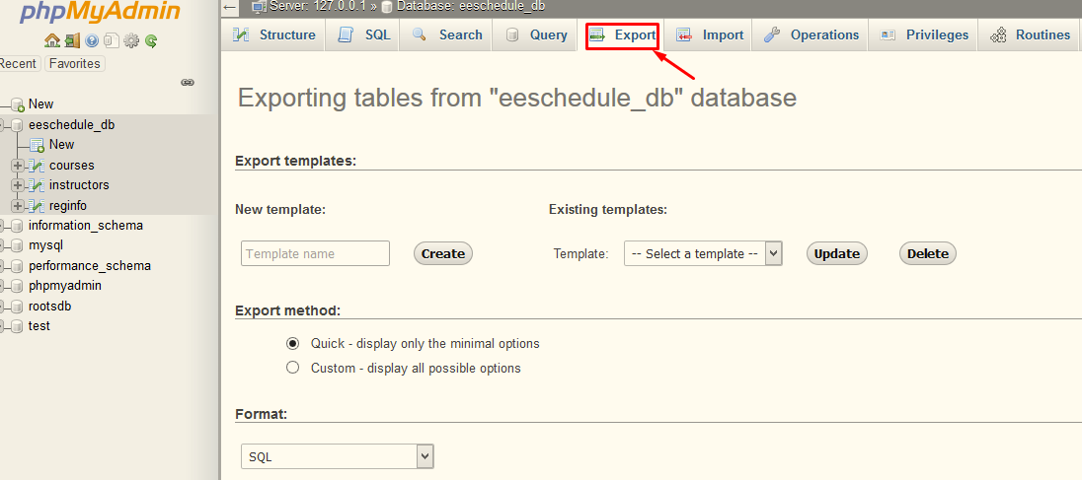
Figure 4 - Click on Export

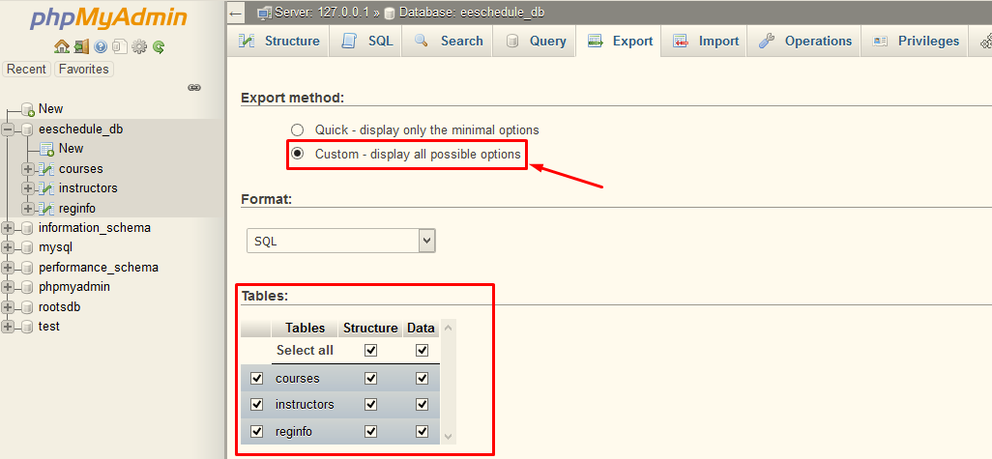
Figure 5- Click on Custom and make for all the tables you have the structure and data selected

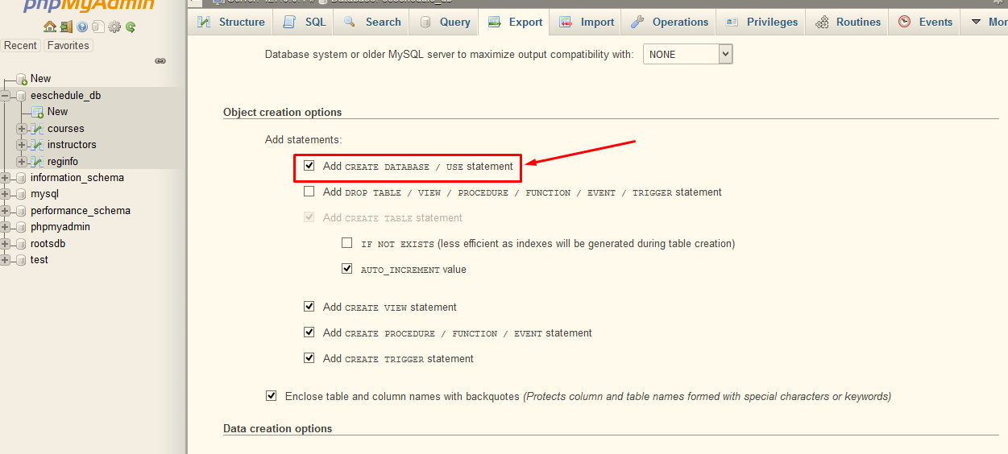
Figure 6-To avoid having to create a new database you should check the Add CREATE DATABASE checkbox

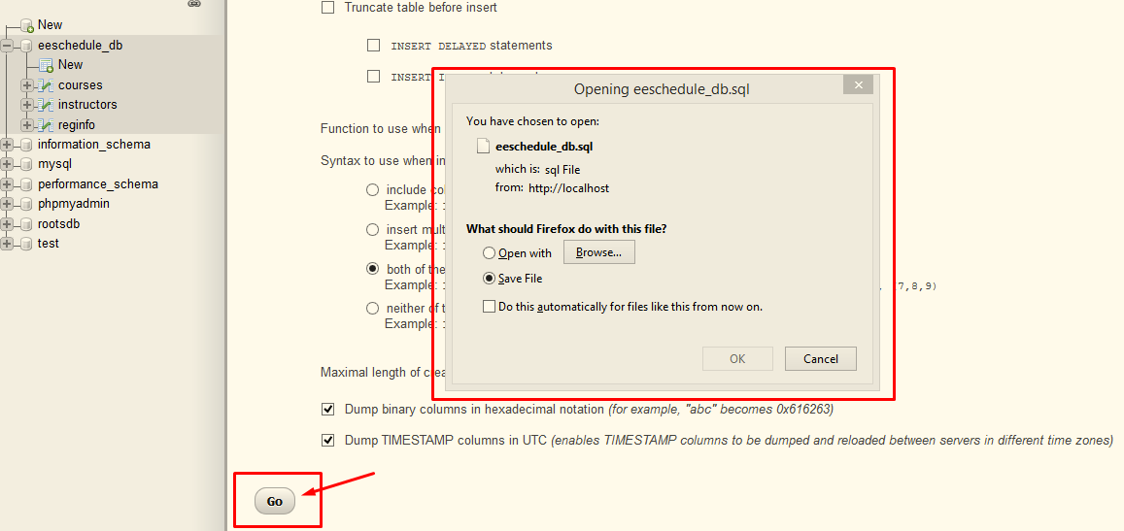
Figure 7-Click on "Go" and then save the new generated .sql file

Importing to a new database
Having the file of the exported database here follows the steps to import:

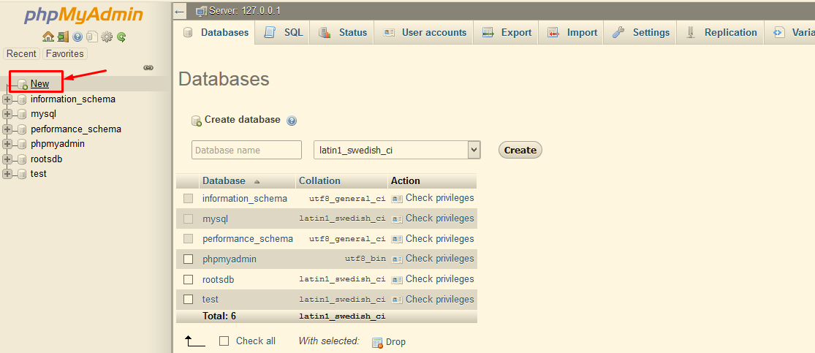
Figure 8-Click on "New"

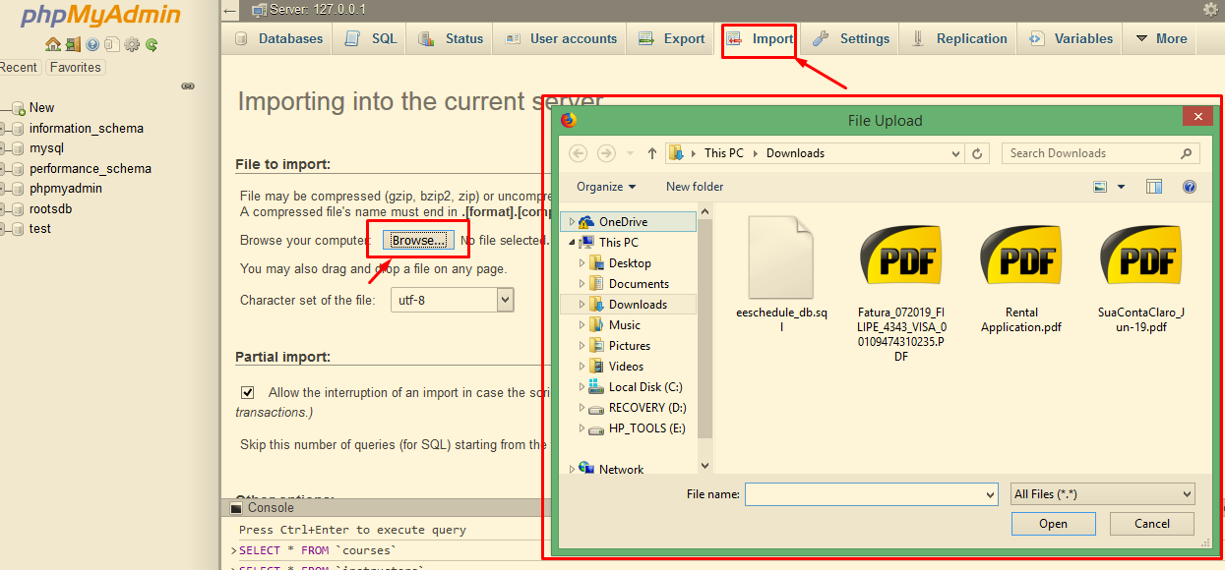
Figure 9-Go to the tab "Import", then click on "Browse" and select the sql file to be imported
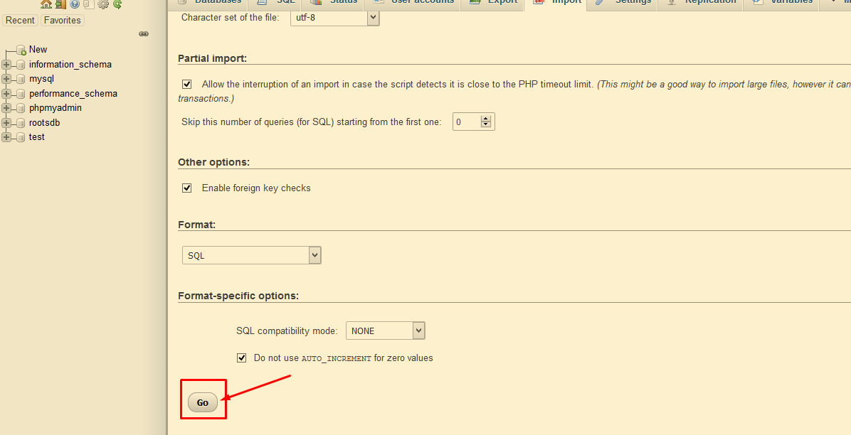
Figure 10-Click on Go

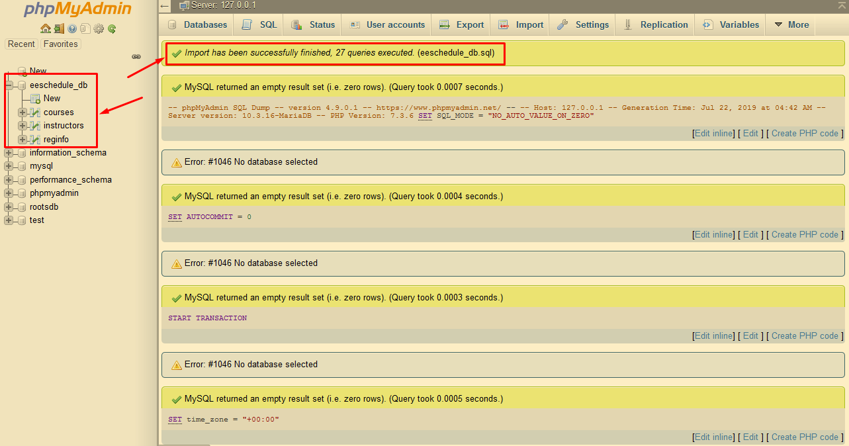
Figure 11-Wait for the message of success and check if database with its corresponded tables are present

References

- (2019, july, 21). Importing/exporting a MySQL database using phpMyAdmin [online webpage]. Available: https://hostpapasupport.com/importingexporting-a-mysql-database-using-phpmyadmin/

