MULTIPLAYER PONG GAME

Authors: Filip Georgiana-Teodora
Ghițan Elena-Daniela
Faculty of Automatic Control and Computing

Description of our project

The project is a multiplayer version of the old, well knwon game of pong. Pong is a two-dimensional sports game that simulates table tennis. The player controls an in-game paddle by moving it vertically across the left or right side of the screen. They can compete against another player controlling a second paddle on the opposing side. Players use the paddles to hit a ball back and forth. The goal is for each player to reach eleven points before the opponent; points are earned when one fails to return the ball to the other.
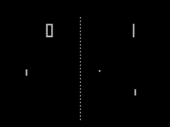

Board Description

To develope our game we used:
1.Arduino Uno Clone
- which is a microcontroller board based on the ATmega328. It has 14 digital input/output pins (of which 6 can be used as PWM outputs), 6 analog inputs, a 16 MHz ceramic resonator, a USB connection, a power jack, an ICSP header, and a reset button.
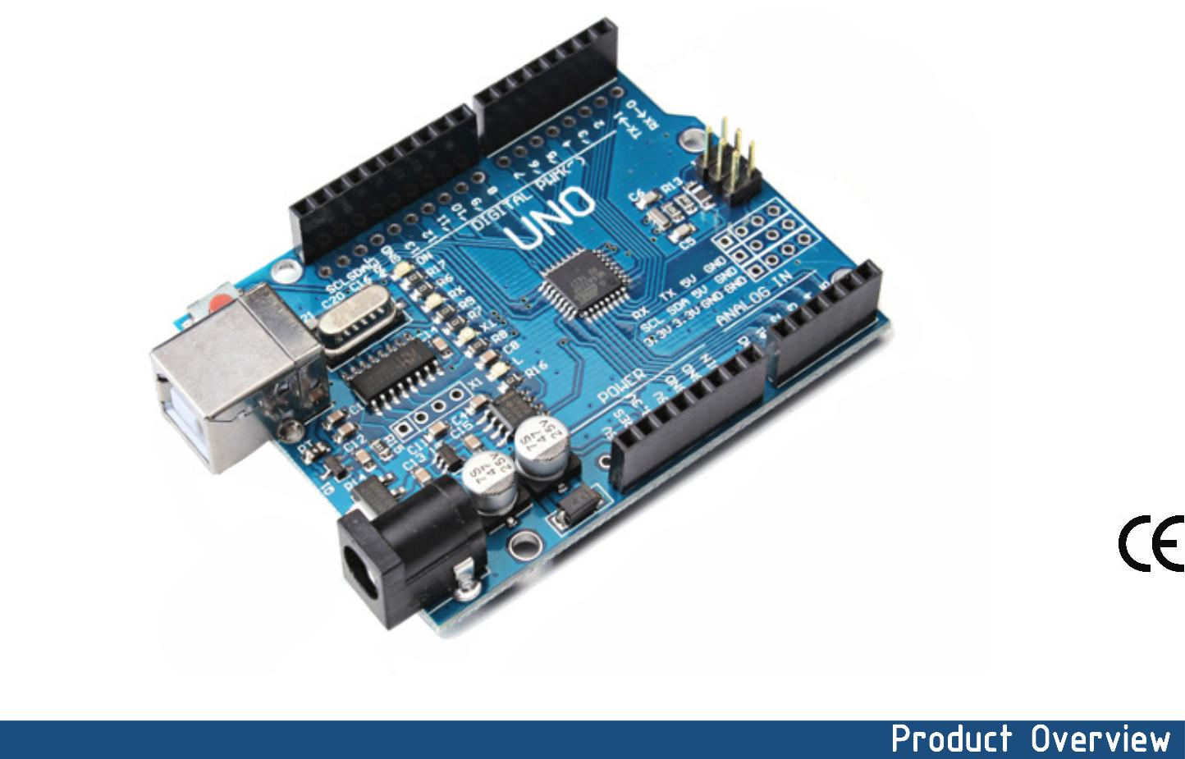
Technical specifications:
- Microcontroller ATmega328P-AU
- Operating Voltage 5V
- Input Voltage (recommended) 7-12V
- Input Voltage (limits) 6-20V
- Digital I/O Pins 14 (of which 6 provide PWM output)
- Analog Input Pins 6
- DC Current per I/O Pin 40 mA
- DC Current for 3.3V Pin 50 mA
- Flash Memory 32 KB of which 0.5 KB used by bootloader
- SRAM 2 KB
- EEPROM 1 KB
- Clock Speed 16 MHz

Power:
The Uno can be powered via the USB connection or with an external power supply. The power source is selected automatically. External (non-USB) power can come either from an AC-to-DC adapter (wall-wart) or battery. The adapter can be connected by plugging a 2.1mm center-positive plug into the board's power jack. Leads from a battery can be inserted in the Gnd and Vin pin headers of the POWER connector. The board can operate on an external supply of 6 to 20 volts. If supplied with less than 7V, however, the 5V pin may supply less than five volts and the board may be unstable. If using more than 12V, the voltage regulator may overheat and damage the board. The recommended range is 7 to 12 volts. The power pins are as follows:
- VIN. The input voltage to the Arduino board when it's using an external power source (as opposed to 5 volts from the USB connection or other regulated power source). You can supply voltage through this pin, or, if supplying voltage via the power jack, access it through this pin.
- 5V. The regulated power supply used to power the microcontroller and other components on the board. This can come either from VIN via an on-board regulator, or be supplied by USB or another regulated 5V supply.
- 3V3. A 3.3 volt supply generated by the on-board regulator. Maximum current draw is 50 mA.
- GND. Ground pins

Memory:
The Atmega328 has 32 KB of flash memory for storing code (of which 0,5 KB is used for the bootloader); It has also 2 KB of SRAM and 1 KB of EEPROM (which can be read and written with the EEPROM library).

Input/Output:
Each of the 14 digital pins on the Uno can be used as an input or output, using pinMode(), digitalWrite(), and digitalRead() functions. They operate at 5 volts. Each pin can provide or receive a maximum of 40 mA and has an internal pull-up resistor (disconnected by default) of 20-50 kOhms. In addition, some pins have specialized functions:
- Serial: 0 (RX) and 1 (TX). Used to receive (RX) and transmit (TX) TTL serial data. TThese pins are connected to the corresponding pins of the ATmega8U2 USB-to-TTL Serial chip .
- External Interrupts: 2 and 3. These pins can be configured to trigger an interrupt on a low value, a rising or falling edge, or a change in value.
- PWM: 3, 5, 6, 9, 10, and 11. Provide 8-bit PWM output with the analogWrite() function.
- SPI: 10 (SS), 11 (MOSI), 12 (MISO), 13 (SCK). These pins support SPI communication, which, although provided by the underlying hardware, is not currently included in the Arduino language.
- LED: 13. There is a built-in LED connected to digital pin 13. When the pin is HIGH value, the LED is on, when the pin is LOW, it's off.

The Uno has 6 analog inputs, each of which provide 10 bits of resolution (i.e. 1024 different values). By default they measure from ground to 5 volts, though is it possible to change the upper end of their range using the AREF pin and the analogReference() function. Additionally, some pins have specialized functionality:
- I 2C: 4 (SDA) and 5 (SCL). Support I2C (TWI) communication using the Wire library. There are a couple of other pins on the board:
- AREF. Reference voltage for the analog inputs. Used with analogReference().
- Reset. Bring this line LOW to reset the microcontroller. Typically used to add a reset button to shields which block the one on the board.

ATmega168/328P-Arduino Pin Mapping
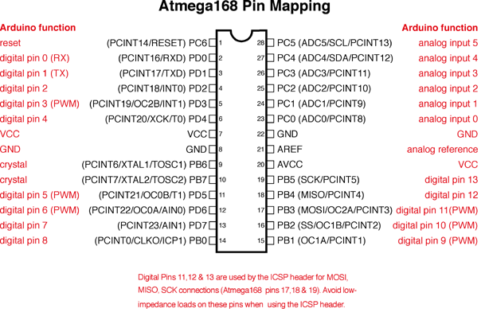
USB overcurrent protection
The Arduino Uno has a resettable polyfuse that protects your computer's USB ports from shorts and overcurrent. Although most computers provide their own internal protection, the fuse provides an extra layer of protection. If more than 500 mA is applied to the USB port, the fuse will automatically break the connection until the short or overload is removed.

Physical characteristics
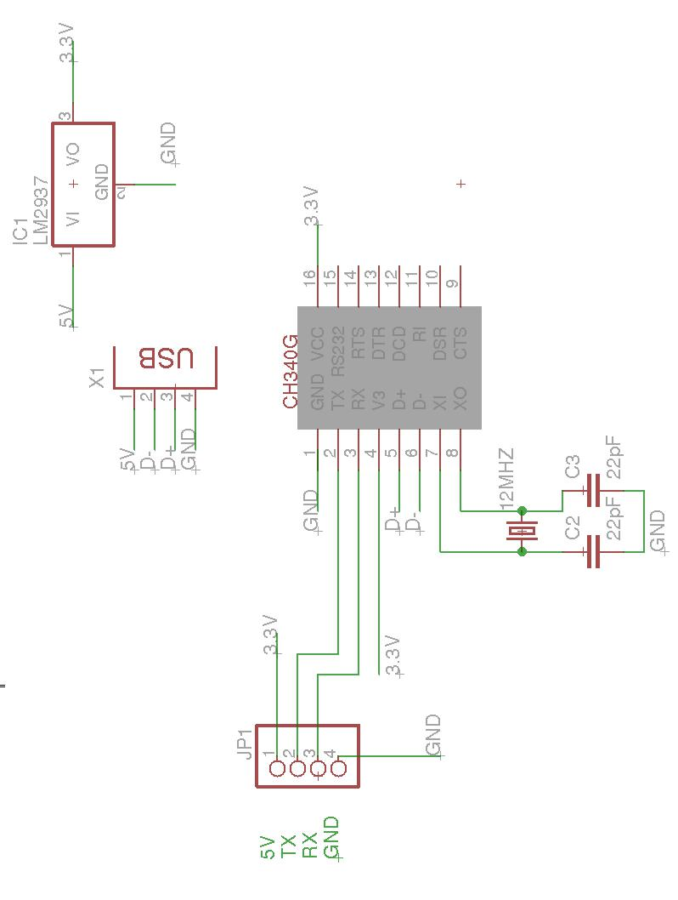
The maximum length and width of the Uno PCB are 2.7 and 2.1 inches respectively, with the USB connector and power jack extending beyond the former dimension. Three screw holes allow the board to be attached to a surface or case. Note that the distance between digital pins 7 and 8 is 160 mil (0.16"), not an even multiple of the 100 mil spacing of the other pins. Arduino can sense the environment by receiving input from a variety of sensors and can affect its surroundings by controlling lights.

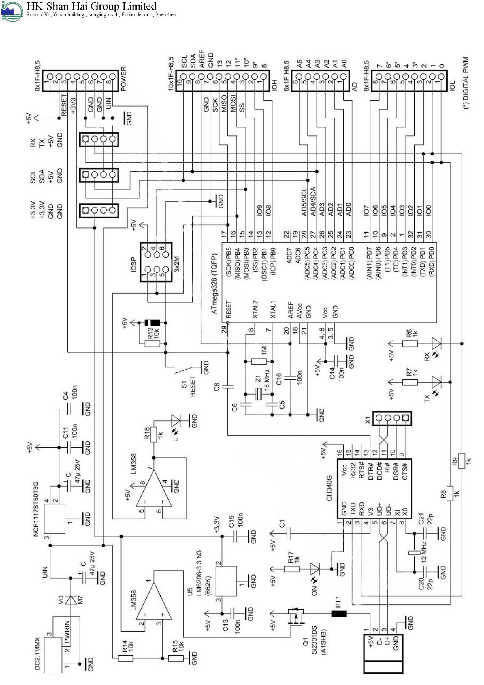

2. Nokia 5110 LCD PCD 8544
General description:
The PCD8544 is a low power CMOS LCD controller/driver, designed to drive a graphic display of 48 rows and 84 columns. All necessary functions for the display are provided in a single chip, including on-chip generation of LCD supply and bias voltages, resulting in a minimum of external components and low power consumption. The PCD8544 interfaces to microcontrollers through a serial bus interface. The PCD8544 is manufactured in n-well CMOS technology.

Pin Configuration:

Pin No: | Pin Name: | Description
1 | Reset | This pin resets the module. It an active low pin (resets when 0V is provided)
2 | Chip Enable (CE) | This pin is made low (0V) to select this particular display when more than one SPI peripherals are used.
3 | Data/Command (DC) | This pin is used to switch between Data mode (high) and Command mode (low)
4 | Serial Input (DIN) | This is the input pin (MOSI) through which serial instructions are sent
5 | Clock (CLK) | All SPI modules require a common clock, this clock source is supplied to this pin
6 | Power (Vcc) | This pin is used to power the display the supply voltage is from 2.7V to 3.3V
7 | Back Light (BL) | This pin powers the backlight of the display (3.3V maximum).
8 | Ground (Gnd) | Connects to the ground of the circuit.

Features of Nokia5110 LCD module:
- Operating Voltage is 2.7V to 3.3V
- Current consumption is 6mA
- Consists of 48 rows and 84 columns (84×48) monochrome pixels
- Works using SPI interface
- Consists of Philips PCD8544 interface chip for easy interfacing
- Can be easily interfaced with Arduino
- Supports decent graphics of bitmap images
- Available in Green and Blue Backlight

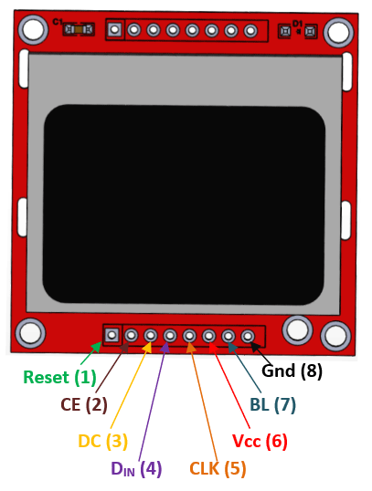

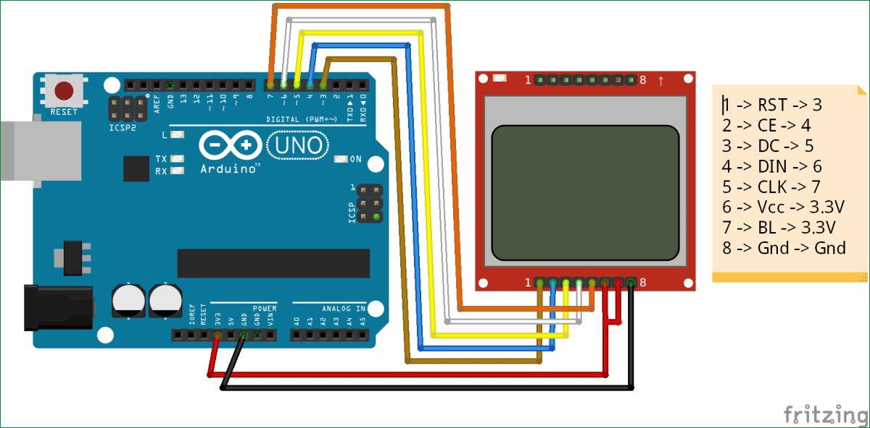

3.Other hardware components
- 4 pushbuttons (the pushbutton is a component that connects 2 points in a circuit when you press it): used for moving the paddle on the screen
- Breadboard
- 4 resistors of 10kΩ
- Jumpers wires male to male (without number)

4. Schematics
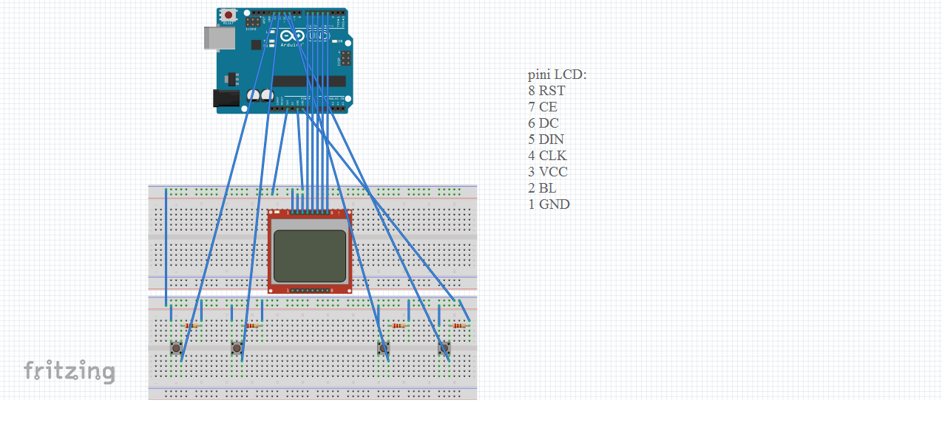

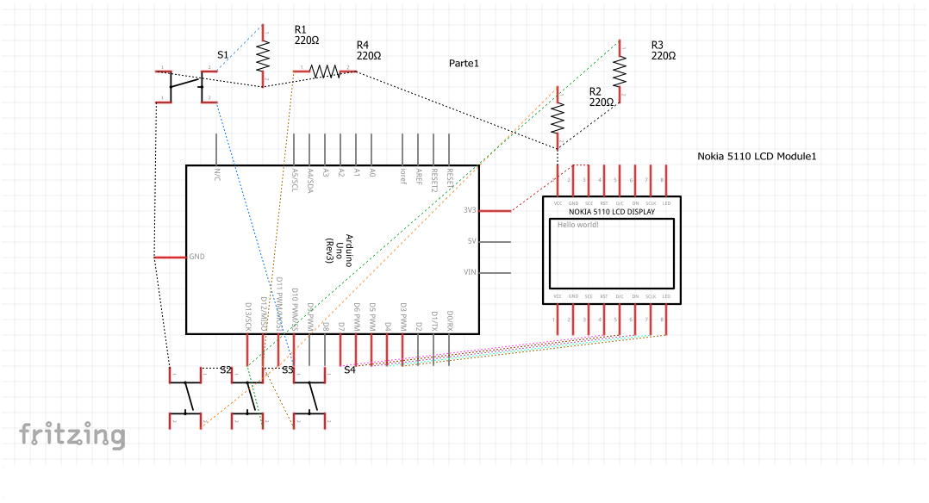

5. Code
#include <SPI.h>
#include <Adafruit_GFX.h>
#include <Adafruit_PCD8544.h>
#define BALL_R 4
#define BAR_HEIGHT 15
#define STEP 2
// pin 7 - Serial clock out (SCLK)
// pin 6 - Serial data out (DIN)
// pin 5 - Data/Command select (D/C)
// pin 4 - LCD chip select (CS)
// pin 3 - LCD reset (RST)
Adafruit_PCD8544 display = Adafruit_PCD8544(7, 6, 5, 4, 3);

int xBall = display.width() / 2; //x coordinate of the ball
int yBall = display.height() / 2; //y coordinate of the ball -: at the beginning, the ball is in the center of the LCD
int dx = 1; //movement on the x axis
int dy = 1; //movement on the y axis
int xCoord=display.width()-1; //pozitia pe axa x a barii playerului 2

//bar player1

int up_Player1 = display.height() / 4; //small nr -> up; the upper end of the bar
int bottom_Player1 = display.height() / 4 + BAR_HEIGHT; //big nr:->down; the bottom end of the bar

//bar player 2
int up_Player2 = display.height() / 4; //small nr -> up; the upper end of the bar
int bottom_Player2 = display.height() / 4 + BAR_HEIGHT; //big nr:->down; the bottom end of the bar

int count_fails_Player1 = 0; //nr of fails Player1
int count_fails_Player2 = 0; //nr of fails Playe2

//buttons player 1
const int buttonPin_up_Player1 = 10; //pin button 1
int buttonState_up_Player1 = 0;

const int buttonPin_down_Player1 = 11; //pin button 2
int buttonState_down_Player1 = 0;

//buttons player 2
const int buttonPin_up_Player2 = 12; //pin button 1
int buttonState_up_Player2 = 0;

const int buttonPin_down_Player2 = 13; //pin button 2
int buttonState_down_Player2 = 0;

void setup() {
//set the data rate in bits per second (baud)
Serial.begin(9600);
display.begin();
display.setContrast(50);
display.clearDisplay();

pinMode(buttonPin_up_Player1, INPUT); //setup for buttons player 1
pinMode(buttonPin_down_Player1, INPUT);

pinMode(buttonPin_up_Player2, INPUT); //setup for buttons player 2
pinMode(buttonPin_down_Player2, INPUT);

}

void gameOver(String s){
while (1)
{
display.display(); // show splashscreen
delay(2000);
display.clearDisplay();
display.setCursor(10, display.height() / 2 - 10); //to write in the middle of the screen
display.print(s); // s -> which player won ???
display.println(" won");
display.setCursor(display.width() / 2 - 10, display.height() / 2);
xBall = display.width() / 2;
yBall = display.height() / 2;
display.fillCircle(0, 0, BALL_R, WHITE); //erase the ball

display.drawLine(0, up_Player1, 0, bottom_Player1, WHITE); //erase the bars
display.drawLine(xCoord, up_Player1, xCoord, bottom_Player1, WHITE);

}

}

void loop() {

display.fillCircle(xBall, yBall, BALL_R, WHITE); //draw the white ball, basically we delete the previous position of the ball
xBall += dx; //we move the ball
yBall += dy;
delay(50);
display.fillCircle(xBall, yBall, BALL_R, BLACK); //draw the black ball at the new position

display.drawLine(0, up_Player1, 0, bottom_Player1, BLACK); //draw the bar for PLAYER 1
display.drawLine(xCoord, up_Player2, xCoord, bottom_Player2, BLACK); //draw the bar for PLAYER 2

display.display();
//if the ball reaches the horizontal borders of the lcd, it keeps moving

if (xBall >= display.width() - BALL_R || xBall <= 0) {
dx = -dx;
}
if (yBall >= display.height() - BALL_R || yBall <= 0) {
dy = -dy;
}

/*
delay(50);
Serial.print(xBall);
Serial.print(",");
Serial.println(yBall);
*/

//bar movements depending on which is pushed by PLAYER 1

buttonState_up_Player1 = digitalRead(buttonPin_up_Player1);
if (buttonState_up_Player1 == HIGH) {
// Serial.println("apasat bara sus");
display.drawLine(0, up_Player1, 0, bottom_Player1, WHITE);
if (up_Player1 - STEP > 0) {
up_Player1 -= STEP;
bottom_Player1 -= STEP;
display.drawLine(0, up_Player1, 0, bottom_Player1, BLACK);
display.display();
}
}
buttonState_down_Player1 = digitalRead(buttonPin_down_Player1);
if (buttonState_down_Player1 == HIGH) {
// Serial.println("apasat bara jos");
display.drawLine(0, up_Player1, 0, bottom_Player1, WHITE);
if (bottom_Player1 + STEP < display.height() ) {
up_Player1 += STEP;
bottom_Player1 += STEP;
display.drawLine(0, up_Player1, 0, bottom_Player1, BLACK);
display.display();
}
}
//bar movements depending on which is pushed by PLAYER 1

buttonState_up_Player2 = digitalRead(buttonPin_up_Player2);
if (buttonState_up_Player2 == HIGH) {
// Serial.println("apasat bara sus");
display.drawLine(xCoord, up_Player2, xCoord, bottom_Player2, WHITE);
if (up_Player2 - STEP > 0) {
up_Player2 -= STEP;
bottom_Player2 -= STEP;
display.drawLine(xCoord, up_Player2, xCoord, bottom_Player2, BLACK);
display.display();
}
}

buttonState_down_Player2 = digitalRead(buttonPin_down_Player2);
if (buttonState_down_Player2 == HIGH) {
// Serial.println("apasat bara jos");
display.drawLine(xCoord, up_Player2, xCoord, bottom_Player2, WHITE);
if (bottom_Player2 + STEP < display.height() ) {
up_Player2 += STEP;
bottom_Player2 += STEP;
display.drawLine(xCoord, up_Player2, xCoord, bottom_Player2, BLACK);
display.display();
}
}
if (xBall == 0)
{
if (up_Player1 < yBall && bottom_Player1 > yBall) //if the player 1 hits the ball, it keeps moving
{
dx = -dx;
dy = -dy;
}
else //if not, he has 2 more chance to win
{ count_fails_Player1++;
display.fillCircle(xBall, yBall, BALL_R, WHITE);
xBall = display.width() / 2;
yBall = display.height() / 2;
if (count_fails_Player1 == 3 && count_fails_Player1>count_fails_Player2)
gameOver("Player2");
}
}
if (xBall == (xCoord - BALL_R))
{
if (up_Player2 < yBall && bottom_Player2 > yBall) //if the player 2 hits the ball, it keeps moving
{
dx = -dx;
dy = -dy;
}
else ///if not, he has 2 more chance to win
{ count_fails_Player2++;
display.fillCircle(xBall, yBall, BALL_R, WHITE);
xBall = display.width() / 2;
yBall = display.height() / 2;
if (count_fails_Player2 == 3 && count_fails_Player2>count_fails_Player1)
gameOver("Player 1");
}
}
}
Bibliography

https://en.wikipedia.org/wiki/Pong
https://www.terraelectronica.ru/pdf/show?pdf_file=%2Fz%2FDatasheet%2FU%2FUNO_R3(CH340G).pdf&fbclid=IwAR17SjQ_9v6j3iaK2mPDEHoT0he5Vq4bynTVmelme07gQhTP0vNUNaaQkR8
https://circuitdigest.com/fullimage?i=circuitdiagram_mic/setup-for-Interfacing-Nokia5110-Graphical-LCD-with-Arduino.png
https://www.arduino.cc/en/tutorial/button
https://cdn-learn.adafruit.com/downloads/pdf/nokia-5110-3310-monochrome-lcd.pdf

