**VISOKA TEHNIČKA ŠKOLA**

**STRUKOVNIH STUDIJA**

**S** **U B O T I C A**

**PROJEKAT**

**iz predmeta Web programiranje**

**KANDIDATI MENTOR**

**Filip Lozo Mihaela Tikvicki dr Zlatko Čović**

**_____________________________________________________________________**

**SUBOTICA 2020.god.**

**SADRŽAJ**

OPIS ZADATKA 3

REALIZACIJA ZADATKA 4

STRUKTURA BAZE PODATAKA (MySQL Workbench) 13

OPIS FUNKCIONALNOSTI 14

KORIŠĆENA LITERATURA 16

# OPIS ZADATKA

Projektni zadatak je predstavljao pravljenje Ajax chat servisa pomoću HTML, CSS, JavaScript, AJAX, PHP i MySQL tehnologija.

# REALIZACIJA ZADATKA

**Login.php**

<?php  
session_start();  
include("db_connect.php");  
$msg="Welcome User";  
if(isset($_POST['email'])) {  
 $email = $_POST['email'];  
 $pass = $_POST['password'];  
 $email = mysqli_real_escape_string($conn, $email);  
  
 if ((!$email) || (!$pass)) {  
 $msg = '<span style="color:#F00;"> Please fill in all fields</span>';  
 }else { //ako je sve uneto, izvrsava se ovaj deo  
 $connection = mysqli_connect($host , $username , $password , $db);  
 $sql = mysqli_query($connection , "SELECT * FROM users WHERE email = '$email' AND password = '$pass' LIMIT 1")or die(mysqli_error());  
 $num_rows = mysqli_num_rows($sql);  
 if($num_rows > 0) {  
 while($row = mysqli_fetch_array($sql)) {  
 $id = $row['id'];  
 $email = $row['email'];  
 $pass = $row['password'];  
 $_SESSION['email'] = $email;  
 $_SESSION['pass'] = $pass;  
 $_SESSION['id'] = $id;  
  
 mysqli_query($connection, "UPDATE users SET activity='1' WHERE email = '$email' AND password = '$pass' LIMIT 1")or die(mysqli_error());  
 header("Location: index.php");  
 exit();  
 }  
  
 }else {  
 $msg = '<span style="color:#F00;">The email or password is not correct!</span>';  
 }  
 }  
}  
?>

<!DOCTYPE html>

<html>

<head>

<title>Login</title>

<style type="text/css">

body{

background:moccasin;

text-align:center;

color:black;

font-size:x-large;

}

</style>

</head>

<body>

<div class="loginForm">

<form action="login.php" method="post">

<strong>Log in</strong>

<br>

<strong><?php echo $msg; ?> </strong>

<br>

<br>

<strong>Email</strong>

<br>

<input type="text" name="email">

<br>

<strong>Password</strong>

<br>

<input type="password" name="password">

<br>

<br>

<input id="button" type="submit" name="submit" value="Log In">

</form>

</div>

</body>

</html>

**Index.php**

<?php

session_start();

if (isset($_SESSION['id'])) {

include_once("db_connect.php");

$id = preg_replace('#[^0-9]#i', '', $_SESSION['id']);

$connection = mysqli_connect($host , $username , $password , $db);

$sql = mysqli_query($connection ,"SELECT username FROM users WHERE id='$id'");

$num_rows = mysqli_num_rows($sql);

if ($num_rows > 0) {

$sqlLog = mysqli_query($connection ,"UPDATE users SET activity='1' WHERE id='$id'") or die(mysqli_error()); //confirming that a user is in the chat

while ($row = mysqli_fetch_array($sql)) {

$username = $row['username'];

$welcome = "Hello $username"; //message says hello to the user

}

} else {

echo "Sorry, you must be logged in to chat"; //message if we are not logged in and trying to send something

exit();

}

}

?>

<!DOCTYPE html>

<html>

<head>

<meta charset="utf-8">

<title>TextDirect</title>

<style type="text/css">

body{

background:moccasin;

padding-left:40px;

}

#viewChats{

padding:12px;

overflow:auto;

border:#333 1px solid;

border-radius:6px;

width:337px;

height:300px;

background-color: white;

}

#username{

color:#F00;

}

#chat{

text-align:left;

color:blue;

padding-top: 6px;

float:left;

height:40px;

width:300px;

font-weight:bold;

}

#status{

color:green;

}

#chatButton{

float:left;

}

#nu{

color:black;

}

</style>

</head>

<body onLoad='window.setTimeout("view_count()",2000);'>

<div id="nu"></div>

<a href="logout.php">Log out</a>

<div id="viewChats"></div>

<br>

<input type="text" name="chat" id="chat" size="48">

<input type="image" id="chatButton" src="104603_send-button-png.jpg" width="67" height="51" onClick="post_chat();">

<div id="status"></div>

<script type="text/javascript" src="chat.js"></script>

<script type="text/javascript">view_count();</script>

<script type="text/javascript">list_chats();</script>

</body>

</html>

**listChats.php**

<?php

$output = "";

include_once("db_connect.php");

$connection = mysqli_connect($host , $username , $password , $db);

$sql = mysqli_query($connection, " SELECT * FROM chatbox ORDER BY postID ASC LIMIT 20"); //writes last 20 messages

while($row = mysqli_fetch_array($sql)) {

$chat = $row['body'];

$username = $row['username'];

$output = '<p id="box"><span id="username">' . $username . ':</span> ' . $chat . '</p>'; //a variable containing the user's username and the message he sent

echo "$output";

}

?>

**chatOut.php**

<?php

include_once("db_connect.php");

$connection = mysqli_connect($host , $username , $password , $db);

if(isset($_GET['id'])){

$id = preg_replace('#[^0-9]#i', '', $_GET['id']);

$sql = mysqli_query($connection , "UPDATE users SET activity='0' WHERE id='$id'")or die(mysqli_error());

exit();

}

?>

**numUsers.php**

<?php

if(isset($_GET["t"])){

include_once("db_connect.php");

$connection = mysqli_connect($host , $username , $password , $db);

$sql = mysqli_query($connection , "SELECT activity FROM users WHERE activity='1'")or die(mysqli_error());

$num_rows = mysqli_num_rows($sql);

if($num_rows > 1){ //if the sql variable returned information that there is more than one user in the chat

$a = $num_rows - 1;

echo "You and $a other user(s) are currently in the chat";

}else if($num_rows == 1){ //if the user is the only one on the chat

echo "You are the only person in the chat";

}else{

echo "There was an error, please log in again"; //in case of any errors exit();

}

}

?>

**chatinsert.php**

<?php

session_start();

include_once("db_connect.php");

$connection = mysqli_connect($host , $username , $password , $db);

if(isset($_SESSION['id'])){

debug_to_console("Test");

$id = preg_replace('#[^0-9]#i', '', $_SESSION['id']);

$sql = mysqli_query($connection, "SELECT * FROM users WHERE id='$id'");

while($row = mysqli_fetch_array($sql)){

$userID = $row['id'];

$username = $row['username'];

}

}

if(isset($_POST['chat'])){

$chat = $_POST['chat'];

if(!$chat){

echo "Please type something";

exit();

}

$chat = mysqli_real_escape_string($connection,$_POST['chat']);

$chat = strip_tags($chat);

$sql = mysqli_query($connection, "INSERT INTO chatbox (userID, body, username) VALUES ('$userID','$chat', '$username')") or die(mysqli_error());

exit();

}

function debug_to_console($data) {

$output = $data;

if (is_array($output))

$output = implode(',', $output);

echo "<script>console.log('Debug Objects: " . $output . "' );</script>";

}

?>

**chat.js**

function list_chats() { //a function that prints messages and refreshes the chat every 2 seconds

var hr = new XMLHttpRequest();

hr.onreadystatechange = function(){

if (hr.readyState == 4 && hr.status == 200){ //kada je zahtev obradjen, odgovor spreman i status 200 (OK)

document.getElementById("viewChats").innerHTML = hr.responseText; //putting response in div by the name of viewChats

}

};

hr.open("GET", "listChats.php?t=" + Math.random(), true); //saljemo zahtev

hr.send();

setTimeout(list_chats, 2000);

}

function post_chat(){ //function that sends messages in chat

var hr = new XMLHttpRequest();

var url = "chatinsert.php";

var ch = document.getElementById("chat").value; //takes value of input text by the name of chat

var kv = "chat="+ch;

hr.open("POST", url, true); //sending request

hr.setRequestHeader("Content-type", "application/x-www-form-urlencoded");

hr.onreadystatechange = function() {

if(hr.readyState == 4 && hr.status == 200) {

var return_data = hr.responseText;

console.log(return_data);

console.log(kv);

document.getElementById("status").innerHTML = return_data;

document.getElementById("chatButton").onclick = view_count;

}

};

hr.send(kv);

document.getElementById("status").innerHTML = "Processing...";

document.getElementById("chat").value = "";

}

function view_count(){ //function that counts number of users in the chat

var hr = new XMLHttpRequest();

hr.onreadystatechange = function(){

if (hr.readyState == 4 && hr.status == 200){

console.log(hr.responseText);

document.getElementById("nu").innerHTML = hr.responseText;

}

};

hr.open("GET", "numUsers.php?t=" + Math.random(), true); //sending request

hr.send();

setTimeout(view_count, 2000);

}

window.onbeforeunload = function leaveChat(){ //function that logs us automatically out of chat

var hr = new XMLHttpRequest();

hr.onreadystatechange = function(){

if (hr.readystate == 4 && hr.status == 200){

document.getElementById("nu").innerHTML = "";

}

};

hr.open("GET", "chatOut.php?id= <?php echo $id; ?> ", true); //sending request

hr.send();

document.getElementById("status").innerHTML = "Logging out...";

alert("You will now be logged out of the chat");

}

**logout.php**

<?php

session_start();

if(isset($_SESSION['id'])){

$id = $_SESSION['id'];

include_once("db_connect.php");

$connection = mysqli_connect($host , $username , $password , $db);

$sql = mysqli_query($connection ,"UPDATE users SET activity='0' WHERE id='$id'")or die(mysqli_error());

}

session_destroy();

header("location: login.php"); //returning to previous page

exit();

?>

# STRUKTURA BAZE PODATAKA (MySQL Workbench)

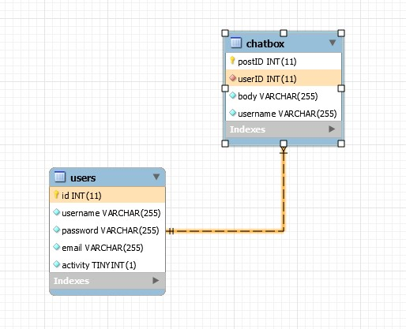

# OPIS FUNKCIONALNOSTI

Sajt funkcioniše tako što nas salje na login stranicu u kojoj u jedno polje unosimo željenu email addresu (1), u drugo polje kucamo lozinku (2) , i klikom na Log In dugme (3), se logujemo na stranicu index.php

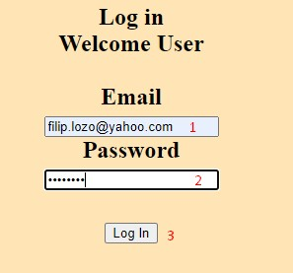

Kada se uspešno ulogujemo na chat, otvara se chat stranica (index.php) u kojoj se nalazi prozor za chat. U gornjem delu se nalazi brojač koji nas obaveštava koliko je ljudi trenutno na chatu (4) i link sa kojim možemo da se izlogujemo iz istog (5).

Zatim sledeće što vidimo je chat prozor u kojem će biti ispisane prethodne poslate poruke u koliko ih ima (6). Ispod chat prozora nalazi se polje za unos željene poruke (7) a pored toga dugme Send koje salje poruku (8).

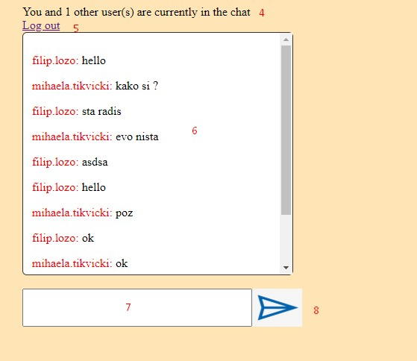

# KORIŠĆENA LITERATURA

W1. <http://www.w3schools.com/>

W2. <http://www.jquery.com>

W3. <https://stackoverflow.com/>