- Proposal - Desktop application
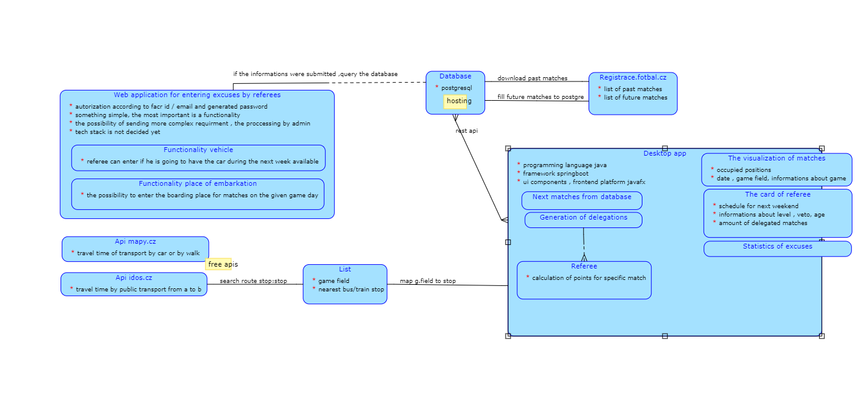
Using the Spring Boot framework with the PostgreSQL database and the JAVA FX design platform. Here is the diagram showing the possible architecture:
Advantages:
- my experience working with Java and JavaFX, Spring Boot
- lower service costs, we don't need to host the app, only the database
- already developed a prototype, could use some graphic components from it
- stability and robustness, less dependent on changing external factors such as browser updates or compatibility issues of different web technologies
Disadvantages:
- can be run only on computers with this software installed
- big - it does not contain the possibility of submitting the excuses directly from referees via web
- we need internet connection anyway, so this desktop app advantage is not relevant
- platform dependency
- we do not know how it will be with the synchronization of data when two administrators change the same match in the same moment

- Proposal - Web application and database hosted on web server
Possible tech stack:
Hosting: Webapp.io or Contabo.com, both have the support for Docker,Plesk
Reverse-proxy: Traefik
CI/CD tool: GitLab
Database: PostgreSQL
Framework: ASP.NET Core
Architecture: MVC (Model-View-Controller)
Backend programming language: C#
Frontend: jQuery, HTML, CSS (as much simple as possible),Bootstrap
Controllers: REST API
Views: Razor syntax (we can include C# code)
Communication client-server: ASP.NET SignalR (for the side of web app
where the delegations are made)
AJAX (for the side of web app where referees excuse themselves)

The main idea is to rent a virtual private server from Webapp.io (free for students) or Contabo.com (4,5 eur/month). Both of these services provide api which enable for us CI/CD. Docker,Plesk support is a matter of course for both. The whole web app can run in Docker container, which ensure that the app will have all the things it needs to, because they are the part of the container. The database based on PostgreSQL can run in other docker image located on the same vps. I am not aware of any obstacle that prevents the use of SignalR and Ajax technology in one web application, so we can take advantage of both. Ajax can be used in page, where referees excuse themselves, so in this page we need only to send or receive information only about one person at the time so the displaying will not be mixed. SignalR technology allows server code to send asynchronous notifications to client-side web applications and these feature we can use in the side , where we occupy the matches, because the same match can be displayed on two clients at the same time , so we need real-time updates about them.

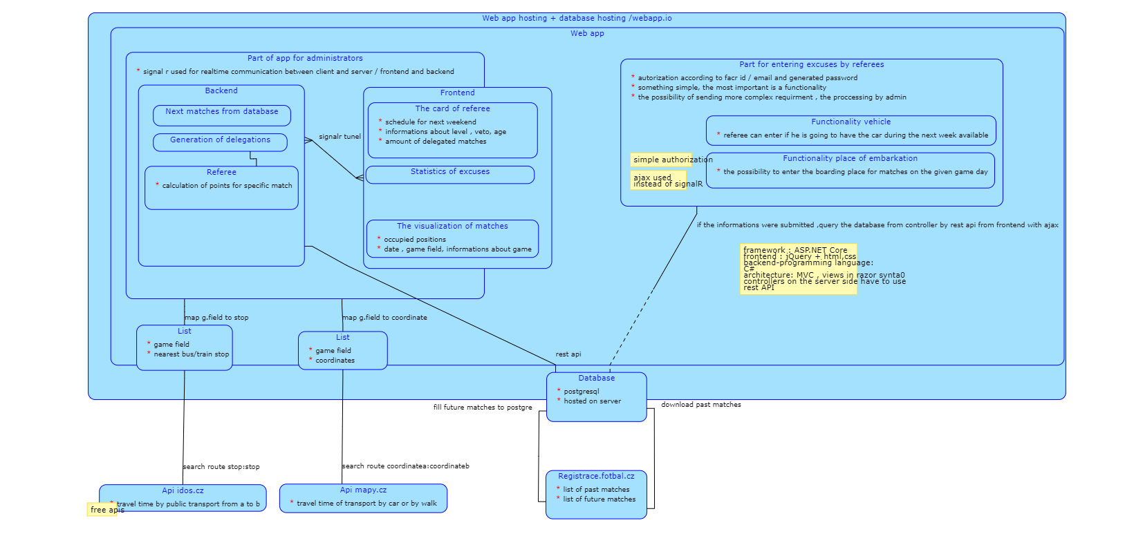

Advantages:
- my work experience working with MVC architecture, C#, jQuery
- the user can join from every computer with internet connection, no need to install something
- frontend technologies are quite old and well tested, we expect that the maintenance rate will be low on the customer side in the future
- we can assume that the SignalR is a good way to ensure data synchronization
- all the technologies are still used and popular nowadays
Disadvantages:
- the operating costs will be higher
- it can be harder to make custom ui components with only html, css
- more complexity in deployment to server or in dockerizing

Resources:
https://contabo.com/en/vps/
https://webapp.io/blog/webapp-io-launch-week-day-3-failing-docker-containers-directly-in-your-prs/
https://stackify.com/asp-net-razor-pages-vs-mvc/
https://www.miroslavholec.cz/blog/asp-net-core-mvc-rest-api-net-framework-signalr-odata-blazor
https://scientificprogrammer.net/2019/08/18/why-you-absolutely-need-signalr-for-asp-net-development/

