Cloud4SOA Meeting

Athens 9-10 December 2010

Place: SingularLogic premises
Al. Panagouli & Siniosoglou str. N. Ionia-Attica, Metro Station: N. Ionia (Line 1)

Useful Information

Meeting Place
The meeting will be held at SingularLogic premises. The offices are in near the Metro Station N. Ionia (Line 1). Walking distance ~ 10 min.
The entrance is at the opposite site of a BP gas station. In general, you can estimate about 45-60 minutes to get from the centre to SingularLogic.
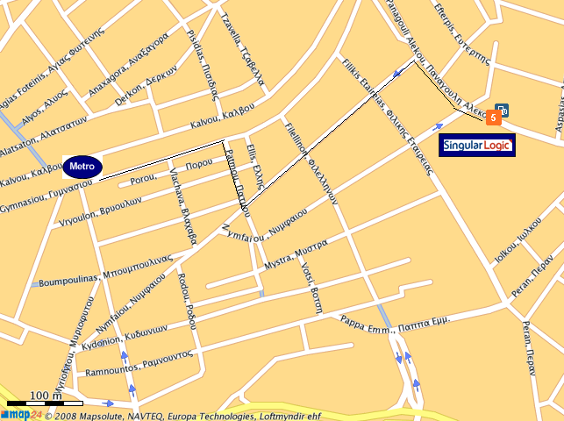

- When you get off the train (towards Kifisia) in N. Ionia Station, go straight on the left and in parallel with the lines.
- You turn right either in Patmou str. Or Fillelinon.
- Left in Nymfaiou str.
- Once you find Al. Panagouli turn right and the entrance of SingularLogic
Hotels-Accommodation
Unfortunately there are no hotels near SingularLogic, neither any specific arrangements with the company. Some (indicative) hotels in the centre and near the metro are the following:

STANLEY HOTEL CATEGORY A
(Metro station: Metaxourgeio)
Tel: +30 210 5241611
www.gtp.gr/stanleyhotel

PRESIDENT HOTEL CATEGORY A
(Metro station: Alexandras or Panormou)
Tel: +30 210 6989500
www.president.gr

PARK HOTEL CATEGORY DELUXE
(Metro station: Victoria)
Tel: +30 210 8894500
www.parkhotel.gr

MAGNA GRECIA BOUTIQUE HOTEL
(Metro station: Syntagma or Monastiraki)
Tel: +30 210 3240314-5
www.magnagreciahotel.com

RESIDENCE GEORGIO CATEGORY DELUXE
(Metro station: Omonoia)
Tel: +30 210 3320100
www.residencegeorgio.com

How to get from your hotel to the meeting place (SingularLogic)
- Take the Metro Line 1 towards Kifisia.
- You will stop at the N. Ionia Station.
- In front of the station (from the side you will get off) you follow the small provided map at page 1.
- After 5-10 minutes walking you will find the Siniosoglou and Al. Panagouli corner. The SingularLogic main entrance is at the opposite site of a BP gas station
You can also use taxi but it is not recommended for working days due to the long traffic (and of course cost…☺).

How to get from the Airport to the hotel or the meeting place
When you will arrive at Athens Airport there are 3 ways to move from there:
- Suburban Railway & Metro line: In such case you will need about 1 hour to get to the hotel. Looking at the metro map you will easily identify which lines to take for your final destination.
- Taxi: More expensive but maybe you will get to the centre faster if you arrive on Sunday. Not recommended for getting from the Airport to the centre in working days!!!
- Buses & Metro Line: There are busses going go the Ethniki Amyna Station from where you can take the metro lines (see below map; also can be found at http://www.amadeus.net/home/new/subwaymaps/en/athens.htm)
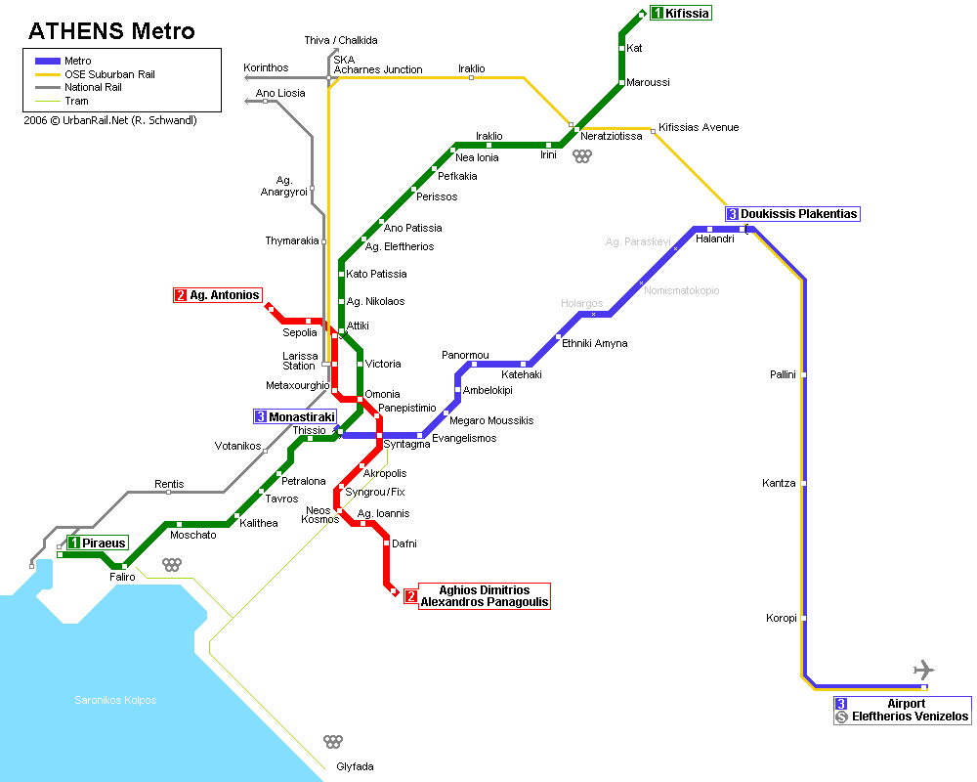
Contact Persons:
For any further information you may contact the following persons:

Stelios Pantelopoulos
Tel: +30 210 62 66 260
Fax: +30 210 62 66 643
Mob.: +30 6974024424
Email: spantelopoulos@singularlogic.eu

Evelina Peristeri
Tel: +30 210 62 66 262
Email: eperisteri@singularlogic.eu

