AdvancedText2SpeechEditor

Sprint Report

“Bug Catchers want to battle”

Papanikolaou Nikolaos 4145  
Priftis Filippo 4162

**Versions History**

|  |  |  |  |
| --- | --- | --- | --- |
| **Date** | **Version** | **Description** | **Author** |
| 26/5/2021 | 1.0v | Added all the information in the report. | Filippo Priftis |

# Introduction

## Document Structure

The rest of this document is structured as follows. Section 2 describes out Scrum team and specifies the this Sprint's backlog. Section 3 specifies the main design concepts for this release of the project.

For the design of the GUI we used JavaFX and SceneBuilder.

# Scrum team and Sprint Backlog

|  |  |  |
| --- | --- | --- |
| **User Story** | **Class** | **Comment** |
| US1 | OpenDocumentTest | Each method tests opening a different type of file or encryption. |
| US2 | SaveDocumentTest | Each method tests saving a different type of file or encryption. |
| US3 | SaveDocumentTest | We edit the contents of the file before saving them. |
| US4 | TextToSpeechTest | Tested in the documentToSpeechTest() method. |
| US5 | TextToSpeechTest | No different than US4 since we always give a string to Transform. |
| US6 | TextToSpeechTest | Tested in the audioParametersTest() method. |
| US7 | RecordingTest | Tested via the testStartRecording() method. |
| US8 | TextToSpeechTest | Tested via replayRecodedAction(). |
| US9 | RecordingTest | Tested via the testEndRecording() method. |

## Scrum team

|  |  |
| --- | --- |
| **Product Owner** | Apostolos Zarras |
| **Scrum Master** | Papanikolaou Nikolaos |
| **Development Team** | Papanikolaou Nikolaos, Filippo Priftis |

## Sprints

|  |  |  |  |  |
| --- | --- | --- | --- | --- |
| **Sprint No** | **Begin Date** | **End Date** | **Number of weeks** | **User stories** |
| **1** | **1/4/2021** | **15/4/2021** | **2** | **US1, US2, US3** |
| **2** | **16/4/2021** | **23/4/2021** | **1** | **US4, US5, US7** |
| **3** | **7/5/2021** | **21/5/2021** | **2** | **US6, US8, US9** |

# Use Cases

## Open File

|  |  |
| --- | --- |
| **Use case ID** | Open File |
| **Actors** | User |
| **Pre conditions** | The App is up and running. |
| **Main flow of events** | 1. The UC starts when the user chooses the “Open File” option from the “File” menu. 2. The user chooses the encryption type of the file from the menu. 3. The File browser window opens. 4. While the desired file is not displayed in the files list of the file browser   4.1. The user selects a directory from the list.  4.2. The application displays the contents of the directory in the files list.   1. The user selects the desired file. 2. If the user has selected to open an encrypted file.   6.1 The file is decrypted according to the specified encryption type.   1. The file open dialog disappears. 2. The file is displayed. |
| **Post conditions** | The contents of the file are available to the user for further processing. |

## Save File

|  |  |
| --- | --- |
| **Use case ID** | Save File |
| **Actors** | User |
| **Pre conditions** | There is an open file in the app |
| **Main flow of events** | 1. The UC starts when the user chooses the “Save File” option from the “File” menu. 2. The user chooses the encryption type of the file from the menu. 3. The File browser window opens. 4. While the desired destination is not displayed in the files list of the file browser   4.1. The user selects a directory from the list.  4.2. The application displays the contents of the directory in the files list.   1. The user types the desired name. 2. If the user has selected to save an encrypted file.   6.1 The file is encrypted according to the specified encryption type.   1. The file save dialog disappears. |
| **Alternative flow 1** | 1. The alternative flow starts after step 5. 2. The application indicates that a file with the desired name already exists in the directory. 3. A window pops up asking the user to choose whether he wants to override the file or to change the desired name. 4. The user chooses one of the options. 5. The window closes. 6. If the user chose to change the file name.   6.1 The use case continues from step 5 of the main flow.   1. The use case continues from step 6 of the main flow. |

## Transform File to Audio

|  |  |
| --- | --- |
| **Use case ID** | Transform File to Audio |
| **Actors** | User |
| **Pre conditions** | There is an open file in the app. |
| **Main flow of events** | 1. The UC starts when the user chooses the “Transform” option from the “Edit” menu. 2. A pop-up window appears asking the user if he wants to transform the whole file, only a part of it that he has selected (enabled only if there is text selected) or to cancel the operation. 3. If the user chooses to transform the whole file.    1. All the text in the file is transformed into audio. 4. If the user chose “Transform Selection.   4.1. The selected text is transformed into audio.   1. If the user chose “Cancel”.    1. The operation is canceled. 2. The pop-up window is closed. 3. A toolbar that handles the audio playback becomes enabled in the main window. |
| **Post conditions** | An audio transformation track is created. |

## Start Recording Transformation Operations

|  |  |
| --- | --- |
| **Use case ID** | Start Recording Operations |
| **Actors** | User |
| **Pre conditions** | The App is up and running. |
| **Main flow of events** | 1. The UC starts when the user chooses the “Start recording” option from the “File” menu. 2. The option “End Recording” is added to the “File” menu. 3. Every time the user executes an operation, it is saved to be played again. |

## End Recording Transformation Operations

|  |  |
| --- | --- |
| **Use case ID** | End Recording Operations |
| **Actors** | User |
| **Pre conditions** | The App is up and running.  The user has executed UC4. |
| **Main flow of events** | 1. The UC starts when the user chooses the “End recording” option from the “File” menu. 2. The recorded Transformation Operations are deleted. 3. The audio controller toolbar becomes disabled in the main window. 4. The option “Start Recording” is added to the “File” menu. |

## Repeat Recorded Transformation Operation

|  |  |
| --- | --- |
| **Use case ID** | Repeat Recorded Operation |
| **Actors** | User |
| **Pre conditions** | Requirements of Recorded Transformation.  The user has executed UC3. |
| **Main flow of events** | 1. The UC starts when the user chooses the “Replay Transformation” in the “File” menu. 2. A pop-up window appears with a list of all the recorded transformations. 3. The user selects an action. 4. The user clicks “OK”. 5. The selected Transformation is executed as in UC1, UC2 or UC3. |

## Play Transformed Audio

|  |  |
| --- | --- |
| **Use case ID** | Play Transformed Audio |
| **Actors** | User |
| **Pre conditions** | There is an open file in the app.  The audio is paused.  There is a loaded audio track from UC3 or UC6. |
| **Main flow of events** | 1. The UC starts when the user clicks the “Play” button in the audio player toolbar. 2. The “Play” button is then replaced with the “Pause” button. 3. The paused audio track resumes playing. |

## Pause Audio Playback

|  |  |
| --- | --- |
| **Use case ID** | Pause Audio Playback |
| **Actors** | User |
| **Pre conditions** | There is an open file in the app.  The user has executed UC7. |
| **Main flow of events** | 1. The UC starts when the user clicks the “Pause” button in the audio player toolbar. 2. The “Pause” button is then replaced with the “Play” button. 3. The audio track pauses playing. |

## Change Audio Volume

|  |  |
| --- | --- |
| **Use case ID** | Change Audio Volume |
| **Actors** | User |
| **Pre conditions** | There is an open file in the app.  There is a loaded audio track from UC3 or UC6. |
| **Main flow of events** | 1. The UC starts when the user chooses the Volume Level of the audio from the slider in the audio player toolbar. 2. The volume changes according to the value of the slider. |
| **Alternative Flow 1** | 1. The user clicks the “Mute” button from the audio player toolbar. 2. The sound volume changes to zero. |

## Change audio Pitch

|  |  |
| --- | --- |
| **Use case ID** | Change audio Pitch |
| **Actors** | User |
| **Pre conditions** | There is an open file in the app.  There is a loaded audio track from UC3 or UC6. |
| **Main flow of events** | 1. The UC starts when the user chooses a new value for the audio pitch slider in the audio player toolbar. 2. The audio pitch changes according to the value of the slider. |

## Change audio Speed

|  |  |
| --- | --- |
| **Use case ID** | Change audio Speed |
| **Actors** | User |
| **Pre conditions** | There is an open file in the app.  There is a loaded audio track from UC3 or UC6. |
| **Main flow of events** | 1. The UC starts when the user clicks the plus or the minus button in the audio player toolbar. 2. The audio speed changes by 0.25(increasing or decreasing) according to the value of the slider. |

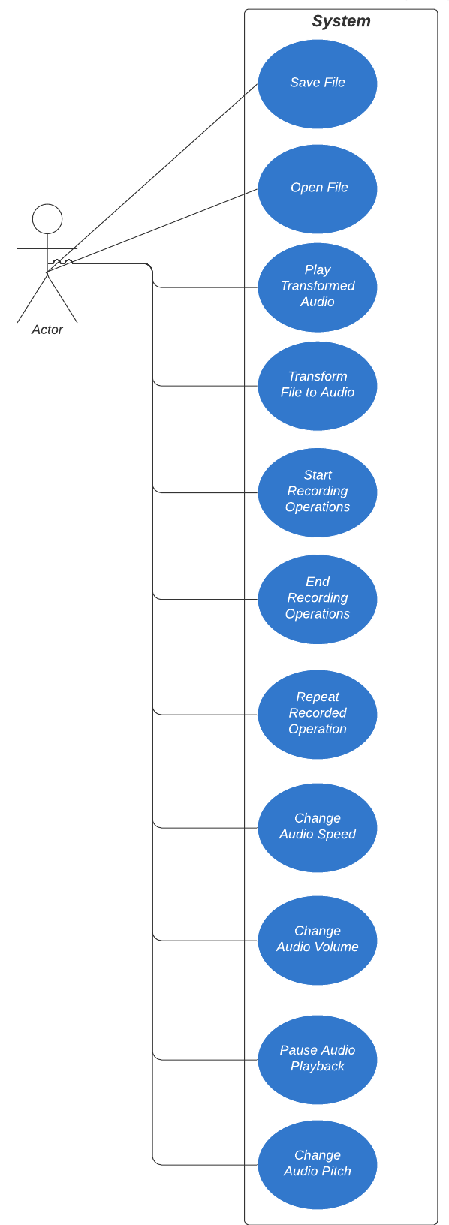

# Design

## Architecture

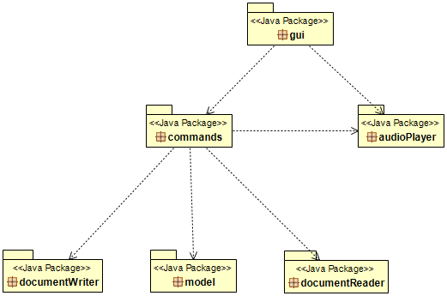

## Design

**Commands Package**

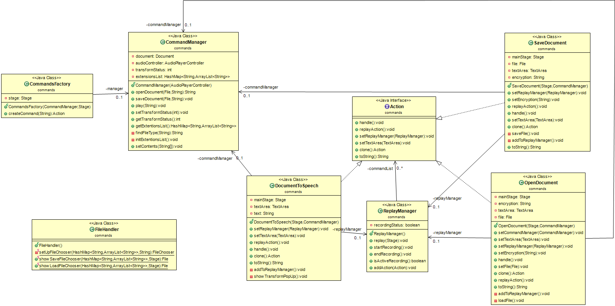

**Document Reader Package**

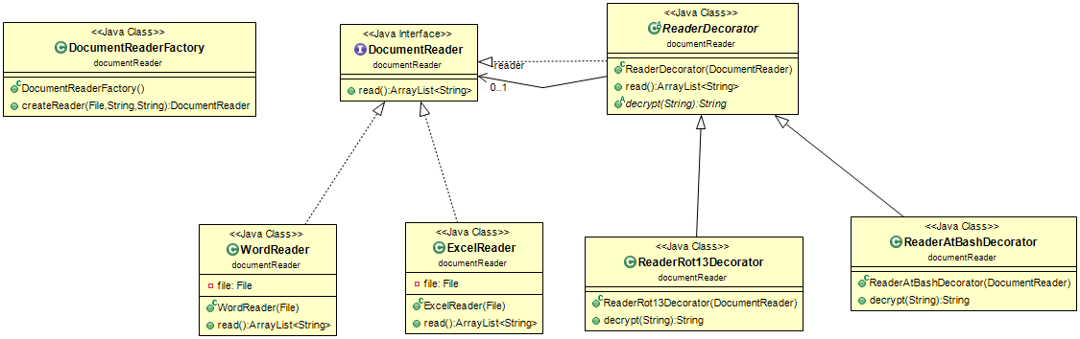

**Document Writer Package**

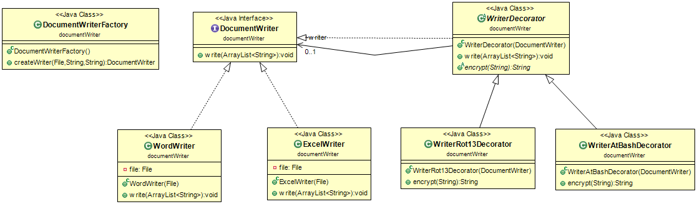

|  |  |
| --- | --- |
| **Class Name: Command Manager** | |
| **Responsibilities:**   * Saves Document to File * Opens Document from File * Transforms Audio to Speech * Calls Audio Manager to play audio * Keeps compatible File Types | **Collaborations:**   * Document * AudioPlayer * DocumentToSpeech * OpenDocument * SaveDocument |

|  |  |
| --- | --- |
| **Class Name: Command Factory** | |
| **Responsibilities:**   * Creates new Command Objects | **Collaborations:**   * **----** |

|  |  |
| --- | --- |
| **Class Name: Save Document** | |
| **Responsibilities:**   * Saves Document to File * Knows textArea * Adds itself to ReplayManager | **Collaborations:**   * CommandManager * Document * ReplayManager |

|  |  |
| --- | --- |
| **Class Name: Open Document** | |
| **Responsibilities:**   * Opens Document from File * Knows textArea * Adds itself to ReplayManager | **Collaborations:**   * CommandManager * Document * ReplayManager |

|  |  |
| --- | --- |
| **Class Name: Document to Speech** | |
| **Responsibilities:**   * Transforms Audio to Speech * Knows textArea * Adds itself to ReplayManager | **Collaborations:**   * CommandManager * Document * ReplayManager |

|  |  |
| --- | --- |
| **Class Name: Replay Manager** | |
| **Responsibilities:**   * Keeps List of Actions if recording is enabled. * Replays an action. | **Collaborations:**   * ---- |

|  |  |
| --- | --- |
| **Class Name: File Handler** | |
| **Responsibilities:**   * Opens File Chooser to Save or Open a File | **Collaborations:**   * ---- |

|  |  |
| --- | --- |
| **Class Name: Document Reader Factory** | |
| **Responsibilities:**   * Creates new DocumentReader Objects | **Collaborations:**   * ---- |

|  |  |
| --- | --- |
| **Class Name: Word Reader** | |
| **Responsibilities:**   * Reads contents of a word File | **Collaborations:**   * ---- |

|  |  |
| --- | --- |
| **Class Name: Excel Reader** | |
| **Responsibilities:**   * Reads contents of an excel File | **Collaborations:**   * ---- |

|  |  |
| --- | --- |
| **Class Name: Reader Decorator(Rot13 Decorator, AtBash Decorator)** | |
| **Responsibilities:**   * Decrypts contents of a File | **Collaborations:**   * DocumentReader(WordReader, ExcelReader) |

|  |  |
| --- | --- |
| **Class Name: Document Writer Factory** | |
| **Responsibilities:**   * Creates new DocumentWriter Objects | **Responsibilities:**   * ---- |

|  |  |
| --- | --- |
| **Class Name: Word Writer** | |
| **Responsibilities:**   * Writes contents to a word File | **Collaborations:**   * ---- |

|  |  |
| --- | --- |
| **Class Name: Excel Writer** | |
| **Responsibilities:**   * Writes contents to an excel File | **Collaborations:**   * ---- |

|  |  |
| --- | --- |
| **Class Name: Reader Decorator(Rot13 Decorator, AtBash Decorator)** | |
| **Responsibilities:**   * Encrypts contents of a File | **Collaborations:**   * DocumentWriter(WordWriter, ExcelWriter) |

|  |  |
| --- | --- |
| **Class Name: Audio Player Controller** | |
| **Responsibilities:**   * Plays audio. * Pauses audio. * Changes audio volume. * Changes audio pitch. * Changes audio speed. | **Collaborations:**   * TTSFacade |

|  |  |
| --- | --- |
| **Class Name: TTS Facade** | |
| **Responsibilities:**   * Plays audio. * Pauses audio. * Changes audio volume. * Changes audio pitch. * Changes audio speed. | **Collaborations:**   * AudioPlayerController |