eNote Podcasts
Extension Key: enotepodcast
Copyright 2010-2011, Kasper Skårhøj, <kaska@llab.dtu.dk>

This document is published under the Open Content License
available from http://www.opencontent.org/opl.shtml

The content of this document is related to TYPO3
- a GNU/GPL CMS/Framework available from www.typo3.org
---------------

Table of Contents
eNote Podcasts 1
Introduction 1
Installation 2
Installation in TYPO3 2
Configuration of the plugin 3
The feed files 5
The meta data text file 6
Uploading with rsync 7
Styling the extension 7
Development 7
Todo list 7
Revision history 7

Introduction
The eNote Podcast extension is a video podcast channel module for TYPO3 which is optimized for a very straight forward and streamlined publishing procedure. Once the podcast channel is set up inside of TYPO3, all updates to the channel in terms of new videos happens through the file system and meta data for each video is located in a single file with a special naming scheme. The idea behind this is that videos are compressed and saved to a folder, a simple text file (UTF-8 encoded) contains the meta data for the episode and everything is pushed to the server with an rsync script.
At DTU we are using this publishing procedure and it is highly efficient for daily production. What misses at this time is evaluation tools which can overlook if human mistakes are made in the writing of meta data and filenaming since this requires that you follow the rules to the point. We are considering developing such tools as a Mac application.
Examples of use can be found at these URLs:
- http://podcast.llab.dtu.dk/ - Here a lot of feeds are aggregated on the same website. Each podcast channel has its own page and plugin instance.
- http://toolbox.llab.dtu.dk/podcast/ - This is the feed for DTUs e-learning toolbox. Actually, this was also found at http://podcast.llab.dtu.dk/feeds/learninglab-e-learning-toolbox/ and they are sharing the same files on the server - so effectively we can update the same feed used on many websites by simply updating files (movies and metadata) in a central folder. This is one of the great features of having the meta data in the filesystem as opposed to a database.
- http://01005.mat.dtu.dk/2010/materialer/podcast/videoer/ - A podcast feed from a course at DTU. As with the toolbox example above, the files are also simultaneously found at http://podcast.llab.dtu.dk/ .

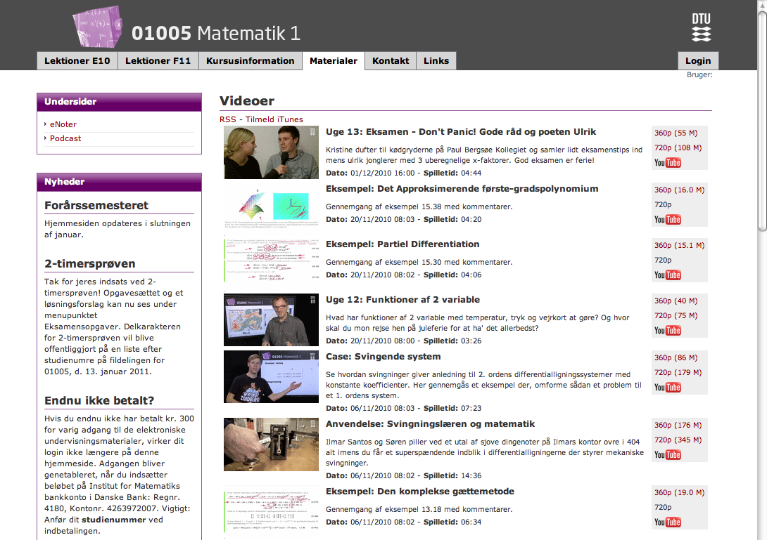

Server Requirements
For thumbnail generation, TYPO3s image processing capabilities must be properly configured.
For extraction of meta data from the video files (such as play length in minutes/seconds) “/usr/bin/exiftool” must exist!

Installation

Installation in TYPO3
The extension is installed in TYPO3 through the Extension Manager. This is standard procedure for all extensions.
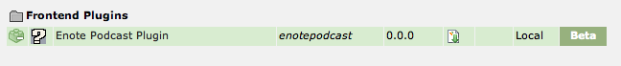

When this is done you can add the plugin on as many pages as you like in your TYPO3 page tree. You add it as a content element to the page, selecting the Type “Plugin”.

Here the plugin is added to a page:

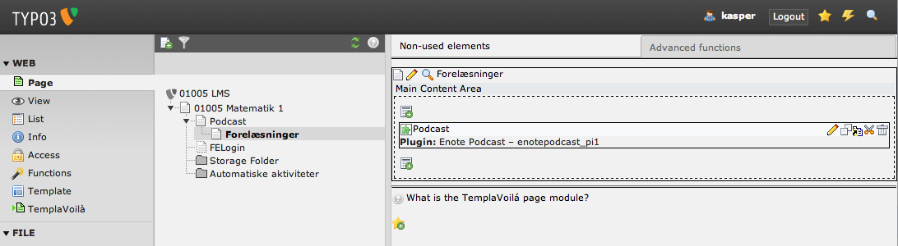
When you edit the content element “Podcast” it looks like this:
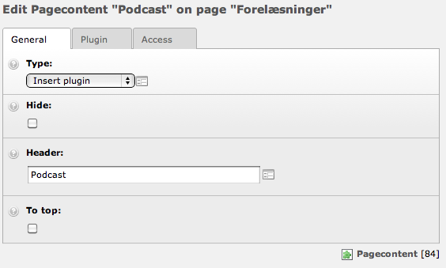
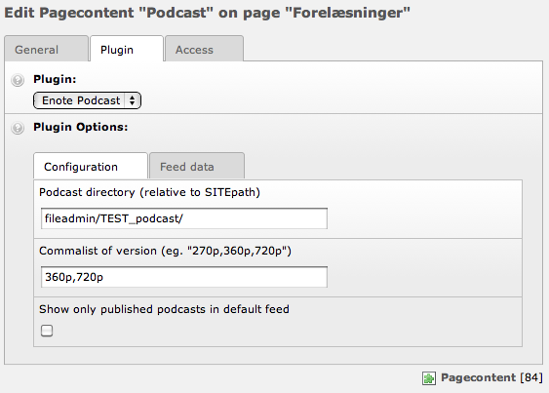
On the website you will (soon) see something like the picture below:
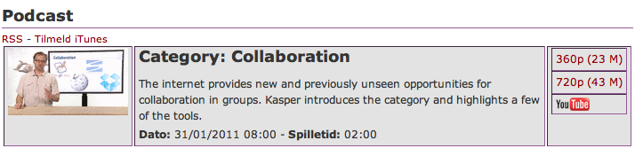

Configuration of the plugin
When the plugin is installed in TYPO3 you must configure a few basic things:

Enter the path in the filesystem where you intend to put the videos and metadata files:
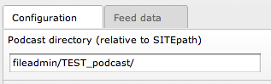
Enter the suffixes for the various formats you want to offer:
The plugin can support multiple formats. You might like to offer SD and HD versions of your podcast. You might like to offer channels with different bitrates (which means different sizes and quality). For each format you wish to distribute, you must simply define a suffix that is used along with the filenaming scheme. At DTU we typically distribute podcasts as 360p (SD) versions as well as HD versions (720p) and thus the prefixes we use are these seen below. They could just as well be “SD,HD” or “NormalQuality,HighQuality”:
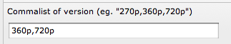
You can enter a title for the website in parenthesis, for instance: “360p(SD),720p(HD)”.
By default, the first format (here 360p) will be accessed as “rss=1” and by default the format “720p” will be translated to “HD”. This was a necessity in order to maintain backwards compatibility at a point in development.

Publication dates:
Each video in the podcast channel must have a publication date and this check box determines if that date is used when listing the videos. If you check this, only episodes with and older date than today are shown in the feed. This allows you to publish videos which will automatically be online the day their publication date/time is exceeded. On the other hand you might like to see all future episodes as well in other cases which is why you get this option:

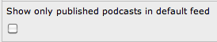

Other options
There is a number of other options related to the feed meta data:
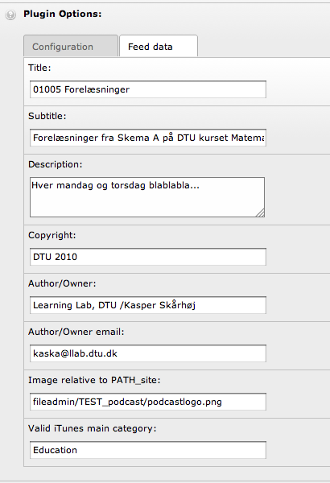

Caching
It is recommended to set the caching of the podcast feed to 5 minutes - or at least less than the default 24 hours:

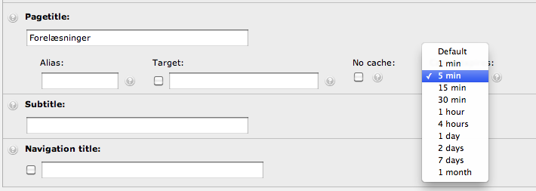
The reason is that otherwise the podcast feed will only be updated with new content after a long while from the moment the synchronization script has been running.

The feed files
This is an excerpt from the files that generates the feed from Learning Lab Toolbox (http://toolbox.llab.dtu.dk/podcast/):
-rw-r--r-- 1 www-data www-data 338393 2011-01-18 10:22 LLToolbox-Category-Collaboration(UK)-1.png
-rw-r--r-- 1 www-data www-data 23806755 2011-01-18 05:01 LLToolbox-Category-Collaboration(UK)-360p.m4v
-rw-r--r-- 1 www-data www-data 45100904 2011-01-18 04:58 LLToolbox-Category-Collaboration(UK)-720p.mov
-rw-r--r-- 1 www-data www-data 509 2011-01-18 21:26 LLToolbox-Category-Collaboration(UK).txt
-rw-r--r-- 1 www-data www-data 342716 2010-12-21 14:01 LLToolbox-Category-ElectronicVotingSystems(UK)-1.png
-rw-r--r-- 1 www-data www-data 45049498 2010-12-20 15:01 LLToolbox-Category-ElectronicVotingSystems(UK)-360p.m4v
-rw-r--r-- 1 www-data www-data 87448931 2010-12-20 15:13 LLToolbox-Category-ElectronicVotingSystems(UK)-720p.mov
-rw-r--r-- 1 www-data www-data 483 2010-12-21 15:37 LLToolbox-Category-ElectronicVotingSystems(UK).txt
-rw-r--r-- 1 www-data www-data 359281 2010-12-21 14:01 LLToolbox-Category-PencastsAndDigitalHandwriting(UK)-1.png
-rw-r--r-- 1 www-data www-data 77175671 2010-12-20 15:17 LLToolbox-Category-PencastsAndDigitalHandwriting(UK)-360p.m4v
-rw-r--r-- 1 www-data www-data 148406635 2010-12-20 15:35 LLToolbox-Category-PencastsAndDigitalHandwriting(UK)-720p.mov
-rw-r--r-- 1 www-data www-data 457 2010-12-21 15:38 LLToolbox-Category-PencastsAndDigitalHandwriting(UK).txt
-rw-r--r-- 1 www-data www-data 346794 2010-12-21 14:01 LLToolbox-Category-ScreenRecording(UK)-1.png
-rw-r--r-- 1 www-data www-data 42808137 2010-12-20 15:38 LLToolbox-Category-ScreenRecording(UK)-360p.m4v
-rw-r--r-- 1 www-data www-data 80410816 2010-12-20 15:46 LLToolbox-Category-ScreenRecording(UK)-720p.mov
-rw-r--r-- 1 www-data www-data 473 2010-12-21 15:38 LLToolbox-Category-ScreenRecording(UK).txt
-rw-r--r-- 1 www-data www-data 388159 2010-11-26 19:55 LLToolbox-Category-ShortVideosAndPodcasts-1.png
-rw-r--r-- 1 www-data www-data 82361656 2010-11-26 18:16 LLToolbox-Category-ShortVideosAndPodcasts-360p.m4v
-rw-r--r-- 1 www-data www-data 158186375 2010-11-26 18:06 LLToolbox-Category-ShortVideosAndPodcasts-720p.mov
-rw-r--r-- 1 www-data www-data 520 2010-12-21 14:24 LLToolbox-Category-ShortVideosAndPodcasts.txt
-rw-r--r-- 1 www-data www-data 340009 2011-01-18 10:22 LLToolbox-Category-VideoRecordedTalks(UK)-1.png
-rw-r--r-- 1 www-data www-data 33396279 2011-01-18 04:51 LLToolbox-Category-VideoRecordedTalks(UK)-360p.m4v
-rw-r--r-- 1 www-data www-data 63436768 2011-01-18 04:47 LLToolbox-Category-VideoRecordedTalks(UK)-720p.mov
-rw-r--r-- 1 www-data www-data 578 2011-01-18 21:26 LLToolbox-Category-VideoRecordedTalks(UK).txt
-rw-r--r-- 1 www-data www-data 342551 2010-12-21 14:02 LLToolbox-Tool-AdobeConnectPolls(UK)-1.png
-rw-r--r-- 1 www-data www-data 43094615 2010-12-20 15:52 LLToolbox-Tool-AdobeConnectPolls(UK)-360p.m4v
-rw-r--r-- 1 www-data www-data 79326825 2010-12-20 16:01 LLToolbox-Tool-AdobeConnectPolls(UK)-720p.mov
-rw-r--r-- 1 www-data www-data 491 2010-12-21 15:38 LLToolbox-Tool-AdobeConnectPolls(UK).txt
....
etc.
What you should look for here is the pattern in play. Notice that every episode seems to be represented by four files, sharing the same “base name”. For instance the episode “LLToolbox-Category-Collaboration(UK)” seems to have a text file (with meta data) called “LLToolbox-Category-Collaboration(UK).txt”, a png file (thumbnail) named “LLToolbox-Category-Collaboration(UK)-1.png” and two video files with a similar base name and suffixes “-360p.m4v” and “-720p.mov”. And that is indeed the structure:

Filename: | Description
[basename].txt | Meta data file in UTF-8 encoding. Contains the title, description, keywords etc for the episode.
[basename]-1.jpg  [basename]-1.png | Thumbnail for the episode. Typically a screenshot from the video.
[basename]-[formatsuffix].[ext] | This is the video files.  - [ext] is the file name extension. options are: “mp4”, “m4v”, “mov”  - [formatsuffix] is one of the strings from the field “Commalist of version” in the plugin set up back in TYPO3 (see previous section in this document). In the examples you see herein that would be “360p” or “720p” but as mentioned you can choose any string suffixes you like such as “HighQuality” and in that case the filename would have to be “[basename]-HighQuality.mp4” for instance.
[basename]-AT-[FilenameInCamelCase.txt] | Any number of attachments to the episode. The filename will be used as the link title.

The driving file is the meta data text. This is what the plugin will look for. If there is a meta data file, there will be an entry in the podcast channel. If there is a thumbnail file with the proper name, there will be a thumbnail - otherwise a default icon. If there is a video file for one of the specified formats, it will be listed; if not, there will just be no link (see this picture:)

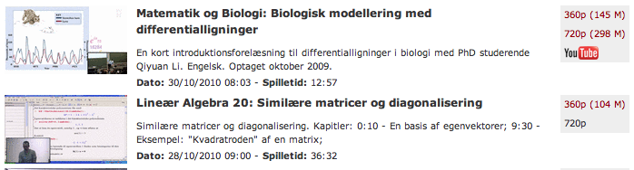
The first entry has both a 360p and 720p version as well as a link to YouTube. The second entry has only the 360p version (so the [basename]-720p.[ext] file is simply missing).

The meta data text file

From the picture above with “Matematik og Biologi: :...” the meta data file looks like this:

# Substitute the brackets with real data.
#If you just leave the bracket it will be regarded as a blank field or a comment and ignored.

title= Matematik og Biologi: Biologisk modellering med differentialligninger
description= En kort introduktionsforelæsning til differentialligninger i biologi med . . . Optaget oktober 2009.
pubDate= 2010-10-30 8:13

itunes:keywords= biologi foredrag matematik differentialligninger
itunes:author= 01005 Matematik 1

enotelms:YouTubeUID = sx5ww_pELA0

The syntax is basically that if a line starts with a keyword like “title = “ then everything after that point is the title until the line breaks. You can also see that comment lines can be used if “#” prefixes the line. Notice that information like file size and play length is automatically extracted from the video files - that information is found nowhere in the meta data files.

Anyway, the full range of fields you can use is shown in this template file:

[TODO]

Uploading with rsync
The uploading procedure of the files could be done with ftp or other means. We are using “rsync” to synchronize a local directory from a Mac laptop to the server. The advantage is that it's a synchronization tool, so basically we can make multiple changes to files in a podcast channel (add many videos or change meta data in a number of files) and they will all be updated once we run the script without us having to keep track of what we changed.
This script we use looks like this:

[TODO]

Styling the extension
As of this time, there are no external templating whatsoever of the extension. Also, there are no shortterm plans of integrating it. The styling is done by manipulating the HTML tags with CSS styles.

Development

Todo list
There are lots of “[TODO]” items in the code and much to improve. Here are some items on the list:

General
- Put the extension in SVN, either at DTU gbar or TYPO3 forge (must investigate this).
- Create Screencast with how to install. Includes a little zip-file with example videos for people to download for that test. Based on TYPO3 demo site.
- Fix (TODO) points in this document.

Mac-application / scripts
- Handles integrity checks locally on a Mac laptop on a given folder of episodes
- Create new episode:
  - Enter meta data in interface which the application writes to meta data file
  - Automatically create or suggest thumbnails from compressed videos
  - Assist compression? Intro-Episode-Outro model, integration with After Effects and turbo H.264
  - Execute upload (executes rsync script)
  - Automatically upload to YouTube
  - Embedding “chapters” in mp4 file from description.

Plugin
- Generally: Search word “TODO” in source code of “class.tx_enotepodcast_pi1.php”

Revision history

Revision key | Highlights

