'''

Rane Gillian R. Villanueva

2018101140

Machine Problem 1

'''

def CtoF(value):

F = value\*(9/5)+32

return str(value) + "°C is " + str(F) + "°F"

def FtoC(value):

C = (value-32)\*5/9

return str(value) + "°F is " + str(C) + "°C"

choice = input("1 - Celsius to Fahrenheit\n2 - Fahrenheit to Celsius\nChoose an option: ")

if int(choice) == 1:

value = input("Enter value in Celsius: ")

print(CtoF(float(value)))

elif int(choice) == 2:

value = input("Enter value in Fahreneheit: ")

print(FtoC(float(value)))

Celsius to Fahrenheit

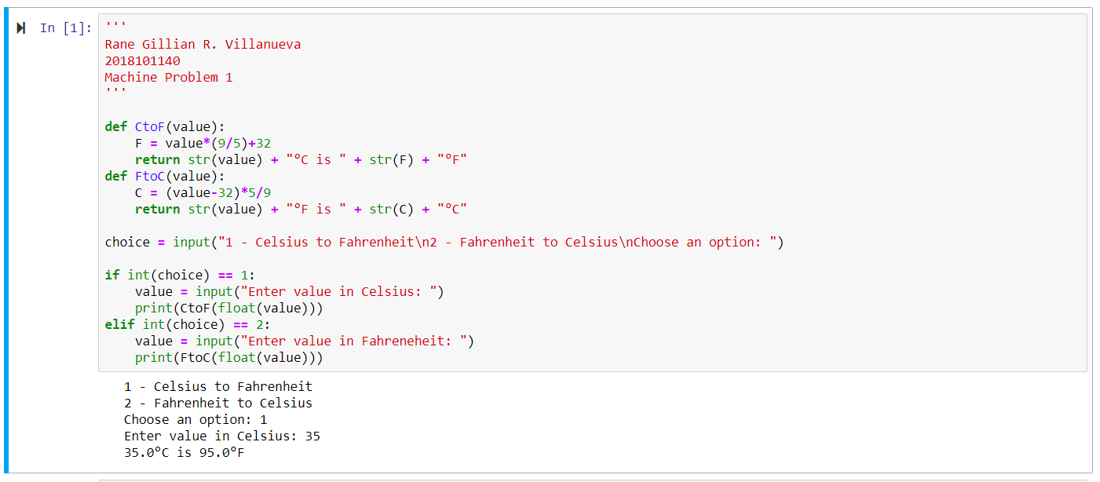

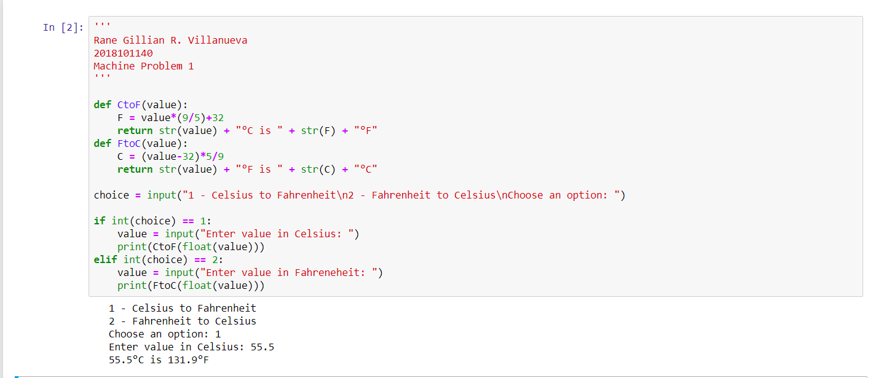

Fahrenheit to Celsius

