UI specification
OTCP

Prepared by: Filliciano Plong
Date: October 28, 2026
Version: 1.0

Readers: Filliciano Plong, developer and tester of OTCP. Status: 1.0 Approved 2026-10-28 — Ink; Stack V1; UI-D10 customizable tables; UI-D11 value summary. Based on approved SRS 1.0 and Architecture 1.0.

Contents
1. Purpose and scope
2. Chosen direction
3. Design tokens (Ink)
4. Components
5. Faceted filters
6. Screens
7. App icon
8. Accessibility
9. Decisions
10. Files

Revision history
Version | Date | Changes
1.0 | October 28, 2026 | Approved by Filliciano Plong. First release of the UI.

Status: Approved 2026-10-28 by Filliciano Plong. Version 1.0.

1. Purpose and scope
This document decides how OTCP looks and feels before implementation-plan issues are cut. It covers chrome, tokens, components, faceted filters, every screen in the SRS Screen map, and the Stack colour round. The SRS wins wherever this specification differs from it.
Source | Constraint
NFR-09 | WCAG 2.2 Level AA
NFR-10 | Full keyboard operability
NFR-11 | Ban status, errors, and selection never by color alone
NFR-12 | First-class layout at 375 CSS px; also 1280 px
NFR-13 | Clean, minimal, monochrome-leaning chrome; card art supplies most color (Should)
NFR-16 | Current Chrome, Firefox, Safari, Edge
Architecture | Tailwind 4; FilterEngine + SearchIndex (ADR-012, ADR-009)

2. Chosen direction
Ink is the product chrome (UI-D1 APPROVED 2026-10-27 6:54 PM PT). Quiet monochrome shell; card art is the only strong color.
Default theme: Match system. Phone nav: hamburger drawer. Desktop search, Lists, and Collection: List / Grid / Table; under ~640 CSS px Table is hidden (List / Grid only on phone). Lists and Collection tables are customizable (UI-D10); Collection/Lists/Decks show a value summary bar (UI-D11).
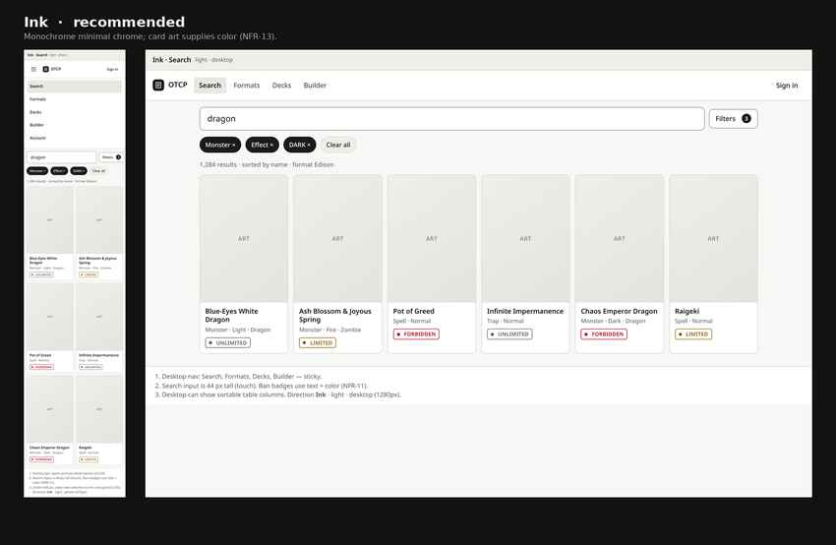
Figure 1. Ink direction — phone and desktop.
Purpose: Lock chrome for implementation.
Assumption: Placeholder ART.
Limitation: Arena/Ledger kept on file only.
Directions considered: Arena and Ledger remain under docs/images/ui/ and docs/ui/directions/ for history; not used in the main screen set.

3. Design tokens (Ink)
File: docs/ui/tokens.css. Light/dark via prefers-color-scheme and data-theme. Contrast: docs/ui/contrast.txt (AA).
Token | Light | Dark | Use
--color-bg | #F7F7F5 | #0E0E0E | Page background
--color-surface | #FFFFFF | #171717 | Cards, panels
--color-text | #141414 | #F2F2F0 | Body
--color-text-2 | #5C5C5C | #A8A8A4 | Secondary
--color-accent | #1A1A1A | #F2F2F0 | Primary / active
--color-ban-forbidden | #B00020 | #FF8A95 | Forbidden + label
--color-ban-limited | #8A5A00 | #F2C661 | Limited + label
--color-ban-semi | #3A5A8A | #8FB4E8 | Semi-Limited + label

Scale | Values
Font | System UI sans; mono for YDK
Size / space / radius | 11–24 px / 4–48 px / 4–12–pill
Touch / motion | ≥44 CSS px / 120–200 ms (0 if reduced)

4. Components
Component | Notes
Search + Filters button | 44 px search; Filters shows active count
Facet group | Collapsible; live counts; search-within; ranges
Active filter chip | Removable; Clear all above results
Ban badge | Text + color + dot (NFR-11)
Data table | Default desktop view (≥~640) on Search, Lists, Collection; customizable columns; phone: compact icon rows (no Table)
Count line | Same live card-count format above Search, Lists, and Collection (updates with filters); no prices or vendor captions
Value summary | Current / Paid / P/L + priced count on Collection, Lists, Decks — only place for price stats
Addable columns | Full catalog in SRS Table columns reference (YGOPRODeck misc=yes); set_price 0→blank; Link markers use icon
Nav | Desktop links; phone hamburger drawer
Sheet / dialog | Phone Filters sheet; export/import/delete

5. Faceted filters
Faceted search in the style of major card marketplaces: game first, then core (any TCG) and game-extension facet groups driven by declaration data. Live option counts; include/exclude and AND/OR where declared; desktop left sidebar; phone full-screen Filters sheet with See N results; chips + Clear all. Presets are Should. Engine: ADR-012 / FilterEngine; 100 ms target for name search and on-screen counts (UNVERIFIED until S-01).
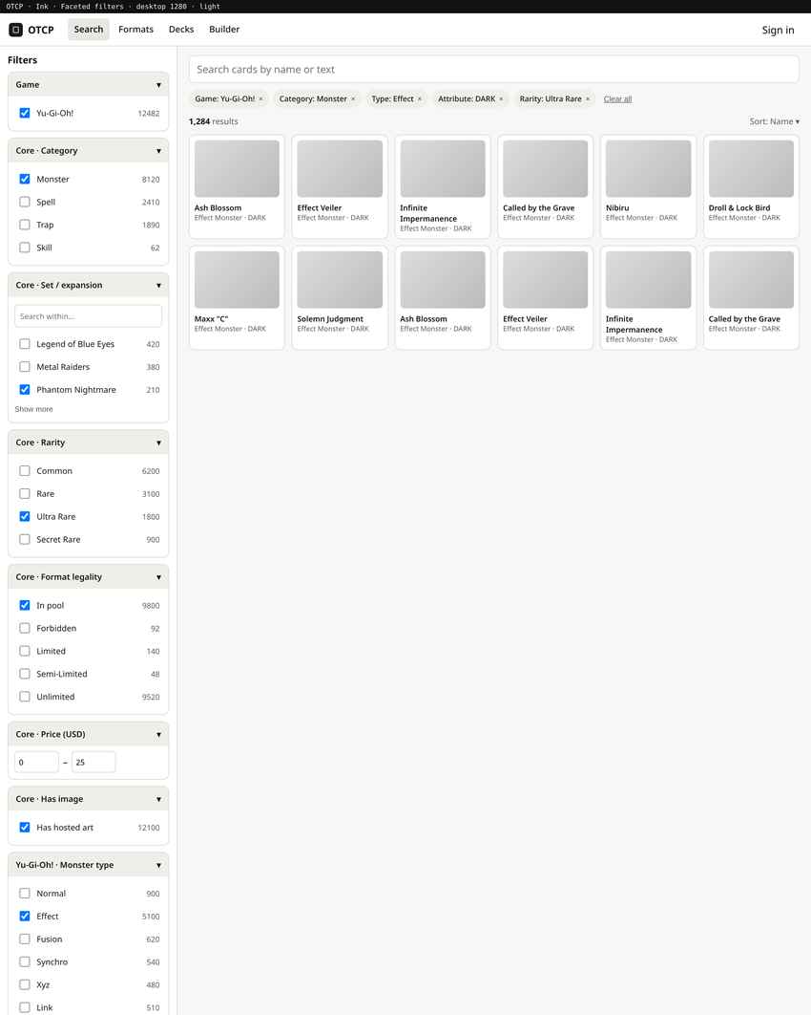
Figure 2. Desktop — left facet sidebar with live counts and active chips.
Purpose: Primary filter chrome at 1280 px.
Assumption: Yu-Gi-Oh! selected.
Limitation: Counts are illustrative.
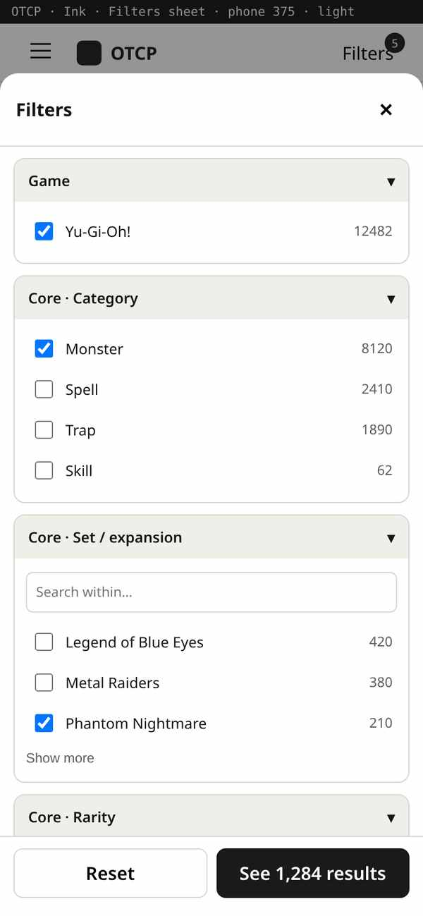
Figure 3. Phone — Filters sheet open over results; hamburger for app nav.
Purpose: Full-screen facet sheet at 375 px.
Assumption: Same declarations as desktop.
Limitation: Apply commits facets.

6. Screens
Phone sheet: screens-ink-phone-sheet.png. Desktop sheet: screens-ink-desktop-sheet.png.
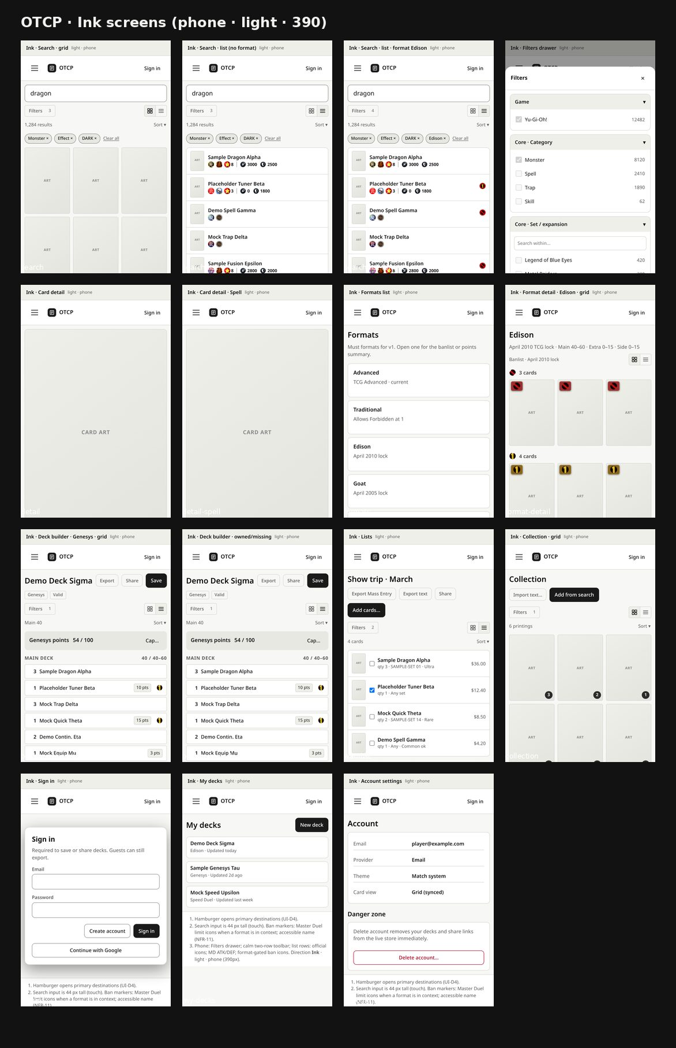
Figure 4. Ink phone screens (hamburger + card grid on narrow table).
Purpose: 375 px inventory.
Assumption: Ink tokens.
Limitation: About/Notices structure-only.
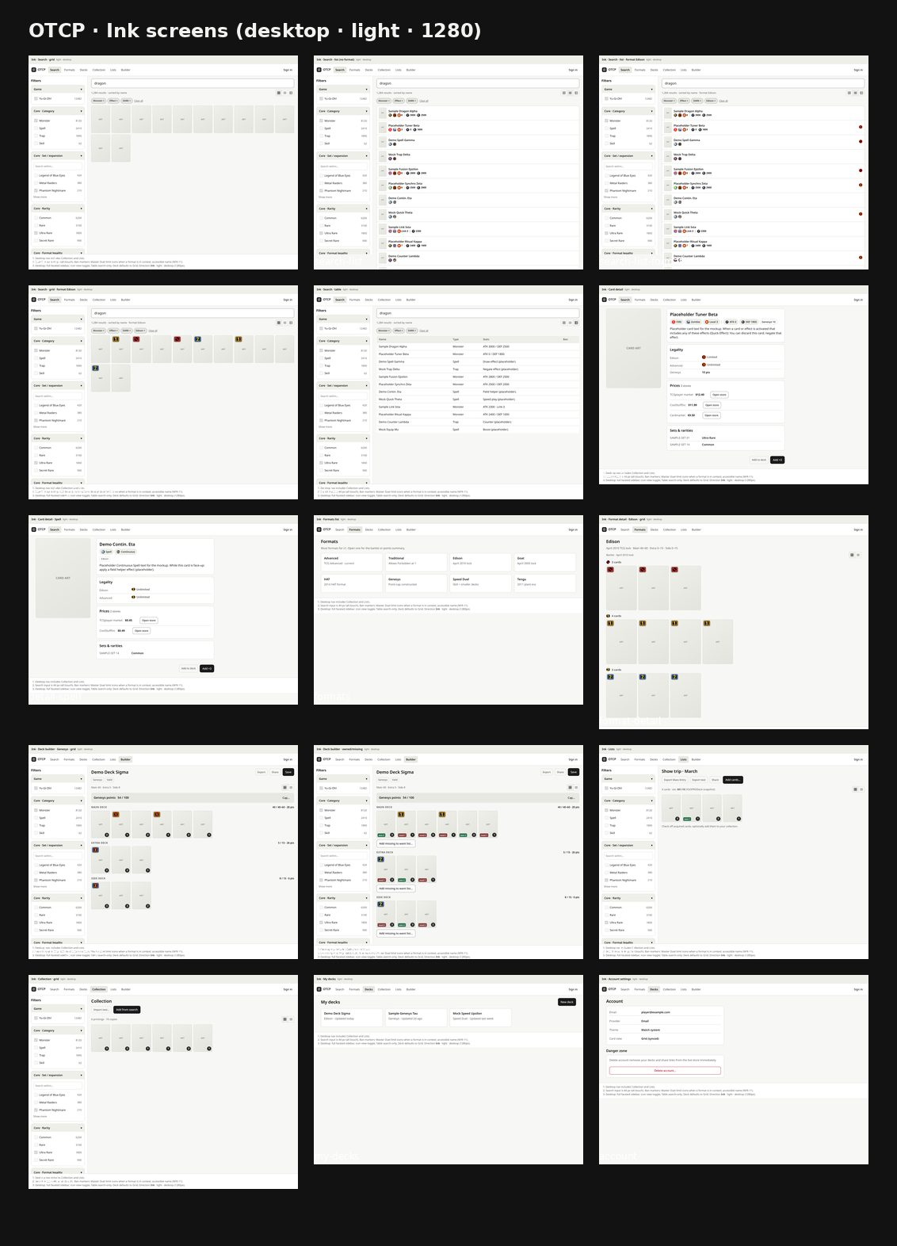
Figure 5. Ink desktop screens.
Purpose: 1280 px inventory.
Assumption: Ink tokens.
Limitation: Filter sidebar detailed in section 5.
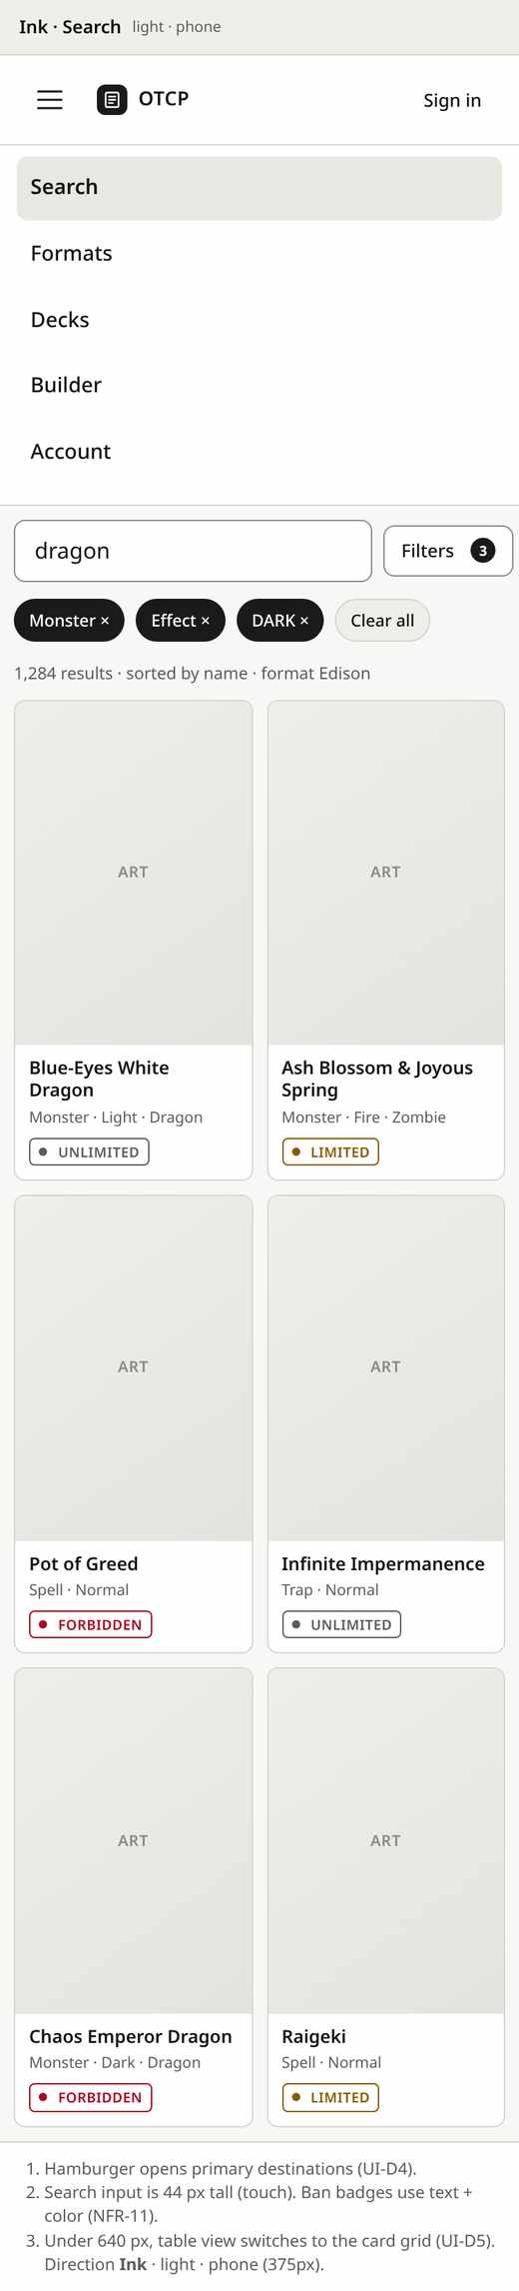
Figure 6. Search — phone with Filters badge and active chips.
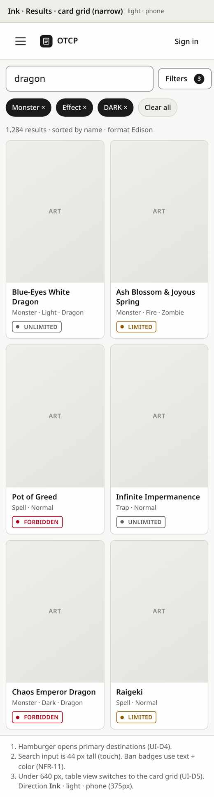
Figure 7. Results on phone — card grid under ~640 px (UI-D5).
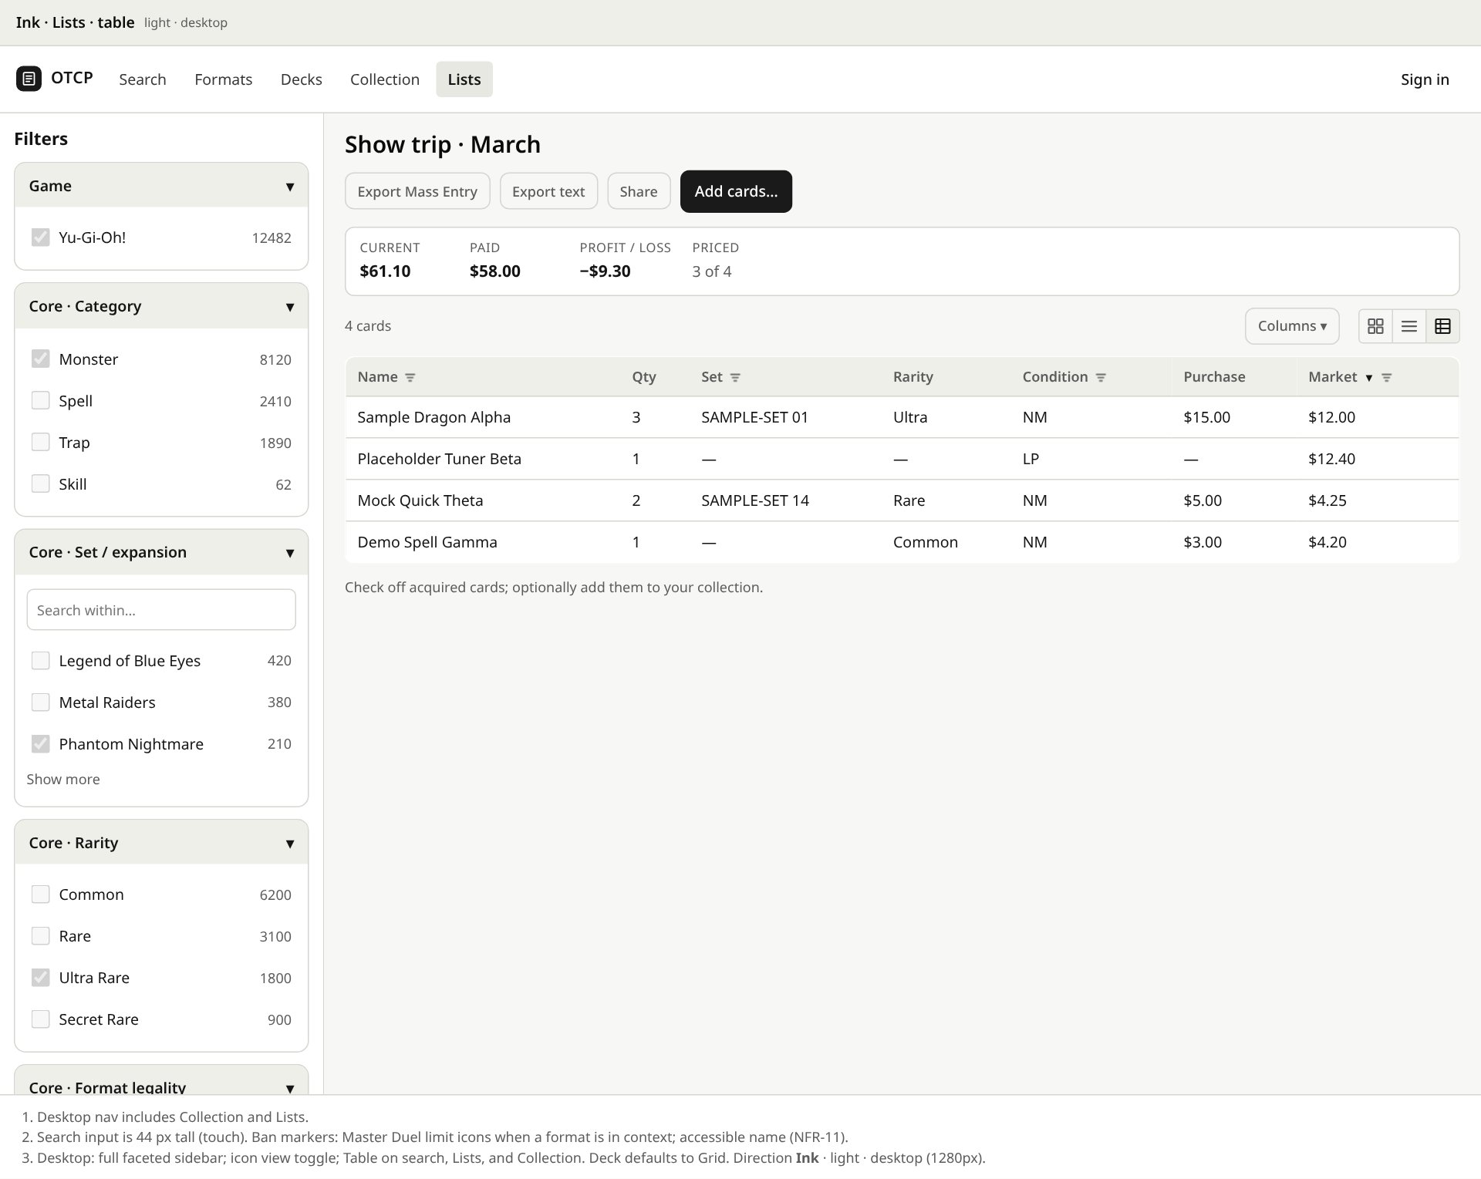
Figure 8. Lists — desktop Table default (incl. Condition); count line “N cards”; value summary (UI-D9, UI-D10, UI-D11).
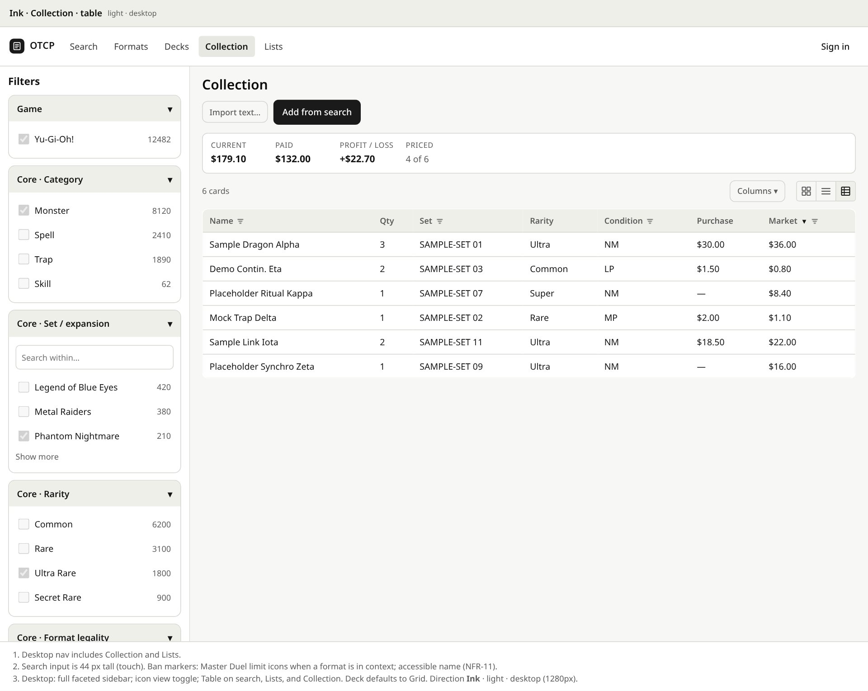
Figure 9. Collection — desktop Table default; count line “N cards”; value summary + Condition (UI-D9, UI-D10, UI-D11).
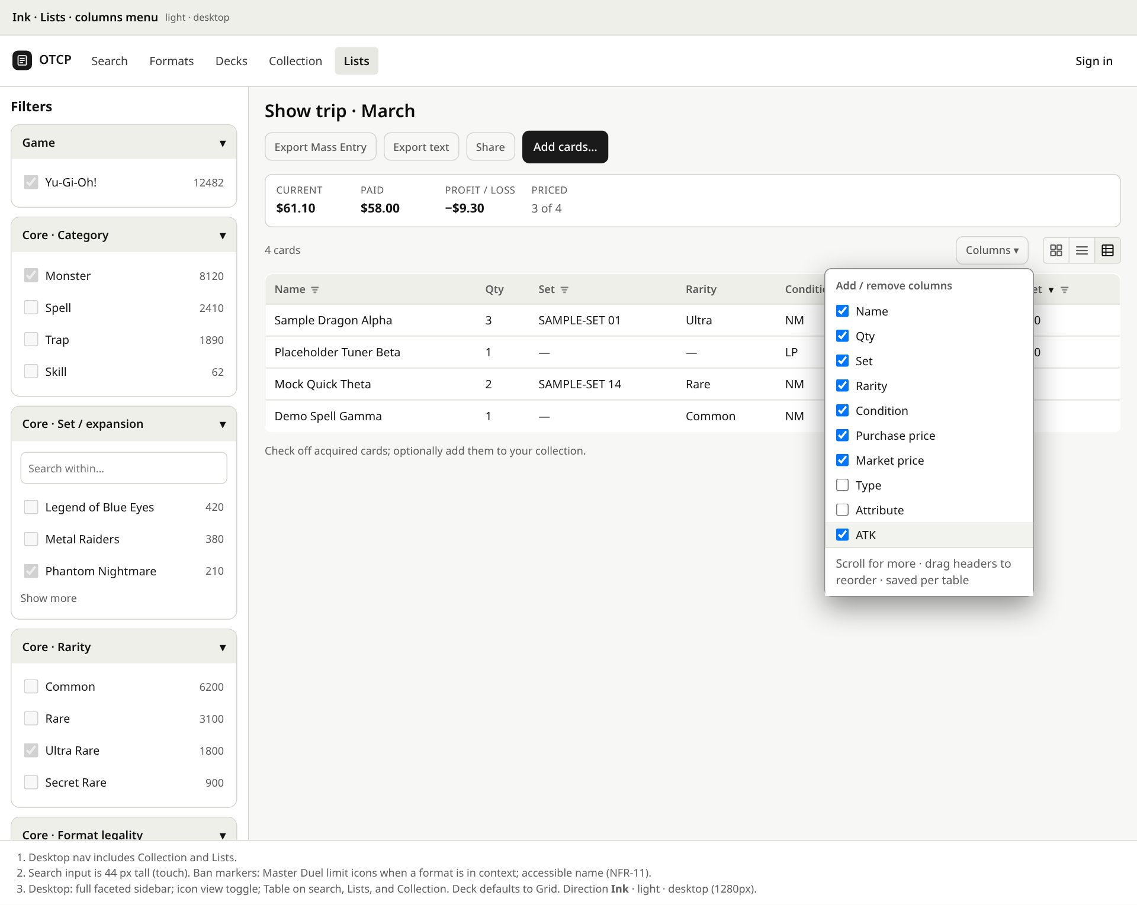
Figure 10. Lists — header Columns / right-click menu adding ATK (UI-D10).
Additional phone frames (detail, Genesys, Speed, account) live in docs/images/ui/ and the phone contact sheet above.

7. App icon
Shape APPROVED: A · Stack. Colour round:
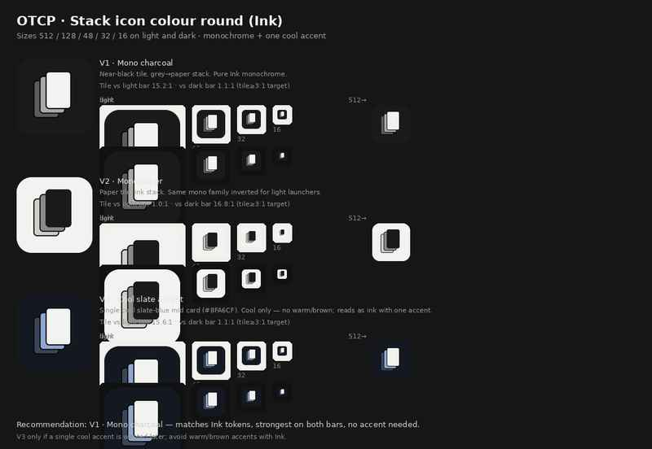
Figure 11. Stack colour variants V1–V3 at 512/128/48/32/16 on light and dark.
Purpose: Approved colour V1 Mono charcoal (UI-D6).
Assumption: No trademarks / card art.
Limitation: V2/V3 rejected for this release.
Variant | Status
V1 · Mono charcoal (#1A1A1A) | APPROVED — ship favicon / PWA assets
V2 · Mono paper | Rejected for this release
V3 · Cool slate accent | Rejected for this release

8. Accessibility
Rule | How
WCAG 2.2 AA | contrast.txt
Keyboard | Tab order; sheets trap focus; Escape
Not by color alone | Ban text; numeric facet counts
Touch | ≥44 px; Filters control
Reduced motion | Motion tokens → 0

9. Decisions
ID | Decision | Status
UI-D1 | Ink | APPROVED
UI-D2 | Stack shape | APPROVED
UI-D3 | Match system | APPROVED
UI-D4 | Hamburger | APPROVED
UI-D5 | Under ~640 px: compact icon rows on Search/Lists/Collection (no Table); Grid optional | APPROVED
UI-D6 | Stack colour V1 Mono charcoal | APPROVED 2026-10-28
UI-D7 | Approve UI 1.0 | APPROVED 2026-10-28
UI-D9 | Table default on desktop Search/Lists/Collection; compact icon rows on phone (no Table) | APPROVED 2026-10-28
UI-D10 | Customizable Search/Lists/Collection tables; Lists&Collection defaults include Condition; full setup restored on reopen | APPROVED 2026-10-28
UI-D11 | Value summary: per-unit prices; Current/Paid/P/L formulas; condition/variants | APPROVED 2026-10-28
UI-P1 | Link marker row size (16 CSS px) | Deferred polish

SRS/Architecture folds are FOLDED in pending_edits.md (no version bump).

10. Files
Path | What
docs/UI.md | This specification (1.0 Approved)
docs/Plong_OTCP_UI.docx / .pdf | House-style copies
docs/ui/tokens.css | Ink light/dark tokens
docs/images/ui/ | Screen sheets, filters, icon colour sheet

