Fixly v2
Hardware inventory, lifecycle and maintenance
and its integration with FBOS
Complete documentation
Version 1.0 · 14 October 2026 · Status: design complete, implementation not started

Contents
Right-click the field below and choose "Update field" to build the table of contents.

Fixly v2 — Documentation
Fixly v2 turns Fixly from a "list of installed cameras" into a full hardware inventory, lifecycle and maintenance system, and plugs it into FBOS so both products share people, customers, documents and notifications.
Status: design complete, implementation not started. Written 2026-10-14. Source of truth for the table design: ../fixly-v2-design.md and ../diagrams/. Source of truth for the integration decisions: ../FIXLY_V2_INTEGRATION_PLAN.md.

How to read these docs
Diagrams are written in Mermaid. They render automatically on GitHub, in VS Code (Markdown preview, with the Mermaid extension on older versions), Obsidian and most Markdown viewers.
# | Document | Read it if you want to know… | Audience
01 | Overview | What Fixly v2 is, why it exists, what changes, the vocabulary | Everyone
02 | Architecture & FBOS integration | How Fixly and FBOS connect, who owns what, how a request travels | Everyone, then engineers
03 | Device lifecycle | Every state a device can be in and how it moves between them | Everyone
04 | Process flows | Step-by-step flows: order → install, fault → repair/replace, disposal, maintenance | Everyone
05 | Data model | Tables, relations, rules that keep data correct | Engineers, analysts
06 | Access & permissions | Who can see and do what, how customers are kept apart | Engineers, product, admins
07 | API & events | Proposed endpoints, error shapes, notifications, documents | Engineers
08 | FBOS UI | Screens that live in the FBOS admin app and how users move between them | Product, designers, frontend
09 | Rollout & migration | Phases, how live data is migrated safely, risks | Everyone
10 | Decisions & open questions | What has been decided and what still needs an answer | Product owner

The whole system in one picture
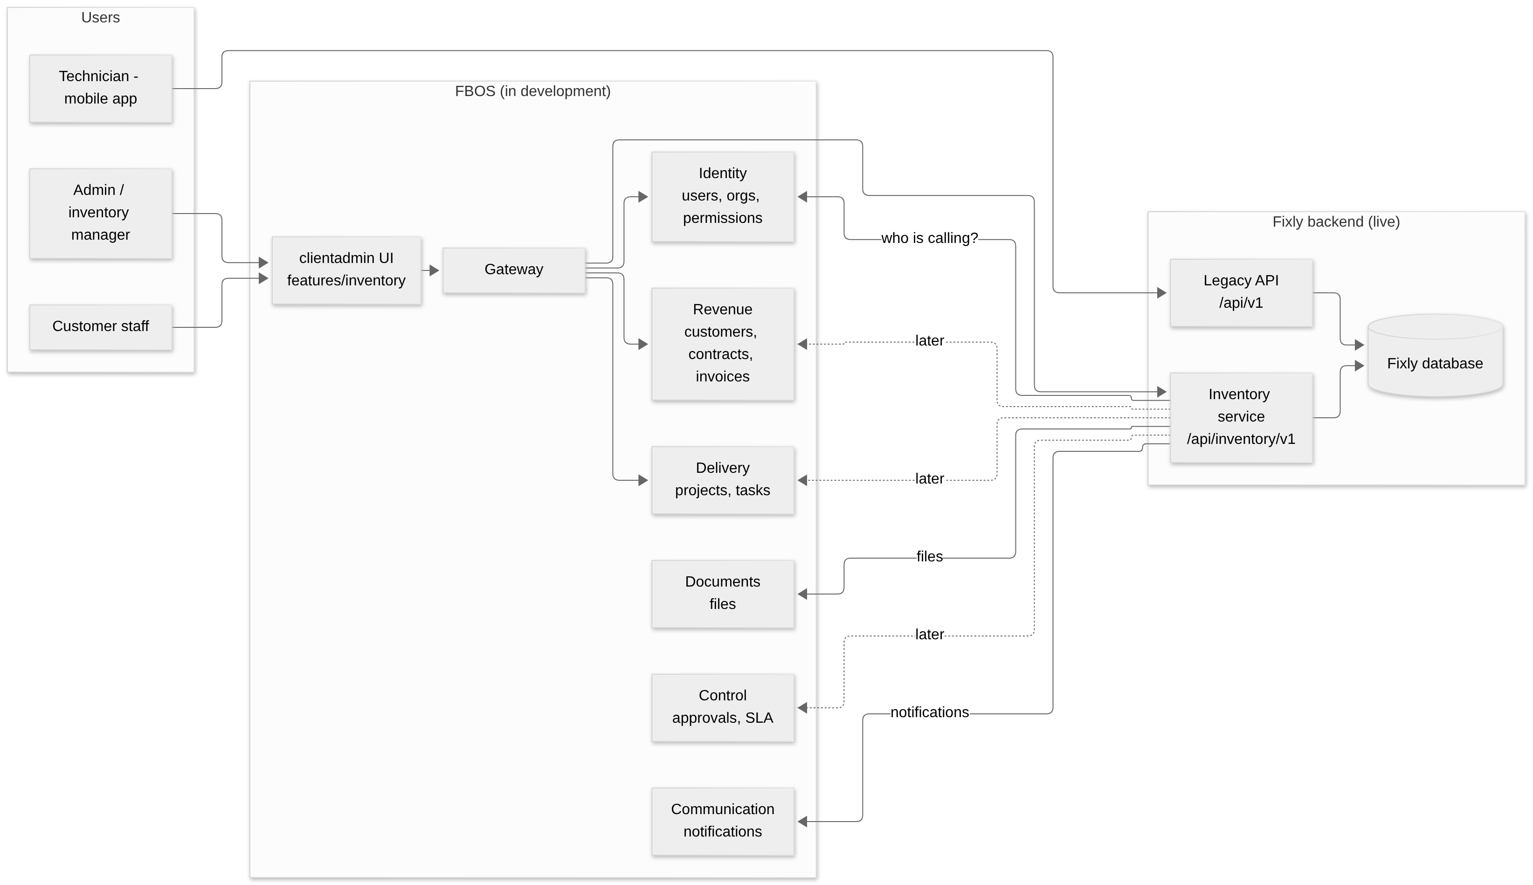
The three ideas to remember
- One brain per topic. Identity owns people. Revenue owns customers. Fixly's inventory service owns devices. Nobody copies another's data; they keep an ID and ask.
- UI in FBOS, data in Fixly. Users work in the FBOS admin app; it talks to the Fixly backend through the FBOS gateway.
- Nothing breaks while we build. Fixly is live. Every change is added next to the old one, then the old one is removed last.

01 · Overview

1. What problem are we solving?
Today Fixly knows that "camera CAM-000136 is in Zone 12 of Rajgir Zoo Safari and is active". It cannot answer:
- Where did this camera come from, who sold it, what did it cost?
- Is it still under warranty?
- Which spare cameras do we hold, and in whose store?
- Who carried it to the site, who installed it, and when?
- It broke: was it repaired, replaced, sent to the vendor, scrapped? Where is it now?
Fixly v2 answers all of these by tracking every physical device from purchase to disposal.
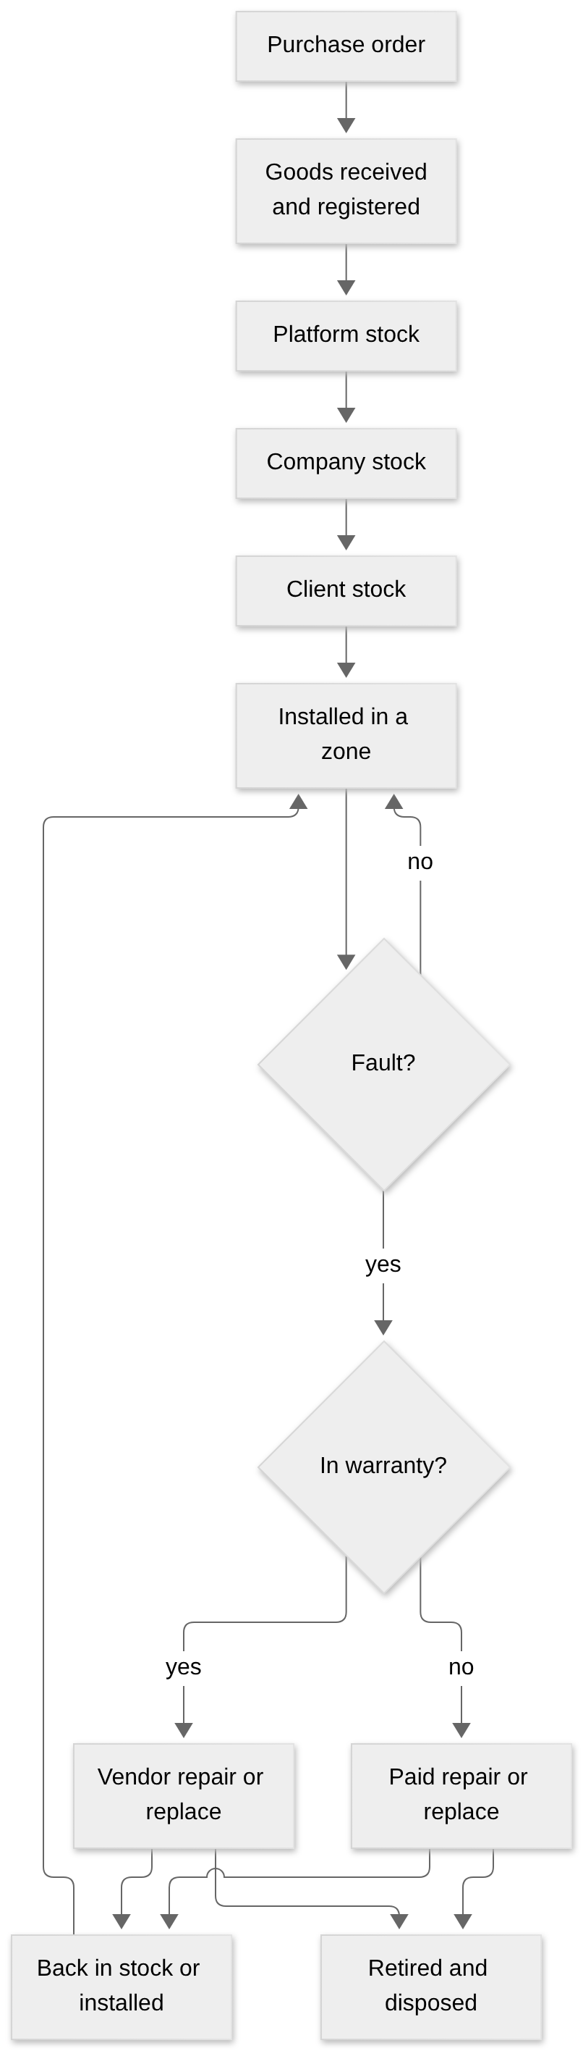

2. Before and after
Question | Fixly v1 (today) | Fixly v2
What is a device? | One row mixing "model" and "physical unit" | A model (what you order) plus one device row per serial number
Where is a spare? | Cannot be represented (no stock concept) | Stock locations at three levels: platform, company, client
Who moved it? | Not recorded | Stock transfers with dispatcher, receiver, condition, tracking
Where was it installed? | Overwritten on every move | Installations history: zone, position, GPS, installer
Warranty? | Not tracked | Warranties per device, looked up automatically when an issue is raised
Repair? | Not tracked | Repair orders with RMA number, cost, parts, round trip
Replacement spare? | Free text, no link | Real link to the replacement device and the transfer that moved it
Status? | 5 values mixing health and place | Lifecycle (14 values) and health kept separate
History? | None | Append-only lifecycle event log
End of life? | None | Disposal record with approver and data-wipe certificate
Login? | Own user table, 5 fixed roles | FBOS Identity, per-user permissions
UI? | Fixly web app | FBOS admin app (Fixly web kept until parity)

3. The six capabilities
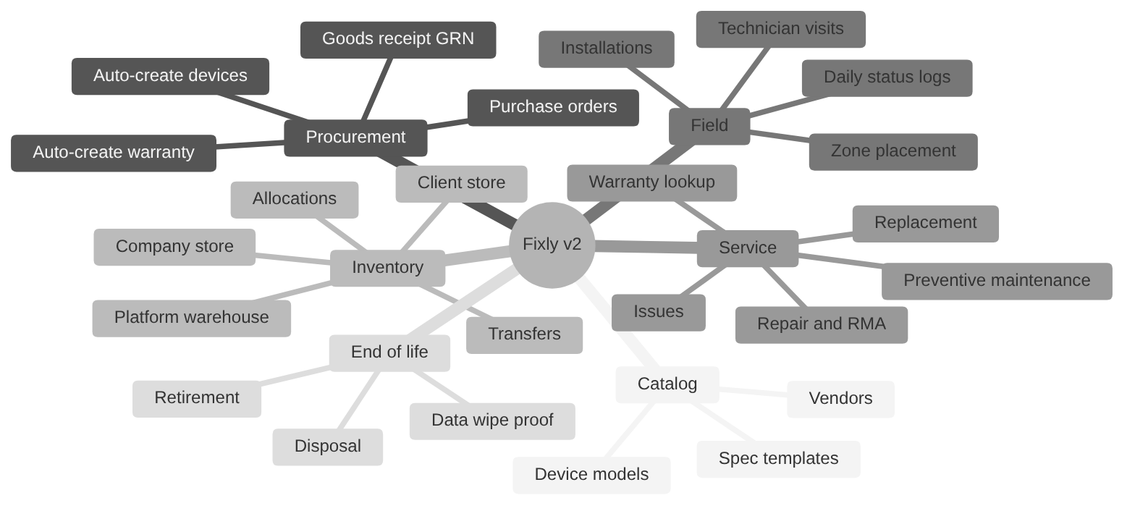

4. Vocabulary (one glossary for both products)
Fixly and FBOS use some of the same words for different things. In v2 we fix the words once.
Say this | It means | Fixly v1 called it | FBOS calls it | Note
Operator (vendor org) | The hardware business running the system | Platform / super admin | Identity Organization | Every inventory row carries organization_id
Customer | A business that buys or uses devices, e.g. Rajgir Zoo Safari | Company | Revenue client | Linked by fbos_customer_id
Site | A facility of a customer | Client | Org unit (recommended) | The API never calls a site "client"
Zone | A nested area inside a site | Zone | — | Stays in inventory
Device model | A product you can order (SKU) | Product type | — | New
Device | One physical unit with a serial number | Device | — | One row per serial
Stock location | Any place a device can sit when not installed | — | — | New
GRN | Goods Receipt Note: proof goods arrived | — | — | New
RMA | Return Merchandise Authorization: vendor repair ticket | — | — | New
Lifecycle status | Where the device is in its life | status | — | New, 14 values
Health status | Is it working today | — | — | New, independent

5. Three levels of stock
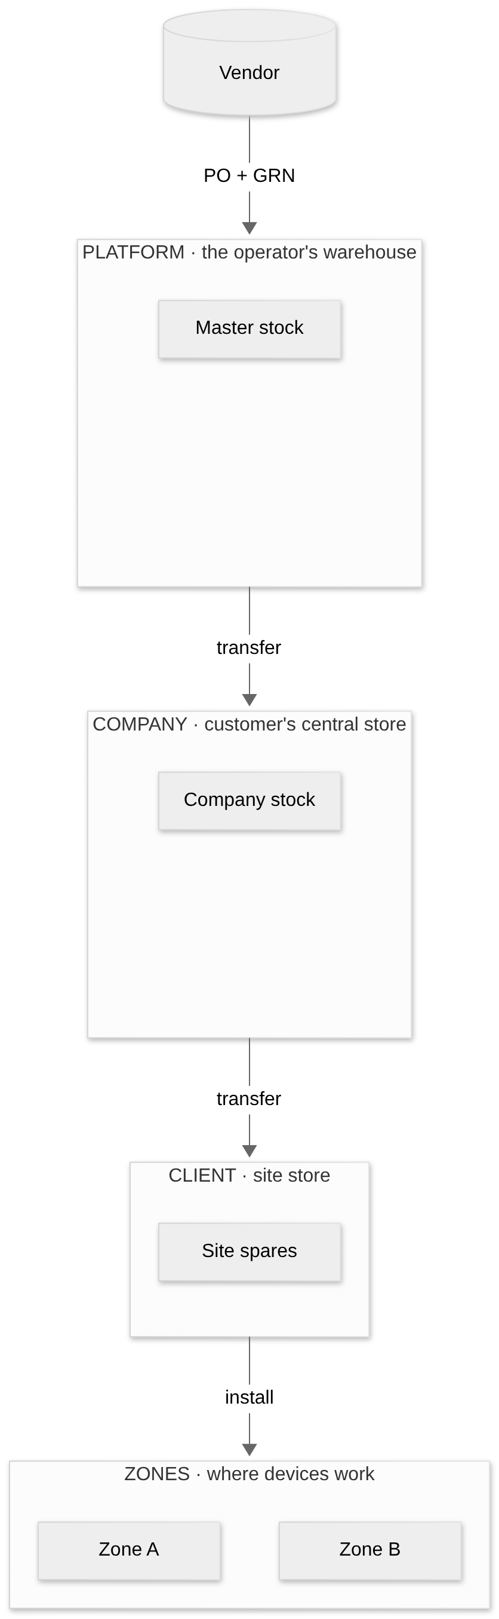
Two ideas keep this clean:
- Custody is not ownership. A device is held by one company and one site at a time (custody), but may be owned by someone else (a lent device). Both fields exist.
- A device is in exactly one place. Either in a stock location or installed in a zone. Never both, never neither (except in transit, lost or disposed).

6. A worked example: CAM-000136
A Dome Camera is ordered, delivered, installed, fails, gets repaired under warranty and returns to service.
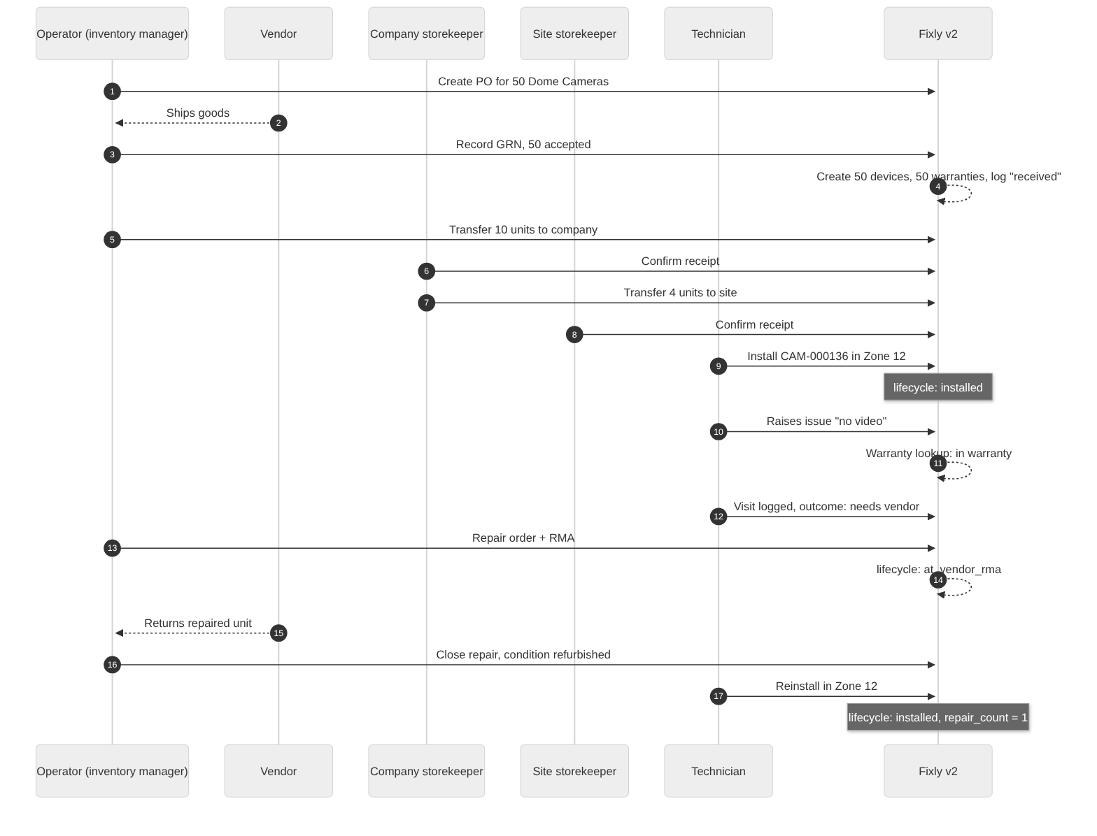
Every arrow that changes the device also writes one row to the lifecycle log, so the whole story can be replayed in order.

7. What changes for each kind of person
Person | Before | After
Inventory manager | Not possible in Fixly | Orders, receives, allocates, tracks warranties and repairs in FBOS
Company storekeeper | Not possible | Receives and forwards stock for their company
Site admin / zone in-charge | Raises issues, sees devices | Same, plus sees stock at their site and the full history of each device
Technician | Mobile app, issues and visits | Same app at first; later signs in via FBOS Identity and sees warranty status before visiting
Finance | Nothing | Warranty and repair costs, billable repairs linked to invoices (later phase)
Developers | Role checks in code | Permission codes; one identity system

8. Scope boundaries
In scope: serial-tracked hardware (cameras, displays, networking), its purchase, stock, custody, installation, faults, repair, replacement, disposal, warranty and preventive maintenance plans.
Out of scope for v2:
- Bulk, non-serial items such as cables and power supplies (design doc §12, question 3).
- Corporate IT assets, software, subscriptions, credentials and vehicles: these stay in FBOS 09_assets.
- Rewriting the Fixly backend in Python.
- A general event bus.

02 · Architecture and FBOS integration

1. Where each side is today
 | Fixly (live) | FBOS (in development)
Stack | Node 20, Express, Prisma, MariaDB, Socket.IO, FCM; React web + Flutter mobile | Python FastAPI, 10 services, Alembic, React clientadmin / superadmin
Sign-in | Own users table, 5 fixed roles, 7-day JWT | Identity service; per-user permission codes; roles are only presets
Tenancy | Company → Client (site) → Zone | Identity Client (tenant) → Organization → Org units; Revenue "client" = customer
Inventory | devices mixes model and unit; no stock, vendor, PO, warranty or repair | 09_assets: IT-asset register (tags, custodian, credentials). Thin, no lifecycle
Data | 445 devices, 5 companies, 4 sites, 227 zones, 9 users, 8 issues | Shared remote MySQL for identity and revenue

2. The decision: three options
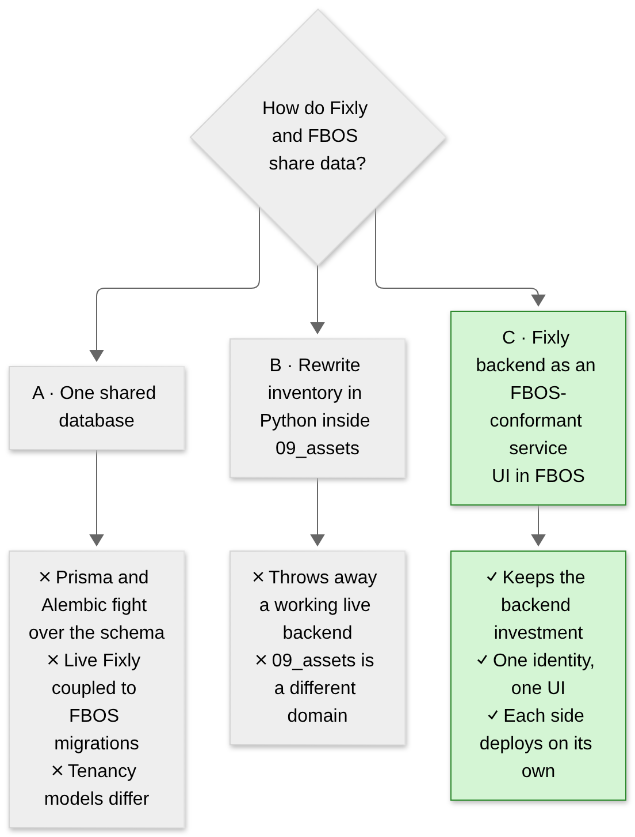
Chosen: Option C. The Fixly Node backend stays the system of record for inventory and is exposed as a service named inventory at /api/inventory/v1.

3. Target architecture
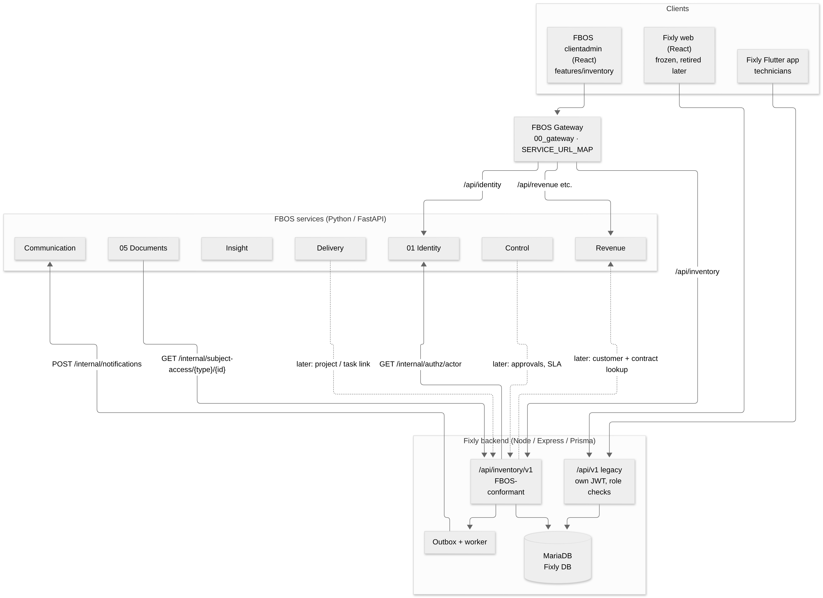
Solid lines exist or are in Phases 1–4. Dotted lines are Phase 5.

Boundary with 09_assets
09_assets (FBOS) | inventory (Fixly backend)
Software, subscriptions, credentials, vehicles, office IT | Field hardware with a lifecycle: cameras, displays, networking
Tag, custodian, vendor accounts | Serial, warranty, stock tier, installation, repair

Do not build a second hardware lifecycle in 09_assets. If one combined register view is wanted later, publish read-only events from inventory.

4. Who owns what (system of record)
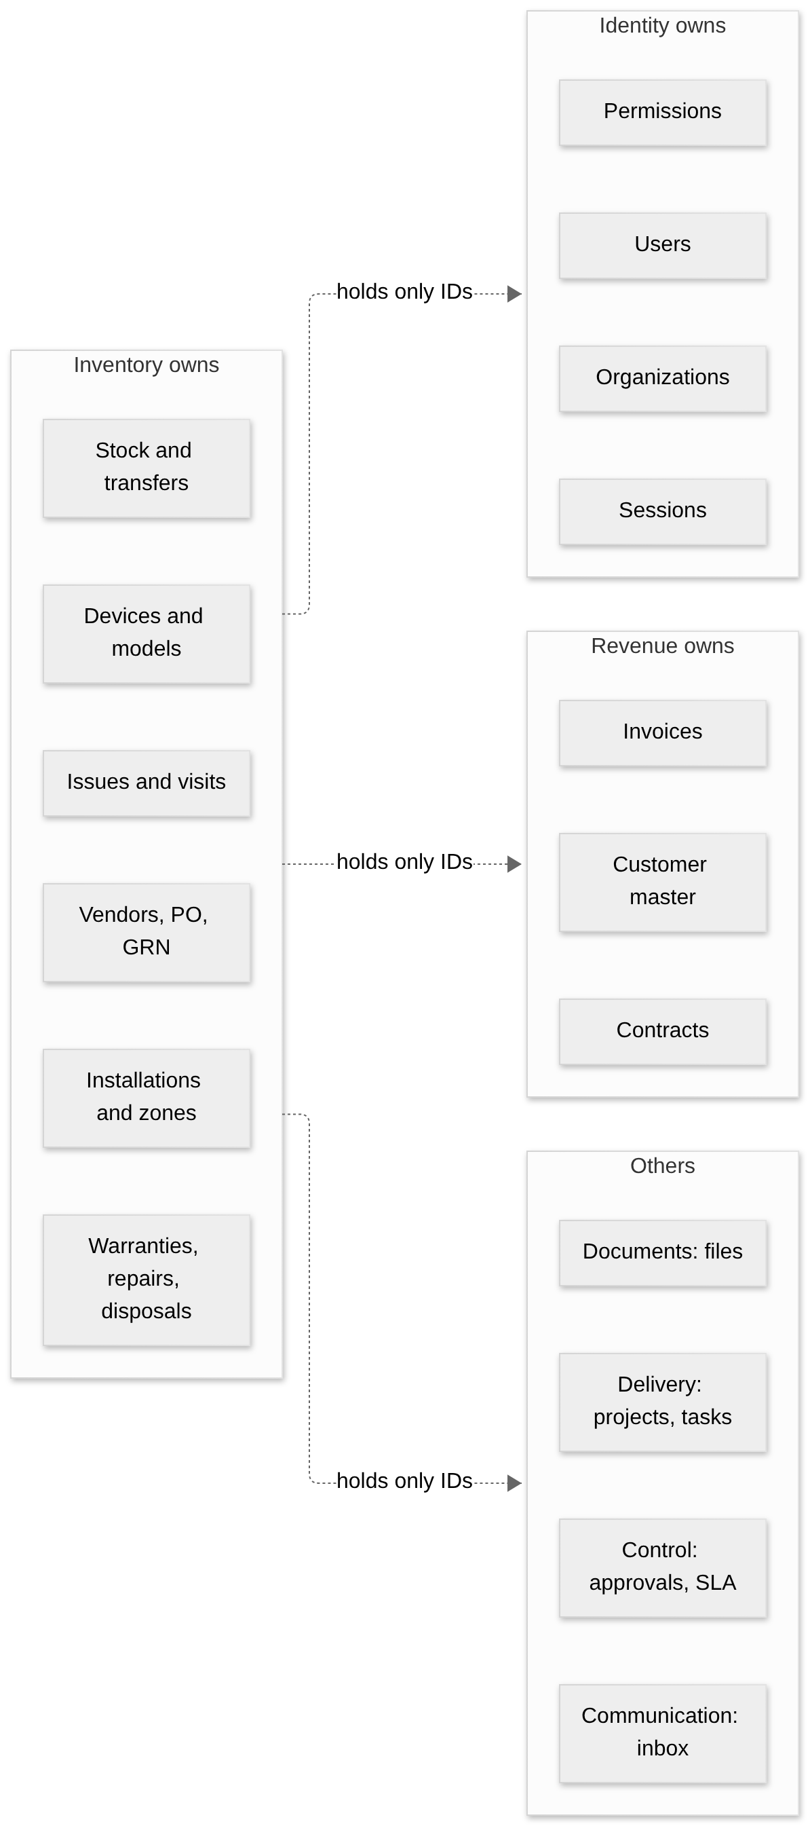
Concept | Owner | What others store
Users, orgs, permissions, sessions | Identity | the user's UUID
Customer master, contacts, tax, contracts, invoices | Revenue | fbos_customer_id on the inventory customer row
Devices, models, vendors, POs, GRNs, stock, transfers, installs, warranties, repairs, disposals, issues, visits, daily logs | Inventory | read via API; events out
Projects, work orders, tasks | Delivery | work_unit_id, task_id on installation / repair
SLA clocks, approvals | Control | approval_request_id, sla_policy_id
Files | Documents | document_id + subject type / id
In-app notifications | Communication | —
Cross-service audit | Insight (fed by events) | — (device_lifecycle_events stays the device history)

Rules of the road
- No shared tables, no foreign keys across systems. Cross-references are plain UUID columns checked by an API call at write time.
- Each service migrates only its own database. Never run Alembic or Prisma migrate against a shared remote DB from a developer machine.

5. How a request travels

5.1 Reading the device list in FBOS
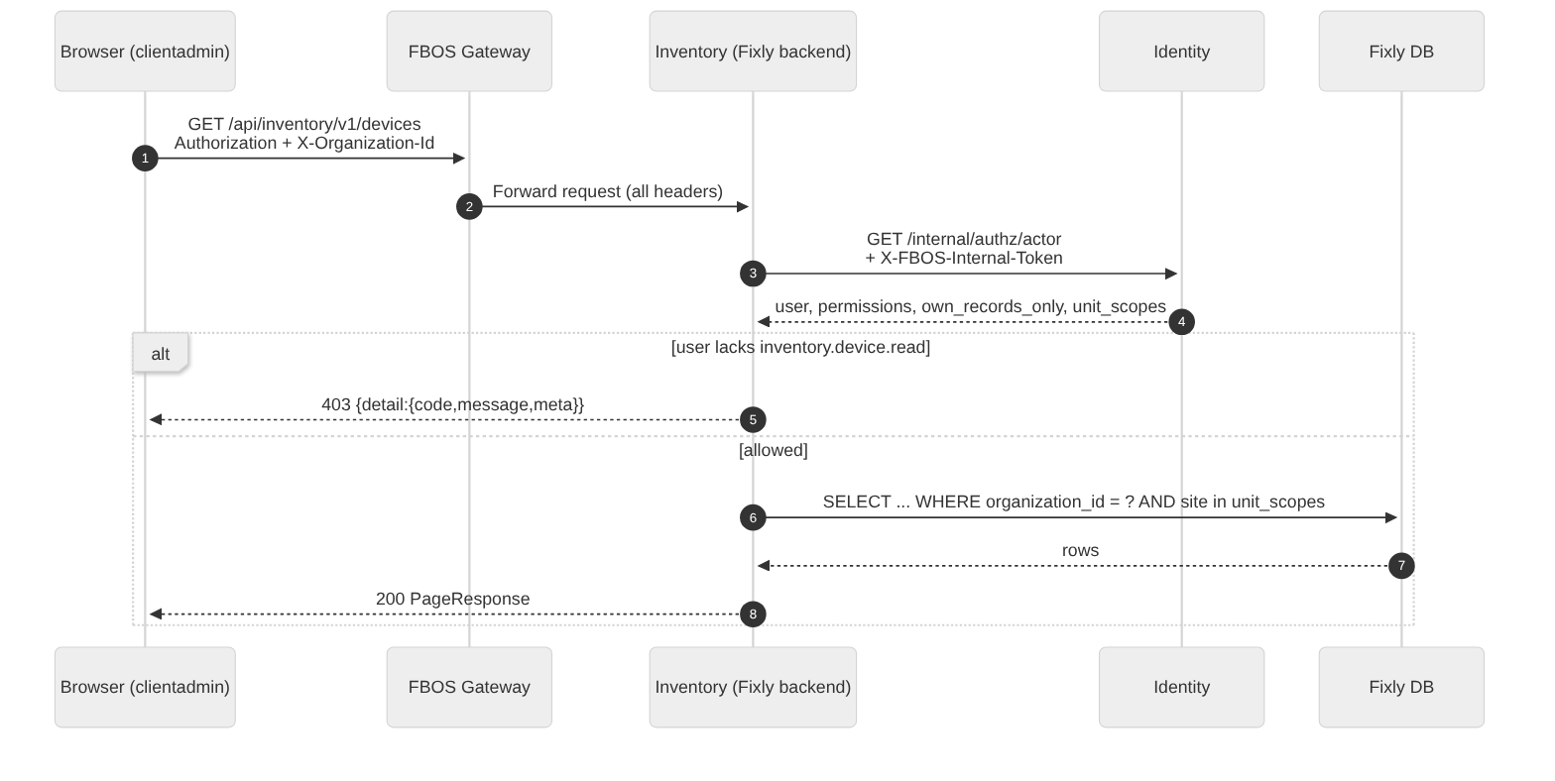
Key points:
- The inventory service never trusts a forwarded identity header. It asks Identity every time (with a short cache, 30 s like the legacy authenticate middleware).
- If Identity is down the service answers 503, never "allow".
- Identity 401/404 are relayed unchanged.

5.2 Attaching a file to a device (Documents ⇄ Inventory)
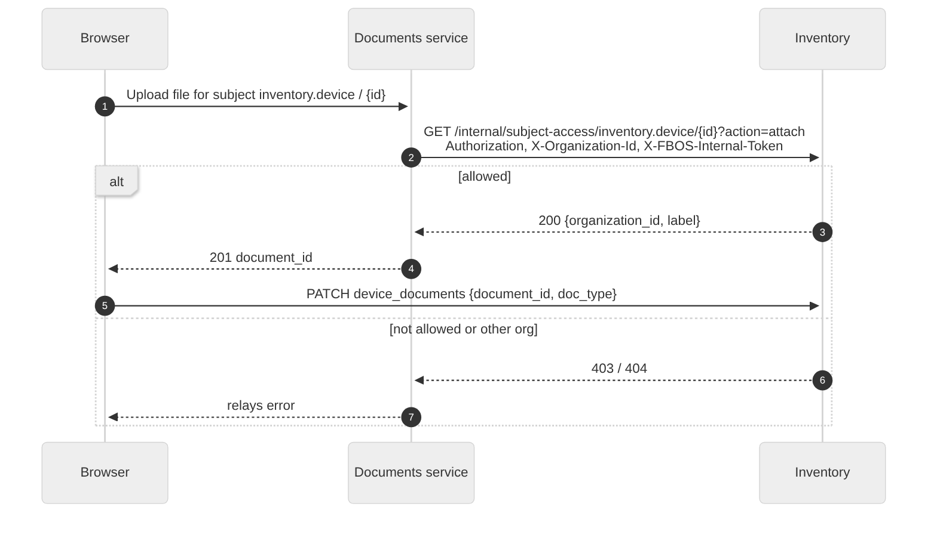
Documents holds no access rules of its own. It asks the owning service. Subject types: inventory.device, inventory.purchase_order, inventory.goods_receipt, inventory.repair_order, inventory.disposal, inventory.issue. An organization mismatch is returned as 404 so ids cannot be probed.

5.3 Telling people something happened (notifications)
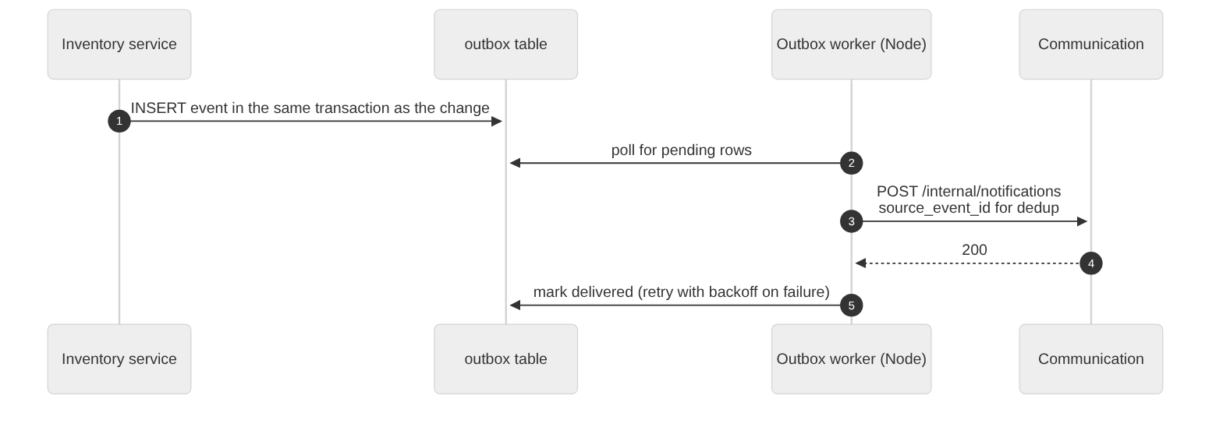
FBOS has no event bus. The pattern used elsewhere in FBOS (03_delivery outbox + worker) is reused. In v2 the only destination is Communication. Other services get explicit endpoints later.

6. Tenancy mapping (the hard part)
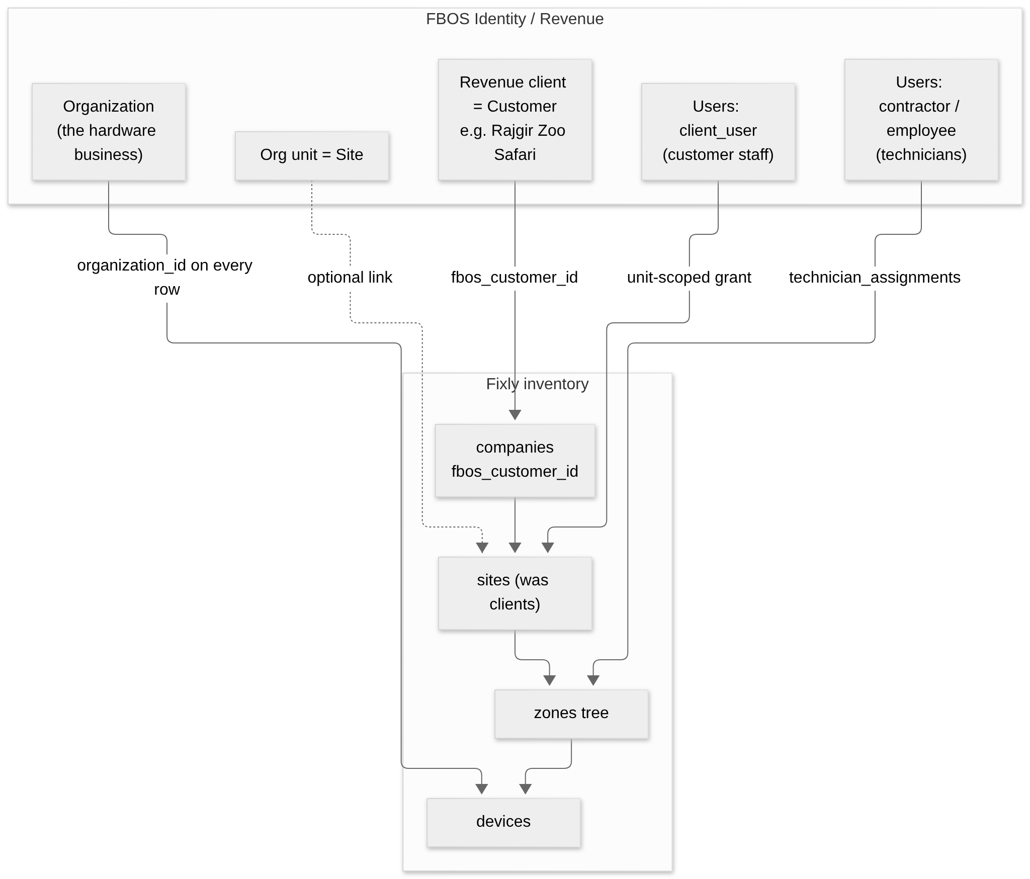
Fixly concept | FBOS concept | How
The hardware business | Identity Organization | organization_id on every inventory row
Company (customer) | Revenue client (customer) | companies.fbos_customer_id
Client (site) | Org unit (recommended) | Stays an inventory table, keyed by customer
Zone tree, installations | Inventory only | —
Fixly platform staff, technicians | Identity users (employee / contractor) | users.fbos_user_id; names resolved from Identity
Customer staff | Identity users client_user in the vendor org | Per-user grants with scope_unit_id or self_only

Why one organization with client_users and not one organization per customer: Identity limits organizations (default 2), and the vendor would lose a cross-customer view. Details in 06.

7. Integration points by FBOS service
FBOS service | Change required | Phase
Identity | Add inventory.* permission codes and matching SENSITIVE_READ_CODES in one change; deploy before inventory routes | 2
Gateway | Add inventory to SERVICE_URL_MAP and config.py | 2
Documents | Add inventory to subject_services | 2
Communication | Notification templates for transfers, issues, warranty expiry | 3–4
Revenue | Internal read of customer + site contacts; later contract warranty / AMC terms and billable repairs → invoices | 5
Delivery | Optional link from installation / replacement to a project or task | 5
Control | Approvals for PO, repair cost, disposal; SLA for issues | 5 (D5)
Insight | Consumers for audit and reports | 5
Frontend | features/inventory/ module, Vite proxy /api/inventory, access gating | 2 onward

8. Cross-cutting contracts
Topic | Rule
Auth | Forward Authorization + X-Organization-Id; Identity decides; never read org/user from other headers
Permissions | inventory.<entity>.<action>; checked on every route; a test fails the build if a route has none
Record-level rules | "Own site", "assigned technician", "own records only" enforced in the service layer using own_records_only and unit_scopes
Errors | { "detail": { "code", "message", "meta" } }
Lists | PageResponse (items, total, page, page size)
Concurrency | If-Match / version on mutable aggregates
Retries | Idempotency-Key on transfers, GRN registration, repair dispatch
Ids | UUIDs everywhere
Money | Currency + GST on PO lines and repair costs; base currency from the organization

03 · Device lifecycle
A device has two independent descriptions:
Field | Answers | Values
lifecycle_status | Where is it in its life? | 14 values (below)
health_status | Is it working today? | working, not_working, needs_attention (from daily status logs)

A device can be installed and not_working at the same moment. That mismatch is exactly what raises an issue.

1. State machine
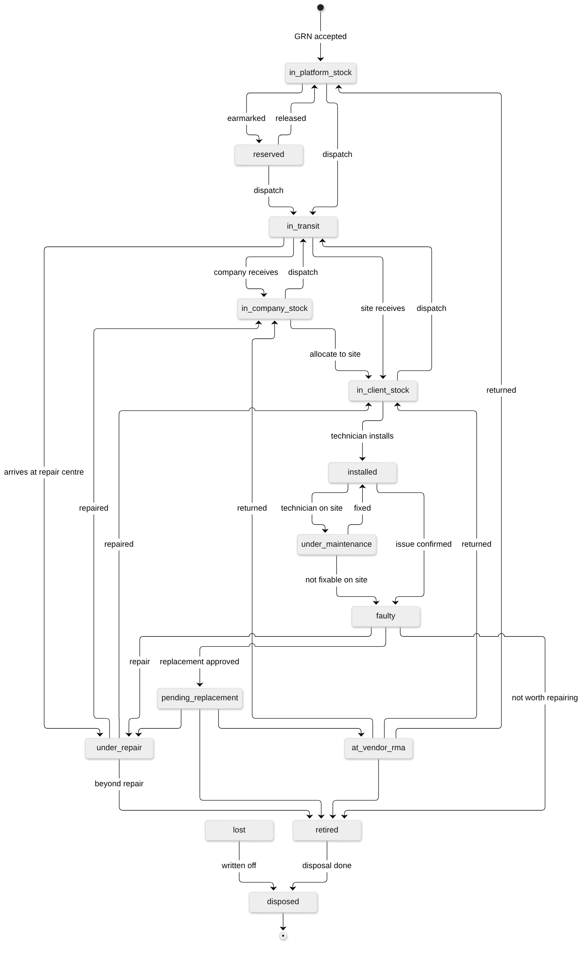
lost can be reached from any state when a device goes missing.

2. Each state in plain words
Status | Meaning | Where it physically is | Group
in_platform_stock | Received, passed QC, available | Operator's warehouse | Stock
reserved | Earmarked for a company, site or replacement | Same stock location | Stock
in_transit | Dispatched, not yet received | An open stock transfer | Moving
in_company_stock | In the customer company's store | Company store | Stock
in_client_stock | In a site's store, ready to install | Site store | Stock
installed | Placed and working in a zone | Zone (active installation) | In service
under_maintenance | Technician working on site | Zone | In service
faulty | Issue confirmed; device still there or just removed | Zone or site store | Problem
pending_replacement | Replacement approved, swap not done | Zone | Problem
under_repair | In-house or service-centre repair | Service-centre location | Problem
at_vendor_rma | Sent to vendor for warranty repair or exchange | Vendor location | Problem
retired | Out of service, waiting for disposal | Any store | End
disposed | Scrapped, sold, recycled or returned | Disposal | End (terminal)
lost | Missing or stolen | Unknown | End

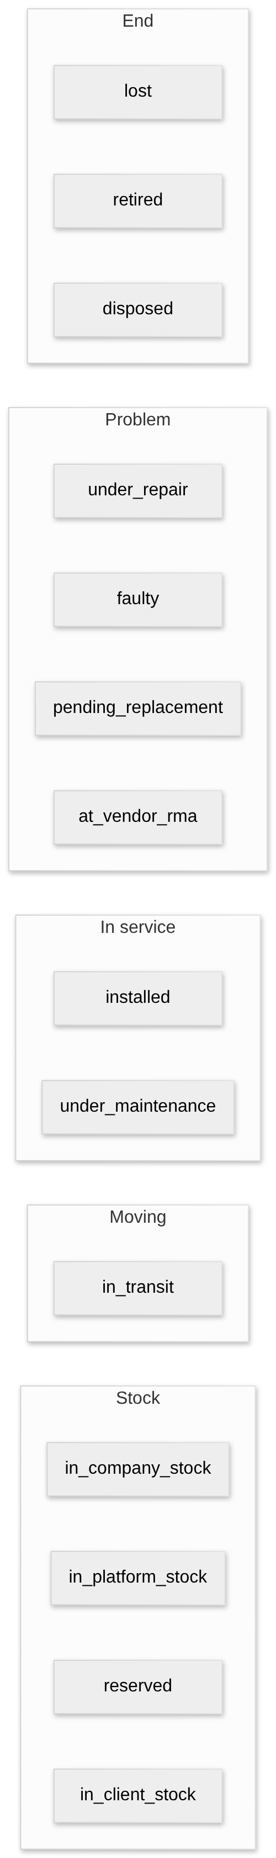

3. Where a device can be (the single-place rule)
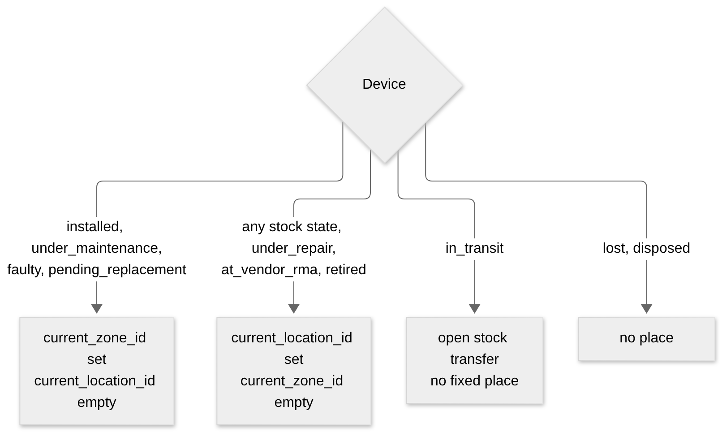
Special stock locations: in_transit, vendor, service_center, disposal.

4. Custody and ownership
Field | Meaning
owner_company_id, ownership_type | Who owns the device: platform_owned, company_owned, client_owned or leased
current_company_id, current_client_id | Who holds it right now (custody)
device_allocations | History of who it was given to, with allocated_at and released_at

Open decision D3: the default ownership_type for existing devices. The design doc assumes company_owned. Confirm before migration. See 10.

5. The audit trail
Every change to status, location, company, client or zone writes one row to device_lifecycle_events in the same transaction. Rows are never edited or deleted.
Column | Example
event_type | received, stocked, allocated, transferred, installed, relocated, status_changed, issue_raised, visit_done, warranty_claimed, repair_sent, repair_returned, replaced, retired, disposed (plus imported_from_v1 for the backfill)
from_status → to_status | installed → faulty
from_location → to_location | Zone 12 → Site store
reference_type / reference_id | purchase_order, transfer, installation, issue, repair_order, replacement_request or disposal
occurred_at, actor | when and who

The "Full life of one device" query in 05 reads this table.

6. Mapping existing data
v1 devices.status | v2 lifecycle_status
active | installed
under_maintenance | under_maintenance
faulty | faulty
retired | retired
provisioned with a zone | installed
provisioned without a zone | in_client_stock

Integration note (change 12): in the live database the old status column is kept and a new lifecycle_state column is added beside it. Altering a MariaDB enum is not additive and would lock and rewrite the table. The old column is retired in Phase 6.

04 · Process flows
Each flow shows who does what, which screen or API is involved, and what is written. The Eraser flowcharts these are based on are 08 and 09.
Index: A Procurement · B Stock movement · C Installation · D Daily operations · E Fault handling · F Warranty claim · G Replacement · H Repair · I Disposal · J Preventive maintenance · K Customer onboarding

0. The master flow
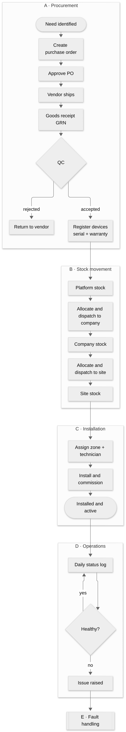

A. Procurement and receiving
Who: inventory manager (operator). Where: FBOS → Inventory → Purchasing.
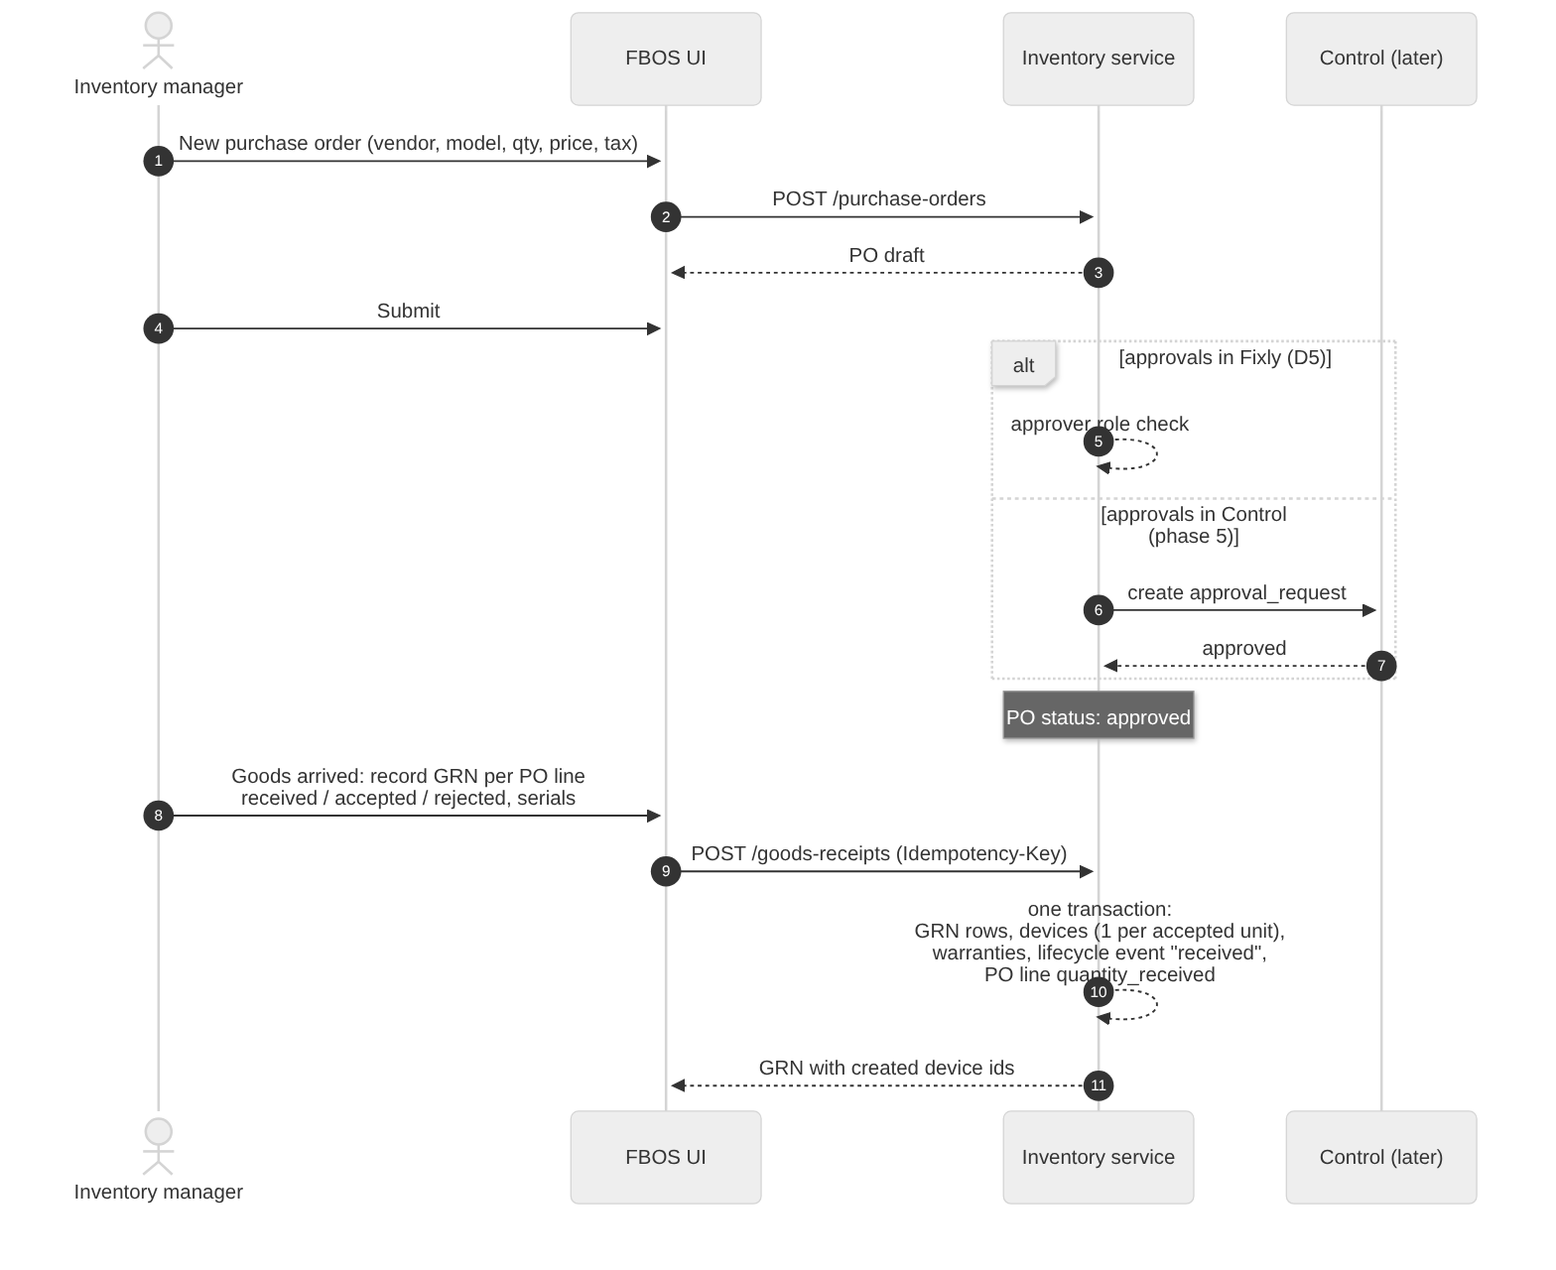
Rules that apply
Rule | Effect
Receiving gate (§8 rule 11) | Accepted quantity on a GRN line = number of device rows created
Warranty at registration (rule 6) | end_date = start_date + default_warranty_months; start is GRN date or install date per vendor terms
Asset tag (rule 13) | Device code from the existing category sequence (e.g. CAM-000136)
Required at receiving | Serial, model, price, receiving location (fixes the empty-data problem in v1)

PO status (purchase_orders.status): draft → submitted → approved → partially_received → received, or cancelled. GRN status: pending_qc → accepted | partially_accepted | rejected.

B. Stock movement (transfers)
The same flow is used at every tier. Only the actors and the transfer_type change.
transfer_type | From → To | Dispatcher | Receiver
platform_to_company | Platform warehouse → company store | Inventory manager | Company storekeeper
company_to_client | Company store → site store | Company storekeeper | Site storekeeper
client_to_client | Site store → another site store | Site storekeeper | Site storekeeper
return_to_company / return_to_platform | Back up one tier | Lower tier | Upper tier
replacement_dispatch | Any store → site | Whoever holds the spare | Technician / site
to_repair / from_repair | Site ⇄ in-house repair centre | Sender | Repair centre / store
to_vendor_rma / from_vendor_rma | Store ⇄ vendor | Operator | Vendor / store

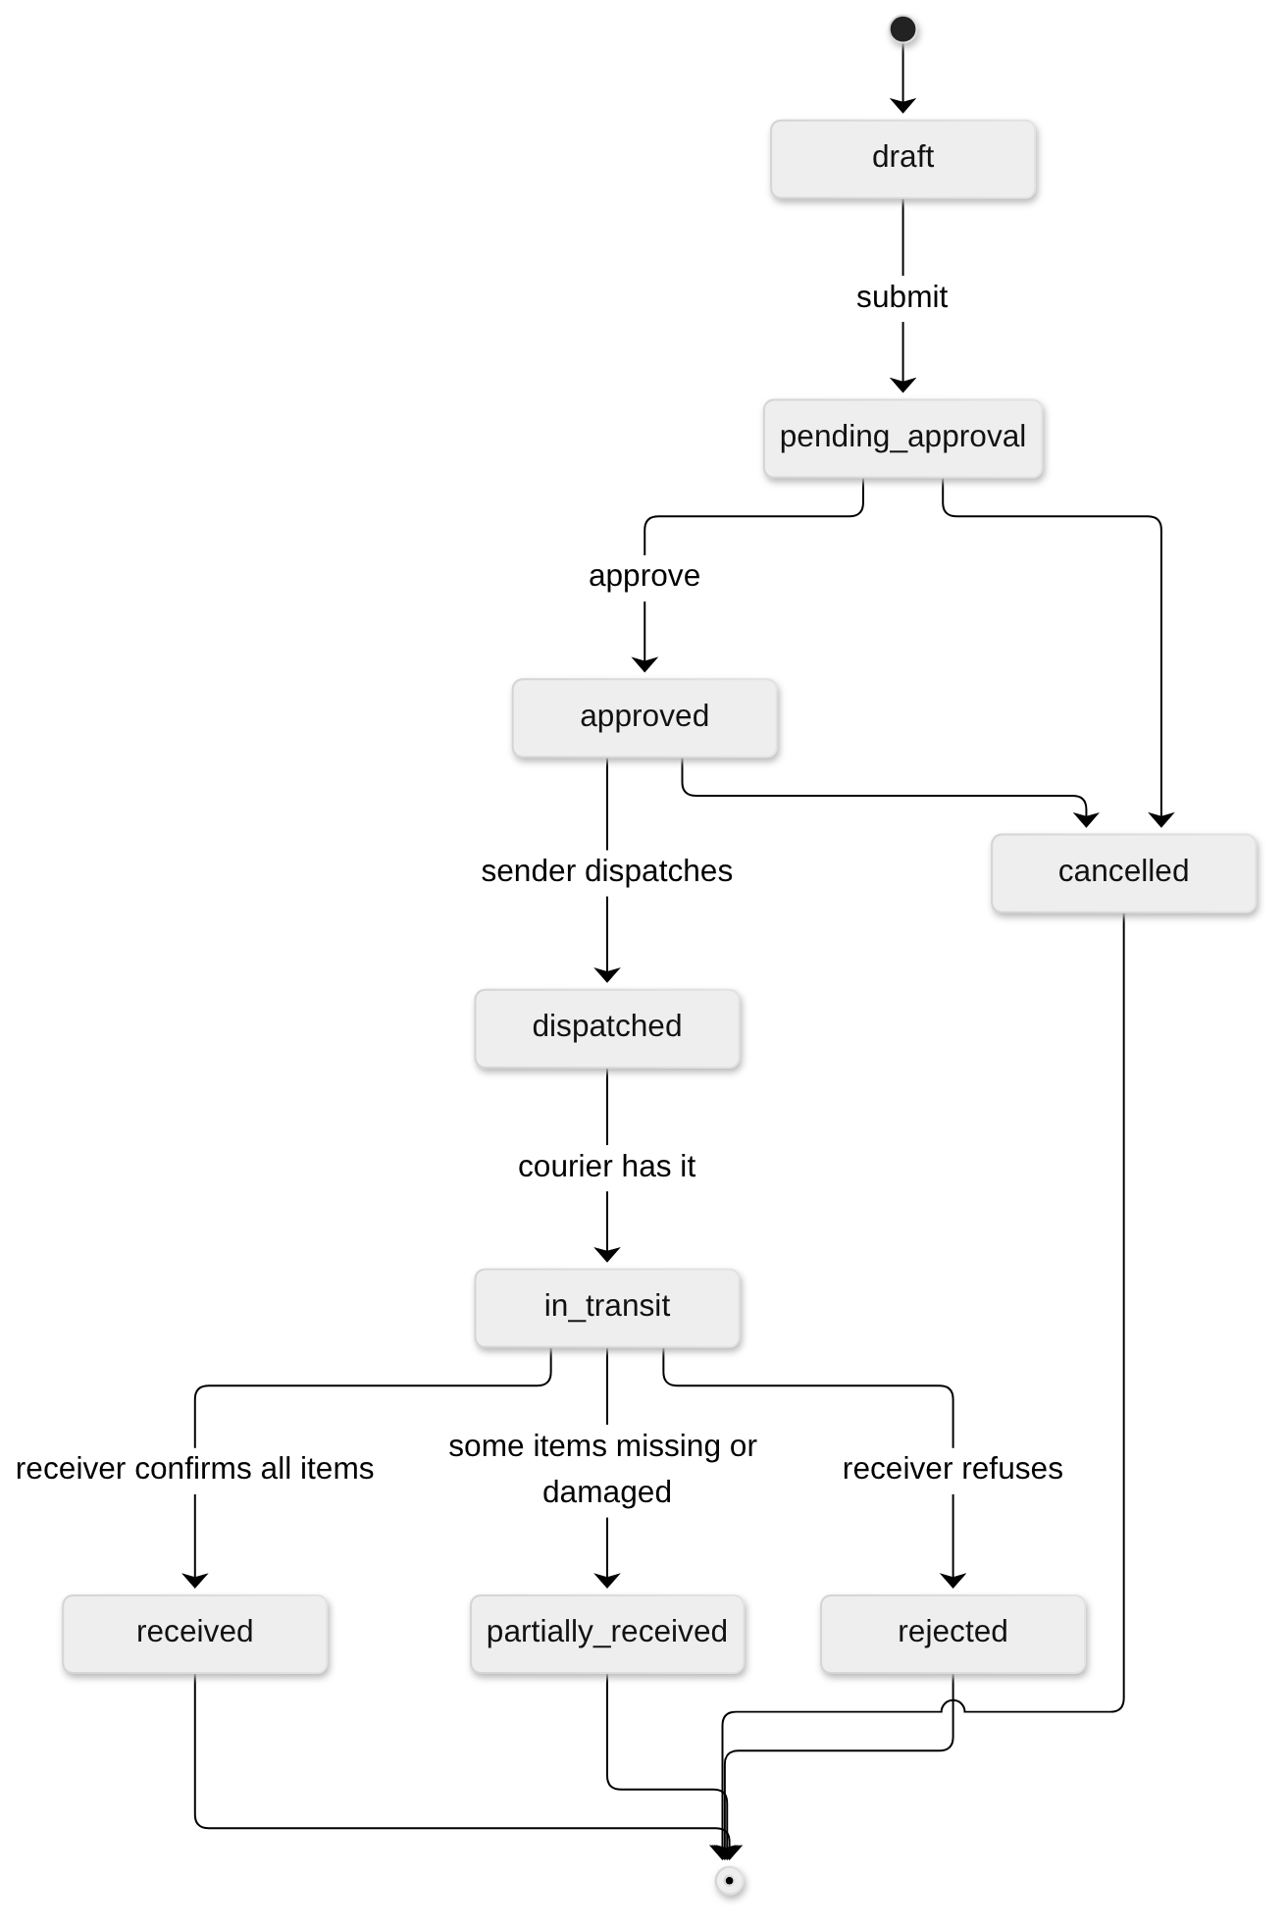
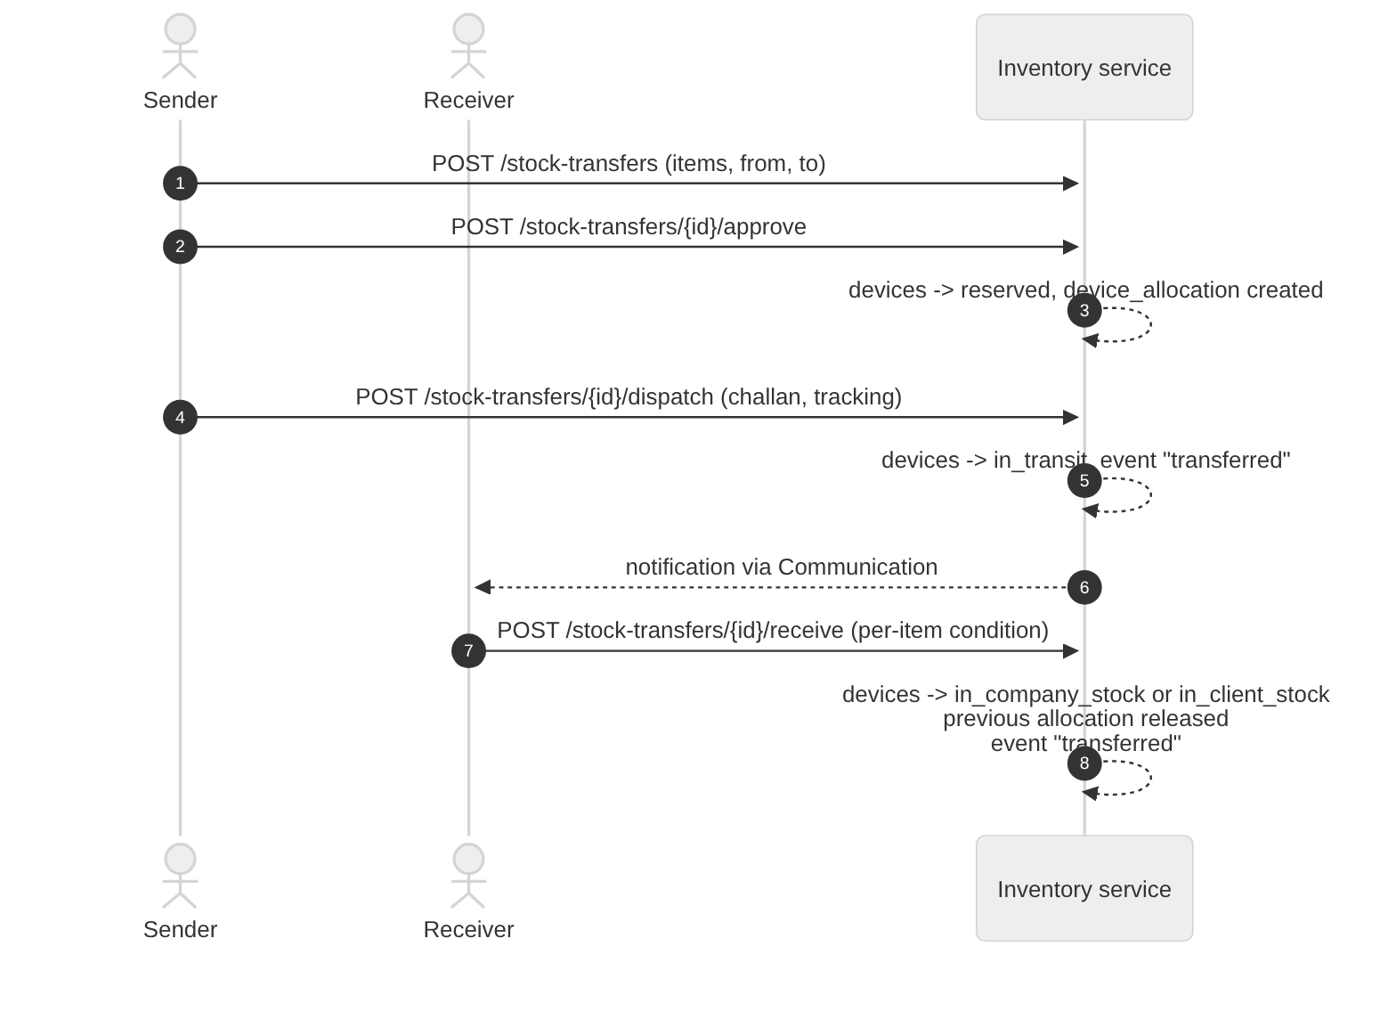
Rules: one open transfer per device (rule 4); each item gets condition_in and an item_status of pending, received, missing or damaged, so a partial receive shows exactly which units need follow-up.

C. Installation
Who: technician (mobile app now; FBOS later).
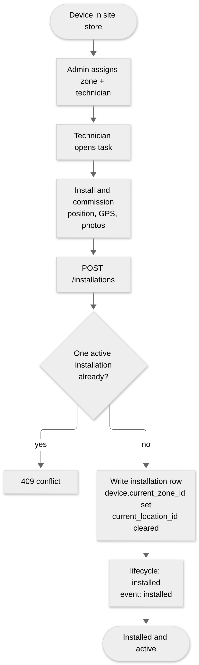
Installation types (installation_type): new, replacement, relocation, reinstall_after_repair. Removal reasons: faulty, replaced, relocated, upgraded, retired.

D. Daily operations
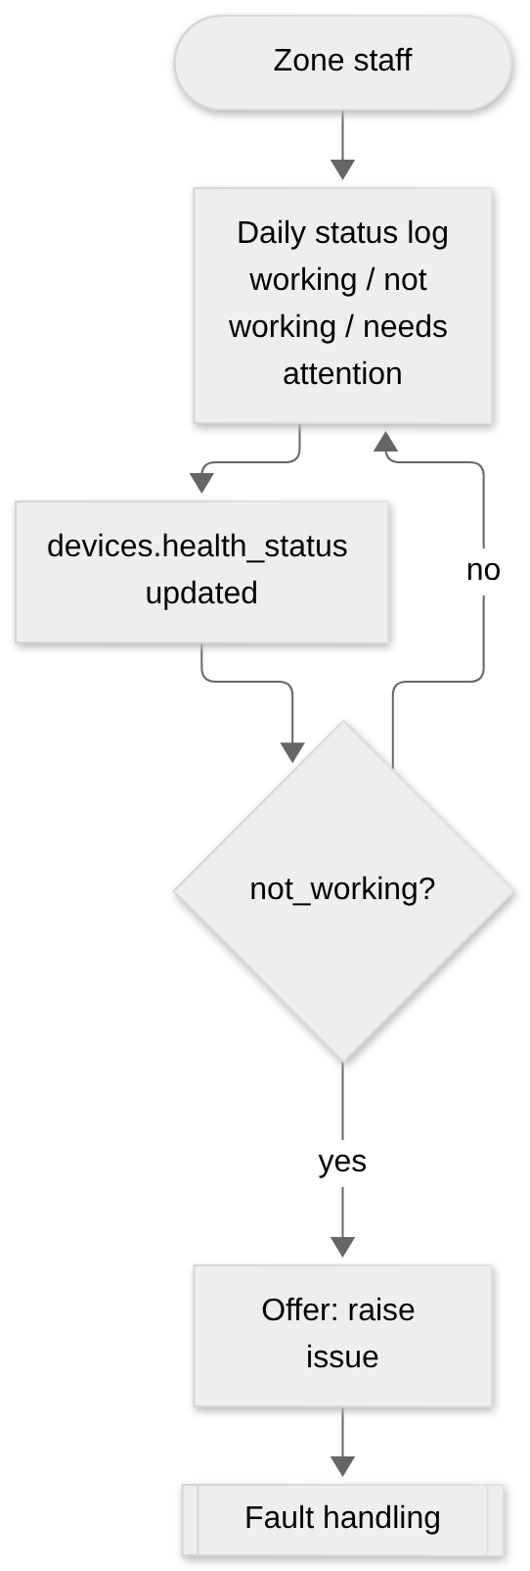
One log per device per day (existing v1 constraint). Issues can also be raised manually or by an automatic alert (issues.raised_via).

E. Fault handling
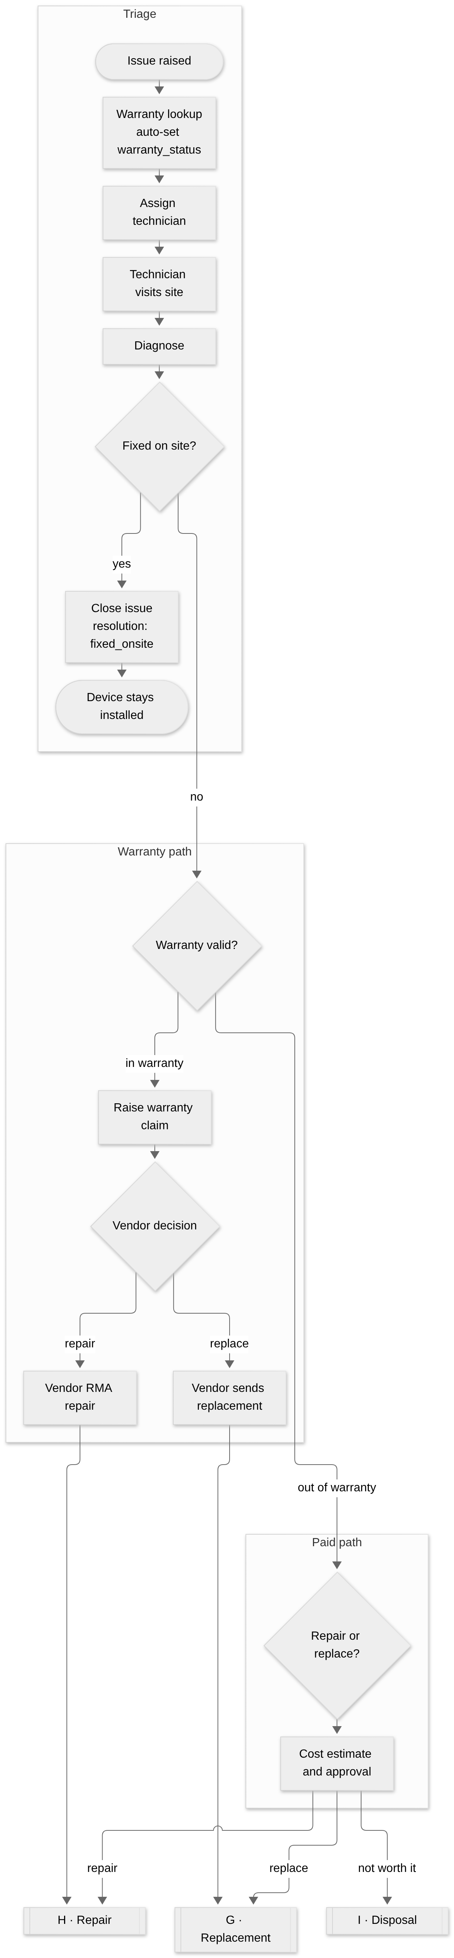
Issue status (history kept in issue_status_history with GPS): open → assigned → in_progress → resolved → closed, with on_hold and reopened as side paths. Resolution types: fixed_onsite, replaced, repaired_offsite, warranty_rma, no_fault_found, not_repairable.
Visit (service_visits): visit_type is diagnosis, onsite_repair, replacement_swap, removal or preventive; status scheduled → en_route → on_site → completed (or cancelled, no_access); check-in/out, GPS, findings, signature; outcome is fixed, needs_replacement, needs_repair, no_fault_found or parts_pending.
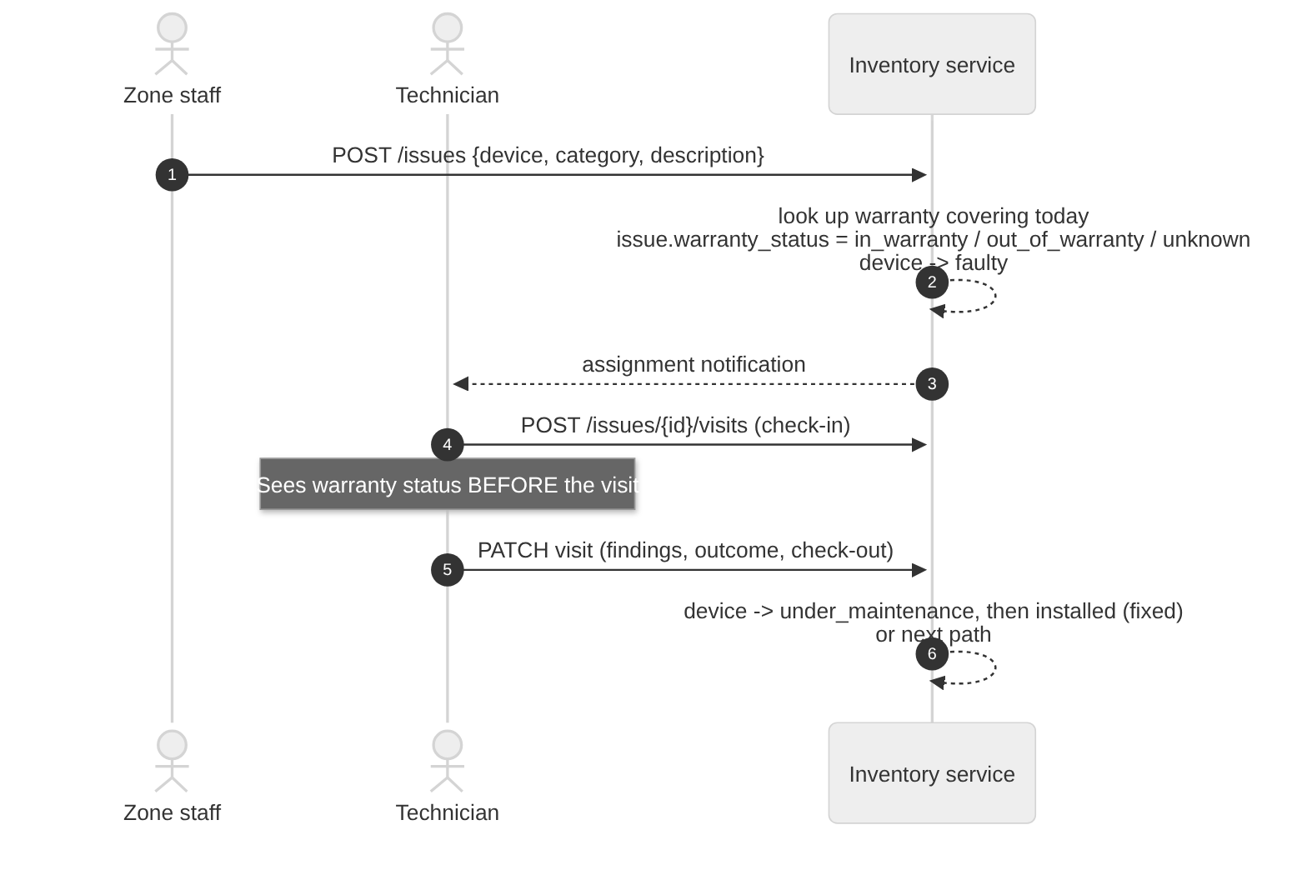

F. Warranty claim and RMA
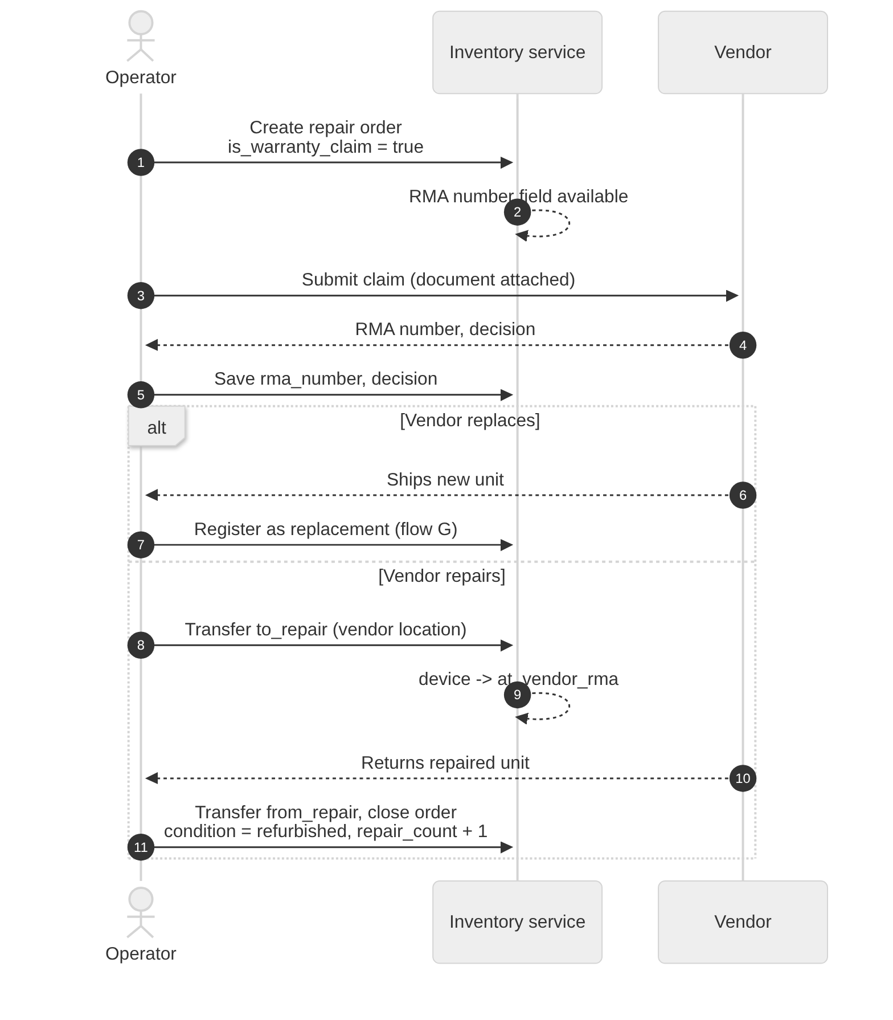

G. Replacement
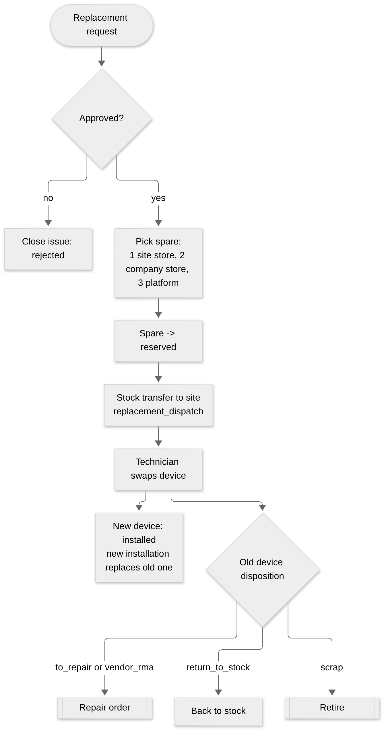
The spare selection order is configurable (rule 8). Loaner during repair is modelled as a normal replacement with disposition to_repair.

H. Repair round trip
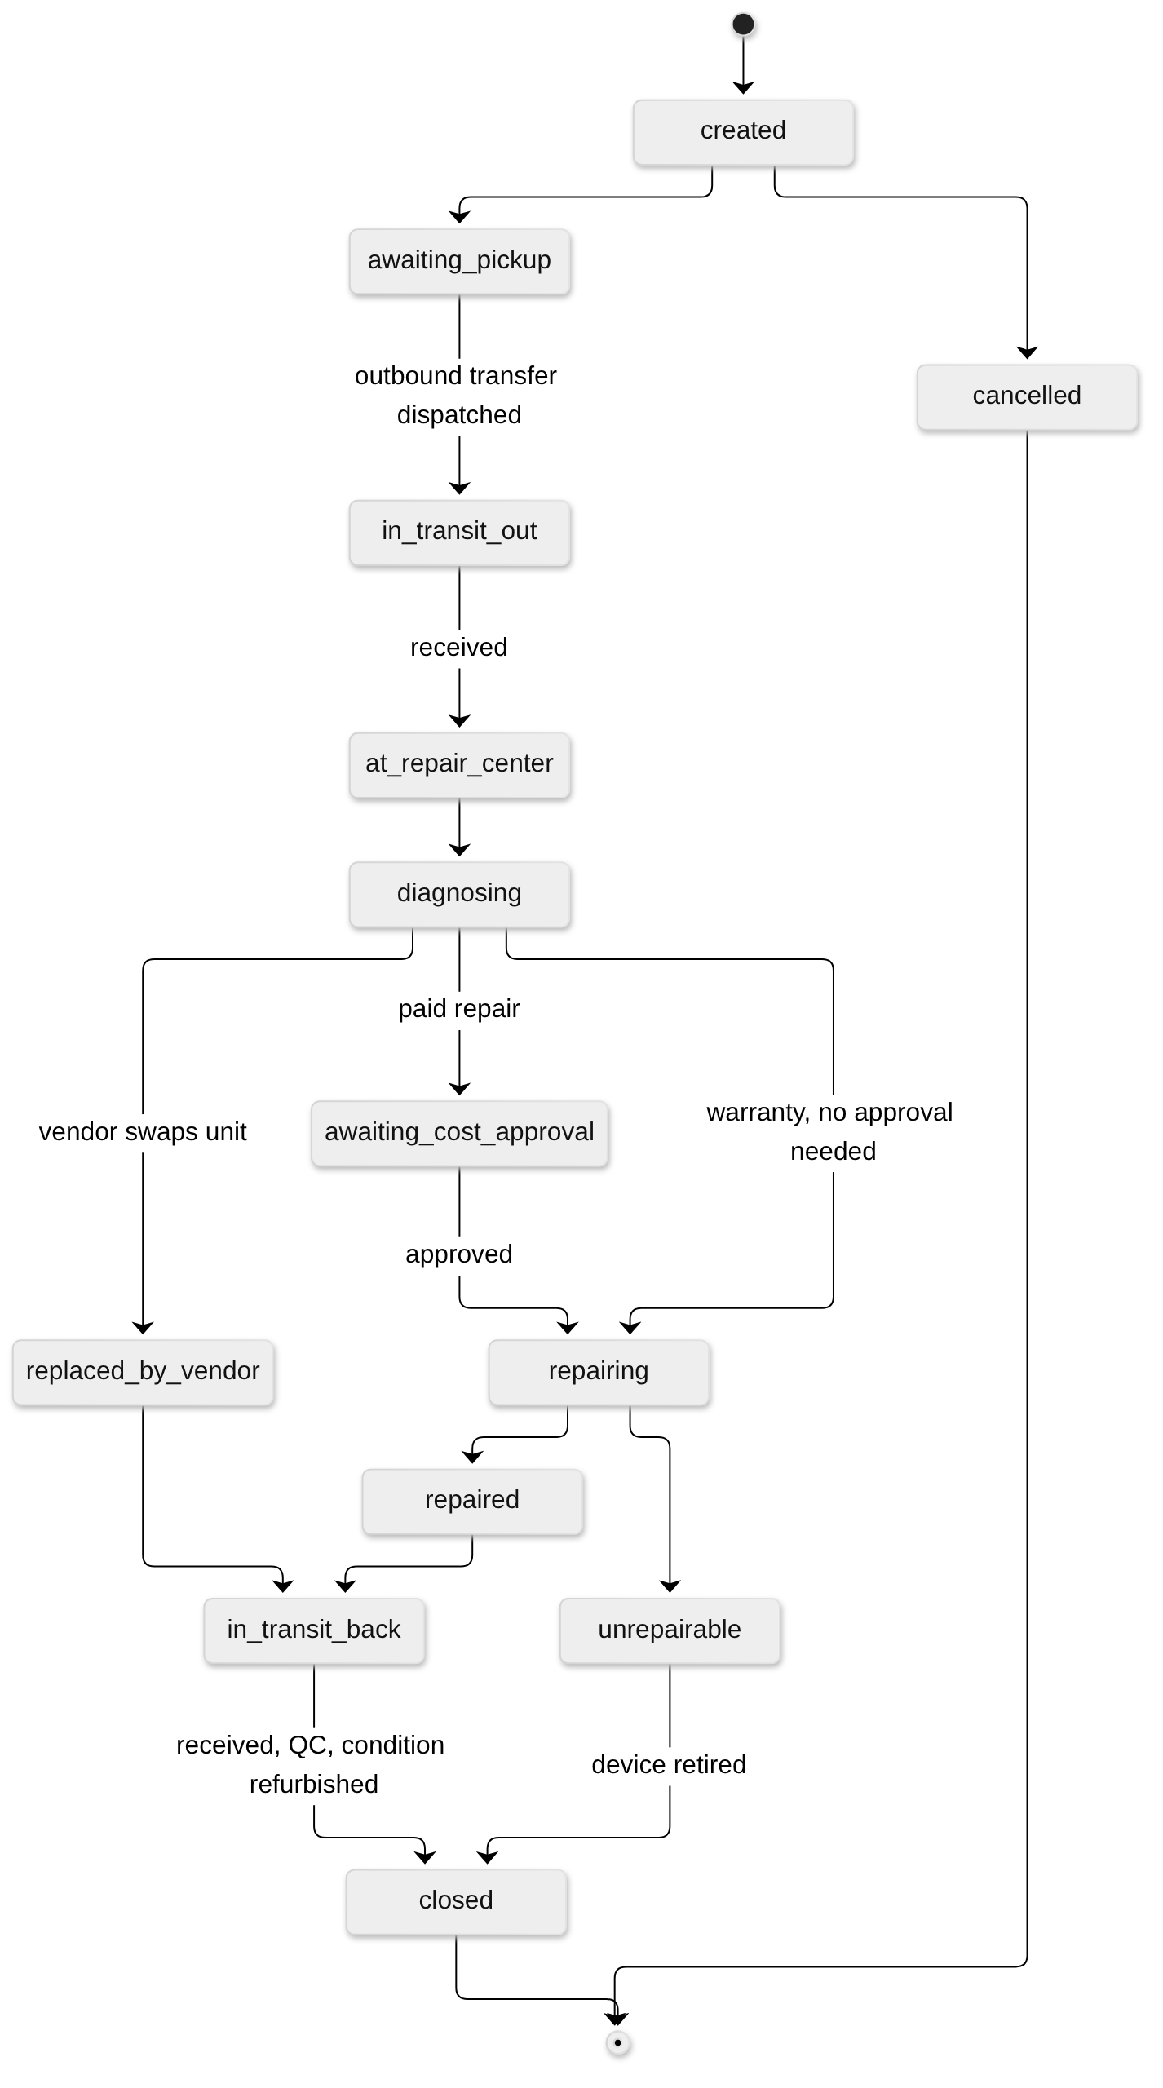
Rule 9 | Detail
Needs | An outbound transfer to a service_center or vendor location and a return transfer
On close | Device goes to the return location's tier stock, condition = refurbished, repair_count + 1
Costs | cost_estimate, final_cost, cost_borne_by (customer / operator / vendor); parts in repair_parts with covered_by_warranty
Billing (phase 5) | billable + invoice_id link to Revenue

I. Retirement and disposal
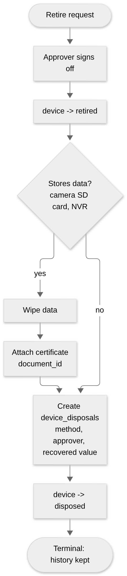
Disposal gate (rule 10): devices that store data cannot become disposed until data_wiped = true and a certificate is attached. Devices are never deleted; history is kept.
Disposal methods: scrap, recycle, sold, returned_to_vendor, donated, lost, stolen.

J. Preventive maintenance (AMC)
New in v2.1 (integration change 9). v2 covered corrective maintenance only; "preventive" existed as a visit_type with nothing generating it.
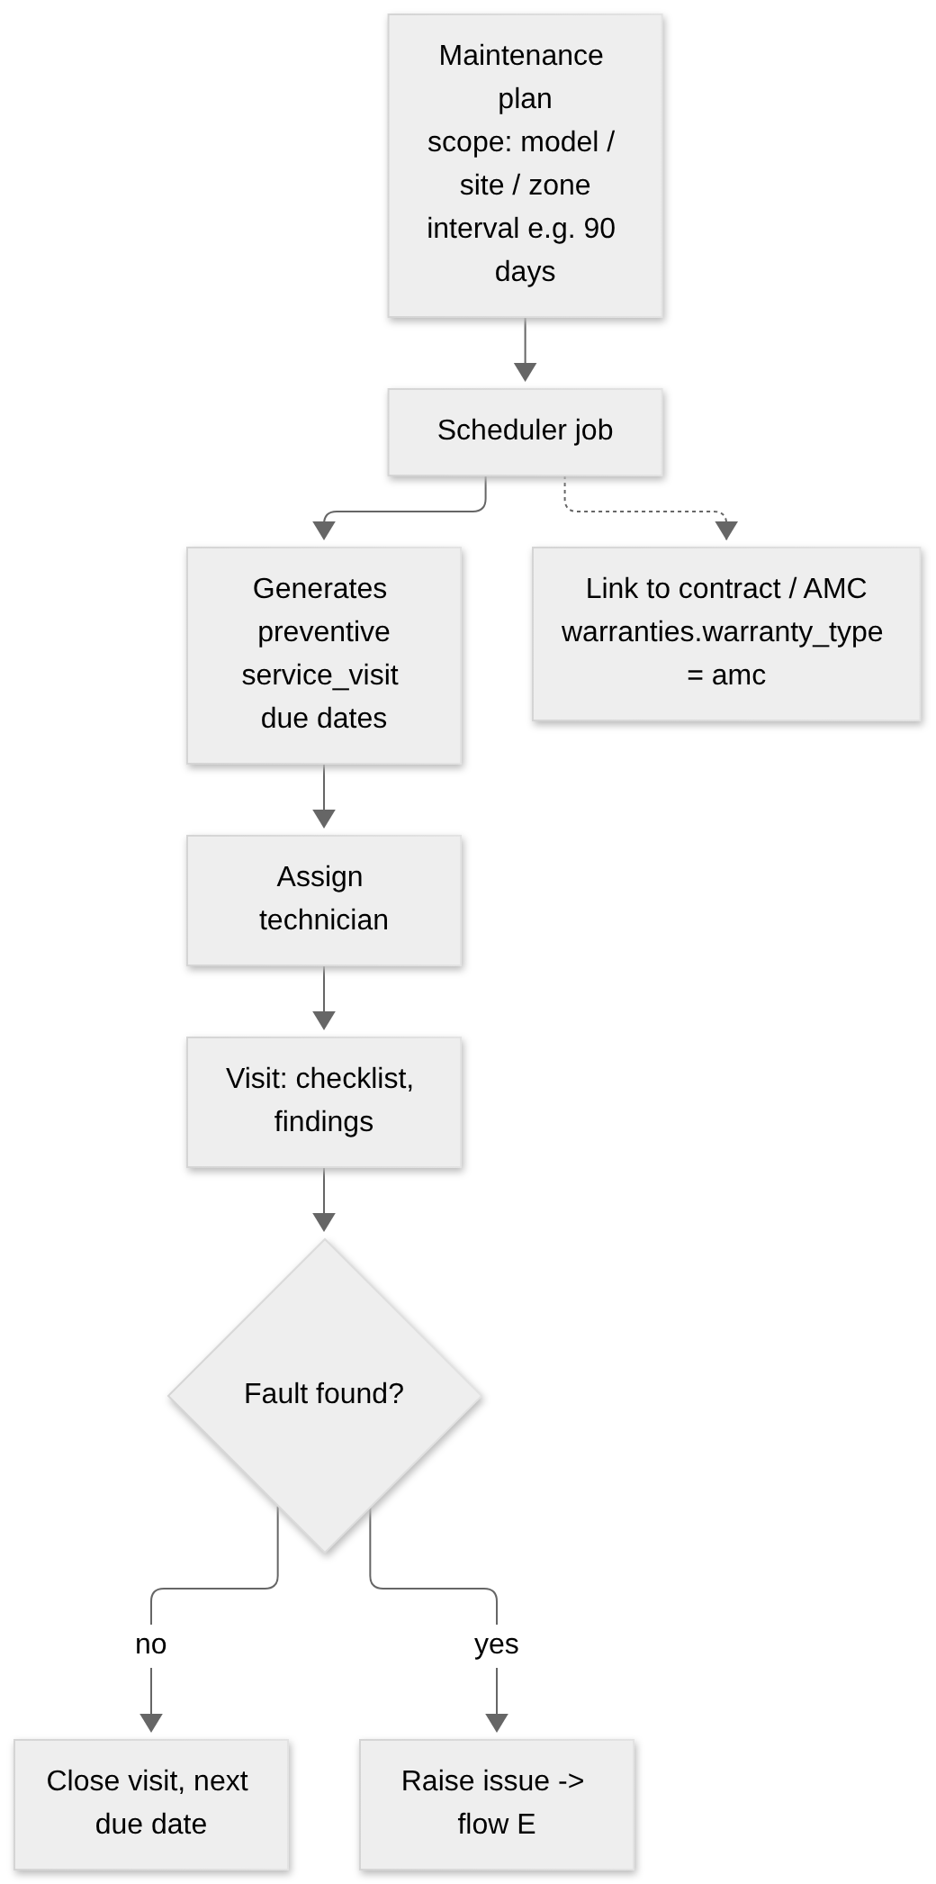

K. Onboarding a new customer and site
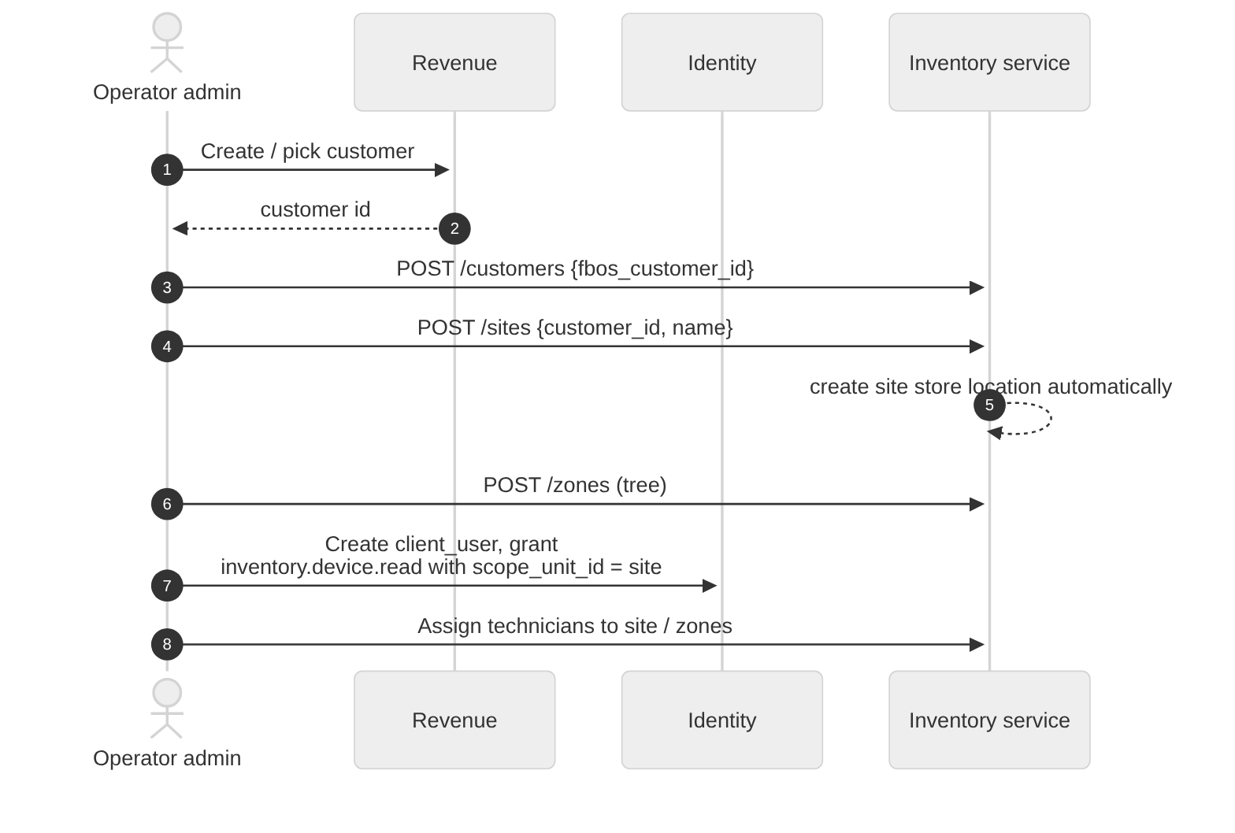
Auto-created: one company_store per customer and one client_store per site (migration step 2 does this for the existing 5 and 4).

05 · Data model
Column-level truth lives in the Eraser sources: ../diagrams/02 … 06, with the whole system in 07 (36 tables). This page gives the same model as readable diagrams plus the v2.1 changes needed for FBOS.
Conventions: NEW = new in v2, CHG = changed from v1, v2.1 = added by the FBOS integration.

1. Domain map
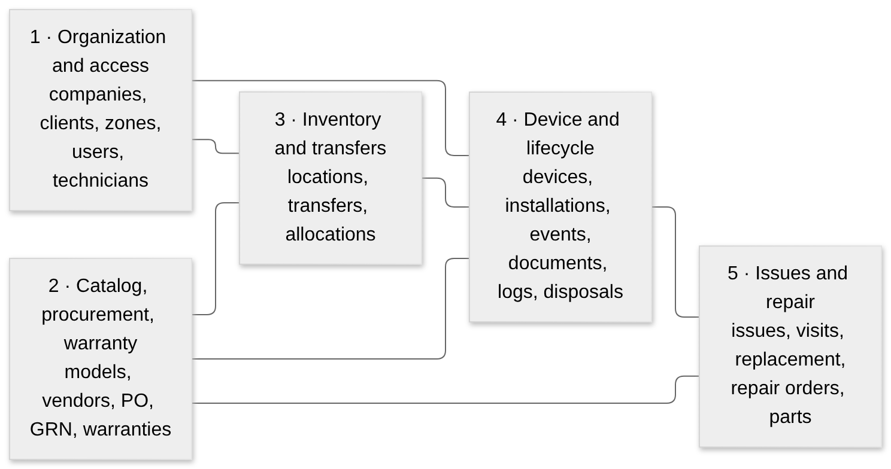

2. Domain 1 — Organization and access
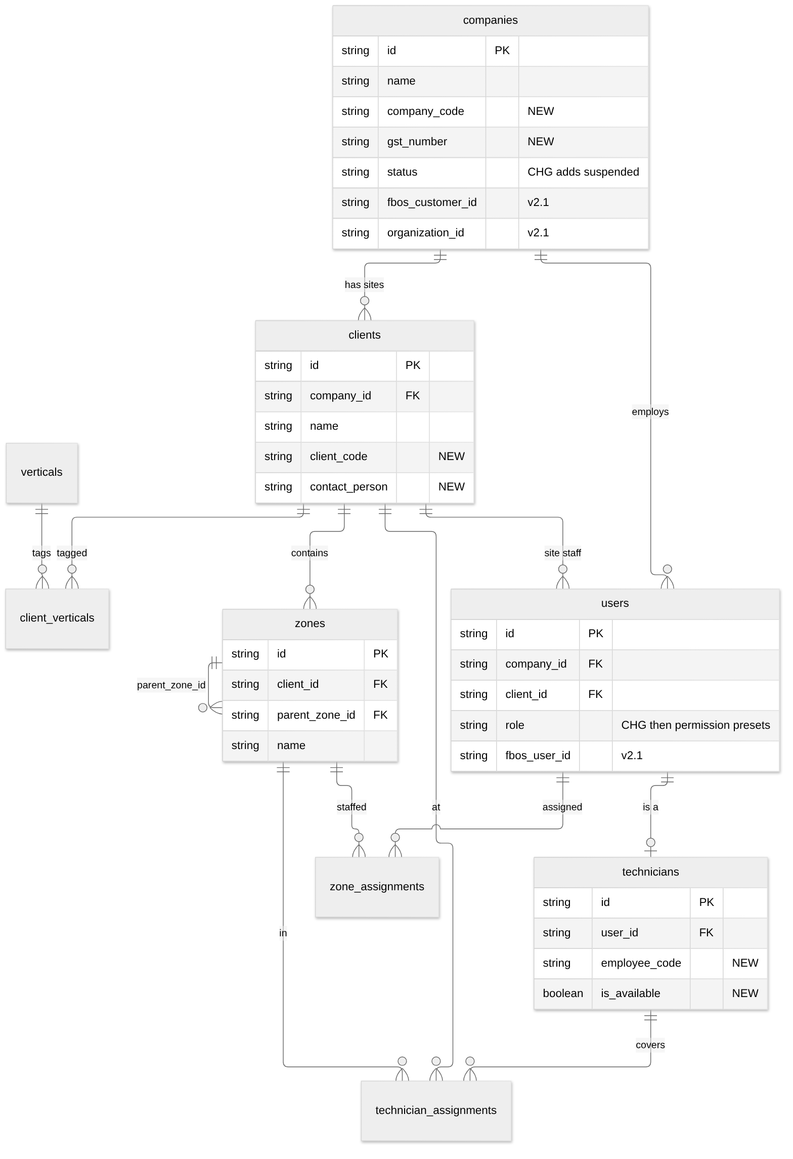

3. Domain 2 — Catalog, procurement, warranty
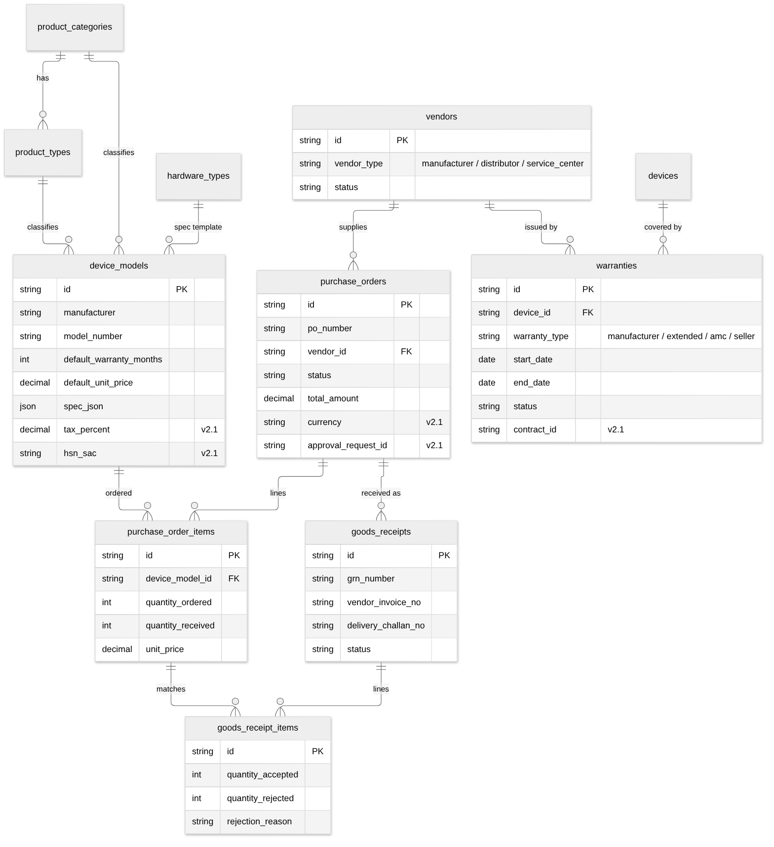

4. Domain 3 — Inventory, transfers, allocation
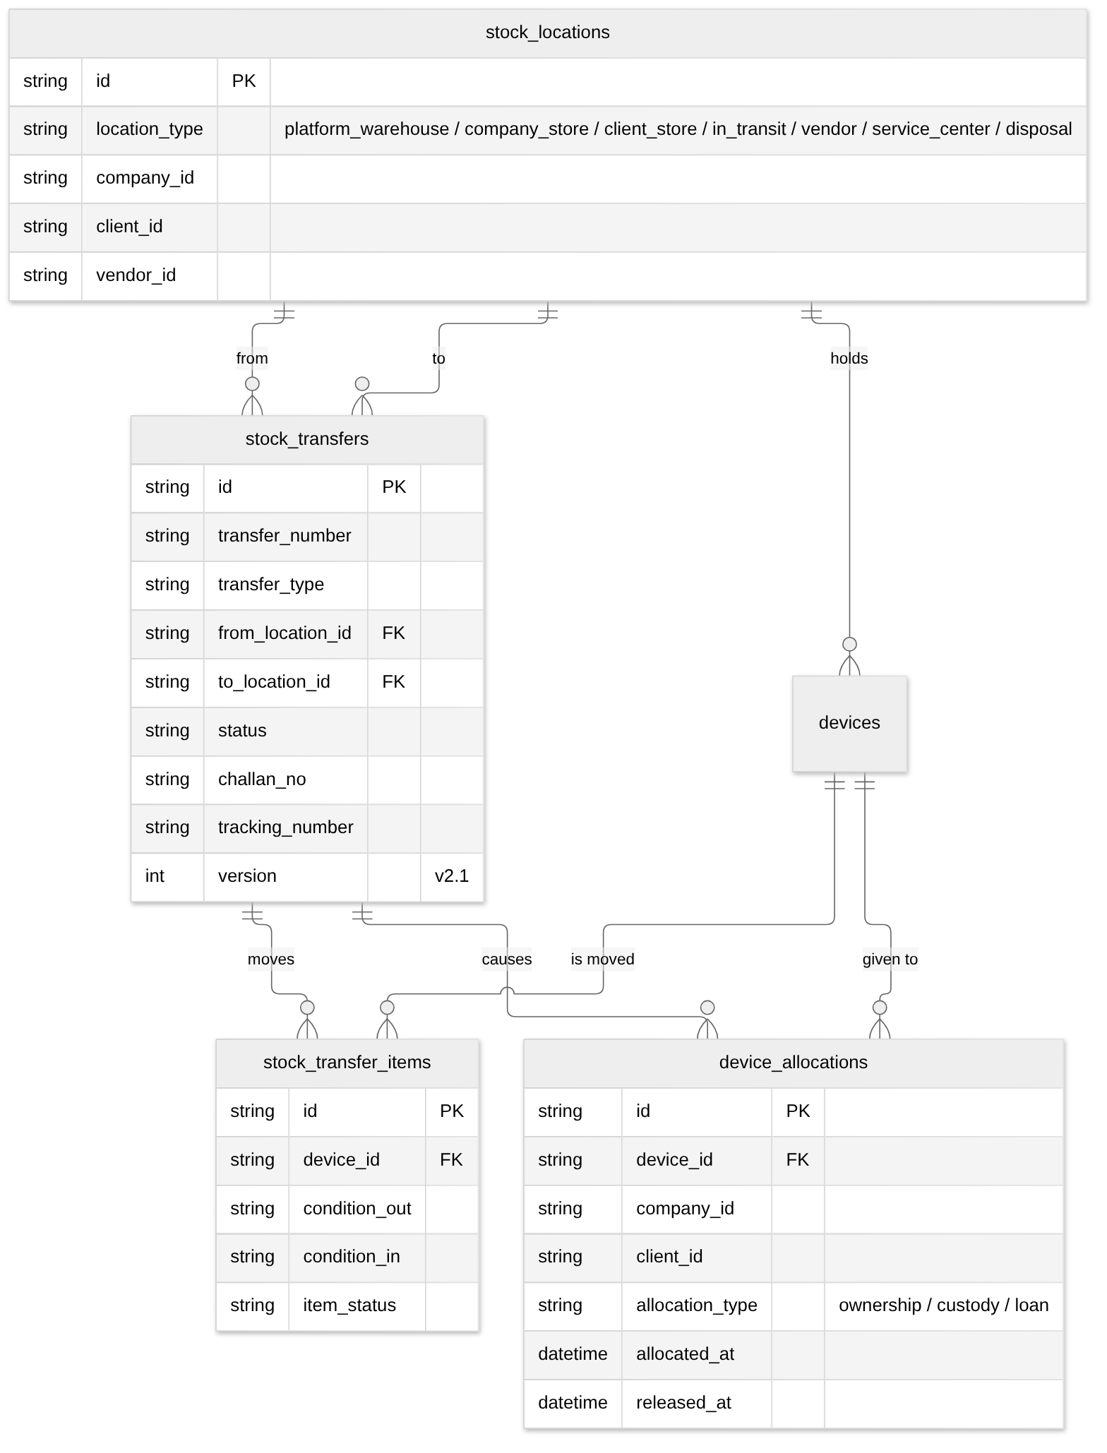

5. Domain 4 — Device, installation, lifecycle log
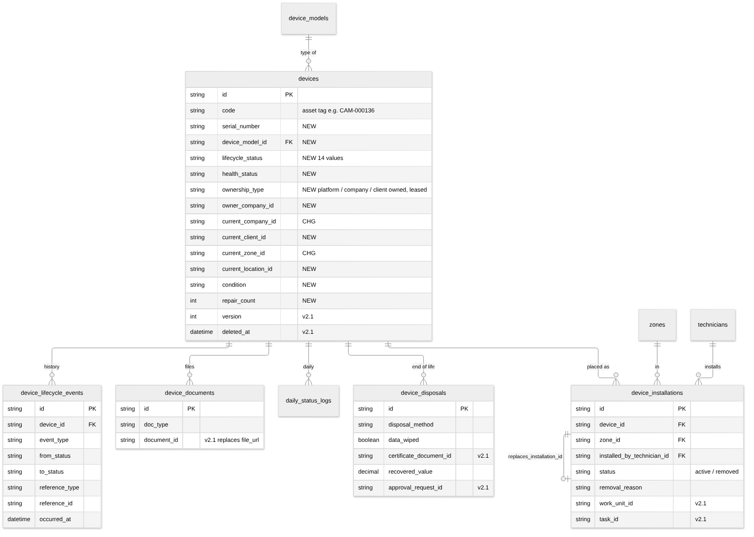

6. Domain 5 — Issues, visits, repair, replacement
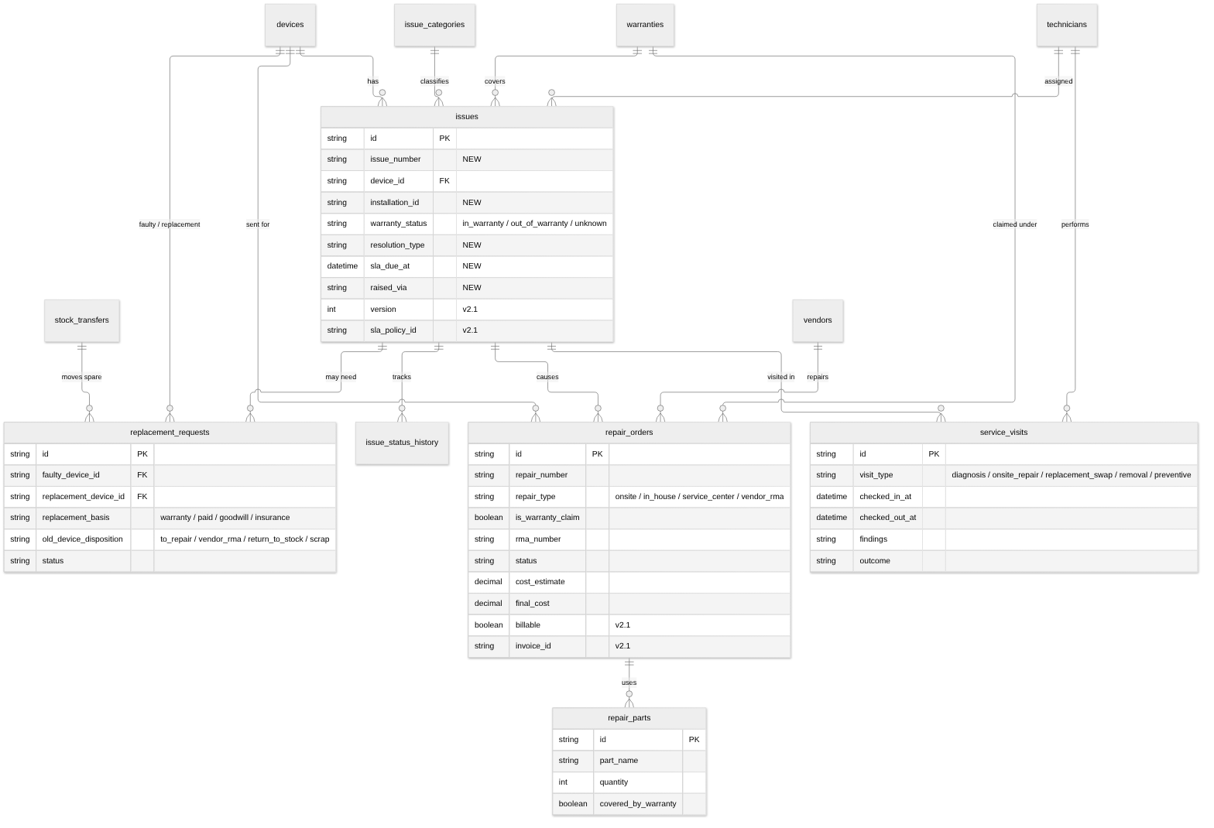

7. Platform tables added by the FBOS integration (v2.1)
Not drawn in the Eraser diagrams yet. Add them to diagram 07 when the schema is generated.
Table | Purpose
outbox | Events to deliver, written in the same transaction as the change; polled by the worker
idempotency_keys | Replay protection for transfers, GRN registration, repair dispatch
fbos_links | Mapping audit (Fixly user / company ↔ FBOS id)
maintenance_plans | Preventive maintenance schedule (scope, interval, next due)
code_sequences | Phase 6 only: replaces product_categories.last_seq
processed_events | Only if a consumer is added later

8. Integrity rules
# | Rule | How it is enforced
1 | Single place: installed (zone) or in a stock location | Service layer + check on write; exceptions in_transit, lost, disposed
2 | One active installation per device | MariaDB generated column active_flag = IF(status='active',1,NULL) + UNIQUE(device_id, active_flag) (raw SQL in migration)
3 | One active custody allocation per device | Same technique on device_allocations
4 | One open transfer per device | Checked when adding an item to a transfer
5 | Atomic history | Status/location change and device_lifecycle_events insert share one transaction; optional DB trigger as a safety net
6 | Warranty at registration | Created in the GRN transaction
7 | Warranty lookup on issue | Done when the issue row is created
8 | Spare selection order | Site → company → platform; configurable; chosen spare becomes reserved
9 | Repair round trip | Outbound and return transfers required to close
10 | Disposal gate | Approver + data_wiped + certificate for data-bearing devices
11 | Receiving gate | Accepted qty = devices created
12 | Tenant isolation | Company roles see their own devices; site users see only their site; operator sees all
13 | Asset tag | Existing last_seq generator kept until Phase 6
14 | Soft integrity | Never cascade-delete devices with history. v2.1 changes Issue → Device from cascade to Restrict and adds deleted_at
15 | Zone delete guard (v2.1) | Block deleting a zone while devices are installed (v1 would silently turn them into "stock")

9. Useful queries
-- Where is each device and who holds it
SELECT d.code, dm.name AS model, d.lifecycle_status,
co.name AS company, cl.name AS client,
z.name AS zone, sl.name AS stock_location
FROM devices d
LEFT JOIN device_models dm ON dm.id = d.device_model_id
LEFT JOIN companies co ON co.id = d.current_company_id
LEFT JOIN clients cl ON cl.id = d.current_client_id
LEFT JOIN zones z ON z.id = d.current_zone_id
LEFT JOIN stock_locations sl ON sl.id = d.current_location_id;

-- Full life of one device
SELECT occurred_at, event_type, from_status, to_status, notes
FROM device_lifecycle_events WHERE device_id = :id ORDER BY occurred_at;

-- Warranties expiring in 60 days
SELECT d.code, w.end_date, v.name AS vendor
FROM warranties w
JOIN devices d ON d.id = w.device_id
LEFT JOIN vendors v ON v.id = w.vendor_id
WHERE w.status = 'active'
AND w.end_date BETWEEN CURDATE() AND CURDATE() + INTERVAL 60 DAY;

More queries (stock on hand, out for repair, repeat failures, transfers in transit) are in design doc §10.

10. Data quality in the live database
Finding (from the dump) | Action
custom_spec holds the text 'null' in 344 devices | Convert to real NULL
Price, purchase date, install date, hardware type, location empty on all 445 devices | Collect; make required at receiving
2 replacement requests have no spare attached | Leave replacement_device_id null
0 daily status logs | Nothing to migrate; health starts from first log

06 · Access and permissions

1. The model in one minute
FBOS is user-based, not role-based. Every user has an explicit list of permission codes. "Roles" exist only as presets: a convenient bundle that fills in the list when you create a user. Code never asks "is this user an inventory_manager?"; it asks "does this user have inventory.purchase_order.create?".
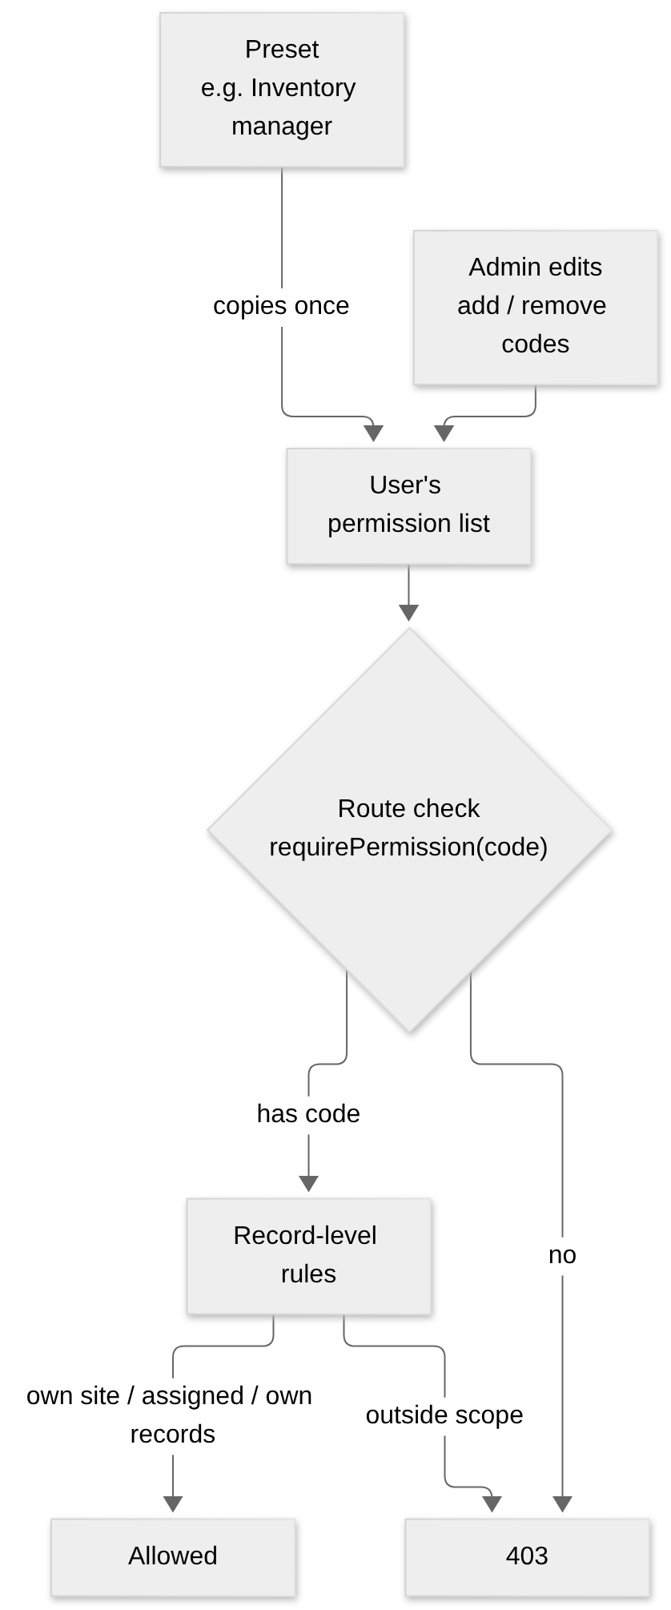
Two layers decide access:
Layer | Question | Where
Permission | May this user do this kind of thing? | Identity (/internal/authz/actor → permissions)
Scope | May they do it on this record? | Inventory service, using unit_scopes and own_records_only from the same response

2. Permission codes (proposed)
Format inventory.<entity>.<action>. Add to Identity's PERMISSION_CATALOG.
Entity | Actions
device | read, create, update, delete
device_model | read, create, update
vendor | read, create, update
purchase_order | read, create, update, approve
goods_receipt | read, create
stock_location | read, create, update
stock_transfer | read, create, approve, dispatch, receive
installation | read, create, update
warranty | read, create, update
issue | read, create, update, assign
service_visit | read, create, update
replacement | read, create, approve
repair_order | read, create, update, approve
disposal | read, create, approve
maintenance_plan | read, create, update
report | read

The exact list is finalized in the Phase 0 spike and published as an OpenAPI file.

⚠ Sensitive codes
Every .read code joins the member preset automatically. SENSITIVE_READ_CODES is a hard-coded set in Identity. Anything that exposes cost, price, vendor terms, disposals or other customers' data must be added to that set in the same Identity change, or every ordinary member gets it.
Candidates: inventory.purchase_order.read, inventory.vendor.read, inventory.repair_order.read (costs), inventory.disposal.read, inventory.warranty.read (terms), inventory.report.read.
Deploy order: Identity first (codes + sensitive set), then inventory routes.

3. Roles become presets
The design doc's capability matrix (§8) maps onto presets like this:
Preset (not checked in code) | Typical permissions
Inventory manager | vendor, model, PO (create/approve), GRN, stock_transfer (create/approve/dispatch), repair_order, disposal (approve), warranty
Company storekeeper | stock_transfer (receive, create company→site), device.read for the company
Company admin | issue create/assign, replacement approve, repair_order approve (cost), reports
Site storekeeper | stock_transfer.receive for their site
Site admin / zone in-charge | issue create, device.read for site, stock.read for site
Technician | installation create, service_visit create/update, issue update (assigned)
Super admin | all inventory codes

Action (from the original matrix) | Permission code
Manage vendors, models, POs, GRN | vendor.*, device_model.*, purchase_order.*, goods_receipt.*
Allocate platform → company | stock_transfer.create + .approve
Receive at company / site store | stock_transfer.receive (scoped)
Install / swap | installation.create
Raise issue | issue.create
Assign technician | issue.assign
Log service visit | service_visit.create
Approve replacement / repair cost | replacement.approve, repair_order.approve
Create repair order / RMA | repair_order.create
Approve disposal | disposal.approve

4. Who is who in Identity
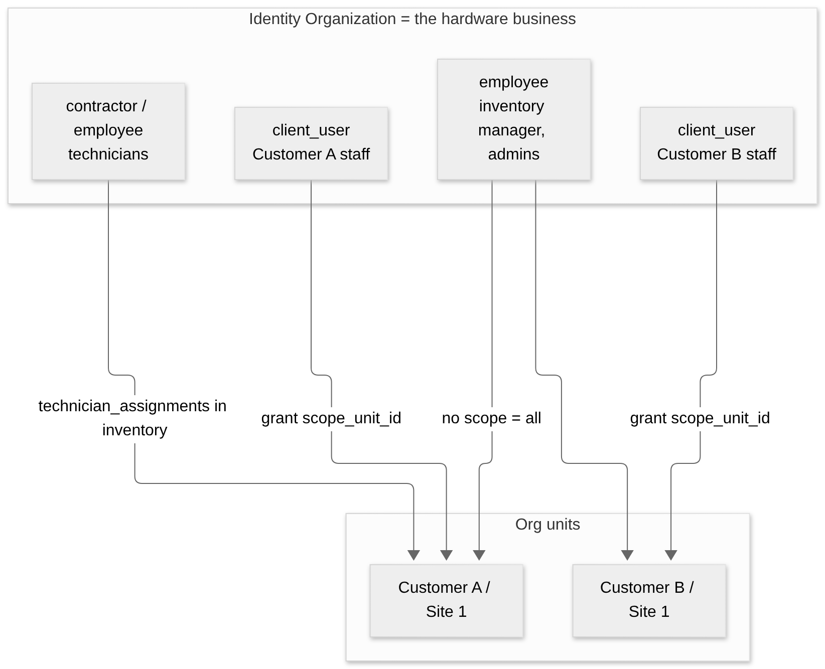
Person | Identity user_type | Scoping
Operator staff | employee | Unscoped grants: sees every customer
Technician | contractor or employee | Coverage in inventory technician_assignments; own_records_only for visits
Customer staff | client_user | Per-user grants with scope_unit_id (site) or self_only

D1 — the decision behind this
Option | Verdict
One Identity organization per customer | Rejected: max_organizations defaults to 2 and the vendor loses the cross-customer view
client_users inside the vendor org, scoped by org unit | Recommended. Identity already has the type and unit-scoped grants (verified in 01_identity)
client_user with self_only grants + site/zone assignments held in inventory | Fallback ("b-lite") if sites are not modelled as org units

The one risk to test first
client_user is only a label today. Each service must apply unit_scopes itself on every list and detail endpoint. A single missed filter shows one customer's devices to another. The Phase 0 spike proves the pattern end to end, and every list endpoint gets a cross-customer test.

5. Record-level rules
Carried over from the design doc (§8 rule 12) and applied in the service layer:
Caller | Sees
Operator (unscoped) | Everything in the organization
Company role | Devices where current_company_id or owner_company_id is their company
Site role | Devices where current_client_id is their site (and its zones)
Technician | Issues and visits assigned to them; devices in their coverage
own_records_only | Only rows they created or are assigned to

Anything outside the caller's scope returns 404, not 403, so ids cannot be probed.

6. Preventing an unguarded route
FBOS Python services have a test that fails if a route has no permission guard. Node cannot reuse it, so Fixly adds an equivalent: walk the Express router at test time and fail on any /api/inventory/v1 route without requirePermission.

7. Two auth stacks during the transition
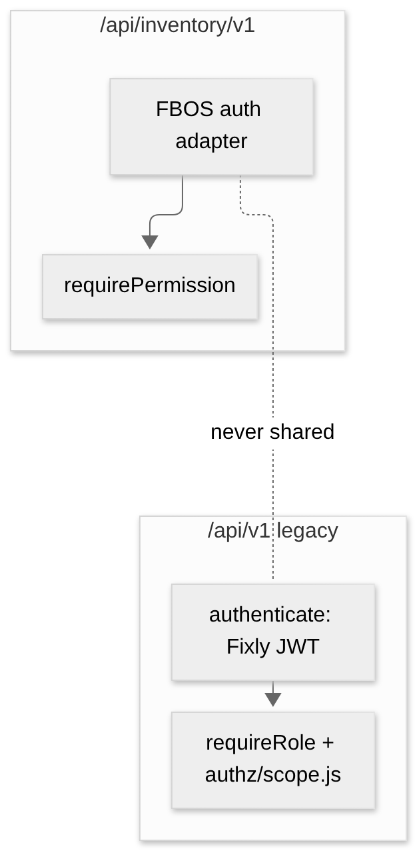
Mounted as separate routers so they never share middleware or tokens. Fixly's nine users are matched to Identity by email (globally unique); passwords are reset rather than migrated. Fixly User rows stay as a mapping layer because Technician.user cascades from User.

07 · API and events
Everything on this page is a proposal to be finalized as an OpenAPI file in Phase 0. Resource names follow FBOS conventions (plural nouns). The legacy /api/v1 API stays untouched.

1. Conventions
Topic | Rule
Base path | /api/inventory/v1 (via the FBOS gateway; dev: Vite proxy INVENTORY_URL)
Auth headers | Authorization: Bearer <FBOS token>, X-Organization-Id
Ids | UUID
Lists | ?page=&page_size=&sort=&q= plus filters; response PageResponse
Errors | { "detail": { "code": "device_not_found", "message": "…", "meta": {} } }
Concurrent edits | If-Match: <version> on PATCH/state changes; 409 on mismatch
Retries | Idempotency-Key header on transfers, GRN registration, repair dispatch
Deletes | Soft only (deleted_at); devices with history are never deleted
Health | GET /health, GET /ready

Error shape
{
"detail": {
"code": "device_already_installed",
"message": "Device CAM-000136 already has an active installation.",
"meta": { "device_id": "…", "installation_id": "…" }
}
}

Status | When
401 / 404 (actor) | Relayed from Identity
403 | Missing permission code
404 | Not found or outside the caller's scope or organization
409 | Version mismatch, duplicate open transfer, second active installation
422 | Rule violation (e.g. disposal without wipe certificate)
503 | Identity unreachable

2. Resource map
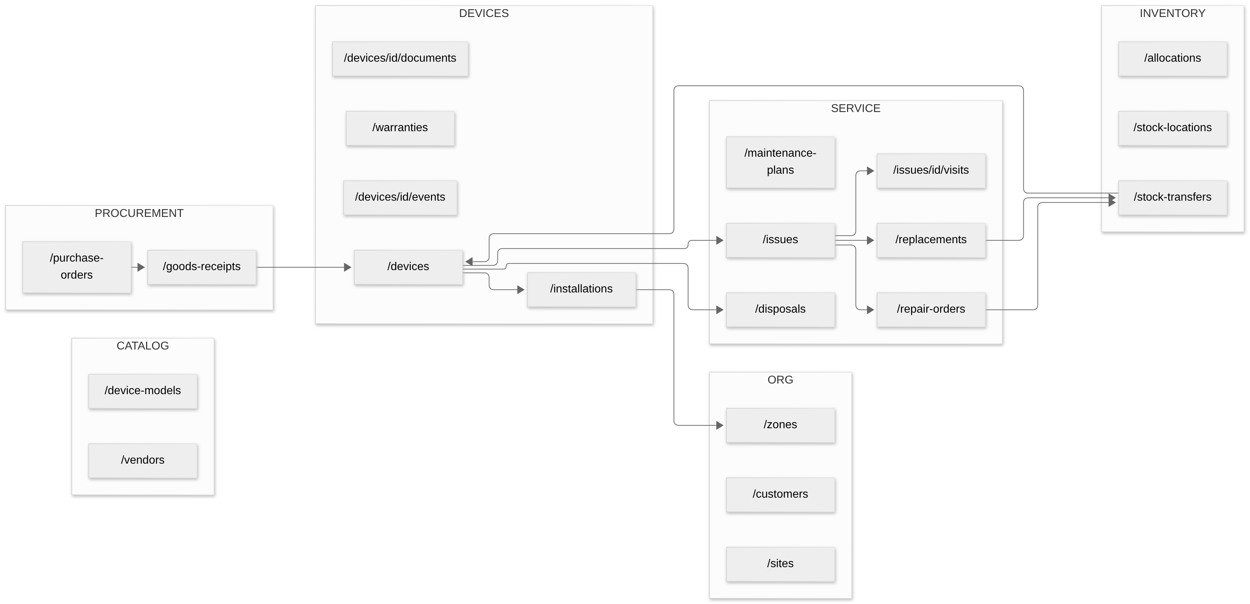

3. Endpoints (proposed)

Organization
Method | Path | Permission
GET | /customers, /customers/{id} | inventory.device.read (scoped)
POST / PATCH | /customers, /customers/{id} | inventory.stock_location.update
GET / POST / PATCH | /sites, /sites/{id} | …stock_location.*
GET / POST / PATCH / DELETE | /zones, /zones/{id} | DELETE blocked while devices installed (409)

Catalog and procurement
Method | Path | Permission
GET / POST / PATCH | /device-models | inventory.device_model.*
GET / POST / PATCH | /vendors | inventory.vendor.*
GET / POST / PATCH | /purchase-orders | inventory.purchase_order.*
POST | /purchase-orders/{id}/submit, /approve, /cancel | …purchase_order.update / .approve
GET / POST | /goods-receipts | inventory.goods_receipt.* (POST needs Idempotency-Key)

Stock and movement
Method | Path | Permission
GET | /stock-locations, /stock-locations/{id}/stock | inventory.stock_location.read
GET / POST | /stock-transfers | inventory.stock_transfer.*
POST | /stock-transfers/{id}/approve | …stock_transfer.approve
POST | /stock-transfers/{id}/dispatch | …stock_transfer.dispatch (Idempotency-Key)
POST | /stock-transfers/{id}/receive | …stock_transfer.receive (per-item condition)
POST | /stock-transfers/{id}/cancel | …stock_transfer.create

Devices
Method | Path | Permission
GET | /devices (filter: model, status, site, zone, location, warranty) | inventory.device.read
GET | /devices/{id} | inventory.device.read
PATCH | /devices/{id} | inventory.device.update (If-Match)
GET | /devices/{id}/events | inventory.device.read (timeline)
GET | /devices/{id}/warranties | inventory.warranty.read
GET / POST | /devices/{id}/documents | inventory.device.read / .update
POST | /installations | inventory.installation.create
POST | /installations/{id}/remove | inventory.installation.update
POST | /daily-status-logs | inventory.device.update

Service
Method | Path | Permission
GET / POST / PATCH | /issues | inventory.issue.*
POST | /issues/{id}/assign | inventory.issue.assign
GET / POST / PATCH | /issues/{id}/visits | inventory.service_visit.*
GET / POST | /replacements | inventory.replacement.*
POST | /replacements/{id}/approve | inventory.replacement.approve
GET / POST / PATCH | /repair-orders | inventory.repair_order.*
POST | /repair-orders/{id}/dispatch | …repair_order.update (Idempotency-Key)
POST | /repair-orders/{id}/close | …repair_order.update
GET / POST | /disposals | inventory.disposal.*
POST | /disposals/{id}/approve | inventory.disposal.approve
GET / POST / PATCH | /maintenance-plans | inventory.maintenance_plan.*

Reports
Method | Path | Source
GET | /reports/stock-on-hand | design doc §10
GET | /reports/warranty-expiry | same
GET | /reports/open-repairs | same
GET | /reports/repeat-failures | same
GET | /reports/transfers-in-transit | same

4. Example: receiving goods
POST /api/inventory/v1/goods-receipts
Authorization: Bearer …
X-Organization-Id: 7e1c…
Idempotency-Key: 5f9a-grn-2026-10-14-001
Content-Type: application/json

{
"purchase_order_id": "…",
"receiving_location_id": "…",
"vendor_invoice_no": "INV-8841",
"items": [
{
"purchase_order_item_id": "…",
"quantity_received": 50,
"quantity_accepted": 49,
"quantity_rejected": 1,
"rejection_reason": "damaged lens",
"units": [
{ "serial_number": "SN100001", "mac_address": "…" }
]
}
]
}

One transaction creates the GRN, 49 devices, 49 warranties, 49 received events, and updates quantity_received. A repeat of the same Idempotency-Key returns the original response instead of creating duplicates.

5. Events and notifications
FBOS has no event bus. v2 uses the same pattern as 03_delivery: an outbox table plus a polling worker.
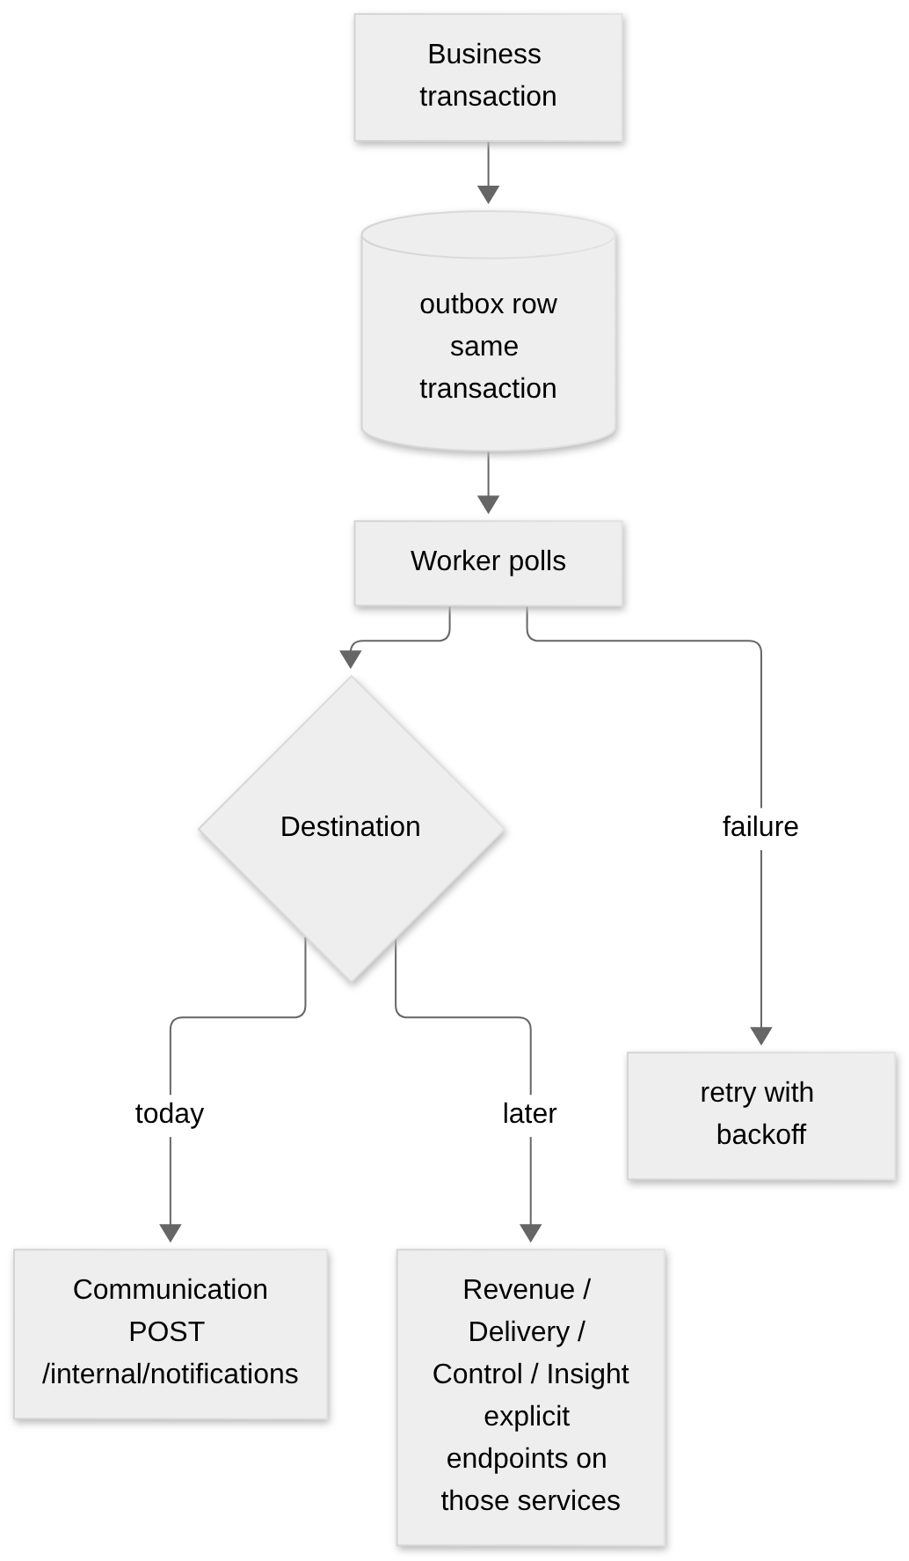
Candidate event | Raised when | Consumer (when it exists)
device.received | GRN accepted | Insight
device.installed | Installation created | Delivery (task done), Revenue (activity)
device.retired | Disposal approved | Insight
transfer.dispatched | Transfer dispatched | Communication → receiver
transfer.received | Transfer received | Communication → sender
issue.raised | Issue created | Communication → assignee, Control (SLA)
issue.resolved | Issue closed | Communication → reporter
repair.sent / repair.returned | Repair order dispatched / closed | Communication, Revenue (billable)
warranty.expiring | Scheduled job, 60 / 30 / 7 days | Communication

processed_events (consumer-side dedup) and a general event catalog are deferred until a service actually consumes events. source_event_id on notifications gives dedup at Communication today.

6. Calls the inventory service makes to FBOS
To | Call | Why
Identity | GET /api/identity/v1/internal/authz/actor | Who is calling and what they may do
Identity | lookup users by ids (add if missing) | Show names of technicians and staff
Documents | file upload and read via subject types | Attach files
Communication | POST /internal/notifications | Notify people
Revenue (phase 5) | customer + site contacts, contract terms | Customer master, warranty/AMC terms
Delivery (phase 5) | task link | Installation ties to a project task
Control (phase 5) | approval request create / status | PO, repair cost, disposal approvals

7. Calls FBOS makes to the inventory service
From | Call | Why
Documents | GET /internal/subject-access/{type}/{id}?action=read|attach | Access check; returns {organization_id, label}
Delivery (phase 5) | list devices for a project | Show installed hardware on a project
Revenue (phase 5) | warranty and repair summaries | Contract and invoice context

All internal calls carry X-FBOS-Internal-Token.

8. Dependency and downtime behavior
If this is down… | Effect
Identity | Inventory returns 503; nothing is allowed
Documents | Uploads fail; inventory data unaffected
Communication | Outbox keeps events; delivered when it returns
Inventory | FBOS inventory pages fail; document attach and read for inventory subjects also fail (Documents calls it synchronously)
Revenue / Delivery / Control | Core inventory flows keep working (phase 5 links are optional)

08 · FBOS UI
The inventory UI lives in the FBOS admin app: fbos_frontend/clientadmin, as a new module features/inventory/. The Fixly web app is frozen (no new features) and kept running for current customers until the FBOS UI reaches parity, then redirected.
Screen names and layout are a proposal. Final designs come from the product owner.

1. Navigation map
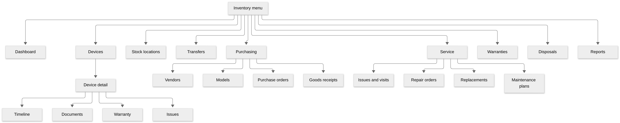

2. Pages
Page | Who uses it | What it shows | Key actions | Permissions
Dashboard | Everyone (content varies) | Stock by tier, open issues, transfers in transit, warranties expiring, out for repair | Jump to lists | device.read + others
Devices | Operator, company, site | Searchable register with model, status, health, holder, zone, warranty end | Filter, export, open detail | device.read
Device detail | Same | Identity, location now, custody, warranty, installation history, files | Install, raise issue, move | device.read
Timeline (tab) | Same | Full lifecycle from device_lifecycle_events | — | device.read
Stock locations | Operator, storekeepers | Platform / company / site stores with stock per model | Open stock, start transfer | stock_location.read
Transfers | Operator, storekeepers | List and detail; sender, receiver, items, status | Create, approve, dispatch, receive | stock_transfer.*
Vendors / Models | Operator | Master data | CRUD | vendor.*, device_model.*
Purchase orders | Operator | PO list, lines, approval status | Create, submit, approve | purchase_order.*
Goods receipts | Operator | GRN against a PO, serial capture, QC | Receive, accept, reject | goods_receipt.*
Warranties | Operator, company | Expiry calendar, claim status | Open claim | warranty.read
Issues and visits | Everyone | Issue list, status, warranty badge, visits | Raise, assign, log visit | issue.*, service_visit.*
Repair orders | Operator | Out-for-repair board, RMA, costs | Create, dispatch, close | repair_order.*
Replacements | Operator, company | Request, approval, spare picker, disposition | Request, approve | replacement.*
Maintenance plans | Operator | Plans and upcoming preventive visits | Create plan | maintenance_plan.*
Disposals | Operator | Retired devices awaiting disposal, certificates | Approve, record wipe | disposal.*
Reports | Operator, company | The reports in design doc §11 | Filter, export | report.read

3. Device detail layout
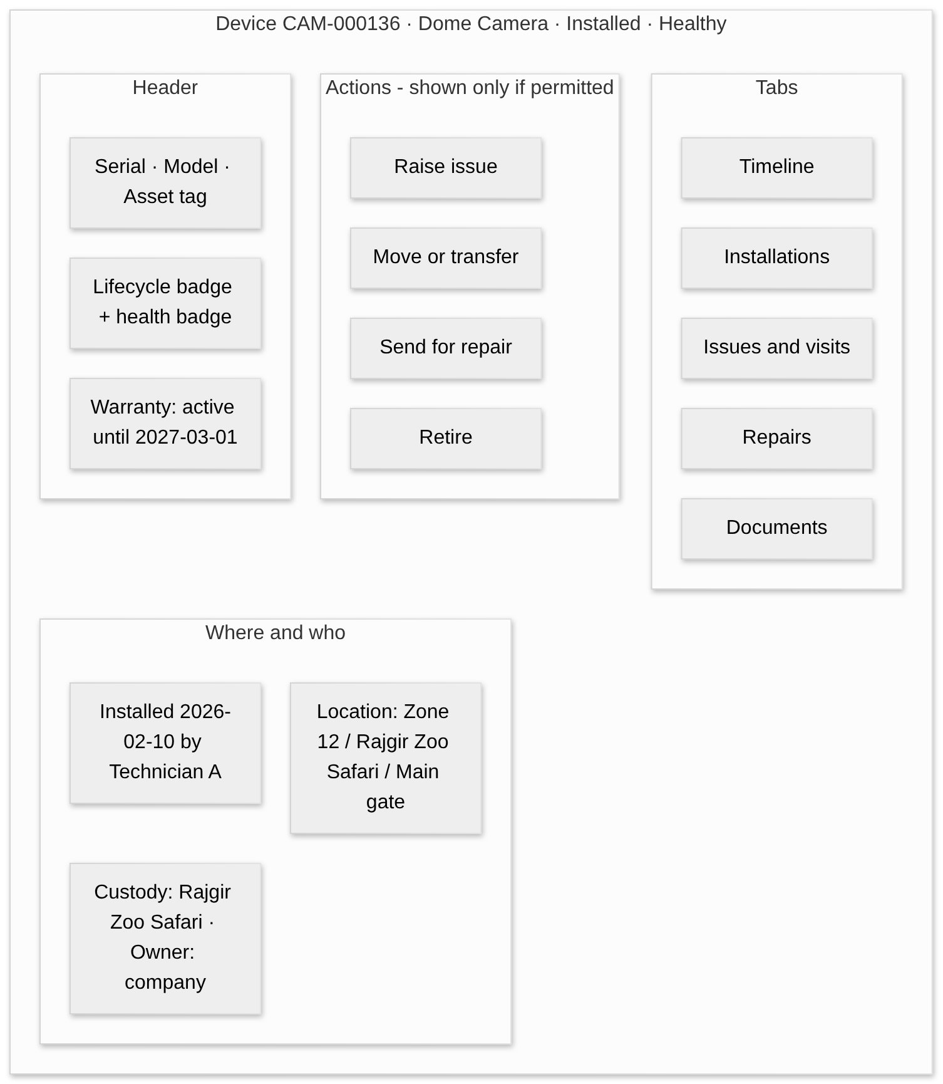

4. How users move through it

Storekeeper receives a delivery
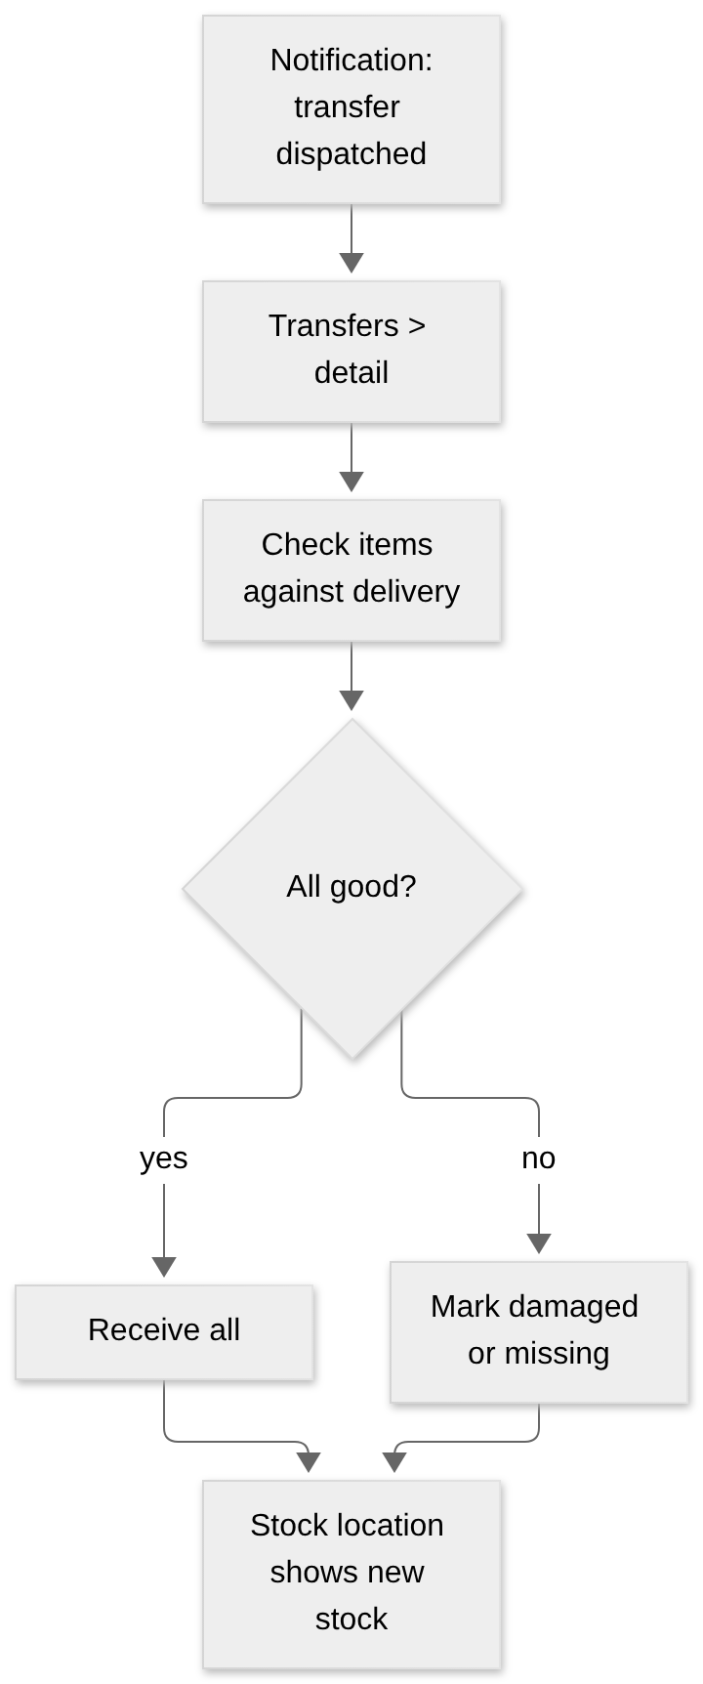

Zone staff reports a problem
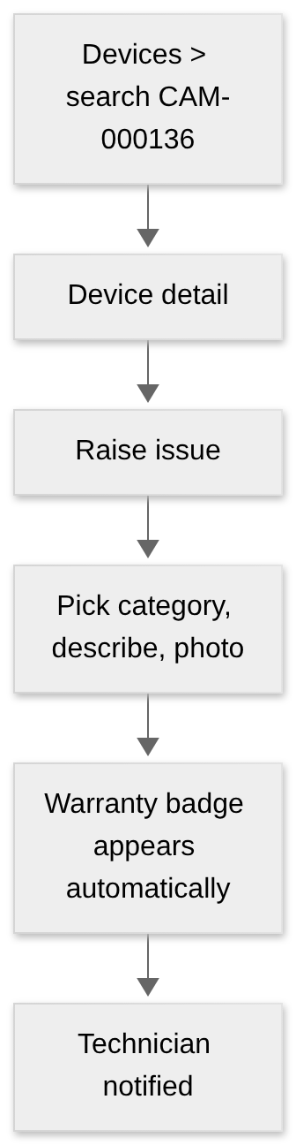

Operator handles a failed unit
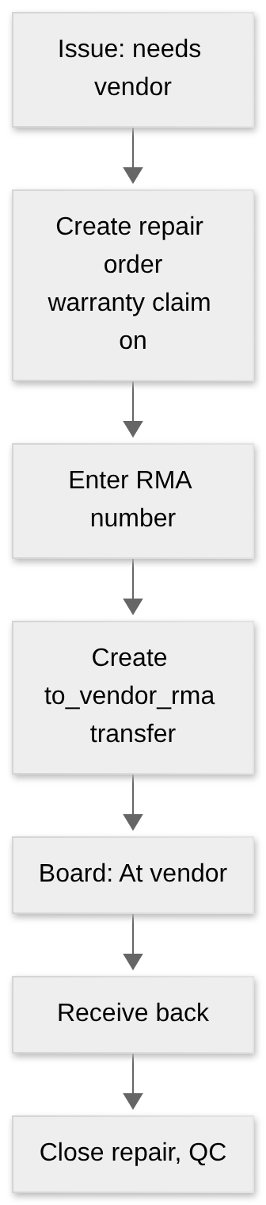

5. Frontend structure
Follows fbos_frontend/CLAUDE.md conventions.
clientadmin/src/features/inventory/
├── api.js # one function per endpoint, base /api/inventory/v1
├── hooks/ # useInventoryNames (id → name, like useDeliveryNames)
├── pages/
│ ├── DashboardPage.jsx
│ ├── devices/ # list, detail, timeline
│ ├── locations/
│ ├── transfers/
│ ├── purchasing/ # vendors, models, POs, GRNs
│ ├── service/ # issues, visits, repairs, replacements, maintenance
│ ├── warranties/
│ ├── disposals/
│ └── reports/
└── components/ # StatusBadge, WarrantyBadge, TransferItemsTable, DocumentPanel use

Concern | How
Access gating | features/auth/access.js hides menu items and actions the user's permission list lacks
Files | Reuse DocumentPanel with subject types inventory.*
Names | Ids resolved to names via Identity / Revenue lookups, not copied
Dev proxy | Add /api/inventory → INVENTORY_URL to the Vite proxy
Feature flag | One flag per page; turning it off falls back to Fixly web during rollout
Docs | Add /api/inventory and the module to fbos_frontend/CLAUDE.md

6. What a customer user sees
Customer staff (client_user) get the same pages with narrower data:
Area | Customer view
Dashboard | Only their site(s)
Devices | Their site's devices; no cost or vendor price
Stock | Their site store
Purchasing, Vendors, Disposals, Reports with cost | Hidden (no permission)
Issues | Raise and follow their own

7. Technician mobile app
The Flutter app stays on the legacy API through Phases 1–3. In Phase 4 it signs in with FBOS Identity (mobile refresh is already supported when the request sends X-Client-Type: mobile) and switches to the inventory API. It must store the refresh token and serialize refreshes, because reusing a refresh token revokes the whole session family.

09 · Rollout and migration
Fixly is live (customers use it daily). FBOS is not live. So all change is done additively: add the new next to the old, move traffic, remove the old last.
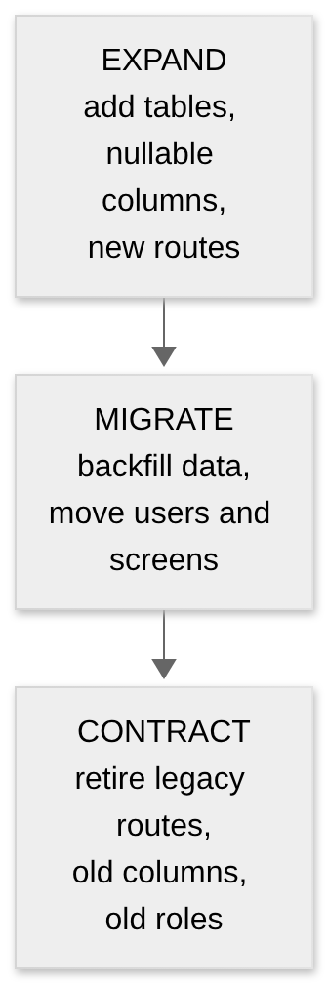

1. Phases
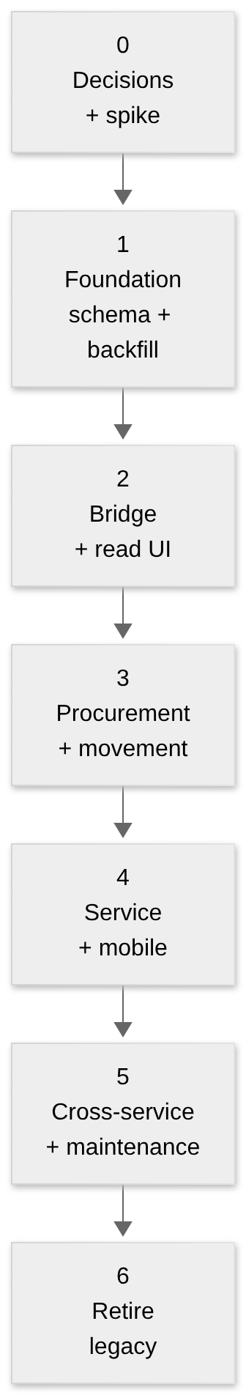
Phase | Scope | Exit gate
0 Decisions + spike | Answer D1–D5; glossary; OpenAPI; permission list; one-day spike: a client_user with a unit-scoped grant calls a Node endpoint through /internal/authz/actor | Spike passes; sign-off
1 Foundation | v2 schema added to Fixly (lifecycle_state column beside status; Issue → Device cascade → Restrict; soft delete; zone-delete guard); backfill; lifecycle events. Legacy app unaffected | Counts reconcile (445 devices, 5 / 4 / 227); legacy smoke test passes
2 Bridge + read UI | Identity permission codes and sensitive set; gateway entry; FBOS auth adapter; /api/inventory/v1 read routes; Documents inventory.* access; Devices, Locations, Timeline pages | FBOS user with permission sees devices; a client_user sees only their site; unguarded-route test green
3 Procurement + movement | Vendors, models, PO, GRN, transfers, allocations, installations (writes) | A device walks PO → GRN → company → client → zone in the FBOS UI
4 Service | Issues, visits, warranty lookup, repair orders, replacement, disposal; mobile moves to Identity | Fault-to-resolution flow including RMA; technician app on new API
5 Cross-service | Revenue / Delivery / Control / Insight links; maintenance plans; event consumers if wanted | Contract → install → warranty → billable repair, end to end
6 Contract legacy | Redirect Fixly web; remove legacy role code; drop old columns; code_sequences | No traffic on legacy routes for 2 weeks

2. What is added, when
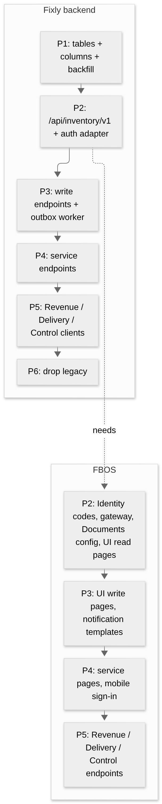

3. Data migration v1 → v2
Order matters; each step is independently deployable (design doc §9).
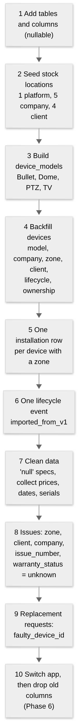

Identity migration (people)
Step | Action
1 | Match Fixly's 9 users to Identity users by email (globally unique)
2 | Create missing Identity users; technicians become contractor / employee
3 | Store users.fbos_user_id; keep Fixly User rows as a mapping layer
4 | Force password reset; do not migrate hashes
5 | Customer staff become client_user with unit-scoped grants

Customer migration
Each Fixly Company gets fbos_customer_id pointing at a Revenue client (create in Revenue if missing). Each Fixly Client becomes a "site".

4. Live-system safety rules
Rule | Why
Additive migrations only until Phase 6 | Legacy app keeps working
Rehearse every migration and backfill on a throwaway local DB restored from a dump | Catch mistakes before production
Backfills are idempotent and have --dry-run | Safe to re-run
Never run Alembic or Prisma migrate against the shared remote DBs from a dev machine | Identity and Revenue share a remote MySQL
Each service migrates only its own DB | Avoid Prisma / Alembic conflicts
One feature flag per FBOS page | Roll back by flipping the flag
Rollback = flag off + legacy routes still served | Fast, no data restore
Legacy and new routers mounted separately | Two auth stacks never mix
Identity change deploys before inventory routes | Prevents the sensitive-code leak

5. Test strategy
Test | Proves
Cross-customer test on every list/detail endpoint | A client_user never sees another customer's data
Unguarded-route test | No inventory route without requirePermission
Reconciliation counts after backfill | 445 devices, 5 companies, 4 sites, 227 zones preserved
Legacy smoke test after each phase | Existing app still works
Rule tests (one active installation, one open transfer, atomic history) | Integrity rules hold under concurrency
Idempotency replay | Repeating GRN or dispatch makes no duplicates
Outbox failure test | Events survive Communication downtime

6. Risks
Risk | Mitigation
Customer data leaks across customers (client_user is only a label) | Phase 0 spike; cross-customer test in every list endpoint
New .read codes auto-granted to all members | Add sensitive codes in the same Identity change
Device cascade deletes issues; zone delete turns units into stock | Phase 1 fixes before any v2 write
No outbox worker in Node, no event consumers in FBOS | Notifications only first; consumers are new FBOS work
Documents calls inventory synchronously | Health checks + timeouts; accept that downtime blocks attach
Two auth systems during transition | Separate routers; no shared token
Dual writes drift (users, customers) | One owner per concept; sync by events; reconcile job
Prisma + Alembic ownership confusion | Strict per-service migration rule
Live data quality (344 'null' specs, missing prices and dates) | Cleanup before backfill; required fields at receiving
Event delivery gaps | Outbox + idempotent consumers + replay

7. Definition of done for v2
- A device can be traced from purchase order to disposal in the FBOS UI with no gaps.
- Customer staff see only their own site.
- Technicians sign in with FBOS Identity.
- Legacy Fixly routes have had no traffic for two weeks and are removed.

10 · Decisions and open questions

1. Integration decisions
# | Decision | Status | Recommendation
D1 | How customer staff sign in | Recommended, confirm in Phase 0 spike | client_user in the vendor organization, sites as org units, unit-scoped grants. Fallback: self_only grants + assignments in inventory
D2 | Service name | Recommended | inventory (not assets, which already means IT assets)
D3 | Who owns devices after delivery | Needs your answer | See below
D4 | Fixly web app | Recommended | Keep until FBOS reaches parity, then retire on a set date
D5 | Approvals | Recommended | Fixly-internal first; move to Control in Phase 5

D3 in plain words
After a device is delivered to a customer, who owns it: the customer, or you (and you lend it)?
If the answer is… | Then
Customer owns it (sold) | Default ownership_type = company_owned. Warranty and repair may be billed to the customer
You own it (leased / lent) | Default platform_owned or leased. You carry repair and replacement cost; the customer holds custody only
Mixed | No default; choose per PO or per delivery

The design supports all three. The answer sets the migration default for the 445 existing devices and the billing logic.

2. Architecture decisions already made
Decision | Why
Fixly Node backend stays the system of record | Working, live, and not worth rewriting
No shared database | Prisma vs Alembic, coupling, different tenancy models
UI in FBOS, backend in Fixly | One admin experience; independent deploys
Outbox + worker, no event bus | FBOS has no bus; reuse the existing pattern
UUID cross-references, no cross-system foreign keys | Independent deploys and migrations
Keep devices.status, add lifecycle_state | MariaDB enum change is not additive
Keep reserveCodes generator until Phase 6 | Monotonic unique codes while legacy is live

3. Open questions from the design doc
# | Question | Why it matters
1 | Ownership model (= D3) | Billing and defaults
2 | Who orders? Only the platform, or can a company buy directly? | If companies can buy, add purchase_orders.buyer_company_id
3 | Bulk / non-serial items (cables, power supplies, spare parts)? | Would need inventory_items with quantity per location (later phase)
4 | Real approval levels and cost limits | The role matrix is a proposal
5 | Do you run an in-house repair bench? | Decides whether service_center locations are yours or vendors'
6 | Notification channels beyond the in-app inbox and mobile push | device_tokens stays for FCM; Communication handles inbox
7 | Loaner devices during repair | Modelled as a normal replacement; add a "temporary swap" flag if the original must auto-reinstall

4. New questions raised by the integration
# | Question | Notes
8 | Should each customer site be an Identity org unit? | Enables the cleanest scoping; otherwise use the b-lite fallback
9 | Which Revenue client does each of the 5 existing companies map to? | Create in Revenue if missing
10 | Which preset names do you want for the first release? | Section 3 of 06 is a starting list
11 | Which dashboards are needed on day one? | Drives Phase 2 scope
12 | What is the SLA per issue priority? | Needed for sla_due_at and, later, Control
13 | When do you want to retire the Fixly web app? | D4; set a date after parity
14 | Is billing of repairs in scope for v2 or later? | Phase 5 billable + invoice_id

5. What happens next
