1. What is the difference between function with argument and function without argument?

Function with argument- The arguments are passing inside the function

Eg: def larg(a,b):

If (a>b):

Print(a)

Else:

Print(b)

Larg(10,5)

Function without argument-The arguments are not passing inside the function

Eg:def add()

a=10

b=23

Print(a+b)

Add()

1. What is argument?

Arguments are independent variable that contain data or code

Types-1.default argument 2.keyword argument 3.Arbitary argument

4,arbitrary keyword argument

1. Find the no: is positive negative or zero using function with arguments?

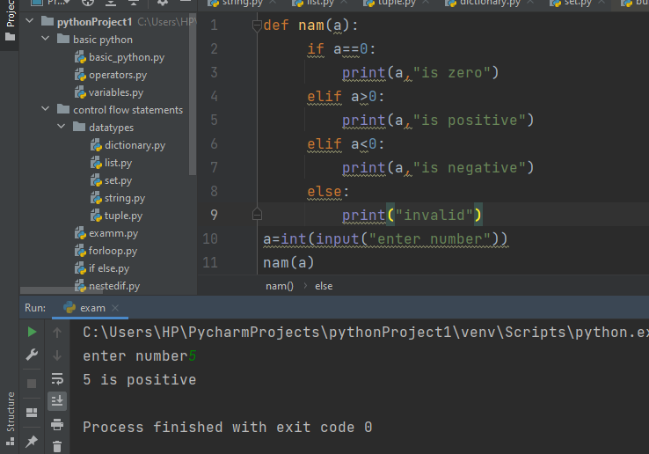

1. Multiplication table using while loop function with arguments?

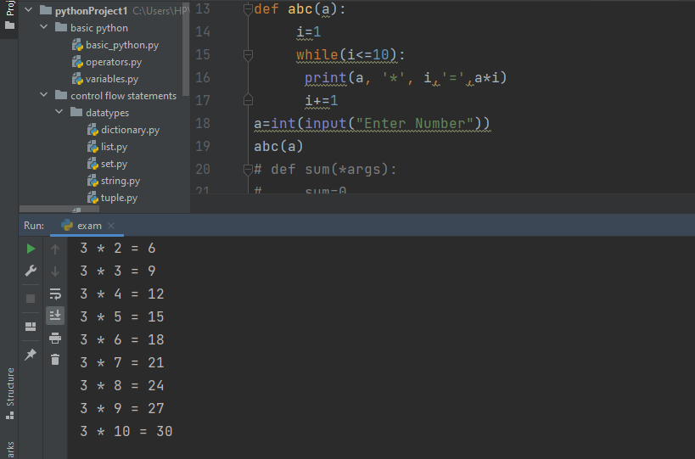

1. Sum of numbers passing into a function using \*args?

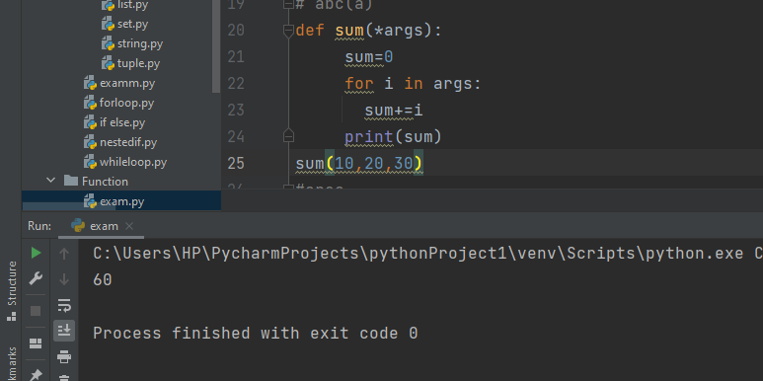

6. Area of triangle using function with arguments?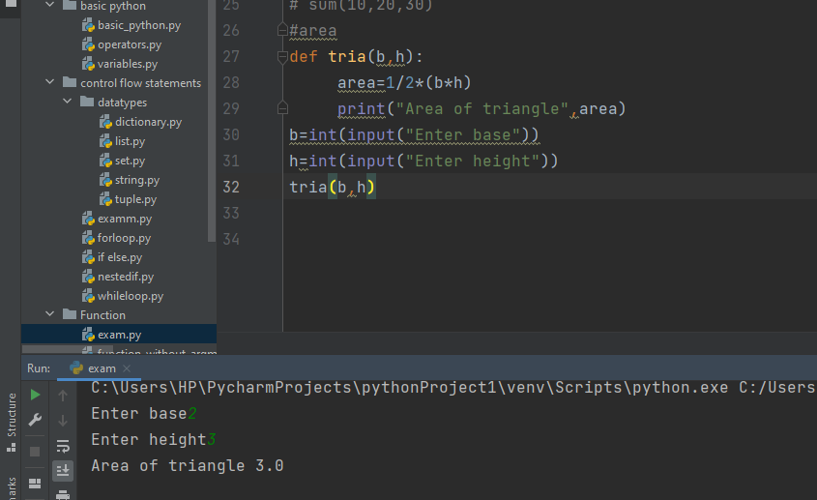

7.Difference between pop() and remove() method?

Pop()—it removes the last item of list

Remove()—it removes the specified item

8. Explain any 5 string methods?

1. capitalize()-it capitalize the first letter in the string

2. casefold()- it convert string into lower case

3.count()-it counts the specified letter in the string

4.center()-it moves the string into center position

5.isalphanum()-it checks the string contain alphabets and numbers

9.what is del in python?

Del-it deleates the item