HARAMAYA UNIVERSITY
[College Name]
[Department Name]

INTERNSHIP REPORT
Design and Development of the WOW Burger Web-Based Management System
Conducted at Enin Tech Solutions PLC
Student name | [Student Full Name]
Student ID | 1279/16
Department advisor | Mekonen [advisor full name], M.Sc., Lecturer
Hosting organization | Enin Tech Solutions PLC
Immediate supervisor | Andargachew Akalu, Software Developer
Internship period | 04/07/2026 to [Internship End Date]
Submission date | 29/08/2026

[Place of Submission, e.g. city]
Submitted in partial fulfillment of the internship requirement of the Bachelor of Science degree in [Program / Degree Name]

DECLARATION AND APPROVAL
Declaration of the student
I, the undersigned, declare that this internship report is my own work. It describes the tasks I carried out and the project I worked on during my internship at Enin Tech Solutions PLC, which began on 04/07/2026. Sources of information, including company documents, books and online references, have been acknowledged. The report has not been submitted to any other institution for a degree, diploma or certificate.
Student name | [Student Full Name]
Student ID | 1279/16
Signature
Date | [Date of signing]

Approval of the department advisor (mentor)
This internship report has been reviewed and is approved for submission.
Name | Mekonen [advisor full name]
Qualification and designation | M.Sc., Lecturer
Signature
Date | [Report Approval Date]

Approval of the immediate supervisor (hosting organization)
I confirm that the student named above worked at Enin Tech Solutions PLC and that this report is a fair account of the work described.
Name | Andargachew Akalu
Designation | Software Developer
Signature and company stamp
Date | [Date of signing]

EXECUTIVE SUMMARY
This report describes my internship at Enin Tech Solutions PLC, which began on 04/07/2026, and the main project I worked on there: the design and development of the WOW Burger Web-Based Management System. The internship was completed as a requirement of my undergraduate program at Haramaya University, under the supervision of Andargachew Akalu, Software Developer, with academic guidance from Mekonen, M.Sc., Lecturer.
WOW Burger is a quick-service restaurant franchise with branches in Addis Ababa. Its branches relied on paper menus and verbal order-taking. According to the project documentation, this led to outdated menus, mistakes in busy dining rooms and no shared view of what each branch was selling. The project replaces these habits with a digital menu and ordering flow for customers and a role-based back office for staff.
The system follows a three-tier architecture. The presentation tier is a React 18 single page application built with Vite and styled with Tailwind CSS. The application tier is a Node.js and Express REST API. The data tier is a MySQL database named wow_burger with six InnoDB tables connected by foreign keys. Customers choose a branch on a map, browse that branch's menu, fill a cart and place a dine-in or takeaway order, with prices in Ethiopian Birr and 15% VAT. Staff sign in through a portal protected by JSON Web Tokens, where orders move through status stages and administrators manage products, categories, branches and staff accounts according to their role. Passwords are hashed with Bcrypt, and an order and its line items are saved inside one database transaction.
The system was checked with 17 documented test cases against the running API and database, plus a production build and a headless browser load. All 17 passed, and the build transformed 1,630 modules without errors. These checks are an honest but limited form of evidence. They did not exercise order placement, write operations, role-based refusals or the interface flows in detail, and the project has no automated test suite, load test or security review. The audit also recorded duplicate branch and product records, a seeded order with no items, a missing ESLint configuration, the absence of online payment, and several role-naming and permission inconsistencies that need verification. The system is therefore best described as a working, documented prototype and not as a production-ready product.
The internship also gave me practice in full-stack development, database design, API security and working within a professional team. The report closes with recommendations for the hosting organization, for future system improvements and for the internship program.
ACKNOWLEDGEMENT
[CONFIRM: adjust names and wording so that they reflect your own thanks]
I thank Almighty God for the health and strength to complete this internship.
I am grateful to Enin Tech Solutions PLC for accepting me as an intern and for the opportunity to work on a real client project. I thank my immediate supervisor, Andargachew Akalu, for his supervision and guidance during the placement. I also thank my department advisor, Mekonen, M.Sc., Lecturer, for his academic guidance and for his comments on this report.
I thank the staff of [Department Name] at Haramaya University for the foundation in programming, databases and software engineering on which this work was built. Finally, I thank my family and friends for their encouragement throughout this period.
LIST OF ACRONYMS AND ABBREVIATIONS
Acronym | Meaning
ACID | Atomicity, Consistency, Isolation, Durability
API | Application Programming Interface
ARIA | Accessible Rich Internet Applications
CORS | Cross-Origin Resource Sharing
CRUD | Create, Read, Update, Delete
CSS | Cascading Style Sheets
ERD | Entity-Relationship Diagram
ETB | Ethiopian Birr
FK | Foreign Key
FR | Functional Requirement
HMR | Hot Module Replacement
HTTP | Hypertext Transfer Protocol
JSON | JavaScript Object Notation
JWT | JSON Web Token
KPI | Key Performance Indicator
MFA | Multi-Factor Authentication
NFR | Non-Functional Requirement
NPM | Node Package Manager
PK | Primary Key
PLC | Private Limited Company
RBAC | Role-Based Access Control
REST | Representational State Transfer
SPA | Single Page Application
SQL | Structured Query Language
UI | User Interface
VAT | Value Added Tax
WCAG | Web Content Accessibility Guidelines

LIST OF TABLES
Table 1: Internship activities by phase (reconstructed; confirm against the logbook) 4
Table 2: Coursework applied during the internship 6
Table 3: Challenges faced and measures taken 6
Table 4: Functional requirements and where they are implemented 10
Table 5: Non-functional requirements 10
Table 6: User roles in the system 11
Table 7: Frontend technologies 15
Table 8: Backend, database and infrastructure technologies 16
Table 9: Foreign keys and cardinalities 20
Table 10: REST API modules 21
Table 11: Status codes used by the API 22
Table 12: Role-based access matrix (as documented) 23
Table 13: Summary of the 17 documented test cases 26
Table 14: Implementation and test status of main features 27
Table 15: Known issues, risks and proposed actions 28
Table 16: Achievement of the specific objectives, based on documented evidence 33
Table 17: Recommended improvements and the findings behind them 34
Table 18: Table specification: branches 37
Table 19: Table specification: categories 38
Table 20: Table specification: products 38
Table 21: Table specification: users 38
Table 22: Table specification: orders 39
Table 23: Table specification: order_items 39
Table 24: Documented REST endpoints (base path /api) 40
Table 25: Documented test cases and results 42
Table 26: Configuration variables (purposes only; values are never shown in this report) 43
LIST OF FIGURES
Figure 1: Conceptual development and verification workflow of the WOW Burger project 13
Figure 2: Three-tier architecture of the WOW Burger system 15
Figure 3: Order-placement sequence with transaction control 18
Figure 4: Entity-relationship diagram of the wow_burger database 20
Figure 5: Administrator authentication and authorization workflow 23
Figure 6: Customer ordering workflow 25
Figure 7: Home page with the branch map 41
Figure 8: Branch menu with category tabs and search 41
Figure 9: Cart drawer showing subtotal, 15% VAT and total 41
Figure 10: Checkout form with order type and table number 42
Figure 11: Staff login page 42
Figure 12: Admin orders page with status tabs 42
TABLE OF CONTENTS
Chapter 1: Introduction 1
1.1 Background of the Internship 1
1.2 Purpose and Significance of the Internship 1
1.3 Background of the Hosting Organization 1
1.4 Vision, Mission and Objectives 1
1.5 Products and Services 2
1.6 Target Customers and Stakeholders 2
1.7 Organizational Structure and Reporting Relationships 2
1.8 General Workflow of the Organization 2
1.9 Scope and Structure of the Report 2
Chapter 2: Internship Experience and Activities Performed 3
2.1 Internship Objectives and Responsibilities 3
2.2 Selection of the Company 3
2.3 Section of Placement and Departmental Workflow 3
2.4 Summary of Activities by Phase 3
2.5 Tasks and Activities Performed 4
2.6 Development Methods, Tools and Environment 5
2.7 Application of University Knowledge 6
2.8 Challenges and Troubleshooting 6
2.9 Collaboration, Communication and Professional Conduct 7
2.10 Skills Acquired 7
Chapter 3: Project Selection, Analysis, Design and Development 8
3.1 Project Overview 8
3.2 Background of the Problem 8
3.3 Problem Statement 8
3.4 Justification and Significance 8
3.5 General Objective 9
3.6 Specific Objectives 9
3.7 Scope and Limitations 9
3.8 Requirements Analysis 10
3.9 Literature Review 11
3.10 Methodology and Development Approach 12
3.11 System Architecture and Design 14
3.12 Frontend Implementation 15
3.13 Backend Implementation 16
3.14 Database Design and Data Relationships 19
3.15 API Design and Integration 21
3.16 Authentication, Authorization and Access Control 22
3.17 Customer and Administrator Workflows 24
3.18 User Interface and Usability Features 26
3.19 Testing Procedures and Results 26
3.20 Results and Discussion 27
3.21 Limitations and Proposed Improvements 28
3.22 Chapter Summary 29
Chapter 4: Benefits, Learning Outcomes and Reflection 30
4.1 Practical Skills Gained 30
4.2 Application of University Knowledge 30
4.3 Problem-Solving Ability 30
4.4 Technical Skills and Tools Learned 30
4.5 Teamwork and Collaboration 30
4.6 Leadership and Responsibility 31
4.7 Work Ethics, Professional Behavior and Workplace Adaptation 31
4.8 Entrepreneurship and Innovation 31
4.9 Communication and Interpersonal Skills 31
4.10 Fit with Career Goals and Changes in Direction 31
4.11 Overall Value of the Internship 31
4.12 Challenges Experienced 32
4.13 Strengths and Areas for Improvement 32
Chapter 5: Conclusion and Recommendations 33
5.1 Overall Conclusion 33
5.2 Extent to Which the Project Objectives Were Achieved 33
5.3 Main Technical and Professional Lessons 33
5.4 Recommendations for the Hosting Organization 34
5.5 Future Improvements for the WOW Burger System 34
5.6 Recommendations for Future Student Internship Placements 35
5.7 Recommendations for Improving the University Internship Program 35
5.8 Final Reflection on Academic Learning and Practical Experience 35
References 36
Appendices 37
Appendix A: Project Technology Stack 37
Appendix B: System Architecture 37
Appendix C: Database Design 37
Appendix D: API Endpoint Summary 40
Appendix E: Representative Application Screenshots 40
Appendix F: Selected Testing Cases and Results 42
Appendix G: Installation and Execution Summary 43
Appendix H: Supporting Documents 44

Chapter 1: Introduction

1.1 Background of the Internship
Haramaya University requires its undergraduate students to spend a period in industry before graduation. The purpose is to let students apply what they learned in lectures and laboratories to real organizational problems and to see how professional teams plan, build and deliver work. I completed this period at Enin Tech Solutions PLC, beginning on 04/07/2026 (all dates in this report are written as day/month/year). I was assigned to a web application project for WOW Burger, a quick-service restaurant franchise with branches in Addis Ababa.

1.2 Purpose and Significance of the Internship
The internship had three purposes. The first was to apply university knowledge in programming, databases, networking and software engineering to a real project. The second was to learn professional practice, such as taking requirements from a client, working under supervision, documenting work and being honest about what is unfinished. The third was to build technical and personal skills that a classroom alone does not provide.
The placement matters for me because it connects coursework with a working system that other people are meant to use. It matters for the host company because it produced a documented reference implementation for a restaurant client. It matters for the university because it shows how well the curriculum prepares students for local software work.

1.3 Background of the Hosting Organization
Enin Tech Solutions PLC is a private limited company. Judging from the placement I was given, it provides software development services to business clients. The organizational facts below were not available to me when this report was drafted and must be completed from the company's own profile or by asking my supervisor.
Year established | [Year of establishment]
Head office and address | [Organization Address]
Number of employees | [Number of staff, if the company allows it to be stated]
Brief history | [Organization Background and History: two or three sentences]

1.4 Vision, Mission and Objectives
[Organization Vision and Mission: insert the company's published vision, mission, core values and objectives. If the company has no written statements, ask the supervisor and say so here.]

1.5 Products and Services
[Insert the services the company actually offers.] In my own placement I saw one of them directly: custom web application development, through the WOW Burger project described in Chapter 3.

1.6 Target Customers and Stakeholders
[Insert the company's customer segments.] For my assignment the client was the WOW Burger franchise. The system has two groups of end users: customers who browse the menu and place orders, and restaurant staff and managers who process orders and maintain the catalog. Other stakeholders are the franchise's head office, which needs a view of branch activity, my supervisor at Enin Tech Solutions PLC, and my department advisor at Haramaya University.

1.7 Organizational Structure and Reporting Relationships
[Insert the company's organizational chart or a short description of its departments and management levels.] The only reporting relationship I can state with confidence is the one that applied to me: I worked under the direct supervision of Andargachew Akalu, Software Developer, who reported within the company's management structure [confirm the reporting line above him].

1.8 General Workflow of the Organization
[Replace with the company's actual process if it differs.] The development work I took part in followed the usual sequence of a software project: gathering the client's needs, designing the architecture, database and screens, implementing the backend and frontend, reviewing and testing the result with the supervisor, and delivering the product with documentation. The section where I worked and the reasons for choosing it are described in Chapter 2.

1.9 Scope and Structure of the Report
The report covers one project from requirements to documentation. Chapter 2 describes the internship experience and the tasks performed. Chapter 3 presents the WOW Burger project: problem, objectives, requirements, design, implementation, testing, results and limitations. Chapter 4 reflects on what I gained. Chapter 5 gives the conclusion and recommendations. The appendices hold supporting detail such as the database schema, the full endpoint list, the test cases and placeholders for screenshots.
Throughout the report I separate four kinds of statement: what the technical documentation says is implemented, what was actually covered by a documented test, what is not yet verified, and what I propose as future work.

Chapter 2: Internship Experience and Activities Performed

2.1 Internship Objectives and Responsibilities
The general objective of the internship was to apply the knowledge gained at Haramaya University to a real software engineering project and to build professional competence in full-stack web development. The specific objectives were to design a relational database for a multi-branch restaurant system, to build a secure REST API with authentication, role-based authorization and transactional order handling, to develop a responsive and accessible React interface for customers and staff, to verify the system through structured testing and a production build, and to learn how a professional team uses review, documentation and communication.
My responsibility was the WOW Burger application, from its database and API to its customer and staff interfaces, working under the supervision of Andargachew Akalu. [CONFIRM: describe exactly which parts you personally built, which parts were done jointly with your supervisor, and which parts already existed before you joined.]

2.2 Selection of the Company
[CONFIRM: state whether you chose Enin Tech Solutions PLC yourself or were placed by the university, and give your real reason.] If the choice was mine, the reasoning is straightforward: I wanted a software development placement and not an IT support role, and a company that builds custom software would let me work across the whole stack, from the database to the user interface.

2.3 Section of Placement and Departmental Workflow
I worked in the software development section [confirm the section name], because the WOW Burger project needed someone who could work across the frontend, backend and database. Work in this section was iterative. My supervisor and I agreed on a small set of features for the next few days, usually one backend module together with the screens that used it. I implemented and tested locally and showed the result, and review comments on validation, queries or reusable components went into the next cycle. Documentation was written as the system grew, which is why the final technical documentation could be checked against the code and the database.

2.4 Summary of Activities by Phase
Table 1 groups the internship work into phases in the order the system components were built. It was reconstructed from the technical documentation and not from a logbook, so the phases and their order must be compared with my signed weekly logbook before submission.
Table 1: Internship activities by phase (reconstructed; confirm against the logbook)
Phase | Main activities | Outcome
1 | Orientation; meeting the supervisor; reviewing the WOW Burger needs; setting up Node.js, MySQL and the editor; choosing the technology stack | Working environment; list of functional and non-functional requirements
2 | Designing the relational schema and ERD; creating the wow_burger database; foreign keys and the unique category-per-branch rule; MySQL2 connection pool and a connection test script | Six InnoDB tables; database connectivity confirmed
3 | Express server; authentication controller and middleware; Bcrypt hashing; JWT login and profile endpoint; branch, category and product CRUD | Authentication and catalog API
4 | Transactional order creation; order status updates; user management; status-code error handling; seed utilities | Orders saved atomically; staff accounts manageable
5 | Frontend scaffolding with Vite, Tailwind and React Router; theme tokens; context providers; reusable UI components; public layout and home page | Public site shell and design system
6 | Branch menu, category tabs, search, product modal; cart drawer and VAT; checkout validation; Leaflet map; Axios service layer; mock-data mode | Customer journey from browsing to placing an order
7 | Admin layout and protected routes; dashboard; orders page with 15-second refresh; products, categories, branches and users pages; accessibility pass | Back office with role-based navigation
8 | Live API checks; production build; audit of code and data; known issues recorded; technical documentation; supervisor review; this report | 17 of 17 documented tests passed; build succeeded; documentation delivered

2.5 Tasks and Activities Performed
Under my supervisor's guidance, the work described in the technical documentation falls into four groups. [CONFIRM: remove or reword any item you did not personally carry out.]

Analysis and design
- Writing functional requirements FR-01 to FR-11 and non-functional requirements NFR-01 to NFR-05.
- Designing the three-tier architecture and the six-table relational schema with its ERD.
- Defining the REST API surface by module: health, authentication, branches, categories, products, orders and users.

Backend development
- Building the Express application, the MySQL2 connection pool, and modular routers and controllers.
- Implementing Bcrypt password hashing, JWT issuance, an authentication middleware and a role-guard middleware.
- Implementing transactional order creation and the order-status workflow.
- Protecting referenced data, so that categories with products cannot be deleted and products used in past orders are deactivated instead.

Frontend development
- Building the public pages: home, branch menu, cart drawer and checkout.
- Building the administrative pages: dashboard, orders, products, categories, branches and users.
- Creating a reusable component library and a light and dark theme system, and adding an interactive branch map with Leaflet and OpenStreetMap.

Verification and documentation
- Running a live test suite against the API and database and recording the results.
- Producing a production build and loading it in a headless browser.
- Auditing the code and data and recording known issues without changing any records.
- Writing the technical documentation on which this report relies.

2.6 Development Methods, Tools and Environment
The project used JavaScript (ES modules), SQL, HTML5, JSX and CSS through Tailwind. On the frontend the main tools were React 18, Vite, React Router, Tailwind CSS, Axios, Lucide React, React Hot Toast and Leaflet. On the backend they were Node.js, Express, MySQL2, BcryptJS, JSONWebToken, CORS and Dotenv, with MySQL 8 and the InnoDB engine as the data store. Node.js v24.11.0 and Google Chrome were used for development and checking, and standalone Node.js scripts were used for API verification. The techniques applied were three-tier architecture, REST API design, role-based access control, context-based state management, transaction handling, defensive programming and mock-driven frontend development.
The technical documentation was prepared from the existing application using an AI-assisted development tool (Antigravity). I mention this openly because it affects how the project record should be read. [CONFIRM: state precisely how AI assistance was used in building the application and writing the documentation, and which parts were your own design and coding work.]

2.7 Application of University Knowledge
Table 2: Coursework applied during the internship
Area of coursework | How it was used
Database systems | Normalizing the schema into six tables, choosing data types such as DECIMAL(10,2) for money, writing foreign keys and unique constraints, and using ACID transactions
Web programming | Building the React single page application, asynchronous code with async/await, and the Express API
Software engineering | Writing requirements, separating concerns across tiers, and working in a build, test and review cycle
Data structures and algorithms | Cart operations, grouping and filtering of menu data, and rendering lists
Computer networks | Applying HTTP semantics, status codes, the Authorization: Bearer header and CORS
Information security | Password hashing, token-based sessions and least-privilege access
Human-computer interaction | Responsive layouts, accessible forms, focus management and theme contrast

The relationship between theory and practice was most visible in three places. Normalization and foreign keys stopped being exam topics and became design decisions I had to justify, for example storing a price snapshot in each order line. ACID transactions became the reason an order cannot exist without its items. Authentication theory became a concrete choice between server sessions and signed tokens.

2.8 Challenges and Troubleshooting
Table 3 lists the main technical challenges recorded in the project documentation and the measures taken. [CONFIRM: add or remove challenges so that the table matches what you actually faced.]
Table 3: Challenges faced and measures taken
# | Challenge | Measure taken
1 | Multi-branch data: an item in one branch might not exist in another, and categories could differ by branch | Gave categories and products a branch_id foreign key, added UNIQUE (branch_id, name) on categories, and made the API fall back to the main branch's categories when a branch has none
2 | Partial orders: a multi-item order could fail halfway | Wrapped order creation in a transaction on a dedicated pooled connection with commit and rollback
3 | The frontend needed screens before the API existed | Added a mock-data mode (VITE_USE_MOCK=true) and switched to the live API with one environment variable
4 | The first access control only checked that a user was logged in | Added a requireRole middleware after authenticateToken and mirrored the rules in ProtectedRoute and role-specific navigation
5 | Deleting referenced data would break order history | Refused to delete categories that still have products and deactivated products used in past orders
6 | Keyboard users could not see focus, and modals let focus escape | Added focus rings, aria-label on icon buttons, associated labels, a skip link, and focus handling with Escape-to-close in modals
7 | Kitchen staff need to see new orders quickly, but push infrastructure was out of scope | Used 15-second polling and documented WebSocket or Server-Sent Events as future work
8 | Some tools and behaviors (Vite configuration, Express 5, JWT handling) were new | Read official documentation, wrote small test scripts before integrating features, and asked focused questions after trying the problem first

The main non-technical challenge was managing time. [CONFIRM: describe any real non-technical difficulty you met, such as time estimation, communication with the client, or adapting to a professional workplace.]

2.9 Collaboration, Communication and Professional Conduct
Work was supervised by Andargachew Akalu through regular review of the code and the running application. Agreeing on the API contract before building both sides, reporting progress honestly and raising blockers early were the working habits that mattered most. The decision to report the duplicate records instead of deleting them, because they affect shared data, is an example of professional conduct that I applied during the audit. [CONFIRM: add specific details about meetings, communication tools and feedback, only where they really happened.]

2.10 Skills Acquired
The internship strengthened my technical skills in full-stack JavaScript development, relational database design, REST API design, authentication and authorization, transaction handling, accessible interface design, and writing technical documentation. It also strengthened my professional skills in planning work in short cycles, responding to review, and describing technical decisions to a reader who has not seen the code.

Chapter 3: Project Selection, Analysis, Design and Development

3.1 Project Overview
The project title is Design and Development of the WOW Burger Web-Based Management System. WOW Burger is a responsive, multi-branch ordering and restaurant management platform for a franchise with branches in Addis Ababa (Bole, Piassa and Kazanchis). It serves two groups of users. Customers locate a branch, browse that branch's menu by category, build a cart and place a dine-in or takeaway order, with transparent pricing in Ethiopian Birr (ETB) and 15% VAT. Managers and administrators sign in to a role-based dashboard, where they move orders through the operational states pending, confirmed, preparing, ready, completed and cancelled, and manage branches, categories, products and staff accounts.
The system is a decoupled full-stack application: a React 18 single page application on the frontend, and a Node.js and Express REST API with a MySQL database on the backend.

3.2 Background of the Problem
Quick-service restaurant chains in Addis Ababa often run several branches in different districts. As the number of customers grows, the traditional way of working becomes hard to maintain. The project documentation describes four recurring difficulties: printed menus that go out of date when an ingredient runs out; no easy way to show that an item may be available in one branch and not in another; orders passed verbally across a noisy dining room, which leads to wrong orders and wrong tables; and a lack of any live view of active orders or branch sales for managers and head office. [CONFIRM: add any firsthand observation, client interview or meeting that supports this description.]

3.3 Problem Statement
WOW Burger branches had no shared digital system for presenting a branch-specific menu, recording customer orders accurately, calculating prices and VAT consistently, and giving staff controlled access to order and catalog management. As a result, menus became outdated, orders were exposed to transcription errors, and managers lacked usable data about what each branch was selling.

3.4 Justification and Significance
A web-based system addresses these problems at modest cost and without special hardware, since customers and staff already carry smartphones. A catalog scoped by branch lets each location show its real availability. Automatic calculation of the subtotal, 15% VAT and total makes billing consistent. Storing orders as structured records, instead of spoken instructions, removes transcription errors and produces data that managers can use. A role-based back office ensures that each staff member can see and change only what the job requires. For me, the project was also a complete case through which to apply database design, API security and interface development in one system.

3.5 General Objective
To design and develop a web-based system that allows WOW Burger customers to browse branch menus and place orders digitally, and allows restaurant staff to manage orders and the catalog securely according to their roles.

3.6 Specific Objectives
- Interactive menu exploration: a responsive digital menu with search, category filtering, product detail modals and an interactive branch map.
- Cart and checkout: client-side cart management, quantity updates, dine-in or takeaway selection and validated submission.
- Backend CRUD: RESTful endpoints for branches, categories, products, orders and administrative users.
- Role-based access control: JWT-protected back-office routes, Bcrypt password hashing and clear permission boundaries between roles.
- Relational reliability: foreign-key constraints, referential integrity and atomic transactions in MySQL.
- Hybrid development support: a live database mode (VITE_USE_MOCK=false) and an offline mock mode (VITE_USE_MOCK=true).

3.7 Scope and Limitations
Within scope are the six-table database, the REST API and its security middleware, the customer interface, the staff back office, verification by scripts and a production build, and the technical documentation. The following are outside the current scope and are therefore limitations of the delivered system:
- online payment (Telebirr, CBE Birr or Chapa); orders are recorded as pending for cash or in-store settlement;
- push notifications; the order queue refreshes by polling every 15 seconds;
- multi-variant product customization and ingredient-level inventory;
- automatic GPS-based distance calculation to branches;
- multi-factor authentication;
- an automated test suite, load testing and an independent security review.

3.8 Requirements Analysis

3.8.1 Functional requirements
Table 4: Functional requirements and where they are implemented
ID | Requirement | Implemented in
FR-01 | Public homepage with brand identity, hero banner, featured products and branch overview | HomePage.jsx
FR-02 | Interactive map showing branch coordinates | LocationsMap.jsx
FR-03 | Branch-specific digital menu | BranchMenuPage.jsx
FR-04 | Category filtering and keyword search | CategoryTabs.jsx
FR-05 | Product quick-view modal with image, description and price | ProductModal.jsx
FR-06 | Cart with add, update, remove, subtotal, 15% VAT and total in a drawer | CartDrawer.jsx, CartContext.jsx
FR-07 | Checkout capturing name, phone, order type and table number (mandatory for dine-in) | CheckoutPage.jsx
FR-08 | Administrator login by email and password, returning a signed JWT | LoginPage.jsx, authController.js
FR-09 | Role-based route protection on frontend and backend | ProtectedRoute.jsx, authMiddleware.js
FR-10 | Order status progression and cancellation with confirmation | OrdersPage.jsx
FR-11 | Dark and light theme with persisted preference | ThemeContext.jsx, ThemeToggle.jsx

3.8.2 Non-functional requirements
Table 5: Non-functional requirements
ID | Area | Requirement
NFR-01 | Performance and build | Production assets are minified and bundled by Vite, and the build completes without errors
NFR-02 | Data integrity | Orders and order items are written in an ACID transaction; foreign keys enforce valid branch, category and product references
NFR-03 | Security | Passwords are salted and hashed with Bcrypt (cost factor 10); JWT secret and database credentials live only in environment variables
NFR-04 | Accessibility | Visible focus indicators, labeled form controls, aria-label on icon buttons, and dialogs that close on Escape (aligned with WCAG 2.1 AA)
NFR-05 | Responsiveness | Layouts adapt to mobile (320 px and up), tablet (768 px and up) and desktop (1024 px and up)

3.8.3 User roles and access requirements
Table 6: User roles in the system
Role | Stored / exposed as | Access requirement
Customer (public) | No account | Browse branches, categories and menus; place an order
Branch staff | staff | View and update orders
Branch manager | manager in the database; admin in the API and frontend | Manage orders and products for the assigned branch; view the branch dashboard
Super administrator | super_admin in the database; superadmin in the API and frontend | All branch data, plus categories, branches and user accounts

3.8.4 Customer requirements
Customers need to find the nearest branch, see only items offered by that branch, understand the price before ordering, and place the order without creating an account. Dine-in customers must give a table number, and every customer gives a name and phone number so that staff can identify the order.

3.8.5 Administrative requirements
Staff need a protected sign-in, a queue of current orders that stays reasonably fresh, the ability to advance or cancel an order with a confirmation step, and, for managers and administrators, catalog management limited to the correct scope. Only the super administrator manages branches and user accounts.

3.9 Literature Review
This section reviews the ideas and technologies on which the project rests, as they relate to digital ordering for a multi-branch restaurant.
Digital ordering. Digital menus and online ordering aim to capture the customer's intent exactly as entered and pass it to the kitchen without re-typing, which reduces transcription errors and produces data about sales. [Add one or two published sources on digital ordering in quick-service restaurants and cite them here.] The project documentation records orders as pending for cash or in-store settlement and lists Telebirr, CBE Birr and Chapa as future payment options. [Add a source on the local payment landscape only if you want to make a claim about it.]
Single page applications and React. In a single page application the browser loads one application shell and updates the view as data changes. React builds the interface from small components whose output depends on state (Meta Platforms, n.d.), which suits an interface where the cart, theme and login state change often. React Router provides client-side routing and nested layouts, used here to separate the public site from the protected admin area.
REST. Fielding (2000) described REST as an architectural style in which resources are addressed by URL and manipulated through a uniform set of HTTP methods. Applied to this project, branches, products and orders are resources, and standard methods and status codes make the API predictable for the frontend and easy to test.
Relational databases and transactions. Order data is naturally relational: an order belongs to a branch and contains many items, each referring to a product. Foreign keys prevent orphan records, and ACID transactions ensure that a multi-row write such as an order with its items either succeeds completely or leaves no trace (Elmasri & Navathe, [year of the edition used]). The InnoDB engine used by MySQL supports both (Oracle Corporation, n.d.).
Tokens and password hashing. A JSON Web Token is a compact, signed credential that a client presents with each request (Jones et al., 2015), so the server does not need a session store. Bcrypt is an adaptive hash with a built-in salt and a tunable cost (Provos & Mazières, 1999), which makes brute-force attacks slower. Together they are common practice for protecting credentials and sessions in a Node.js API.
Role-based access control. RBAC assigns permissions to roles instead of individuals. In a franchise it lets a branch manager run one branch without changing another branch's data or managing staff accounts.
Accessibility. The Web Content Accessibility Guidelines describe how to make web content usable by people with disabilities (World Wide Web Consortium, 2018). Visible focus indicators, labeled controls and keyboard-operable dialogs are among the practices they call for, and they were adopted here as NFR-04.

3.10 Methodology and Development Approach
The available evidence does not show that a formal methodology such as Scrum or the waterfall model was followed. What the documentation does show is an incremental, iterative way of working in short cycles agreed with the supervisor, with verification and review after each cycle. Figure 1 presents this as a conceptual workflow reconstructed from the documentation. It is not a verified historical record.
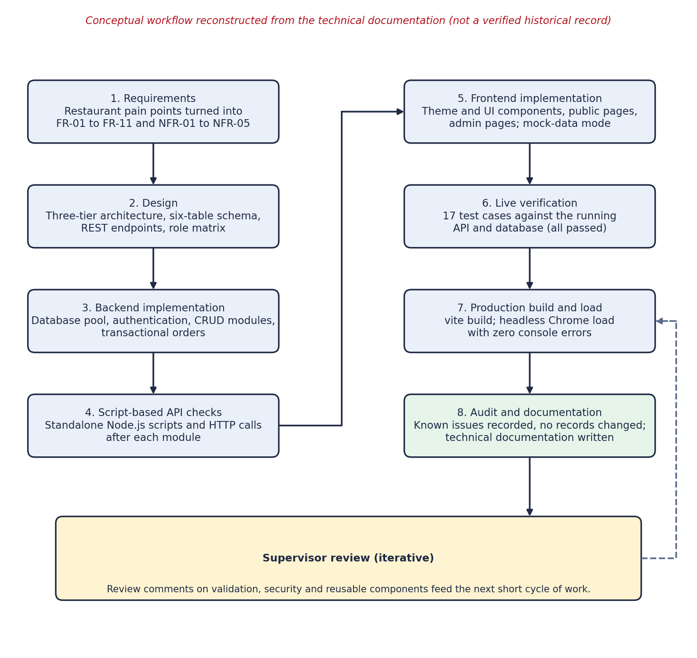
Figure 1: Conceptual development and verification workflow of the WOW Burger project
- Requirements analysis. The restaurant's pain points were turned into functional requirements FR-01 to FR-11 and non-functional requirements NFR-01 to NFR-05.
- Design. A three-tier architecture, a six-table schema with its ERD, the REST endpoints and a role-permission matrix were defined.
- Backend-first implementation. The database layer and API modules were built first and each endpoint was checked with scripts, so that the frontend could depend on a stable contract.
- Frontend implementation. The design system (theme tokens and reusable components) came first, then the public pages and the administrative pages. Mock mode allowed this to proceed alongside the backend.
- Verification. A live test suite ran against the running server and database, followed by a production build and a headless browser load.
- Audit and documentation. The code and database were inspected, known issues were recorded, and the technical documentation was written.
The tools were Node.js v24, MySQL 8, Vite, a code editor, Google Chrome, standalone Node.js test scripts and regular supervisor review. The technical documentation was prepared with the AI-assisted tool Antigravity, as noted in Section 2.6. [CONFIRM: describe your own contribution to design and coding, and how AI assistance was used.]

3.11 System Architecture and Design
The platform implements a three-tier architecture, shown in Figure 2. The presentation tier is a React single page application running in the browser. The application tier is a Node.js and Express REST API on port 5000, which holds business logic, authentication middleware, validation and transaction coordination. The data tier is the MySQL database wow_burger on port 3306. Each tier talks only to its neighbor: the browser sends HTTP requests with JSON bodies to the API, and the API sends SQL to the database through a connection pool.
Every request passes through the same pipeline. cors() allows cross-origin calls from the frontend and express.json() parses JSON bodies. The router dispatches the request to the module mounted at /api/auth, /api/users, /api/branches, /api/categories, /api/products or /api/orders. On protected routes authenticateToken verifies the JWT and loads the user, and requireRole compares the user's role with the roles allowed for the route. A missing or invalid token produces a 401 response and insufficient permission a 403. The controller then runs its query through the pool, maps database rows from snake_case to the camelCase format the frontend expects, and returns JSON.
The main components cooperate as follows. AuthContext holds the signed-in user and token, CartContext holds the cart and its totals, and ThemeContext holds the theme. The Axios client in the service layer attaches the token to each request. On the server, authMiddleware.js validates the token and role, and orderController.js coordinates the transactional checkout.
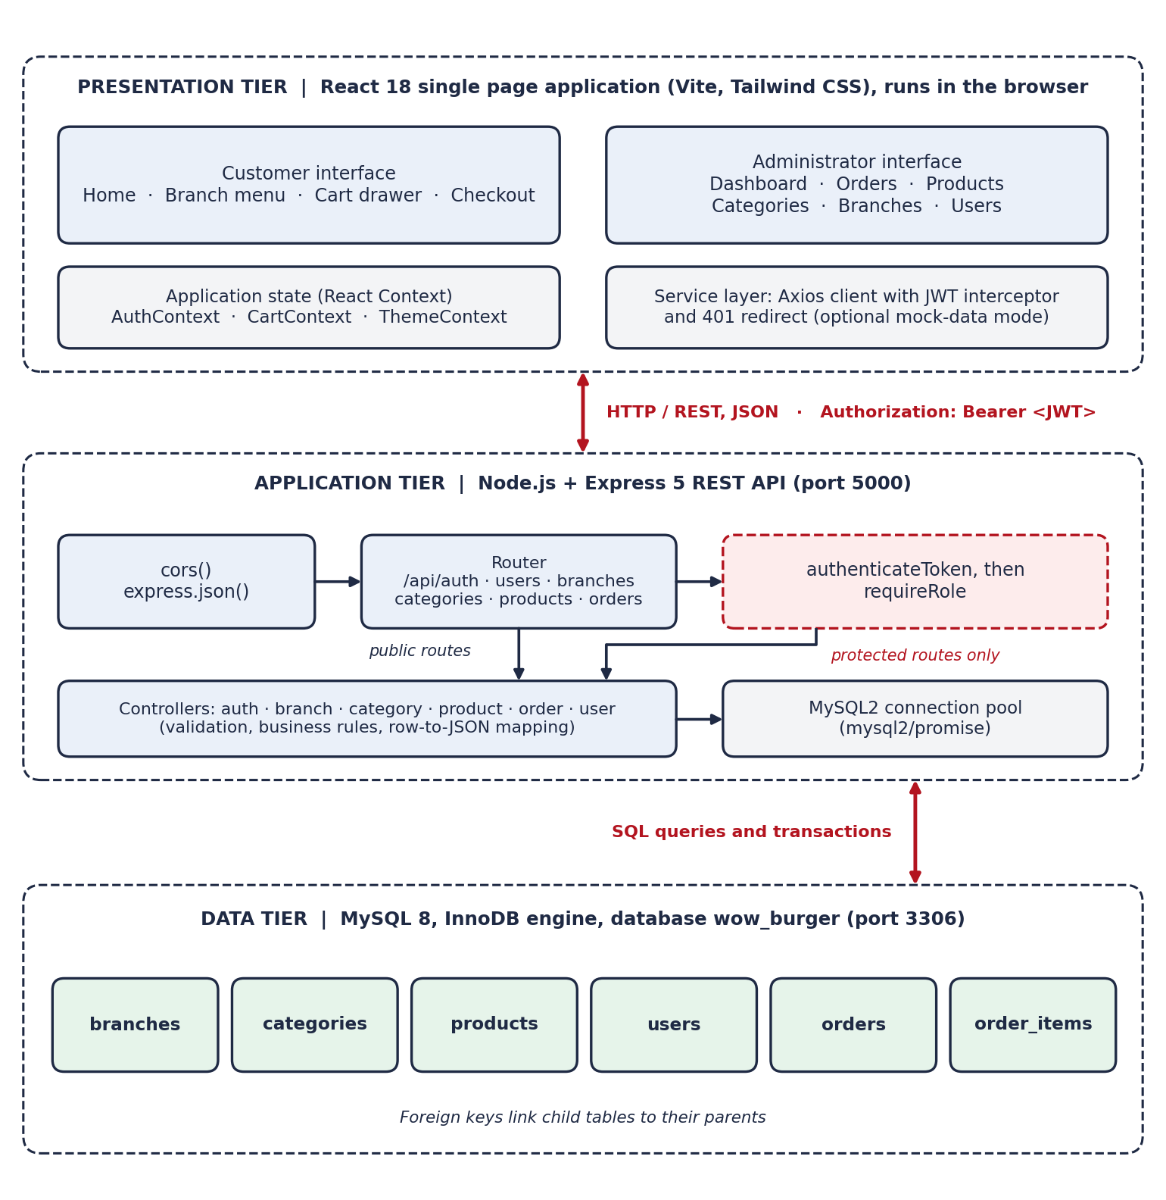
Figure 2: Three-tier architecture of the WOW Burger system

3.12 Frontend Implementation
The frontend is a React 18 single page application built with Vite and styled with Tailwind CSS. Table 7 lists its main technologies and their purposes.
Table 7: Frontend technologies
Technology | Version | Purpose
React / React DOM | ^18.2.0 | Component-based interface and rendering
Vite | ^5.2.0 | Development server with hot module replacement and the production bundler
React Router DOM | ^6.22.3 | Client-side routing, nested layouts and route guards
Tailwind CSS | ^3.4.3 | Utility-first styling mapped to semantic theme tokens
Lucide React | ^0.363.0 | SVG icon set
Axios | ^1.6.8 | HTTP client with a JWT request interceptor and 401 handling
Leaflet / React Leaflet | ^1.9.4 / ^4.2.1 | Interactive branch map on OpenStreetMap tiles
React Hot Toast | ^2.4.1 | Non-blocking notifications

Routing and structure. Routing is defined in App.jsx, wrapped in AuthProvider and CartProvider. Public pages share a PublicLayout with a skip link, header, footer and cart drawer: the home page at /, the branch menu at /branch/:branchId and the checkout at /branch/:branchId/checkout. The login page sits at /login. The admin area at /admin is placed behind a ProtectedRoute and an AdminLayout with sidebar navigation, and contains the dashboard, products and orders pages, plus the categories, branches and users pages intended for the super administrator only.
State management. React Context was used instead of an external state library because the application has only three pieces of global state. AuthContext restores a saved session on page load and discards a corrupted stored value instead of crashing. CartContext recalculates the subtotal, VAT and total whenever the cart changes, and ties each cart to one branch (cartBranchId) so that items from two menus cannot be mixed. ThemeContext follows the system preference by default and remembers an explicit choice in localStorage.
Communication with the backend. All network access goes through the services folder, with thin hooks (useBranch, useCategories, useProducts) on top. A single Axios instance attaches Authorization: Bearer <token> to every request, and a 401 response clears the stored session and returns the user to the login page. In mock mode each service answers from a local data file instead of calling the API, which allowed the interface to be developed independently of the backend.

3.13 Backend Implementation
Table 8: Backend, database and infrastructure technologies
Technology | Version / specification | Purpose
Node.js | v24.11.0 | Asynchronous JavaScript runtime
Express.js | 5.x | Routing, middleware and controllers
MySQL2 | ^3.24.5 | MySQL driver with promises and connection pooling
BcryptJS | ^3.0.3 | Salted password hashing
JSONWebToken | ^9.0.3 | Signing and verifying JWTs
CORS | ^2.8.6 | Cross-origin access for the frontend
Dotenv | ^18.0.7 | Environment-variable configuration
MySQL Server | 8.0+ or MariaDB | Relational data store
Engine and collation | InnoDB, utf8mb4_unicode_ci | ACID transactions, foreign keys and full UTF-8 text

The backend is organized by responsibility: config/db.js for the connection pool, controllers/ with one controller per module, routes/ with one router per module, middleware/authMiddleware.js, utils/ for seed and maintenance scripts, and server.js as the entry point. Configuration is read from environment variables (see Appendix G), so no credential is written into the source code.

3.13.1 Transactional order processing
An order is written to two tables: one row in orders and one or more rows in order_items. If the server or database failed between those writes, the restaurant could hold an order with missing food. The createOrder controller therefore treats the whole sequence as one transaction, as shown in Figure 3. It takes a dedicated connection from the pool, begins a transaction, verifies that the target branch exists and is active, inserts the order with the initial status pending, inserts each line item, and commits. On any failure it rolls back, and in every case it releases the connection.
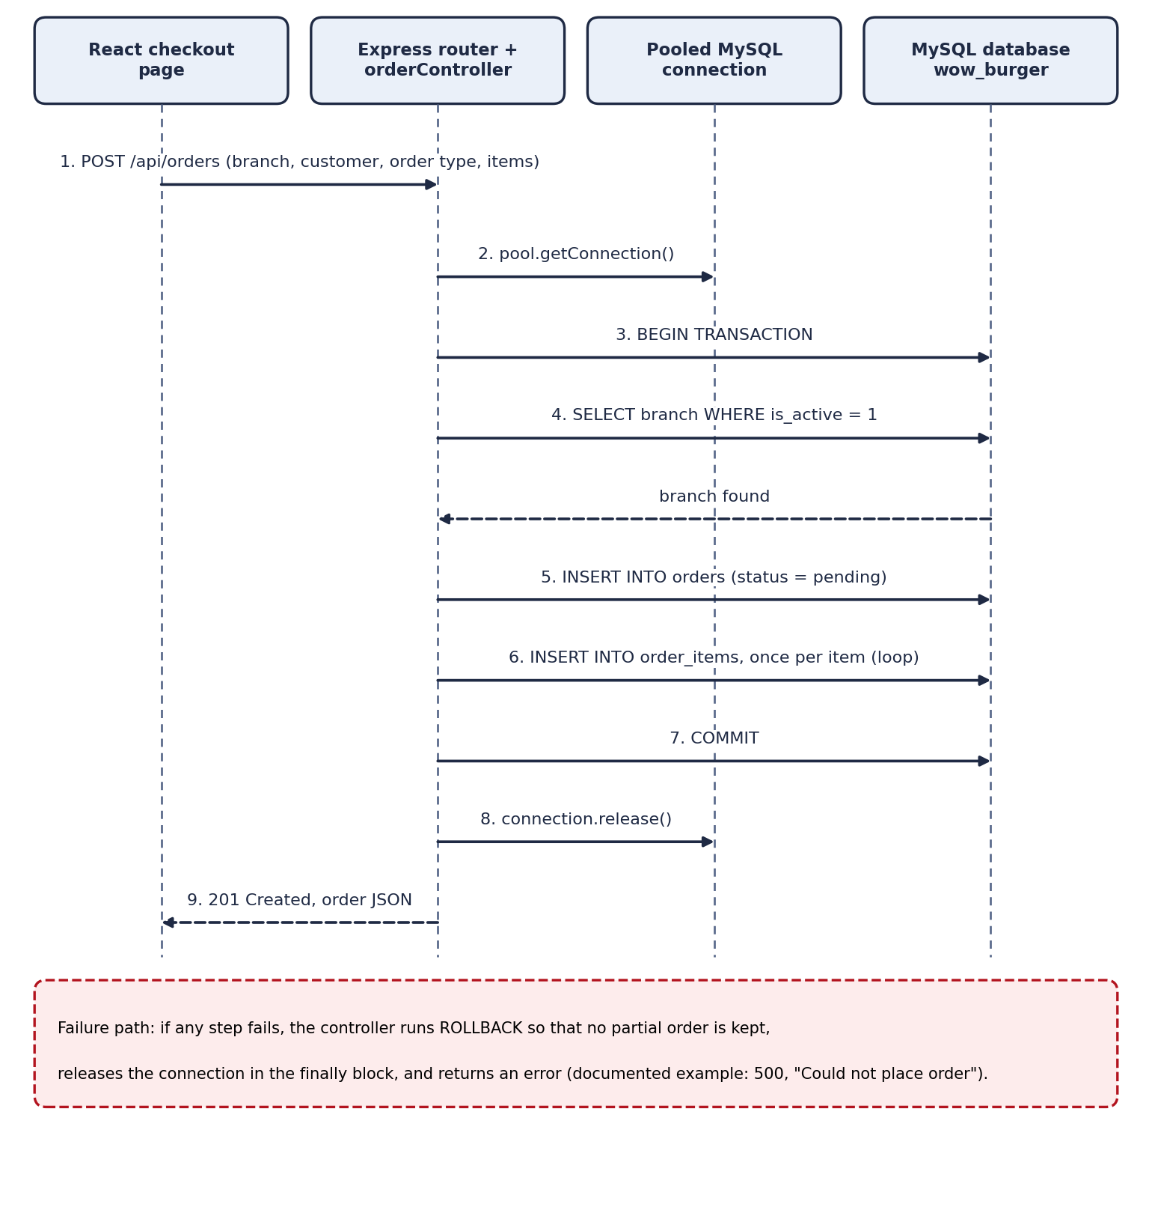
Figure 3: Order-placement sequence with transaction control
const connection = await pool.getConnection();
try {
await connection.beginTransaction();
// verify branch is active
// INSERT INTO orders (...)
// for each item: INSERT INTO order_items (...)
await connection.commit();
res.status(201).json(order);
} catch (err) {
await connection.rollback();
res.status(500).json({ message: 'Could not place order' });
} finally {
connection.release();
}
Totals follow a fixed rule: the subtotal is the sum of the line totals (unit price times quantity), the VAT amount is 15% of the subtotal, and the total is the subtotal plus VAT. The frontend shows the same breakdown in the cart and at checkout, formatted as Ethiopian Birr. The documentation describes the order controller as verifying prices, but the listed procedure does not state whether prices and totals are recomputed on the server from the stored product prices or accepted as sent by the client. This should be confirmed in the code (see Section 3.21).
An order begins as pending. Staff move it forward to preparing, ready and completed, or cancel it from an open state. The database and the status endpoint also support a confirmed state, and cancelling requires confirmation in a dialog so that an accidental click cannot lose an order.

3.13.2 Error handling
Every controller wraps its database calls in try...catch and returns a meaningful status code (see Table 11 in Section 3.15). On the frontend, session restore is wrapped in try...catch, list pages check Array.isArray() before mapping, product images fall back to a placeholder on error, and failed requests surface through toast notifications and an error component.

3.14 Database Design and Data Relationships
The wow_burger database has six InnoDB tables with the utf8mb4_unicode_ci collation. Figure 4 shows their keys and relationships, Table 9 lists the foreign keys, and Appendix C gives the column specifications.
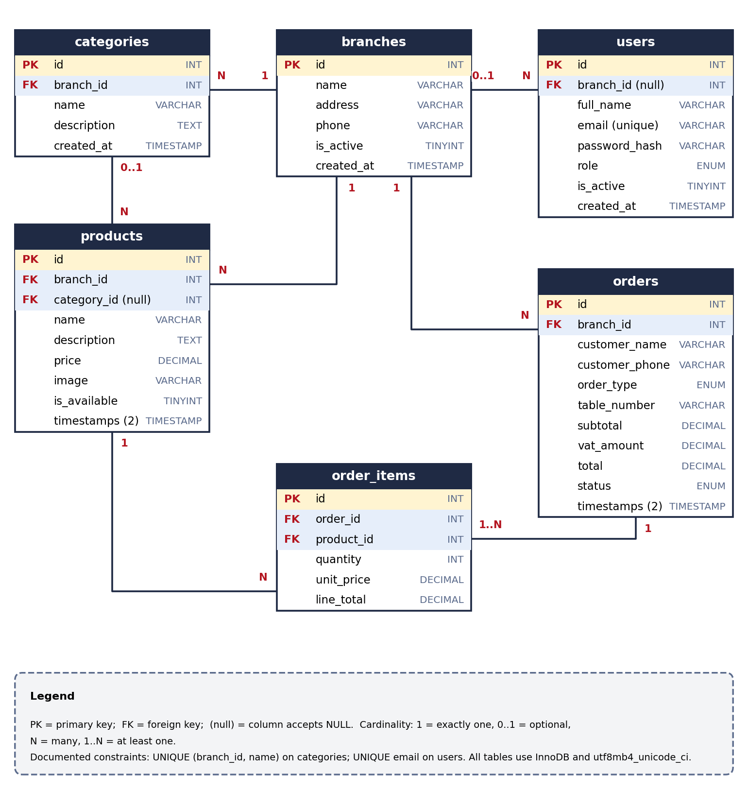
Figure 4: Entity-relationship diagram of the wow_burger database
Table 9: Foreign keys and cardinalities
Parent | Child | Foreign key | Cardinality
branches | categories | categories.branch_id | 1 : N
branches | products | products.branch_id | 1 : N
branches | orders | orders.branch_id | 1 : N
branches | users | users.branch_id | 1 : N (branch optional; NULL for super admin)
categories | products | products.category_id | 1 : N (category optional)
orders | order_items | order_items.order_id | 1 : N (at least one item)
products | order_items | order_items.product_id | 1 : N

Several design decisions are worth noting. Money is stored as DECIMAL(10,2) because floating-point types cannot represent decimal currency exactly. Each order_items row stores unit_price and line_total at the time of purchase, so a later price change does not rewrite order history. branch_id appears on categories, products, orders and users, which makes per-branch menus, queues and permissions a simple filter. The constraint unique_category_per_branch allows two branches to have a category called Burgers but prevents duplicates within one branch. Because order_items references products, products that appear in past orders are deactivated and not deleted.
The enumerations also deserve attention. The orders.order_type column allows dine_in, takeaway and delivery, but the customer interface documented here offers only dine-in and takeaway, so delivery is a database capability without a documented user flow. Role values are stored as super_admin, manager and staff (Section 3.16).

3.15 API Design and Integration
The API follows REST conventions. Resources are addressed by URL under the base path /api (in development, http://localhost:5000/api), manipulated with GET, POST, PUT, PATCH and DELETE, and answered with JSON and meaningful status codes. Table 10 summarizes the modules, and Appendix D lists every documented endpoint with its access level.
Table 10: REST API modules
Module | Base path | Documented operations
Health | /api/health | Confirms that the API and the database pool are connected
Authentication | /api/auth | Login returning a user object and JWT; profile of the token holder
Branches | /api/branches | Public list and detail; create, update and remove for the super administrator
Categories | /api/categories | Public list by branch with fallback to the main branch; create, update and delete (blocked while products reference the category)
Products | /api/products | Public catalog with branch and category filters; create, update, availability toggle, delete or deactivate
Orders | /api/orders | Customer checkout (transactional); list and detail with items; status update by staff
Users | /api/users | List, view, create, update and delete staff accounts (super administrator; self-deletion blocked)

The frontend integrates with these endpoints through the Axios service layer described in Section 3.12. The documented login exchange illustrates the format. The client posts an email and password to POST /api/auth/login; on success the API answers 200 with a user object (id, name, email, role, branch and active flag) and a signed token, and on failure it answers 401 with the message "Invalid email or password".
Table 11: Status codes used by the API
Code | Meaning in this system
400 | Validation failure: missing fields, negative price or zero quantity
401 | Missing, invalid or expired token, or wrong login credentials
403 | Insufficient role, or deactivated account
404 | Requested entity does not exist
500 | Unhandled database or server failure

3.16 Authentication, Authorization and Access Control
Password security. Passwords are never stored in plaintext. When an account is created or updated, the password is hashed with bcryptjs using 10 salt rounds and only the hash is saved in users.password_hash. At login, bcrypt.compare checks the submitted password against the stored hash. The API does not return password hashes; this was confirmed in test case TC-15.
JSON Web Tokens. After a successful login the server signs a JWT whose payload carries the user id, role and branch, with a 7-day expiry and a secret read from the JWT_SECRET environment variable. The client keeps the token in localStorage and the Axios interceptor adds it to each request. On every protected request authenticateToken verifies the signature and then loads the user to confirm that the account still exists and is active, so a deactivated user loses access even though an older token is still technically valid. Figure 5 shows the sequence.
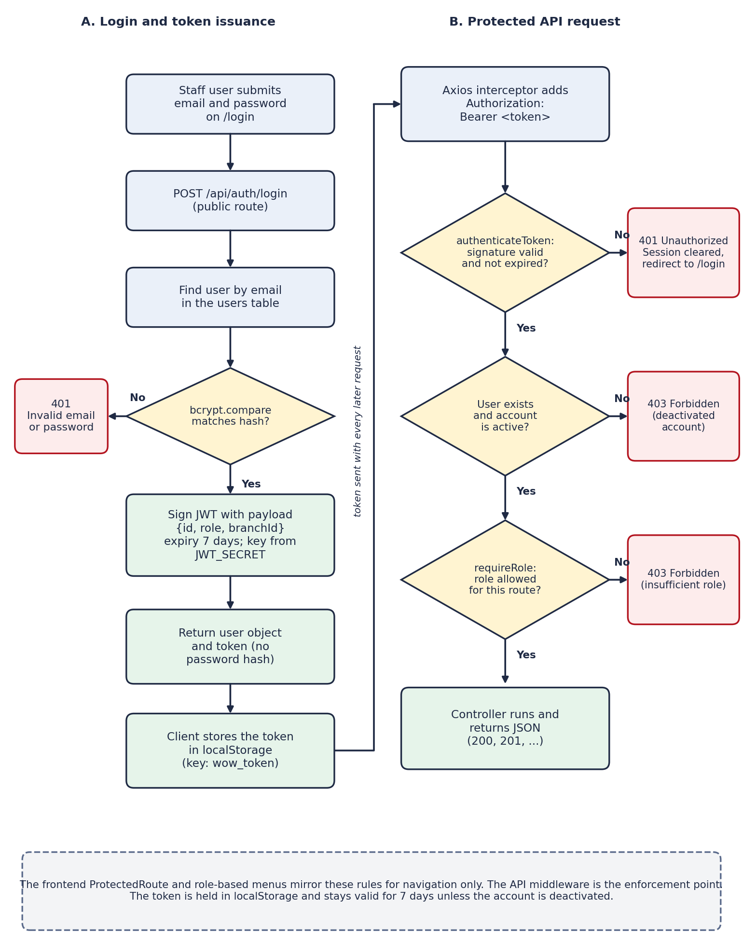
Figure 5: Administrator authentication and authorization workflow
Role-based access control. Table 12 shows the access matrix described in the documentation.
Table 12: Role-based access matrix (as documented)
Feature | Public | Branch staff | Branch manager | Super admin
Browse branches, categories and menu | Yes | Yes | Yes | Yes
Place a customer order | Yes | Yes | Yes | Yes
View admin dashboard | No | No | Own branch | All
Manage products | No | No | Own branch | All branches
Manage orders and update status | No | Yes | Own branch | All branches
Manage menu categories | No | No | No | Yes
Manage branches | No | No | No | Yes
Manage user accounts | No | No | No | Yes

The same rules are meant to be enforced in two places. On the frontend, ProtectedRoute and role-specific navigation hide pages a user may not use. On the backend, the middleware refuses the request even if someone calls the API directly. The frontend check is a convenience, and the backend check is the real security boundary. Secrets are kept in .env files and not in the source code.
Three points in the documentation need verification before the access model can be called consistent. First, the database stores super_admin and manager, while the API and frontend use superadmin and admin; the mapping works in the documented tests, but two naming schemes for one concept invite mistakes. Second, the endpoint listing gives category creation, update and deletion to "Admin / Super admin", while the matrix above and the frontend restrict category management to the super administrator. Third, the endpoint listing shows order retrieval as "Public / Admin", although orders contain customer names and phone numbers; the audit does not record whether a token is required. These points are carried into Sections 3.20 and 3.21.

3.17 Customer and Administrator Workflows
Figure 6 shows the customer journey. A customer opens the home page, selects a branch from the map or a link, browses and filters that branch's menu, opens a product and adds it to the cart, reviews the cart drawer with the subtotal, VAT and total, and completes the checkout form. The form requires a name, a phone number and an order type, and a table number for dine-in orders. If validation fails, field-level errors are shown and the customer stays on the form. If it passes, the frontend posts the order, the backend saves it in a transaction with status pending, a confirmation screen is shown and the cart is cleared. No online payment is involved: the order is settled in the restaurant.
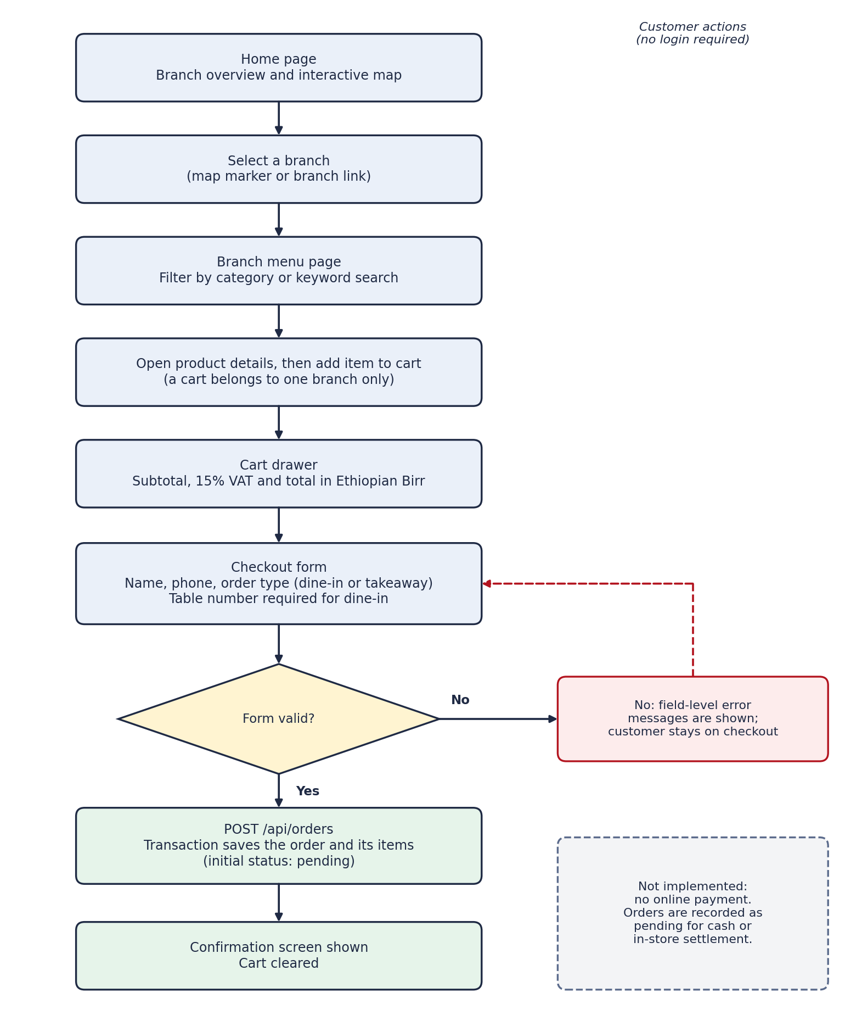
Figure 6: Customer ordering workflow
The administrator journey begins at /login. After a successful login the role decides what is shown: the super administrator sees the dashboard with all six navigation links, and a branch manager sees three branch-scoped links. On the orders page the list refreshes every 15 seconds, can be filtered by status, and lets staff advance an order or cancel it after a confirmation dialog. Managers maintain products for their assigned branch and the super administrator for all branches. Only the super administrator manages categories, branches and user accounts.

3.18 User Interface and Usability Features
Styling uses Tailwind utilities connected to semantic CSS variables, so a color change is made in one place and both themes stay consistent. The brand red (#e30613) is used for primary actions and focus rings, and the bun gold (#fbb900) for badges and price highlights. The dark theme uses near-black backgrounds with lighter card surfaces. A small component library (Button, Input, Badge, Modal, ConfirmDialog, Spinner, EmptyState and ErrorMessage) keeps the interface consistent and the pages short.
Usability and accessibility measures include a skip link, visible :focus-visible indicators, labeled form fields with descriptive error text, aria-label on icon-only buttons, dialogs that trap focus and close on Escape, responsive layouts for mobile, tablet and desktop, and an empty state instead of a blank screen when a request fails. These measures are implemented according to the documentation, but no accessibility audit with an assistive tool or user test is recorded, so conformance with WCAG 2.1 AA has not been demonstrated.

3.19 Testing Procedures and Results
The project has no automated test framework, so verification used standalone Node.js scripts and direct HTTP calls against the live backend (port 5000) and the real MySQL database, followed by a production build and a headless browser load of the frontend. Each test recorded the command, what it checks, the expected result and the actual result. Table 13 groups the 17 documented cases, and Appendix F lists them individually.
Table 13: Summary of the 17 documented test cases
Group | Cases | What was checked | Result
Service health | TC-01 | Database pool connection and database name | Pass
Branches | TC-02 to TC-04 | List, single branch, and 404 for a missing branch | Pass (3 of 3)
Catalog reads | TC-05 to TC-09 | Categories and products, with and without branch filters; price returned as a number | Pass (5 of 5)
Orders read | TC-10 | Orders returned with nested line items | Pass
Authentication | TC-11 to TC-13 | Wrong password rejected; valid login returns a token; token unlocks the profile endpoint | Pass (3 of 3)
Access protection | TC-14 to TC-15 | No token gives 401; super administrator token lists users without password hashes | Pass (2 of 2)
Frontend | TC-16 to TC-17 | Production build exits with code 0; built app mounts with no console errors | Pass (2 of 2)

The production build transformed 1,630 modules without errors in about 50 seconds. Its output was index.html (about 0.95 kB), one CSS file (about 55.25 kB) and one JavaScript file (about 522.32 kB). Because the JavaScript is a single bundle, customers also download the admin code on first visit; splitting by route would reduce this.
Table 14 separates what the documentation says is implemented from what the documented tests actually covered. This distinction matters: a feature that is implemented but not tested has not been shown to work.
Table 14: Implementation and test status of main features
Feature | Implemented (documented) | Evidence of testing
Branch, category and product read endpoints | Yes | Tested (TC-02 to TC-09)
Order retrieval with items | Yes | Tested (TC-10)
Login, JWT issue, profile endpoint | Yes | Tested (TC-11 to TC-13)
Rejection of requests without a token | Yes | Tested on GET /users only (TC-14)
Super administrator access to user list | Yes | Tested (TC-15)
Order placement (transactional POST /orders) | Yes | Not covered by the 17 cases; rollback behavior not tested
Order status update and cancellation | Yes | Not covered
Create, update and delete for products, categories, branches, users | Yes | Not covered
403 refusals for lower roles; branch scoping | Yes | Not covered
Cart, checkout validation, admin pages, map, theme | Yes | Only build and page mount (TC-16, TC-17)
Accessibility measures | Yes | No audit recorded
Mock-data mode | Yes | Not covered
Online payment | No | Not applicable (not implemented)
Real-time order push | No (15-second polling) | Not applicable
Automated tests; load testing | No | None exist

3.20 Results and Discussion
All 17 documented test cases passed. Read the way they were designed, they support four conclusions. The API is connected to the database and returns correctly shaped JSON, including a numeric price. Errors are handled with readable 404 and 401 responses instead of crashes. The login chain works: a wrong password is refused, a correct one yields a signed token, and the token unlocks a protected endpoint while a request without one is refused. The frontend builds and mounts without console errors.
Against the specific objectives in Section 3.6, the evidence is strongest for backend CRUD reads, authentication and the build. It is weaker for the cart and checkout experience, role-based access and transactional integrity, which are implemented and described in detail but have not been shown by a recorded test. I therefore describe those objectives as implemented, with verification still to be completed. Chapter 5 returns to this point.
The audit also found issues that the passing tests do not reveal. The branches table holds three records, and record 4 repeats the name, address and phone number of record 2 (WOW Burger Piassa). Products 1 to 6 are complete, while products 8 to 13 repeat their names and prices but have no image and look like leftover test records. Order 1 has no rows in order_items, whereas orders 2, 3 and 4 do. The tests pass because the read endpoints simply return what the database holds. These records were not changed, because they are shared data and changing them needs the supervisor's approval.
Security discussion should stay measured. Bcrypt hashing, signed tokens, an active-account check on each request, and enforcement at the API layer are sound practices. However, the evidence does not support calling the system fully secure. The token lives in localStorage and is valid for 7 days, there is no rate limiting on login and no multi-factor authentication, the allowed CORS origins are not documented, and the open points on categories, order retrieval and server-side price calculation (Section 3.16 and Section 3.13) are unresolved. A successful build is also not the same as a production-ready system.

3.21 Limitations and Proposed Improvements
Table 15 lists the known issues and open points, the risk each one carries, and a proposed action. No action involving existing records should be carried out without verification and the supervisor's approval.
Table 15: Known issues, risks and proposed actions
Issue or open point | Risk | Proposed action
Duplicate branch record (id 4 repeats id 2) | Duplicate branch in the public list; split order history | After supervisor approval, merge in a supervised migration; add a uniqueness rule on name and address
Products 8 to 13 duplicate products with no image | Confusing catalog and inflated product counts | Verify whether they are test records; clean up in staging first
Order 1 has no line items | Misleading totals in reports | Confirm whether it is seed data; handle it with the supervisor
Role names differ between database and API | Mistakes in role checks | Adopt one naming scheme or document the mapping in one place
Category management permission differs between API and frontend | Backend may allow more than the interface suggests | Check the route guards and align them with the intended matrix
Order retrieval listed as public | Possible exposure of customer names and phones | Verify; if public, require authentication for staff views
Server-side recalculation of prices not confirmed | A client could submit altered prices | Recompute prices and totals on the server from stored product prices
Token in localStorage; 7-day expiry; no login rate limit; no MFA | Token theft; brute-force attempts | Add rate limiting; consider HttpOnly cookies and shorter expiry; MFA for super admin
No automated tests; no load test | Regressions go unnoticed; unknown behavior under load | Add Jest with Supertest and Vitest; turn the 17 cases into the first suite
Missing ESLint configuration | Inconsistent code quality checks | Add a standard ESLint configuration and run it in CI
No online payment; polling every 15 seconds | Manual settlement; delayed order visibility | Plan payment integration with webhooks; replace polling with WebSocket or Server-Sent Events
Single JavaScript bundle (about 522 kB) | Slower first load | Split by route and lazy load the admin pages

3.22 Chapter Summary
This chapter presented the WOW Burger system from problem to results. A multi-branch restaurant needed a digital menu, accurate ordering and a controlled back office. The solution is a three-tier application with a React frontend, an Express API and a six-table MySQL database, protected by Bcrypt hashing, JWT authentication and role checks, and with transactional order handling. Seventeen documented checks passed, but they do not cover order placement, write operations or role refusals, and the audit recorded data issues and open security points. The system is a working prototype with a clear list of work still needed before it could be considered production-ready.

Chapter 4: Benefits, Learning Outcomes and Reflection
[CONFIRM: Everything in this chapter is a draft built from the project record. It describes what the work would plausibly have taught, not a verified account of your own experience. Read each subsection, keep what is true, and rewrite or delete the rest in your own words before submitting.]

4.1 Practical Skills Gained
[CONFIRM] The internship gave me hands-on experience of the full stack in one project: setting up a Node.js and Express server, designing a schema and writing SQL, building React components, connecting them to an API and producing a production build. Before the internship I had written each of these in isolation. Following one customer action from the browser through the API and a transaction into the database made the architecture concrete.

4.2 Application of University Knowledge
[CONFIRM] Several topics from my courses became meaningful in use. Normalization and foreign keys turned into decisions I had to defend, such as keeping a price snapshot in each order line. ACID transactions became the reason an order cannot exist without its items. Authentication theory became a practical choice between sessions and tokens and a salt-rounds setting.

4.3 Problem-Solving Ability
[CONFIRM] The multi-branch menu, partial-order and role-scoping problems had no ready answer in a textbook. I learned to state a problem precisely, consider two or three designs, choose one for a stated reason and test it. Writing a small script to prove an idea before changing the main code saved time.

4.4 Technical Skills and Tools Learned
[CONFIRM] New or strengthened technical skills include React with Context and React Router, Tailwind CSS theming, Vite builds, Express middleware, MySQL2 connection pooling and transactions, JWT and Bcrypt, Leaflet maps and writing technical documentation. [CONFIRM: list only the tools that were genuinely new to you.]

4.5 Teamwork and Collaboration
[CONFIRM] Working with my supervisor, Andargachew Akalu, taught me to treat review as a conversation about the work and not as a verdict on me. I learned to agree on API contracts before building both sides and to say early when I was blocked.

4.6 Leadership and Responsibility
[CONFIRM] Although I was an intern, I was responsible for planning my own tasks, deciding the order of features and keeping the documentation up to date. I learned to own a deliverable and to report honestly on its state, including what is unfinished.

4.7 Work Ethics, Professional Behavior and Workplace Adaptation
[CONFIRM] Professional ethics in software proved to be concrete. It means not storing plaintext passwords, keeping secrets out of source code, not deleting shared data without approval (which is why duplicate records were reported and not removed) and being open about known limitations. In terms of industrial psychology, I saw how short work cycles, regular feedback and clear expectations help a team stay motivated and reduce stress. [CONFIRM: add one real example of adapting to the workplace, such as working hours, communication style or handling pressure.]

4.8 Entrepreneurship and Innovation
[CONFIRM] Building for a restaurant client showed me how a small piece of software can reduce real costs, such as wrong orders and outdated menus, and how a local product must fit local conditions, such as Birr pricing, VAT and cash settlement. It made me think about the client's problem and cost before thinking about features.

4.9 Communication and Interpersonal Skills
[CONFIRM] I practiced explaining technical decisions in plain language, writing short status updates and asking precise questions. Writing the technical documentation also improved my ability to describe a system to a reader who has not seen the code.

4.10 Fit with Career Goals and Changes in Direction
[CONFIRM] The internship fits my goal of working as a software engineer in web application development. [CONFIRM: say whether your career goals changed. For example, you may have found that you enjoy backend design and data modeling as much as interface work, or that you want to learn testing and deployment more deeply. Write only what is true for you.]

4.11 Overall Value of the Internship
[CONFIRM] I consider the internship valuable because I was given responsibility for a real deliverable, received supervision and produced something that people are meant to use. That is different from a class project, because the requirements, constraints and consequences are real. [CONFIRM: describe your own feelings about the value of the internship in a sentence or two.]

4.12 Challenges Experienced
[CONFIRM] The main technical challenges are listed in Table 3. A less technical challenge was managing time. Some tasks, such as the accessibility work and the audit, may take longer than planned, and I learned to build a margin into estimates. [CONFIRM: replace with the challenges you actually experienced.]

4.13 Strengths and Areas for Improvement
[CONFIRM] Strengths: [Write your real strengths, for example persistence, testing your work before presenting it, documenting as you go, and accepting feedback.] Areas for improvement: the project itself points to useful targets: writing automated tests alongside features, planning for performance and deployment earlier, and estimating the time a task needs. [CONFIRM: edit to reflect your honest self-evaluation.]

Chapter 5: Conclusion and Recommendations

5.1 Overall Conclusion
The internship met its main purpose. I applied university theory to a real project and contributed to a system that replaces paper menus and verbal ordering with a branch-aware digital menu, consistent VAT calculation, a role-based staff back office and transactional order handling. The documented checks show that the core read, login and build functions work as designed. At the same time the evidence is limited: order placement, write operations and role refusals were not covered by a recorded test, and the audit left several data and security points open. The result is a working, documented prototype that is a sound base for further development, and not yet a production-ready system.

5.2 Extent to Which the Project Objectives Were Achieved
Table 16: Achievement of the specific objectives, based on documented evidence
Objective | Evidence | Assessment
1. Interactive menu exploration | Menu, filtering, modal and map implemented; build and page mount verified | Implemented; interactions not individually tested
2. Cart and checkout | Cart, VAT and validated checkout implemented | Implemented; not covered by documented tests
3. Backend CRUD | All modules implemented; read endpoints and user list tested | Reads verified; create, update and delete not tested
4. Role-based access control | JWT, Bcrypt and role middleware implemented; login and no-token cases tested | Partly verified; role refusals untested; open points in Section 3.16
5. Relational reliability | Six tables with foreign keys; transaction in order creation | Implemented; rollback untested; duplicate records found
6. Hybrid development mode | Live mode used in tests; mock mode implemented | Live mode verified; mock mode not tested

5.3 Main Technical and Professional Lessons
- A feature is not finished when it is written. It is finished when it has been tested, and the documented test suite shows where that step is still missing.
- Security needs consistency. Strong building blocks such as Bcrypt and JWT do not help if role names, route permissions and frontend rules disagree.
- Transactions and foreign keys protect data integrity, but data quality still needs checking. Duplicate records passed every test.
- Mock-data mode and short, agreed development cycles let frontend and backend work move in parallel.
- Honest reporting of limitations, and leaving shared data untouched until approval, is part of professional conduct.

5.4 Recommendations for the Hosting Organization
[CONFIRM: edit to match your real experience.] I recommend that Haramaya University consider Enin Tech Solutions PLC for future student placements, because the placement involved a real client project and supervised, reviewable work. To make the experience smoother for later interns, the company could prepare a short written onboarding guide covering tools, coding conventions and the project plan, and could fix a regular weekly review meeting with each intern. It could also agree on a simple definition of done for each feature, including a test, so that unverified work is visible.

5.5 Future Improvements for the WOW Burger System
Table 17 links each recommendation to the finding that supports it, so that every item can be traced to Chapter 3.
Table 17: Recommended improvements and the findings behind them
# | Recommendation | Finding it addresses | Priority
1 | Verify and align role names and category permissions; confirm whether order retrieval requires a token; recompute totals on the server | Section 3.16 and Section 3.13 open points | High
2 | Add an automated test suite (Jest with Supertest; Vitest with React Testing Library), starting with order placement, write operations and 403 cases | The test status table in Section 3.19; no automated tests | High
3 | Run a supervised data cleanup in staging, with approval, for the duplicate branch, duplicate products and the empty order | Section 3.20 audit findings | High
4 | Harden authentication: login rate limiting, restricted CORS origins, shorter token life, consider HttpOnly cookies, MFA for super admin | Token in localStorage, 7-day expiry | Medium
5 | Replace 15-second polling with WebSocket or Server-Sent Events | Delayed visibility of new orders | Medium
6 | Integrate Telebirr, CBE Birr or Chapa with webhook confirmation before an order leaves pending | No online payment | Medium
7 | Add a public order-tracking page and image upload for managers | Customer visibility; static image files | Low
8 | Add an ESLint configuration and route-based code splitting | Lint failure; 522 kB single bundle | Low

5.6 Recommendations for Future Student Internship Placements
Students placed on similar projects should ask early for the technology stack and read about it beforehand, keep a weekly logbook from the first day, agree with the supervisor on what counts as their own contribution, and record test evidence as they work, because it is much harder to reconstruct later. They should also be clear about any use of AI tools and note it in their records.

5.7 Recommendations for Improving the University Internship Program
- Earlier placement. Confirming placements well before the start would give students time to review the company's technology stack in advance.
- Industry-aligned preparation. Short workshops on version control, REST API design, testing and deployment would help students become productive faster.
- Structured supervision. A standard logbook template and at least one advisor visit or call at mid-point would keep students and companies aligned.
- Clear guidance on report evidence. A short note on how to separate implemented, tested and proposed work would make reports easier to assess.
- Duration. [CONFIRM: state whether the internship length was enough. A longer period would allow students to take part in deployment and maintenance as well, if that matches your experience.]

5.8 Final Reflection on Academic Learning and Practical Experience
The internship showed me that university learning and industry practice depend on each other. Coursework gave me the vocabulary and the foundations: normalization, transactions, HTTP, hashing and requirements. Practice taught me judgment: which trade-off to accept, when a result is good enough to show, and how to be honest about what has not been proven. I leave the internship with stronger technical skills and a clearer understanding of how much of professional software work is verification, documentation and communication.

References
References follow APA 7th edition. The university guideline does not name a citation style. Entries marked for verification are missing information that I could not confirm from the files supplied.
Elmasri, R., & Navathe, S. B. ([year]). Fundamentals of database systems ([edition]). Pearson. [verify before submission]
Enin Tech Solutions PLC. ([year]). WOW Burger web application: Technical documentation [Unpublished internal company document]. [verify author, title and date of the supplied document]
Fielding, R. T. (2000). Architectural styles and the design of network-based software architectures [Doctoral dissertation, University of California, Irvine].
Haramaya University. ([year]). Internship report writing guideline [Unpublished guideline document]. [verify year or version]
Jones, M., Bradley, J., & Sakimura, N. (2015). JSON Web Token (JWT) (RFC 7519). Internet Engineering Task Force. https://www.rfc-editor.org/info/rfc7519
Meta Platforms. (n.d.). React documentation. https://react.dev
Oracle Corporation. (n.d.). MySQL 8.0 reference manual. https://dev.mysql.com/doc/refman/8.0/en/
Provos, N., & Mazières, D. (1999). A future-adaptable password scheme. In Proceedings of the 1999 USENIX Annual Technical Conference, FREENIX Track. USENIX Association. [verify page range]
World Wide Web Consortium. (2018). Web Content Accessibility Guidelines (WCAG) 2.1. https://www.w3.org/TR/WCAG21/
[CONFIRM: if you consulted the official documentation of Node.js, Express, Vite, Tailwind CSS, React Router, Leaflet or OpenStreetMap, add each one here with its access date, and cite it in the text. Do not add sources you did not use.]

Appendices
Appendices A and B point to the main body, where the technology stack and the architecture are discussed, and add supporting detail. Appendix E contains placeholders for real screenshots, which must be captured from the running application.

Appendix A: Project Technology Stack
The frontend technologies are listed in Table 7 and the backend, database and infrastructure technologies in Table 8. The verified project structure is shown below.
WOW Burger/
backend/
config/db.js MySQL2 connection pool
controllers/ auth, branch, category, order, product, user
middleware/authMiddleware.js JWT authentication and role gates
routes/ one router per module
utils/ seedUsers.js, updateImages.js
server.js Express entry point
test-db.js connection test script
frontend/
public/images/ product images
src/components/ auth, layout, locations, menu, ui
src/context/ AuthContext, CartContext, ThemeContext
src/data/mockData.js mock-mode data set
src/hooks/ useBranch, useCategories, useProducts
src/layouts/ AdminLayout, PublicLayout
src/pages/ HomePage, BranchMenuPage, CheckoutPage,
LoginPage, admin pages
src/services/ api and per-module services
src/styles/index.css Tailwind directives and theme tokens
src/utils/ formatPrice.js, timeAgo.js
App.jsx, main.jsx, tailwind.config.js, vite.config.js

Appendix B: System Architecture
The architecture diagram appears as Figure 2 in Section 3.11, the order-placement sequence as Figure 3 in Section 3.13, and the authentication workflow as Figure 5 in Section 3.16. The request pipeline is: cors(), express.json(), the /api/* router, authenticateToken and requireRole on protected routes, the controller, the connection pool and the database, followed by a JSON response.

Appendix C: Database Design
The relationships are shown in Figure 4 and Table 9. The column specifications of the six tables follow, as documented.
Table 18: Table specification: branches
Column | Type | Constraints
id | INT | PK, AUTO_INCREMENT
name | VARCHAR(100) | NOT NULL
address | VARCHAR(255) | NULL
phone | VARCHAR(30) | NULL
is_active | TINYINT(1) | NOT NULL, DEFAULT 1
created_at | TIMESTAMP | DEFAULT CURRENT_TIMESTAMP

Table 19: Table specification: categories
Column | Type | Constraints
id | INT | PK, AUTO_INCREMENT
branch_id | INT | NOT NULL, FK to branches.id
name | VARCHAR(100) | NOT NULL
description | TEXT | NULL
created_at | TIMESTAMP | DEFAULT CURRENT_TIMESTAMP
(constraint) |  | UNIQUE unique_category_per_branch (branch_id, name)

Table 20: Table specification: products
Column | Type | Constraints
id | INT | PK, AUTO_INCREMENT
branch_id | INT | NOT NULL, FK to branches.id
category_id | INT | NULL, FK to categories.id
name | VARCHAR(150) | NOT NULL
description | TEXT | NULL
price | DECIMAL(10,2) | NOT NULL
image | VARCHAR(255) | NULL
is_available | TINYINT(1) | NOT NULL, DEFAULT 1
created_at, updated_at | TIMESTAMP | updated_at set ON UPDATE CURRENT_TIMESTAMP

Table 21: Table specification: users
Column | Type | Constraints
id | INT | PK, AUTO_INCREMENT
branch_id | INT | NULL, FK to branches.id
full_name | VARCHAR(150) | NOT NULL
email | VARCHAR(150) | NOT NULL, UNIQUE
password_hash | VARCHAR(255) | NOT NULL
role | ENUM('super_admin','manager','staff') | NOT NULL, DEFAULT 'staff'
is_active | TINYINT(1) | NOT NULL, DEFAULT 1
created_at | TIMESTAMP | DEFAULT CURRENT_TIMESTAMP

Table 22: Table specification: orders
Column | Type | Constraints
id | INT | PK, AUTO_INCREMENT
branch_id | INT | NOT NULL, FK to branches.id
customer_name | VARCHAR(150) | NULL
customer_phone | VARCHAR(30) | NULL
order_type | ENUM('dine_in','takeaway','delivery') | NOT NULL, DEFAULT 'takeaway'
table_number | VARCHAR(20) | NULL
subtotal, vat_amount, total | DECIMAL(10,2) | NOT NULL, DEFAULT 0.00
status | ENUM('pending','confirmed','preparing','ready','completed','cancelled') | NOT NULL, DEFAULT 'pending'
created_at, updated_at | TIMESTAMP | updated_at set ON UPDATE CURRENT_TIMESTAMP

Table 23: Table specification: order_items
Column | Type | Constraints
id | INT | PK, AUTO_INCREMENT
order_id | INT | NOT NULL, FK to orders.id
product_id | INT | NOT NULL, FK to products.id
quantity | INT | NOT NULL, DEFAULT 1
unit_price | DECIMAL(10,2) | NOT NULL
line_total | DECIMAL(10,2) | NOT NULL

Appendix D: API Endpoint Summary
The table lists the documented endpoints with their stated access levels. The access column reproduces the documentation and includes the points flagged for verification in Section 3.16.
Table 24: Documented REST endpoints (base path /api)
Module | Method and path | Access (as documented) | Purpose
Health | GET /health | Public | API and database status
Auth | POST /auth/login | Public | Validate credentials; return user and JWT
Auth | GET /auth/me | Authenticated | Profile of the token holder
Branches | GET /branches, GET /branches/:id | Public | List active branches; one branch
Branches | POST /branches, PUT /branches/:id, DELETE /branches/:id | Super admin | Create, update, deactivate or remove
Categories | GET /categories?branchId=, GET /categories/:id | Public | Categories with fallback to branch 1
Categories | POST, PUT /:id, DELETE /:id | Admin / Super admin (verify) | Manage; delete blocked while products exist
Products | GET /products?branchId=&categoryId=, GET /products/:id | Public | Catalog with filters and fallback
Products | POST, PUT /:id | Admin / Super admin | Create and update
Products | PATCH /products/:id/availability | Admin / Super admin | Toggle availability
Products | DELETE /products/:id | Super admin | Delete, or deactivate if used in past orders
Orders | POST /orders | Public | Customer checkout (transactional)
Orders | GET /orders?branchId=, GET /orders/:id | Public / Admin (verify) | Orders with items
Orders | PATCH /orders/:id/status | Staff / Admin / Super admin | Update order status
Users | GET /users, GET /users/:id | Super admin | List and view accounts
Users | POST, PUT /:id, DELETE /:id | Super admin | Manage accounts; self-deletion blocked

Appendix E: Representative Application Screenshots
[Insert real screenshots captured from the running application. No screenshots were supplied, so none have been invented. Replace each box below with an image and keep its caption.]
[Insert real screenshot here: Home page with the branch map]
Figure 7: Home page with the branch map (screenshot to be inserted)
[Insert real screenshot here: Branch menu with category tabs and search]
Figure 8: Branch menu with category tabs and search (screenshot to be inserted)
[Insert real screenshot here: Cart drawer showing subtotal, 15% VAT and total]
Figure 9: Cart drawer showing subtotal, 15% VAT and total (screenshot to be inserted)
[Insert real screenshot here: Checkout form with order type and table number]
Figure 10: Checkout form with order type and table number (screenshot to be inserted)
[Insert real screenshot here: Staff login page]
Figure 11: Staff login page (screenshot to be inserted)
[Insert real screenshot here: Admin orders page with status tabs]
Figure 12: Admin orders page with status tabs (screenshot to be inserted)

Appendix F: Selected Testing Cases and Results
The full list of the 17 documented cases follows. All were recorded as passed. They do not cover order placement, write operations or role refusals (see Table 14).
Table 25: Documented test cases and results
ID | Command or method | Expected | Actual | Status
TC-01 | GET /api/health | 200, status success, database wow_burger | 200, status success, database wow_burger | Pass
TC-02 | GET /api/branches | 200, array of active branches | 200, 3 branch records | Pass
TC-03 | GET /api/branches/1 | 200, Bole branch | 200, id 1, WOW Burger Bole | Pass
TC-04 | GET /api/branches/999 | 404 with message | 404, "Branch not found" | Pass
TC-05 | GET /api/categories | 200, array | 200, 6 categories | Pass
TC-06 | GET /api/categories?branchId=1 | 200, categories of branch 1 | 200, 3 categories (Burgers, Sides, Drinks) | Pass
TC-07 | GET /api/products | 200, array | 200, 12 product records | Pass
TC-08 | GET /api/products?branchId=1 | 200, products of branch 1 | 200, 6 products | Pass
TC-09 | GET /api/products/1 | 200, price as a number | 200, price 450, image path present | Pass
TC-10 | GET /api/orders | 200, orders with items arrays | 200, 4 orders with line totals | Pass
TC-11 | POST /api/auth/login (invalid) | 401 with message | 401, "Invalid email or password" | Pass
TC-12 | POST /api/auth/login (valid) | 200, user and token | 200, Super Admin user and signed JWT | Pass
TC-13 | GET /api/auth/me | 200, decoded profile | 200, super administrator profile | Pass
TC-14 | GET /api/users (no token) | 401 | 401, "Access token required" | Pass
TC-15 | GET /api/users (with token) | 200, array of users | 200, 2 users, no password hashes | Pass
TC-16 | npm run build (frontend) | Exit code 0, minified bundles | Exit code 0, 1,630 modules, about 50 s | Pass
TC-17 | Headless Chrome load of the app | No blank page or console errors | Exit code 0, page title shown, 0 console errors | Pass

Appendix G: Installation and Execution Summary
Local setup needs Node.js 18 or later (v24.11.0 was used), NPM 9 or later, and MySQL 8.0 or later (or MariaDB 10.5 or later). The steps documented are:
- Create the database: CREATE DATABASE wow_burger CHARACTER SET utf8mb4 COLLATE utf8mb4_unicode_ci;
- In the backend folder, create the .env file (variables in Table 26), run npm install, then start the server with node server.js (port 5000).
- In the frontend folder, create the .env file, run npm install, then start the development server with npm run dev (port 3000).
- For production, turn mock mode off, point VITE_API_URL to the deployed API and set a strong, unique JWT_SECRET. The documentation suggests a reverse proxy such as Nginx and a process manager such as PM2.
[CONFIRM: the documentation does not say how the tables and initial users are created (for example, a schema script or the seed utilities). Add the exact step here.]
Table 26: Configuration variables (purposes only; values are never shown in this report)
Variable | File | Purpose
DB_HOST, DB_PORT | backend .env | Address of the MySQL server
DB_USER, DB_PASSWORD | backend .env | Database account used by the API
DB_NAME | backend .env | Name of the database (wow_burger)
PORT | backend .env | Port on which the API listens
JWT_SECRET | backend .env | Secret used to sign and verify tokens
VITE_API_URL | frontend .env | Base URL of the backend API
VITE_USE_MOCK | frontend .env | Switches between the live API and mock data

Appendix H: Supporting Documents
[Attach or summarize the signed weekly logbook, the supervisor's evaluation form and the internship completion letter from Enin Tech Solutions PLC, if the department requires them. These documents were not supplied and have not been reproduced or invented.]

