Progmem vs RAM?

The Arduboy offers 32KB of Flash to store programs (known as Progmem) and 2.5KB of RAM to store variables used when executing a program. Once the Arduboy core library has been included, these figures reduce to approximately 22KB of flash and 1.3Kb RAM! Without forward planning, it is very easy to write programs that run out of either memory quickly.

Static data like the puzzle configurations in Pipes lend themselves to being stored in PROGMEM as they are relatively large (especially when storing hundreds of puzzles) and static.

PROGMEM acts differently to normal RAM and needs to be accessed using the commands pgm\_read\_byte(), pgm\_read\_word() and pgm\_read\_dword() for the data types byte (or char), int and long respectively.

What’s an array?

*Arrays* are a data structure that can store a collection of items (bytes, integers or even other objects). Arrays can be single- or multi- dimensional and the items are retrieved using an index. Arrays in an Arduboy environment have a fixed size and cannot be resized.

For example, the following snippet of code defines a one dimensional array of 5 items and populates the 3rd item.

int newArrayA[5];

newArrayA[2] = 23;

Notice that when we want to read the 3rd item from the array we actually use the index of 2. This is because in C / C++ the first position in the array is referred to a position 0. The last item ion the array can be retrieved using the index 4 which is the size of the array, 5, less 1.

Arrays can have multiple dimensions and each dimension is declared with its own size in specified in square parenthesis. For example, the code below defines an array that is 5 columns wide and 3 columns high. It then populates the cell that is in the 4th column of the 2nd row.

int newArrayB[3][5];

newArrayB[1][3] = 666;

Again, notice that the indexes are zero-based. Also notice that the declaration of the array defined the row first, followed by the column. When referring to the array using X and Y coordinates, this produces the counter-intuitive syntax of a[y][x].

Arrays can be populated as part of their declaration. The two declarations above can be extended to include initial values, as shown below:

int newArrayA[5] = { 0, 1, 2, 3, 4 };

int newArrayB[3][5] = {

{ 1, 2, 3, 4, 5 }, // row 0

{ 6, 7, 8, 9, 10 }, // row 1

{ 11, 12, 13, 14, 15 } // row 2

};

Finally, the number of items in the array can be returned using the sizeOf() function. Be warned though that this returns the number of bytes the array uses not the number of items. The sizeOf() function will return a value of 10 for the declaration int newArrayA[5] as each integer takes up two bytes. The number of items in the array can be determined by dividing the size of the array in bytes by the size of the data type, for example:

int numberOfItems = sizeof(newArrayA)/sizeof(int)

What are Sprites?

Sprites are a computer graphic which can be rendered and moved on screen as a single unit. In older systems such as the Commodore 64 and Atari, the sprite was rendered by hardware as an overlay to the normal screen image. As the sprite is an overlay, it can be moved around without it affecting the background image.

The Arduboy library has support for sprites but due to the lack of a powerful graphics processor handles them differently. When rendering a sprite, the image is mapped into a single display buffer that may already have a background image drawn on it. If you move the sprite you need to regenerate the background from its old position.

The Arduboy library also provides some nice masking utilities that allow you to render a sprite over a background and have it take that background into account. The drawing functions include:

* drawOverwrite()
* drawErase()
* drawExternalMask()
* drawPlusMask()
* drawSefMasked()

But what do they each do? Consider the following image and mask:

../Pipes_Article1_SpritesDemo/images/ball.png ../Pipes_Article1_SpritesDemo/images/mask.png

drawOverwrite() - The sprite is drawn by simply overwriting what was already there. A bit set to 1 in the frame will set the pixel to 1 in the buffer, and a 0 in the array will set a 0 in the buffer. In the example below, the black corners of the ball are visible as the ball passes into the white area.





drawErase() - Erases the sprite. When "erasing" a sprite, bits set to 1 in the sprite will set the corresponding pixel in the background to 0. Sprite bits set to 0 will not affect the background. In the example below, the ball is not visible on the left hand side of the screen as the white portions of the image has set the background to black. The right hand shows that the white sections of the image have ‘erased’ the white background.



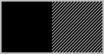

drawExternalMask() and drawPlusMask() - draw a sprite using a mask. As the name implies, the drawExternalMask() function allows the image and mask to be nominated separately whereas drawPlusMask() uses a single image with the mask embedded within it.

When rendering a sprite, bits set to 1 in the mask indicate that the pixel will be set to the value of the corresponding image bit. Bits set to 0 in the mask will be left unchanged. This can be seen clearly as the ball moves into the right hand side of the background. The top-left and bottom-right corners of the image are rendered as black as the mask is set to 1 in these areas which in turn ensures that the images pixels (both zeroes and ones) are rendered on the background.





drawSelfMasked - Draw a sprite using only the bits set to 1. Bits set to 1 in the frame will be used to draw the sprite by setting the corresponding pixel in the background to 1. Bits set to 0 in the sprite will remain unchanged in the background.

As you can see, when the ball moves onto the white and striped backgrounds the highlights on the ball are not visible on the solid white as the background is rendered (also white!) whereas the highlights are visible on the striped background. This is simply due to the position of the ball that fortuitously placed the highlights over the black area between stripes on the background.

To ensure that the ball’s highlight was always visible, you could create a mask that was the exact shape and size of the ball and was solid – without a highlight – and use either of the drawExternalMask() and drawPlusMask() functions.





A sample application that demonstrates the various draw commands can be found here >

https://github.com/filmote/Pipes\_Article1\_SpritesDemo

Decimal vs Binary vs Hexadecimal Numbers

Humans have ten fingers and it’s no wonder we have a number system based on that fact. The Hindu-Arabic numbering system which we all use is known as a positional, decimal numbering system where each column increases in value by a factor of ten. This is totally different to Roman numerals which use a range of different letters to represent different values.

With a decimal number 137, we can break it down to 1 x 100, 3 x 10 and 7 x 1.

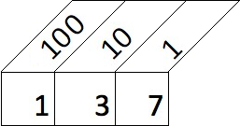

Computers store numbers as ones and zeroes in a system known as binary. Like the decimal system, each column is two times the value of the previous one. The decimal number 137 is represented as 10001001 in binary. The image below shows the number 10001001 with the decimal equivalent column value above. If you break it down, 1 x 128, 1 x 8 and 1 x 1 = 137 decimal.

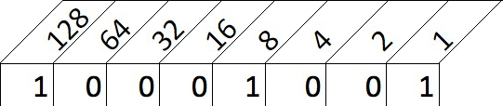

But what about Hexadecimal? Using ones and zeroes to communicate with a computer is not really human-friendly so we convert the binary numbers into a number system known as hexadecimal (or hex for short) where each column is 16 times greater than the one before it. The numbers range from 0 to 9 and then from A to F to represent the 16 ‘numbers’. So the decimal number 3 is the same as the hex value 3 and the decimal number 9 is the same as the hex number 9. The decimal number 10 becomes the hex ‘number’ A, likewise 11 becomes B and 15 becomes F. The decimal number 16 is the equivalent of the hex number 10, 17 decimal equals 11 hex and so on.

But why hexadecimal? If you recall I said computers use zeroes and ones – referred to as a bit - and groups them together in lots of eight which are known as a byte (8 bits equals 1 byte). A byte can hold a value between 0000 0000 (decimal 0) and 1111 1111 (decimal 255). Four bits can hold a value between 0000 (decimal 0) and 1111 (decimal 15) – which just happens to align with the range of a single hexadecimal value. So we use hexadecimal as it is easy for humans to read and dead simple for a computer to convert into binary.

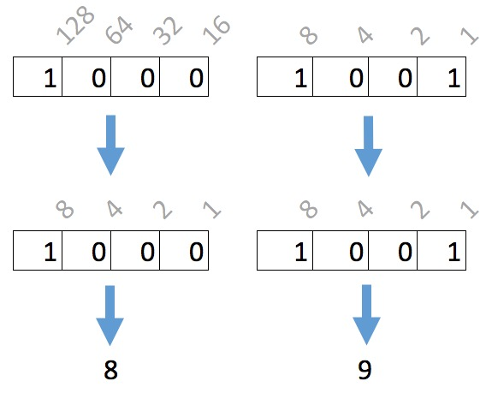

Bit Manipulation

As we discussed earlier, we can use hexadecimal notation when specifying arrays and save space by combining two values into one byte. When we read the data back we need to easily be able to split the two digits apart.

As we saw, the decimal value 137 was equal to the hexadecimal value 0x89 and the binary number 10001001.

If we want to retrieve the ‘8’ from 0x89 we can perform what is known as a ‘4 bit left shift’. A ‘left shift’ moves all values one location to the left while discarding the left most value. After four shifts, 0x89 becomes ..

1000 1001 (Original number of 0x89)

0100 0100 (1st shift)

0010 0010 (2nd shift)

0001 0001 (3rd shift)

0000 1000 (4th shift)

.. and convert this back to hex, we end up with 0x08. In C / C++ notation this is represented as 0x89 >> 4.

If we want the ‘9’ value from 0x89, we can perform some Boolean trickery by logically ANDing the value with 0x0F. This is best visualized using binary representations of the number:

1000 1001 (0x89)

AND 0000 1111 (0x0F)

---------

0000 1001 (0x09).

In C / C++ notation this is represented by the code 0x89 & 0x0F.

Stop pointing your finger at me!

For beginner programmers, one of the hardest concepts to grasp when writing C or C++ are pointers. Put simply, a pointer is a variable that ‘points’ to a location in memory where a value, a piece of text or even a piece of code lives.

The following piece of code shows how pointers work.

|  |  |
| --- | --- |
| int a = 5; | Define a normal variable and assign a value of 5 to it. |
| Serial.println(a); | This will print out 5. |
| int \*b = null; | Define a ‘pointer’. As yet it does not have a value. |
| b = &a; | Assign the memory address of the variable ‘a’ to the pointer ‘b’. The ampersand is used to retrieve the memory address of a variable. |
| Serial.println(b); | Will return a large number which is the memory address (position) in the Arduboy’s memory range where ‘a’ was stored. |
| Serial.println(\*b); | This will print out 5. The asterisk is used to retrieve the value stored in the memory address referred to by ‘b’. This is called ‘dereferencing’. |