Creating a Hex File

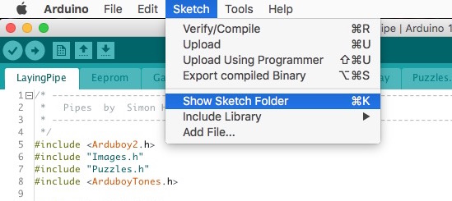

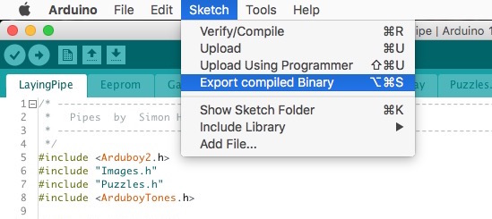

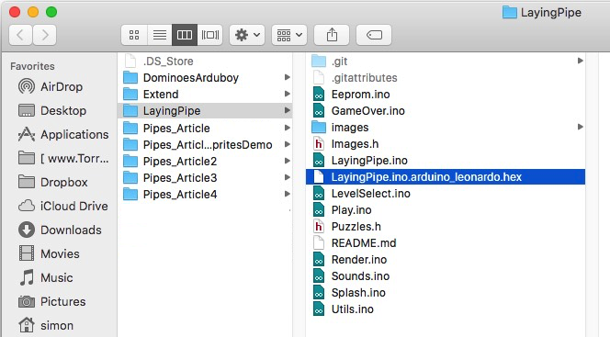

How to create an .arduboy file.

<http://www.team-arg.org/AGL-technical.html>

Using [Jeremy Dorn4](http://jeremydorn.com/) his JSON editor, we are providing a form where you can fill out all fields and it will create a correct json schema, you then can copy paste in your own info.json file. Because of the nature of the link, I had to shrink the link with TinyURL.

[http://tinyurl.com/jkw9vpf24](http://tinyurl.com/jkw9vpf)

{

  "schemaVersion": 2,

  "title" : "Pipes",

  "description" : "The classic pipe laying game for the Arduboy.",

  "version" : "1.0.0",

  "device" : "Arduboy",

  "author" : "Filmote",

  "url" : "<https://github.com/filmote/LayingPipe>",

  "sourceUrl" : "<https://github.com/filmote/LayingPipe>",

  "genre" : "Puzzle",

  "date" : "2017-06-28",

  "idea" : "Filmote",

  "code" : "Filmote",

  "art" : "Filmote",

  "sound" : "Filmote",

  "publisher" : "Filmote",

  "banner": "banner.png",

  "screenshots": [

    { "title": "Title Screen",    "filename": "screenshot00.png" },

    { "title": "Level Select 1",  "filename": "screenshot01.png" },

    { "title": "Level Select 2",  "filename": "screenshot02.png" },

    { "title": "Simple Game",     "filename": "screenshot03.png" },

    { "title": "Complex Game 1",  "filename": "screenshot04.png" },

    { "title": "Complex Game 2",  "filename": "screenshot05.png" }

  ],

  "buttons": [

    { "control": "Down",    "action": "Down" },

    { "control": "Up",      "action": "Up" },

    { "control": "Left",    "action": "Left" },

    { "control": "Right",   "action": "Right" },

    { "control": "A",       "action": "Select" },

    { "control": "B",       "action": "Back" }

  ]

}

You can use zip command in Terminal to zip the files without the *.DS_Store*, *__MACOSX* and other .* files.

Open Terminal (search for terminal in spotlight)

Navigate to the folder you want to zip using the cd command

Paste this zip -r dir.zip . -x ".*" -x "__MACOSX"

Example: Let's say you have a folder on your desktop called Folder with stuff to zip.

Open terminal and write following commands:

cd Desktop/Folder

zip -r dir.zip . -x ".*" -x "__MACOSX"

Now you have a file called dir.zip without *__MACOSX* and .* files in the folder Folder on your desktop.