Data Visualization: Assignment 4

Student 1: Filip Firkowski

Student 2: Eryk Walter

# Design

# Dashboard name and purpose

Spotify Dashboard, its purpose is to make experiencing new music easier and better.

# Tasks solved using the dashboard

1. – Finding songs based on their mood
2. – Getting recommendations to new songs
3. – Exploring new artists

# Sketches

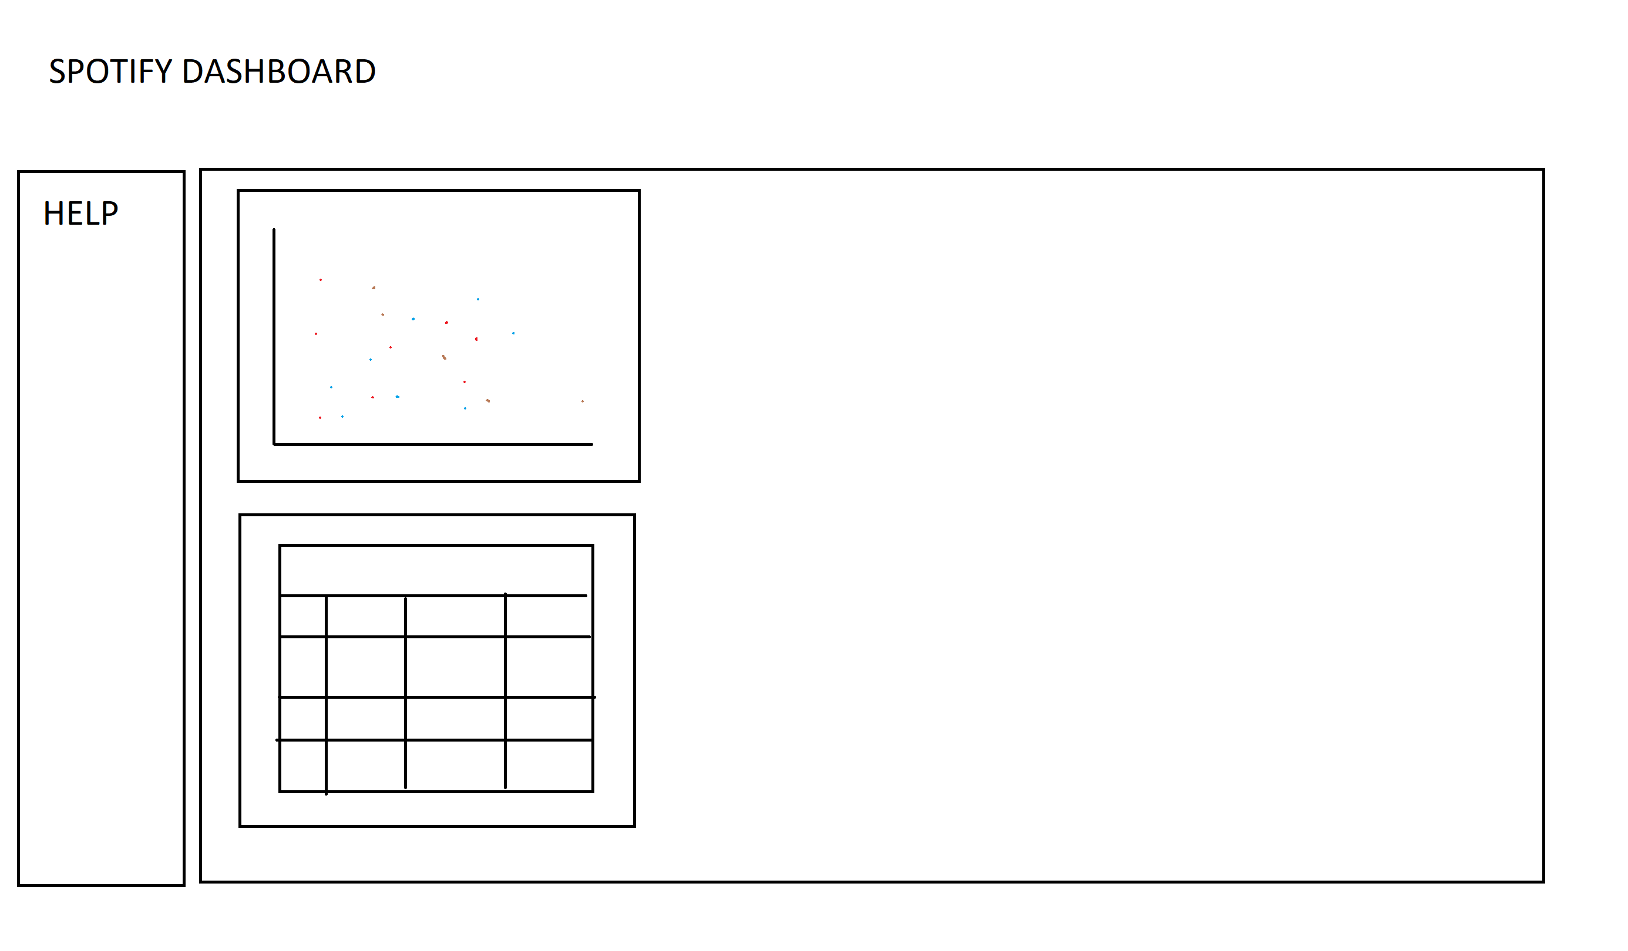

# Implementation

# Screenshots

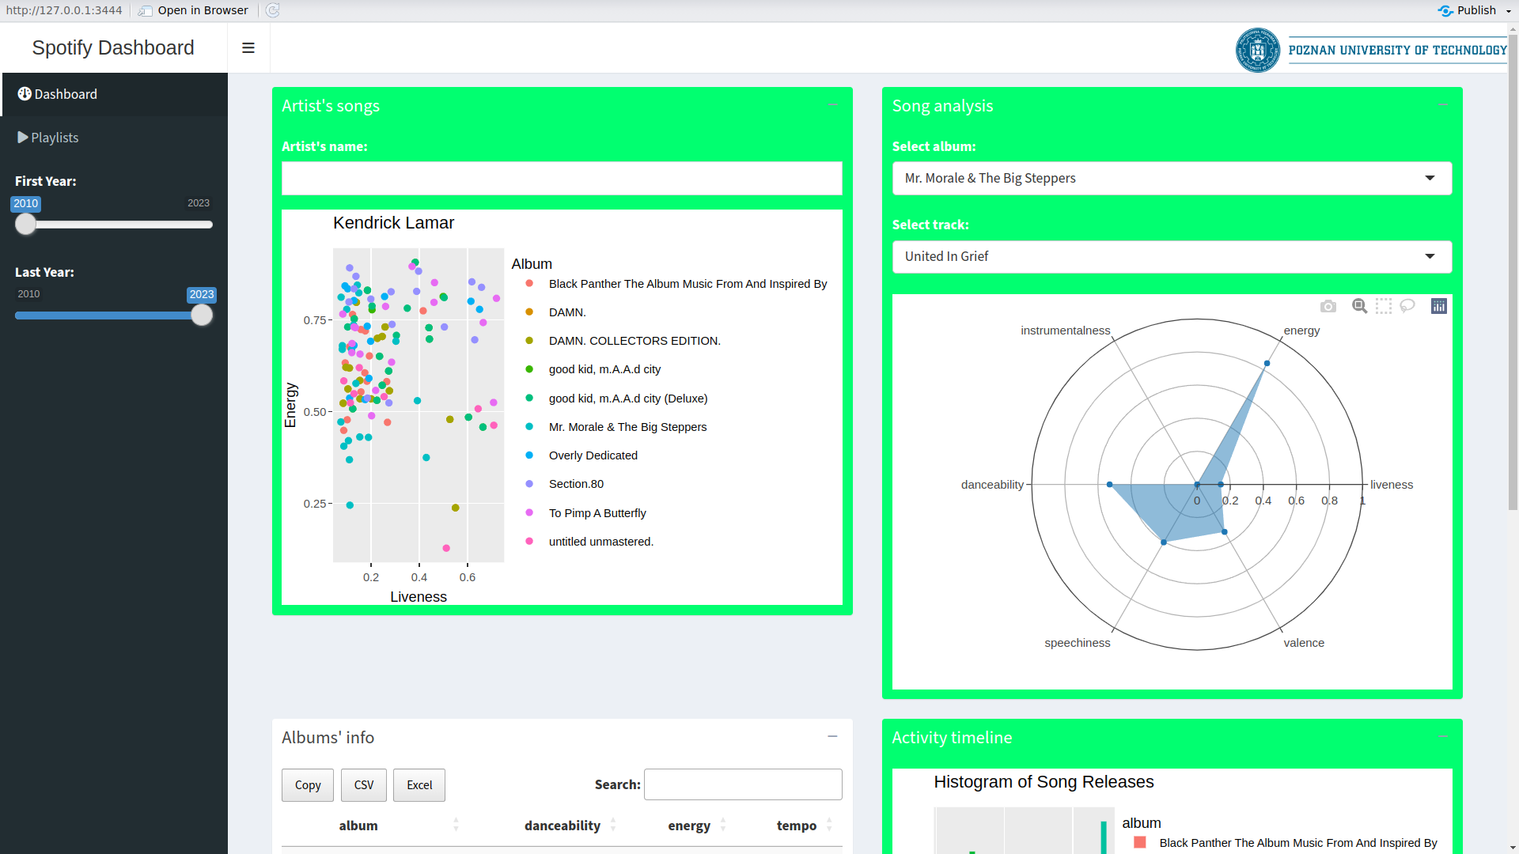

# 

# 

# Github

Repository is private, but we can add as sollaborator

# Link to live demo

<https://filo.shinyapps.io/Spotify_Dashboard/>