Project 2 Report
CSE: 420 Design of Operating Systems
Fern Potter

Description and Implementation of mapper.c

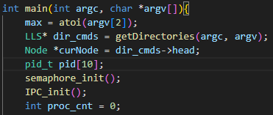
Overview
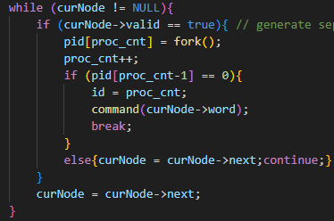
The program is split into three primary phases. First, a single process is used to interpret the command file, initialize the semaphore for later use in the bounded buffer, and initialize some data structures.
Figure 2: Phase 2 - Main work/File Parsing
The second phase takes each of these directories and forks a separate process to handle each directory. Once the contained files have been parsed and the necessary data sent to the receiver, the processes return for the final phase, which consists of freeing all dynamically allocated data.
Figure 1: Phase 1 - Setup
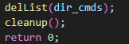

Figure 3: Phase 3 - Cleanup

Phase 1 – setup
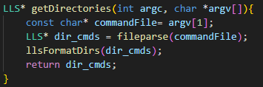
All phase 1 code is related to events that must happen before the program forks. The directory ‘map’ file must be processed, the semaphore and IPC must be initialized, and some other basic data structures must be set up. For context, the linked list data structure I made for the previous project was reused extensively. The content and functionality of this data structure are covered in my Project 1 report (see datastructures.h).
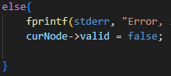
The getDirectories() function returns a pointer to a linked list of each valid directory entry contained in the given command file. getDirectories() itself calls fileparse(), which hands over a data structure containing each line of the command file. The next function, llsFormatdirs(), takes this list of lines and formats them into directory entries that can be used directly for interacting with the file system. The preceding ‘map’ command is removed along with any whitespace, and if there is formatting the program is not designed to handle, the accompanying node will be set as invalid. A repeating theme I tried to follow was separating as much of the functionality as possible into separate functions for readability. This program used a lot of features with which I was unfamiliar, and this helped immensely with debugging.
Figure 4: getDirectories()
Figure 5: Setting a node to be invalid

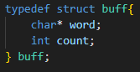
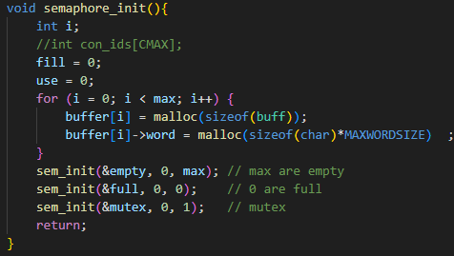
The semaphore_init() function is straightforward, using the sem_init() function to establish the empty, full, and mutex semaphores. The function also creates the bounded buffer that will be used later in file parsing and message sending. The bounded buffer is based on its own data structure, consisting of a word pointer (made to hold a space equivalent to the constant MAXWORDSIZE) and an integer count variable.
Figure 7: buff struct
Figure 6: Semaphore Init
Leaving the setup phase, we now have our bounded buffer established, the semaphores and IPC initialized, and our list of directory commands ready to begin processing our files.

Phase 2 – File Parsing
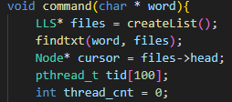
In the main loop, we begin by breaking away a process for each valid directory command based on the list created in setup. A single parent process iterates through the list and forks a child process that handles the directory through the command() function. The command() function can be thought of as the main() for each child process. After leaving command(), the only items left for each child process are some small cleanup tasks.
Figure 8: command() - setup for multithreading
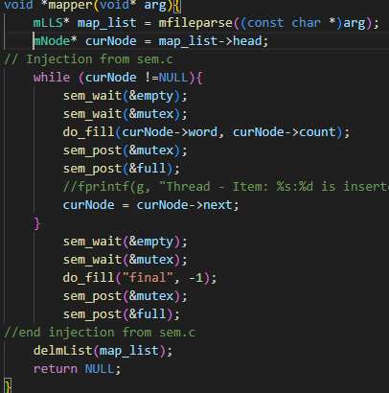
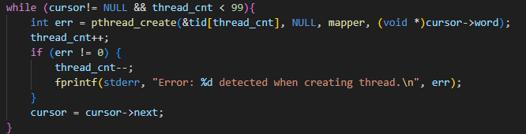
Each child process begins in command() with the directory entry string it is supposed to process. Findtxt() takes a list and a directory name string. It then iterates through each directory entry, adding each .txt file it finds to the list. Crucially, it also appends this file to the directory name so that the resulting string can be used directly by fopen().
Figure 10: mapper() call
Figure 9: Multithreading While loop
With this resulting list of ‘.txt’ files, each process then breaks off a thread for each file found. These threads go on to process the file contents, while the parent thread continues to the consumer() function, which receives the parsed information in the bounded buffer. Each thread sent off to the mapper function immediately parses the entire file it was handed in the mfileparse() function. Note that an additional linked list data structure was created to handle the map data structure that is sent to the reducer; it is essentially a copy of the linked list used in Project 1, but with added functionality for the slightly different node structure used.
The thread then iterates through this list and inserts each node into the bounded buffer using semaphores, along with a final message to communicate that it has completed.
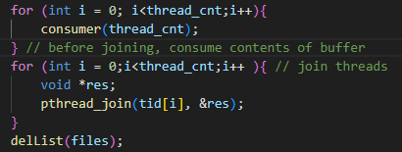
While all this is going on, the parent process calls the consumer() function, which uses the same semaphores and bounded buffer to consume the data and add it to a list. This list is then used to send the data over IPC to the reducer via the SendmList() function. For simplicity, this function uses a basic blocking send and iterates through the list, sending each item until the list is empty. To begin and end IPC messaging, the mapper.c file is used as the key (see IPC_init() in datastructures.h). Additionally, start and end messages are both sent from the startTransaction() and endTransaction() functions so that the reducer can keep track of the number of processes sending it data. startTransaction() also ensures that messaging is working properly before proceeding. Once the last item on the list is sent, the parent thread can exit the consumer() function and rejoin all the threads. On exit, the dynamically allocated memory used herein is freed and control is returned to main().
Figure 12: Consumer calls, joining, clenaup
Figure 11: SendmList()

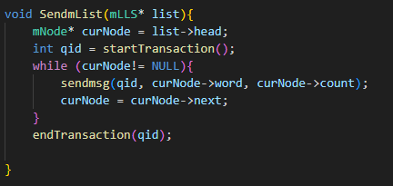

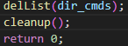
Phase 3 – Cleanup
Figure 13: Cleanup
By far the simplest phase, this phase merely deallocates any remaining data structures that have not already been deallocated. The cleanup() function is called to deallocate the bounded buffer, and the directory commands list is deleted using the linked list member function delList().

Description and Implementation of reducer.c

Overview
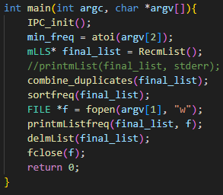
The reducer.c program consists of two primary phases: the IPC reception of mapper data and the processing of this data. The first phase is entirely contained within the RecmList() function. The second phase consists of combining duplicates (guess which function in main() does that), sorting, and removing those below the given frequency (handled in sortfreq()). Again, the structure was made to encourage the separation of functionality whenever possible so that readability is improved.
Figure 14: main()

Phase 1 – List reception
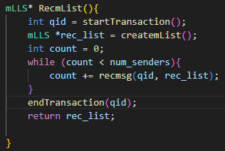
Figure 15: RecmList()
The list reception operates similarly to the mapper implementation, with startTransaction() using the ‘mapper.c’ key and checking that messaging is working. Checking that messaging is working was implemented as a debug feature because messaging tends to be a more sensitive process, and it is very helpful to know when messaging was broken versus when my data was lost somewhere else in the code.
The code initially sets the global variable num_senders to a large value for initialization. The recmsg() function then waits until it receives its first ‘start transaction’ message; it then sets the number of senders to 1. After this, for every ‘start transaction’ message it receives, it increments num_senders. It also serves to increment count by returning 1 for every ‘end transaction’ message it receives. The recmsg() function also takes each mapper item and inserts it into rec_list.
Once the while loop has determined that each message sender has finished sending messages, it ends the messaging by deleting the list. Note that this assumes that each process has some overlap with the others during the time it spends sending messages. It could be added that each process sends a special message giving information on the total number of transactions expected; however, this design worked without error and was chosen for simplicity.

Phase 2 – Sorting
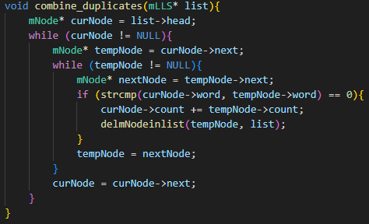
The sorting process begins by combining duplicate words (combining their counts and condensing them into one node). It does this by taking each node and searching the list for any nodes after it in the list with the same string. If it encounters this case, it adds the found node count to the original and deletes the found node. This function sets up the preconditions necessary for the sorting algorithm.
Figure 16: combine_duplicates()
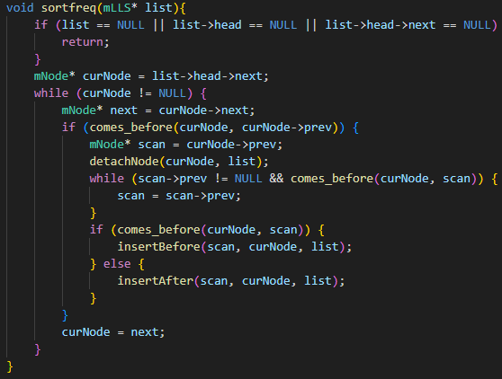
The sortfreq() function uses a form of insertion sort. The function iterates through each node in the list. If the count for the node ahead of it in the list is less than its own, it removes the node from its current position and mends the list using detatchNode(). It then searches up the list until it finds the proper location for that node.
Figure 17: sortfreq()
The comes_before() function returns either the result of node1 < node2 or the result of strcmp() should their counts be the same. This way each node is sorted first by count, and if their counts are equal, they are sorted alphabetically.
In hindsight, the insertAfter() function is not really necessary, but at one point in the development process it was needed. Since the program works as is, it was left in as a vestige.

Memory Leaks and Results
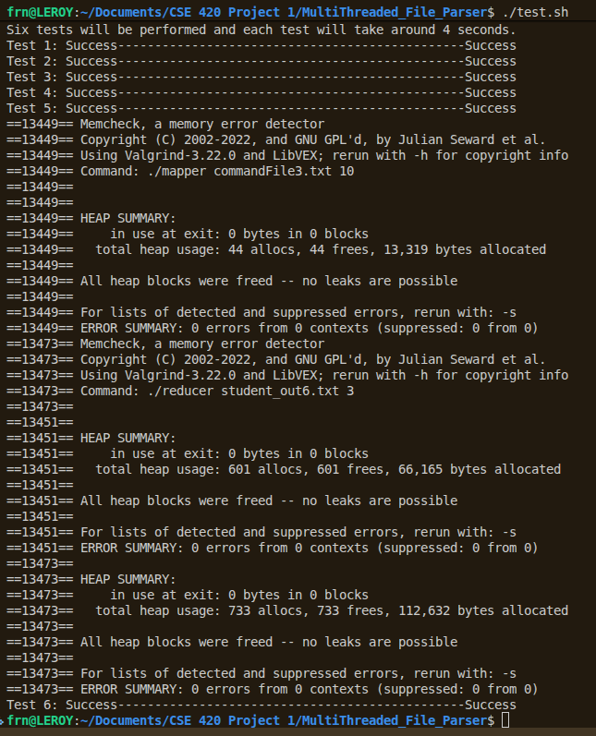
The program is free of any memory leaks. To show this, I chose to run Test 5 using Valgrind, which uses commandFile3, since commandFile3 is the only file with multiple search directories. The results are shown in the figure to the right. The program did pass valgrind on the remaining tests, but I omitted these from the results for brevity. Additionally, the program passed all black-box testing scripts.

