Project Plan

Survey application

Version | Change decription | Person | Date

Returned: _____________________
Checked: _____________________
Approved: _____________________

Contents
1 Preword 4
1.1 General description of project 4
1.2 Target of project 4
1.3 Project Group 4
1.4 Rights to deliverables of project 4
2 Project phases 4
3 Resource and TIME allocation plan 5
4 Working methods and tools 5
4.1 Tools and devices 5
4.2 Documentation methods and tools 5
4.3 Working methods 5
4.4 Risk management 6
4.5 Working roles and responsibility areas 6
4.6 Reference list 6
5 Project Control Plan 6
5.1 Following the status of the project 6
5.2 Schedule 6

Preword

General description of project
This project is created
<to whom>

Target of project
<Describe accurately what is delivered from this project>

Project Group
<Role and contact information to all project members and cuswtomer>
Role: (Manager, developer, controller ...)
Name:
Tel:
e-mail:
<Link to projects common file area>

Rights to deliverables of project
<System or parts of it can become financially important, so it is wise to make an agreement as early as possible, who will own rights for the system software and HW design. >
<VAMK will hold all the rights for system developed to be used as non-commercial ways. e.g. use in educational purposes without fees.>

Project phases
<Project is divided into three phases, Prestudy, Prototype 1 and prototype 2>
<Each phase is divided into tasks 10-50 depending on the size of the project>
<Project plan is made into dotProject, that can be found on http://alpha.cc.puv.fi/dotproject/index.php>
<From dotproject the project schedule can be printed here>
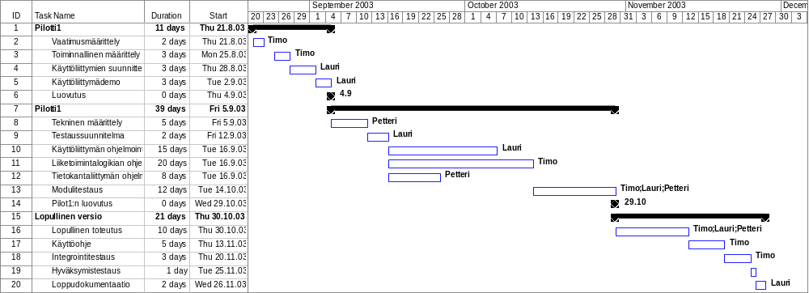

Resource and TIME allocation plan
<Project resources are calculated to each person so that workload is divided equally >
<Available allocated resource hours per people is calculated from school time table multiblied by 2 e.g. if students have 4 hours / week time for the course then available hours are 2*4=8h/week>

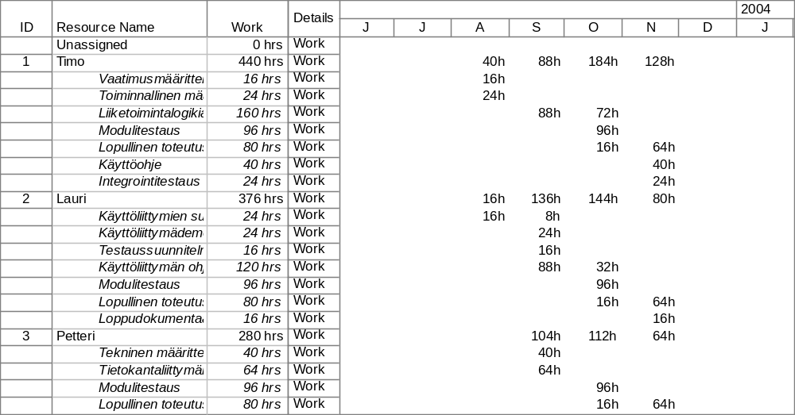

Working methods and tools

Tools and devices
<Needed devices and development tools, purchase plan and availability of them>
<Compilers, version control system, test equipment, development kits, ...>

Documentation methods and tools
<Course teacher will deliver Document templates>
<Document quality control methods>
<Documenting sohtware and HW design>
<Minutes of Review meetings and team meetings >
<Change control and reporting>

Working methods
<Weekly team leader meetings, team meetings, phace reviews, ...>

Risk management
<How to do risk analysis, risk plans, risk control>
<Use following table to evaluate the risks in project. Find at least 10 possible risks an estimate in scale 0-3 (3 is highest) the probability of the risk and impact of the risk. Multiply them and each risk that will get higher result than 3, has to be planned some actions to get the probability or impact lower

Risk | Ananlysis | Action
Experience of persons making the estimation are weak | 2*2=4 | Create new estimates during project.
Major changes of requirements during project | 2*3=2.0 | Write down, priorize and discuss with customer before project

Working roles and responsibility areas
<Define in detail responsibility areas for each member of the project environment >

Reference list
<Collection of used reference documents>

Project Control Plan

Following the status of the project
<How to follow that project is on time and all needed actions have been made. Following the quality of the project deliverables, Following the resources allocation (not too much/little work for anyone)>

Schedule
<Milestones, deliverable delivery timetable, reviews, demostrations>
<Ream biweekly control meetings>

