Project Plan

Survey application

Version | Change decription | Person | Date

Returned: _____________________
Checked: _____________________
Approved: _____________________

Contents
1 Preword 4
1.1 General description of project 4
1.2 Target of project 4
1.3 Project Group 4
1.4 Rights to deliverables of project 4
2 Project phases 4
3 Resource and TIME allocation plan 5
4 Working methods and tools 5
4.1 Tools and devices 5
4.2 Documentation methods and tools 5
4.3 Working methods 5
4.4 Risk management 6
4.5 Working roles and responsibility areas 6
4.6 Reference list 6
5 Project Control Plan 6
5.1 Following the status of the project 6
5.2 Schedule 6

Preword

General description of project
This project consists of a web application which provides user interface and communication with database.

Target of project
This project is created to provide students, teachers and other users with functionality of creating surveys and collecting data from them.

Project Group
Role: Developer
Name: Egor Filonov
Tel: +358449164716
e-mail: e1700698@edu.vamk.fi

Rights to deliverables of project
VAMK will hold all the rights for system developed to be used as non-commercial ways. e.g. use in educational purposes without fees.

Project phases
Project is divided into two phases, Pre-study and Prototype 1
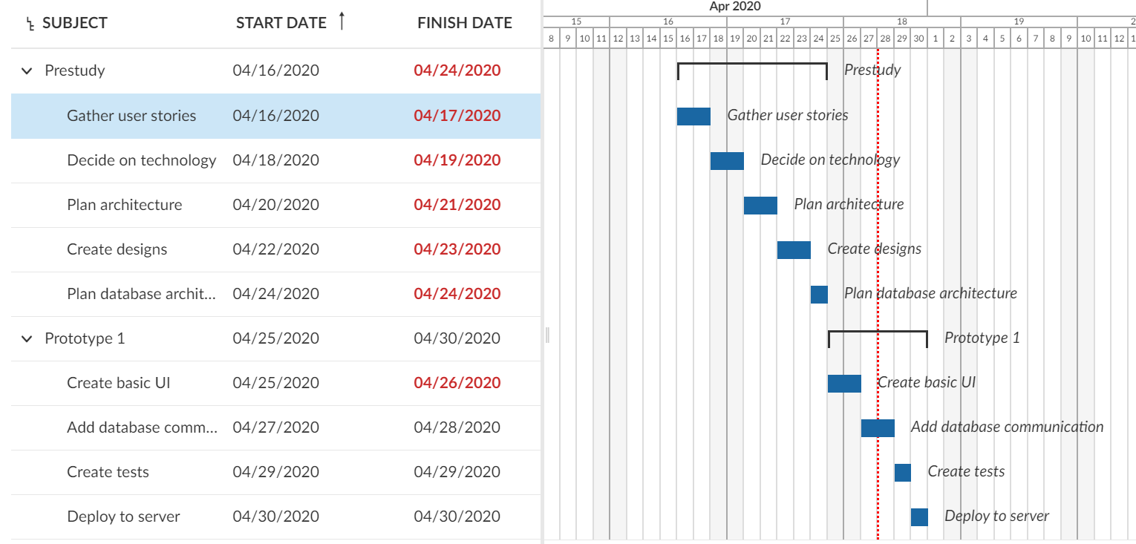

Resource and TIME allocation plan
The team of the project consists of one member – Egor Filonov, therefore, all the tasks were allocated to the one member.

Working methods and tools

Tools and devices
Compilers:
- Typescript compiler
Version Control System:
- Git
Testing library:
- Jest
Development library:
- ReactJS
Database:
- Firebase

Documentation methods and tools
Documentation was recorded in README.md file in the project repository.

Working methods
The work was done with the respect to the project plan discussed previously with the supervisor of the course.

Risk management

Risk | Ananlysis | Action
Experience of persons making the estimation are weak | 2*2=4 | Create new estimates during project.
Major changes of requirements during project | 2*3=6 | Write down, prioritize and discuss with customer before project
Database will be unreachable | 0*3=0
Application architecture might be not suitable | 1*3=3 | Create flexible and scalable architecture
Design will not satisfy the customer | 2*2=4 | Use design templates which are easy to modify and discuss design with the customer throughout the development process
Security issues might arise | 1*3=3 | Do not store personal data or any sensitive data
The application might be error-prone | 2*3 | Write necessary test for all the functional parts of the application

Working roles and responsibility areas
The team consists of one member – Egor Filonov, who is responsible for planning, design, architecture, development, testing and communication with a customer.

Reference list
React documentation: https://reactjs.org/
React Router documentation: https://reacttraining.com/react-router/
Design library documentation: https://material-ui.com/

Project Control Plan

Following the status of the project
The progress of the project was maintained by Egor Filonov.

Schedule
Demonstrations and meetings were held according to the customer demands for the changes in the project.

