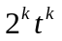 = 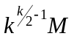

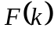 = 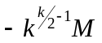

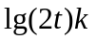 = 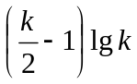 + 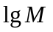
Let 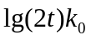 = 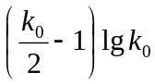 + (*)
Let = 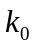 + ; 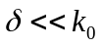
+ 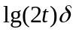 + + 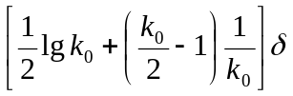
From (*) 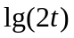 = 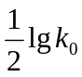 + 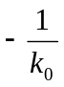
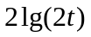 = 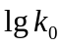 + 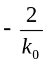
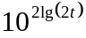 = 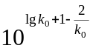
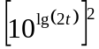 = 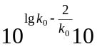
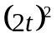 = 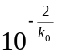
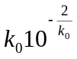 = 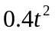
= , 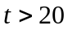

Natural logarithm 10

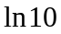 = 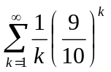 = 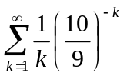 = 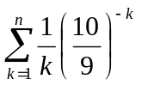 + 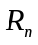
Rest
 = 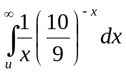, = 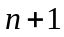
 = 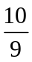
= 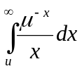 = 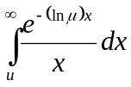 = 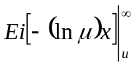 = 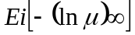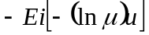 =
Asimptotic


 