|  |
| --- |
| **Quality of Life Solutions** |



**Business Plan**

**14.12.2017.**

Studentski trg 16

11000 Belgrade, Serbia

mi171047@alas.matf.bg.ac.rs

mi171054@alas.matf.bg.ac.rs

mi171089@alas.matf.bg.ac.rs

# 1. Table of contents

1. Table of contents 2

2. Executive Summary 3

3. Business Description and Vision 4

4. Definition of the Market 5

5. Description of Products and Services 6

6. Organization and Management 9

7. Marketing and Sales Strategy 10

8. Financial Management 11

8.1. Projected income statement (1 year forward) 11

8.2. Projected cash flow statement (1 year forward) 11

8.3. Total yearly cash flow statement (1 year forward) 12

8.4. Net profit 13

# 2. Executive Summary

Quality of Life Solutions is a group of young, enthusiastic developers dedicated to creating software that helps people in their daily lives. Using their knowledge in the fields of robotics, computer vision, intelligent sensors and internet technology, these young people strive to make peoples’ lives easier and more relaxed.

After writing many research papers, attending many seminars and courses, the team decided to embark on their first journey – the SRHC project.

The SRHC is designed to do all those tiring daily chores around the house that take away so much energy and life from us. It will allow us to have more time for ourselves and our loved ones.

Do you have a 9 – 16 job every day? Do you travel home for hours only to find it in a mess? Then SRHC is the thing for you. Just turn it on in the morning, and by the time you are back, your home will be sparkly clean and in perfect shape. You can just sit back and relax, spend time on your hobby, sport, children – all the things you love!

|  |  |
| --- | --- |
| Name | **Quality of Life Solutions** |
| Short name | **QoL Solutions** |
| Location | **Studenstki trg 16, Belgrade, Serbia** |
| Phone no. | **011 – 1237 – 456** |
| Mail | **qol@solutions.com** |
| Date | **08.08.2017.** |
| Owners | **Nikola Dimitrijević**  **Strahinja Stanojević**  **Ana Bajić** |

# 3. Business Description and Vision

The team assembled with one goal – making life simpler for everybody. We realize that life can get tiring from time to time – we all experienced a long day at work at least once. Then we would get home and noticed all the dust laying around, the mess our pet made, windows almost black from all the smog from the streets and realize it’s all up to us to clean it. But imagine having someone to help you in these tasks. Not only would we have more time for activities we enjoy, but we would be fully rested and more productive at work.

The company was formed in early august of this year. The team members are professionals in robotics and internet technologies. The team is small for now, counting only 3 members, but we intend on expanding in the future – both employing more people and opening offices around Europe. We have developed a strong partnership with science and technology centers in Germany, Switzerland and England.

Our goal is to create software and robots that will help us in everyday life, starting with a robot cleaner but then expanding to smart kitchens (fridges keeping track of expiration dates, stoves and ovens that know how to cook by themselves, without presenting any danger), robot helpers for old people and people with disabilities who can’t take care of themselves, or have no one to take care of them etc.

Our company thrives on teamwork, we believe that your colleagues are your second family and you should feel at home at the workplace. Thus, we motivate our employees to interact with one another as much as possible, especially during company organized team-building exercises. We encourage our workers to be very creative, which we try to motivate on our brainstorming sessions which are organized often with the whole team. Lastly, we value when our employees show initiative. Because we make a home-like environment, we try very hard not to allow procrastination, so when employees show initiative it helps to restore the balance in the workplace which we highly encourage and reward.

# 4. Definition of the Market

Our target market consists of every single person that lives under a roof – be it young, old, single, in a family, rich or poor.

Our clients are typically, but not limited to, regular human beings, politicians and lawyers. Regardless of whether or not you are busy, employed, family oriented or full of free time, the SRHC will make your everyday life easier with its outstanding usefulness.

Because of the fast technological advances, the team pays a lot of attention to analyzing the market, following its changes, appearances of new robot models and other technologies so that they could successfully to the needs and wishes of potential buyers. We expect that the production amount would rise yearly, while the market share would almost always be at 100%, because of the clear advantages over the competition.

# 5. Description of Products and Services

The robot consists of hardware and software components, that put together make a modern cleaning machine. Some of its features are:

* It can clean all surfaces, including the hard-to-reach ones.
* It starts its daily routine by scanning the room and finding important surfaces in need of cleaning.
* It can finish its routine without damaging or hurting anything in its way.
* It can calculate its distance from the charging station and arrive at it before the battery runs out.
* It can detect that its garbage bag is full and dispose of it on its own.
* It’s made of high quality materials, making it resistant to any damage.

Some of the key components are:

* Processor – the brain of the robot, needed for calculations and computing. It can’t be a regular processor, since some operations need to be faster and more optimized.
* Sensors – used to gather information about the SRHC surroundings, which include movement sensors, static object sensors etc.
* All sorts of microchips needed for different functionalities.
* Steel chassis
* Wheels, levers and other necessary extensions.

# 5. Description of Products and Services

Some of the modes include:

* Regular vacuuming.

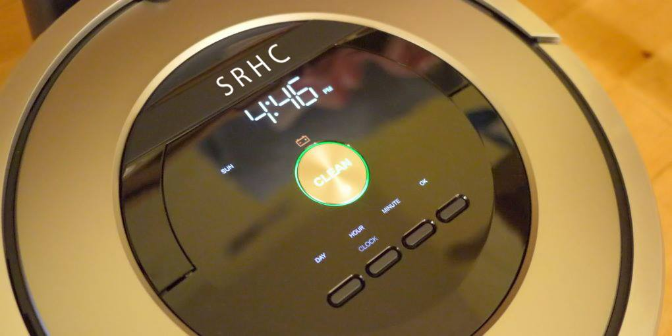

This is the default mode. The SRHC can navigate around the rooms, reaching all areas in need of cleaning.

* Dusting.

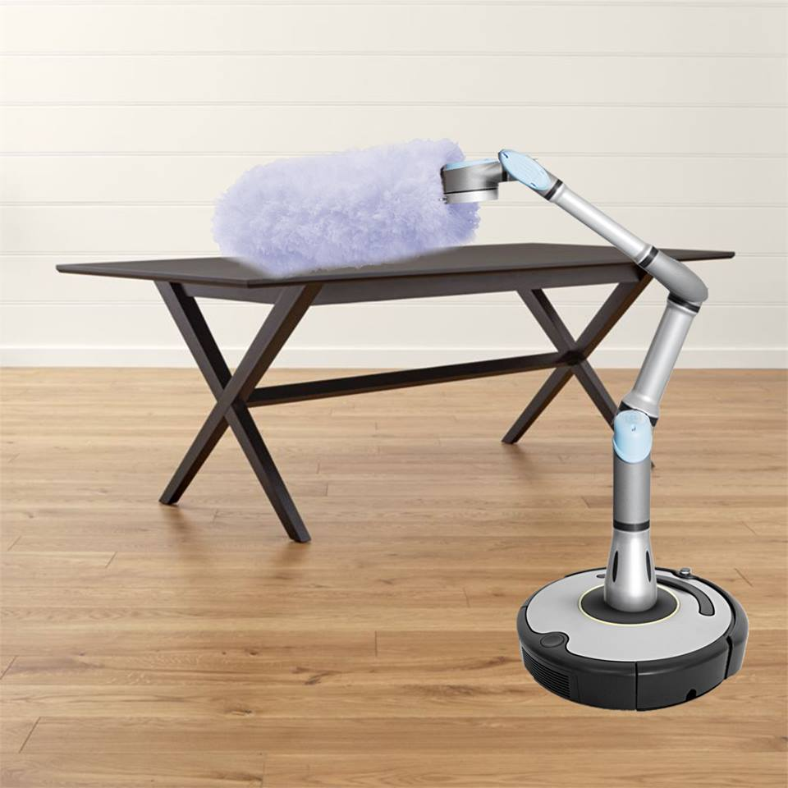

The SRHC possesses an extendable arm, that can have different attachments. They come with the robot, and the specific mode has to be included in the daily routine by the user.

# 5. Description of Products and Services

* Window cleaning.

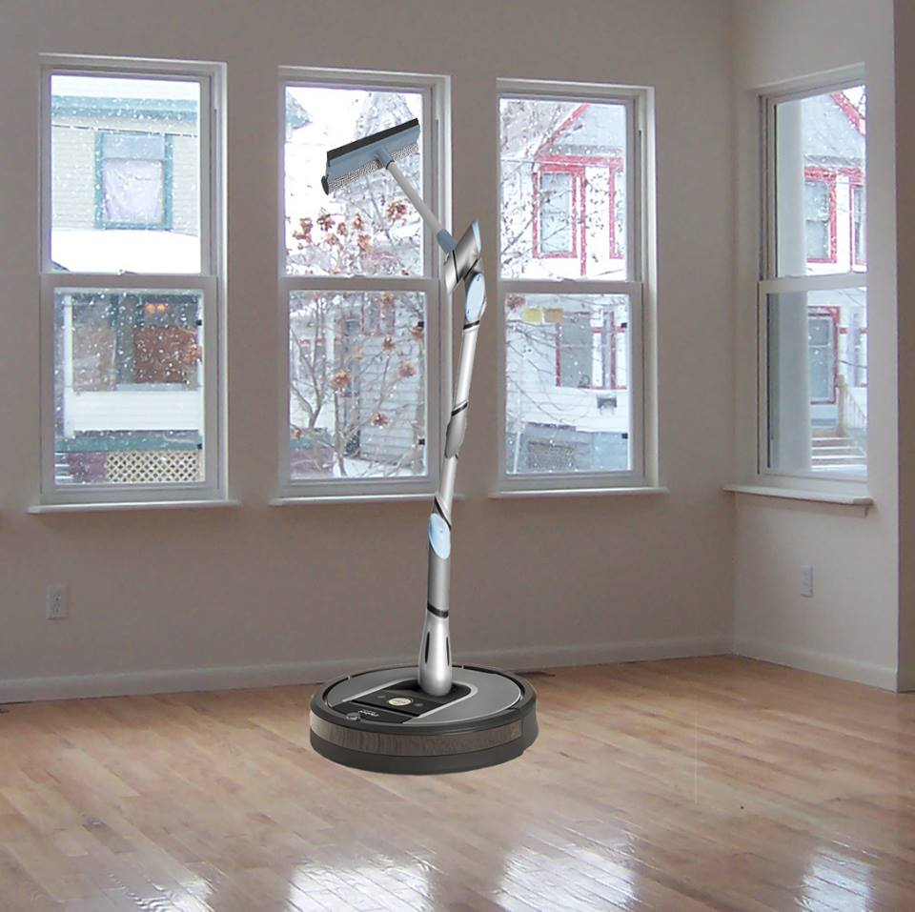

The arm can be extended to great heights, reaching all areas unreachable to humans.

We designed SRHC while having the Roomba robot in mind – specifically all its faults. While the foundation of our robot is the improvement of the Roomba, it also possesses its own attributes. We expect to crush the market with SRHC for it is the ultimate robot design.

# 6. Organization and Management

The SRHC will be mostly be developed in Serbia, with support from partner companies across Europe. Currently, there are 3 members working on the project, with potential increase. The success of the project mostly depends on communication and coordination between both the team members and the partners.

The project management will be led in accordance with the Scrum methodology. The goals will be defined on a daily level, on short 15 minute meetings. The main questions that will be asked on these meeting will be:

* What was done yesterday?
* What will be done today?
* What are the expected obstacles?

The development and crucial improvements will be tracked daily.

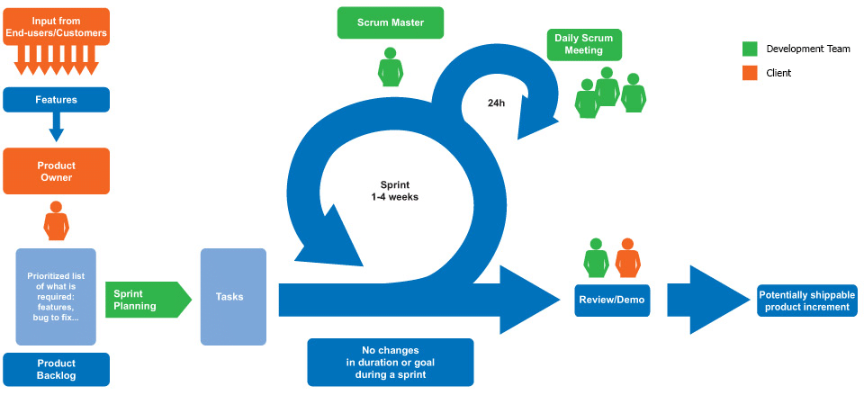

# 7. Marketing and Sales Strategy

Our product represents a modern and state of the art machine, designed to help people in their everyday tasks.

Our main goal is to increase productivity and happiness by reliving the users of unnecessary stress. We will focus on helping people acknowledge how much of their life they waste slaving away to these mundane chores, and how carefree their lives could become without them.

We plan to start with the marketing campaign the very second the product gets released. We will appoint sale representatives in all stores where our products will be sold, so they could educate potential customers face to face.

Next step would be the internet ads. We will open our e-shop, that will allow users to purchase our product and get to know it and its functionalities better.

If the interest is high enough, we intend to hold several presentations, where people could come and see the SRHC in action. If time allows, we would even hold a short training course for the present customers.

Once the sales come in, we will expand the marketing to the television and even billboards. We plan on making ads that will consist of the product details and a short demonstration of the product.

# 8. Financial Management

## 8.1. Projected income statement (1 year forward)

|  |  |  |  |  |
| --- | --- | --- | --- | --- |
| **Income source** | **Unit** | **Amount** | **Unit price (euro)** | **Total value** |
| SRHC sales | robot | 10.000 | 1.500 | 15.000.000 |
| Attachments | attachment | 20.000 | 200 | 4.000.000 |
| Donations | year | 1 | 500.000 | 500.000 |
| Training courses | course | 1.000 | 100 | 100.00 |
| Total |  | | | **19.600.000** |

## 8.2. Projected cash flow statement (1 year forward)

|  |  |  |  |  |
| --- | --- | --- | --- | --- |
| **Income source** | **Unit** | **Amount** | **Unit price (euro)** | **Total value** |
| Sensors | sensor | 30.000 | 200 | 6.000.000 |
| Processors | processor | 10.000 | 210 | 2.100.000 |
| Chassis | chassis | 10.000 | 150 | 1.500.000 |
| Attachments | attachment | 20.000 | 50 | 1.000.00 |
| Total |  | | | **10.600.000** |

# 8. Financial Management

## 8.3. Total yearly cash flow statement (1 year forward)

|  |  |
| --- | --- |
| Production | 10.600.000 |
| Energy products  electricity  gas  heating | 15.000 |
| Paychecks (3 employees, 2000e avg) | 72.000 |
| Maintenance costs | 20.000 |
| Other  transport  lease of workspace  marketing  services | 20.000  24.000  180.000  250.000 |
| Total | **11.181.000** |

# 8. Financial Management

## 8.4. Net profit

|  |
| --- |
| **TOTAL INCOME – TOTAL CASH FLOW** |
| **19.600.000 – 11.181.000 = 8.419.000** |

1. Coefficient of productivity $\frac{total income}{total flow}$
2. Accumulation rate $\frac{net profit}{total investments} x 100\%$
3. Investment return time $\frac{total investments}{net profit}$

|  |
| --- |
| **Calculation** |
| 1. Coefficient of productivity 2. Accumulation rate 3. Investment return time $\frac{10.600.000}{8.419.000}=1.26 years$ |

After careful consideration of all cash flow, we came to a conclusion that the project is more than acceptable. It would take only a bit more than a year to return all the investments, which is incredibly promising.