FilterBubbler Dev-Notes #1: React/Redux and WebExtensions
The first prototype of FilterBubbler was a very simple proof of concept with the most basic HTML pop-up and Bayesian classifier. This version proved that we could provide useful classification of web page content based on hand-loaded corpura. Before we could start adding important features like remote recipe servers, classification displays and configuration screens we clearly had some decisions to make about the infrastructure we would use.

React/Redux
The React UI framework and its associated Flux implementation took the HTML UI world by storm when Facebook released the tool as Free Software in 2013. React was originally deployed in 2011 as part of the newsfeed display infrastructure on Facebook itself. Since then the library has found use in Instagram, Netflix, AirBnB and many other major users. The tool revolves around a strategy called Flux which tightly defines the way state is updated in an application.
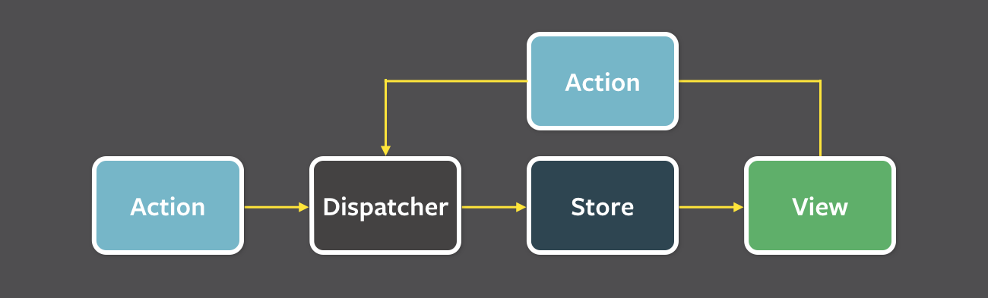
Flux is a strategy not an actual implementation and there are many libraries that provide its functionality. One of the most popular libraries today is Redux. The Redux core value is a simplified universal view of the application state. Because there is a single state for the application the behavior that results from a series of action events is completely deterministic and predictable. This makes your application easier to reason about, test and debug. A full discussion of the concepts behind React and Redux is beyond the scope of this article so if you are getting started with them I would recommend that you read the Redux introductory material or check out Dan Ambramov’s excellent introductory course at Egghead.

Integrating with WebExtensions
Digging into the web extension framework one of the first hurdles you see is that the UI pop up and config page context is separate from the background context and that the state of the UI context is recreated each time you open and close the UI displays. Communication between the UI context and the background script context is achieved by a message passing architecture.
The state of the FilterBubbler WebExtension will be stored in the background context but we need to bind that state to UI elements in the pop-up and config page context. One solution for this problem is Alexander Ivantsov’s Redux-WebExt project. This tool provides an abstraction layer between the UI and background pages with a proxy. This proxy gives the appearance of direct access to the Redux store in the UI but it actually forwards events to the background context and then sends resulting state modifications generated by the reducers back to the UI context.
This arrangement makes it possible to use standard React/Redux tooling with only some minimal changes and configuration. Existing sophisticated libraries for form handling and other major UI tasks can plug into the WebExtension environment without any knowledge of the underlying message based connectivity. One example tool we have already integrated is Redux-Form, which provides a full system for managing form input with validation and the other services you would expect in a modern development effort.
Having established that we can use a major UI toolkit without starting from scratch the next concern is making things look good. Google’s Material Design is one popular look and feel standard and the React platform has the popular Material UI too which implements the Google standard as a set of React/Redux components. This gives us the ability to produce great looking UI popups and config screens without having to develop a new UI toolkit.

Get thunky
Some of the operations we need to perform are callback based, which makes them asynchronous. In the React/Redux model this presents some issues. Actions generator functions and reducers are designed to do their work immediately when called. Solutions like providing access to the store within an action generator and calling dispatch in a callback are considered an anti-pattern. One popular solution to this problem is the Redux-Thunk middleware. Adding Redux-Thunk to your application is easy, you just pass it in when you create the store.
import thunk from 'redux-thunk'

const store = createStore(
reducers,
applyMiddleware(thunk))

With Redux-Thunk installed you are provided with a new style of action generators where you return a function to the store that will later be passed a dispatch function. This inversion of control allows Redux to stay in the drivers seat when it comes to sequencing your asynchronous operations with other actions in the queue. As an example, take this function that requests the URL of the current tab and then dispatches a request to set the result in the UI:
export function requestActiveUrl() {
return dispatch => {
return browser.tabs.query({active: true}, tabs => {
dispatch(activeUrl(tabs[0].url));
})
}
}

The activeUrl() function looks more typical:
export function activeUrl(url) {
return {
type: ACTIVE_URL,
url
}
}

Since WebExtensions span several different contexts and communicate with asynchronous messaging a tool like Redux-Thunk is an indispensable tool.

Debugging under Firefox and compatibility with Chrome
You may have noticed that the JavaScript examples in the article are using some ES6 language constructs. That is because we are using Webpack and Babel to transpile our source. If you have worked with these tools before you already know that the source they output can be barely understandable after they are processed because the sources are heavily translated, concatenated and minified. The solution is, of course, the “source maps” feature which provides a mapping between the original source files and the translated output. Unfortunately we discovered that sourcemaps do not function correctly when debugging WebExtensions in current Firefox builds. We could not find an open bug for this issue so we opened bug #????. It could be that we have missed something in our configuration but we have tried several different sourcemap configurations without any success.
Debugging a WebExtension without any real developer tools support is a painful process. After a day or two of that we decided to switch our focus to getting the tool working in Chrome so that we could both support users of a popular browser platform and see if we had better luck with the Chrome developer tools. Unfortunately Chrome does not currently support the more standardized WebExtensions “browser” object and instead offers a “chrome” object for communicating with the browser internals. Luckily there is also a popular solution for this problem from Mozilla, the Browser-Polyfill library. Simply import the browser object from the library in any sources where you need to talk to the browser and you will be able to portably access those features. Once this was implemented we were able to run the extension in both browsers without issue and were happy to discover that the Chrome debugger supported source-maps. Hooray!

Classified materials
With all our new infrastructure in place and a working debugger we were back on track adding features to FilterBubbler and

References
Redux WebExt: https://github.com/ivantsov/redux-webext
Redux Form: http://redux-form.com/6.7.0/
Source-map options in FirefoxOS, which seems to have similar issues: https://github.com/ractivejs/ractive/issues/2286
Mozilla browser polyfill: https://github.com/mozilla/webextension-polyfill
Bugzilla search for WebExtensions sourcemap: https://bugzilla.mozilla.org/buglist.cgi?quicksearch=webextensions+sourcemap
Curated collection of WebExtension resources: https://github.com/bfred-it/Awesome-WebExtensions

