Filum
“From need to proof, without a break”
User manual
Version 1.2.1 — August 2026

Contents

After opening in Word: right-click the table of contents → “Update field”.

1. Welcome to Filum
Filum manages traceability, compliance and documentation for medical device R&D. Its founding principle: data does not live in disconnected Word or Excel documents, but in a traceability graph — a continuous thread linking every user need to its requirements, specifications, tests (or studies), results and evidence, with ISO 14971 risk running across the whole.
The documents you know — design request, test plans and reports, traceability matrix, Design History File (DHF), Risk Management File (RMF), nonconformity reports and CAPA reports — are not re-entered: they are generated from the graph, on demand, and are therefore always up to date. You enter each link once; missing items are flagged automatically.

The thread, in one line
Need → Requirement → Specification → Test/Study → Result → Evidence with ISO 14971 risk attached to every link.
💡 One idea to keep in mind throughout this manual: if a piece of information exists only once in the graph, it cannot contradict itself from one document to the next. That is the whole point of Filum.

2. Getting started and signing in

Reaching Filum
Filum runs on a server in your organisation, inside a Docker container: there is nothing to install on your machine and nothing to start. Your IT team gives you the address; open it in your usual browser.
1. Open the address provided by your IT team (for example https://filum.your-company.com).
2. Enter your initials or your email, then your password.
3. If you do not have one yet: your administrator hands you a token, and the “I have a reset token” link lets you choose your password.
💡 Server installation and operation are described in the installation guide handed to your IT team: backups, restore, updates and administrator access recovery are all covered there.

Signing in
The whole application is behind a sign-in. Enter your initials (e.g. KGA) or your email, then your password. Sign-ins and sign-outs are recorded in the audit trail (ALCOA+ principle: attributable).
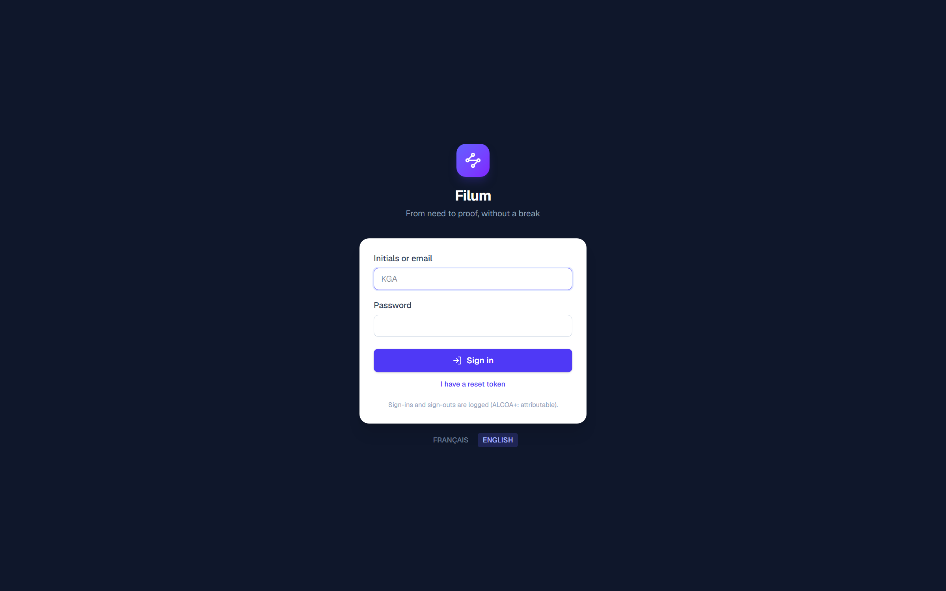
The sign-in screen — the gateway to every page.

Roles
Role | What it allows
Administrator | Everything, plus user account management (roles, access tokens, deactivation) and deletions with a mandatory reason.
Approver | Release documents, open revisions, sign their own approvals, sign nonconformity dispositions and CAPA closures — on top of Editor rights.
Editor | Create and edit graph content: activities, documents, requirements, specifications, results, risks, studies, nonconformities, comments.
Viewer | View and download — no changes.
💡 Buttons your role does not allow are not hidden: they are visible but disabled, with a tooltip naming the required role. You always know what exists.
💡 A person without sign-in access is “referenced”: they appear in documents (signatories, operators) but cannot sign in.

3. The dashboard
The dashboard is the steering view of the file. It shows continuously: verification coverage (the share of specifications actually demonstrated), document status, open activities, review comments to resolve, pending specifications, ISO 14971 risks with their verification state, and open nonconformities and CAPAs.
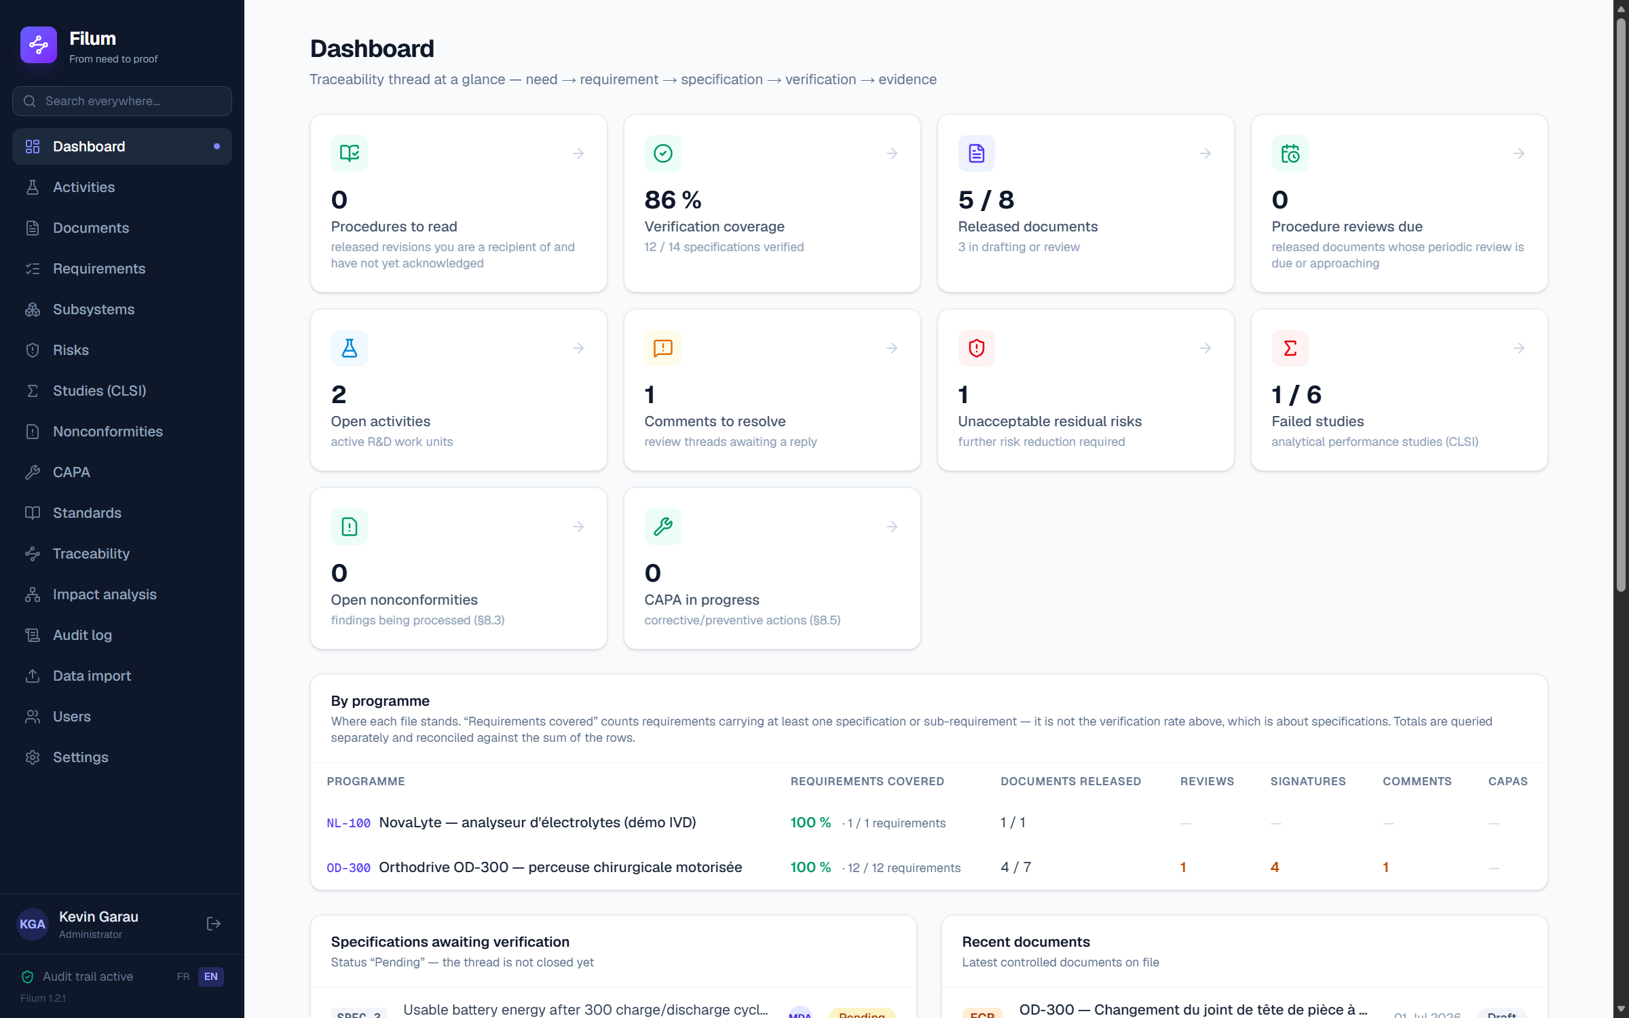
The dashboard — verification coverage is the central metric.
💡 Every card is clickable and leads to the matching detail screen. Empty states are never dead ends: they explain what to create and offer the button to do it.

4. Activities (ACT-####)
The activity is the R&D unit of work — it carries its documents, requirements and tests. Its identifier follows a readable pattern (ACT-0101). In the demonstration data, activity ACT-0101 drives the OD-300 “Orthodrive” programme (a surgical drill).

Creating an activity
1. “Activities” menu → “New activity” button.
2. Fill in the identifier (ACT-####), the title, the context (the future “Background & purpose” of the design request), the programme and the owner.
3. “Create activity” — you land on its page.

Editing an activity
From the activity page, the “Edit” button opens the same form, pre-filled: correct the title, the context or the owner, then save. As everywhere in Filum, editing (the “U” of CRUD) is available on every record, and each change is logged with its before/after values.

The activity page and the DHF
The activity page brings together the context, the requirements with their coverage, the documents, the team and the user needs. The “Design History File (DHF)” card runs several completeness checks continuously (uncovered requirements, unexecuted tests, missing signatures, overdue calibrations…) and compiles the full Design History File in one click — the “Compile the DHF (.docx)” button.
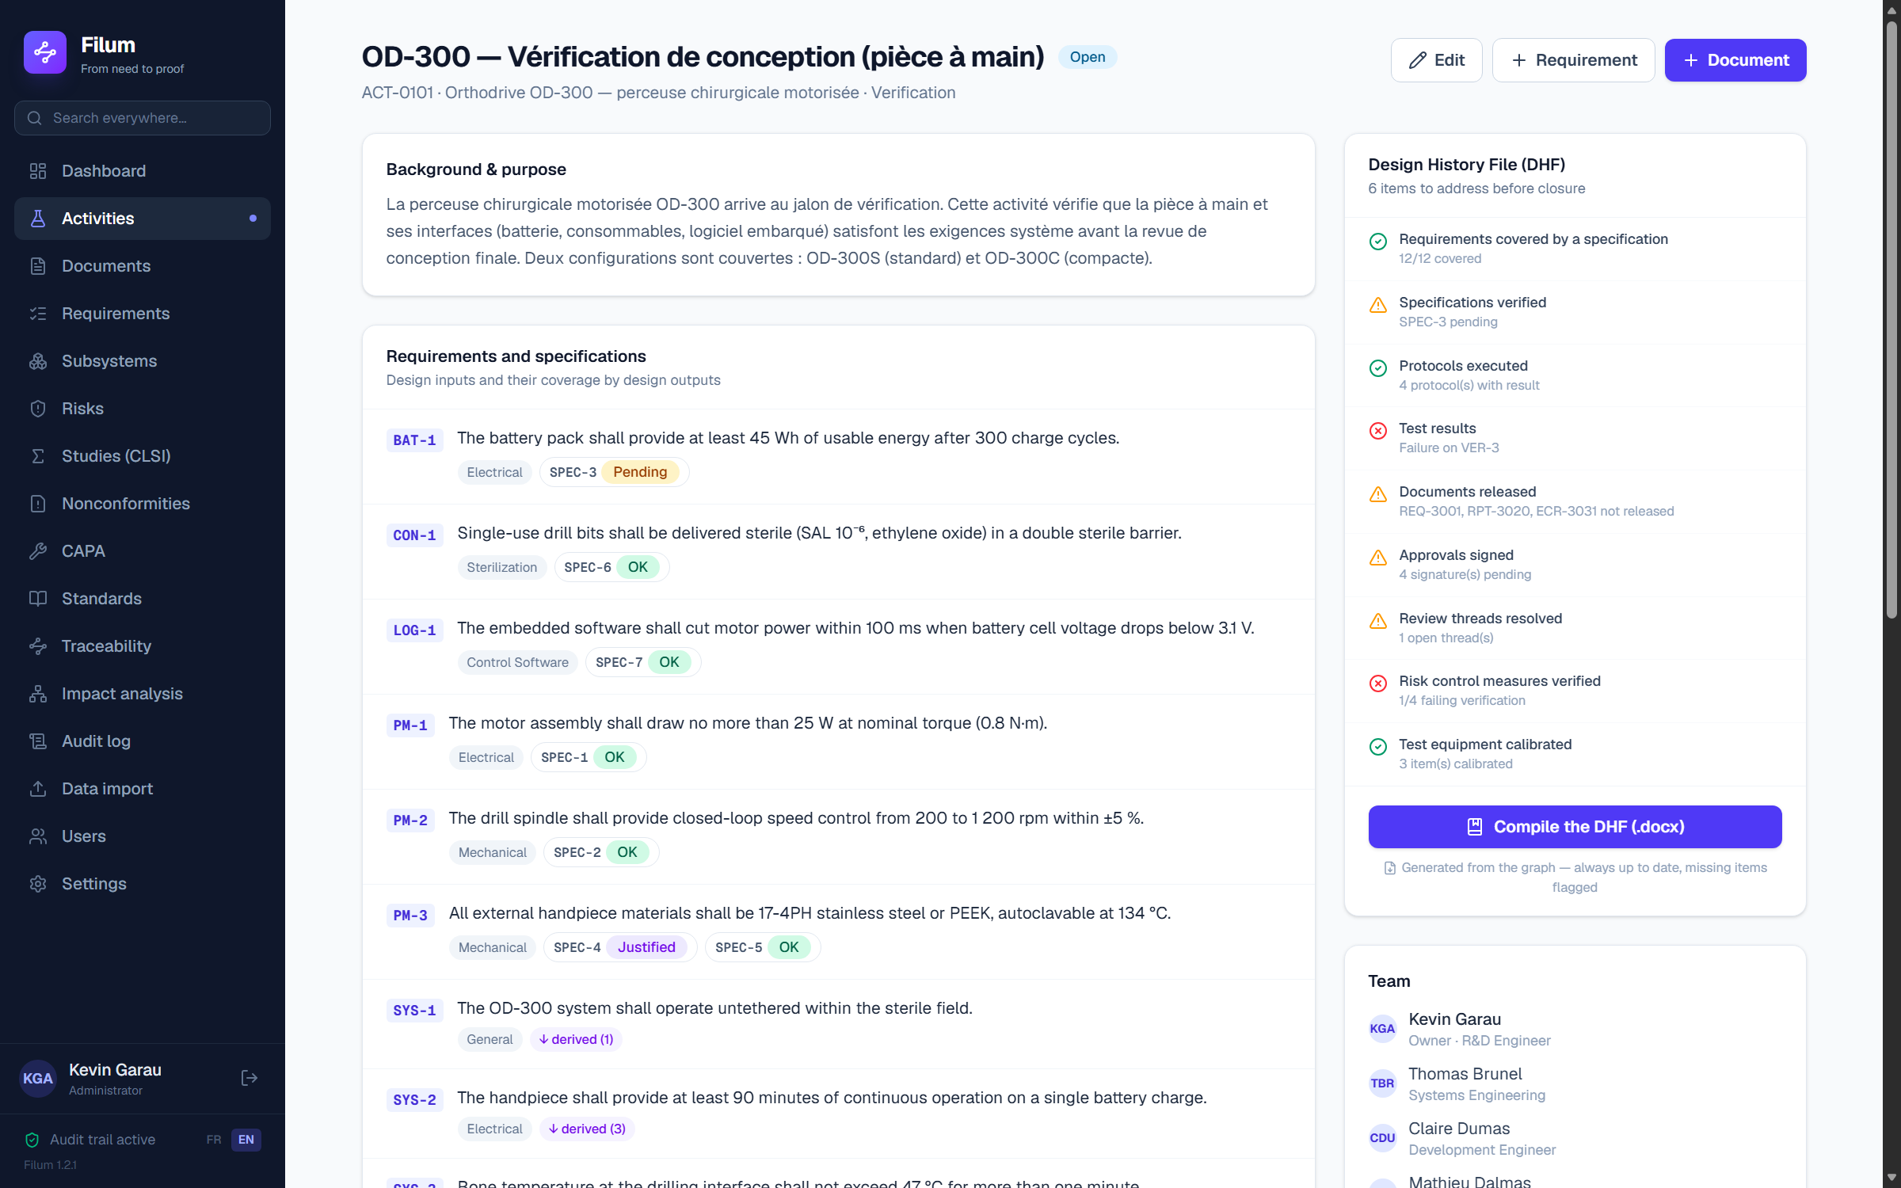
Activity ACT-0101 (OD-300 programme) — on the right, the DHF completeness analysis flags what is missing.

5. Controlled documents and the release workflow
A Filum document (design request, test plan, report, ECR…) is a container: its content — requirement and specification tables, protocols, results — is projected from the graph. It carries a controlled number, a revision, a status and approvals. In the demo, activity ACT-0101 carries REQ-3001/REQ-3002 (requirements), PLN-3010 (verification plan), RPT-3020/3021 (reports) and DR-3040.
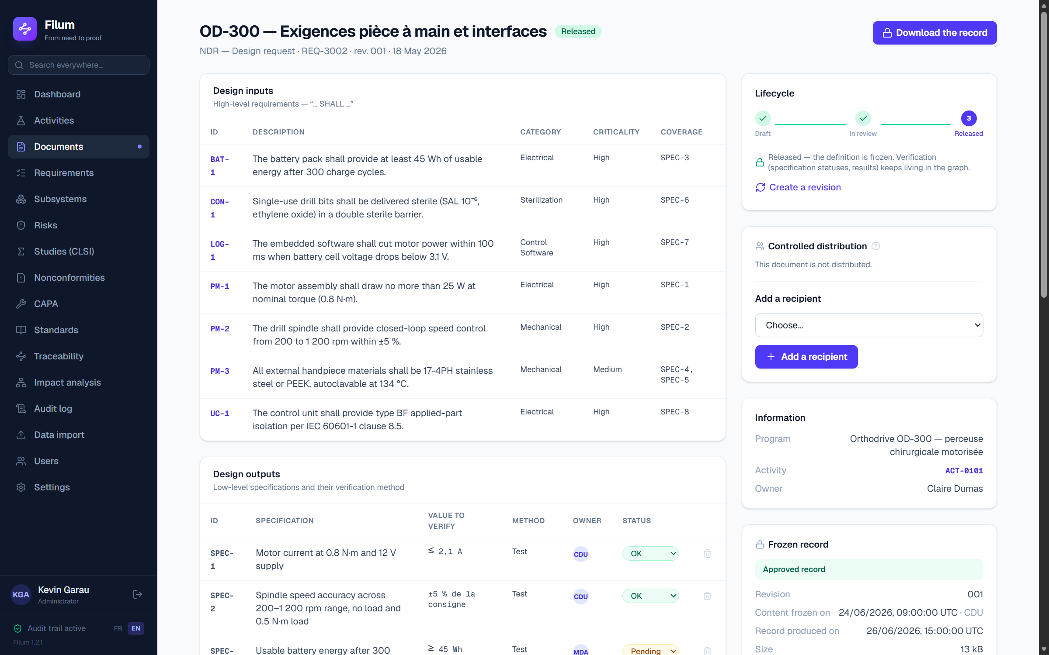
Document REQ-3002: generated tables, verification statuses, lifecycle and frozen record on the right.

The lifecycle: draft → review → released
1. The document is born as a Draft (rev. 001).
2. “Submit for review”: request the approvals (signatory + role) in the Approvals card. The document content is FROZEN — Filum keeps an exact copy of it, and that copy is what the signatures will attest.
3. Each designated signatory signs under their own session — nobody else can sign in their place (21 CFR Part 11 style electronic signature).
4. “Release” unlocks once every signature is applied and every review thread resolved. Releasing produces the approved record, after checking that the content has not moved since the freeze.
5. To change a released document: “Create a revision” (justification mandatory) — rev. +1, back to draft, signatures reset.
🔒 Sending a document under review back to draft invalidates every signature already applied: one never signs a version that may have changed since. That is a lock, not a bug — Filum warns you before doing it.
💡 Verification keeps living after release: specification statuses and test results evolve in the graph; the released document, for its part, stays frozen on the signed version.

Signing: what is asked of you, and why
When it is your turn, the Approvals card shows “Your signature is expected” and a “Sign” button. The panel that opens states in full who you are, what the signature means and on which document — then asks for YOUR PASSWORD.
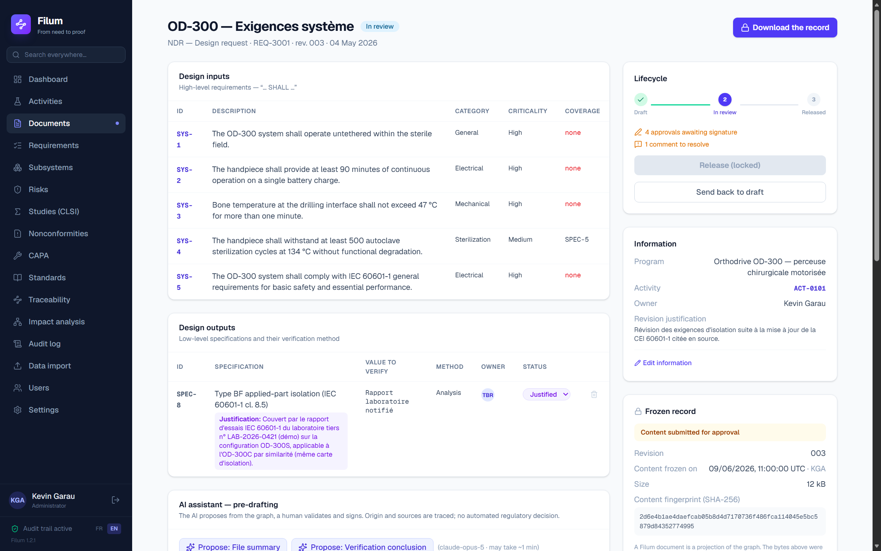
The signature panel: identity, meaning, document and revision, then password re-entry.
This re-entry is not a formality. 21 CFR 11.200(a)(1) requires two distinct identification components at signing. Filum requires BOTH every single time — your authenticated session and your password — where the regulation tolerates only one for successive signatures within a single continuous session. This is deliberately stricter: it removes the need to demonstrate that a session stayed “continuous”.
🔒 A wrong password applies nothing. The attempt is logged under your name and counts towards account lockout: five failures and access is suspended for fifteen minutes, sessions revoked. That is the 21 CFR 11.300(d) safeguard.
Once applied, the signature shows the signatory’s printed name, the meaning, the UTC date and time, and the fingerprint of the attested content — the particulars required by 21 CFR 11.50 and 11.70. The name is FROZEN at signing time: renaming the person later does not rewrite a signed record. These particulars appear identically in the generated Word document.

Downloading the record
On a draft, the “Generate the .docx” button projects the graph content into a structured Word file (title block, approvals, revision history, design inputs/outputs, protocols, results, references), carrying the DRAFT notice. As soon as content is frozen, the button becomes “Download the record” and serves the stored bytes — never a regeneration. The live projection stays available and then carries, on its first page, the WORKING VIEW notice. Every download is logged.

6. Requirements, specifications and subsystems

Creating a requirement
1. “Requirements” menu → “+ Requirement” (or from an activity page).
2. Fill in the code (REQ-…), the statement (“The … shall …”), the category and the criticality.
3. Tick the applicable standard clauses — the standards library is pre-loaded.
4. Attach the requirement to an activity and, if needed, to a parent requirement (system → subsystem hierarchy).

Statement quality, checked as you type
Under the “Statement” field, a panel analyses what you write, on every keystroke. This is not about style: “the system shall start quickly” cannot be verified, and the test claiming to verify it will prove nothing. The cost of a badly written requirement is multiplied by ten at each stage it passes — specification, protocol, design file.
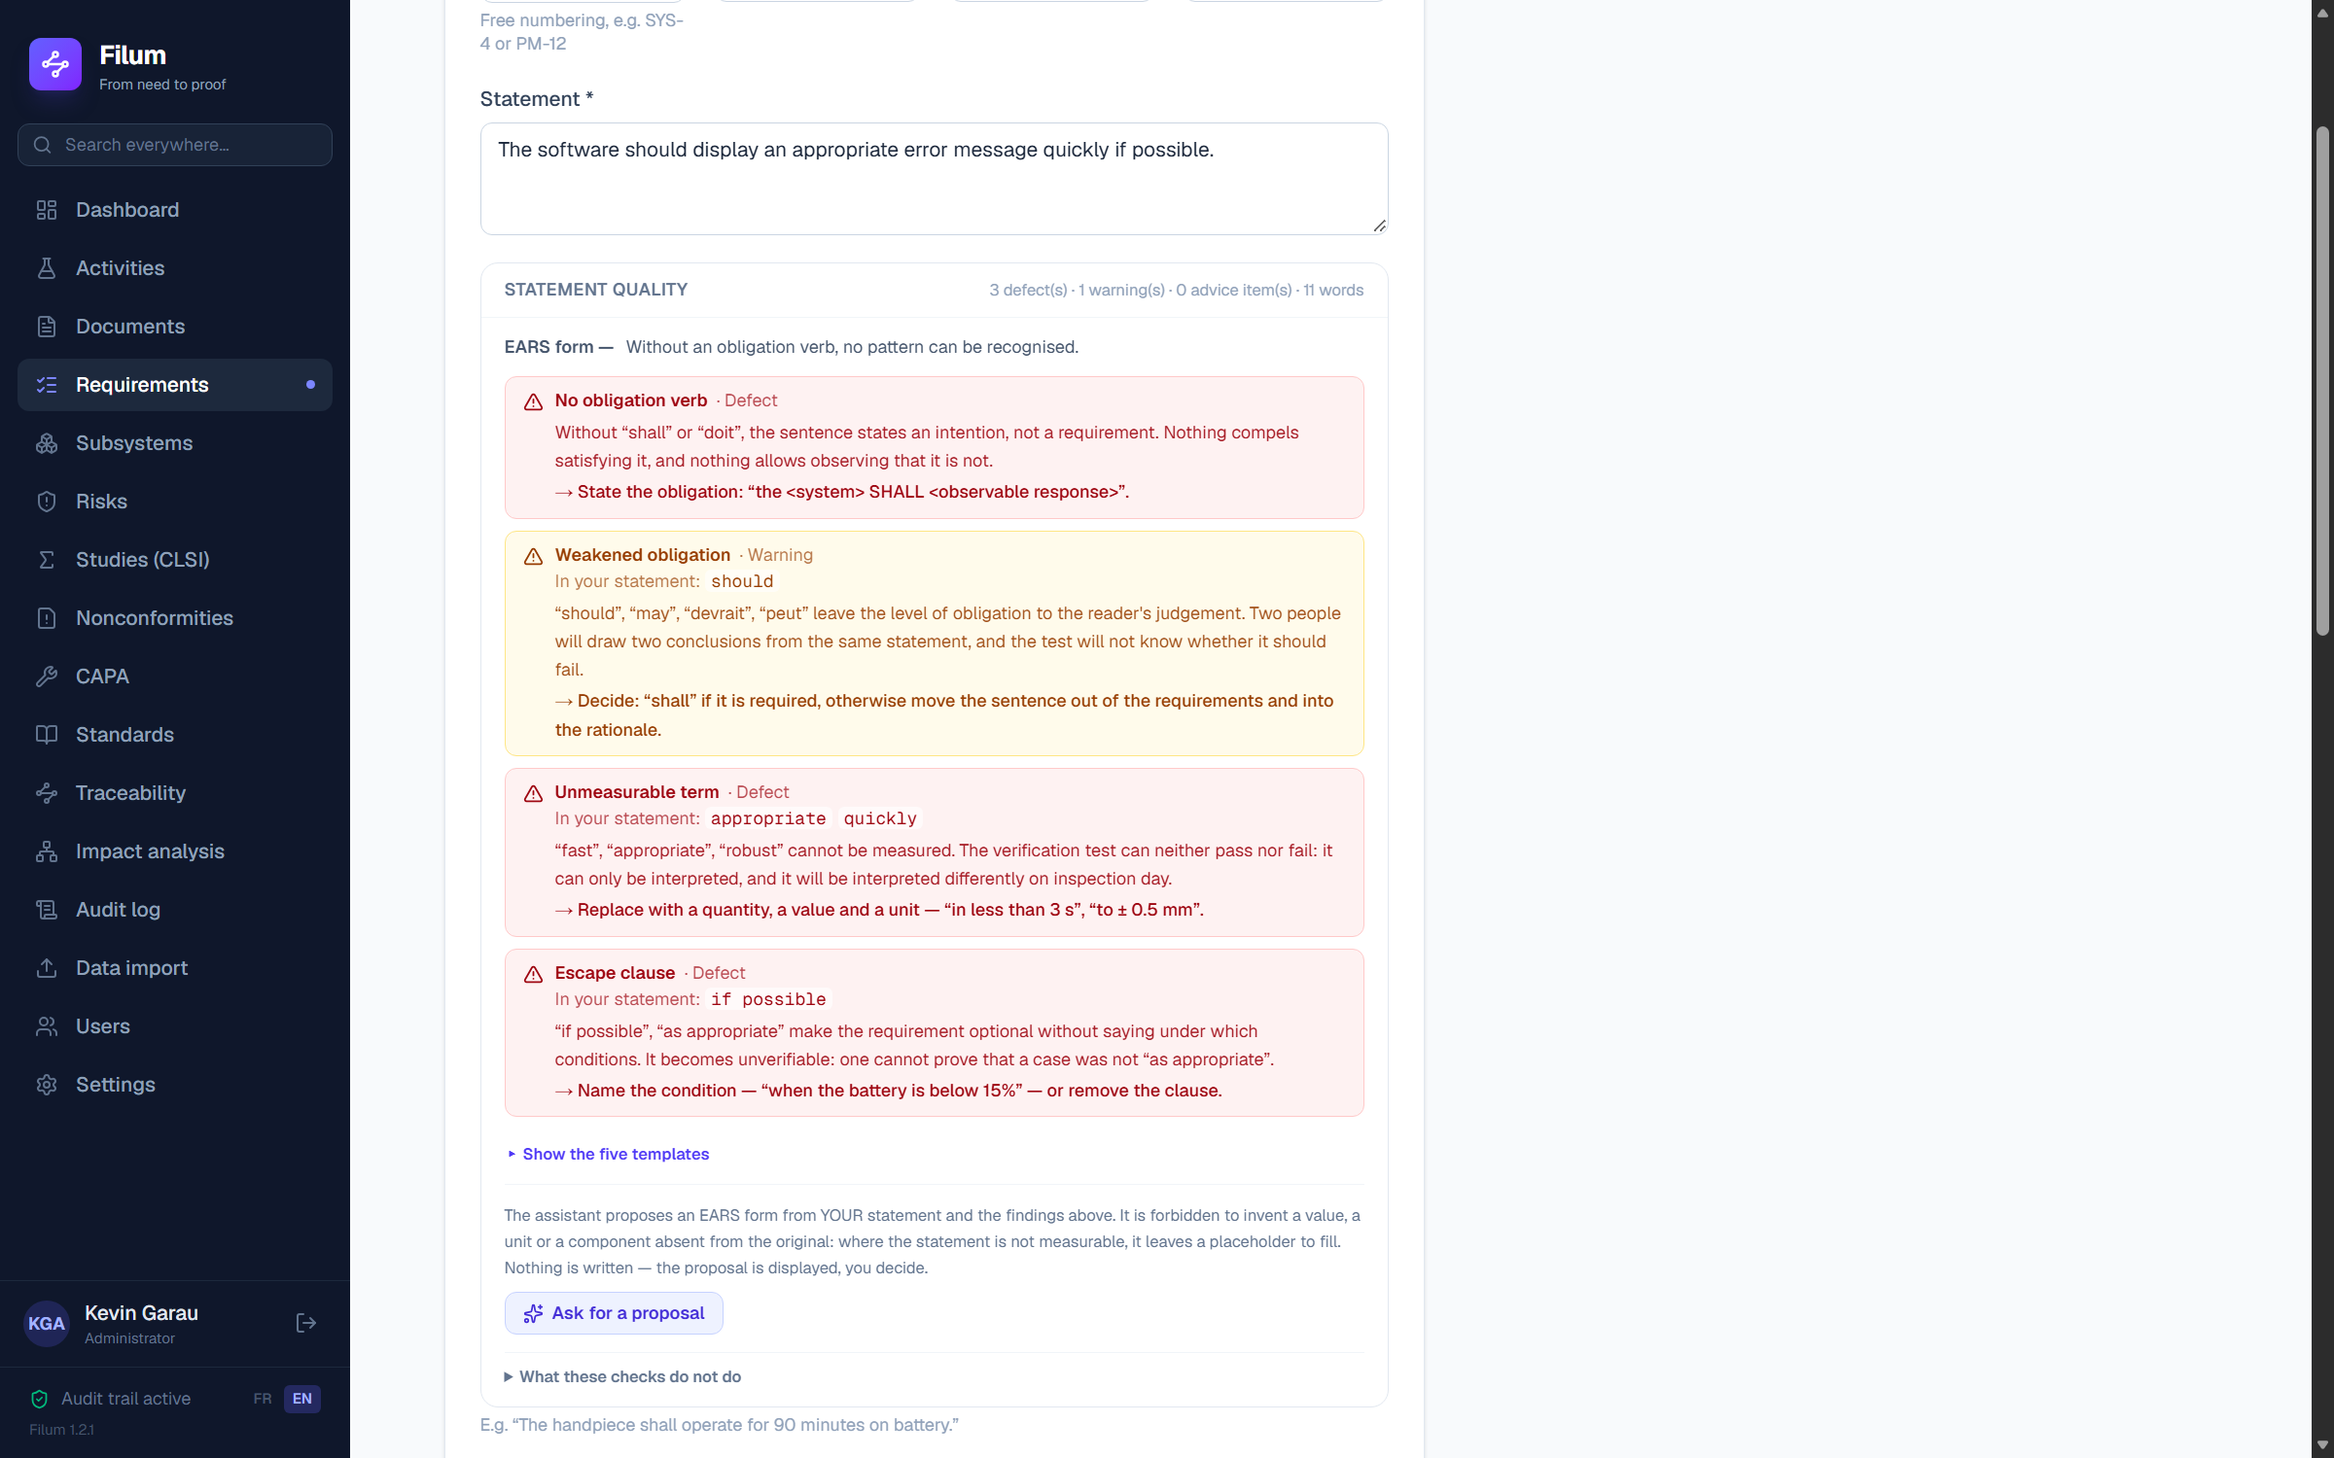
The checks quote the offending word, say why it is a problem, and propose the action.
Each finding quotes the exact fragment of YOUR sentence that triggers it. An alert that does not show the offending word leaves you searching, and you end up not reading it. Three levels: defect (the requirement is not verifiable as it stands), warning (it is ambiguous), advice (it would gain from being made precise).

EARS templates
EARS (Easy Approach to Requirements Syntax) constrains the form of a statement to five patterns: ubiquitous, event-driven (When…), state-driven (While…), unwanted behaviour (If… then…), optional feature. The point is not elegance: it is that the TRIGGER and the CONDITION become explicit, hence testable, and that two engineers write the same thing the same way. The panel recognises your statement's pattern and displays its skeleton; the “Show the five templates” button unfolds all five, each with an example.
💡 EARS is defined in English and its French rendering is not standardised: the keywords offered — “Quand”, “Tant que”, “Si… alors” — are reasonable usage, not a standard. Fix your own in your procedure and stick to it.

Assisted rewriting
If your organisation has configured an Anthropic key, the “Ask for a proposal” button submits YOUR statement and the findings raised, and displays a rewrite. The model is forbidden to invent a value, a unit or a component absent from the original: where your sentence is not measurable, it leaves a placeholder in angle brackets rather than a plausible figure. An invented figure would have no source, and it is the source that holds a design file together.
🔒 Nothing is ever written in your place. The proposal is displayed, you copy it if it suits you, and it is your keystrokes that enter the record. Rewriting someone's statement would change the author of a record without anyone deciding it. Nor does any finding block saving: a check that forbids saving gets circumvented — you remove the word that triggers the alert, and the measure becomes decoration.
Finally, these checks read ONE SENTENCE, not a design file. They judge neither the relevance of the requirement, nor its completeness, nor its possible contradiction with its neighbour. A statement with no finding can be perfectly useless — your design review will say so, not Filum.

The N-to-M hierarchy and subsystems
A system requirement can be broken down into several subsystem requirements, and a subsystem requirement can serve several system requirements (N-to-M relation). The “Subsystems” menu shows the product breakdown; each subsystem groups its own requirements and specifications. This lets you trace a high-level requirement down to the components that realise it.
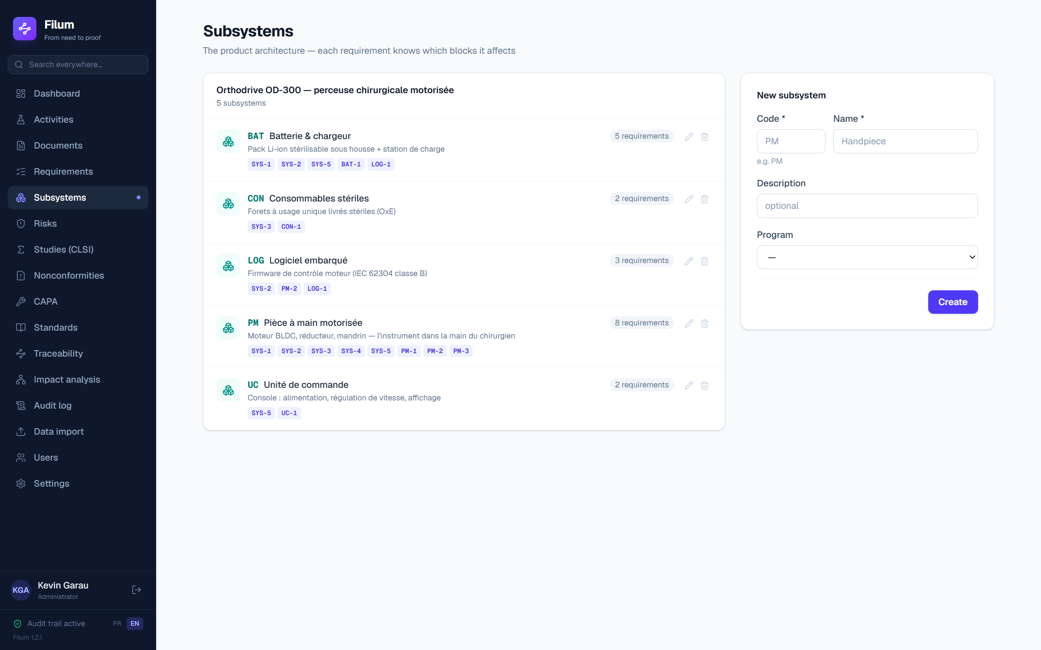
The product subsystems — the bridge between system and component requirements.

Creating a specification
A specification carries the measurable value (e.g. Ø7.8 ±0.22 mm), the verification method and its status: Pending, OK, NOK, Justified or N-A. One specification can cover several requirements: tick every requirement concerned at creation. The status is then changed directly in the document table — each change is logged.
💡 The “Justified” status is for a specification demonstrated not by a test but by reasoning (analysis, reference to a proven design): the matrix distinguishes it clearly from a proven “OK”.

7. The standards library
The “Standards” menu lists the references shipped with Filum (ISO 13485, MDR, ISO 14971, IEC 62304 software, IEC 62366 usability, IEC 61010 electrical safety, IEC 61326 EMC, ISO 10993 biocompatibility…). Each standard carries a usage description, its metadata and a link to the official page. In line with copyright, Filum stores metadata only — the normative text is read in your own purchased copies.
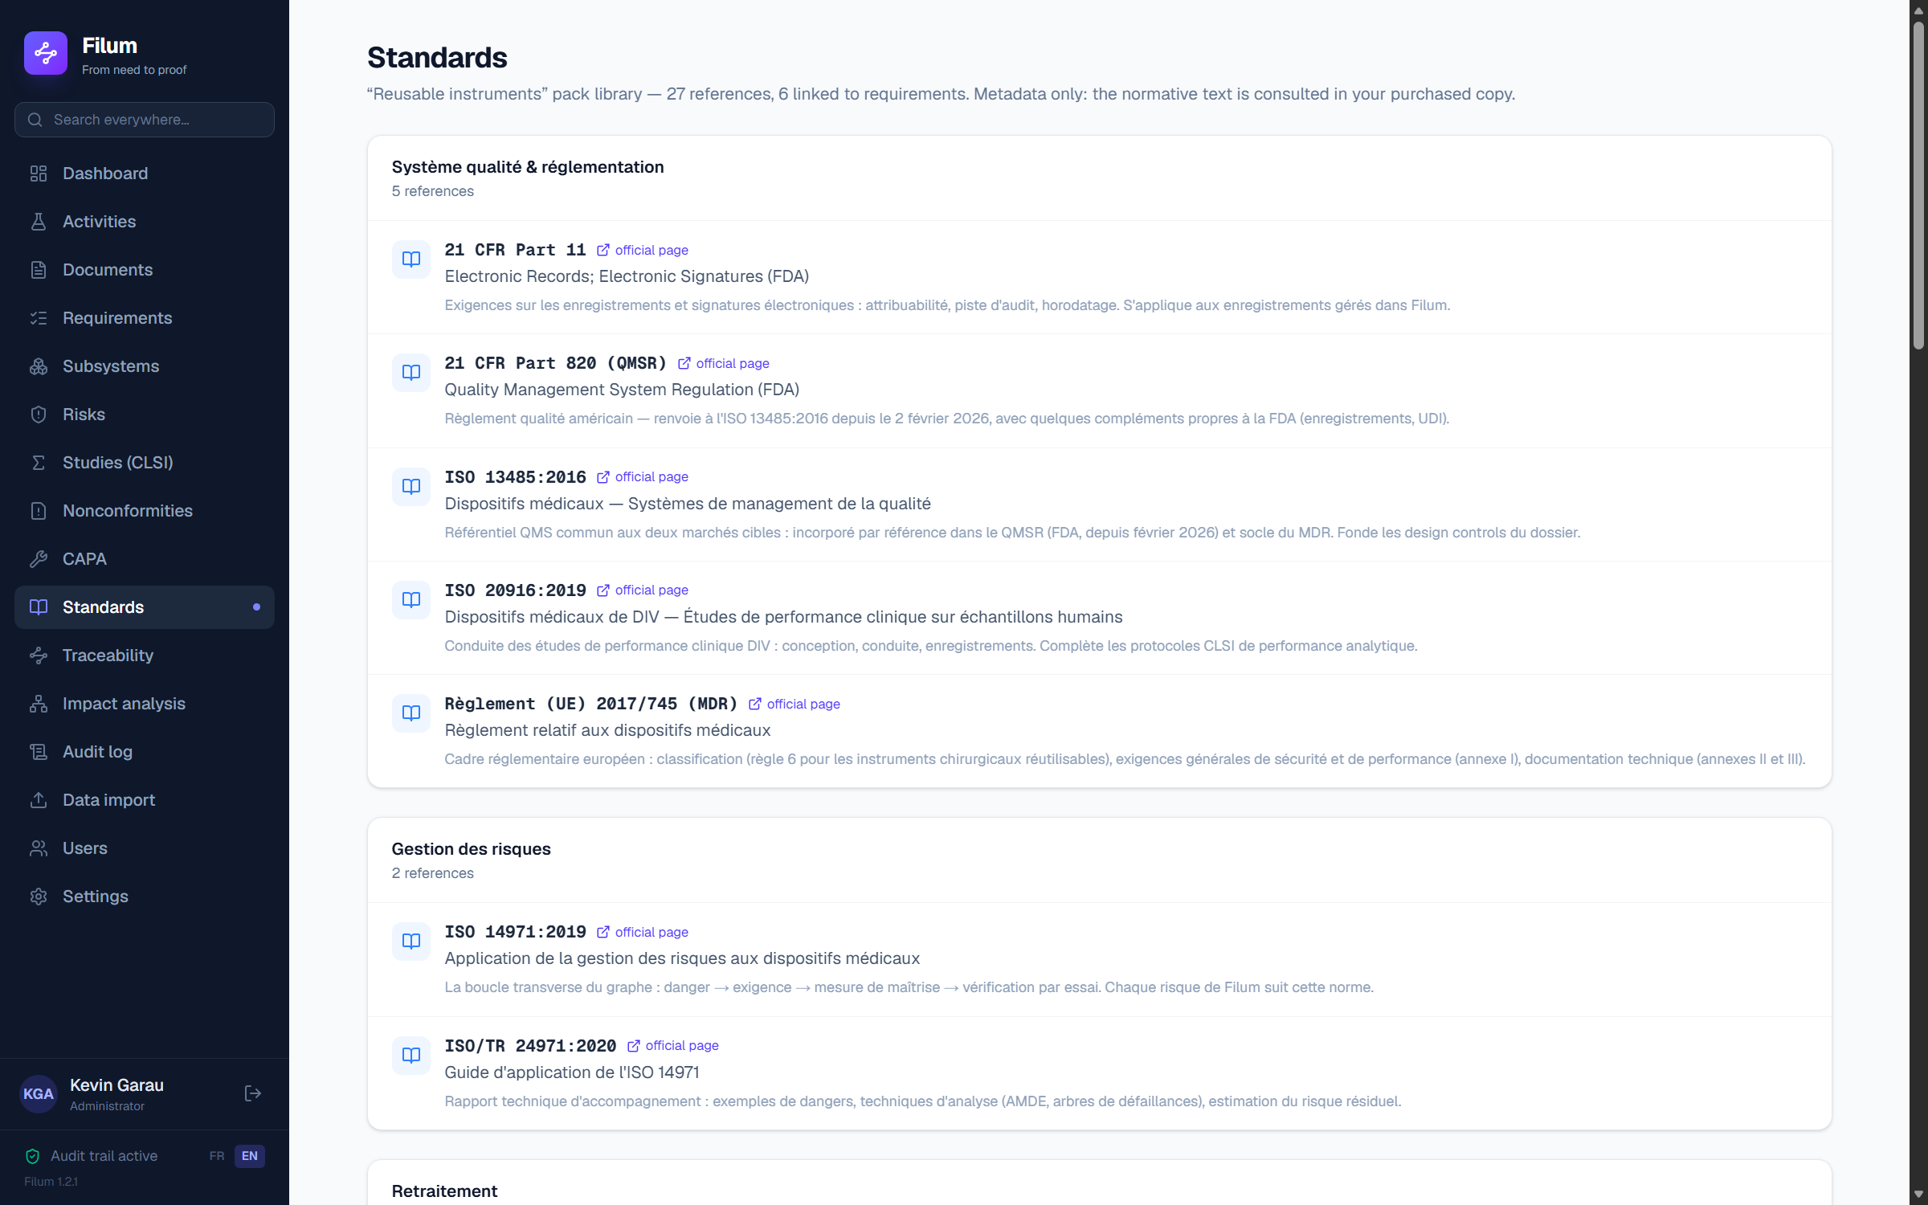
The standards library — linked requirements appear under each reference.
💡 Linking a standard to a requirement flows automatically into the matrix and the DHF: you demonstrate standards coverage without keeping a separate table.

8. Verification: protocols, results and CSV import
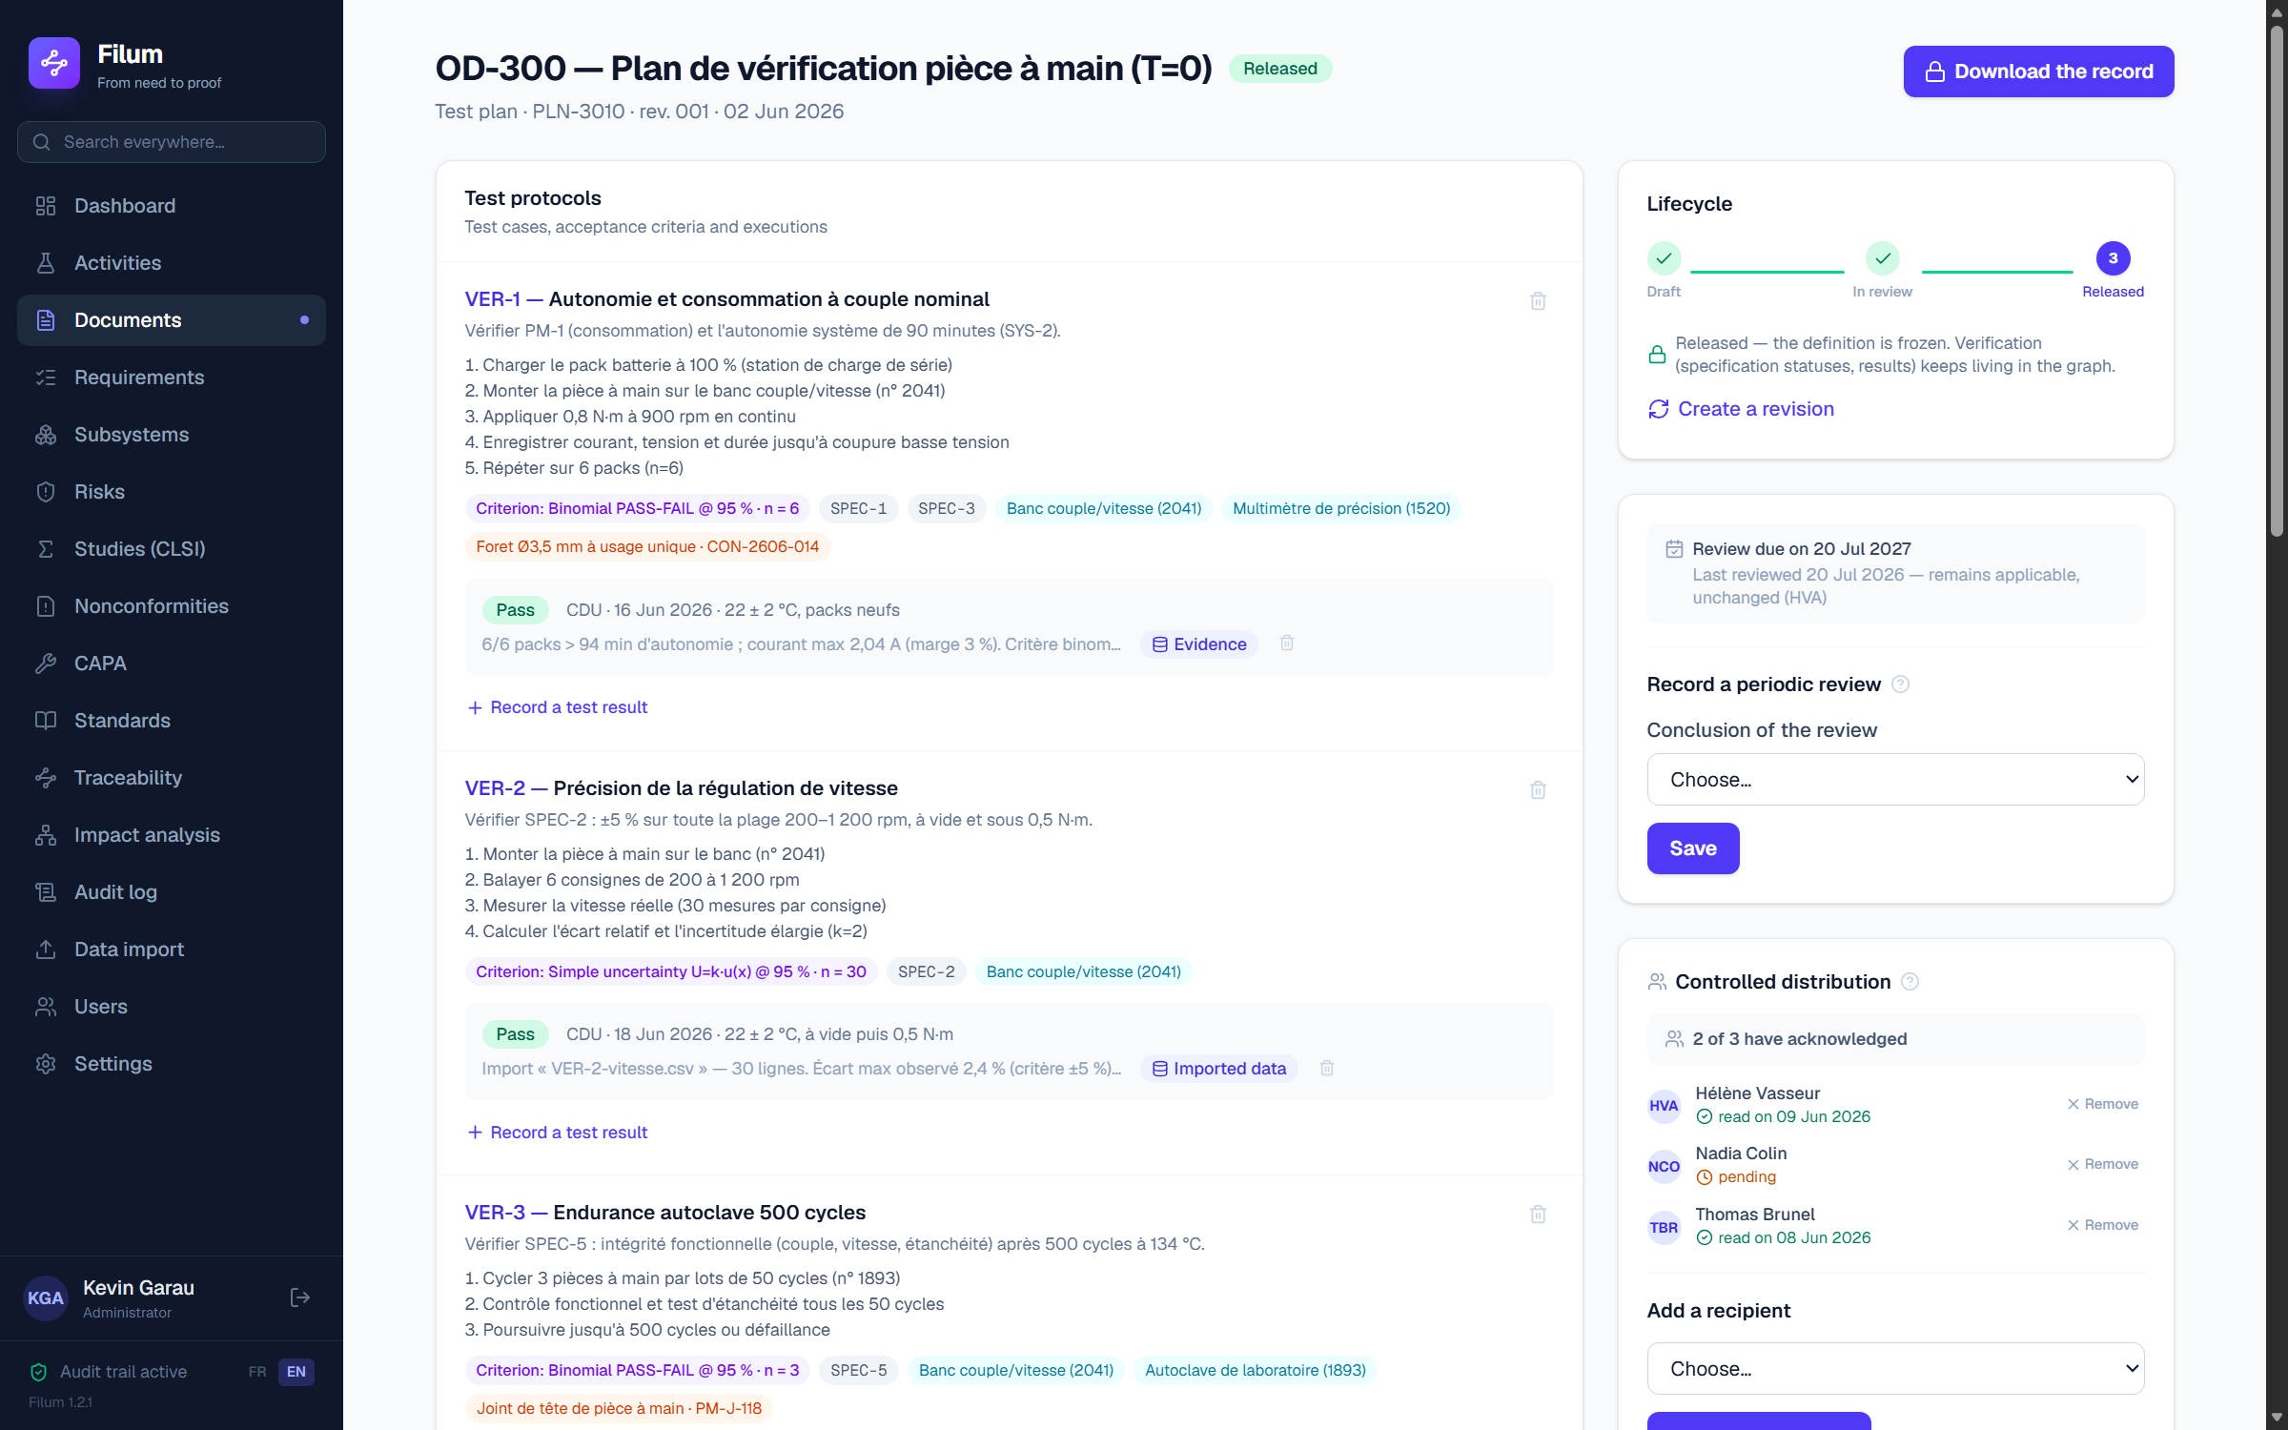
Verification plan PLN-3010: protocols, acceptance criteria, calibrated equipment and critical lots.

Recording a test result
1. On the test plan, expand “Record a test result” under the protocol concerned.
2. Choose the outcome (Pass / Fail / Pending), the operator, the date and the conditions (e.g. 26 ± 1 °C).
3. Optionally attach the measurement file (CSV/TXT): Filum keeps it as-is, computes n, mean, standard deviation, min and max per column, and creates the evidence automatically.
4. “Save (logged)”.

The data viewer
The “Imported data” chip on a result opens the viewer: statistics cards with distribution histograms, a table of the raw data, and download of the original file, intact. Raw data is never modified (ALCOA+: original, enduring); statistics are recomputed on display.
🔒 A failed test does not just display “Fail”: it triggers the creation of a nonconformity (see chapter 14). The graph thereby links the failure to its disposition and, if needed, to a CAPA — nothing is lost. In the demo, the failed VER-3 test created NC-1.

9. Data import — bringing in your existing requirements
You are not going to re-type a design file by hand. The “Data import” menu brings in your requirements, specifications, risks, needs and protocols from a CSV file — the one you get by saving your Excel sheet as “CSV UTF-8” or “CSV semicolon-delimited”.
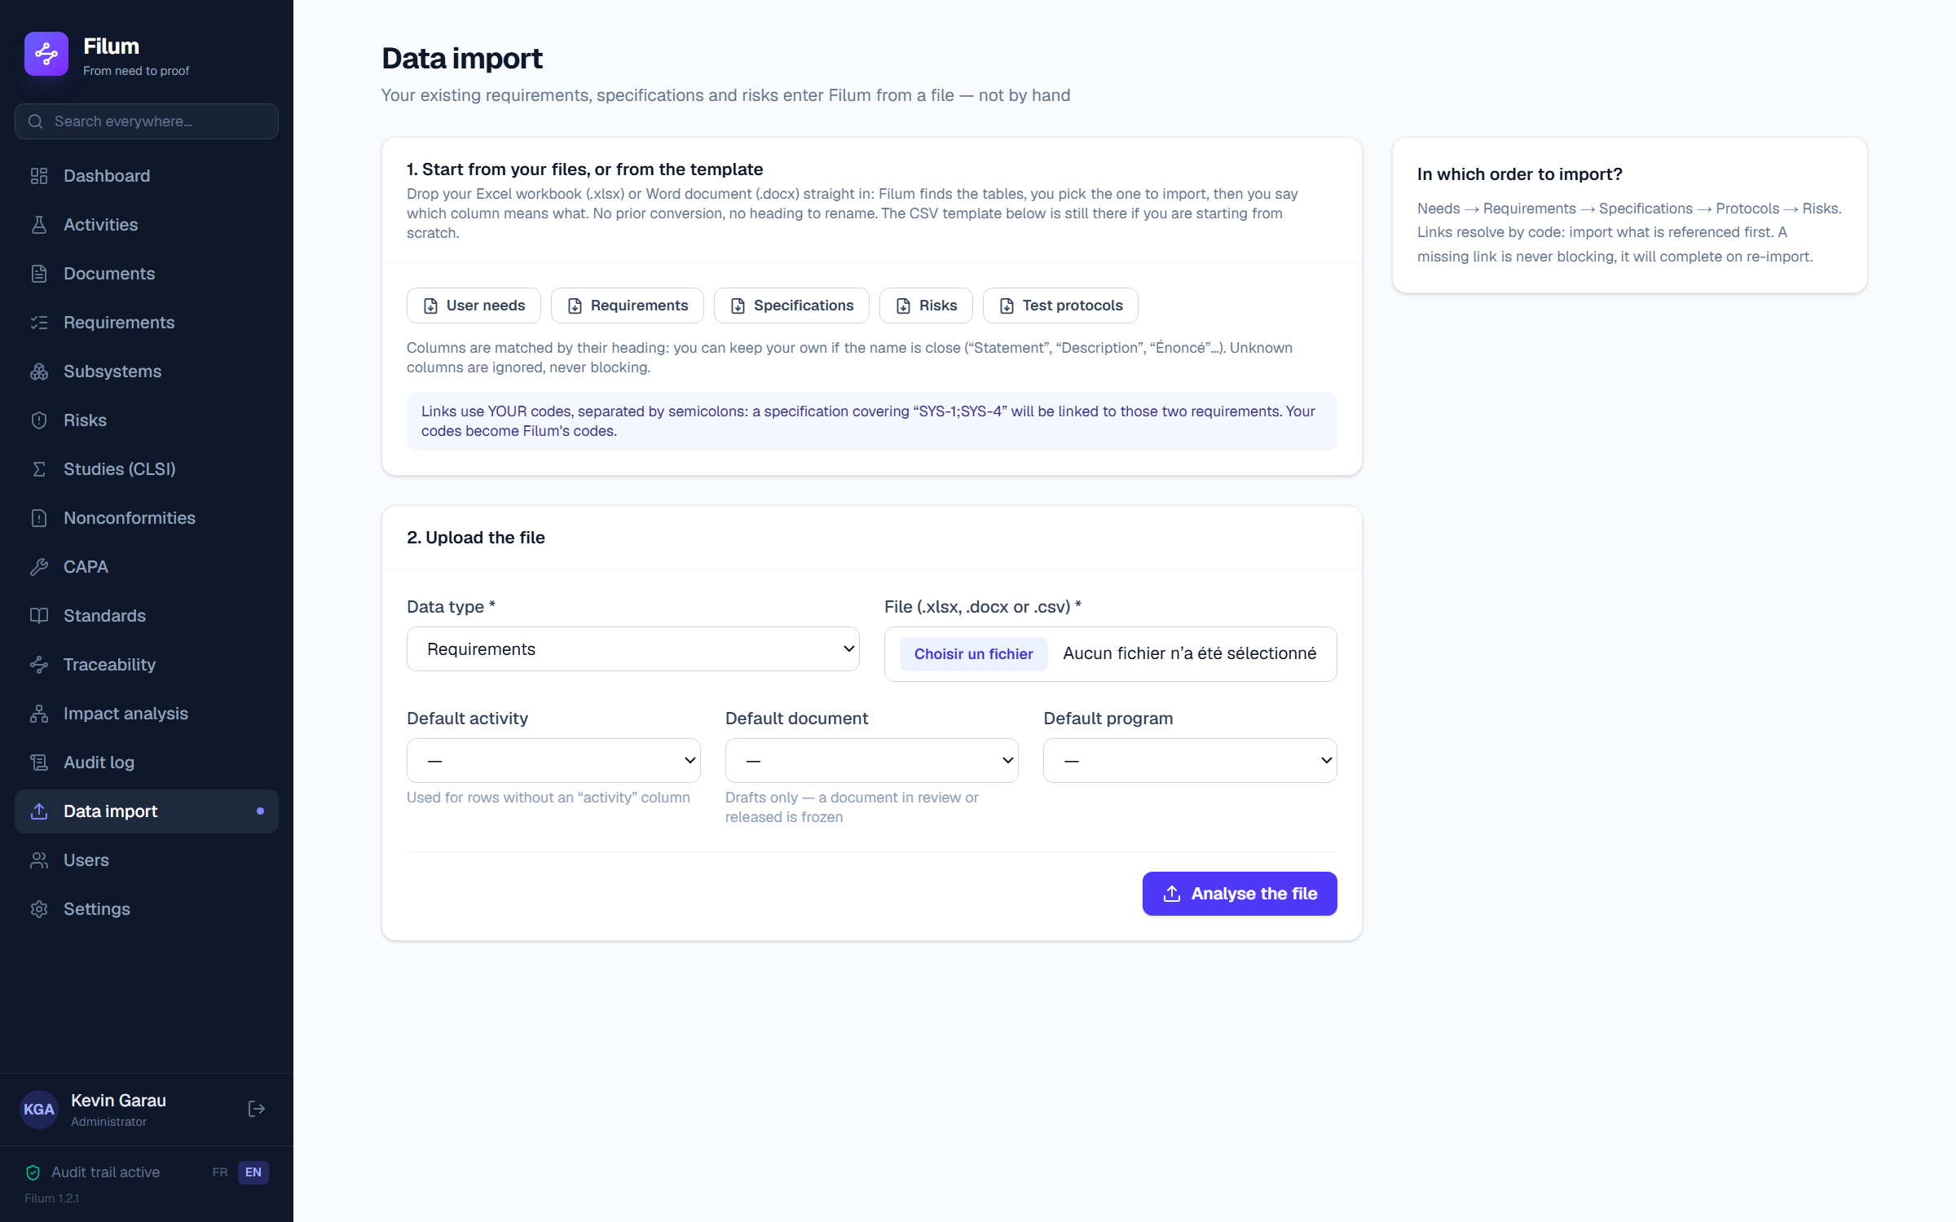
The import screen: templates, file drop, and a reminder of the import order.

Your workbooks and documents, as they are
Drop an Excel workbook (.xlsx) or a Word document (.docx) straight in. No prior conversion, no heading to rename: that was the friction that made people give up before their first import, and it is gone.
1. Filum lists the tables found in the file — a workbook's sheets, a document's tables — with their real name, size and headings. You pick the one to import; the others are left alone.
2. Filum recognises the columns whose heading it understands, and shows you which. You assign the others by hand: under each choice, the file's first real value tells you at once whether you have put the dates column into the statement field.
3. As long as a required column is unassigned, the preview is not computed — and the screen tells you how many are missing.
🔒 Nothing is guessed in silence. An import that guesses writes the wrong column into the right field, and nobody sees it before the audit. Your headings are yours — “Req ID”, “Crit.”, “Functional description” — and ten years of in-house vocabulary cannot be guessed.
💡 Values are mapped back to Filum's vocabulary whatever your file's language: a “Haute” criticality becomes “High”. A value it does not know is REPORTED in the preview and left empty — never stored as is, because it would drop out of the filters without anything saying so.
What is not carried over, and should be checked in the preview: formulas are not recomputed — the last value saved by the spreadsheet is read —, dates stay as numbers, and a merged cell gives its value only to its first box.

Three steps, one of them risk-free
1. Download the template for the type you are importing (French or English). Its headings are readable — Code, Statement, Criticality — and an example row shows what is expected. You may also keep YOUR own headings if they are close: columns are recognised by their heading, accents and case being irrelevant, and an unknown column is ignored without ever blocking.
2. Drop the file. You can set a default activity, document and programme for rows that carry none.
3. READ THE PREVIEW. Nothing has been written yet: Filum shows what it would do — how many creations, updates and rejections — and, for every faulty row, the reason, with the line number as you see it in Excel.
4. Confirm. The import runs in batches, and every item created carries your name in the audit trail.

Links resolve through YOUR codes
This is the point that changes everything: a specification covering “SYS-1;SYS-4” will be linked to those two requirements, by your own codes. You never handle a technical identifier, and your numbering becomes Filum’s. Recommended order: needs, then requirements, then specifications, then protocols, then risks — import what is referenced first.
💡 A reference that cannot be found is never blocking: the item is created, the missing link is flagged, and it will attach by itself on re-import once the target is loaded. Re-importing a corrected file is the NORMAL operation: a code already present is updated, never duplicated.
🔒 A row targeting a document under review or released is rejected. An import does not bypass the document lifecycle — that would be the first thing an auditor looked for.

10. The traceability matrix
“Traceability” menu: each row is a complete thread — need, requirement, specification, method, test or study, result, evidence, status. An empty cell is a gap in the file. The progress bar counts closed threads. The matrix is bidirectional (it reads top-down as well as bottom-up) and “Export (CSV)” produces an Excel-compatible file (semicolon-delimited).
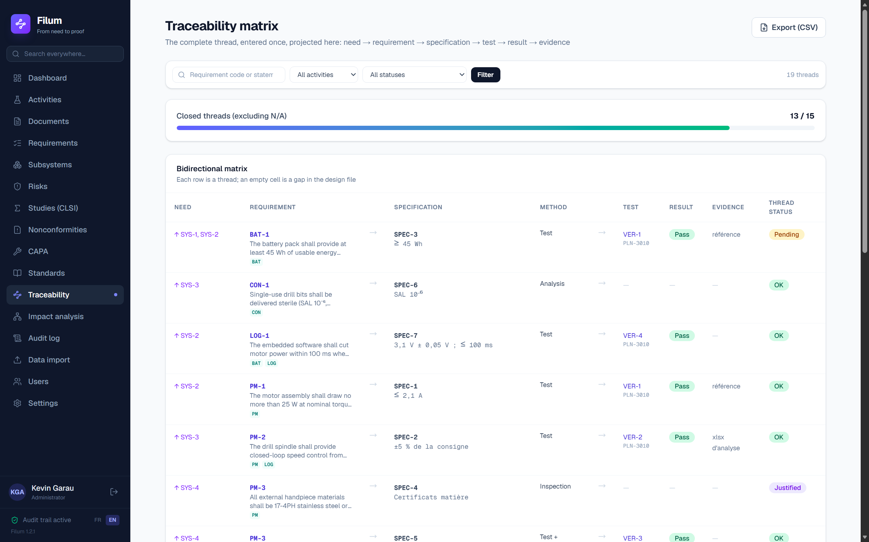
The bidirectional matrix — generated from the graph, never maintained by hand.

11. Impact analysis
“Impact analysis” menu (or click a requirement/specification code in the matrix): pick an item and Filum maps its complete thread — upstream in amber (where it comes from), downstream in emerald (everything a change would call into question, including risks, nonconformities and documents to re-revise). Every node is clickable and re-centres the analysis.
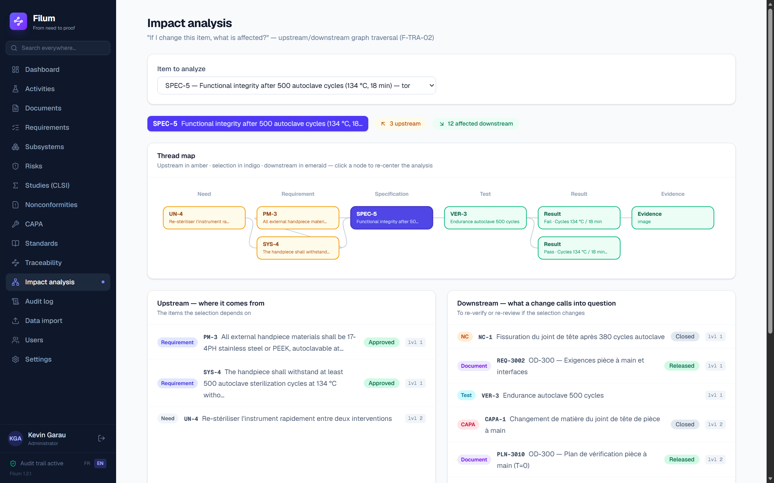
SPEC-5 in impact analysis: the thread runs up to the need and down to NC-1 / CAPA-1.
💡 Before any design change, go through impact analysis: it answers “what am I about to break?” in a second and prevents forgotten re-verification.

12. ISO 14971 risk management
This module keeps the Risk Management File (RMF) per ISO 14971. It is not one more FMEA spreadsheet: every risk lives in the same graph as the requirements and tests, so its controls are verified by evidence already present, not by a hand-ticked box. You document the hazard, the hazardous situation and the harm; Filum computes the acceptability zone and monitors the actual effectiveness of the controls.

The register and the 5×5 matrix
The “Risks” menu shows the FMEA register (one row per risk: hazard → hazardous situation → harm) and two 5×5 heat maps — initial risk and residual risk. The axes are severity (Negligible → Catastrophic) and probability (Improbable → Frequent); an optional detectability refines the analysis. Each cell carries a zone colour: Acceptable (green), ALARP (amber, “as low as reasonably practicable”) or Unacceptable (red). The ALARP legend explains the acceptability policy.
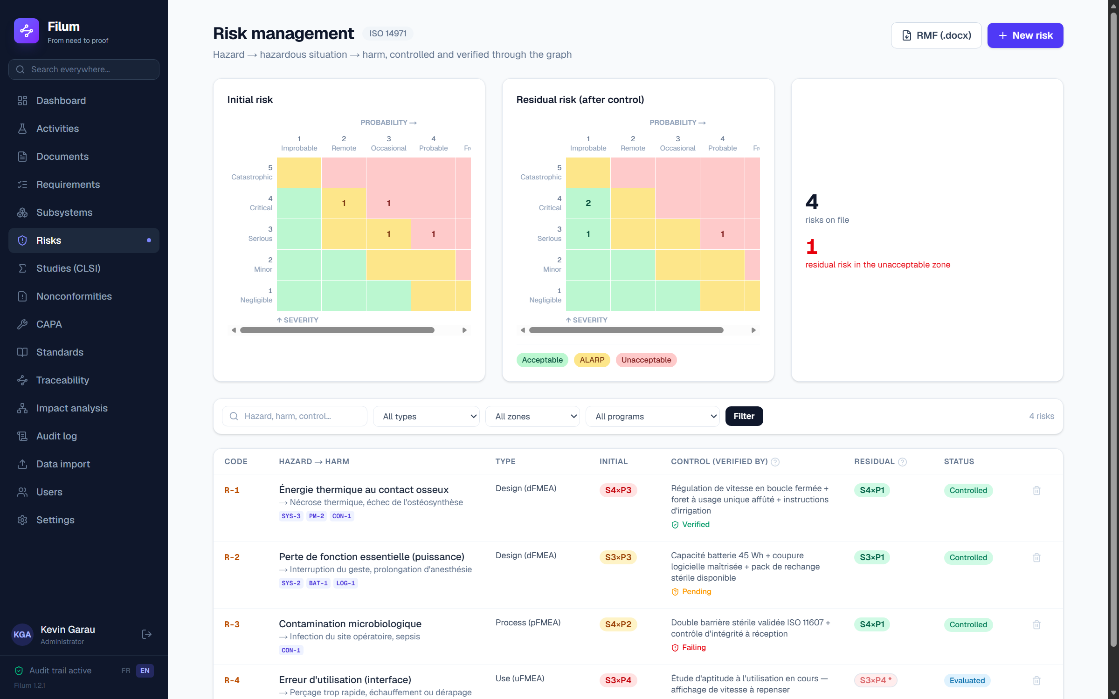
The risk module: initial/residual heat maps, FMEA register and ALARP zone legend.

Documenting a risk (step by step)
1. “Risks” menu → “+ Risk”. Choose the type (design dFMEA, process pFMEA, use uFMEA, software).
2. Describe the hazard (e.g. thermal energy from the burr), the hazardous situation and the potential harm. You can draw on the pre-filled hazard library.
3. Rate the initial risk: severity × probability (+ detectability). Filum places the point in the matrix and shows the zone.
4. Describe the risk control measures, then LINK THEM to the specifications or tests that demonstrate them (this is the key step — see below).
5. Rate the residual risk after control. The second heat map updates; the risk moves to “Controlled”, then “Accepted” once the control is verified.

Control verified BY THE GRAPH
This is what sets Filum apart. A risk control measure is not “verified” because a box has been ticked: it is verified when the specifications and tests linked to it are closed favourably (OK status, test Passed). Filum thereby applies the ISO 14971 §7.2 loop — verification of implementation AND of effectiveness — with no re-entry. In the demo, R-1 (thermal energy) is controlled and verified because its tests passed; R-4 (use error) stays “in progress” until its control is demonstrated.
🔒 If you reopen or fail a test linked to a control, that control automatically returns to “not verified” and the risk loses its “Accepted” status. The risk file cannot misrepresent the actual state of the evidence.

Generating the RMF report
The “RMF report (.docx)” button compiles the full file from the graph: acceptability policy, initial/residual FMEA table, verification state of each control, accepted residual risks. Like every Filum deliverable, it is always up to date because it is recomputed on demand.
💡 Good practice: start with severity (it almost never goes down), then act on probability and detectability through the controls. The residual heat map shows you live whether you have left the red zone.

13. CLSI studies — validating an IVD method
This module validates the measurement methods of an in vitro diagnostic (IVD) device against the CLSI protocols. You import your bench data as CSV, Filum runs the appropriate statistical computation and returns a reasoned Pass / Fail verdict, with the regulatory charts. The study verifies a specification: the evidence flows straight into the matrix, with no double entry. In the demo, the NL-100 “NovaLyte” programme (electrolyte analyser, activity ACT-0201) is validated by six studies, STU-1 to STU-6.

Protocols covered
Protocol | Purpose | Statistic
EP05 | Precision (repeatability + within-laboratory) | Nested ANOVA
EP06 | Linearity over the measuring range | Polynomial regression
EP09 | Method comparison | Passing-Bablok, Bland-Altman
EP17 | Detection capability (LoB / LoD / LoQ) | Parametric approach
EP25 | Stability / shelf life | Regression over time
EP26 | Reagent lot-to-lot verification | Critical difference test
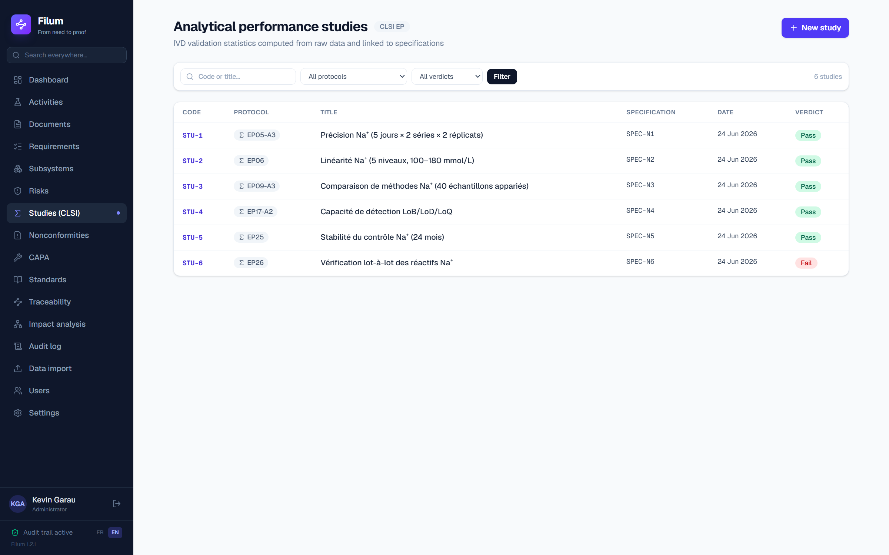
The Studies menu: the six CLSI validations of the NovaLyte programme with their verdicts.

Running a study (step by step)
1. “Studies (CLSI)” menu → “+ Study”. Choose the protocol (EP05, EP06, …).
2. Import the CSV measurement file and map each column to its role (day, run, replicate, level, reference method… depending on the protocol).
3. Enter the acceptance parameters a priori (allowable CV, allowable deviation from linearity, α…). They are set BEFORE seeing the result.
4. Attach the study to the specification it verifies (e.g. SPEC-N1).
5. Run the computation: Filum shows the statistics, the charts and the Pass / Fail verdict.
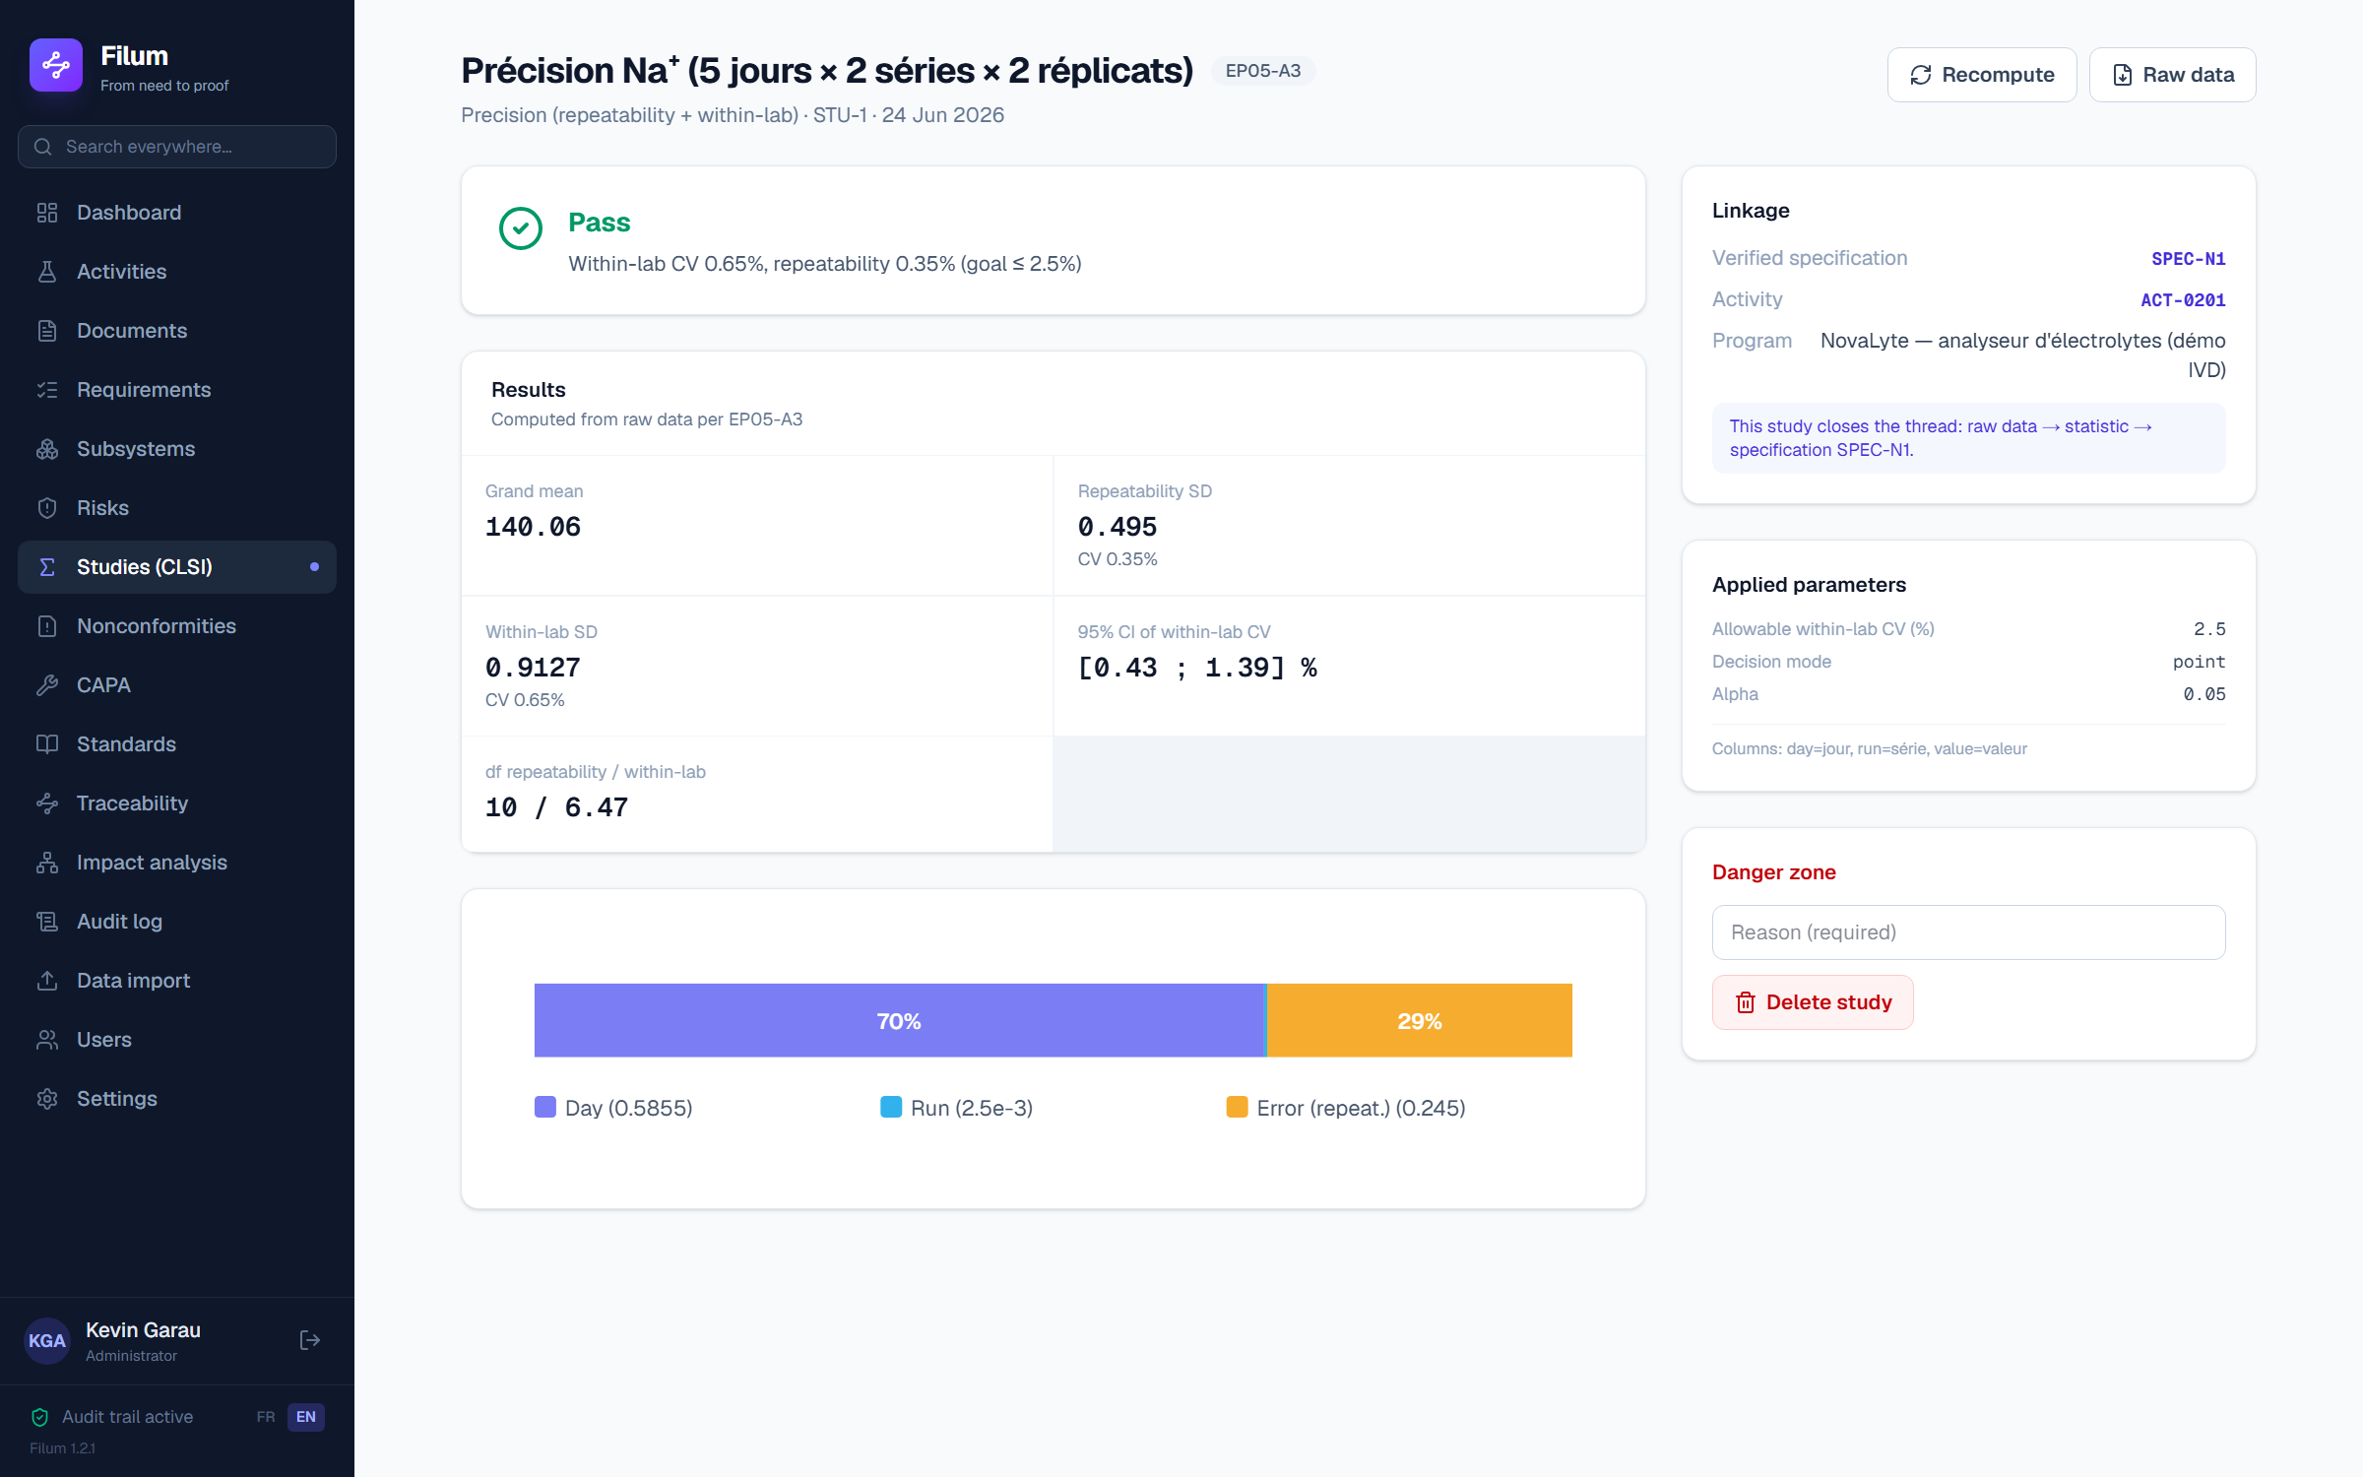
An EP05 study (precision): ANOVA breakdown, repeatability and within-lab CV, verdict.
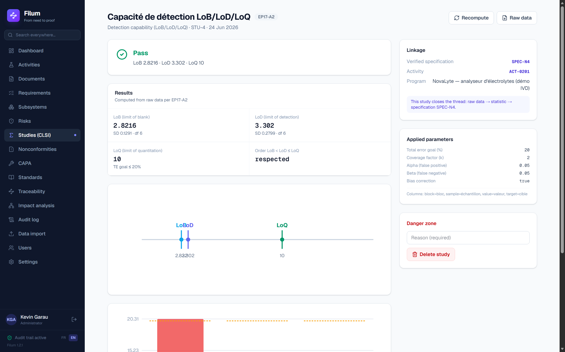
An EP17 study (detection capability): LoB, LoD and LoQ estimated with their intervals.

Verdict and flow into the matrix
When a study passes, the linked specification moves to OK and the evidence appears in the traceability matrix, exactly like a test. When it fails, the specification stays NOK — and you are precisely in the case that feeds the next module. In the demo, five NovaLyte studies pass and only one, EP26 (lot-to-lot), fails.
🔒 Acceptance parameters are set a priori: Filum asks you for them at creation, before the computation runs. One does not choose the threshold after seeing the result — that is a validation integrity requirement.

14. Nonconformities & CAPA
This module covers ISO 13485 §8.3 (control of nonconforming product) and §8.5 (corrective action). Its strength: nonconformities are not entered in a separate register — they are BORN from the graph. A failed test, a failed study, a NOK specification or an uncontrolled risk generates a nonconformity attached to its source. The disposition is signed, escalation to CAPA is justified by risk, and closure feeds back into the graph (a NOK spec can turn OK again). Nothing is orphaned.

The nonconformity (NCR)
A nonconformity carries its source (the graph link that created it), its description, its disposition and its lifecycle Open → Investigation → Disposition → Closed. The disposition (use-as-is, rework, scrap, deviation…) is signed electronically. In the demo, the failure of test VER-3 created NC-1.
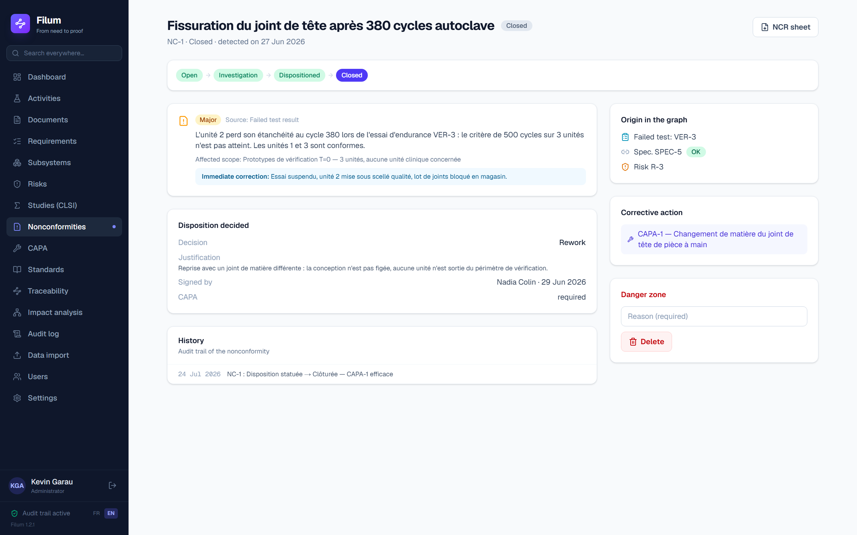
Nonconformity NC-1, born from the failure of test VER-3, with its traced source and its disposition.
1. A failed test result and a study concluded Fail carry an “Open a nonconformity” button: the NC is pre-filled from the failing item, and the link to it is kept. You can also create one from scratch from the register.
2. Open the NC: record the investigation, then choose the disposition (use-as-is / rework / scrap / deviation) and sign it.
3. Decide on escalation: a minor NC can be closed on its disposition alone; a significant NC is escalated to a CAPA with a risk-based justification.
🔒 Escalation to CAPA is neither automatic nor discretionary: Filum requires a risk-based justification. Delegating that decision to a ticked box would be a shortcut — traceability of the decision is part of the file.

The locked CAPA cycle
A CAPA (corrective / preventive action) follows a strict cycle in which each step requires its deliverable before the next one opens. No square can be skipped: the locks are explicit and explained on screen.
Step | What Filum requires to move on
Open | The CAPA is created from the source nonconformity.
Investigation | A responsible owner must be appointed.
Action plan | The root cause must be recorded (no action without a diagnosis).
Implementation | The complete action plan must be approved.
Effectiveness check | Effectiveness criterion set a priori, evidence = test/study re-run and Passed, verifier independent of the owner.
Closed | Signed closure; feedback into the graph (spec turned green again, NC closed, risk reassessed).
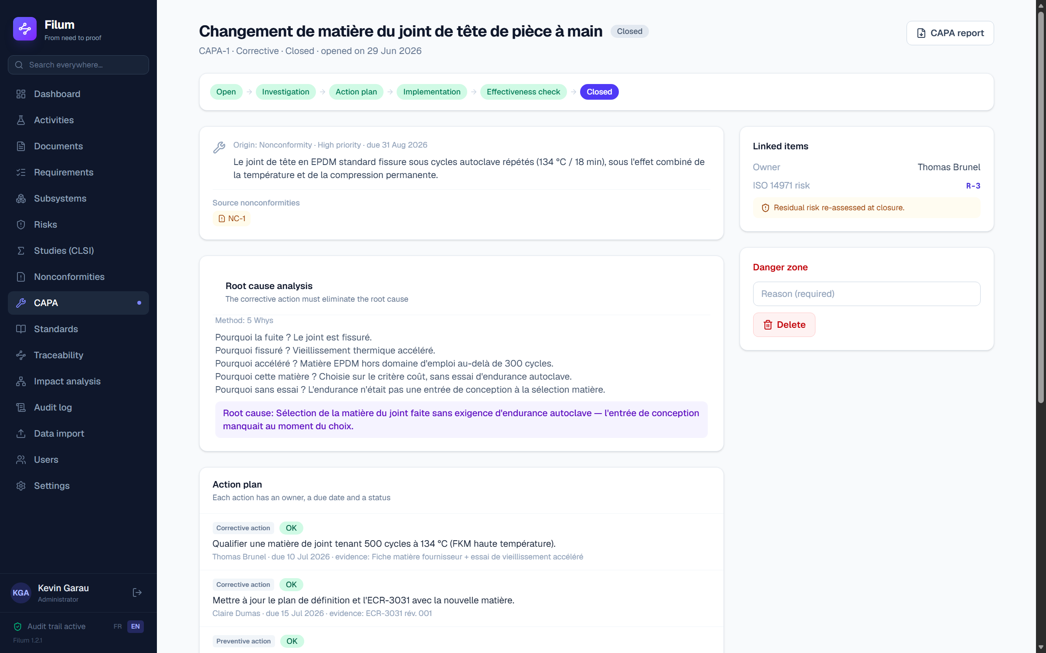
CAPA-1 closed EFFECTIVE: the complete stepper, the root cause and the independent verification.

A complete example — the loop that closes
In the demo the story reads from one end of the graph to the other: test VER-3 fails → NC-1 is created → it is escalated to CAPA-1 → the investigation identifies the root cause (an unsuitable seal elastomer) → the action plan is implemented → the test is re-run and this time Passes → the effectiveness check is validated by an independent verifier → CAPA-1 is closed EFFECTIVE. On closure, specification SPEC-5 automatically moves back from NOK to OK and NC-1 closes. None of these updates was entered twice.
🔒 The effectiveness check requires a verifier independent of the CAPA owner and objective evidence (the test that failed must pass again) — not a mere statement that “it is fixed”. That is what separates a closed CAPA from a closed AND effective one.

Generated forms and reports
The “NCR form (.docx)” button on a nonconformity and “CAPA report (.docx)” on a CAPA compile the complete file from the graph — source, investigation, disposition, root cause, actions, effectiveness check, signatures. Always current, never re-typed.

15. Global search and filters
The sidebar search box queries the whole graph at once: activities, documents, requirements, specifications, risks, studies, nonconformities, CAPAs. Type a code (SPEC-5, R-1, NC-1) or a keyword; results are grouped by type and clickable. On every list page (documents, requirements, matrix, risks, studies, nonconformities, audit trail) a filter bar narrows the view by status, category, activity or date range.
💡 The tick-lists in creation forms (requirements covered by a spec, applicable standards…) are filterable too: on a large file you find the item to link by typing its code rather than scrolling.

16. The audit trail
“Audit trail” menu: every write — creation, edit, status change, signature, generation, import, sign-in — is recorded with the authenticated actor, the timestamp to the second, the reason and the before/after values. The trail is append-only: the application never modifies or deletes an entry (ALCOA+, heading towards 21 CFR Part 11).
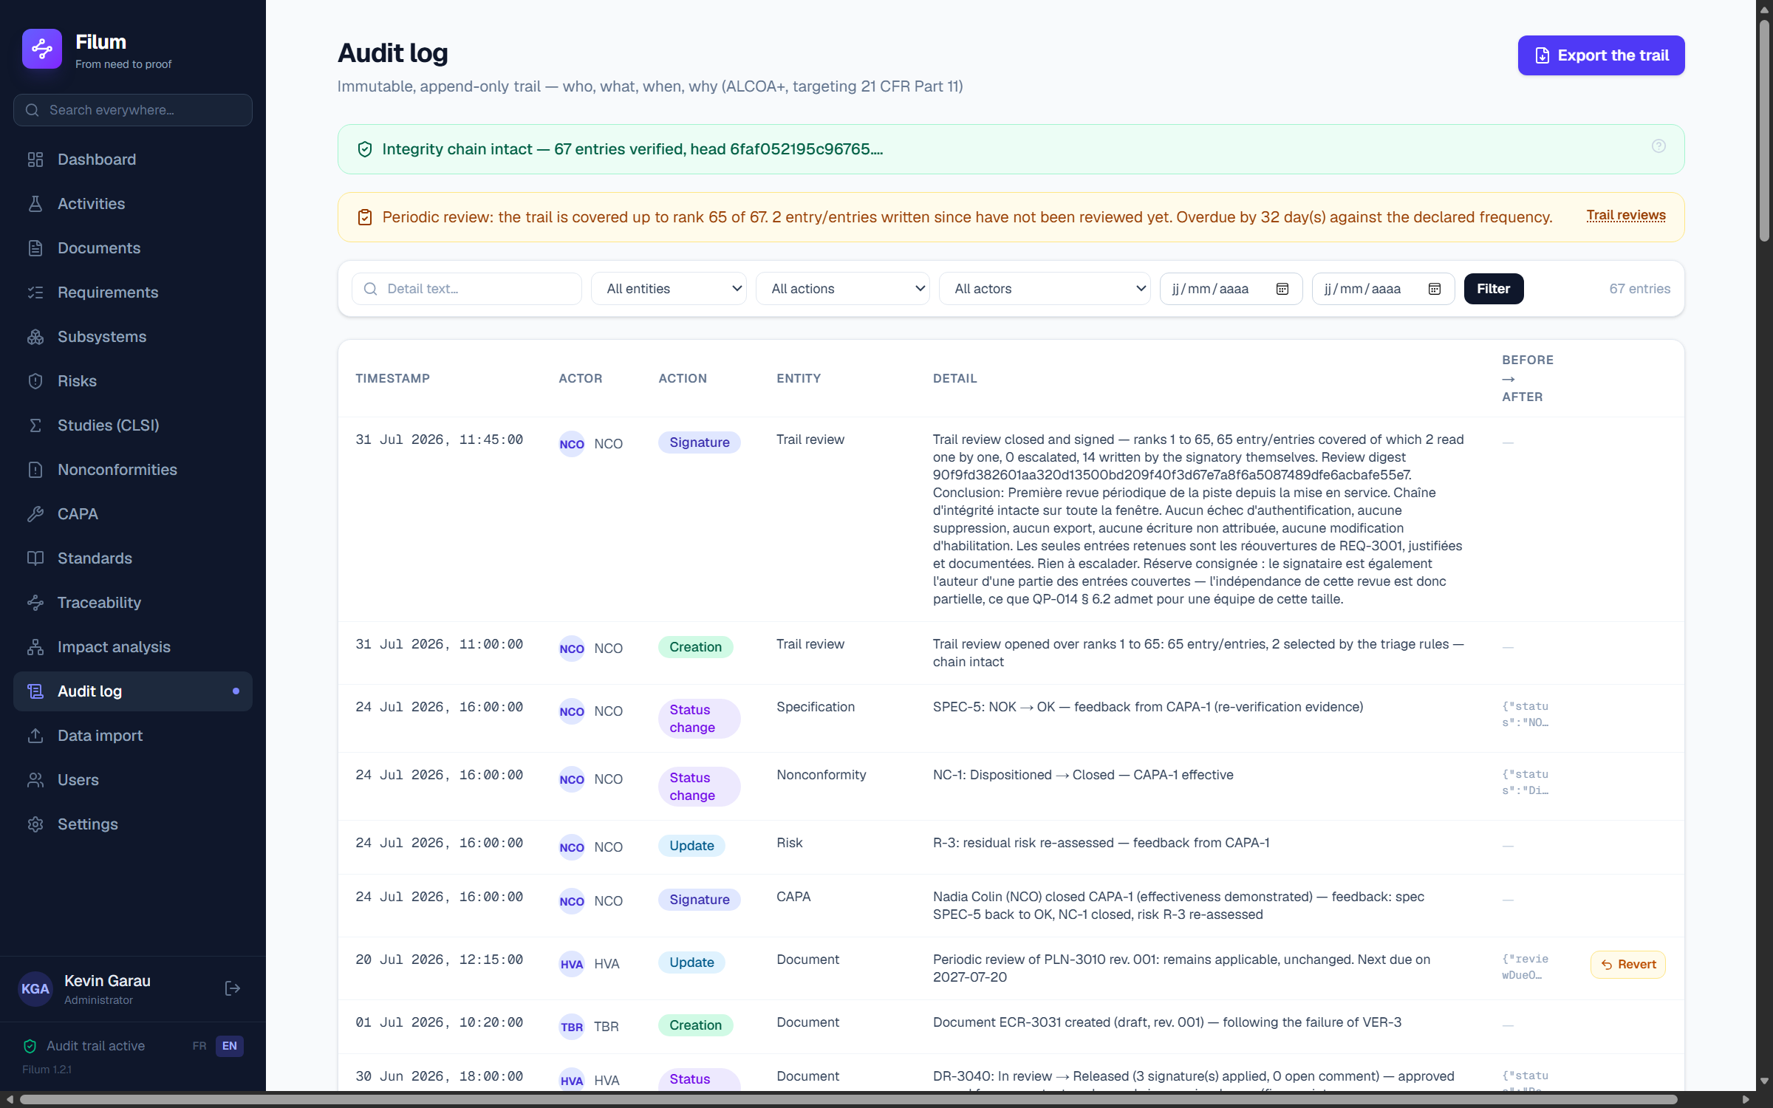
The audit trail — who, what, when, why, before → after.

The integrity chain
Each entry carries the fingerprint of the previous one. Modifying or deleting an entry directly in the database — outside the application, from the server console — breaks the link of every entry after it. A banner at the top of the log verifies the chain on every display: green when intact, red when not, with the exact rank of the break. The CSV export carries each entry’s rank and both fingerprints, so the chain can be recomputed outside Filum from that file alone.
🔒 Chaining DETECTS tampering, it does not prevent it — and whoever writes to the database can recompute the whole chain. It is the chain head recorded in the inspection archive, then countersigned by a time-stamping authority, that makes tampering undeniable: a chain recomputed after the fact will not reproduce the timestamped head. Producing timestamped archives and recording their anchors outside the system is therefore part of the mechanism, not a convenience.

The periodic review of the trail
The chain says the trail has not been tampered with. It does not say it has been READ — and a trail nobody reads back detects nothing, it archives. The “Trail reviews” link at the top of the log opens the periodic review screen. The draft Annex 11 makes this an explicit requirement.
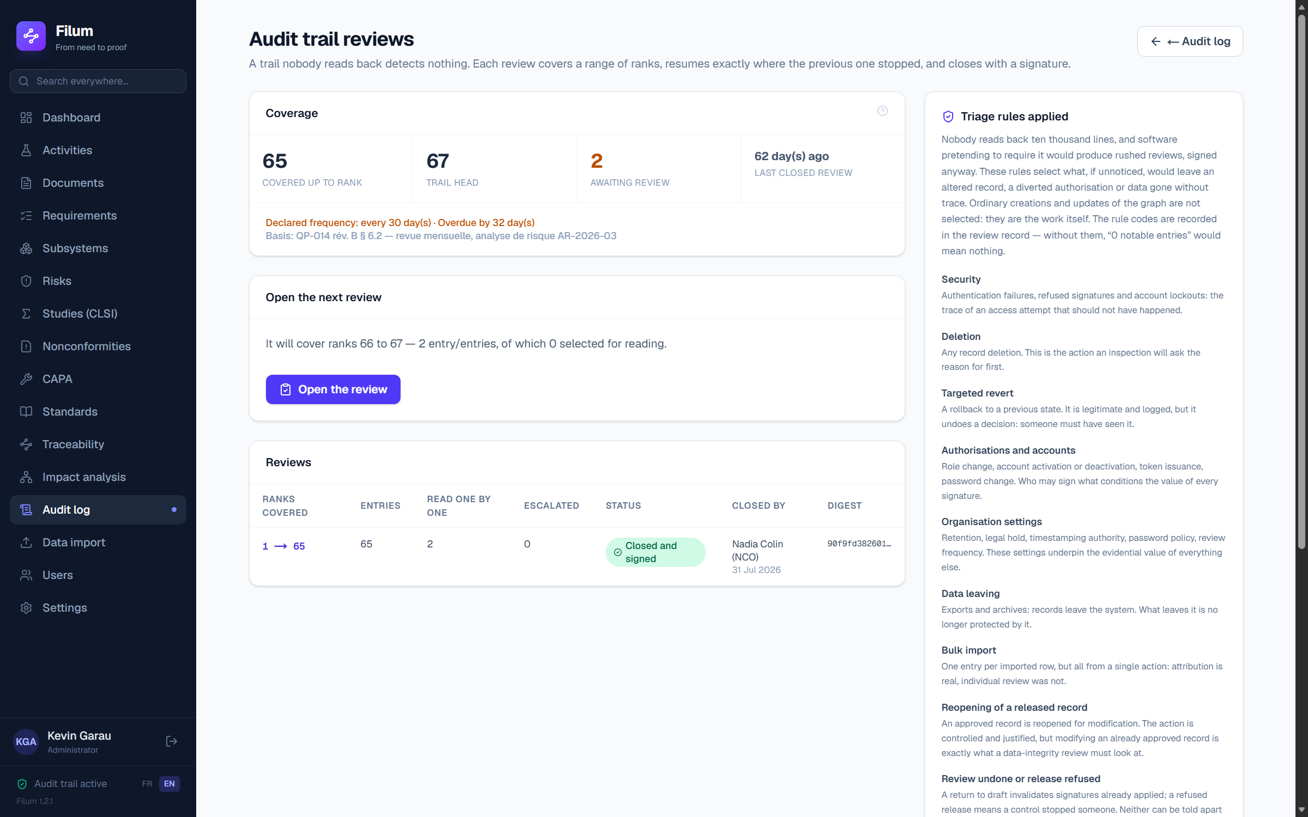
Trail reviews: coverage, next window, triage rules.
Coverage is counted in RANKS, not dates. A review “from 1 to 31 March” would let through whatever is written on the 31st at 23:59 while it is being closed: the next one would start on 1 April, and those entries would be read by nobody. Each review therefore starts exactly at the rank following the previous one, and the distance between the last covered rank and the trail head is shown permanently on the log.
Open a review: its window is FROZEN at that moment. Whatever is written while you conduct it — including your own verdicts — belongs to the next review. This is not a side effect: it is how the reviewer's work gets reviewed in turn.
Nobody reads back ten thousand lines. Risk-based triage rules designate the entries to be read one by one: security, deletion, targeted revert, authorisations, organisation settings, data leaving, bulk import, reopening of a released record, review undone, unattributed write. The rest is COUNTED, not read, and the record says so. Ordinary creations and edits are not selected: they are the work itself. Neither are signatures — they are already reviewed by the process that produces them.
Every selected entry receives a verdict: Expected, Explained, or Escalated. The last two require a reason — without it, the record would say you looked without saying what you saw. Closing is refused while a single entry remains undecided.
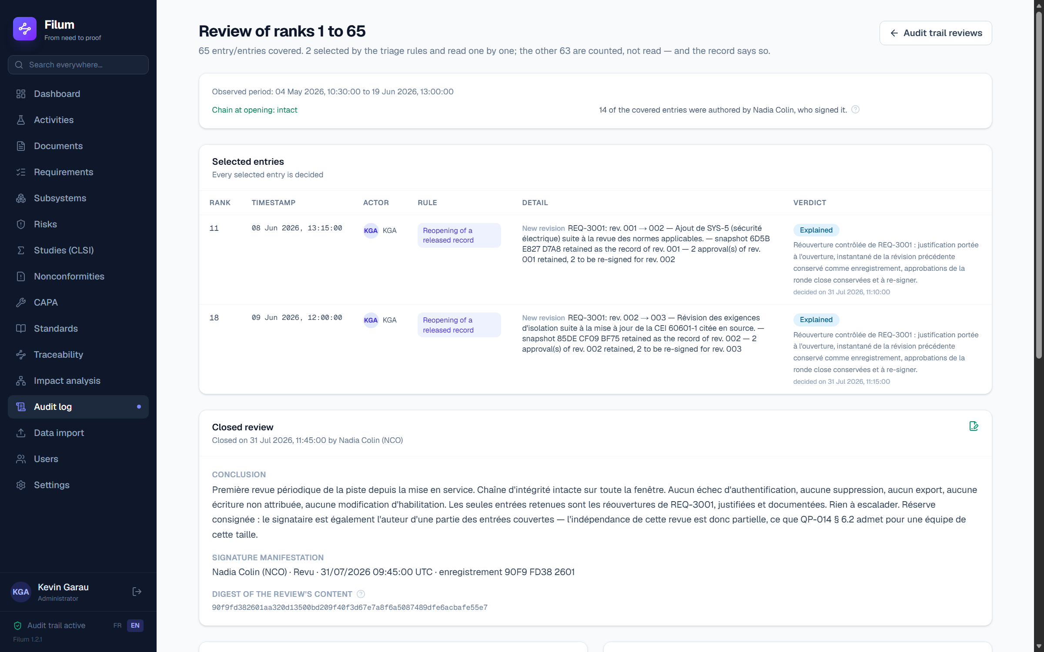
A review in progress: each selected entry, its rule, its verdict and its reason.
Closing is a signature: your password is re-entered, and the manifestation carries your printed name, the date, the meaning “Reviewed” and the digest of the review's CONTENT — window, counts, rules applied, verdicts and conclusion. Without that digest, “reviewed on 6 August” would not say WHAT was reviewed. A closed review does not reopen: a correction goes through the next review, like a document revision.
💡 Declare your review frequency in Settings. Filum imposes none — the right period depends on your activity volume — but without it, no due date can be computed and the screen tells you so.
🔒 Filum does not judge for you. It cannot tell a legitimate change from a suspicious one: that requires knowing the project, the context and the people. Nor does it block anything at the due date — refusing a write because a review is late would punish the data for a procedural failing. And it does not forbid reviewing your own actions: in a team of three, requiring otherwise would make review impossible. It MEASURES that share and writes it into the record, so the inspector knows without having to work it out.

Extracting the trail for an inspection
The “Export the trail” button produces a COMPLETE CSV file — the screen itself caps the display at 200 rows. Active filters are applied to the export, so you can answer precisely “every action by Mr X between January and March”, which is an inspector’s first request. Generating the export is itself logged: it is known who extracted what, and when.
💡 Filter by actor AND by period before exporting: you then hand over exactly what was asked for, no more and no less.

Targeted revert
Targeted revert applies only to content EDITS: neither a creation, nor a deletion, nor a signature, nor a state change can be undone in one click — a signature cannot be undone by a revert. On an edit, the “Revert this action” button restores the previous state of that one item, leaving everything else untouched. The revert is itself logged as a new entry — history is never erased, it is enriched. That is safer than a global “Ctrl+Z” that would sweep away legitimate changes.
💡 Search the trail first (filter by actor or by entity) before reverting: you will see the exact chain of changes and revert only the right one.

17. User administration
“Users” menu (Administrator only): create accounts, assign roles, open or reset an access, deactivate an account (its sessions are revoked immediately). Creating a person without sign-in access adds them as “referenced”: they can be named as a signer or performer without having access to the application.
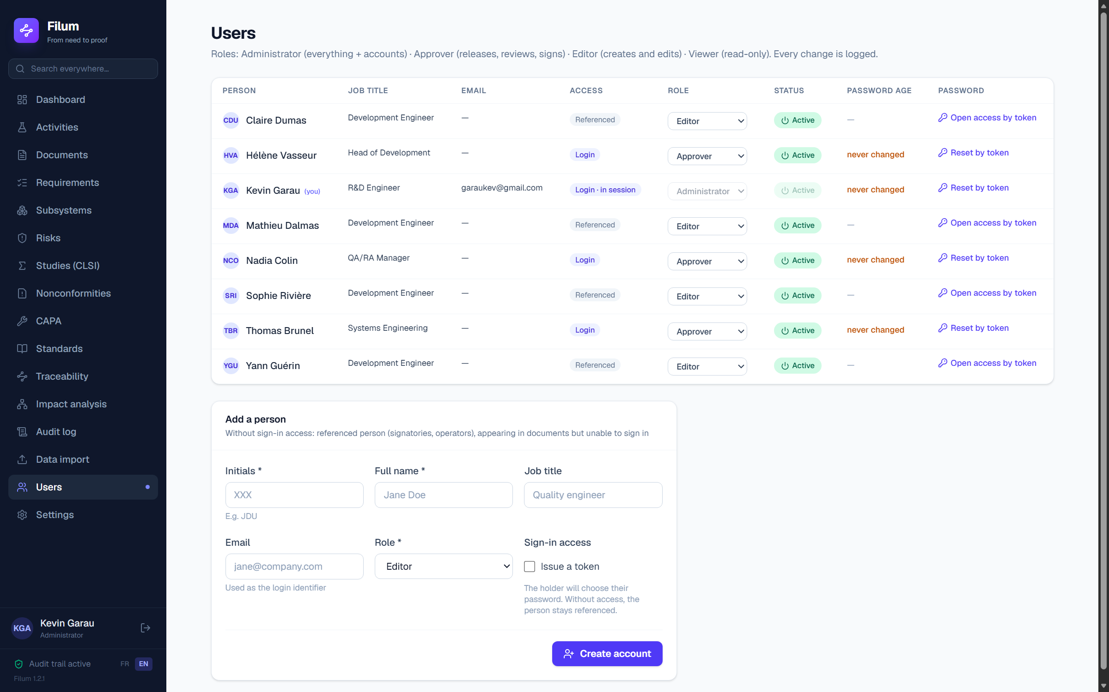
Account management — every change is logged.

Opening or resetting an access: the token
You never type someone else's password. The button in the “Password” column issues a single-use token, valid 24 hours, shown once only: write it down, it is stored as a hash alone and nothing lets you recover it afterwards. The account's open sessions are revoked in passing — you reset precisely when you suspect an access has slipped away from its holder.
Hand this token to its holder through the channel your procedure prescribes: in person, by phone, through your internal messaging. Filum has no outbound channel and will not send it for you — that is the price of “nothing leaves your infrastructure”. The holder redeems it from the sign-in screen, link “I have a reset token”, and chooses their OWN password.
🔒 This is 21 CFR 11.200(a)(3) at work. An administrator who TYPES an account's password holds both signature components — the identifier, which is public, and the secret: they can sign in the holder's place without collaborating with anybody. One reserve remains, and you should know it: the administrator sees the token they issue. But they now have to ACT, the act is timestamped in the audit trail, and the holder notices at once since their token is refused as “already used”. If that happens to you, report it.
🔒 Every administrator-only deletion requires a written reason, kept in the audit trail. Nothing is deleted “silently”: the reason is part of the record.

18. Settings: your account, your programmes, your AI key
The “Settings” menu is open to ALL roles — everyone must be able to change their own password, otherwise an electronic signature could not truly be attributable to one person.
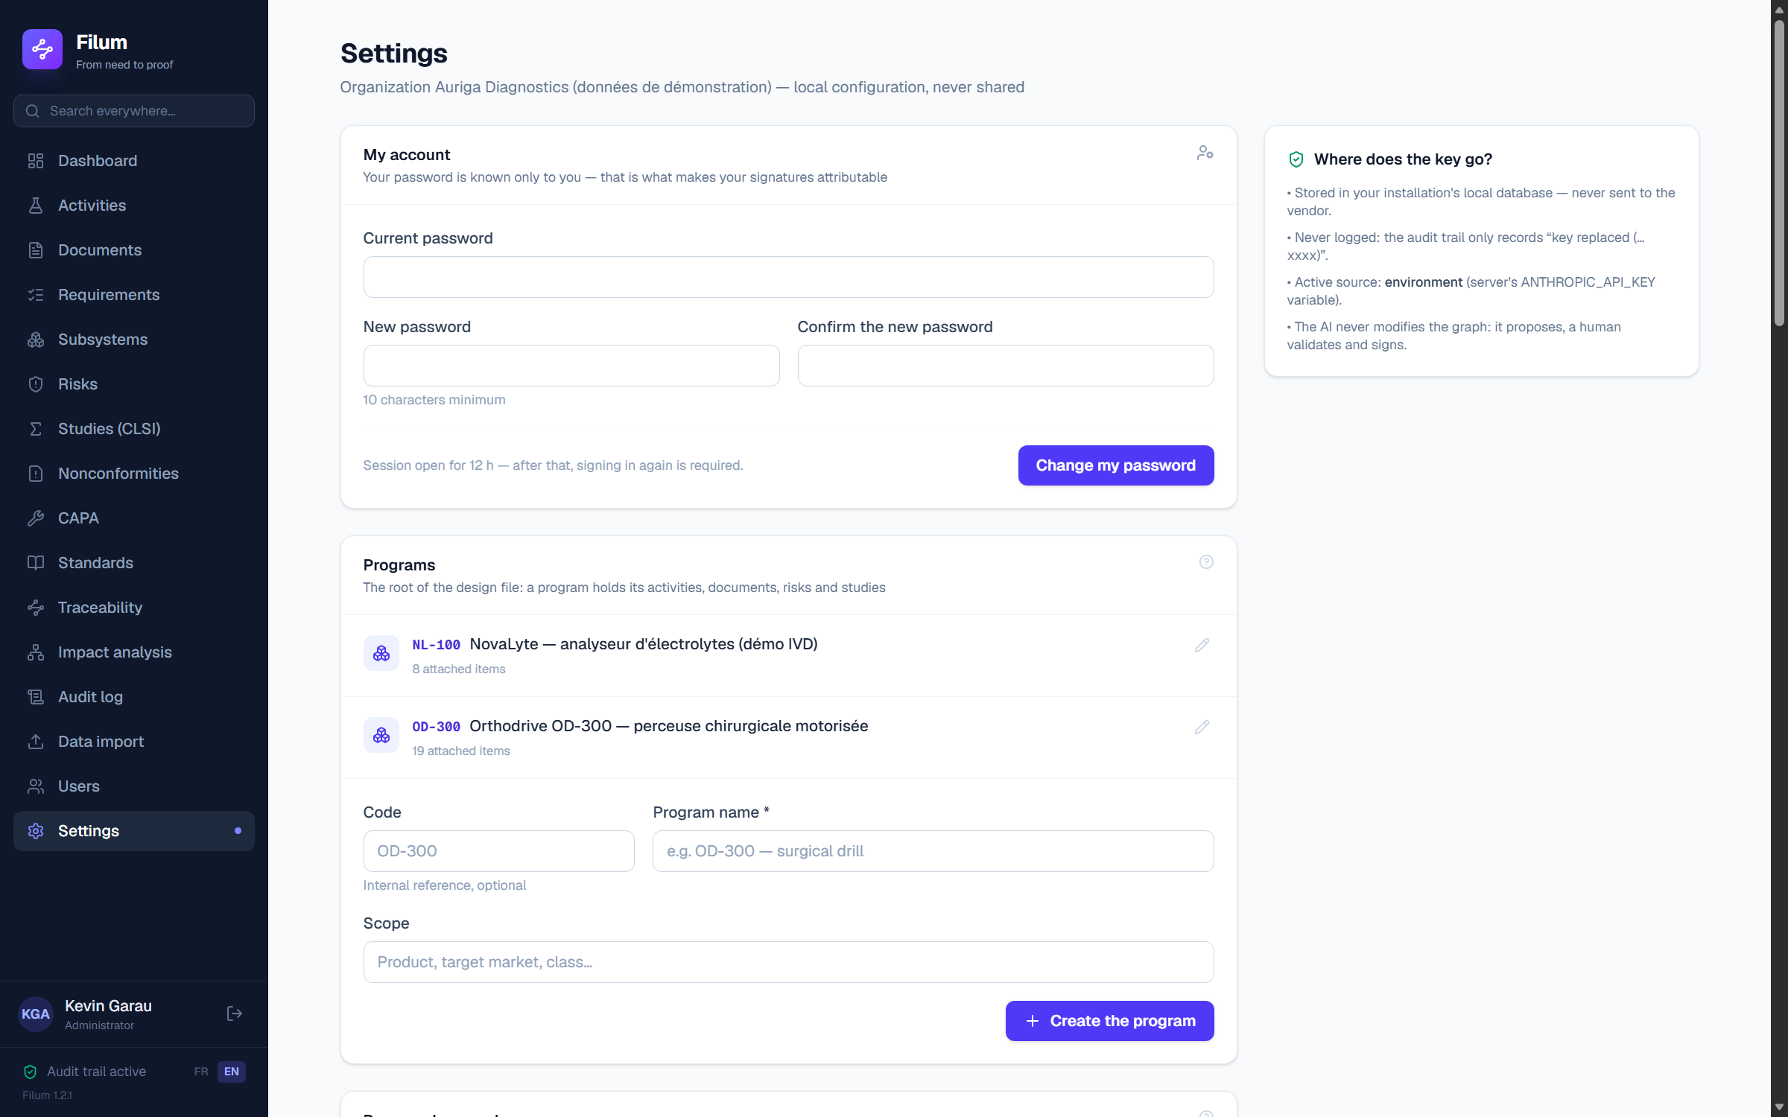
Settings: personal account for everyone, programmes and AI key for the administrator.

My account
Change your password (ten characters minimum) by supplying the old one. All your OTHER sessions are then revoked — the current one stays open. This is what to do whenever you doubt your password is still private. If you have forgotten it, do not ask to be given one: ask for a token, and choose the new one yourself.

Password renewal
Filum records the date of your last password change, and the users screen shows the age for every account: this is what makes possible the periodic review of identification codes expected by 21 CFR 11.300(b). The very first administrator account of an installation is an exception and must renew its password at first sign-in: that password comes from the compose file handed to your IT team, so it is not a secret but a temporary pass, and a signature applied afterwards would be attributable to nobody.
Your organisation may also declare a validity period, in Settings. That field is deliberately empty by default: the clause sets no period, and NIST SP 800-63B advises against arbitrary periodic expiry, which drives predictable increments — “Filum2026!” then “Filum2027!”. Not expiring is therefore a defensible decision, provided you write it down and keep up the account review. When a declared period is exceeded, the renewal screen takes over and nothing else is accessible until the change.
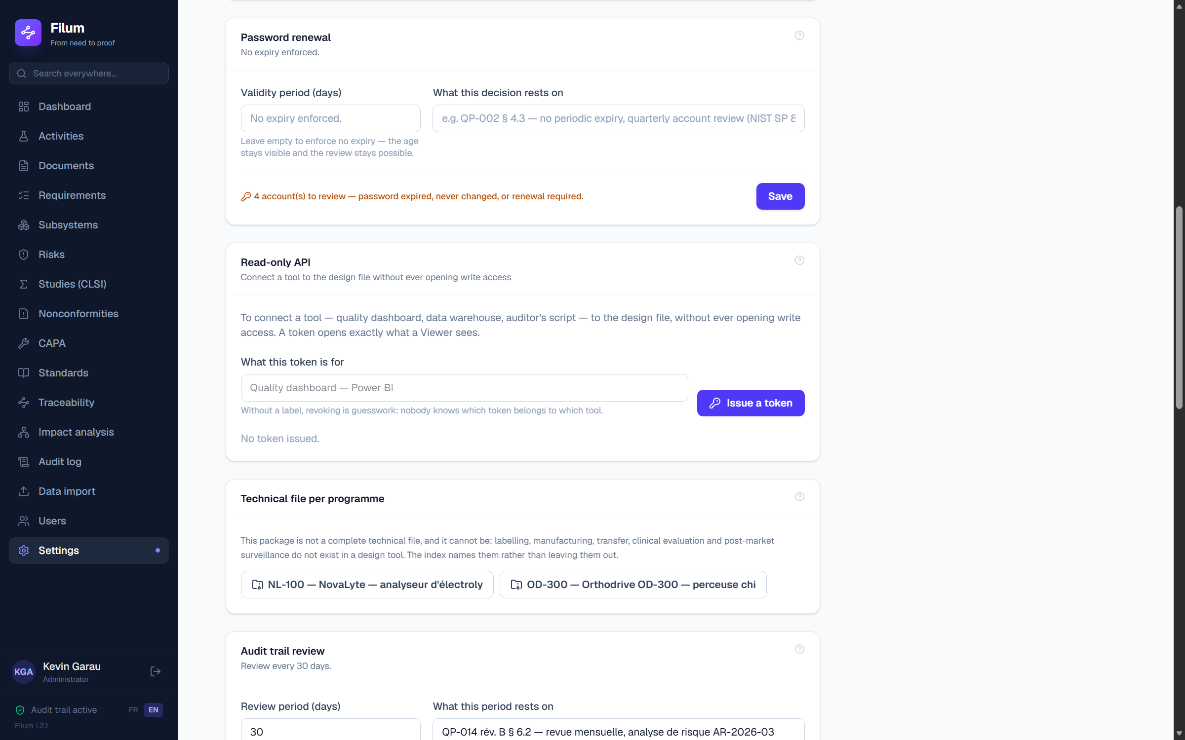
Password renewal — the period is empty by default, with the basis for the decision written alongside.

Programmes (administrator)
A programme is the product or product family your activities relate to. Create as many as you need; a programme can only be deleted once it carries no content at all.

AI assistant — your key, your contract
The drafting assistant runs on YOUR Anthropic API key, entered here. It is stored in your own database, never at the vendor, and the call leaves from your server under your own contract: no design data passes through Filum. The test button checks the key without consuming tokens.
What is sent to the API is written under the assistant block on every document: the drafting context — activity, needs, requirements, specifications, protocols and the results that verify them, risk register, initials of the people involved. File paths and raw data never leave.
🔒 The AI PROPOSES, a human validates and signs. A proposed draft only enters a document after explicit acceptance, and its origin stays traced. No regulatory decision is automated.

19. Data, backup and security
What | Where / how
All the data | On the server, in two Docker volumes: the database and the uploaded files. Backing up one without the other would leave test evidence orphaned — the procedure and its verification are in the installation guide.
Imported measurement files | The uploads folder — kept exactly as imported, to be included in the backup.
Before an upgrade | Your IT team backs up both volumes BEFORE updating the image — the procedure and the archive check are in the installation guide.
AI key | Entered in Settings, it is stored in YOUR database — hence present in your backups, and to be protected as a secret. Calls leave from your server, under your own contract: no data passes through the vendor.
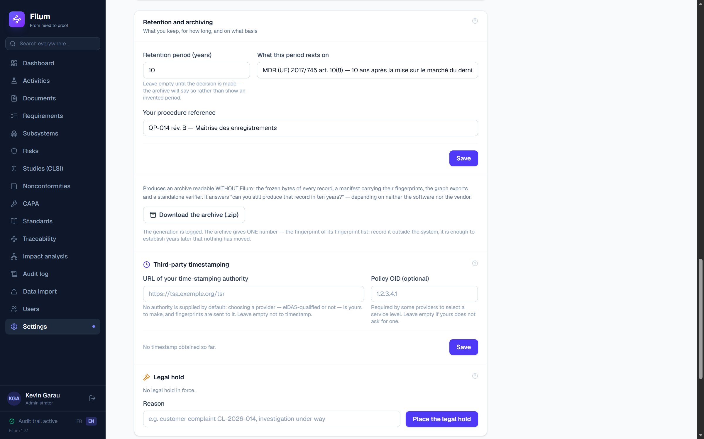
Retention, inspection archive and legal hold — the Settings card, administrator only.

How long is all of this kept?
Filum NEVER deletes a frozen record: no purge, no expiry, no bin that empties itself. The retention period is declared in Settings — the period, what it rests on (ISO 13485 § 4.2.5, MDR art. 10(8)…) and the reference of your own procedure. It triggers nothing: it is carried onto every record in the archive as a due date, so the decision sits in the file. Until a period is declared, the archive says so plainly instead of showing an invented value.

The technical file, per programme
Settings → “Technical file per programme”. One download per programme, and it answers a DIFFERENT question from the inspection archive. The archive proves your records are authentic; this package shows whether the file is complete, and where each piece is.
It indexes what Filum holds against the 50 items of the diagnostic referential — the very one we supply ahead of a mission — each linked to its ISO 13485 clause, its historical 21 CFR 820.30 reference and its Annex II section. Each line states what is covered, what is partial, what is missing, and what must come from your quality system.
1. technical-file-index.csv — the 50 lines, with their regulatory references, their status and what was found.
2. dossiers/ — the design file compiled for each activity, with its completeness analysis.
3. enregistrements/ — the frozen bytes of each released document, exactly as they were signed.
4. donnees/ — the traceability matrix, and empreintes.sha256 to verify the whole package.
🔒 NO STATUS IS TYPED IN. “Covered”, “partial”, “absent” are derived from the graph at the moment of export, and change when the graph changes. An index whose statuses were hand-typed would be a statement of intent, not a state — and that is exactly what an auditor tries to tell apart.
🔒 THIS PACKAGE IS NOT A COMPLETE TECHNICAL FILE, and its cover note says so in plain words. Labelling, instructions for use, manufacturing specifications, design transfer, clinical evaluation and post-market surveillance do not exist in a design tool: fifteen of the fifty items are named as out of scope, each with the source it must come from. An index leaving them out would look complete — and the file would not be.
💡 The export is logged with the index state at the moment it leaves: a file handed over with missing items cannot later be presented as if it had been complete.

The inspection archive
The “Download the archive” button in Settings produces a folder readable WITHOUT Filum: the frozen bytes of every record, a manifest that opens in a spreadsheet, the CSV exports of the design file, the complete audit trail, and a fingerprint file in the standard sha256sum format. It answers “will you still be able to produce that record in ten years?” — a regulatory period of ten to fifteen years outlives any software installation, so retrieval cannot depend on the software.
The archive’s cover letter gives ONE number: the fingerprint of the fingerprint file, which itself carries that of every other file. Copy it into your management-review record. Years later, that single number establishes that the archive presented is the one produced on that day. On a Linux or macOS machine, “sha256sum -c empreintes.sha256” checks everything; elsewhere, “node verifier.mjs”, included in the archive, does the same with nothing to install.
💡 Produce an archive at the moments that matter: every management review, before every major upgrade, at the closure of a programme, at decommissioning. And keep it somewhere other than the server it is meant to outlive.
🔒 A record damaged on disk is marked ALTERED in the manifest and included nonetheless. Removing it would produce an archive that merely looked sound — worse than the defect itself.

Having the archive timestamped by a third party
A fingerprint establishes that content has not moved. It does not establish that it existed on a given date: nothing prevents computing today the fingerprint of a backdated document. That is what third-party timestamping is for, as standardised by RFC 3161. In Settings, enter the URL of YOUR time-stamping authority — Filum supplies none by default, because fingerprints are sent to it and choosing a provider, eIDAS-qualified or not, is yours to make. The “Test the authority” button timestamps a dummy fingerprint, writing nothing into your design file.
Once the authority is configured, every archive carries a “horodatage.tsr” file: the token by which the authority countersigns the anchor. The cover letter gives the openssl command that verifies it, anchor included. Filum timestamps the anchor and nothing else — calling an external authority at every review submission would make approving your documents depend on a third-party service, which a medical device cannot afford.
💡 If the authority is unreachable at extraction time, the archive is produced anyway, without a token, and says so plainly. It simply attests less: re-run the extraction once the service is back.

The legal hold
A complaint arrives, an inspection is announced, litigation opens: from that moment, any deletion becomes destruction of evidence. An administrator places the legal hold from Settings, with a written reason. It immediately suspends EVERY deletion in the installation — including those an administrator may otherwise perform, and including the purge of import files launched from the server console. An attempted deletion then shows a banner quoting the reason and the date it was placed.
🔒 Lifting the hold requires its own reason, distinct from the one used to place it. Placing only restricts; lifting reopens the possibility of deletion. The audit trail must be able to say who reopened it, when, and on what decision.

20. Troubleshooting
Problem | Solution
Forgotten password | An administrator resets it in “Users” — your open sessions are then revoked. If it is the last administrator account: your IT team runs “docker compose exec filum node scripts/reset-admin.mjs” on the server; the operation is logged.
The page keeps returning to sign-in | Expired session, deactivated account, or account locked after several failures (15 min by default). See an administrator — the audit trail says which of the three.
An action does nothing / a panel refuses me | Your role does not allow it: the panel or banner names the required role and yours. Nothing was saved. Ask an administrator to raise your role.
A document cannot be released | Signatures are still missing or review threads are unresolved — the Approvals card lists what is blocking.
A document cannot be deleted | It is released or carries signatures: it is a record. The compliant route is a new revision.
The service is unresponsive | Your IT team checks the container state (“docker compose ps”) and its logs (“docker compose logs -f filum”).

21. Scope: what Filum does, and what it does not
This chapter exists so you do not go looking for a feature that is not there. Everything on the left is done in the software; everything on the right is not, and comes with no promised date.
What is in place | What does not exist
Traceability — Graph need → requirement → specification → test → evidence. Matrix and impact analysis generated, never stale. | This is not an eQMS — No training, no suppliers, no complaints, no internal audits, no management review.
Statement quality — Deterministic checks as you type, EARS templates, rewrite proposed — never written. | No configuration management — No baselines, no configuration items, no comparison between two frozen states.
Document control — Draft → Review → Released, content frozen on entering review. Design reports, DHF, RMF, NCR, CAPA generated as .docx. | IEC 62304 is a stub — No tooled software lifecycle, no anomaly tracking, no SOUP management.
Electronic signature — Two components at every signature, human-readable manifestation, fingerprint of the attested content. | No outbound channel — Filum sends no email: no notifications, no due-date reminders, no approver chasing.
ISO 14971 risk — FMEA, 5×5 matrix, ALARP. A control is verified only when the tests carrying it are closed favourably. | No integration with your information system — No webhooks, no PLM / ERP / ALM connector, no ReqIF. Filum is not an ERP and does not stand in for one.
IVD method validation — Six CLSI protocols computed internally — EP05, 06, 09, 17, 25, 26 — automatic pass / fail verdict. | One installation, one organisation — Not multi-tenant: isolation is per instance, one per entity.
Nonconformities and CAPA — Locked lifecycles. No closure without effectiveness proven by a re-run test that passes. | You only sign what Filum produces — No signing of an uploaded PDF or a file coming from elsewhere.
Technical file — The package an inspector asks for: index over 50 regulatory items, statuses derived from the graph. | Audit entries already written are not retranslated — The trail is bilingual; what was recorded earlier stays in its own language.
Software compliance — Chained AND REVIEWED audit trail, archive verifiable without Filum, RFC 3161 timestamping, declared retention, legal hold. | Concurrent users are not qualified — Growth in volume is measured; concurrency is not.
Migrating your data — Your Excel workbooks and Word documents as they are, links resolved by YOUR codes, mandatory dry run before any write. | No mobile app, no offline mode — Web application served by your own server, for a computer screen.
Operations — Self-hosted Docker, FR / EN interface, four roles, IQ/OQ validation pack delivered.

What remains your organisation's responsibility
No software makes an organisation compliant. The following points belong to your procedures, and your vendor cannot take them over:
- The 21 CFR §11.100(c) certification, where applicable: it binds the legal entity whose staff sign, by handwritten letter to the FDA. No vendor can carry it for you.
- Installation, operational and performance qualification in YOUR environment, the system criticality decision, and your revalidation policy after updates. The delivered pack feeds your protocols; it does not replace them.
- The audit trail review FREQUENCY, and the JUDGEMENT passed at each review. Filum computes coverage, designates what deserves reading, requires a reasoned verdict on every selected entry and signs the closure — but it cannot tell a legitimate change from a suspicious one, and it imposes no period: the right one depends on your activity volume and the criticality of the system. Reviewer independence is measured and recorded on every review, never enforced — it is for your quality system to say whether it suffices.
- Backups — database AND file volume together — and restricting direct access to the database. The software's controls apply to writes made BY the application; direct file access writes outside them.
- Declaring your retention period and its basis, choosing a timestamping authority if you want one, and producing inspection archives at the moments your procedure prescribes.
- The channel for handing over reset tokens, and the instruction to users to report a token refused as “already used”.
🔒 We never write that Filum is “21 CFR Part 11 compliant”. The §11.100(c) certification binds the legal entity whose staff sign, by handwritten letter to the FDA — no vendor can carry it for you. What we do provide: a clause-by-clause matrix, a data integrity note with its verification protocol, and a validation pack you can replay on your side.
💡 This chapter is the short version. The scope note delivered with the software expands every line, states the three design trade-offs behind the absences, and names the cases where Filum is not a fit. Ask for it: it is meant to be read before committing, not after.

Manual generated from the real application, version 1.2.1 — every screenshot comes from a running instance. Any question: garaukev@gmail.com.

