PROJECT REPORT

Design and Implementation of a
Single-Cycle RISC-V (RV32I) Processor

Implemented Using Verilog HDL

Department of Electrical Engineering
Course: Digital System Design

Submitted to : Dr. Muhammad Imran

Submitted by:
Filza Umar (464340)
Rameen Shirazi (463717)

2026

Abstract
This report presents the design, implementation, and functional verification of a single-cycle RISC-V 32-bit Integer (RV32I) processor using Verilog Hardware Description Language (HDL). The processor implements the full base integer instruction set including R-type, I-type, Load, Store, Branch, and Jump instructions. A modular bottom-up design methodology was followed, with each datapath component individually verified before integration. Functional correctness was confirmed through simulation using a custom assembly test program converted to hexadecimal machine code. Simulation waveforms and console monitor outputs are presented as evidence of correct execution.

Table of Contents
Abstract 1
Table of Contents 1
1. Introduction to RISC-V 1
2. Methodology and Hardware Implementation 1
2.1 Hardware Implementation Strategy 1
2.2 Datapath Architecture 1
2.2.1 Instruction Fetch Stage 1
2.2.2 Decode Stage 1
2.2.3 Register File 1
2.2.4 Execution Stage (ALU) 1
2.2.5 Memory Access Stage 1
2.2.6 Branch and Jump Resolution 1
3. Implemented Instruction Set 1
4. Verification and Simulation Results 1
4.1 Test Program 1
4.2 Simulation Results 1
4.2.1 Console Monitor Output 1
4.2.2 Waveform Analysis 1
4.3 Verified Hardware Behaviours 1
5. Conclusion 1
References 1

1. Introduction to RISC-V
RISC-V is an open-standard Instruction Set Architecture (ISA) grounded in well-established Reduced Instruction Set Computer (RISC) principles. First developed at the University of California, Berkeley in 2010, RISC-V is unique among modern ISAs in being fully open and royalty-free, enabling academic institutions and commercial organizations alike to design and manufacture processors without licensing fees or legal restrictions [1].
The RV32I base integer instruction set, used in this project, specifies 47 instructions operating on 32-bit wide registers with a 32-bit address space. It is intentionally minimal to serve as the stable foundation upon which standard and custom extensions (e.g., M for multiplication, F for floating-point) are layered. This simplicity makes RV32I an ideal target for educational processor implementations, as it retains all fundamental architectural concepts while remaining tractable for a modular Verilog implementation [2].
The objective of this project is to implement a fully functional single-cycle RV32I processor in Verilog HDL, simulate it using a representative test program, and verify the correctness of all major instruction categories through waveform analysis and monitor output.

2. Methodology and Hardware Implementation
The design methodology followed a structured, modular bottom-up approach using Verilog HDL. Each functional hardware unit was designed, simulated, and verified independently before being integrated into the complete processor datapath. This strategy reduces debugging complexity and enables parallel development of individual modules.

2.1 Hardware Implementation Strategy
- Modular Development: Each functional unit — including the Arithmetic Logic Unit (ALU), Register File, Control Unit, Immediate Generator, Data Memory, and Program Counter — was designed as a standalone, self-contained Verilog module. Testbenches were written to verify each module in isolation before integration.
- Datapath Synthesis: The verified modules were interconnected to form a complete processor datapath, realising the full fetch-decode-execute-writeback cycle within a single clock period.
- Hardware Control Logic: A central combinational Control Unit decodes the opcode, funct3, and funct7 fields of each instruction. It generates the ALUOp, RegWrite, MemRead, MemWrite, ALUSrc, MemToReg, Branch, and Jump control signals that govern data routing through hardware multiplexers.
- Integration and Verification: A System-on-Chip (SoC) top-level module was assembled to connect the processor with a pre-loaded Instruction Memory. A custom test program compiled to a hexadecimal memory image (program.hex) was used for end-to-end functional simulation.

2.2 Datapath Architecture
The single-cycle datapath completes the entire fetch-decode-execute-memory-writeback sequence within one clock cycle. Each instruction therefore imposes a worst-case critical path delay that determines the maximum achievable clock frequency. The datapath is illustrated in Figure 3. The RISC-V instruction formats and the associated opcode/funct encoding are shown in Figures 1 and 2 respectively.

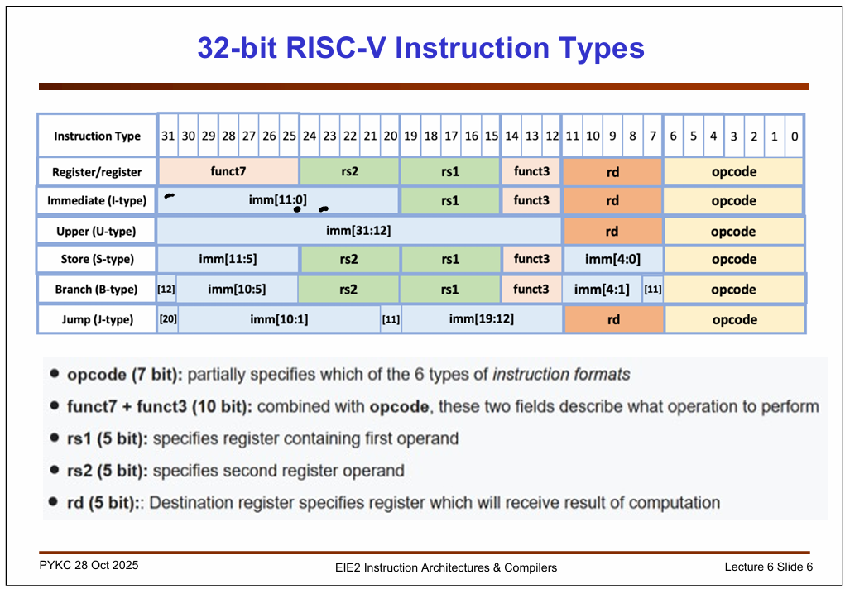
Figure 1: The six RV32I instruction formats showing the bit-field layout for R-, I-, S-, B-, U-, and J-type instructions

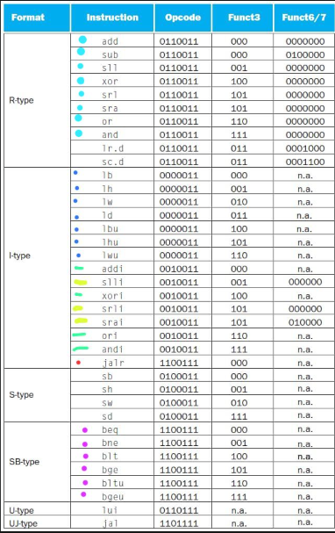
Figure 2: Opcode, funct3, and funct7 encodings for the RV32I base instruction set

2.2.1 Instruction Fetch Stage
The Program Counter (PC) is a 32-bit register that holds the address of the currently executing instruction. On every rising clock edge, the PC is updated to either PC+4 (sequential execution), a branch target address (for taken branches), or a jump destination (for JAL/JALR). The Instruction Memory is a read-only, word-addressed module that outputs the 32-bit instruction word at the address supplied by the PC.

2.2.2 Decode Stage
The fetched 32-bit instruction word is decoded combinationally. Fixed bit ranges are extracted: bits [6:0] form the opcode, bits [11:7] identify the destination register (rd), bits [19:15] and [24:20] identify the two source registers (rs1, rs2), and bits [14:12] carry the funct3 qualifier. The Immediate Generator assembles and sign-extends the appropriate immediate value depending on the instruction format (I, S, B, U, or J).

2.2.3 Register File
A 32-entry, 32-bit wide register file is implemented with two asynchronous read ports and one synchronous write port. Register x0 is hardwired to zero and cannot be modified. Writes are gated by the RegWrite control signal and are committed on the rising clock edge, ensuring data is available for dependent instructions in subsequent cycles.

2.2.4 Execution Stage (ALU)
The Arithmetic Logic Unit (ALU) performs all arithmetic (add, sub), logical (and, or, xor), and comparison (slt, sltu) operations. A 2-to-1 multiplexer controlled by the ALUSrc signal selects whether the ALU's second operand is the rs2 register value (R-type) or the sign-extended immediate (I-type, Load, Store, and Branch instructions). A dedicated branch adder computes the branch target address as PC + sign_extended_immediate.

2.2.5 Memory Access Stage
The Data Memory module supports byte (8-bit), half-word (16-bit), and word (32-bit) read and write operations. The access width is encoded in the funct3 field. A dedicated load-processing unit handles sign-extension for signed loads (lb, lh) and zero-extension for unsigned loads (lbu, lhu), ensuring correct representation of sub-word values in the 32-bit register file.

2.2.6 Branch and Jump Resolution
Conditional branch outcomes are determined by comparing ALU outputs. A multiplexer at the PC input selects the next PC based on the PCSrc control signal, which is asserted when a branch condition is satisfied (e.g., rs1 == rs2 for BEQ). For JALR, the ALU computes the target address as rs1 + sign_extended_immediate and the link address (PC+4) is written to rd.

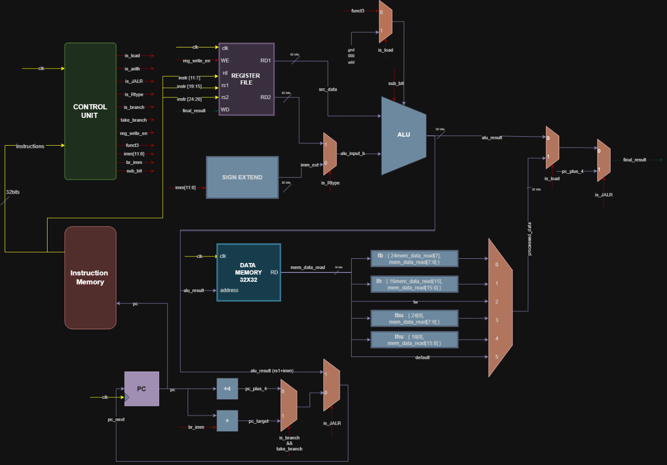
Figure 3: Complete single-cycle RV32I processor datapath showing all functional units, data buses, and control signal routing

3. Implemented Instruction Set
The processor implements and verifies the following RV32I instructions. All instructions operate on the 32 general-purpose integer registers (x0–x31), with x0 permanently zero. The implemented instruction categories are detailed below.

Category | Instructions | Description
R-Type | add, sub, xor, or, and, sll | Register-register operations. Both operands sourced from rs1 and rs2; result written to rd.
I-Type (ALU) | addi, xori, ori, andi, slli, srli, srai | Register-immediate operations. rs1 and a 12-bit sign-extended immediate; result written to rd.
I-Type (Jump) | jalr | Jump and link register. Jumps to rs1 + imm, saves PC+4 to rd.
Load | lb, lh, lw, lbu, lhu | Memory-to-register transfers with byte/half/word granularity and sign/zero extension.
B-Type (Branch) | beq, bne, blt, bge, bltu, bgeu | Conditional branches comparing rs1 and rs2; PC updated to PC + offset if condition true.
Table 1: RV32I Instruction Set Implemented in the Single-Cycle Processor

4. Verification and Simulation Results
Functional verification was performed using a custom RISC-V assembly test program compiled to a hexadecimal memory image (program.hex) and loaded into the Instruction Memory at simulation time. The simulation environment was a Verilog testbench that instantiates the SoC top-level module, applies a clock, and drives a reset signal. The $monitor system task was used to log register and signal values at every clock edge, providing a cycle-accurate trace of processor behaviour [3].

4.1 Test Program
The assembly test program exercises all major instruction categories in sequence: it first populates registers using immediate instructions (addi), performs arithmetic and logical operations (add, sub, xor), tests conditional branches (beq), and executes a subroutine call using jalr. The hexadecimal encoding of the program as loaded into instruction memory is shown in Figure 4.

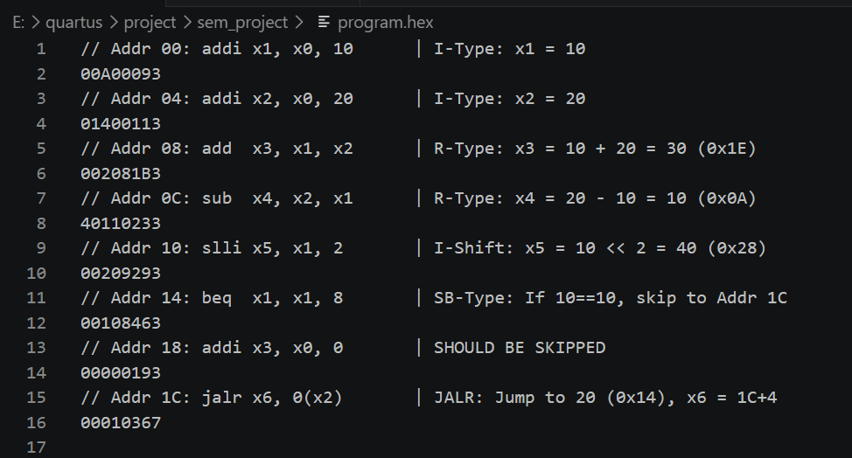
Figure 4: Program.hex file contents — hexadecimal machine-code encoding of the test assembly program with inline comments

4.2 Simulation Results
Simulation was performed using a commercial Verilog simulator. Results were captured in two forms: (1) a text-based console log generated by the $monitor task, and (2) waveform plots exported from the simulator's waveform viewer. Both outputs confirm correct processor behaviour across all tested instruction types.

4.2.1 Console Monitor Output
The console log records signal values at each clock edge and provides a cycle-accurate trace. The log confirms: correct register initialisation, accurate ALU computation results, correct branch taken/not-taken decisions, and proper PC update sequences. The monitor output is shown in Figure 5.

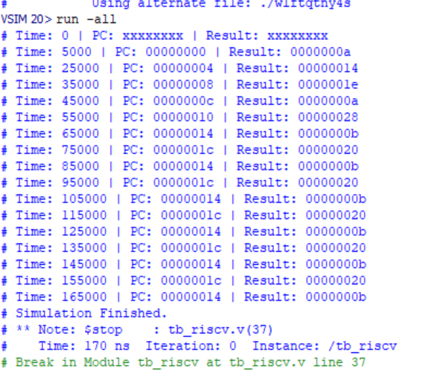
Figure 5: Console log output via Verilog $monitor — cycle-accurate trace of register values and control signals during simulation

4.2.2 Waveform Analysis
The simulation waveforms provide a visual, time-domain record of all major datapath signals. Three waveform captures are provided below, each covering a different phase of the test program execution. The waveforms confirm correct signal transitions, stable combinational outputs, and proper clocking behaviour.

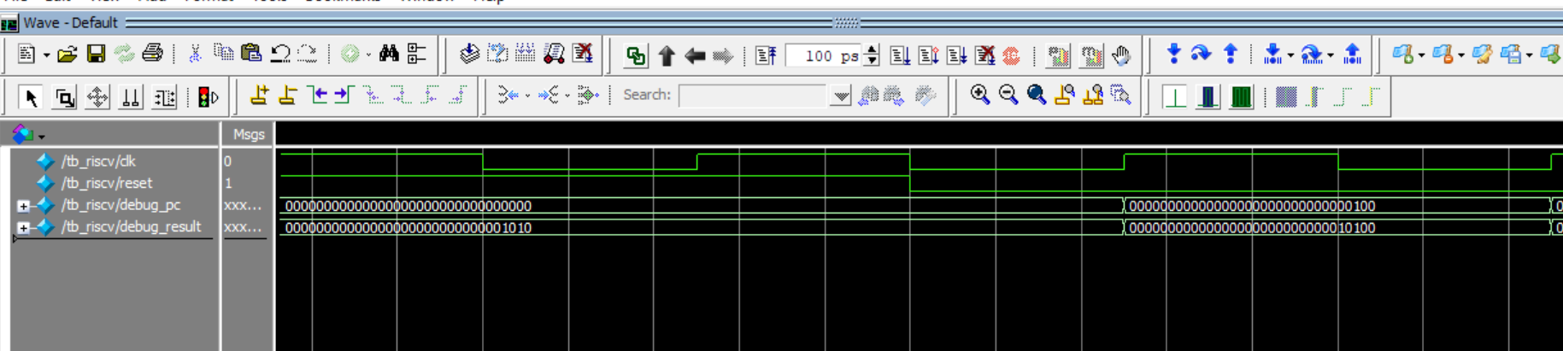
Figure 6: Simulation waveform — Phase 1: instruction fetch, register initialisation using I-type instructions, and early ALU operations

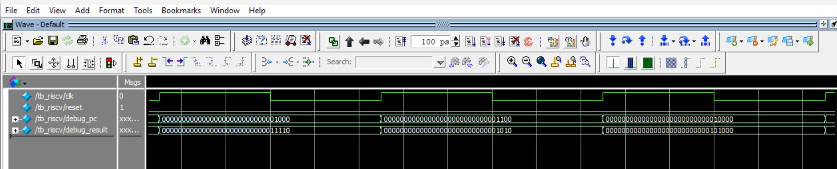
Figure 7: Simulation waveform — Phase 2: R-type arithmetic and logical operations showing correct ALU results and register write-back

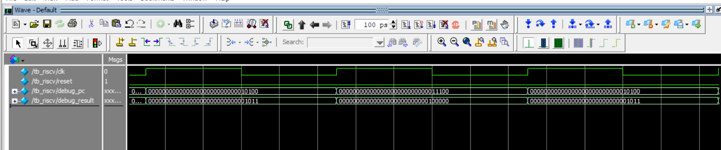
Figure 8: Simulation waveform — Phase 3: conditional branch resolution (BEQ) and JALR jump-and-link execution with PC updates

4.3 Verified Hardware Behaviours
The simulation campaign confirmed the following hardware behaviours:
- Arithmetic and Logic Precision: The ALU correctly computed additions, subtractions, and bitwise XOR operations. All results were stored to the correct destination register within the same clock cycle.
- Branching Correctness: The hardware correctly evaluated branch conditions (BEQ, BNE, BLT, BGE) and updated the PC to the branch target when the condition was satisfied, or incremented PC by 4 when not taken.
- Jump-and-Link (JALR): The jalr instruction correctly transitioned the PC to the target address (rs1 + imm) while simultaneously writing the return address (PC+4) to the link register (rd).
- Load Sign-Extension: Byte and half-word loads correctly produced sign-extended 32-bit values in the destination register.
- Fetch-Decode-Execute Stability: The processor maintained a stable, glitch-free fetch-decode-execute loop across all instruction types with no spurious control signal transitions detected.

5. Conclusion
This project successfully demonstrates the complete design and functional verification of a single-cycle RV32I processor implemented in Verilog HDL. By executing a comprehensive test sequence covering R-type, I-type, Load, Branch, and Jump instructions, the integrity of the register file, the accuracy of the ALU, the correctness of the control unit, and the robustness of the branching and jump logic were all confirmed.
The modular design methodology proved effective: individual module verification prior to integration significantly reduced system-level debugging effort. The resulting architecture is clean, readable, and extensible. Future work could extend this foundation by adding the M extension (integer multiplication and division), implementing a pipelined version with hazard detection and forwarding, or synthesising the design to an FPGA target for hardware-in-the-loop testing [4].
The open RISC-V ISA and the accessibility of Verilog-based toolchains make this an excellent platform for continued exploration of computer architecture concepts at both the educational and research levels [5].

References

- RISC-V International. (2023). The RISC-V Instruction Set Manual, Volume I: Unprivileged ISA (Document Version 20191213). Available: https://github.com/riscv/riscv-isa-manual
- Patterson, D. A., & Hennessy, J. L. (2017). Computer Organization and Design RISC-V Edition: The Hardware/Software Interface (1st ed.). Morgan Kaufmann Publishers.
- Harris, S., & Harris, D. (2021). Digital Design and Computer Architecture: RISC-V Edition. Morgan Kaufmann Publishers.
- Weste, N. H. E., & Harris, D. M. (2011). CMOS VLSI Design: A Circuits and Systems Perspective (4th ed.). Pearson Education.
- IEEE. (2006). IEEE Standard for Verilog Hardware Description Language. IEEE Std 1364-2005. IEEE Computer Society.

