- Testing alu arithmetic operations only: Tb arithmetic.v:

1. ADDI (Add Immediate)
Instruction: addi x5, x0, 15
- Immediate: 15 (Binary: 000000001111)
- rs1: x0 (00000)
- funct3: 000
- rd: x5 (00101)
- Opcode: 0010011
32-bit Instruction (Binary): 000000001111_00000_000_00101_0010011 (Hex: 00F00293)
Result in ALU (Binary): 00000000000000000000000000001111 (Decimal: 15)

2. ANDI (And Immediate)
Instruction: andi x6, x5, 7
- Operation: 15 (1111) AND 7 (0111)
- Funct3: 111
- rd: x6 (00110)
32-bit Instruction (Binary): 000000000111_00101_111_00110_0010011 (Hex: 0072F313)
Result in ALU (Binary): 00000000000000000000000000000111 (Decimal: 7)

3. ORI (Or Immediate)
Instruction: ori x7, x0, 8
- Operation: 0 (0000) OR 8 (1000)
- Funct3: 110
32-bit Instruction (Binary): 000000001000_00000_110_00111_0010011 (Hex: 00806393)
Result in ALU (Binary): 00000000000000000000000000001000 (Decimal: 8)

4. XORI (Xor Immediate)
Instruction: xori x8, x7, 1
- Operation: 8 (1000) XOR 1 (0001)
- Funct3: 100
32-bit Instruction (Binary): 000000000001_00111_100_01000_0010011 (Hex: 0013C413)
Result in ALU (Binary): 00000000000000000000000000001001 (Decimal: 9)

5. Negative ADDI (Sign Extension)
Instruction: addi x9, x0, -1
- Immediate: -1 (12-bit Two's Complement: 111111111111)
- Funct3: 000
32-bit Instruction (Binary): 111111111111_00000_000_01001_0010011 (Hex: FFF00493)
Result in ALU (Binary): 11111111111111111111111111111111 (Decimal: -1)

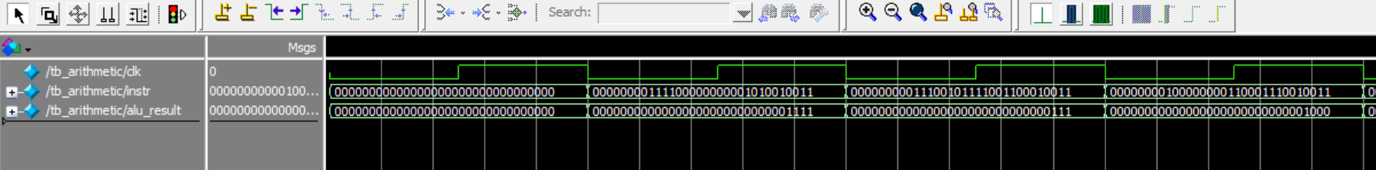
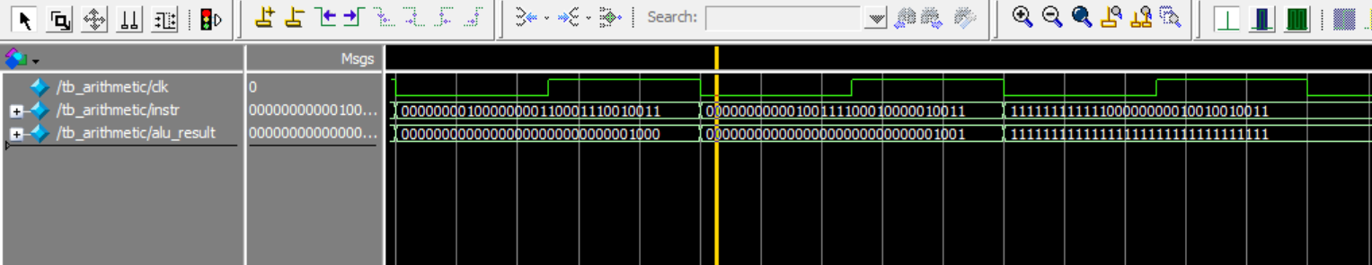

- Adding load word lw and lw with offset: arithmetic also checked
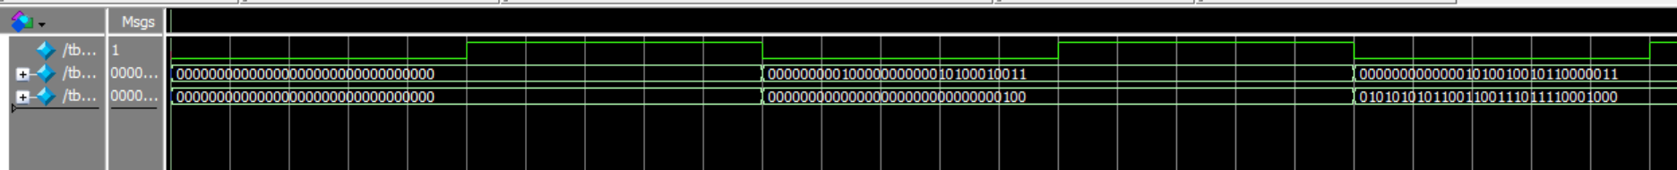
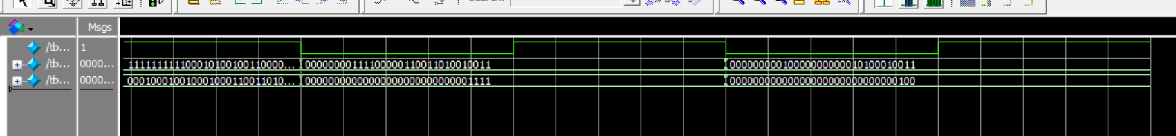
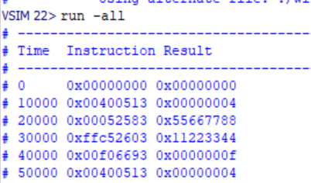
///////////////////////////////////////////////////////
////// Data memory.v ////
////// ram block for storing data in simulatio ////
///////////////////////////////////////////////////////

module data_memory(
input clk,
input [31:0] addr,
output [31:0] read_data
);
reg [31:0] memory [63:0]; // 64 words of memory

initial begin
memory[0] = 32'h11223344;
memory[1] = 32'h55667788;
memory[2] = 32'h99AABBCC;
end

// Use bits [7:2] for word alignment in a small 64-word array
assign read_data = memory[addr[7:2]];
endmodule
TB AT THIS POINT:
`timescale 1ns / 1ps

module tb_riscv_i_processor();
// Inputs
reg clk;
reg [31:0] instr;

// Outputs
wire [31:0] final_result;

// Instantiate the Unit Under Test (UUT)
riscv_i_processor uut (
.clk(clk),
.instr(instr),
.final_result(final_result)
);

// Clock generation (10ns period)
always #5 clk = ~clk;

initial begin
// Initialize Inputs
clk = 0;
instr = 32'h0;

$display("-------------------------------------------------");
$display("Time\tInstruction\tResult");
$display("-------------------------------------------------");

$monitor("%0t\t0x%08h\t0x%08h", $time, instr, final_result);

// Wait for system to settle
#10;

// --- TEST 1: ADDI (Setup Base Address) ---
// Assembler: addi x10, x0, 4 (x10 = 4)
// We will use x10 as the base address for our load.
// Binary: 000000000100_00000_000_01010_0010011
instr = 32'h00400513;
#10;

// --- TEST 2: LW (Load Word) ---
// Assembler: lw x11, 0(x10)
// Logic: Addr = x10 + 0 = 4. Read memory[4].
// memory[1] (which is byte addr 4) contains 32'h55667788
// Opcode: 0000011, Funct3: 010 (lw), rd: 11, rs1: 10, Imm: 0
// Binary: 000000000000_01010_010_01011_0000011
instr = 32'h00052583;
#10;

// --- TEST 3: LW with Offset ---
// Assembler: lw x12, -4(x10)
// Logic: Addr = 4 + (-4) = 0. Read memory[0].
// memory[0] contains 32'h11223344
// Imm: -4 (12'hFFC), rs1: 10, rd: 12
// Binary: 111111111100_01010_010_01100_0000011
instr = 32'hFFC52603;
#10;

// --- TEST 4: ORI (Verify Arithmetic still works) ---
// Assembler: ori x13, x0, 15
instr = 32'h00F06693;
#10;
instr = 32'h00400513;
#10;

$display("Simulation Complete. Check if x11=55667788 and x12=11223344");
$stop;
end
endmodule
- Lb lh lw lbu lhu
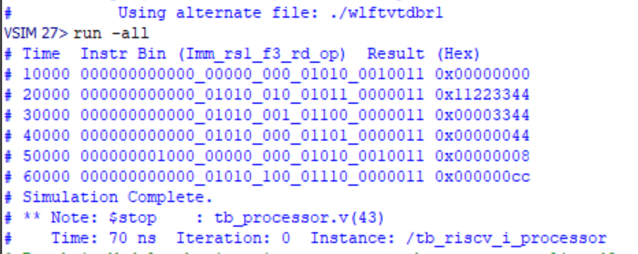
`timescale 1ns / 1ps

module tb_riscv_i_processor();
reg clk;
reg [31:0] instr;
wire [31:0] final_result;

riscv_i_processor uut (
.clk(clk),
.instr(instr),
.final_result(final_result)
);

always #5 clk = ~clk;

initial begin
clk = 0; instr = 32'h0;
#10;

$display("Time\tInstr Bin (Imm_rs1_f3_rd_op)\t\tResult (Hex)");
$monitor("%0t\t%b_%b_%b_%b_%b\t0x%08h",
$time, instr[31:20], instr[19:15], instr[14:12], instr[11:7], instr[6:0], final_result);

// Pre-setup: x10 = 0 (Base Address)
instr = 32'b000000000000_00000_000_01010_0010011; #10;

// TEST lw: x11 = Mem[0] (Expected: 0x11223344)
instr = 32'b000000000000_01010_010_01011_0000011; #10;

// TEST lh: x12 = Mem[0] (Expected: 0x00003344)
instr = 32'b000000000000_01010_001_01100_0000011; #10;

// TEST lb: x13 = Mem[0] (Expected: 0x00000044)
instr = 32'b000000000000_01010_000_01101_0000011; #10;

// TEST lbu: x14 = Mem[2] (where Mem[2] = 0x99AABBCC)
// Setup x10 = 8
instr = 32'b000000001000_00000_000_01010_0010011; #10;
// lbu x14, 0(x10) -> Expected: 0x000000CC
instr = 32'b000000000000_01010_100_01110_0000011; #10;

$display("Simulation Complete.");
$stop;
end
endmodule

R_type add sub everything

`timescale 1ns / 1ps

module tb_riscv_processor();
reg clk;
reg [31:0] instr;
reg [31:0] pc;
wire [31:0] final_result;

riscv_processor uut (
.clk(clk),
.instr(instr),
.pc(pc),
.final_result(final_result)
);

always #5 clk = ~clk;

initial begin
// Initialize
clk = 0; pc = 32'h0000_1000; instr = 32'h0;
#10;

$display("-------------------------------------------------------------------------");
$display("Time\tOp\tInstr (Imm_rs1_f3_rd_op)\t\tResult (Hex)");
$display("-------------------------------------------------------------------------");
$monitor("%0t\tR-Type\t%b_%b_%b_%b_%b\t0x%08h",
$time, instr[31:20], instr[19:15], instr[14:12], instr[11:7], instr[6:0], final_result);

// 1. Setup: x5 = 10, x6 = 3 (using ADDI)
instr = 32'h00A00293; #10; // x5 = 10
instr = 32'h00300313; #10; // x6 = 3

// 2. TEST ADD: x7 = x5 + x6 (Expected: 13 / 0xD)
// func7=0000000, rs2=6, rs1=5, f3=000, rd=7, op=0110011
instr = 32'b0000000_00110_00101_000_00111_0110011; #10;

// 3. TEST SUB: x8 = x5 - x6 (Expected: 7)
// func7=0100000, rs2=6, rs1=5, f3=000, rd=8, op=0110011
instr = 32'b0100000_00110_00101_000_01000_0110011; #10;

$display("-------------------------------------------------------------------------");
$stop;
end
endmodule
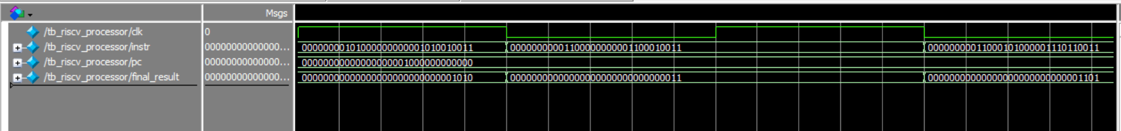
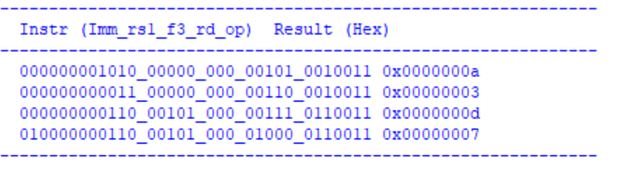

- OVERALL CHECK BY CLAUDE AFTER FIXING JALR
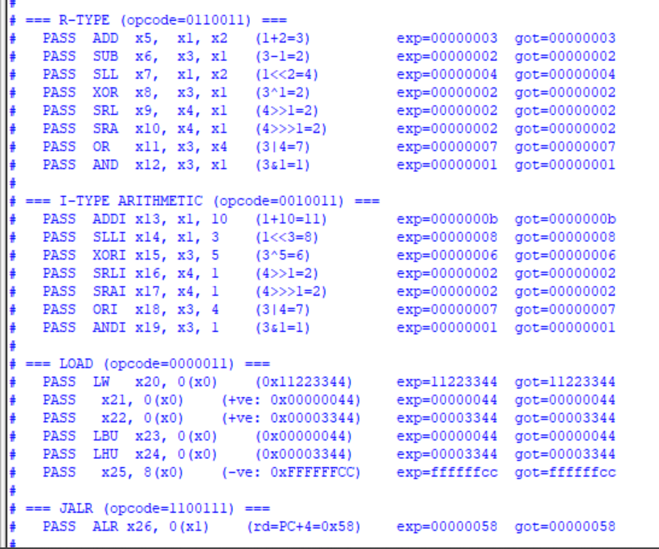
`timescale 1ns/1ps
// ============================================================
// Testbench: tb_riscv_processor
// Covers: R-type, I-type arithmetic, Load (all variants), JALR
//
// Register file initial values (from your design):
// rf[0] = 0, rf[1] = 1, rf[2] = 2,
// rf[3] = 3, rf[4] = 4 (rf[i] = i for all i)
//
// Data memory initial values (from your design):
// memory[0] = 0x11223344 (addr 0..3)
// memory[1] = 0x55667788 (addr 4..7)
// memory[2] = 0x99AABBCC (addr 8..11)
// ============================================================
module tb_riscv_processor;

// ── DUT signals ──────────────────────────────────────────
reg clk;
reg reset;
reg [31:0] instr;
wire[31:0] final_result;

// Instantiate your processor
// NOTE: remove the 'pc' input port from your module if you
// haven't already — it is unused now that you have pc_reg.
riscv_processor dut (
.clk (clk),
.reset (reset),
.instr (instr),
.final_result(final_result)
);

// 10 ns period clock (posedge at 5, 15, 25, ...)
initial clk = 0;
always #5 clk = ~clk;

// ── Counters ─────────────────────────────────────────────
integer pass_count = 0;
integer fail_count = 0;

// ── Core task ────────────────────────────────────────────
// 1. Drive instr on the falling edge
// 2. Wait 3 ns so combinational logic settles BEFORE posedge
// 3. Snapshot final_result <-- this is what gets written to rd
// 4. Rising edge commits the write to reg file and advances PC
//
// We snapshot BEFORE posedge because:
// • For normal instructions the snapshot equals post-posedge anyway
// (source regs x0..x4 are never overwritten in our test sequence)
// • For JALR, final_result = pc_plus_4; after posedge pc_reg jumps
// to the target so pc_plus_4 changes — we must capture first
task run_and_check;
input [31:0] inst;
input [31:0] expected;
input [8*32:1] label;
reg [31:0] captured;
begin
@(negedge clk); // set on falling edge
instr = inst;
#3; // combinational settle (posedge 2 ns away)
captured = final_result; // snapshot here
@(posedge clk); #1; // commit write + advance PC
if (captured === expected) begin
$display(" PASS %-34s exp=%h got=%h",
label, expected, captured);
pass_count = pass_count + 1;
end else begin
$display(" FAIL %-34s exp=%h got=%h",
label, expected, captured);
fail_count = fail_count + 1;
end
end
endtask

// ── Main test sequence ───────────────────────────────────
initial begin
$dumpfile("riscv_tb.vcd");
$dumpvars(0, tb_riscv_processor);

// Reset for one full cycle → pc_reg latches to 0
reset = 1; instr = 32'h0;
@(posedge clk); #1;
reset = 0;

// =====================================================
// R-TYPE (opcode = 0110011)
// Source registers use their initial values:
// x1=1, x2=2, x3=3, x4=4
// Results are written to x5..x12 (never read as src)
// =====================================================
$display("\n=== R-TYPE (opcode=0110011) ===");

// ADD x5, x1, x2 → 1 + 2 = 3
// funct7=0000000 rs2=x2 rs1=x1 funct3=000 rd=x5
run_and_check(
{7'b0000000, 5'd2, 5'd1, 3'b000, 5'd5, 7'b0110011},
32'd3,
"ADD x5, x1, x2 (1+2=3)");

// SUB x6, x3, x1 → 3 - 1 = 2
// funct7=0100000 distinguishes SUB from ADD
run_and_check(
{7'b0100000, 5'd1, 5'd3, 3'b000, 5'd6, 7'b0110011},
32'd2,
"SUB x6, x3, x1 (3-1=2)");

// SLL x7, x1, x2 → 1 << 2 = 4
run_and_check(
{7'b0000000, 5'd2, 5'd1, 3'b001, 5'd7, 7'b0110011},
32'd4,
"SLL x7, x1, x2 (1<<2=4)");

// XOR x8, x3, x1 → 3 ^ 1 = 2 (011 ^ 001 = 010)
run_and_check(
{7'b0000000, 5'd1, 5'd3, 3'b100, 5'd8, 7'b0110011},
32'd2,
"XOR x8, x3, x1 (3^1=2)");

// SRL x9, x4, x1 → 4 >> 1 = 2 (logical, zero-fill)
run_and_check(
{7'b0000000, 5'd1, 5'd4, 3'b101, 5'd9, 7'b0110011},
32'd2,
"SRL x9, x4, x1 (4>>1=2)");

// SRA x10, x4, x1 → 4 >>> 1 = 2 (arithmetic; same here,
// positive number, sign-bit is 0)
run_and_check(
{7'b0100000, 5'd1, 5'd4, 3'b101, 5'd10, 7'b0110011},
32'd2,
"SRA x10, x4, x1 (4>>>1=2)");

// OR x11, x3, x4 → 3 | 4 = 7 (011 | 100 = 111)
run_and_check(
{7'b0000000, 5'd4, 5'd3, 3'b110, 5'd11, 7'b0110011},
32'd7,
"OR x11, x3, x4 (3|4=7)");

// AND x12, x3, x1 → 3 & 1 = 1 (011 & 001 = 001)
run_and_check(
{7'b0000000, 5'd1, 5'd3, 3'b111, 5'd12, 7'b0110011},
32'd1,
"AND x12, x3, x1 (3&1=1)");

// =====================================================
// I-TYPE ARITHMETIC (opcode = 0010011)
// imm is the upper 12 bits of the instruction.
// For SLLI / SRLI / SRAI the upper 7 bits are funct7
// and the lower 5 are the shift amount (shamt).
// =====================================================
$display("\n=== I-TYPE ARITHMETIC (opcode=0010011) ===");

// ADDI x13, x1, 10 → 1 + 10 = 11
run_and_check(
{12'd10, 5'd1, 3'b000, 5'd13, 7'b0010011},
32'd11,
"ADDI x13, x1, 10 (1+10=11)");

// SLLI x14, x1, 3 → 1 << 3 = 8
// imm[11:5]=0000000 (funct7), imm[4:0]=00011 (shamt=3)
// instr[30]=0 → ALU does logical shift
run_and_check(
{7'b0000000, 5'd3, 5'd1, 3'b001, 5'd14, 7'b0010011},
32'd8,
"SLLI x14, x1, 3 (1<<3=8)");

// XORI x15, x3, 5 → 3 ^ 5 = 6 (011 ^ 101 = 110)
run_and_check(
{12'd5, 5'd3, 3'b100, 5'd15, 7'b0010011},
32'd6,
"XORI x15, x3, 5 (3^5=6)");

// SRLI x16, x4, 1 → 4 >> 1 = 2 (logical, instr[30]=0)
run_and_check(
{7'b0000000, 5'd1, 5'd4, 3'b101, 5'd16, 7'b0010011},
32'd2,
"SRLI x16, x4, 1 (4>>1=2)");

// SRAI x17, x4, 1 → 4 >>> 1 = 2 (arithmetic, instr[30]=1)
run_and_check(
{7'b0100000, 5'd1, 5'd4, 3'b101, 5'd17, 7'b0010011},
32'd2,
"SRAI x17, x4, 1 (4>>>1=2)");

// ORI x18, x3, 4 → 3 | 4 = 7
run_and_check(
{12'd4, 5'd3, 3'b110, 5'd18, 7'b0010011},
32'd7,
"ORI x18, x3, 4 (3|4=7)");

// ANDI x19, x3, 1 → 3 & 1 = 1
run_and_check(
{12'd1, 5'd3, 3'b111, 5'd19, 7'b0010011},
32'd1,
"ANDI x19, x3, 1 (3&1=1)");

// =====================================================
// LOAD (opcode = 0000011)
//
// Data memory layout (your design: memory[addr[7:2]]):
// addr 0..3 → memory[0] = 0x11223344
// addr 4..7 → memory[1] = 0x55667788
// addr 8..11 → memory[2] = 0x99AABBCC
//
// All loads below use rs1=x0 (value=0), so addr = imm.
//
// IMPORTANT: your current data_memory reads a full 32-bit
// word using addr[7:2]. Sub-word selection (which byte/
// halfword within the word) is done entirely in your
// processed_load_data mux, which always uses the LOWEST
// byte or halfword of mem_read_data. That is correct only
// when addr is 0 (or any word-aligned address where the
// target byte is at the LSB). For a full implementation
// you will later need to add addr[1:0] muxing.
// =====================================================
$display("\n=== LOAD (opcode=0000011) ===");

// LW x20, 0(x0) → full 32-bit word at addr 0
// Expected: 0x11223344
run_and_check(
{12'd0, 5'd0, 3'b010, 5'd20, 7'b0000011},
32'h11223344,
"LW x20, 0(x0) (0x11223344)");

// LB x21, 0(x0) → sign-extend byte 0 of memory[0]
// memory[0][7:0] = 0x44 = 0100_0100 (bit7=0, positive)
// sign-extended = 0x00000044
run_and_check(
{12'd0, 5'd0, 3'b000, 5'd21, 7'b0000011},
32'h00000044,
"LB x21, 0(x0) (+ve: 0x00000044)");

// LH x22, 0(x0) → sign-extend halfword 0 of memory[0]
// memory[0][15:0] = 0x3344, bit15=0 → positive
// sign-extended = 0x00003344
run_and_check(
{12'd0, 5'd0, 3'b001, 5'd22, 7'b0000011},
32'h00003344,
"LH x22, 0(x0) (+ve: 0x00003344)");

// LBU x23, 0(x0) → zero-extend byte 0 of memory[0]
// Result = 0x00000044 (same as LB here; byte is positive)
run_and_check(
{12'd0, 5'd0, 3'b100, 5'd23, 7'b0000011},
32'h00000044,
"LBU x23, 0(x0) (0x00000044)");

// LHU x24, 0(x0) → zero-extend halfword 0 of memory[0]
// Result = 0x00003344
run_and_check(
{12'd0, 5'd0, 3'b101, 5'd24, 7'b0000011},
32'h00003344,
"LHU x24, 0(x0) (0x00003344)");

// LB x25, 8(x0) → addr=8 → memory[2]=0x99AABBCC
// byte = 0xCC = 1100_1100, bit7=1 → negative sign-extension
// sign-extended = 0xFFFFFFCC
// This is the critical sign-extension test!
run_and_check(
{12'd8, 5'd0, 3'b000, 5'd25, 7'b0000011},
32'hFFFFFFCC,
"LB x25, 8(x0) (-ve: 0xFFFFFFCC)");

// =====================================================
// JALR (opcode = 1100111)
//
// JALR x26, 0(x1):
// rd ← PC + 4 (return address saved)
// PC ← (rs1 + imm) & ~1 (jump to rs1+imm, clear LSB)
//
// PC calculation at this point:
// After reset: 1 posedge → pc_reg = 0
// After 8 R-type: 8 posedges → pc_reg = 32 = 0x20
// After 7 I-arith: 7 posedges → pc_reg = 60 = 0x3C
// After 6 loads: 6 posedges → pc_reg = 84 = 0x54
// ─────────────────────────────────
// Total before JALR: 21 instruction posedges
// pc_reg at JALR negedge = 21 × 4 = 84 = 0x54
// pc_plus_4 = 0x54 + 4 = 0x58
//
// final_result = pc_plus_4 = 0x58 (written into x26)
// jump target = (rf[1] + 0) & ~1 = 1 & ~1 = 0 (new PC)
// =====================================================
$display("\n=== JALR (opcode=1100111) ===");

run_and_check(
{12'd0, 5'd1, 3'b000, 5'd26, 7'b1100111},
32'h00000058,
"JALR x26, 0(x1) (rd=PC+4=0x58)");

// ── Summary ──────────────────────────────────────────
$display("\n============================================");
$display(" TOTAL PASSED : %0d", pass_count);
$display(" TOTAL FAILED : %0d", fail_count);
$display("============================================\n");
$finish;
end

// Safety timeout (2000 ns >> time needed for ~22 tests × 10 ns)
initial #5000 $finish;

endmodule

- Final with branch
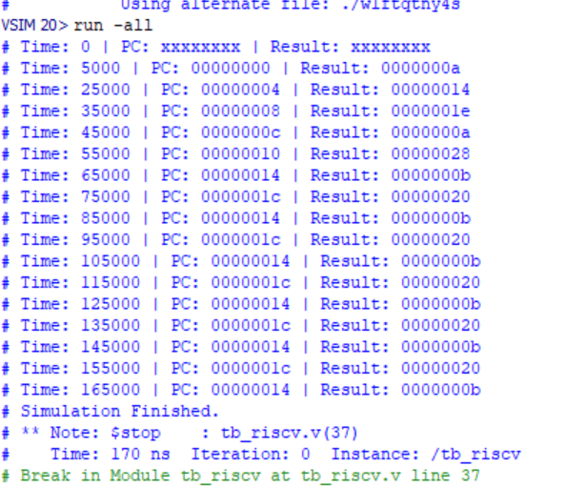
// Addr 00: addi x1, x0, 10 | I-Type: x1 = 10
00A00093
// Addr 04: addi x2, x0, 20 | I-Type: x2 = 20
01400113
// Addr 08: add x3, x1, x2 | R-Type: x3 = 10 + 20 = 30 (0x1E)
002081B3
// Addr 0C: sub x4, x2, x1 | R-Type: x4 = 20 - 10 = 10 (0x0A)
40110233
// Addr 10: slli x5, x1, 2 | I-Shift: x5 = 10 << 2 = 40 (0x28)
00209293
// Addr 14: beq x1, x1, 8 | SB-Type: If 10==10, skip to Addr 1C
00108463
// Addr 18: addi x3, x0, 0 | SHOULD BE SKIPPED
00000193
// Addr 1C: jalr x6, 0(x2) | JALR: Jump to 20 (0x14), x6 = 1C+4
00010367
// ... Fill remaining with 0 until 32 lines ...
00000000
00000000
00000000
00000000
00000000
00000000
00000000
00000000
00000000
00000000
00000000
00000000
00000000
00000000
00000000
00000000
00000000
00000000
00000000
00000000
00000000
00000000
00000000
00000000

This project report provides a comprehensive overview of the design, implementation, and verification of a single-cycle RISC-V 32I processor. It details the architectural choices, the hardware methodology employed, and the specific instruction set verified during simulation.

Project Report: Design and Implementation of a Single-Cycle RISC-V (RV32I) Processor

1. Introduction to RISC-V
RISC-V is an open-standard Instruction Set Architecture (ISA) based on established Reduced Instruction Set Computer (RISC) principles. Unlike proprietary ISAs, RISC-V is free to use, allowing for worldwide modularity and scalability in hardware design. The RV32I base integer instruction set used in this project is designed to be the foundation upon which all other extensions are built.

2. Methodology and Hardware Implementation
The methodology followed a modular "bottom-up" hardware design approach using Verilog HDL.

2.1 Hardware Implementation Strategy
- Modular Development: Each functional unit, such as the ALU, Register File, and Control Unit, was designed and verified as a standalone Verilog module.
- Datapath Synthesis: These modules were interconnected to form a complete processor loop, enabling the fetch-decode-execute cycle.
- Hardware Control Logic: A central control unit was implemented to decode the instruction fields (opcode, funct3, etc.). This unit generates the internal "Enable" and "Select" signals that dictate how data moves through the hardware multiplexers.
- Integration and Verification: A System-on-Chip (SoC) top-level module was created to link the processor with an Instruction Memory loaded with a custom program.hex for functional simulation.

2.2 Datapath Textual Explanation
The hardware datapath is organized into a continuous loop that completes an entire instruction in one clock cycle (Images: Instruction Types for 32 bit RISCV also shown, Instructions opcode func shown, datapath shown.):
- Instruction Fetch: The Program Counter (PC) register provides the current address to the Instruction Memory, which retrieves a 32-bit instruction.
- Decoding: The hardware splits the instruction into fields: opcode, rd, rs1, rs2, funct3, and immediate.
- Register File: A 32-entry register file manages operand storage, supporting two asynchronous read ports and one synchronous write port.
- Execution (ALU): The ALU performs mathematical and logical operations based on control signals. Hardware multiplexers select whether the ALU's second input is a register value (for R-type) or a sign-extended immediate (for I-type).
- Memory Access: A specialized data memory handles storage. A load-processing unit manages sign-extension for byte and half-word loads.
- Branch/Jump Resolution: A dedicated adder calculates the branch target address. A MUX at the start of the datapath determines the next PC address based on branch comparison results or jump instructions.
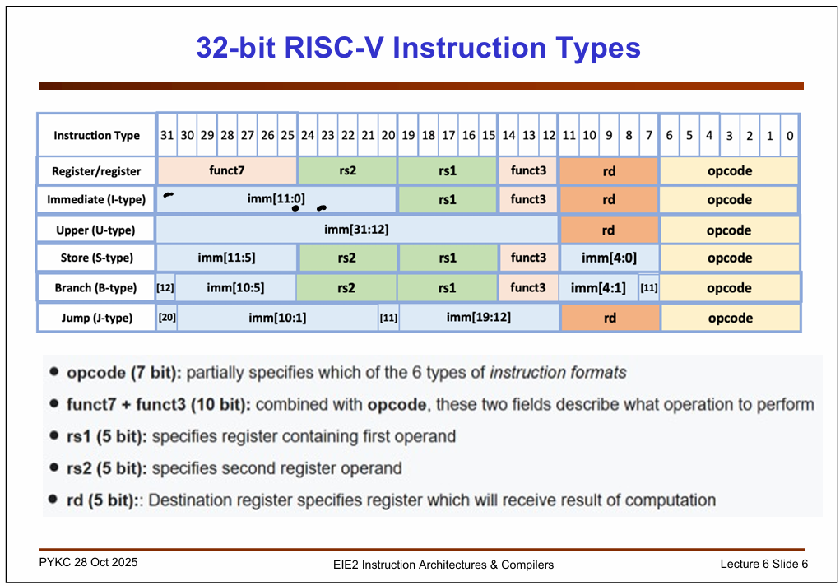
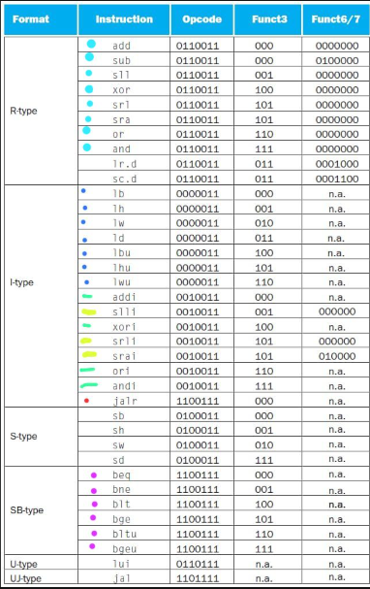
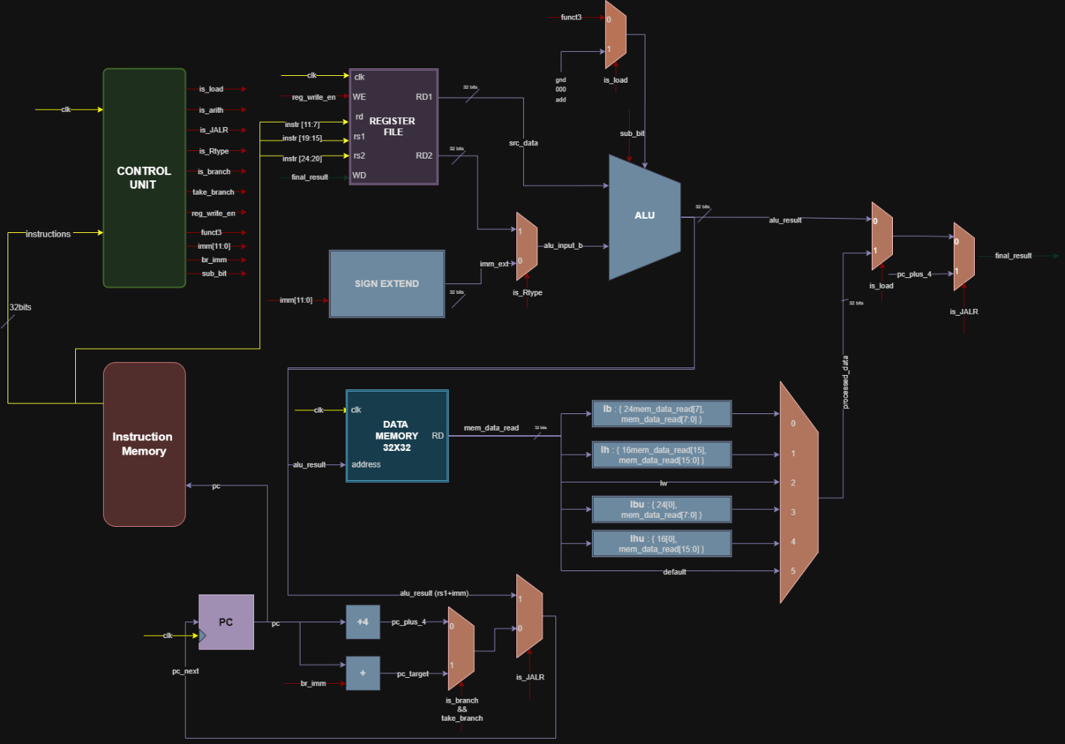

3. Implemented Instruction Set
The processor successfully implements and verifies the following core RV32I instructions:

- R-Type (Register-Register): add, sub, xor, and other logical/arithmetic operations using two source registers.
- I-Type (Immediate Arithmetic/Logic): addi (immediate addition), slli (logical shift left immediate), and other operations involving a register and an immediate value.
- I-Type (Jumps): jalr (jump and link register), which uses the ALU to calculate the target address.
- Load Instructions: lb, lh, lw, lbu, and lhu (memory-to-register transfers with width-specific sign extension).
- SB-Type (Conditional Branches): beq, bne, blt, bge, bltu, and bgeu.

4. Verification and Simulation Results
The design was verified using a custom assembly program converted to hexadecimal. Simulation logs confirmed the following hardware behaviors:
- Arithmetic and Logic Precision: The ALU correctly computed additions, subtractions, and XOR operations, with results correctly stored in the register file.
- Branching Success: The hardware correctly identified branch conditions (e.g., beq) and modified the PC to skip instructions as intended.
- Jump Logic: The jalr instruction successfully transitioned the PC to a stored register value while saving the return address (PC+4).
- Stability: The simulation confirmed the processor's ability to maintain a stable fetch-decode-execute loop across multiple instruction types.
Program hex instructions, results commented for ease:
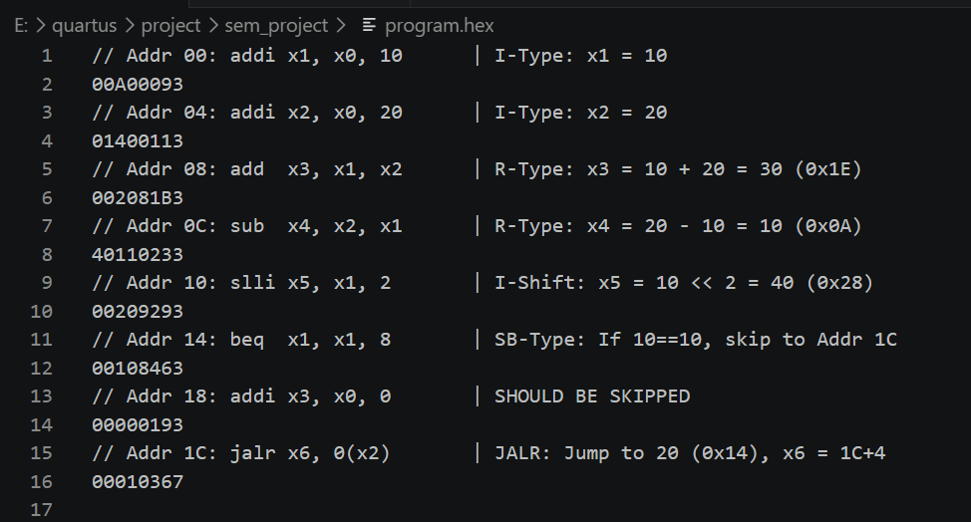
Simulation Results:
- Console log via monitor function:

- waveforms

5. Conclusion
The project successfully demonstrates the implementation of a single-cycle RV32I architecture. By executing a complex test sequence including R-type, I-type, Load, and Branch instructions, we verified the integrity of the register file, the accuracy of the ALU, and the robustness of the hardware branching logic. This modular Verilog design serves as a foundational architecture capable of being extended with further RISC-V instruction set modules.

