Laporan Implementasi Basis Data I

**Anggota**

Filza Valorisantyo Hudiyono 1406577215

Ihsan Naufal Ardanto 1406576641

Mahdi Firdaus 1406575815

Muhammad Irfan Bisyr 1406578205

**Alamat Repository**

<https://github.com/filzav/TKBasdat>

**Perintah DDL Untuk Setiap Table**

Berikut adalah perintah DDL beserta screenshot perintah \d beserta state dari table setelah diisi data asli.

MATA_KULIAH

CREATE TABLE MATA_KULIAH(  
 Kode CHAR(10) PRIMARY KEY,  
 Nama VARCHAR(100) NOT NULL,  
 Prasyarat CHAR(10) REFERENCES MATA_KULIAH(Kode) ON UPDATE CASCADE ON DELETE SET NULL  
);

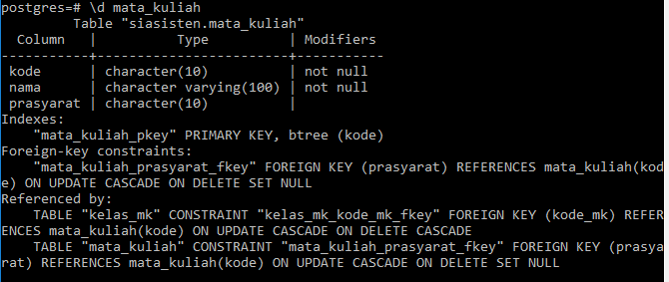

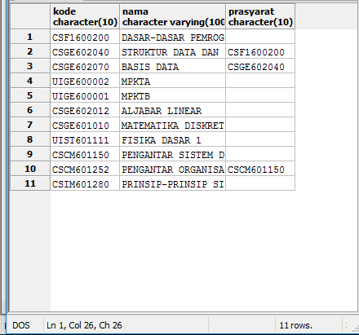

TERM

CREATE TABLE TERM(  
 Tahun INTEGER,  
 Semester INTEGER,  
 PRIMARY KEY(Tahun, Semester)  
);

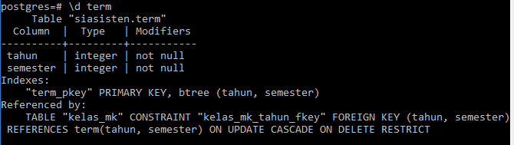

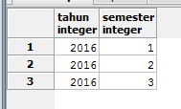

KELAS_MK

CREATE TABLE KELAS_MK(  
 IDKelasMK ID PRIMARY KEY,  
 Tahun INTEGER NOT NULL,  
 Semester INTEGER NOT NULL,   
 FOREIGN KEY(Tahun, Semester) REFERENCES TERM(Tahun, Semester) ON UPDATE CASCADE ON DELETE RESTRICT,  
 Kode_MK CHAR(10) NOT NULL REFERENCES MATA_KULIAH(Kode) ON UPDATE CASCADE ON DELETE CASCADE  
);

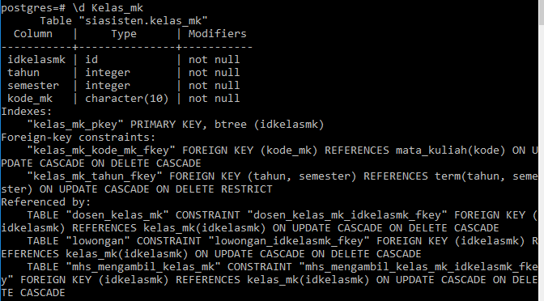

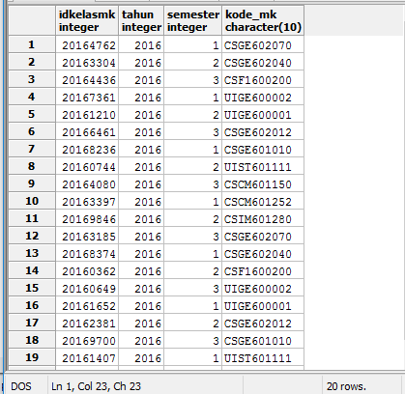

DOSEN

CREATE TABLE DOSEN(  
 NIP VARCHAR(20) PRIMARY KEY,  
 Nama VARCHAR(100) NOT NULL,  
 Username VARCHAR(30) NOT NULL,  
 Password VARCHAR(20) NOT NULL,  
 Email VARCHAR(100) NOT NULL,  
 Universitas VARCHAR(100) NOT NULL,  
 Fakultas VARCHAR(100) NOT NULL  
);

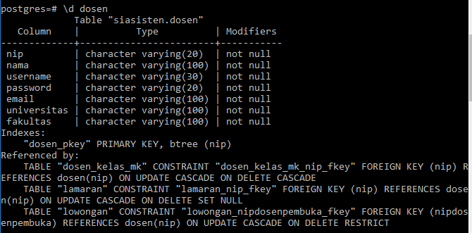

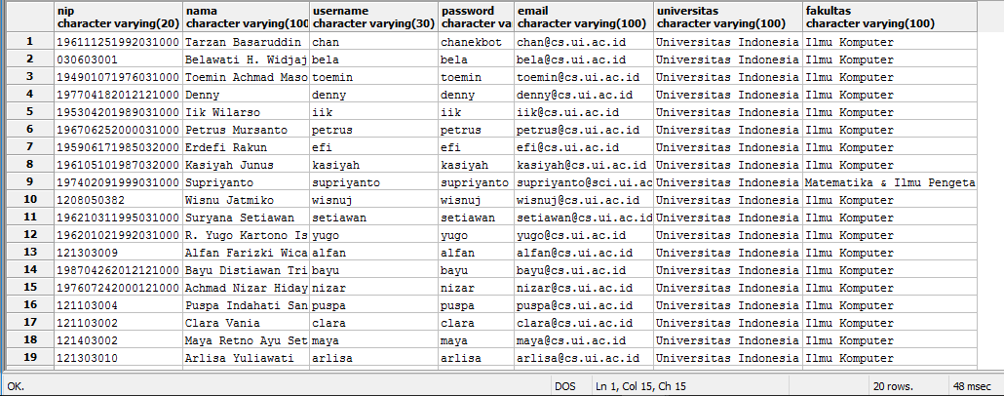

MAHASISWA

CREATE TABLE MAHASISWA(  
 NPM CHAR(10) PRIMARY KEY,  
 Nama VARCHAR(100) NOT NULL,  
 Username VARCHAR(30) NOT NULL,  
 Password VARCHAR(20) NOT NULL,  
 Email VARCHAR(100) NOT NULL,  
 Email_aktif VARCHAR(100),  
 Waktu_kosong VARCHAR(100),  
 Bank VARCHAR(100),  
 Norekening VARCHAR(100),  
 Url_mukatab VARCHAR(100),  
 Url_foto VARCHAR(100)  
);

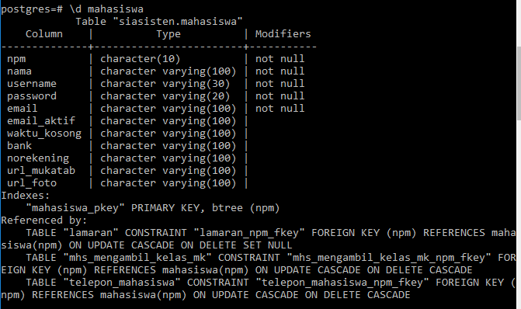

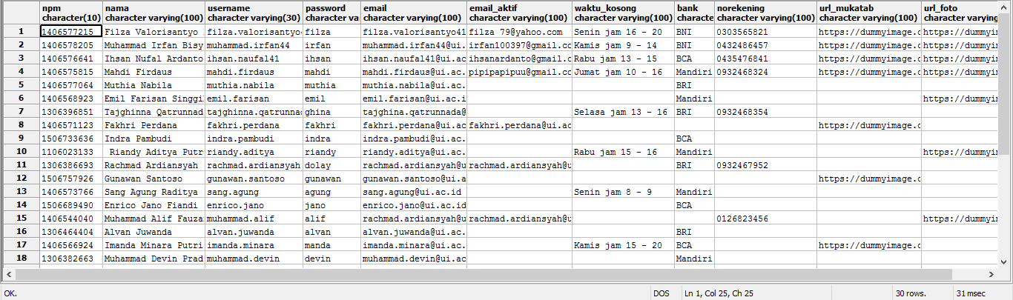

TELEPON MAHASISWA

CREATE TABLE TELEPON_MAHASISWA(  
 NPM CHAR(10) REFERENCES MAHASISWA(NPM) ON UPDATE CASCADE ON DELETE CASCADE,  
 Nomortelepon VARCHAR(20) NOT NULL,  
 PRIMARY KEY (NPM, Nomortelepon)  
);

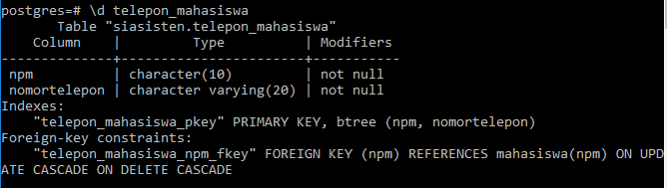

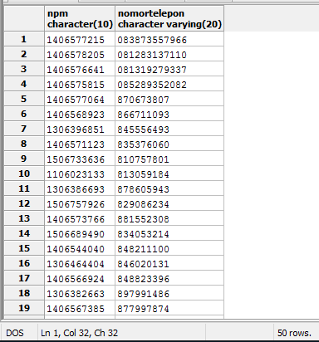

MHS_MENGAMBIL_KELAS_MK

CREATE TABLE MHS_MENGAMBIL_KELAS_MK(  
 NPM CHAR(10) REFERENCES MAHASISWA(NPM) ON UPDATE CASCADE ON DELETE CASCADE,  
 IDKelasMK ID REFERENCES KELAS_MK(IDKelasMK) ON UPDATE CASCADE ON DELETE CASCADE,  
 Nilai NUMERIC(5,2),  
 PRIMARY KEY(NPM, IDKelasMK)  
);

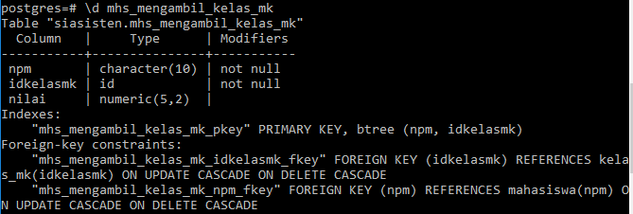

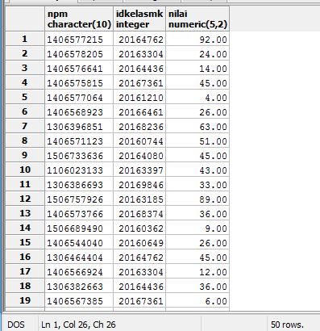

DOSEN_KELAS_MK

CREATE TABLE DOSEN_KELAS_MK(  
 NIP VARCHAR(20) REFERENCES DOSEN(NIP) ON UPDATE CASCADE ON DELETE CASCADE,  
 IDKelasMK ID REFERENCES KELAS_MK(IDKelasMK) ON UPDATE CASCADE ON DELETE CASCADE,  
 PRIMARY KEY(NIP, IDKelasMK)  
);

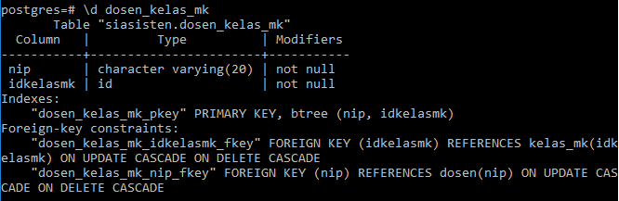

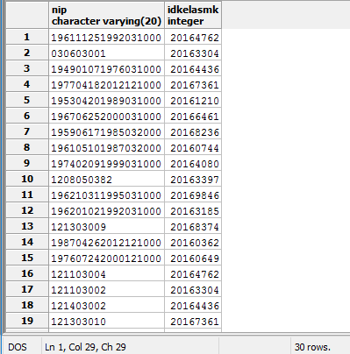

LOWONGAN

CREATE TABLE LOWONGAN(  
 IDLowongan ID PRIMARY KEY,  
 IDKelasMK ID NOT NULL REFERENCES KELAS_MK ON UPDATE CASCADE ON DELETE CASCADE,  
 Status BOOLEAN NOT NULL DEFAULT False,  
 Jumlah_asisten INTEGER NOT NULL DEFAULT 0,  
 Syarat_tambahan VARCHAR(100),  
 NIPDosenPembuka VARCHAR(20) NOT NULL REFERENCES DOSEN(NIP) ON UPDATE CASCADE ON DELETE RESTRICT  
);  
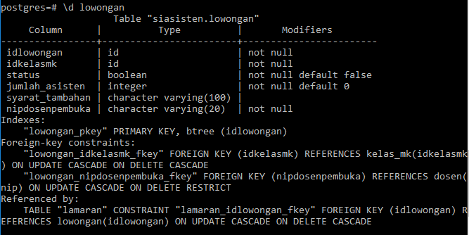

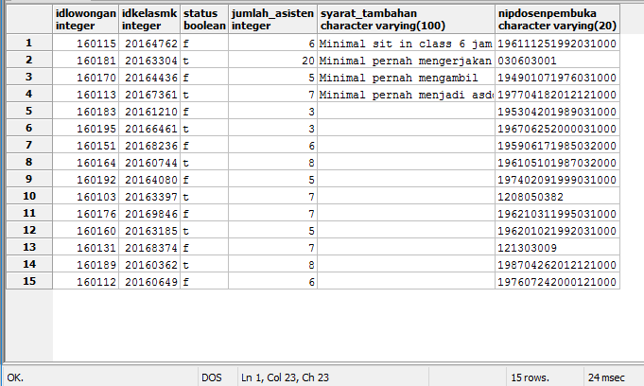

STATUS_LAMARAN

CREATE TABLE STATUS_LAMARAN(  
 ID ID PRIMARY KEY,  
 Status VARCHAR(20) NOT NULL  
);  
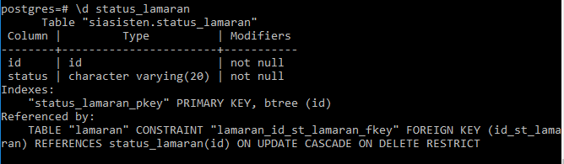  
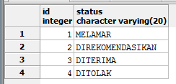

LAMARAN

CREATE TABLE LAMARAN(  
 IDLamaran ID,  
 NPM CHAR(10) REFERENCES MAHASISWA(NPM) ON UPDATE CASCADE ON DELETE SET NULL,  
 IDLowongan ID NOT NULL REFERENCES LOWONGAN(IDLowongan) ON UPDATE CASCADE ON DELETE CASCADE,  
 ID_st_lamaran ID NOT NULL REFERENCES STATUS_LAMARAN(ID) ON UPDATE CASCADE ON DELETE RESTRICT,  
 IPK NUMERIC(5,2) NOT NULL,  
 JumlahSKS INTEGER NOT NULL,  
 NIP VARCHAR(20) REFERENCES DOSEN(NIP) ON UPDATE CASCADE ON DELETE SET NULL,  
 PRIMARY KEY(IDLamaran, NPM)  
);

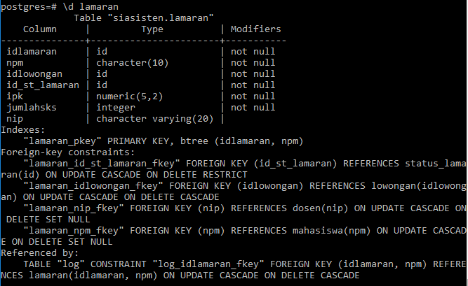

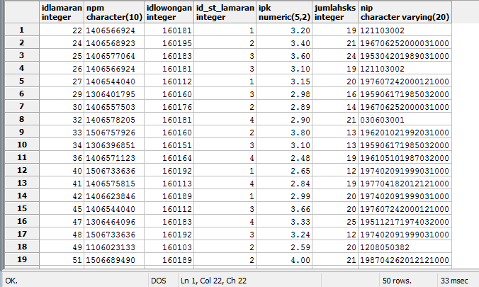

STATUS_LOG

CREATE TABLE STATUS_LOG(  
 ID ID PRIMARY KEY,  
 Status VARCHAR(10) NOT NULL  
);

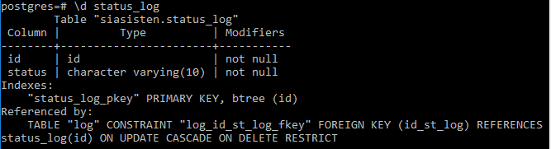  
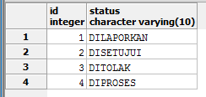

KATEGORI_LOG

CREATE TABLE KATEGORI_LOG(  
 ID ID PRIMARY KEY,  
 Kategori VARCHAR(50) NOT NULL  
);  
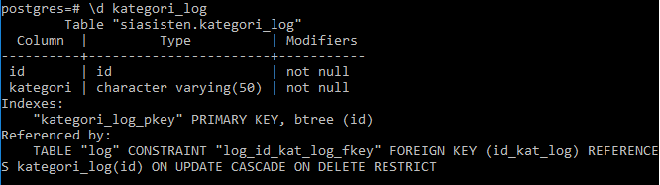

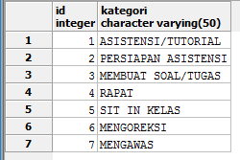

LOG

CREATE TABLE LOG(  
 IDLog ID PRIMARY KEY,  
 IDLamaran ID NOT NULL,  
 NPM CHAR(10) NOT NULL,  
 FOREIGN KEY(IDLamaran, NPM) REFERENCES LAMARAN(IDLamaran, NPM) ON UPDATE CASCADE ON DELETE CASCADE,  
 ID_kat_log ID NOT NULL REFERENCES KATEGORI_LOG(ID) ON UPDATE CASCADE ON DELETE RESTRICT,  
 ID_st_log ID NOT NULL REFERENCES STATUS_LOG(ID) ON UPDATE CASCADE ON DELETE RESTRICT,  
 Tanggal TIMESTAMP NOT NULL,  
 Jam_mulai TIMESTAMP NOT NULL,  
 Jam_selesai TIMESTAMP NOT NULL,  
 Deskripsi_kerja VARCHAR(100) NOT NULL  
);

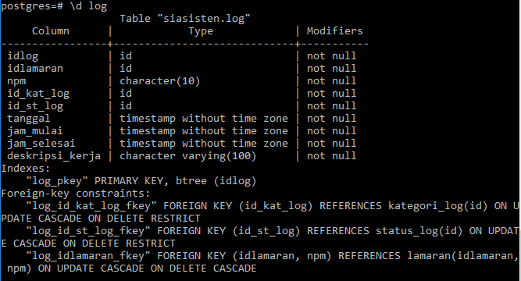

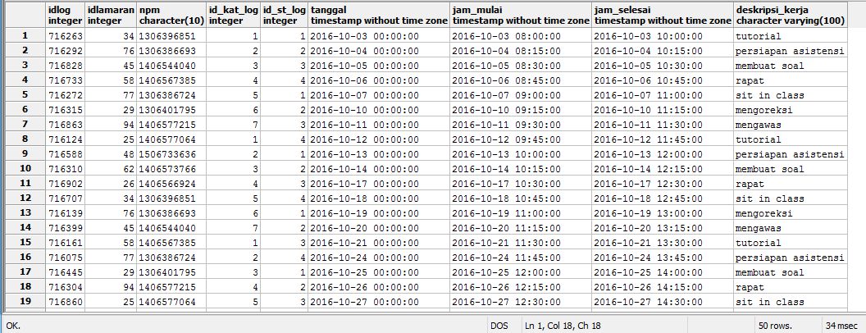

**Persentase Pengerjaan**

|  |  |  |  |
| --- | --- | --- | --- |
| NPM | Nama | Deskripsi Tugas | Kontribusi |
| 1406577215 | Filza Valorisantyo Hudiyono | Membuat git, membuat data real | 25% |
| 1406576641 | Ihsan Naufal Ardanto | Membuat laporan | 25% |
| 1406575815 | Mahdi Firdaus | Membuat DDL tabel, melakukan validasi input data, membuat local database | 25% |
| 1406578205 | Muhammad Irfan Bisyr | Membuat data random, membuat aplikasi untuk me-*random* data | 25% |