# 

# Build Instructions: Chair Call

Allowing remote control over a wheel chair via Bluetooth

Developed by: Idan Timsit, Natan Vinshtok Melnik, Maor Farid, Rafael Borenstein, Effi Hagai, Fima Autenshlus, Hila Boral, Mati Gurten, Yonatan Schachter

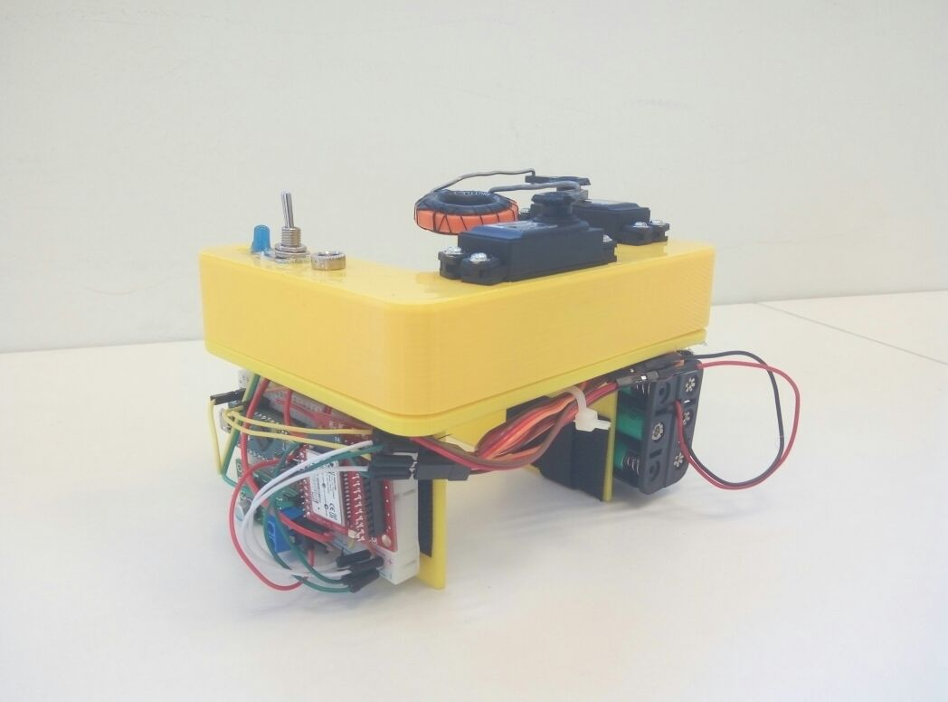

Approximate Cost: Insert cost

Time Required: 6 hours

# General Warnings and Cautions

* **Read through entire manual before attempting to build this device.**
* **Do not attempt a step if you are unsure of what you are doing.** Certain steps in this manual require experience with fabrication tools.

# User Assistance

For any questions regarding the assembly, operation, or specifications of this device, please visit https://github.com/fima85/remotecontrol

# Icon Glossary

The following icons may be used throughout this manual—each with its own purpose.

* **Caution:** The caution icon is used to signify whenever someone attempting the procedure may injure themselves or damage their equipment.
* **Note:** The note icon is used to signify useful bits of information that complement the instructions.
* **Reminder:** The reminder icon is used to provide information for after the procedure is completed, such as tips for disassembly.

# Purpose of Device:

This device allows a wheel chair user to remotely control his wheelchair. It can be very useful for some cases. For example, when the user has visitors, he might want to move the chair away from his bed.

# Physical Description:

The device consists of three parts:

1. Software: The user uses the controls in the custom app that we built. The app sends the commands via Bluetooth to the Electronics.
2. Electronics: A Bluetooth module receives the commands sent by the user. It then moves the servos accordingly.
3. Mechanical: the servos are mechanically connected to the original joystick of the wheelchair.

**History of Development:**

This device was developed at TOM:IL 2017.

# Bill of Materials

# 

# Tools Required:

* 3D printer
* A computer with the Arduino software and drivers
* Hot glue
* Screwdrivers
* Soldering iron
* Pliers

# Parts Inventory:

* Click here to enter text.
* Click here to enter text.
* Click here to enter text.

[Insert image of parts]

# Subassembly 1: Title of Subassembly

[Insert image of subassembly]

Approximate Cost: Insert cost

Time Required: Insert time

# Step Number

## Parts and Tools Used In This Step:

[Insert image(s) for step]

* Click here to enter text.
* Click here to enter text.
* Click here to enter text.

[Insert image of parts and tools used]

## Instructions

* Click here to enter text.
* Click here to enter text.
* Click here to enter text.
* Click here to enter text.
* Click here to enter text.
* Click here to enter text.
* Click here to enter text.

# Step Number

## Parts and Tools Used In This Step:

[Insert image(s) for step]

* Click here to enter text.
* Click here to enter text.
* Click here to enter text.

[Insert image of parts and tools used]

## Instructions

* Click here to enter text.
* Click here to enter text.
* Click here to enter text.
* Click here to enter text.
* Click here to enter text.
* Click here to enter text.
* Click here to enter text.

# Step Number

## Parts and Tools Used In This Step:

[Insert image(s) for step]

* Click here to enter text.
* Click here to enter text.
* Click here to enter text.

[Insert image of parts and tools used]

## Instructions

* Click here to enter text.
* Click here to enter text.
* Click here to enter text.
* Click here to enter text.
* Click here to enter text.
* Click here to enter text.
* Click here to enter text.