RuFLEX: A Hybrid Deep Fuzzy Learning Platform for Geodata with Interpretable Analysis of Rules, Factors, and Hidden Concepts
Author One, Author Two
Organization, City, Country
author1@example.com, author2@example.com
ORCID: 0000-0000-0000-0000, 0000-0000-0000-0000
Abstract
This paper presents RuFLEX, a platform for hybrid deep fuzzy learning oriented toward geoanalytics, spatially informed classification, forecasting, and intelligent decision support. The platform combines interpretable rule-based mechanisms, differentiable fuzzy layers, and deep fuzzy feature-learning architectures within a unified workflow implemented in Python and PyTorch. Experimental validation was carried out on California Housing Regression and California Value Binary Geo.
Keywords: deep fuzzy learning; hybrid neuro-fuzzy models; deep fuzzy feature learning; explainability; geoanalytics; interpretable machine learning
I. Introduction
RuFLEX is designed as a platform rather than a single fixed architecture. It extends a vendored deep fuzzy backend with its own SDK, project model, explainability tooling, visual workbench, and reproducible experiment layer. This separation enables both backend continuity and independent platform evolution.
The main objective is to support multiple hybrid deep fuzzy modeling modes while preserving interpretable reasoning at the level of membership functions, rules, hidden concepts, and factor contributions.
II. Platform Architecture and Modeling Modes
The current architecture includes a core layer with variables, terms, membership functions, rules, and model specifications; a model layer with flat neuro-fuzzy baselines and deep fuzzy feature learning; a training layer with bootstrap initialization, stage-wise pretraining, refinement, and fine-tuning; and an explainability layer with rule records, concept flow, and dashboard payloads.
The first release already supports two main modes: a compact flat neuro-fuzzy baseline and a deep fuzzy feature-learning regime with hidden concept layers. The schemes below summarize the separation between the backend and the platform layer, the shared modeling contour, and the explainability workflow.
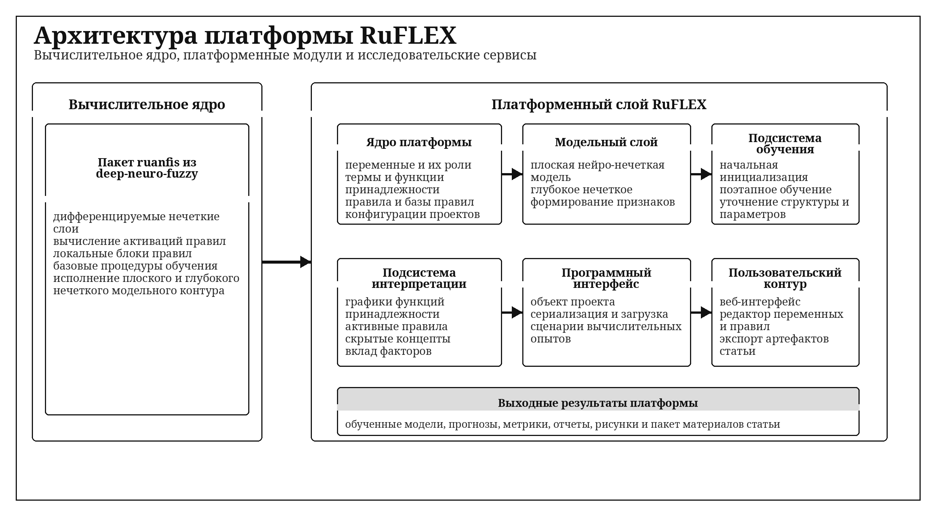
Scheme 1. General RuFLEX architecture with the deep fuzzy backend and the platform layer.
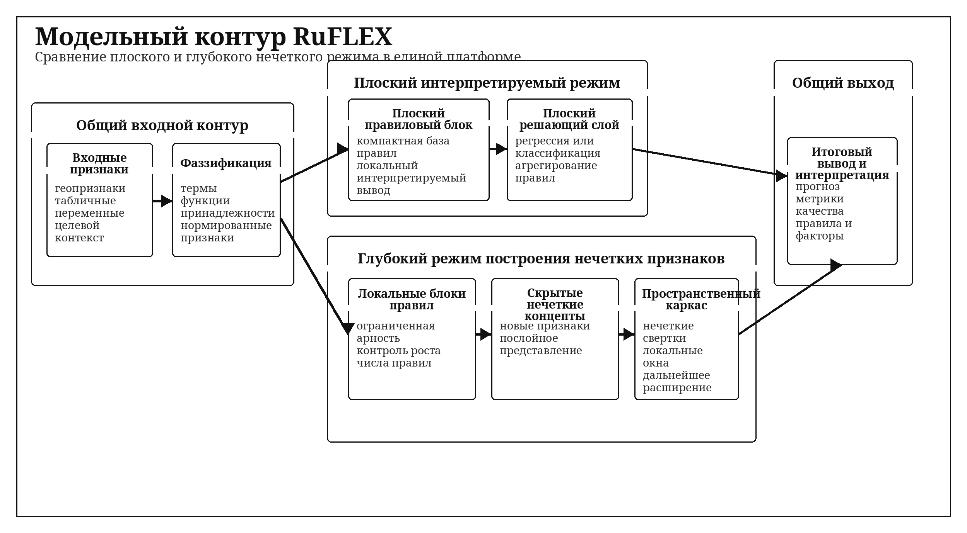
Scheme 2. Shared modeling contour for the flat baseline and deep fuzzy feature learning.
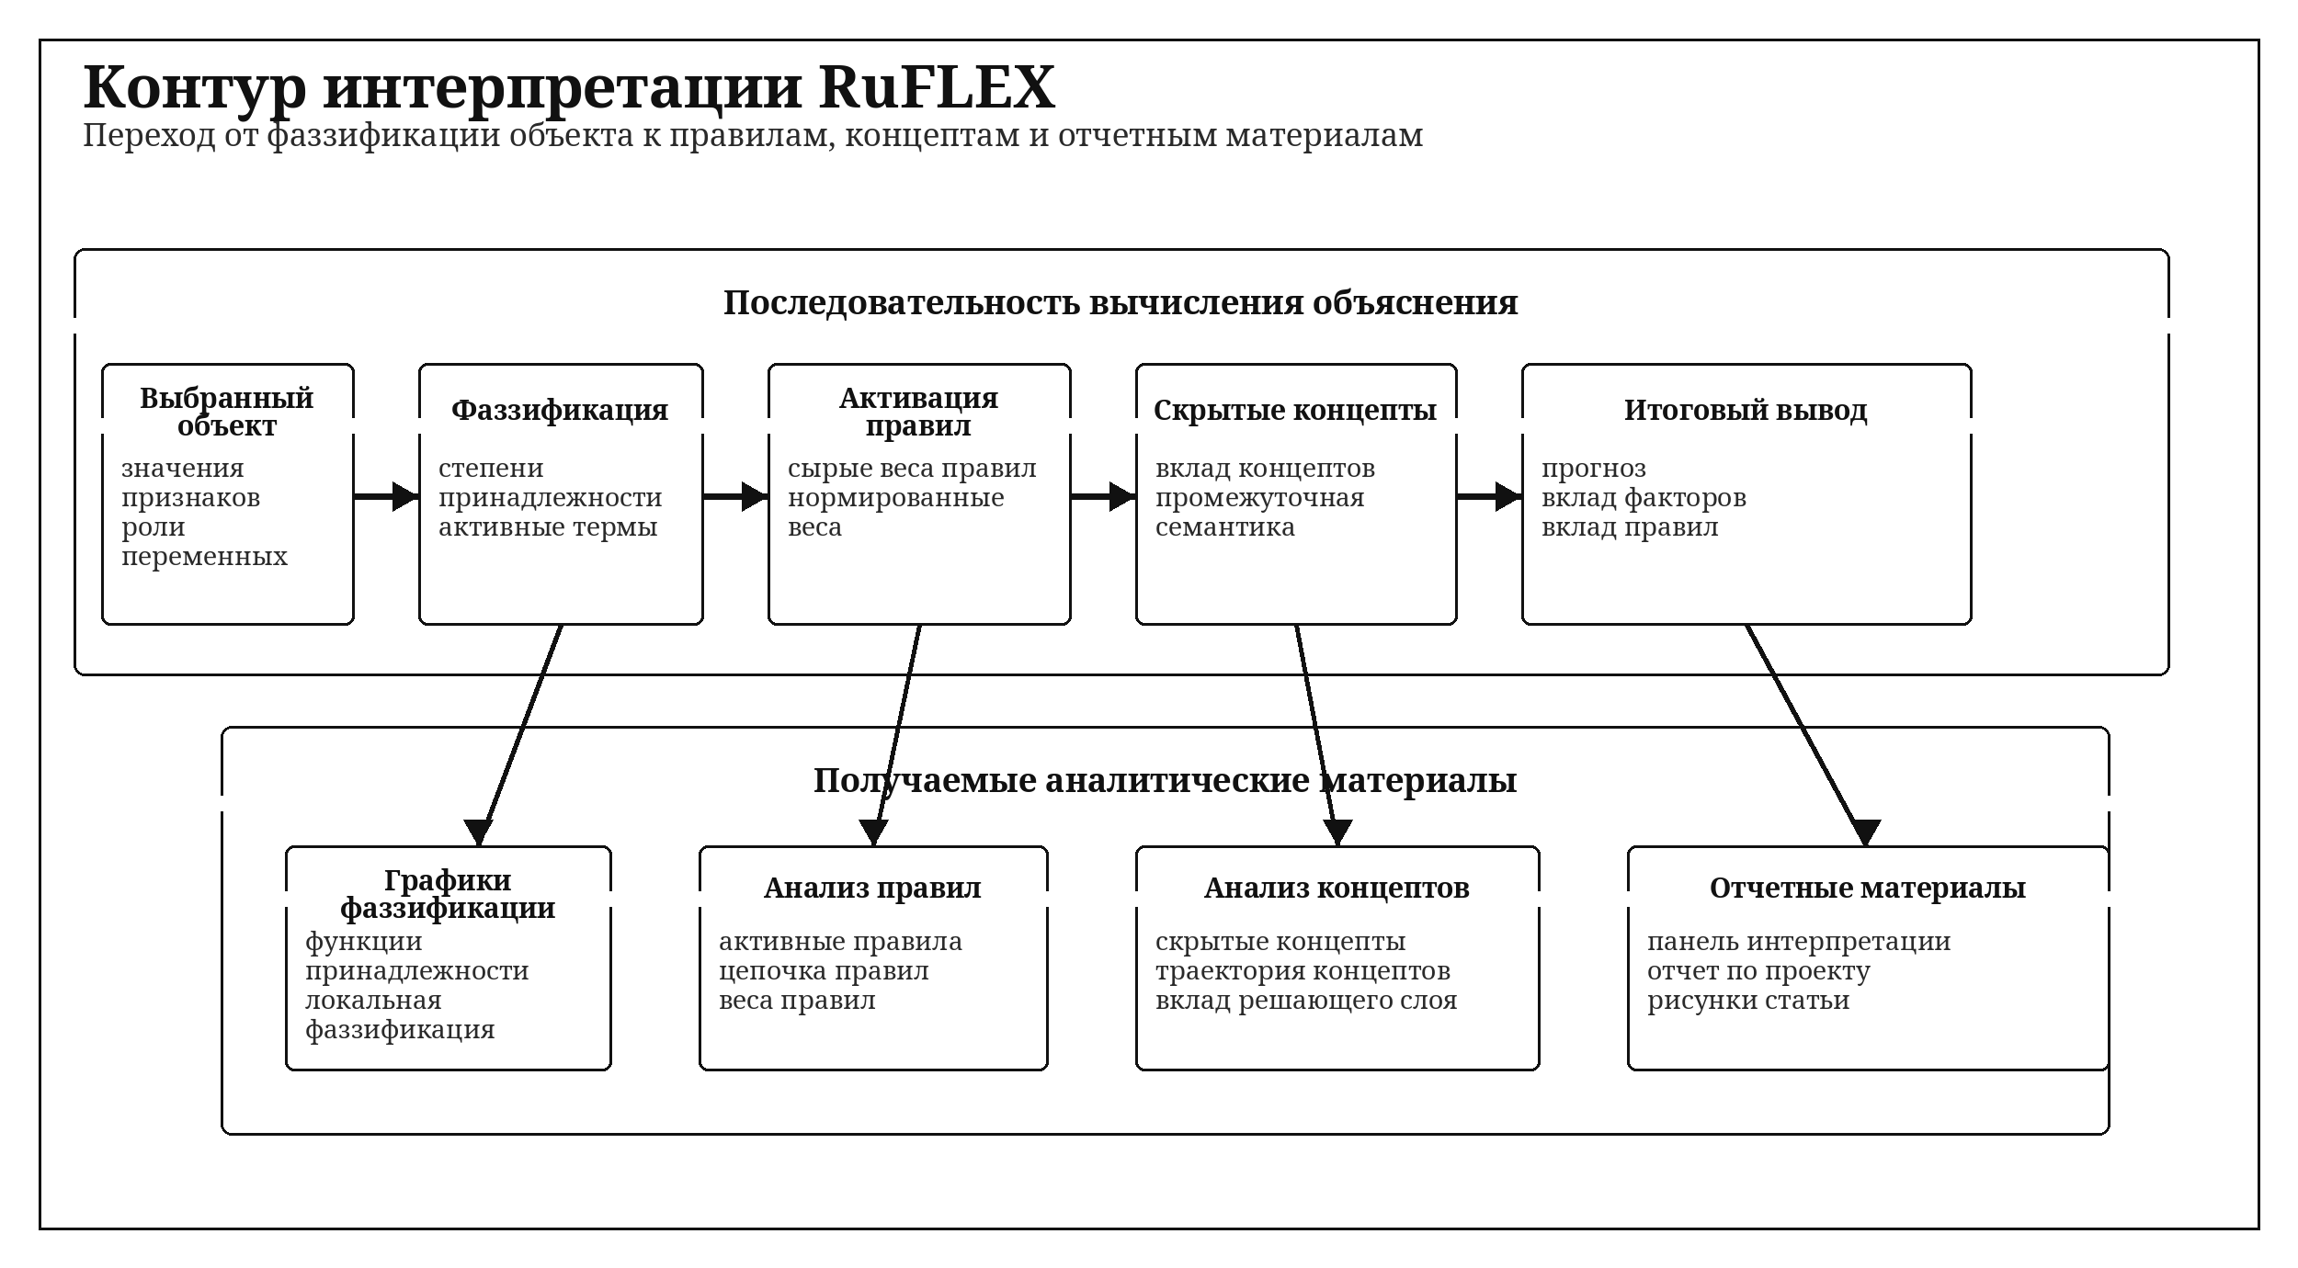
Scheme 3. Explainability pipeline from fuzzification to reports and article artifacts.
III. Experimental Setup
Two geo-oriented tabular tasks were used in validation: California Housing Regression and California Value Binary Geo. The first task preserves the spatial predictors Latitude and Longitude, while the second task uses the same source data to define a balanced binary classification problem based on housing value.
The compared configurations were Flat Baseline, Flat Interpretable, Deep Article Demo, and Deep Research.
IV. Results and Discussion
On California Housing Regression, the best configuration was Deep Research with `test_rmse = 0.795757` and `test_r2 = 0.507159`. On California Value Binary Geo, the best configuration was Flat Interpretable with `test_accuracy = 0.746341` and `test_f1 = 0.739348`. This supports the platform-oriented design: different fuzzy regimes may become preferable depending on task structure.
Table I. Regression benchmark results
Configuration | Test RMSE | Test MAE | Test R2
Flat Baseline | 0.890950 | 0.678868 | 0.382192
Flat Interpretable | 1.115952 | 0.880786 | 0.030747
Deep Article Demo | 0.816314 | 0.610628 | 0.481367
Deep Research | 0.795757 | 0.593770 | 0.507159

Table II. Classification benchmark results
Configuration | Test Accuracy | Test Precision | Test F1
Flat Baseline | 0.742683 | 0.739899 | 0.735257
Flat Interpretable | 0.746341 | 0.743073 | 0.739348
Deep Article Demo | 0.739024 | 0.724221 | 0.738386
Deep Research | 0.743902 | 0.741772 | 0.736181

V. Explainability Figures
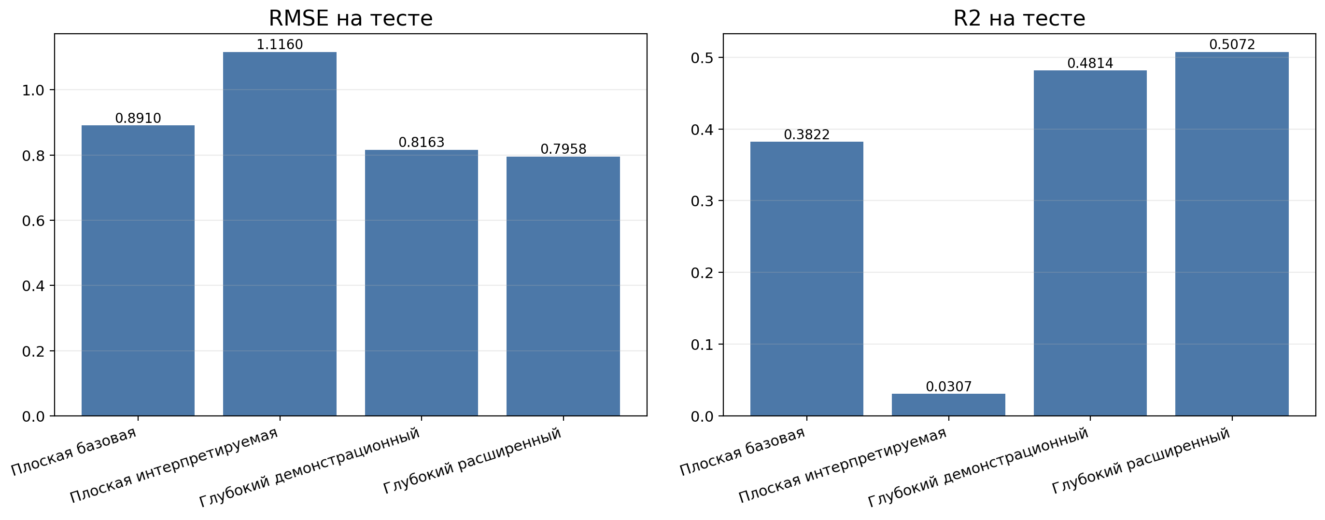
Fig. 1. Comparison of flat and deep fuzzy configurations on California Housing Regression.
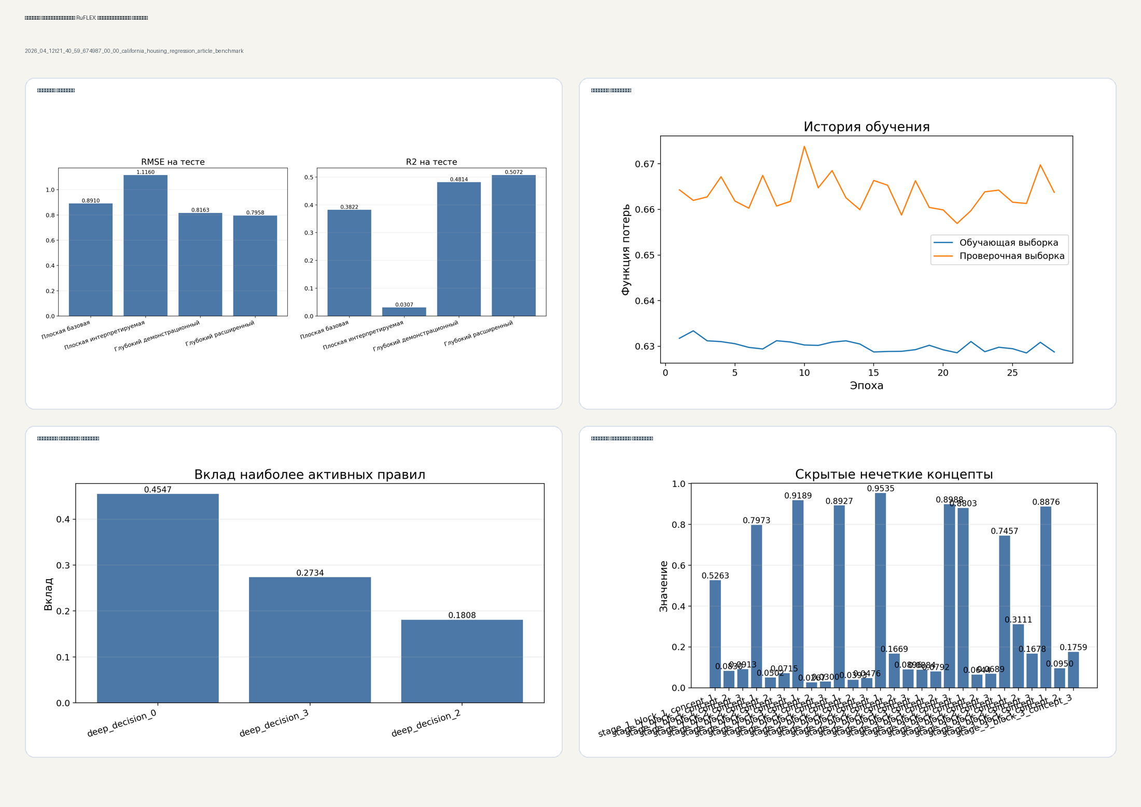
Fig. 2. Explainability board for the best regression configuration.
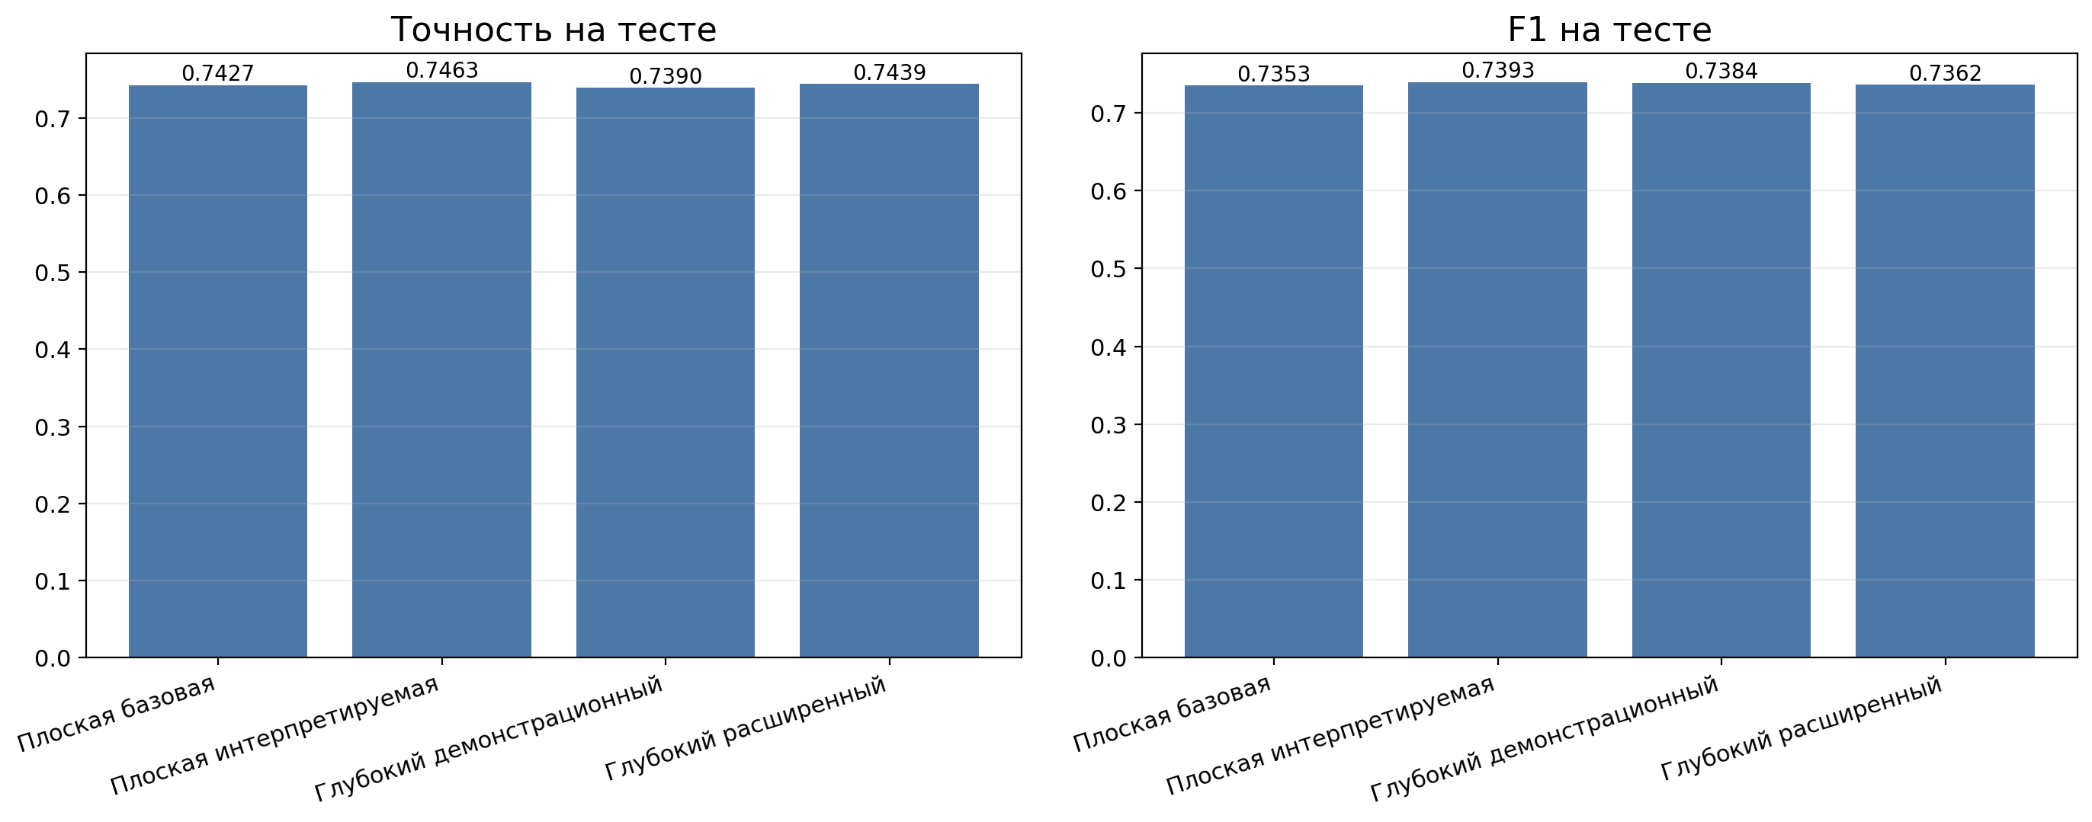
Fig. 3. Comparison of RuFLEX configurations on California Value Binary Geo.
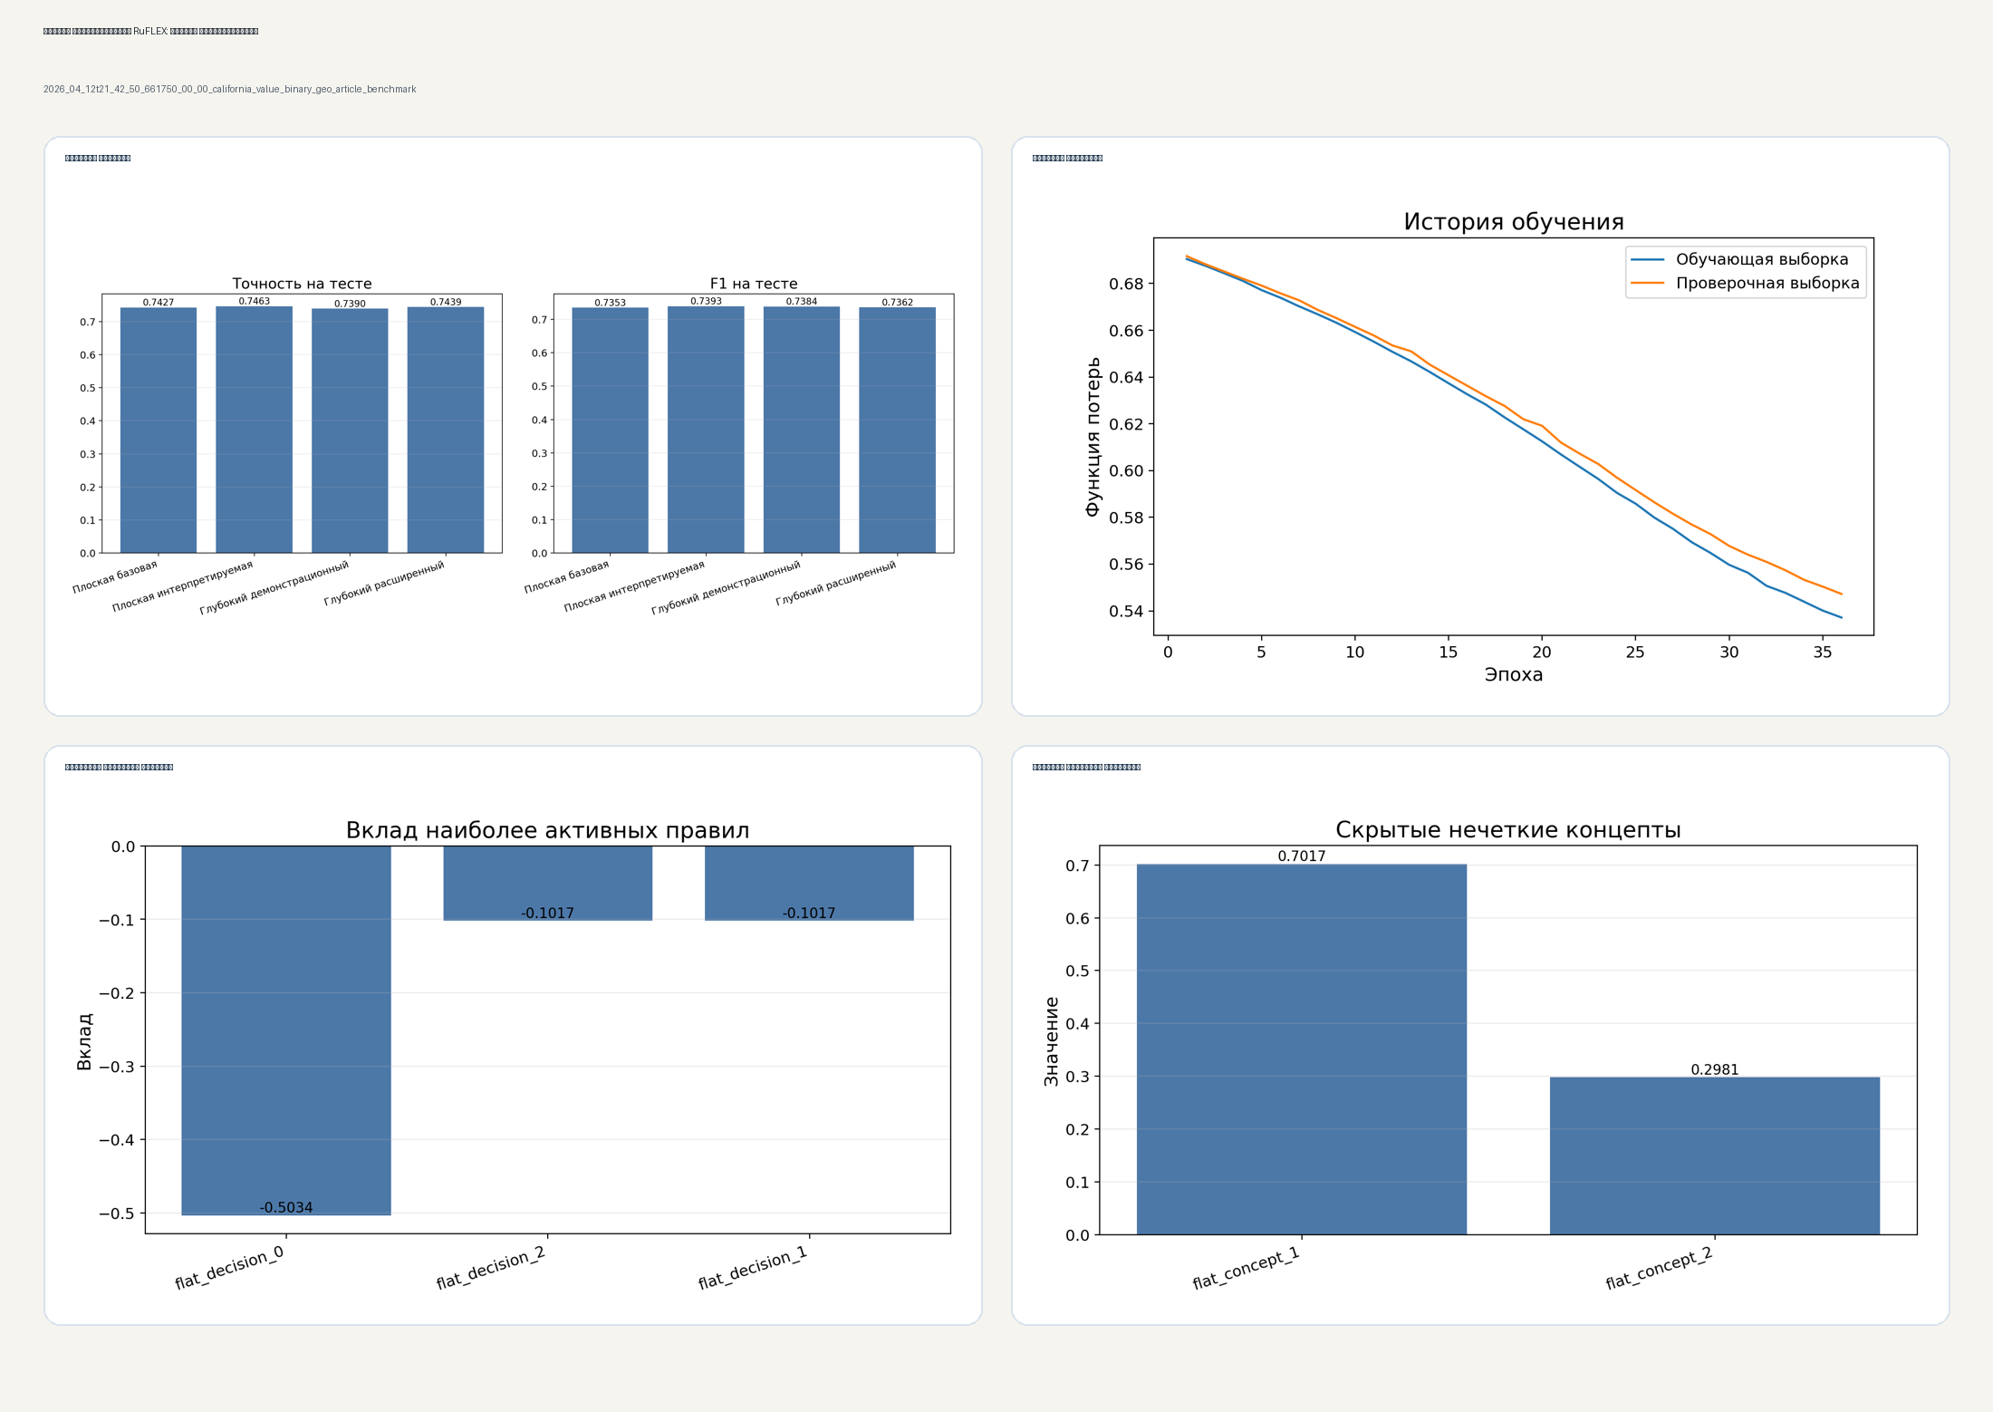
Fig. 4. Explainability board for the best classification configuration.
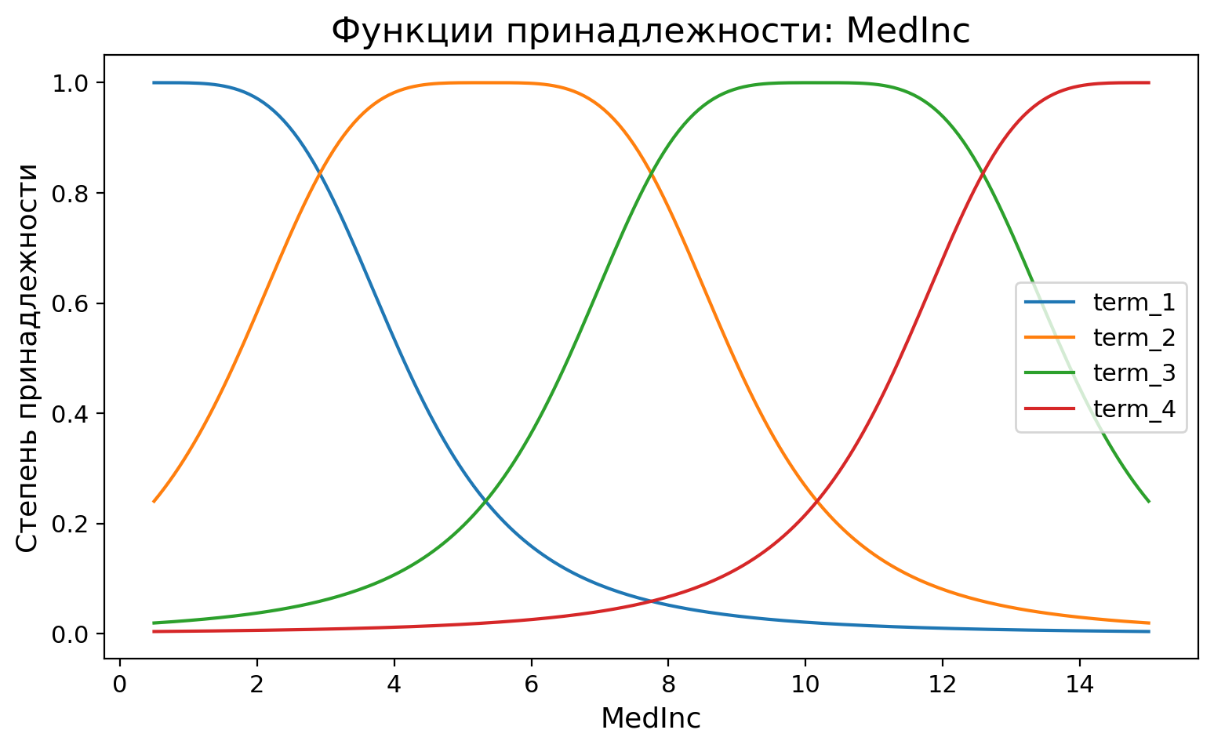
Fig. 5. Example membership functions used for interpretable fuzzification.
VI. Conclusion
RuFLEX combines interpretable rule-based mechanisms, differentiable fuzzy layers, deep fuzzy feature learning, a Python SDK, a visual workbench, and explainability tooling within one reproducible workflow. The current implementation is suitable for both regression and classification scenarios and provides a foundation for future work on spatial fuzzy modules, stronger logical traceability, and counterfactual analysis.
Acknowledgment
This block can be filled with acknowledgments or institutional support if required by the venue.
Funding
Funding information can be placed here if required by the venue.
References
- J.-S. R. Jang, “ANFIS: Adaptive-Network-Based Fuzzy Inference System,” IEEE Transactions on Systems, Man, and Cybernetics, vol. 23, no. 3, pp. 665-685, 1993.
- A. Paszke, S. Gross, F. Massa et al., “PyTorch: An Imperative Style, High-Performance Deep Learning Library,” in Advances in Neural Information Processing Systems, vol. 32, 2019.
- F. Pedregosa, G. Varoquaux, A. Gramfort et al., “Scikit-learn: Machine Learning in Python,” Journal of Machine Learning Research, vol. 12, pp. 2825-2830, 2011.
- R. K. Pace and R. Barry, “Sparse Spatial Autoregressions,” Statistics & Probability Letters, vol. 33, no. 3, pp. 291-297, 1997.
- C. Rudin, “Stop Explaining Black Box Machine Learning Models for High Stakes Decisions and Use Interpretable Models Instead,” Nature Machine Intelligence, vol. 1, pp. 206-215, 2019.
- X. Ma, L. Chen, Z. Deng Z. et al., “Deep Image Feature Learning With Fuzzy Rules,” IEEE Transactions on Emerging Topics in Computational Intelligence, vol. 8, pp. 724-737, 2024.
- Lebedeffson, “deep-neuro-fuzzy,” GitHub repository. Available: https://github.com/lebedeffson/deep-neuro-fuzzy. Accessed: Apr. 13, 2026.

