**CQRS AND EVENT SOURCING IN SPRING BOOT AND AXON**

The **Microservices Architecture** World, we can meet many **concepts** and **patterns**, like the **Centralized Configuration**, **Circuit Breaker**, **Service Registry and Discovery**, etc.. Two of these patterns are the **CQRS** and the **Event Sourcing** patterns, coming from the **Domain Driven Design** planet  In the most of the use-cases, these two patterns are sold together  in this new tutorial, we will discover what does each one ? why they are usually used together ? and for sure **we will implement these two patterns in Java**

Let’s start with some definitions and literature

WHAT IS THE CQRS PATTERN ?

**CQRS** stands for **Command Query Responsibility Segregation** is a design pattern that aims to **separate** the **Read**and**Write**operations. In the CQRS distinguishes the operations as:

* **Queries**: a Read only operation – no state is updated after executing queries
* **Commands**: a Writing operation – state is updated after executing commands

The schema describes the **CQRS** pattern:

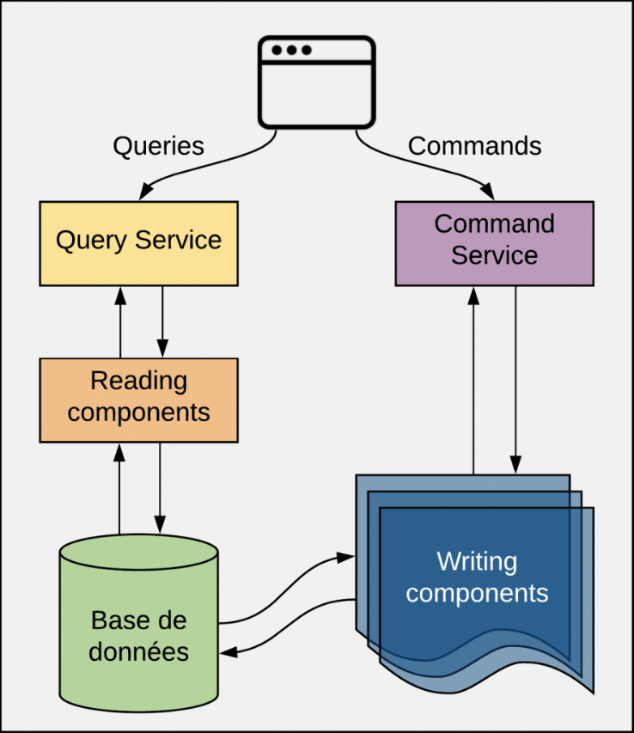

*CQRS pattern*

A **Query** is a **Read operation**, that **does not update any the state** of the application. A **Query** is handled by the **Reading Components** that will interact with the **DB**, parses the **DB response**, creates a **Data Transfert Object** that will be returned to the User.

A **Command** is a **Business Action** that the Application’s user want to do, for example: *RegisterStudent*, *MakeDeposit*, etc..

Every **Command** has a **Handling Layer** that knows how to apply the **Business Action**. Generally, commands are inserted in a **Queue** to be processed **asynchronously**, so technically speaking, a **Command Handler** is invoked by a **Queue Listener**..

WHAT IS THE EVENT SOURCING PATTERN ?

Event Sourcing aims to persist the state of a business entity (**BankAccount** for example) as a sequence of state-changing events. Every action performed on a business entity should be persisted. The application reconstructs an entity’s current state by replaying the events.

For example, to reconstruct a given **BankAccount** current state, we need to replay all the events occurred on this business entity. It means we do not store the state of the **BankAccount**.

Applications persist events in a database of events called **event store**. The store has an API for adding and retrieving an entity’s events. The **event store** also behaves like a message broker. It provides an API that enables services to subscribe to events. When a service saves an event in the event store, it is delivered to all interested subscribers.

Some entities, such as a **BankAccount**, can have a large number of events. In order to optimize loading, an application can periodically save a **snapshot** of an entity’s current state. To reconstruct the current state, the application finds the most recent **snapshot** and the events that have occurred since that **snapshot**. As a result, there are fewer events to replay.

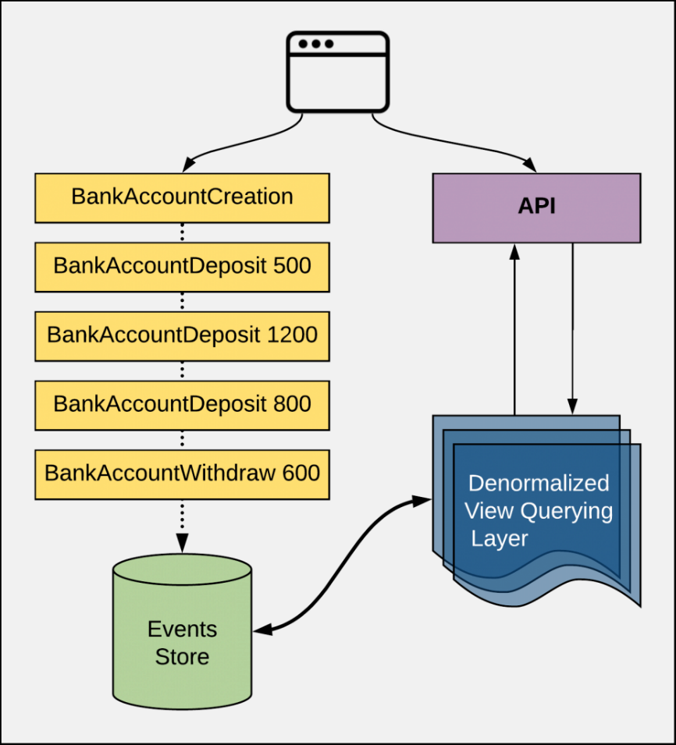

*Event Sourcing (very) simplified diagram*

WHY WE ARE ALWAYS COUPLING THESE PATTERNS ?

**CQRS** separates the responsibilities, typically into different components. The first component covers **CUD operations** (without the Reading), while a second component will ensure the **Read** **operation**.

**Reads** and **writes** from different places can create a timing issue. Most database theory focuses on consistency. It should be possible to keep a log of every data change. That way, at any point in time, the values that the queries display are logically correct. Here comes the **Event Sourcing**, which will ensure consistency. **Event Sourcing** stores a record of every action in a dedicated database. From there, an **event handler** reads these changes in order, applies them appropriately and marks them as complete once the transaction is complete. This **event handler** does not need to be complex — it can be as simple as an *API endpoint*. Once the **event handler** creates an event record, a central service messaging system can push notifications every time it discovers about a new event.

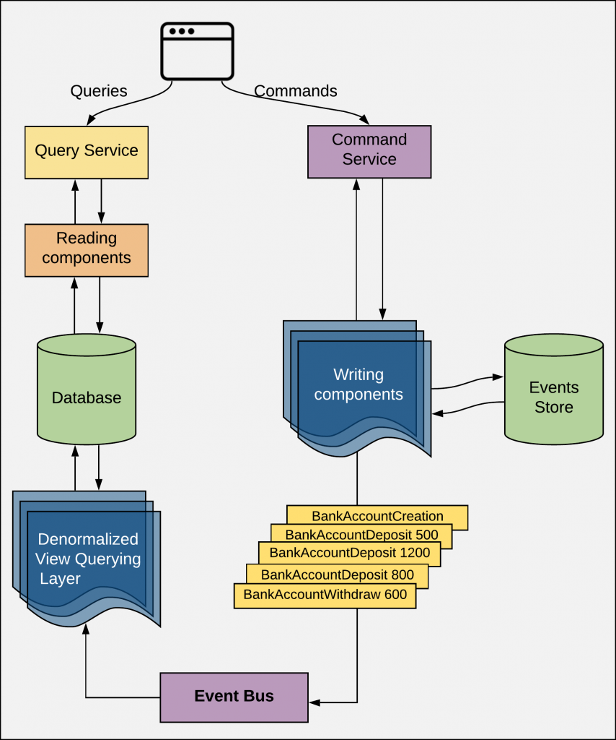

*Coupling CQRS and Event Sourcing Diagram*

**CQRS** and **Event Sourcing** patterns are frequently used together. Coupling these two patterns means that each event on the **Writing** part of our application. Obviously  the Reading part is made by playing the events.

LET’S IMPLEMENT THE CQRS & EVENT SOURCING IN A TYPICAL JAVA APPLICATION

We will create a small **Spring Boot application** on which we will implement **CQRS**and**Event Sourcing patterns** using **Axon**.

What is **Axon** ?

Based on the official documentation:

**Axon** provides a unified, productive way of developing Java applications that can evolve without significant refactoring from a monolith to Event-Driven microservices. **Axon** includes both a programming model as well as specialized infrastructure to provide enterprise ready operational support for the programming model – especially for scaling and distributing mission critical business applications. The programming model is provided by the popular **Axon Framework** while **Axon Server** is the infrastructure part of **Axon**, all open sourced.

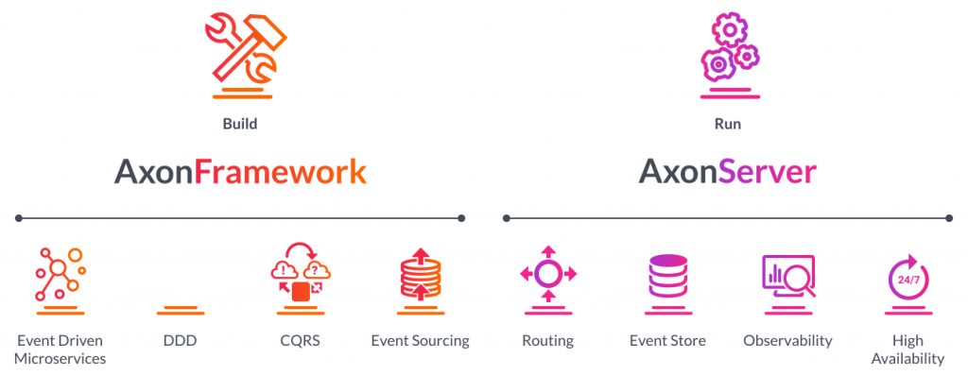

*Axon Framework and Server – Official documentation*

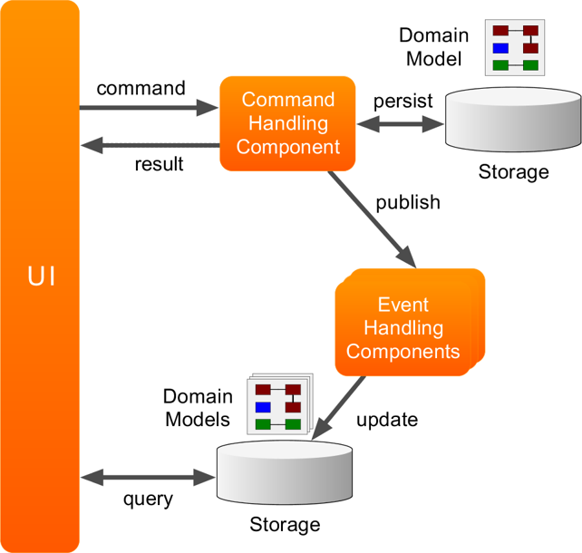

Let’s dig into the coding part; we will start by generating the **Spring Boot application** using the **Spring Initializr** with these dependencies:

* Web
* H2
* Actuator
* H2 Database
* Lombok

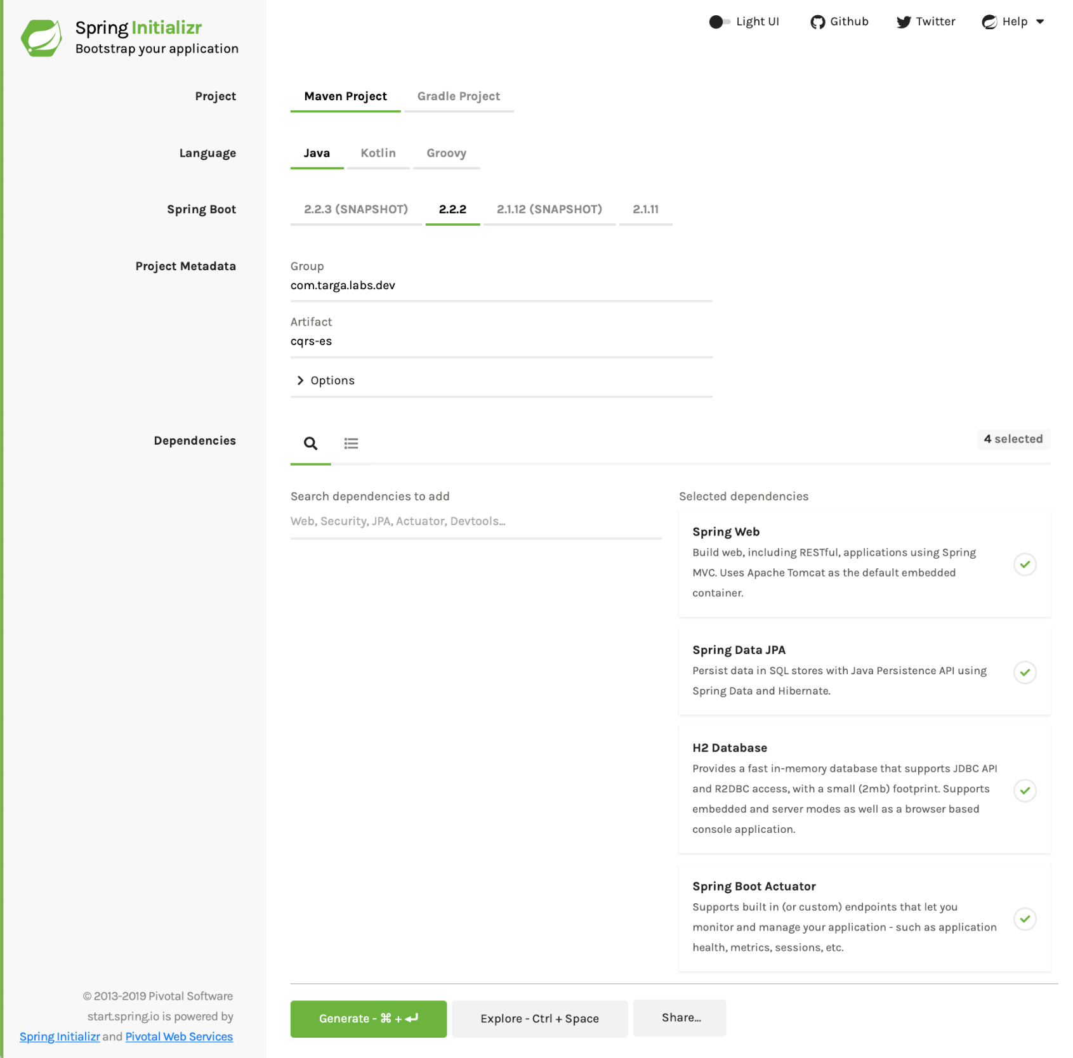

*Generating the Spring Boot application*

After generating the project. We will add these dependencies to the pom.xml:

* **SpringFox Swagger2** and **Swagger UI**:

<dependency>

<groupId>io.springfox</groupId>

<artifactId>springfox-swagger2</artifactId>

<version>2.9.2</version>

</dependency>

<dependency>

<groupId>io.springfox</groupId>

<artifactId>springfox-swagger-ui</artifactId>

<version>2.9.2</version>

</dependency>

* **Axon Spring Boot Starter**:

<dependency>

<groupId>org.axonframework</groupId>

<artifactId>axon-spring-boot-starter</artifactId>

<version>4.2.1</version>

</dependency>

* **Axon Test module**We will be testing our code

<dependency>

<groupId>org.axonframework</groupId>

<artifactId>axon-test</artifactId>

<version>4.2</version>

<scope>test</scope>

</dependency>

Our **sample application** will be a **Bank Account** manager. Our **application** will have these features:

* Create a new account for a given **Owner** with a given **Initial Balance**
* Credit an amount on a given account
* Debit an amount from a given account
* Read information about a given account

A **BankAccount** will look like:

Data *// Lombok*

@NoArgsConstructor *// Lombok*

@AllArgsConstructor *// Lombok*

@Entity

**public** **class** BankAccount {

@Id

**private** UUID id;

**private** String owner;

**private** BigDecimal balance;

}

**commands and queries**

Now, we need to list the **Reading** and **Writing** actions related to the application features:

|  |  |  |
| --- | --- | --- |
| **Feature** | **Command** | **Query** |
| Create a new account | Yes | No |
| Credit an amount from account | Yes | No |
| Debit an amount from account | Yes | No |
| Get Account information | No | Yes |

Based on this table, our commands will be:

* CreateAccountCommand
* CreditMoneyCommand
* DebitMoneyCommand

For the queries, we will have only one:

* FindAccountQuery

– Did you forgot that the **CQRS and Event Sourcing** are two patterns that belong to the **DDD paradigm**?  As it’s a **Domain Driven**, we need to start designing our **Domain**

We will start by implementing the**Command model** for our **CQRS segments**, using **Aggregates**

**Aggregate**

I have found two definitions of Aggregates in the Axon Documentation:

* *An****Aggregate****is a regular object, which contains state and methods to alter that state.*
* *An****Aggregate****is a business entity or group of business entities that is always kept in a consistent state (within a single ACID transaction). The****Aggregate Root****is the business entity within the****aggregate****that is responsible for maintaining this consistent state.*

For example: an **aggregate** can be an e-Commerce **Order** with the related **OrderItems** and **Customer** information. Here, the **Order** class is the **Aggregate Root**:

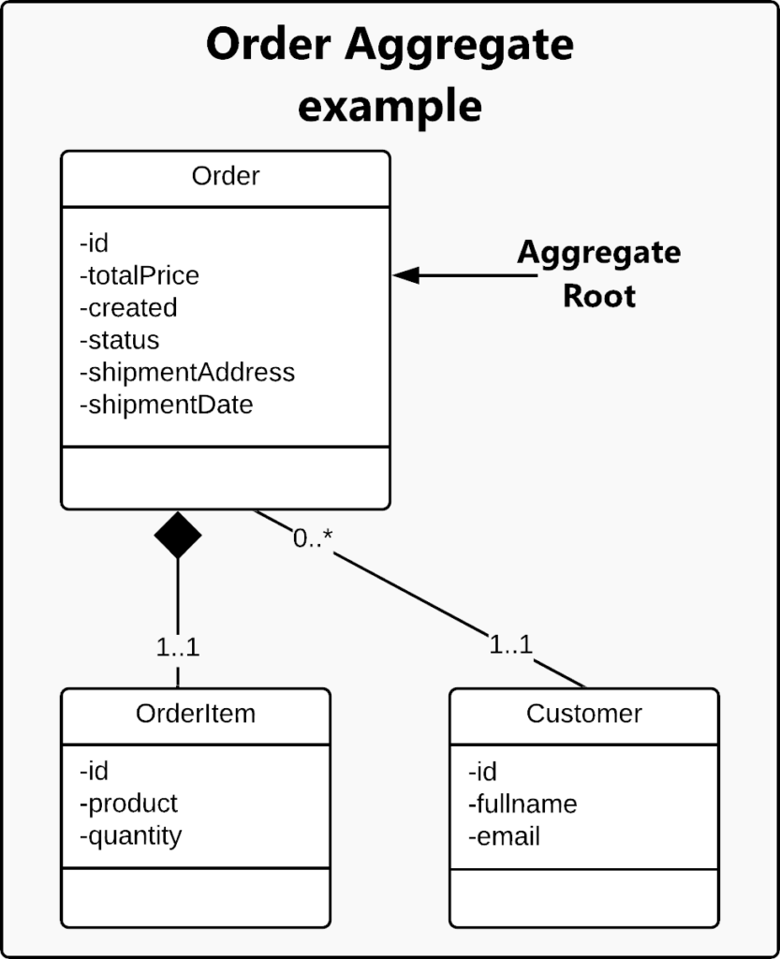

*Order Aggregate example*

In our application, our **Aggregate** is the **BankAccountAggregate** will look like:

@AllArgsConstructor *// Lombok*

@NoArgsConstructor *// Lombok*

@Getter *// Lombok*

@Aggregate *// 1*

**public** **class** BankAccountAggregate {

@AggregateIdentifier *// 2*

**private** UUID id;

**private** BigDecimal balance;

**private** String owner;

...

}

1. The @Aggregate annotation informs **Axon’s auto configurer for Spring** that this class is an **Aggregate** instance.
2. The @AggregateIdentifier identifies the field as the identifier of the **Aggregate**.

 For sure that you are saying now that the **BookAccountAggregate** and the **BookAccount** *JPA Entity* looks like the same structure. Why are we duplicating the code? Why don’t we use the **BookAccountAggregate** class as the *JPA Entity* class? The answer is that the **BookAccountAggregate** will contain more **Axon** boilerplate code which cannot fit to a *JPA Entity* class, which is used only to represent data stored in a DB

Let’s continue to code our **BookAccountAggregate** class.

Now we will code the constructor. We already said that we have a **Command** that will create a new account: **CreateAccountCommand**. Here will come the first glue between the **Commands** and the **Aggregate**: the **CreateAccountCommand** will be passed to the **Aggregate** constructor:

@CommandHandler

**public** BankAccountAggregate(CreateAccountCommand command) {

}

The @CommandHandler will mark this method (constructor) as a **Handler** of the **CreateAccountCommand**. The command needs to bring the data needed by to construct the **BankAccount** instance. Think of it as a **Data Transfert Object** used to wrap data received and sent via REST APIs. Obviously a **CreateAccountCommand** will have the same content like the **BankAccount**JPA Entity and the **BookAccountAggregate**. It will look like:

@Data *// Lombok*

@NoArgsConstructor *// Lombok*

@AllArgsConstructor *// Lombok*

**public** **class** CreateAccountCommand {

@TargetAggregateIdentifier

**private** UUID accountId;

**private** BigDecimal initialBalance;

**private** String owner;

}

The @TargetAggregateIdentifier will identify the field as the identifier of the targeted **aggregate**.

We said before that in the **CQRS** and **Event Sourcing** based applications, for every **Command** made, we dispatch an **Event**.

For example; for the **CreateAccountCommand** we need to create an **AccountCreatedEvent** that will be used to say that a **Command** has been received.

You can notice that the Command is formed by an Action + Command suffix while the Event is PastAction + Event suffix

Guess what  the **AccountCreatedEvent** will look like:

@Data *// Lombok*

**public** **class** AccountCreatedEvent {

**private** **final** UUID id;

**private** **final** BigDecimal initialBalance;

**private** **final** String owner;

}

Now, the **CommandHandler** will look like:

@CommandHandler

**public** BankAccountAggregate(CreateAccountCommand command) {

AggregateLifecycle.apply(

**new** AccountCreatedEvent(

command.getAccountId(),

command.getInitialBalance(),

command.getOwner()

)

);

}

The AggregateLifecycle component is used to notify the **Aggregate** that a new **BankAccount** was created by publishing the **AccountCreatedEvent**.

Good ! The same way, if we dispatched a **Command**, we defined its **CommandHandler**. Now, as we dispatched an **Event**, we need to define the **EventHandler**:

@EventSourcingHandler

**public** **void** on(AccountCreatedEvent event) {

**this**.id **=** event.getId();

**this**.owner **=** event.getOwner();

**this**.balance **=** event.getInitialBalance();

}

The @EventSourcingHandler will define the annotated method as a handler for **Events** generated by that **Aggregate**.

Now, we will define the two remaining **Commands**:

* The **CreditMoneyCommand**:

@Data

@NoArgsConstructor

@AllArgsConstructor

**public** **class** CreditMoneyCommand {

@TargetAggregateIdentifier

**private** UUID accountId;

**private** BigDecimal creditAmount;

}

* The **DebitMoneyCommand**:

@Data

@NoArgsConstructor

@AllArgsConstructor

**public** **class** DebitMoneyCommand {

@TargetAggregateIdentifier

**private** UUID accountId;

**private** BigDecimal debitAmount;

}

The remaining two **Events**:

* The **MoneyCreditedEvent**:

@Value

**public** **class** MoneyCreditedEvent {

**private** **final** UUID id;

**private** **final** BigDecimal creditAmount;

}

* The **MoneyDebitedEvent**

@Value

**public** **class** MoneyDebitedEvent {

**private** **final** UUID id;

**private** **final** BigDecimal debitAmount;

}

The **BankAccountAggregate** will finally look like:

@AllArgsConstructor

@NoArgsConstructor

@Getter

@Aggregate

**public** **class** BankAccountAggregate {

@AggregateIdentifier

**private** UUID id;

**private** BigDecimal balance;

**private** String owner;

@CommandHandler

**public** BankAccountAggregate(CreateAccountCommand command) {

AggregateLifecycle.apply(

**new** AccountCreatedEvent(

command.getAccountId(),

command.getInitialBalance(),

command.getOwner()

)

);

}

@EventSourcingHandler

**public** **void** on(AccountCreatedEvent event) {

**this**.id **=** event.getId();

**this**.owner **=** event.getOwner();

**this**.balance **=** event.getInitialBalance();

}

@CommandHandler

**public** **void** handle(CreditMoneyCommand command) {

AggregateLifecycle.apply(

**new** MoneyCreditedEvent(

command.getAccountId(),

command.getCreditAmount()

)

);

}

@EventSourcingHandler

**public** **void** on(MoneyCreditedEvent event) {

**this**.balance **=** **this**.balance.add(event.getCreditAmount());

}

@CommandHandler

**public** **void** handle(DebitMoneyCommand command) {

AggregateLifecycle.apply(

**new** MoneyDebitedEvent(

command.getAccountId(),

command.getDebitAmount()

)

);

}

@EventSourcingHandler

**public** **void** on(MoneyDebitedEvent event) **throws** InsufficientBalanceException {

**if** (**this**.balance.compareTo(event.getDebitAmount()) **<** 0) {

**throw** **new** InsufficientBalanceException(event.getId(), event.getDebitAmount());

}

**this**.balance **=** **this**.balance.subtract(event.getDebitAmount());

}

}

I defined an InsufficientBalanceException for handling an error while debiting money:

**public** **class** InsufficientBalanceException **extends** Throwable {

**public** InsufficientBalanceException(UUID accountId, BigDecimal debitAmount) {

**super**("Insufficient Balance: Cannot debit " **+** debitAmount **+**

" from account number [" **+** accountId.toString() **+** "]");

}

}

At this stage, we created the **aggregate** that receives and handles the **Commands** and for every **Command** will dispatch a **Query**.

Good ! But no data is inserted in the DB, no boundary is available to emit instructions

Now we will create the *JPA Repository* for our **BankAccount** *JPA Entity*:

@Repository

**public** **interface** BankAccountRepository **extends** JpaRepository**<**BankAccount, UUID**>** {

}

Now, we can use the **BankAccountRepository** to made CRUD operations on **BankAccount** in the DB. Ok, but from where ?

You can think in the **BankAccountAggregate**, but it will not be suitable, as it will be doing many tasks which will cause us to lose the ***Single Responsibility principle***.

The common practice is to create a dedicated class that will match the DB operations for every received event. I saw that the **Axon team is calling it Projector class**.

We will call our **Projector** class **BankAccountProjection**that looks like:

@Slf4j

@RequiredArgsConstructor

@Component

**public** **class** BankAccountProjection {

**private** **final** BankAccountRepository repository;

...

}

The **BankAccountProjection**is a **Spring Component** on which we injected our **BankAccountRepository**.

Good ! Now, we need to define the **Handler** for every emitted **Event**. For example, the **EventHandler** for **AccountCreatedEvent**will look like:

@EventHandler

**public** **void** on(AccountCreatedEvent event) {

log.debug("Handling a Bank Account creation command {}", event.getId());

BankAccount bankAccount **=** **new** BankAccount(

event.getId(),

event.getOwner(),

event.getInitialBalance()

);

**this**.repository.save(bankAccount);

}

Opppaaa  ! The **Event** is serving as a **DTO** wrapping the needed values to create a **BankAccount**

The same thing for the **MoneyCreditedEvent** and **MoneyDebitedEvent**:

...

@EventHandler

**public** **void** on(MoneyCreditedEvent event) **throws** AccountNotFoundException {

log.debug("Handling an Account Credit command {}", event.getId());

Optional**<**BankAccount**>** optionalBankAccount **=** **this**.repository.findById(event.getId());

**if** (optionalBankAccount.isPresent()) {

BankAccount bankAccount **=** optionalBankAccount.get();

bankAccount.setBalance(bankAccount.getBalance().add(event.getCreditAmount()));

**this**.repository.save(bankAccount);

} **else** {

**throw** **new** AccountNotFoundException(event.getId());

}

}

@EventHandler

**public** **void** on(MoneyDebitedEvent event) **throws** AccountNotFoundException {

log.debug("Handling an Account Debit command {}", event.getId());

Optional**<**BankAccount**>** optionalBankAccount **=** **this**.repository.findById(event.getId());

**if** (optionalBankAccount.isPresent()) {

BankAccount bankAccount **=** optionalBankAccount.get();

bankAccount.setBalance(bankAccount.getBalance().subtract(event.getDebitAmount()));

**this**.repository.save(bankAccount);

} **else** {

**throw** **new** AccountNotFoundException(event.getId());

}

}

...

Here, I defined an **AccountNotFoundException** thrown when no account is found:

**public** **class** AccountNotFoundException **extends** Throwable {

**public** AccountNotFoundException(UUID id) {

**super**("Cannot found account number [" **+** id **+** "]");

}

}

 Now, we will need the REST API and the **Spring Service** that will be receiving the **HTTP Requests** and dispatching the **Commands** to the **Axon Engine**.

Let’s start by the **REST API** for the **Commands**:

1

2

3

4

5

6

7

8

9

10

11

12

13

14

15

16

17

18

19

20

21

22

23

24

25

@RestController

@RequestMapping(value **=** "/accounts")

@Api(value **=** "Bank Account Commands", description **=** "Bank Account Commands API")

@AllArgsConstructor

**public** **class** AccountCommandController {

**private** **final** AccountCommandService accountCommandService;

@PostMapping

@ResponseStatus(value **=** CREATED)

**public** CompletableFuture**<**BankAccount**>** createAccount(@RequestBody AccountCreationDTO creationDTO) {

**return** **this**.accountCommandService.createAccount(creationDTO);

}

@PutMapping(value **=** "/credit/{accountId}")

**public** CompletableFuture**<**String**>** creditMoneyToAccount(@PathVariable(value **=** "accountId") String accountId,

@RequestBody MoneyAmountDTO moneyCreditDTO) {

**return** **this**.accountCommandService.creditMoneyToAccount(accountId, moneyCreditDTO);

}

@PutMapping(value **=** "/debit/{accountId}")

**public** CompletableFuture**<**String**>** debitMoneyFromAccount(@PathVariable(value **=** "accountId") String accountId,

@RequestBody MoneyAmountDTO moneyDebitDTO) {

**return** **this**.accountCommandService.debitMoneyFromAccount(accountId, moneyDebitDTO);

}

}

The **AccountCreationDTO**:



1

2

3

4

5

@Value

**public** **class** AccountCreationDTO {

**private** **final** BigDecimal initialBalance;

**private** **final** String owner;

}

The **MoneyAmountDTO**:



1

2

3

4

5

@Data

@NoArgsConstructor

**public** **class** MoneyAmountDTO {

**private** BigDecimal amount;

}

Now, we will create the **Spring Service** that will be dispatching the **Commands** to the **Axon Engine**. To do this, the framework has a very useful component called **CommandGateway**, which is a very convenient interface towards the command dispatching mechanism

Our **AccountCommandService** will look like:



1

2

3

4

5

6

7

8

9

10

11

12

13

14

15

16

17

18

19

20

21

22

23

24

25

26

27

28

29

@Service

@AllArgsConstructor

**public** **class** AccountCommandService {

**private** **final** CommandGateway commandGateway;

**public** CompletableFuture**<**BankAccount**>** createAccount(AccountCreationDTO creationDTO) {

**return** **this**.commandGateway.send(**new** CreateAccountCommand(

UUID.randomUUID(),

creationDTO.getInitialBalance(),

creationDTO.getOwner()

));

}

**public** CompletableFuture**<**String**>** creditMoneyToAccount(String accountId,

MoneyAmountDTO moneyCreditDTO) {

**return** **this**.commandGateway.send(**new** CreditMoneyCommand(

formatUuid(accountId),

moneyCreditDTO.getAmount()

));

}

**public** CompletableFuture**<**String**>** debitMoneyFromAccount(String accountId,

MoneyAmountDTO moneyDebitDTO) {

**return** **this**.commandGateway.send(**new** DebitMoneyCommand(

formatUuid(accountId),

moneyDebitDTO.getAmount()

));

}

}

Cool !  We need to define the **Query** part. Let’s start by defining **FindAccountQuery**:

@Data

@NoArgsConstructor

@AllArgsConstructor

**public** **class** FindBankAccountQuery {

**private** UUID accountId;

}

In the **BankAccountProjection**, we need to add a **QueryHandler** method:



1

2

3

4

5

@QueryHandler

**public** BankAccount handle(FindBankAccountQuery query) {

log.debug("Handling FindBankAccountQuery query: {}", query);

**return** **this**.repository.findById(query.getAccountId()).orElse(**null**);

}

We need to create the **Query REST API** and **Service**. The **AccountQueryController** looks like:



1

2

3

4

5

6

7

8

9

10

11

12

13

14

15

16

17

18

@RestController

@RequestMapping(value **=** "/accounts")

@Api(value **=** "Bank Account Queries", description **=** "Bank Account Query Events API")

@AllArgsConstructor

**public** **class** AccountQueryController {

**private** **final** AccountQueryService accountQueryService;

@GetMapping("/{accountId}")

**public** CompletableFuture**<**BankAccount**>** findById(@PathVariable("accountId") String accountId) {

**return** **this**.accountQueryService.findById(accountId);

}

@GetMapping("/{accountId}/events")

**public** List**<**Object**>** listEventsForAccount(@PathVariable(value **=** "accountId") String accountId) {

**return** **this**.accountQueryService.listEventsForAccount(accountId);

}

}

The **AccountQueryService** looks like:



1

2

3

4

5

6

7

8

9

10

11

12

13

14

15

16

17

18

19

20

21

@Service

@AllArgsConstructor

**public** **class** AccountQueryService {

**private** **final** QueryGateway queryGateway;

**private** **final** EventStore eventStore;

**public** CompletableFuture**<**BankAccount**>** findById(String accountId) {

**return** **this**.queryGateway.query(

**new** FindBankAccountQuery(formatUuid(accountId)),

ResponseTypes.instanceOf(BankAccount.**class**)

);

}

**public** List**<**Object**>** listEventsForAccount(String accountId) {

**return** **this**.eventStore

.readEvents(formatUuid(accountId).toString())

.asStream()

.map(Message::getPayload)

.collect(Collectors.toList());

}

}

**STOP!!** What is this strange **EventStore** ?? **EventStore** provides access to both the global event stream comprised of all domain and application events. We will be using it to list all the events about a given **aggregate**.

We need to add these properties to the application.properties:



1

2

3

4

5

*# H2 settings*

spring.h2.console.enabled**=**true

spring.h2.console.path**=**/h2-console

*# Axon*

axon.serializer.general**=**jackson

We will be using **Swagger** to have a small **UI** to test our **REST APIs**. The **SwaggerConfiguration** file looks like:



1

2

3

4

5

6

7

8

9

10

11

12

13

14

15

16

17

18

19

20

21

22

23

24

25

26

27

@Configuration

@EnableSwagger2

**public** **class** SwaggerConfiguration {

@Bean

**public** Docket apiDocket() {

**return** **new** Docket(DocumentationType.SWAGGER_2)

.select()

.apis(RequestHandlerSelectors

.basePackage("com.targa.labs.dev.cqrses"))

.paths(PathSelectors.any())

.build()

.apiInfo(getApiInfo());

}

**private** ApiInfo getApiInfo() {

**return** **new** ApiInfo(

"CQRS & ES Sample App based on Spring Boot and Axon",

"App to demonstrate CQRS & ES based on Spring Boot and Axon",

"0.0.1-SNAPSHOT",

"Terms of Service",

**new** Contact("Nebrass Lamouchi", "https://blog.nebrass.fr", "lnibrass@gmail.com"),

"",

"",

Collections.emptyList());

}

}

Now, let’s start our application:



1

2

3

4

5

6

7

8

9

10

11

12

13

14

15

16

17

18

19

20

21

22

23

24

25

26

27

28

29

30

31

$ mvn spring-boot:run

[INFO] Scanning **for** projects...

[INFO]

[INFO] **---------------------**< com.targa.labs.dev:cqrs-es **>---------------------**

[INFO] Building cqrs-es 0.0.1**-**SNAPSHOT

[INFO] **--------------------------------**[ jar ]**---------------------------------**

....

...AxonServerConnectionManager: Connecting using unencrypted connection...

...AxonServerConnectionManager: Requesting connection details **from** localhost:8124

...AxonServerConnectionManager: Connecting to AxonServer node [localhost]:[8124] failed: UNAVAILABLE: io exception

**\*\*\*\*\*\*\*\*\*\*\*\*\*\*\*\*\*\*\*\*\*\*\*\*\*\*\*\*\*\*\*\*\*\*\*\*\*\*\*\*\*\*\*\*\*\***

**\*** **\***

**\*** **!!!** UNABLE TO CONNECT TO AXON SERVER **!!!** **\***

**\*** **\***

**\*** Are you sure it's running? **\***

**\*** If you haven't got Axon Server yet, visit **\***

**\*** https:**//**axoniq.io**/**download **\***

**\*** **\***

**\*\*\*\*\*\*\*\*\*\*\*\*\*\*\*\*\*\*\*\*\*\*\*\*\*\*\*\*\*\*\*\*\*\*\*\*\*\*\*\*\*\*\*\*\*\***

To suppress this message, you can

**-** explicitly configure an AxonServer location,

**-** start with **-**Daxon.axonserver.suppressDownloadMessage**=**true

...AxonServerQueryBus: Error subscribing query handler

org.axonframework.axonserver.connector.AxonServerException: No connection to AxonServer available

...

...DocumentationPluginsBootstrapper: Context refreshed

...TrackingEventProcessor: Fetch Segments **for** Processor 'com.targa.labs.dev.cqrses.projection' failed: No connection to AxonServer available. Preparing **for** retry **in** 1s

...

Wooh  These errors are due to a missing **Axon Server**. We can start a new instance it easily using a **Docker Container**:



1

docker run **-**d **--**name axon-server **-**p 8024:8024 **-**p 8124:8124 axoniq**/**axonserver

Now, the **Axon Server UI** will be reachable on <http://localhost:8024/>

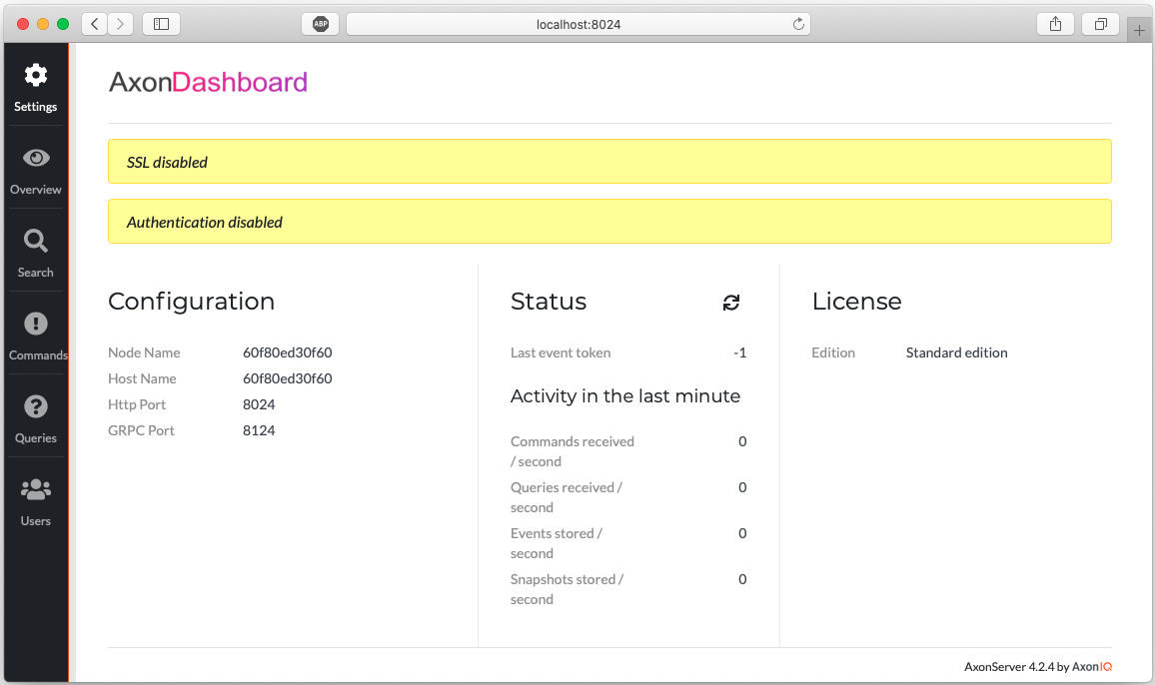

*Axon Server UI*

If you click on the **Overview** section:

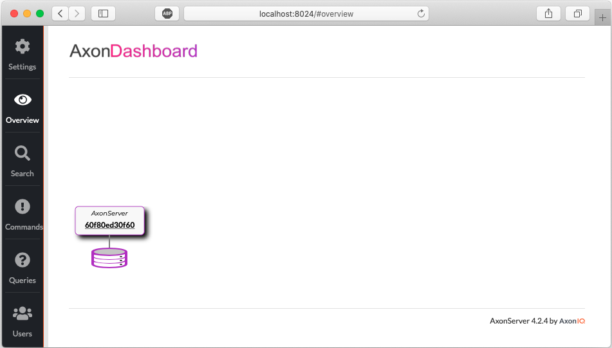

*Axon Server UI – Overview*

Next, check the **Commands** section:

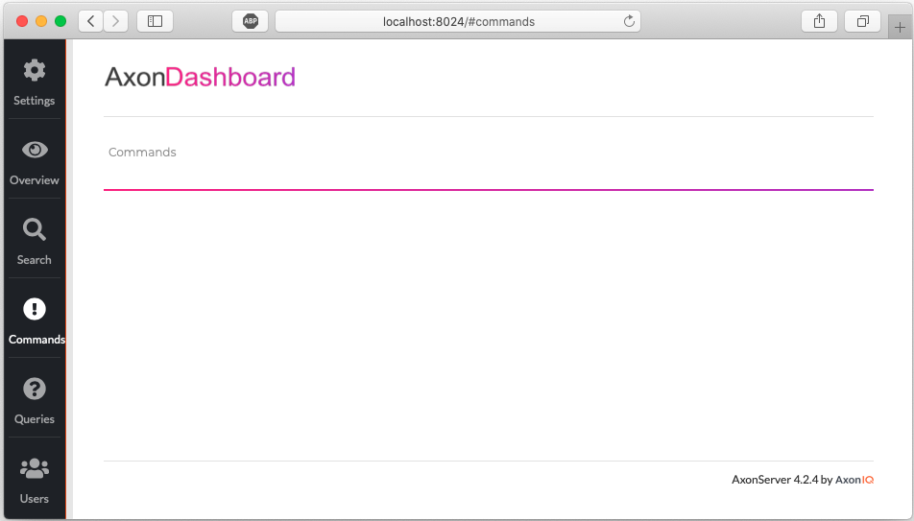

*Axon Server UI – Commands*

Next, check the **Queries** section:

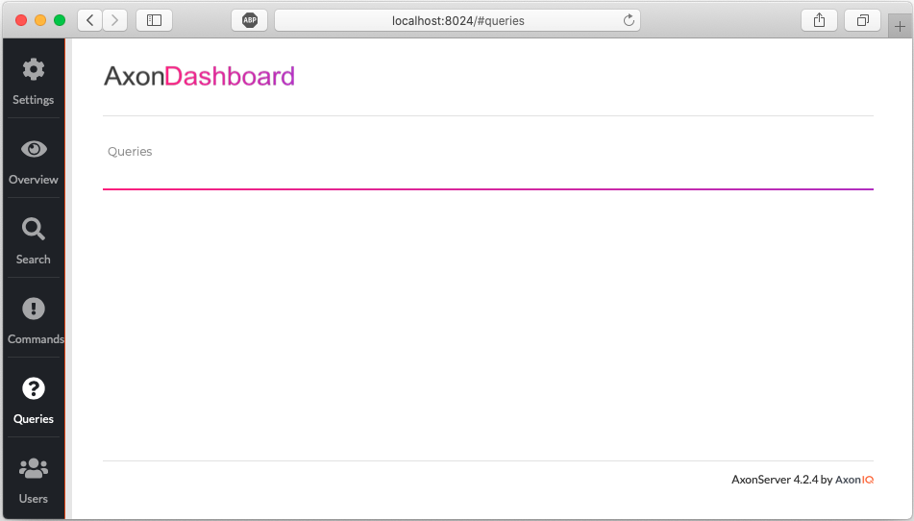

*Axon Server UI – Queries*

Nothing wrong  Don’t be scared, as no application is communicating with the **Axon Server**, everything is empty.

Let’s start now the application again:

1

2

3

4

5

6

7

8

9

10

11

12

13

14

15

16

17

18

19

20

21

22

23

24

25

26

27

28

29

30

$ mvn spring-boot:run

[INFO] Scanning **for** projects...

[INFO]

[INFO] **---------------------**< com.targa.labs.dev:cqrs-es **>---------------------**

[INFO] Building cqrs-es 0.0.1**-**SNAPSHOT

[INFO] **--------------------------------**[ jar ]**---------------------------------**

...

. ____ _ __ _ _

**/**\\ **/** ___'_ __ _ _(_)_ __ __ _ \ \ \ \

( ( )\___ **|** '_ | '_**|** **|** '_ \**/** _` **|** \ \ \ \

\\**/** ___)**|** **|**_)**|** **|** **|** **|** **|** **||** (_**|** **|** ) ) ) )

' **|**____**|** .__**|**_**|** **|**_**|**_**|** **|**_\__, **|** **/** **/** **/** **/**

**=========|**_**|==============|**___**/=/**_**/**_**/**_**/**

:: Spring Boot :: (v2.2.2.RELEASE)

...

..AxonServerConnectionManager : Connecting using unencrypted connection...

..AxonServerConnectionManager : Requesting connection details **from** localhost:8124

..AxonServerConnectionManager : Reusing existing channel

..AxonServerConnectionManager : Re-subscribing commands and queries

..AxonServerCommandBus : Creating new command stream subscriber

..AxonServerQueryBus : Creating new query stream subscriber

..DocumentationPluginsBootstrapper : Context refreshed

..DocumentationPluginsBootstrapper : Found 1 custom documentation plugin(s)

..ApiListingReferenceScanner : Scanning **for** api listing references

..TrackingEventProcessor : Worker assigned to segment Segment[0**/**0] **for** processing

..TrackingEventProcessor : Using current Thread **for** last segment worker: TrackingSegmentWorker{processor**=**com.targa.labs.dev.cqrses.projection, segment**=**Segment[0**/**0]}

..TrackingEventProcessor : Fetched token: null **for** segment: Segment[0**/**0]

..AxonServerEventStore : open stream: 0

..TomcatWebServer : Tomcat started on port(s): 8080 (http) with context path ''

..CqrsEsApplication : Started CqrsEsApplication **in** 5.262 seconds (JVM running **for** 5.532)

Cool ! Let’s access now the **Swagger UI** on <http://localhost:8080/swagger-ui.html>:

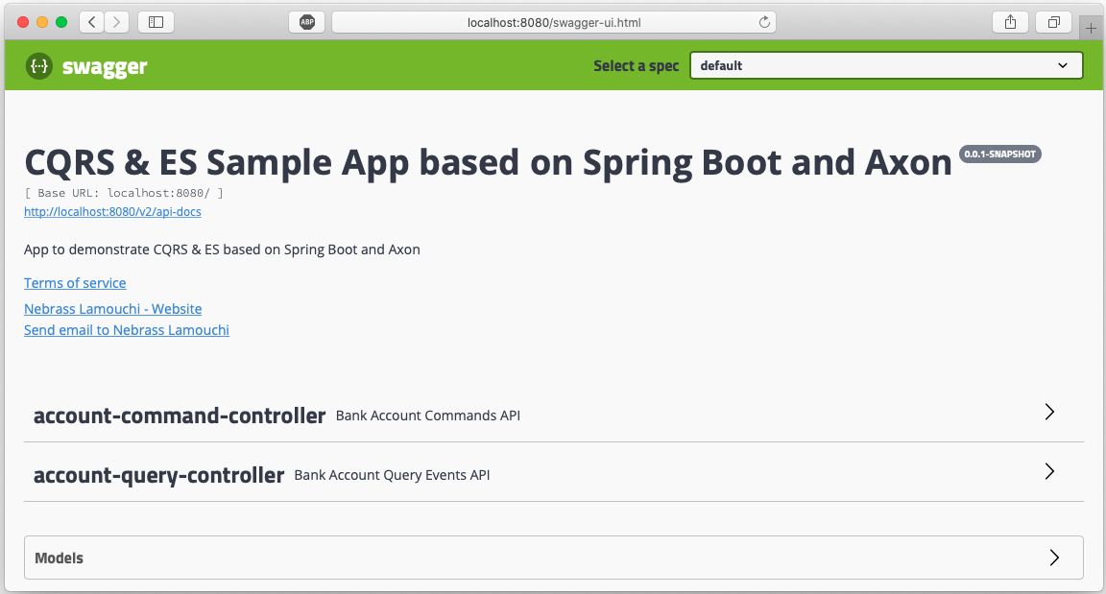

*Swagger UI*

As you see, there is already two **REST Controllers** one for the **Commands** and one for the **Queries**. Let’s test the **createAccount REST API**:

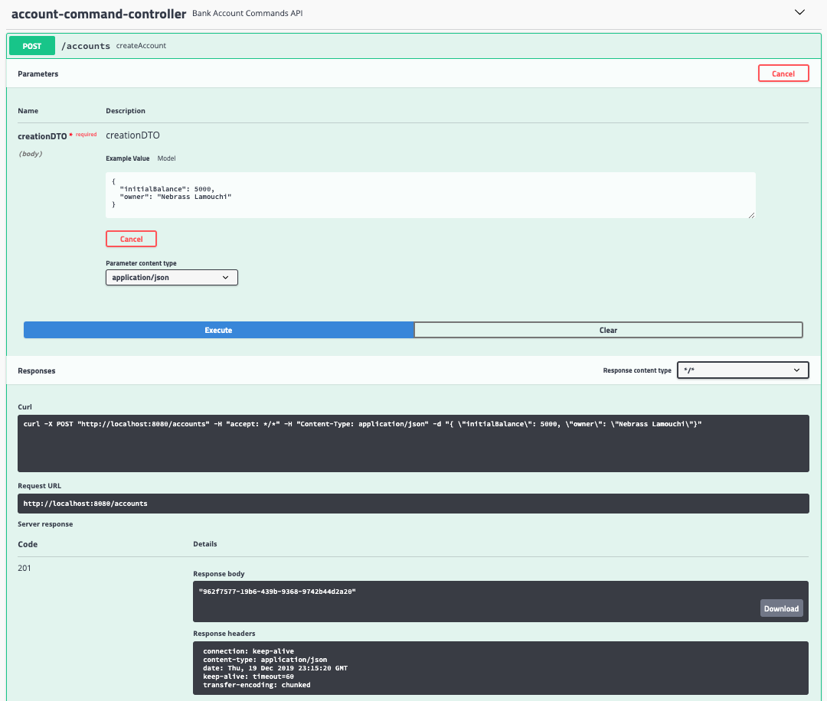

*Create Account – Swagger UI*

Here we created a new **BankAccount** that has:

* **id:** 962f7577-19b6-439b-9368-9742b44d2a20
* **initialBalance:** 5000
* **owner:** Nebrass Lamouchi

Next, I will test some **creditMoneyToAccount** operation **twice** the first with an amount of **300** and the second with **480**:

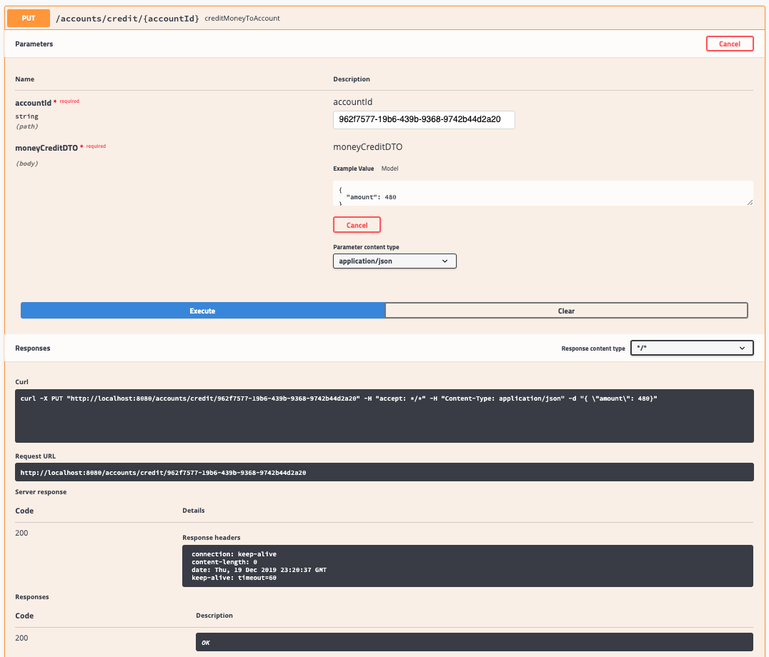

*Credit Account – Swagger UI*

Let’s **debit** the amount of **2000** from the sample account using the **debitMoneyFromAccount** operation:

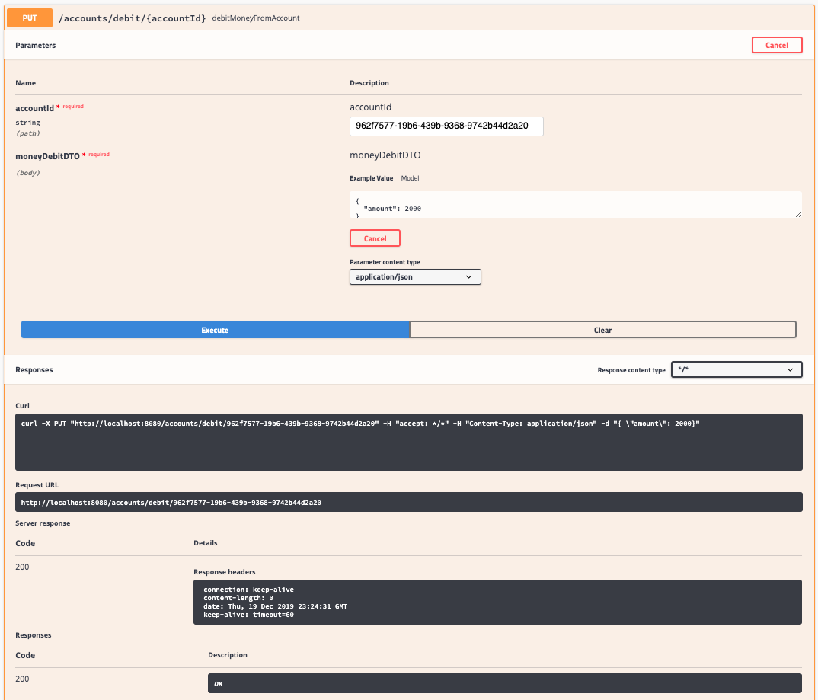

*Debit Account – Swagger UI*

Now, we need to check how much we have in our account, normally the remaining balance will be **5000 + 300 + 480-2000 = 3780**.

Let’s check the account using the **findById** operation on the **AccountQueryController**:

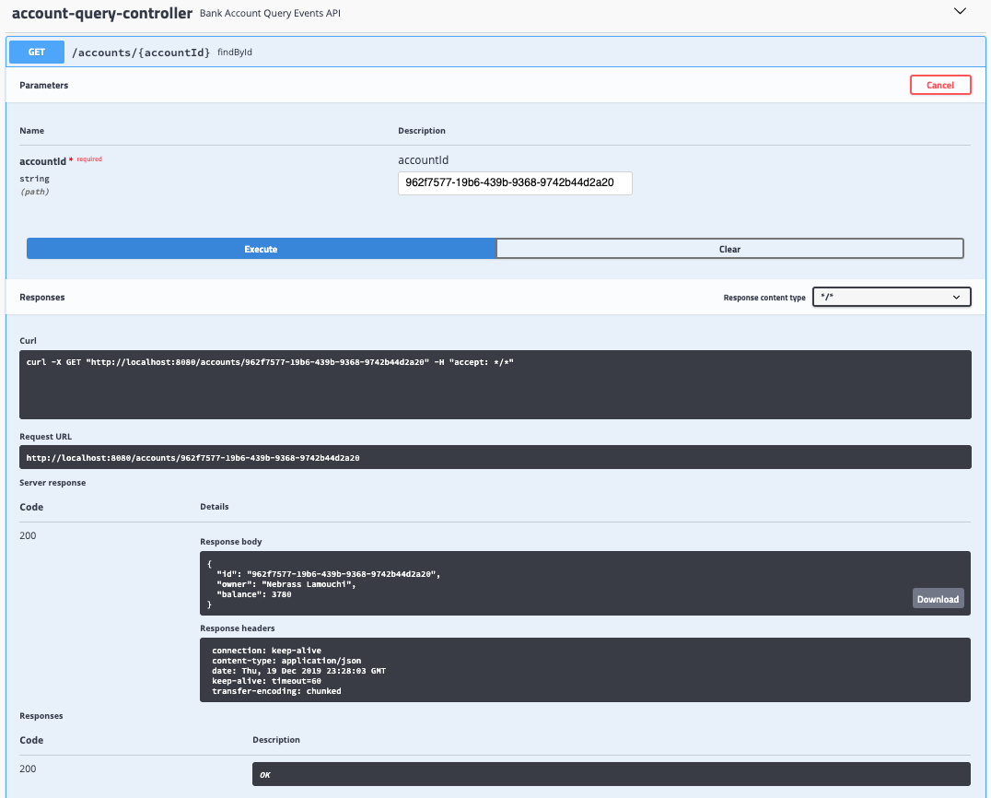

*Find Account by ID – Swagger UI*

As expected ! **the balance is 3780**

We can verify the Events list occurred on our **BankAccount**using the **listEventsForAccount** operation:

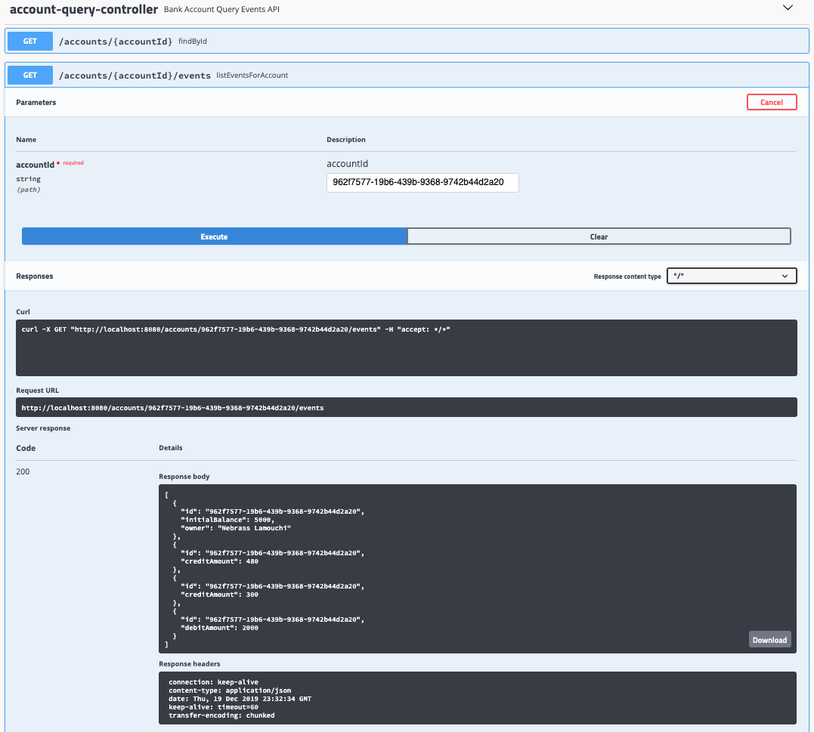

*Account Events list – Swagger UI*

Great ! Everything is working like a charm !

After we executed our application and after we did some operations, let’s visit again the **Axon Server UI**:

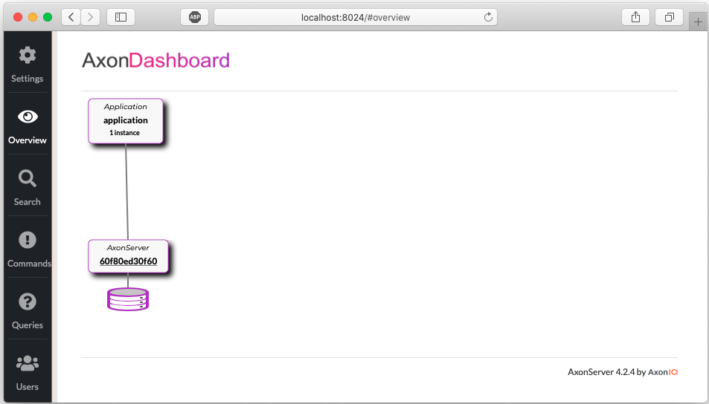

*Axon Server UI – Overview after execution*

As you see, our application instance is spotted on the **Axon Dashboard**. Let’s move to the **Commands** section:

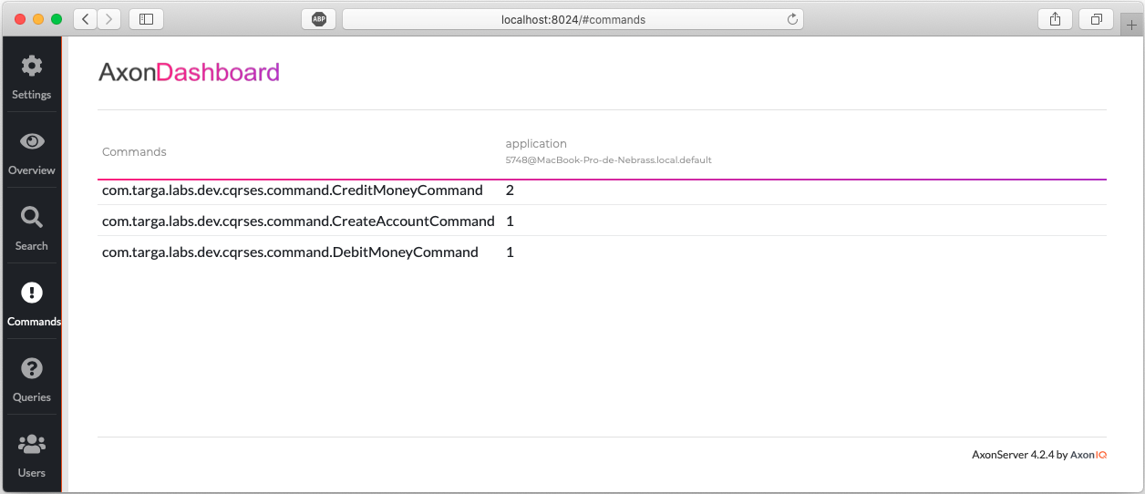

*Axon Server UI – Commands after execution*

You already see that the **CreateAccountCommand** was fired once, the **CreditMoneyCommand** twice (300 & 480) and the **DebitMoneyCommand** once (2000).

Next, move to the **Queries** section:

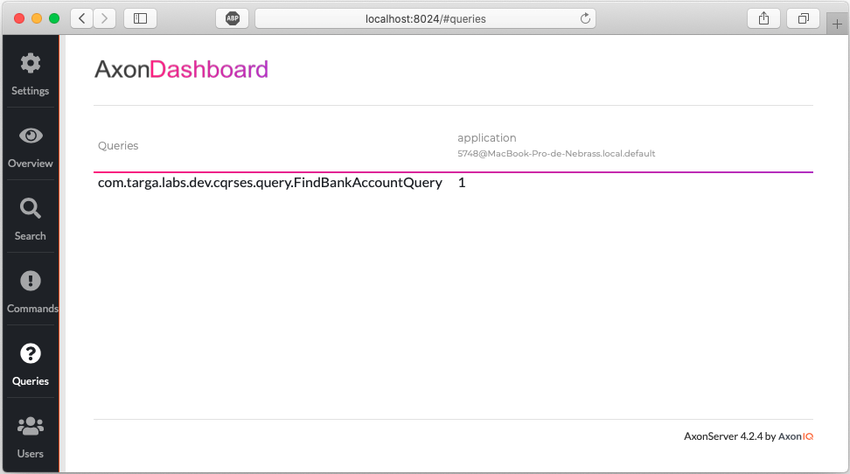

*Axon Server UI – Queries after execution*

You can easily see that the **FindBankAccountQuery** was executed once.

You can see all of the **Events** in the **Search** section. Click directly on **Search button** to **grab all the Events**:

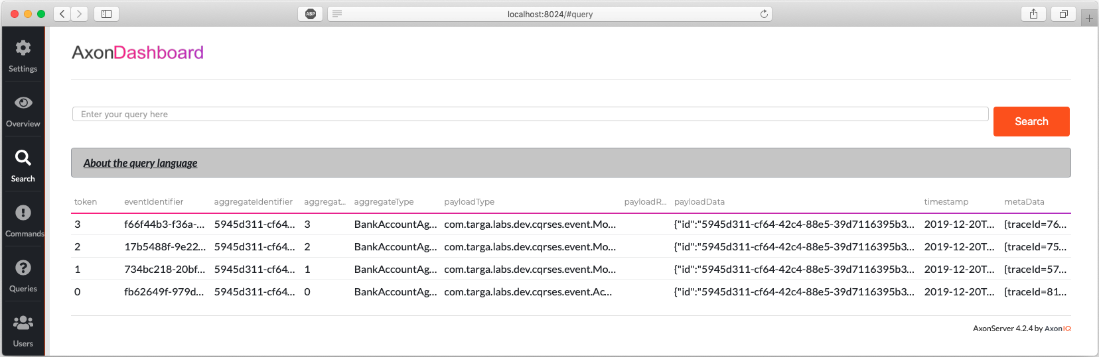

*Axon Server UI – Search section*

If you want to test our **Axon** code **programmatically**, we will start by adding the **Axon Test module** to the pom.xml:



1

2

3

4

5

6

<dependency>

<groupId>org.axonframework</groupId>

<artifactId>axon-test</artifactId>

<version>4.2</version>

<scope>test</scope>

</dependency>

Next, we will create a **BankAccountTest** class:



1

2

3

4

5

6

7

8

9

10

11

12

13

14

15

16

17

18

19

20

21

22

23

24

25

26

27

28

29

30

31

32

33

34

35

36

37

38

39

40

41

42

43

44

45

46

47

48

49

50

51

52

53

54

55

56

57

58

59

60

61

62

63

64

65

66

67

68

69

**public** **class** BankAccountTest {

**private** **static** **final** String customerName **=** "Nebrass";

**private** FixtureConfiguration**<**BankAccountAggregate**>** fixture;

**private** UUID id;

@BeforeEach

**public** **void** setUp() {

fixture **=** **new** AggregateTestFixture**<>**(BankAccountAggregate.**class**);

id **=** UUID.randomUUID();

}

@Test

**public** **void** should_dispatch_accountcreated_event_when_createaccount_command() {

fixture.givenNoPriorActivity()

.when(**new** CreateAccountCommand(

id,

BigDecimal.valueOf(1000),

customerName)

)

.expectEvents(**new** AccountCreatedEvent(

id,

BigDecimal.valueOf(1000),

customerName)

);

}

@Test

**public** **void** should_dispatch_moneycredited_event_when_balance_is_lower_than_debit_amount() {

fixture.given(**new** AccountCreatedEvent(

id,

BigDecimal.valueOf(1000),

customerName))

.when(**new** CreditMoneyCommand(

id,

BigDecimal.valueOf(100))

)

.expectEvents(**new** MoneyCreditedEvent(

id,

BigDecimal.valueOf(100))

);

}

@Test

**public** **void** should_dispatch_moneydebited_event_when_balance_is_upper_than_debit_amount() {

fixture.given(**new** AccountCreatedEvent(

id,

BigDecimal.valueOf(1000),

customerName))

.when(**new** DebitMoneyCommand(

id,

BigDecimal.valueOf(100)))

.expectEvents(**new** MoneyDebitedEvent(

id,

BigDecimal.valueOf(100)));

}

@Test

**public** **void** should_not_dispatch_event_when_balance_is_lower_than_debit_amount() {

fixture.given(**new** AccountCreatedEvent(

id,

BigDecimal.valueOf(1000),

customerName))

.when(**new** DebitMoneyCommand(

id,

BigDecimal.valueOf(5000)))

.expectNoEvents();

}

}

In our **BankAccountTest** class, we are using **FixtureConfiguration** class which we will use to define a test scenario in terms of events and commands:

* Given certain events in the past
* When executing this command
* Expect these events to be published

Our test are designed like:

* In the first test, we are testing an **Account Creation operation**:
  + we are supposing that we don’t have any account created
  + when we will dispatch a **CreateAccountCommand**
  + we are expecting to get the a **AccountCreatedEvent** with the same values
* In the second test, we are testing the **Credit Money operation**:
  + we are supposing that we have an account
  + when we will dispatch a **CreditMoneyCommand** with an amount of 100
  + we are expecting to get the a **MoneyCreditedEvent** with an amount of 100
* In the third test, we are testing the **Debit Money operation**:
  + we are supposing that we have an account
  + when we will dispatch a **DebitMoneyCommand** with an amount of 100
  + we are expecting to get the a **MoneyDebitedEvent** with an amount of 100
* In the third test, we are testing the impossibility to execute **Debit Money operation** when **the requested amount is higher than the account balance**:
  + we are supposing that we have an account
  + when we will dispatch a **DebitMoneyCommand** with an amount of 5000
  + we are expecting to have **NO events that occurred**