### x-pack为elasticsearch-kibana设置登录用户和密码

1. 版本

Elasticsearch：7.x

Kibana：7.x

从 ES 6.8 & ES 7.0 开始，Security 纳入 x-pack 的 Basic 版本中，免费使用一些基本的功能

2. 修改Elasticsearch密码

2.1修改配置

修改 elasticsearch.yml ，加上以下配置项：

xpack.security.enabled: true

xpack.license.self_generated.type: basic

xpack.security.transport.ssl.enabled: true

然后重启ES服务

2.2 设置密码

切换到 ${ES_HOME}/bin 目录下，执行命令：./elasticsearch-setup-passwords interactive

先输入 y 确认修改密码， 然后根据提示输入每个账号的密码即可

[es@localhost bin]$ ./elasticsearch-setup-passwords interactive

Initiating the setup of passwords for reserved users elastic,apm_system,kibana,kibana_system,logstash_system,beats_system,remote_monitoring_user.

You will be prompted to enter passwords as the process progresses.

Please confirm that you would like to continue [y/N]y

Enter password for [elastic]:

Reenter password for [elastic]:

Enter password for [apm_system]:

Reenter password for [apm_system]:

Enter password for [kibana_system]:

Reenter password for [kibana_system]:

Enter password for [logstash_system]:

Reenter password for [logstash_system]:

Enter password for [beats_system]:

Reenter password for [beats_system]:

Enter password for [remote_monitoring_user]:

Reenter password for [remote_monitoring_user]:

Changed password for user [apm_system]

Changed password for user [kibana_system]

Changed password for user [kibana]

Changed password for user [logstash_system]

Changed password for user [beats_system]

Changed password for user [remote_monitoring_user]

Changed password for user [elastic]

2.3 修改指定账号的密码

例如：把 elastic 密码改成 123456

curl -H "Content-Type:application/json" -XPOST -u elastic 'http://192.168.25.131:9200/_xpack/security/user/elastic/_password' -d '{ "password" : "123456" }'

执行之后，输入一遍原始密码，即可以成功修改成新的密码了。

3. 修改Kibana配置

找到 kibana.yml，修改以下配置项：

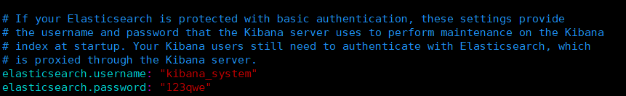

最后重启 kibana 即可。