*陳志偉 B06901126電機五*

**Electrical Engineering Lab（topics on Communication System）**

**Lab1 Report**

1. a)

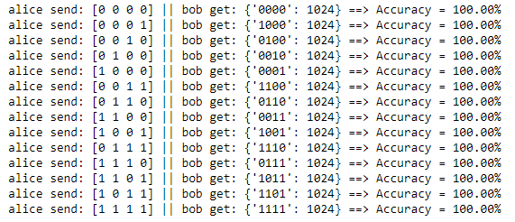

1. a)

i) ∣ψ ⟩B:

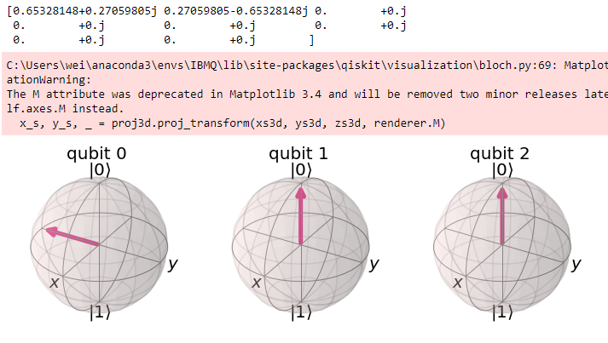



∣ψ ′ ⟩­B:

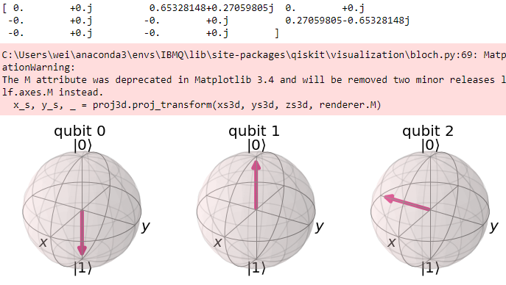



ii)