*陳志偉 B06901126電機五*

**Electrical Engineering Lab（topics on Communication System）**

**Lab3 Report**

1 a) By measuring the corresponding output, we observe that the first bit of circuit 1 is all 0 and the first bit of circuit 2 is all 1. So, quantum oracles 1 and 2 are constant functions. But the first bit of circuit 3 has two results, 1 and 0 which is a balanced function.

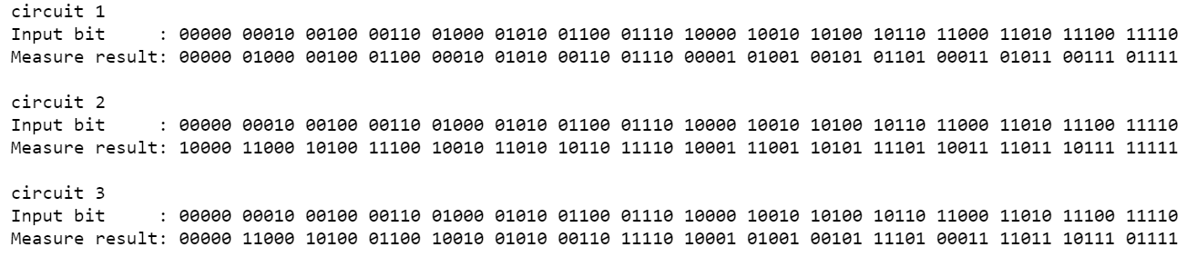

Figure 1a

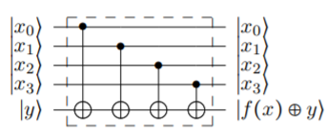

Quantum oracle 3

1 b)

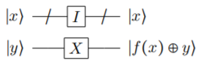

Quantum oracle 2

Figure 2b

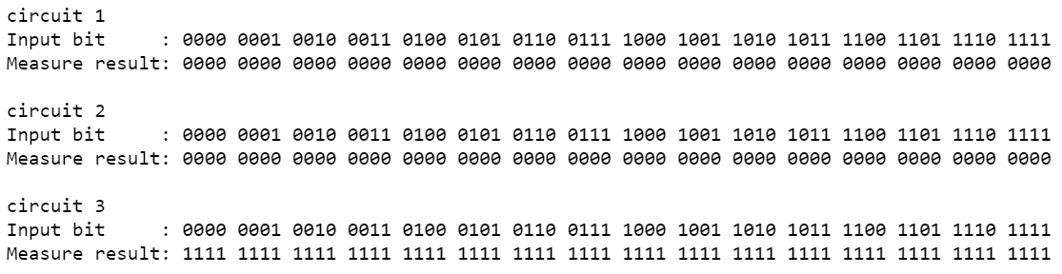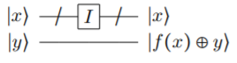

Quantum oracle 1

By the result showing as *Figure 1a*, we confirm the following conclusions.

Quantum oracles 1 and 2 are constant functions, quantum oracle 3 is a balanced function.