*陳志偉 B06901126電機五*

**Electrical Engineering Lab（topics on Communication System）**

**Lab6 Report**

1. The figure showed the implement of 3 type of modulation, and the figure 2 showed the corresponding output.

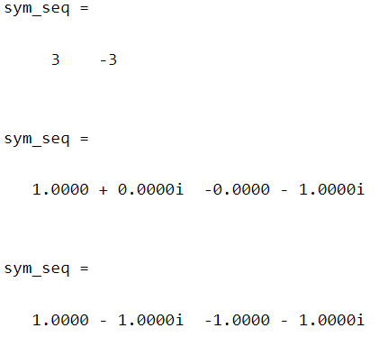

Figure 2: The output of the sample calling of figure1

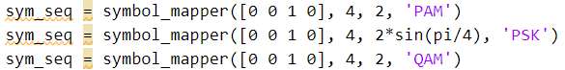

Figure 1: Calling the implement function of problem 1

1. a)

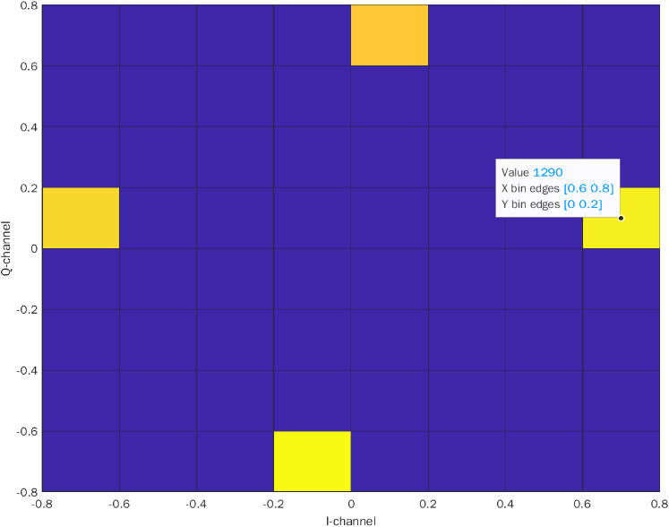

Figure 3: The histogram of QPSK

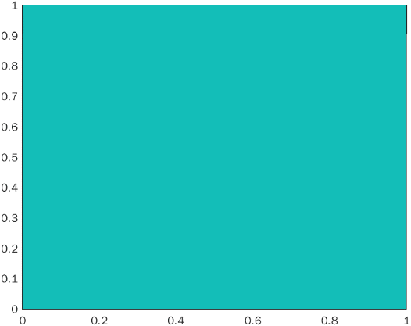

Figure 3 a): Eb/N0 = 0 dB

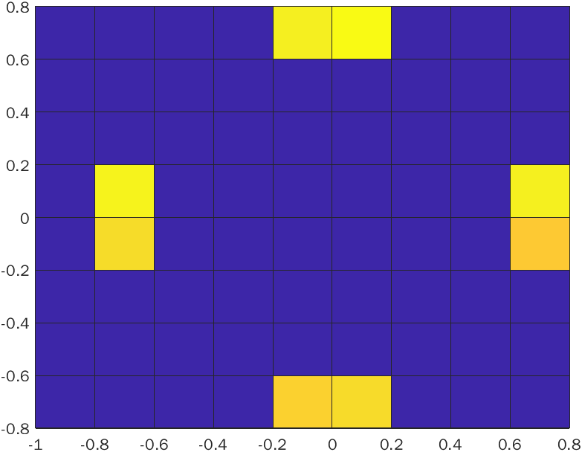

Figure 3 b): Eb/N0 = 10 dB

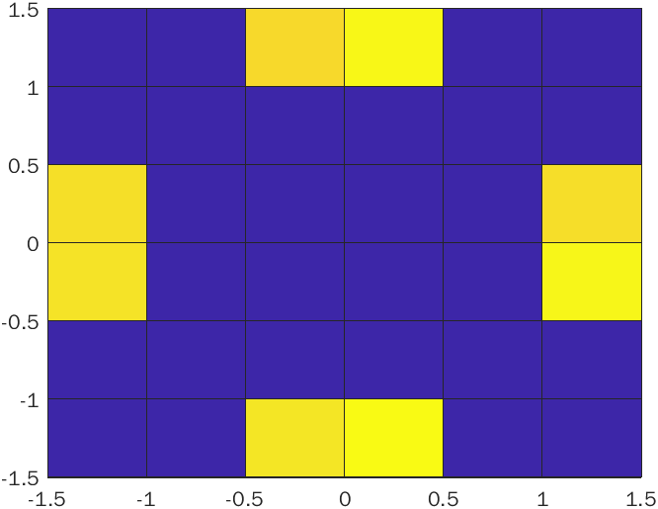

Figure 3 a): Eb/N0 = 20 dB

b) From the Figure 4 the Eb/N0 = 0 dB have almost 2% of SER and the rest of other 2 have 0% SER.

Figure 4: The SER from the received symbol sequence in problem 2a

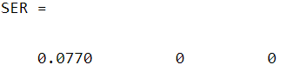

1. a)

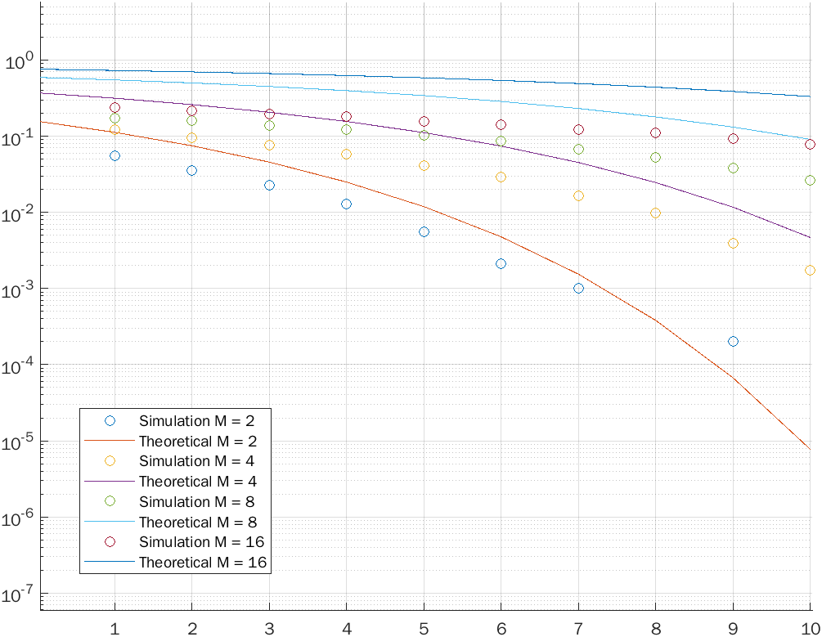

Figure 5: The simulation of PAM

b)

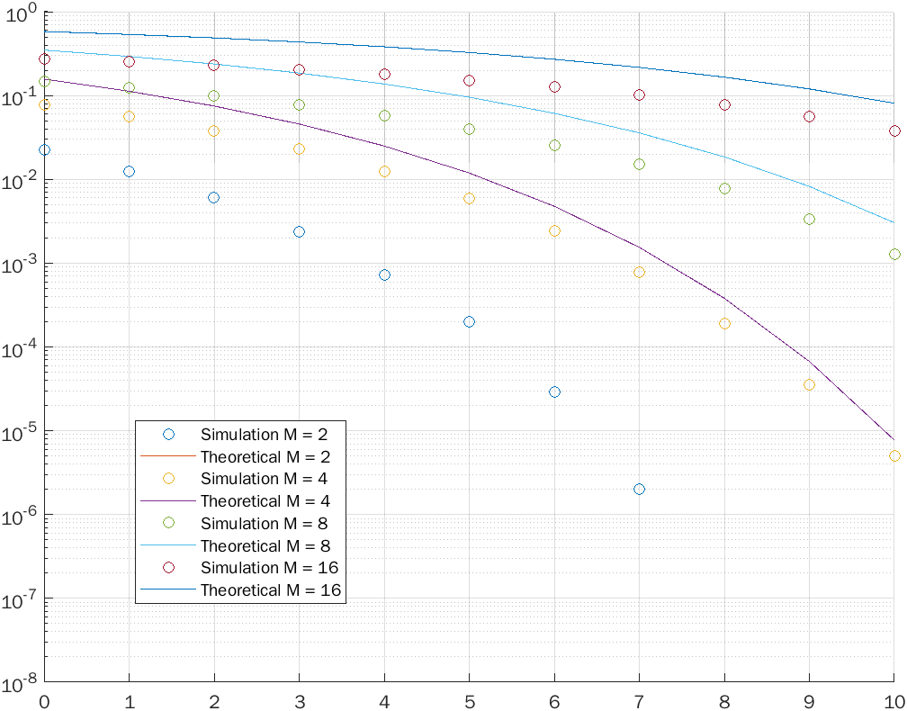

Figure 6: The simulation result of PSK

c)

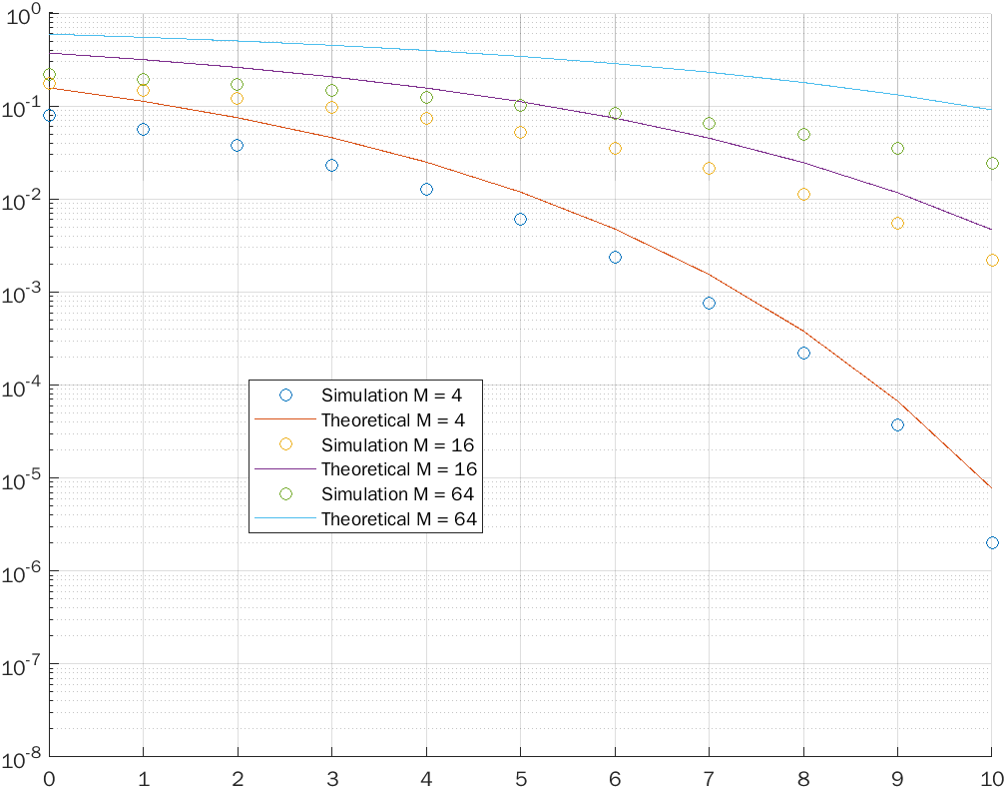

Figure 7: The simulation result of QAM

d) From the result of 3a) to 3c), the larger of Eb/No the smaller of SER. The simulation results are not as expected as the result of theoretical, but the gradient of 2 results is similarly.

***Appendix***

**Code**

1. close all; clear; clc;
2. % sym_seq = symbol_mapper([0 0 0 1 1 1 10], 4, 2, 'PAM')
3. % sym_seq = symbol_mapper([0 0 1 0], 4, 2*sin(pi/4), 'PSK')
4. % sym_seq = symbol_mapper([0 0 1 0], 4, 2, 'QAM')
5. % M = 4;
6. % d = 1;
7. % x = randi([0 1],10^4,1);
8. % sym_qpsk = symbol_mapper(x, M, d, 'PSK');
9. %histogram2(real(sym_qpsk), imag(sym_qpsk), 'DisplayStyle','tile','ShowEmptyBins','on')
10. %xlabel('I-channel')
11. %ylabel('Q-channel')
12. % e_n = [0, 10, 20];
13. % SER = [];
14. %
15. % for i = 1:length(e_n)
16. % N_o = 1/((10^(e_n(i)/10))*4*log2(M)*(sin(pi/M)^2));
17. % sym_wgn = sym_qpsk;
18. % wgn_real = 0+sqrt(N_o/2)*randn(length(sym_qpsk),1);
19. % wgn_imag = 0+sqrt(N_o/2)*randn(length(sym_qpsk),1);
20. % for j = 1:length(sym_qpsk)
21. % sym_wgn(j) = sym_wgn(j) + complex(wgn_real(j), wgn_imag(j));
22. % end
23. %
24. % bin_seq = MD_symbol_demapper(sym_wgn, M, d, 'PSK');
25. % error = 0;
26. % for k = 1:length(bin_seq)
27. % if bin_seq(k) ~= num2str(x(k))
28. % error = error+1;
29. % end
30. % end
31. % SER = [SER, error/length(bin_seq)];
32. % end
33. %
34. % display(SER)
35. name = 'QAM';
36. d = 2;
37. max_db = 10;
38. legendmat = {};
39. f = figure();
40. hold on
41. for i = 1:3
42. M = 4^i;
43. x = randi([0 1],i*10^6,1);
44. sym_qpsk = symbol_mapper(x, M, d, name);
45. SER = [];
46. theoretical = [];
47. for j = 0:max_db
48. % N_o = (d^2 * (M^2-1))/ (10^(j/10) * 12 * log2(M)); % PAM
49. % N_o = d^2/((10^(j/10))*4*log2(M)*(sin(pi/M))^2); % PSK
50. N_o = (d^2)*(M-1)/( (10^(j/10)) * 6 * log2(M)); % QAM
51. sym_wgn = sym_qpsk;
52. wgn_real = sqrt(N_o/2)*randn(length(sym_qpsk),1);
53. wgn_imag = sqrt(N_o/2)*randn(length(sym_qpsk),1);
54. for k = 1:length(sym_qpsk)
55. sym_wgn(k) = sym_wgn(k) + complex(wgn_real(k), wgn_imag(k));
56. end
57. bin_seq = MD_symbol_demapper(sym_wgn, M, d, name);
58. bin_seq = str2num(reshape(bin_seq, [length(bin_seq), 1]));
59. [num, ratio] = symerr(bin_seq, x);
60. SER = [SER, ratio];
61. % theo = sqrt((6*log2(M))*(10^(j/10))/(M^2 -1)); % PAM
62. % theo = sqrt(2*log2(M)*(sin(pi/M))^2 * (10^(j/10))); % PSK
63. theo = sqrt(3*log2(M)* (10^(j/10)) / (M - 1));
64. theoretical = [theoretical, 2*qfunc(theo)];
65. end
66. display(SER);
67. semilogy(0:max_db, SER, 'o');
68. semilogy(0:max_db, theoretical);
69. ylim([1E-8 1])
70. l = sprintf('M = %d', M);
71. set(gca, 'YScale', 'log');
72. grid on
73. end
74. legend({'Simulation M = 4', 'Theoretical M = 4', 'Simulation M = 16', 'Theoretical M = 16', 'Simulation M = 64', 'Theoretical M = 64', 'Simulation M = 16', 'Theoretical M = 16'});
75. function bin_seq = MD_symbol_demapper(sym_seq, M, d, name)
76. if mod(log2(M), 1) ~= 0
77. error 'Input M must be the power of 2'
78. else
79. bits_len = log2(M);
80. end
81. gray_code = dec2bin(0, bits_len);
82. gray_code = generateGrayCode(gray_code, bits_len);
83. gray_code = cellstr(reshape(gray_code, bits_len, [])');
84. sym = generateSYM(M, d, name);
85. bin_seq = [];
86. for i = 1:length(sym_seq)
87. eucli_dist = 10^3;
88. hold_sym = gray_code{1};
89. for j = 1:length(sym)
90. dist = norm(sym(j) - sym_seq(i))^2;
91. if dist < eucli_dist
92. eucli_dist = dist;
93. hold_sym = gray_code{j};
94. end
95. end
96. bin_seq = [bin_seq, hold_sym];
97. end
98. end
99. function sym_seq = symbol_mapper(bin_seq, M, d, name)
100. if mod(log2(M), 1) ~= 0
101. error 'Input M must be the power of 2'
102. else
103. bits_len = log2(M);
104. end
105. if ~isa(bin_seq, 'char')
106. bin_seq = sprintf('%d', bin_seq);
107. end
108. gray_code = dec2bin(0, bits_len);
109. gray_code = generateGrayCode(gray_code, bits_len);
110. gray_code = cellstr(reshape(gray_code, bits_len, [])');
111. sym = generateSYM(M, d, name);
112. sym_seq = [];
113. while mod(length(bin_seq), bits_len) ~= 0
114. bin_seq = [bin_seq, '0'];
115. end
116. bin_seq = cellstr(reshape(bin_seq, bits_len, [])');
117. for i = 1:length(bin_seq)
118. for j = 1:length(gray_code)
119. if strcmp(gray_code{j}, bin_seq{i})
120. sym_seq = [sym_seq, sym(j)];
121. end
122. end
123. end
124. end
125. function sym = generateSYM(M, d, name)
126. sym = [];
127. if name == "PAM"
128. for m = 1:M
129. sym = [sym, (d/2)*M+d/2-d*m];
130. end
131. elseif name == "PSK"
132. d = d/(2*sin(pi/(M)));
133. for m = 1:M
134. s = complex(d*cos(2*pi*(m-1)/M), d*sin(2*pi*(m-1)/M));
135. sym = [sym, s];
136. end
137. elseif name == "QAM"
138. row = floor(sqrt(M));
139. col = M/row;
140. for j = 1:col
141. ax = ((d/2)*col + d/2 - d*j);
142. for i = 1:row
143. ay = (d*i+1-d*row)*((-1)^(j+1));
144. s = complex(ax, ay);
145. sym = [sym, s];
146. end
147. end
148. end
149. end
150. function gray_code = generateGrayCode(start_bin, bits_len)
151. for i = 1:2^bits_len-1
152. pre_code = start_bin(end-(bits_len-1):end);
153. if rem(i,2) == 0
154. for j=length(pre_code):-1:1
155. if pre_code(j) == '1'
156. if pre_code(j-1) == '0'
157. pre_code(j-1) = '1';
158. break
159. else
160. pre_code(j-1) = '0';
161. break
162. end
163. end
164. end
165. elseif rem(i,2) ~= 0
166. if pre_code(end) == '0'
167. pre_code(end) = '1';
168. else
169. pre_code(end) = '0';
170. end
171. end
172. start_bin = [start_bin, pre_code];
173. end
174. gray_code = start_bin;
175. end