# Proposal: Design a CTA button for high CTR in landing webpage

Dawei LIU

## Abstract

1. (What is the objective of the project?)

We present a method, which automatically assist users to add a call-to-action (CTA) button to the web page for higher click through rate (CTR). It mainly helps a non-trained user to design a CTA button in a landing page (see Fig.1).

1. (Give a summary of the proposed model or algorithms, including its input, output, main components, and important procedure.)

To do this, we collect kinds of well-designed web pages whose contents are labeled manually as input. And we use our feature descriptor to build the dataset. Then we develop a model to learn the training data and predict the clickable button’s position and size as output. Finally, we evaluate our method by user study as well as calculating discrepancy from web pages that are originally designed.

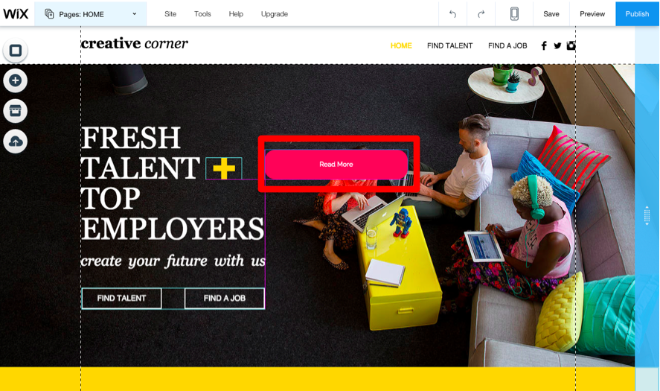 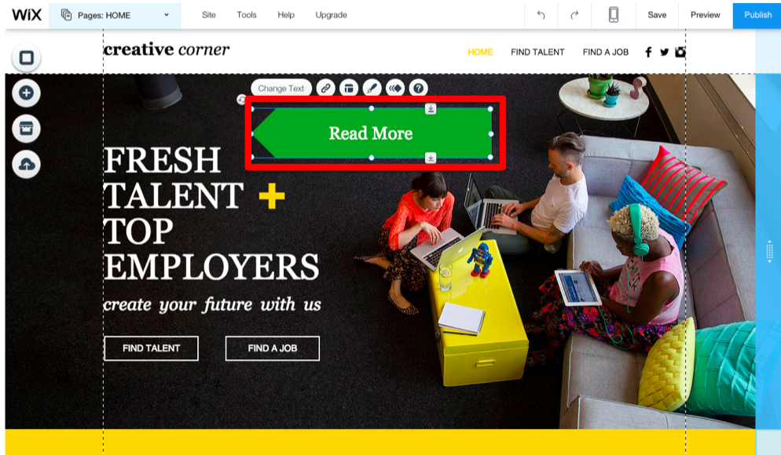

*Fig 1. Using online web page design tool--WIX, users can add a CTA button by drag and put operations (red bounding box on the left). And user can change the attribute, e.g., color, shape (red bounding box on the right, the color becomes green and the shape becomes left-oriented arrow).*

## Introduction

1. (What is broad context of the project?)

Click-through rate (CTR) refers to the percentage of visitors clicking on a button, link or image that can redirect visitor to other pages. CTR has been a common and important measurement of the user experience, especially for landing web page, which usually contains single objective of conversion (Fig 2). CTR can tell you the success of your business. And CTR will affect the life-circle of your landing web page. ***To improve CTR means more visitors, more clients and even more money.***

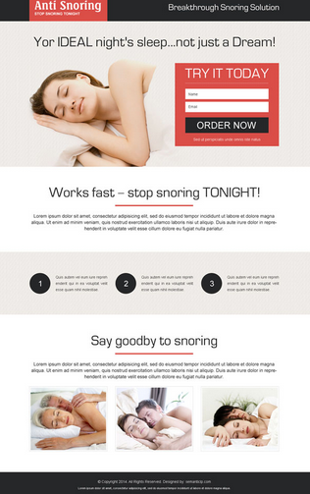 

*Fig.2. Examples about landing web page: The left web page has single objective for visitor –leading user to make orders. The right one’s is for attracting visitor to join their group. The common feature of a landing page is about converting site visitors into sales or leads, meanwhile there is no other navigation button or hyper links inside the webpage that will confuse the conversion.*

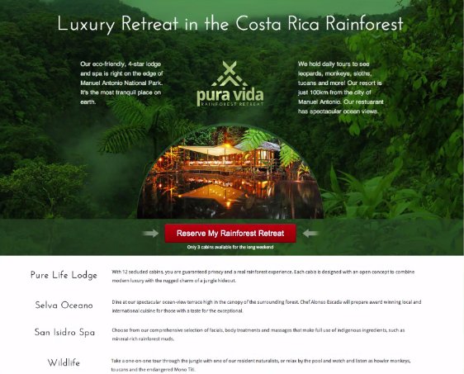 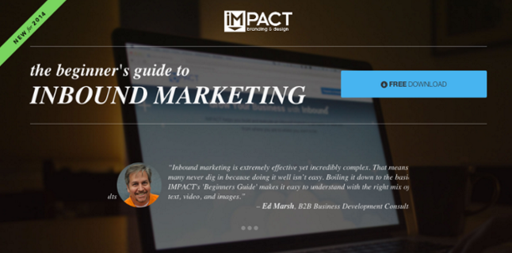

*Fig.3. Examples about CTA button: On the left one, the red rectangle button is the only user control for site visitors to take action. The right one is landing page to lead visitors to download the resources.*

1. (How to improve CTR?)

To improve CTR, besides replacing better content to the landing webpage, designing a good call-to-action (CTA) button for the web page is of great contributions. We can see in a landing web page (like Fig.2.), a CTA button is the only way as user control to access another page. Having strong but relevant CTA button on the website will help you grab the attention of visitors, increasing user interaction while achieving goals like: email subscriptions, sales, sign-ups, and so much more.

1. (Why the design of CTA button in landing page is important)

Because the purpose for landing page is only for leading visitors, the design of the page should be clear and simple. Also, following the rule of “timing is every thing”, designers will match the content to the CTA button straightforwardly, e.g., match “Order now!” to the button, and visitors will always contact this CTA button before his decision. Any subtle changes in CTA button will affect the CTR greatly (see Fig.3). Hence, the design of the CTA button is very sensitive.

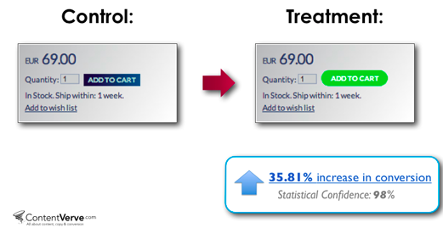

*Fig.3. Examples of the effect of different design of the CTA button: if we use the right design, comparing to the left one, there are 35.81% increase in CTR.*



*Fig.4. The CTR is very sensitive to the CTA button design. Just adjust a little bit size appropriately will get CTR increased.*

1. (How difficult to design a CTA button for a man to increase CTR?)

To design a good CTA button already with text content, there are 4 main considerations: color, placement, size and the immediate surrounding of the button. Also, it is all about making the button standing out from the rest of the content in the page. ***Let the CTA button be the king of the landing page***. A good designer always has knowledge to, pay attention carefully to change the button’s attribute slightly, to make an increasingly better CTR (see Fig.3, Fig.4). Actually, to pay attention with these 4 main aspects in the design process is not the hard work, the most difficult part is to learn the global information of the web page, considering other elements of the web page, and then combine the successful experience or examples, to design carefully, ***to make the CTA button standing out, to establish the visual hierarchy of the page.***

***However, there can be sometimes other candidate versions of CTA button design would like to contest the appearance chance. It introduces another issue of design selection or design contest.***

1. (Existing methods to choose the “best” design among the candidates.)
2. A/B testing

A/B testing is intuitive, deploying the version A and version B of potential web pages on the Internet, using life traffic to test them. And site visitors are bucketed into one version or the other (see Fig.5). ***However, when the number of variable of the design increases, the A/B testing will not perform well in revealing the interaction of the variables.***

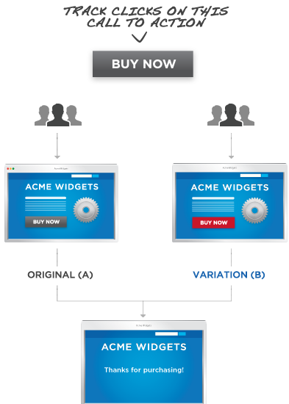 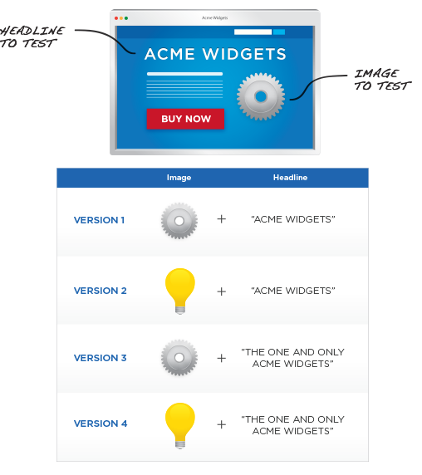

*Fig.5. A/B testing on the left, and multivariate testing on the right*

1. Multivariate testing

Multivariate testing produces different versions from combinations of different variables in design (see fig.5). It is a powerful way to help designer to find out which variable will impact most significantly to the web page. E.g., if there are 3 variables of the design: headline, button and image, and designers propose many combinations of them with different design, then these vary designs will equally show to the site visitors by chance. ***The limitation of multivariate testing is the amount of visitor traffic, especially when the number of combinations is large.***

1. Epsilon-greedy

This method improves the A/B testing or multivariate testing, by changing the equally random pick of version A and version B, to that with high probability, each time it picks the design with highest expectation value. ***This method still needs time and visitors as testers for the design selection.***

1. (What is the specific problem of our work? And what are advantages of it? )

Since a CTA button design is important to CTR, and designing a good CTA button require: proficient design techniques, a long time period and heavy visitor traffic for testing and selection, it will be of great contributions if we can replace with a automated method to help non-trained to set their CTA button. ***Automatically design a CTA button will greatly reduce a non-trained man’s manual efforts: design knowledge, design or redesign time period and heavy visitor traffic.***

1. (What is the problem not properly addressed by previous methods?)

Many methods in the literature are indirectly related to our problem that considers the relations between web design and usability. There are currently existing methods help users with shape placement, e.g., [Paul Guerrero et al.2015; K Xu et al.2002]. Moreover, [Paul Merrell et al. 2011; LF Yu et al.‎2011] provide different methods for furniture arrangement. And [Y Cao et al.‎2012] develop a system to complete manga layout automatically. These methods are relative to our issue to some extends but not exactly, directly identical, ***because of lack consideration of web page design principles***.

1. (What are assumptions of the our work?)
2. We assume that designing a good CTA button for a landing web page uses some high-level principles. And these principles can be learned in the landing pages that own good CTR.
3. We also assume that the order of designing CTA button and other elements of a landing page is not decisive to the design. We suppose other elements are fixed and after adding the CTA button, those fixed elements will still stay unchanged. Intuitively, a CTA button, under our assumption, becomes a “slave”, having no power to alter the other elements. And those elements are playing rule of “master” and staying fixed, though it is opposite in the read situation.
4. (What are the constraints to our CTA button design problem?)
5. ***(Placement)*** Firstly, a button is not coming alone in common, and it is always associated with other surrounding elements, e.g. a “buy it” button is usually near the product image.
6. ***(Message)*** Secondly, the message of the CTA button will affect whether it is standing out enough to attract visitor for the leads or sales. We consider the message’s size and its color.
7. ***(Color)***Thirdly, a CTA button’s color can be affect by the button’s message color, the button’s local information or the web page global information.
8. ***(CTA button’s immediate surrounding)*** The button design will be affect by its immediate surrounding design. Here we consider the border (see fig.6). And we leave the around icon, shadow and round corners of the button to the future work.

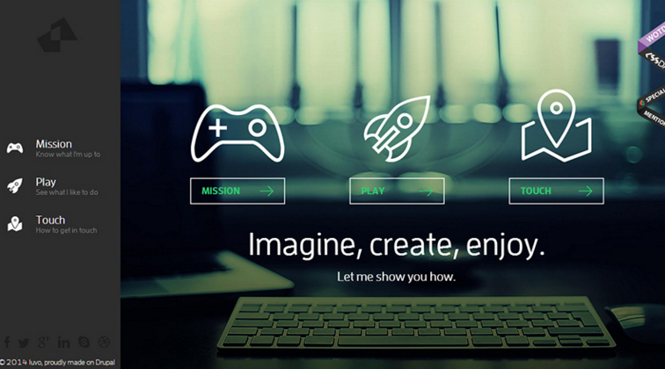

*Fig.6. A Button with transparent color and the white border*

1. ***(Other CTA button’s reference)*** See Fig.6, if the “play” button (the middle) is the target we want to design, the left button and the right button will affect our design, to let the button have the same style to be standing out equally.
2. ***(Priorities of elements)*** A CTA button can be affected by more than one elements, e.g. Image and the input text, in some cases, a CTA button should follow the input text’s position, while another case, the button can just be put under the image. For each page, what are the priorities of elements can also constrain a CTA button’s design.
3. ***(*Object in Background image)*** Sometimes a CTA button will be placed on a background image, and the object of the image may influence the button’s attributes. For example, a button should not cover a beautiful female model’s face. Here we do not consider such high sematic relationship problem, and we may just put it on to a lower level for this by changing color.
4. ***(Real-time performance)***Another constraint of our method is about running time, as we intend to assist users to design a CTA button with during the ongoing design process, we prefer a real-time service for user to achieve the goal.
5. (What are the challenging factors of our automated design method?)
6. (User’s various input). It respects users’ various design while optimize CTA button design on the web page for higher CTR. The style of existing design of the current user may not exist in the previous time. To jointly combine the user’s input design with good example pages to make a decision for a CTA button design is challenging.
7. (Web page layout recognition). The global layout information is greatly affecting the CTA button’s size and placement, while the structures of good examples of landing pages vary a lot.
8. (Shape placement). Learning the previous examples about how to place a button, especially combining the web page semantics, is a great challenge.
9. (Weights of color filling). It’s another challenge to design a CTA button. As the color of background image, color of immediate surrounding, color of the message content and global color histogram will affect the button’s color and it’s border together. Different parts of color own different weights to influence the button’s design.
10. (CTA button’s Similarity). If existing other CTA buttons in the user input, it is necessary to consider both those existing CTA buttons and the buttons in the learning examples. How to choose features from synthesis factors to design a CTA button becomes another challenge.
11. (Summarize the major contributions made in the project.)

The main contribution of our work is in proposing a method for guiding a user to add a new CTA button to improve the web page CTR during the design process.

## Related work

###### Shape placement

[Paul Guerrero et al.2015] propose a method of shape placement for both 2D and 3D scene, by transforming the relations among elements into shape descriptor and use kernel regression with candidates selected by local maxima of density to rank and filter the candidate placements as output. *We mainly study this method and reshape it to adapt to our problem.*

###### Layout

Previous work on layout recognition of table-formed documents, e.g., [T Watanabe et al.‎1995] suggested a classification tree model for layout recognition of the table-formed documents. Also in other field like manga, auto structure of Comic layout also has been proposed in the literature, e.g., [Y Cao et al. ‎2012], using tree structure to represent comic layout. *We will study these methods for our web page design representation.*

###### Image Composition

[CB Atkins et.al 2008] proposed methods about how to arrange the photos into a specific area given its size by user. These methods are based on a binary tree storing the layout information, *but such methods are too restrict to the arranging principles and not adaptive to our design problem.*

###### Furniture arrangement

Other researchers develop methods for furniture arrangement, e.g., [Lap-Fai Yu et al. ‎2011; Paul Merrell et al. 2011]. Paul proposes a method for automatic furniture placement, with some specific criteria. Lap-Fai Yu developed a system for furniture rearrangement by simulating real world furniture’s movement. *However, those methods are not covering the web page design principles, and should be altered to be adaptive.*

###### Structural Relationships

[M Fisher et al. ‎2011] proposed a method to measure the structural relationships in a 3D scene. Our problem is focus on 2D web page design, and while referring this method, some metrics should be changed to be adapted into a web design field.

###### Web page usability and testing [industry] [academics]

[A Chadwick-Dias et al.2003], through experimental and statistical method, concludes that *web design is related to web page usability*.

[M Matera et.al 2006] proposed the principles and evaluation of web usability. And [JW Palmer et.al 2002] identified appropriate metrics for web site design and usability testing. To improve usability, *these methods are more likely heuristic and may not be adaptive in the future*. *We prefer a data driven method that can adapt since data changes.*

[Craig Tomlin] listed 24 kinds of tools to collect users’ performance data for usability testing. Likewise, [M Nebeling et al. 2013] propose an interface instrumentation toolkit for designers to collect performance data of *touchable device*. There is also cases study proposed in the literature, for example, [B Battleson et.al 2001] took academic library web site as an example for usability testing. *We can refer these methods for our usability testing.*

Moreover, [R Kumar et.al 2013] developed a system that can *support users to query* particularly style web pages for designers to study them. However this method *needs users to specify the query*, which is lack of instructions.

## Reference

1. Nielsen, Jakob. (2003). Usability 101: Introduction to Usability. Alertbox: Current Issues in Web Usability. <http://www.useit.com/alertbox/20030825.html>
2. Zukerman, Erez (2012). Create a Website Easily With Wix. [http://www.pcworld.com/ article/253379/wix.html](http://www.pcworld.com/%20article/253379/wix.html)
3. Guerrero P, Jeschke S, Wimmer M, et al. Learning Shape Placements by Example[J].
4. Xu K, Stewart J, Fiume E. Constraint-based automatic placement for scene composition[C] //Graphics Interface. 2002, 2.
5. Merrell P, Schkufza E, Li Z, et al. Interactive furniture layout using interior design guidelines[J]. ACM Transactions on Graphics (TOG), 2011, 30(4): 87.
6. Yu L F, Yeung S K, Tang C K, et al. Make it home: automatic optimization of furniture arrangement[J]. ACM Transactions on Graphics (TOG)-Proceedings of ACM SIGGRAPH 2011, v. 30, no. 4, July 2011, article no. 86, 2011.
7. Cao Y, Chan A B, Lau R W H. Automatic stylistic manga layout[J]. ACM Transactions on Graphics (TOG), 2012, 31(6): 141.
8. Watanabe T, Luo Q, Sugie N. Layout recognition of multi-kinds of table-form documents[J]. Pattern Analysis and Machine Intelligence, IEEE Transactions on, 1995, 17(4): 432-445.
9. Atkins C B. Blocked recursive image composition[C]//Proceedings of the 16th ACM international conference on Multimedia. ACM, 2008: 821-824.
10. Fisher M, Savva M, Hanrahan P. Characterizing structural relationships in scenes using graph kernels[C]//ACM Transactions on Graphics (TOG). ACM, 2011, 30(4): 34.
11. Chadwick-Dias A, McNulty M, Tullis T. Web usability and age: how design changes can improve performance[C]//ACM SIGCAPH Computers and the Physically Handicapped. ACM, 2003 (73-74): 30-37.
12. Matera M, Rizzo F, Carughi G T. Web usability: Principles and evaluation methods[M]//Web engineering. Springer Berlin Heidelberg, 2006: 143-180.
13. Palmer J W. Web site usability, design, and performance metrics[J]. Information systems research, 2002, 13(2): 151-167.
14. Craig Tomlin. 24 Usability Testing Tools. [http://www.usefulusability.com/ 24-usability-testing-tools/](http://www.usefulusability.com/%2024-usability-testing-tools/)
15. Nebeling M, Speicher M, Norrie M. W3touch: metrics-based web page adaptation for touch[C]//Proceedings of the SIGCHI Conference on Human Factors in Computing Systems. ACM, 2013: 2311-2320.
16. Battleson B, Booth A, Weintrop J. Usability testing of an academic library web site: a case study[J]. The Journal of Academic Librarianship, 2001, 27(3): 188-198.
17. Kumar R, Satyanarayan A, Torres C, et al. Webzeitgeist: design mining the web[C]//Proceedings of the SIGCHI Conference on Human Factors in Computing Systems. ACM, 2013: 3083-3092.

## Project Plan and schedule

|  |  |
| --- | --- |
| 1. literature review | 14 days |
| 1. Implementation |  |
| 1. Deciding algorithm and model 2. Coding | 28 days |
| 28 days |
| 1. Experiment test |  |
| 1. Web usability testing of our results | 7 days |
| 1. Comparison with other methods if exist | 7 days |
| 1. Integrate materials into paper | 7 days |
| Total | 91 days |