Appendix/Technical Reference
This appendix is the engineering / maintenance reference. It intentionally contains the deeper technical details that are not placed in the client-facing docs. If you are an operator/client and you are only trying to use the system, you usually do not need this appendix.

A1. Bill of Materials

Vest Unit (Transmitter)
Component | Quantity | Notes
ESP32 DevKit V1 | 1 | Main controller
LoRa SX1278 (Ra-02) | 1 | Wireless transmission
GPS Module GY-NEO6MV2 | 1 | Location tracking
Rain Sensor (plate + module) | 1 set | Water detection
Lithium Battery (18650) | 3 | Power source
Battery Holder (3-slot) | 1 | Holds batteries
DC-DC Step Down Regulator | 2 | One for 5V rail, one for 3.3V rail
Switch | 1 | Power control
Capacitor 100µF | 1 | For LoRa stability
Capacitor 10µF | 1 | For GPS stability
Wires | --- | Connections
Perfboard | 1 | Mounting
Connectors | --- | Connections

Control Tower (Receiver)
Component | Quantity | Notes
ESP32 DevKit V1 | 1 | Main controller
LoRa SX1278 (Ra-02) | 1 | Receive data
Power Supply (USB) | 1 | Stable power
Jumper Wires | --- | Connections
Perfboard | 1 | Mounting

A2. Circuit Schematic
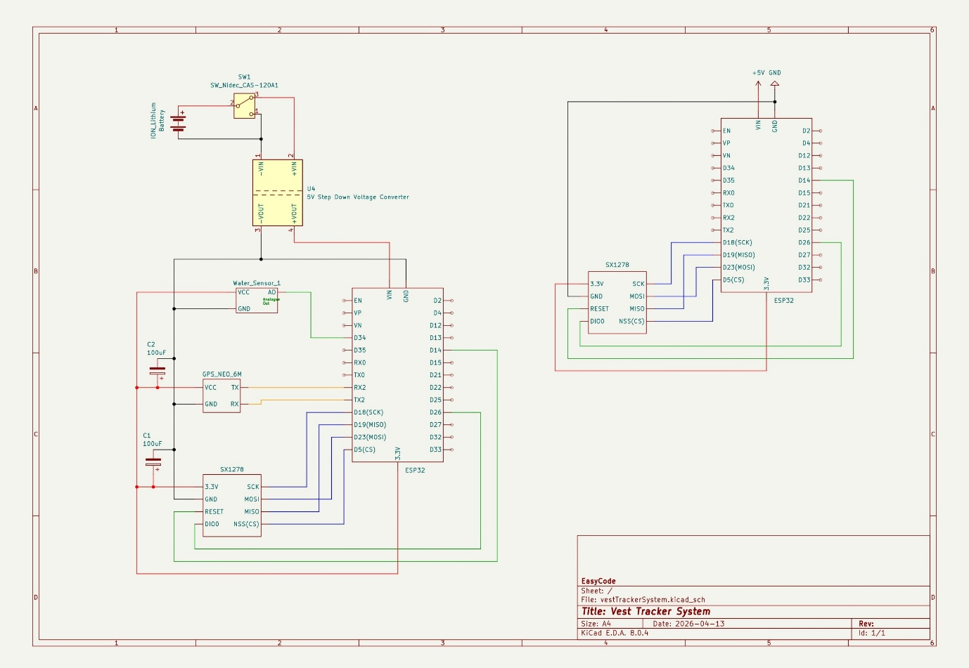

A3. Pin Connections / Wiring Tables

Vest Unit Wiring (Power Chain)
Component | Pin/Label | Connected To | Notes
Battery Holder (3x Lithium) | + | Switch input | Main power
Battery Holder | – | Common GND | Ground
Switch | Output | DC-DC (5V rail) IN+ and DC-DC (3.3V rail) IN+ | Power control
DC-DC (5V rail) | IN+ | Switch output | Input power
DC-DC (5V rail) | IN– | GND | Common ground
DC-DC (5V rail) | OUT+ (5V) | ESP32 VIN | 5V rail
DC-DC (5V rail) | OUT– | GND | Common ground
DC-DC (3.3V rail) | IN+ | Switch output | Input power
DC-DC (3.3V rail) | IN– | GND | Common ground
DC-DC (3.3V rail) | OUT+ (3.3V) | LoRa VCC, GPS VCC and rain sensor VCC | 3.3V rail
DC-DC (3.3V rail) | OUT– | GND | Common ground

Vest Unit Wiring (ESP32 Pin Map)
ESP32 | Connected To | Notes
VIN | 5V (from regulator) | Power input
GND | Common GND | Shared ground
3V3 | Not used for powering modules | Use dedicated DC‑DC 3.3V rail instead
GPIO16 (RX2) | GPS TX | UART
GPIO17 (TX2) | GPS RX (optional) | Can leave unconnected
GPIO18 | LoRa SCK | SPI
GPIO19 | LoRa MISO | SPI
GPIO23 | LoRa MOSI | SPI
GPIO5 | LoRa NSS (CS) | SPI select
GPIO14 | LoRa RST | Reset
GPIO26 | LoRa DIO0 | Interrupt
GPIO34 | Rain Sensor AO | Analog input

LoRa (SX1278 / Ra-02) Wiring
LoRa Pin | Connected To | Notes
VCC | DC-DC (3.3V rail) OUT+ | 3.3V only (do not power from ESP32 3V3)
GND | GND
SCK | GPIO18
MISO | GPIO19
MOSI | GPIO23
NSS | GPIO5
RST | GPIO14
DIO0 | GPIO26

GPS (GY-NEO6MV2) Wiring
GPS Pin | Connected To | Notes
VCC | DC-DC (3.3V rail) OUT+ | 3.3V only (do not power from ESP32 3V3)
GND | GND
TX | GPIO16 | Data to ESP32
RX | GPIO17 (optional) | Can leave open

Rain Sensor Module Wiring
Rain Module | Connected To | Notes
VCC | 5V rail or 3.3V rail | Prefer 3.3V rail for stable
GND | GND
AO | GPIO34 | Analog reading
DO | Not used | Optional only

A4. Capacitor Placement (Reference)
Location | Capacitor | Connection
LoRa | 100µF | 3.3V rail to GND (near module)
GPS | 10µF | 3.3V rail to GND (near module)

A5. Assembly Notes (Reference Only)

Vest Unit Assembly (High level)
- Wire the power chain: Battery holder to Switch to DC‑DC (5V rail) and DC‑DC (3.3V rail).
- Connect GPS to ESP32 UART2.
- Connect LoRa to ESP32 SPI (power LoRa from the DC‑DC 3.3V rail, not ESP32 3V3).
- Connect Rain Sensor analog output to the ESP32 analog input.
- Add the recommended capacitors close to the LoRa and GPS modules.

Control Tower Assembly (High level)
- Connect LoRa module to ESP32 (same pin map as vest LoRa wiring).
- Power ESP32 via USB or regulated 5V supply.

A6. Optional Operator Quick Reference

Glossary
- LoRa: Long-range, low-power radio link used between the vest and control tower.
- Control tower: The receiver unit that listens for LoRa packets and uploads them to the database.
- RTDB: Firebase Realtime Database where control tower uploads packets when available.
- GPS lock: GPS has a fresh valid position fix.

Normal timing expectations
- Scheduled LoRa transmit: about once per minute (per vest).
- Event LoRa transmit: immediately when the sensor transitions from dry to wet.

A7. ESP32 Pin Out

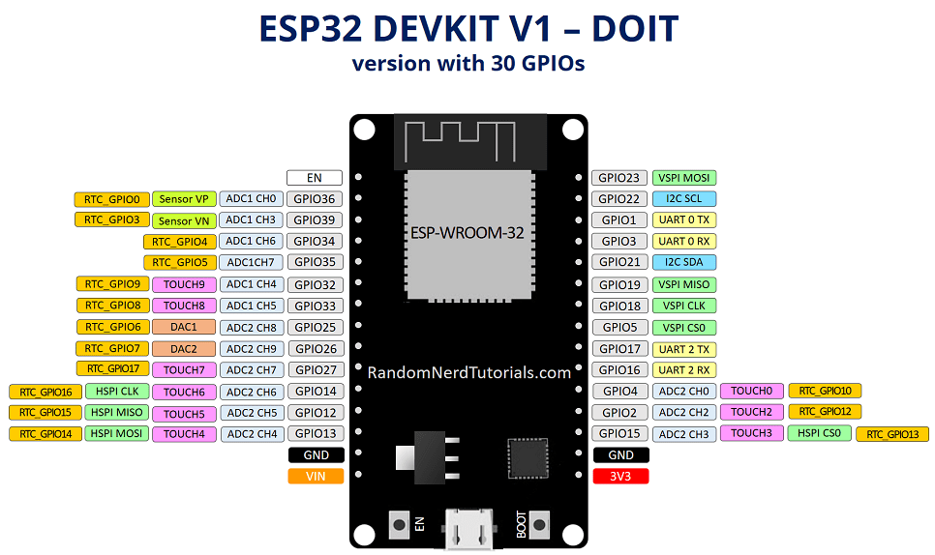

A7. LoRa SX1278 Pin Out

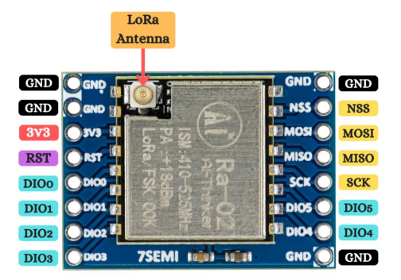

A8. GY-NEO6MV2 Pin Out

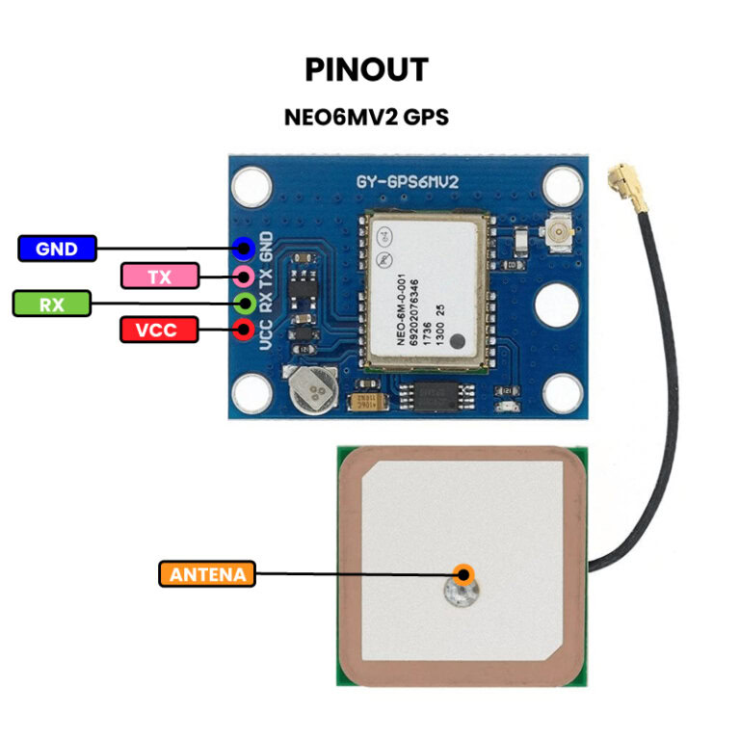

A9. Rain Sensor Pin Out

