Hardware
This document explains the physical parts of the Vest Tracker system in plain language. It is meant for operators and clients, not for detailed assembly or wiring (see Appendix.pdf for pin tables, BOM, and schematic).

H1. Hardware handling instructions
- Do not open the enclosure unless you are authorized, internal modules can be damaged and support may be affected.
- Avoid heavy rain and submersion.
- Charge before use (best practice: charge the day before deployment).
- Avoid dropping or crushing the device (GPS and radio modules are sensitive to shock).
- For battery safety, read PowerSafetyNotes.pdf before charging or field use.

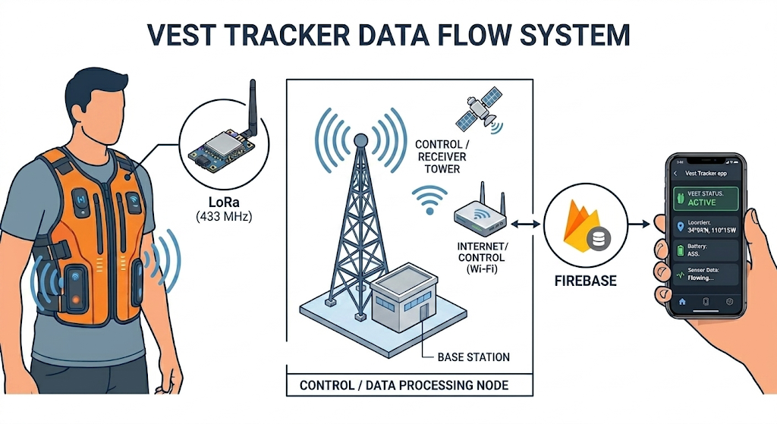

H2. What’s inside the vest (overview)
Inside the vest unit are these main building blocks:
- ESP32 Dev Module (ESP32 DevKit V1): main computer, reads sensors and sends LoRa packets.
- LoRa radio (SX1278 / Ra-02): long-range radio to the control tower (433 MHz in default firmware).
- GPS module (GY-NEO6MV2 / NEO-6M family): latitude/longitude when sky view is available.
- Rain / water sensor: moisture on an exposed sensing plate (analog type in shipped firmware).
- Battery pack and regulators: 3×18650 and dual DC-DC rails (5 V for ESP32, 3.3 V for radio and sensors).

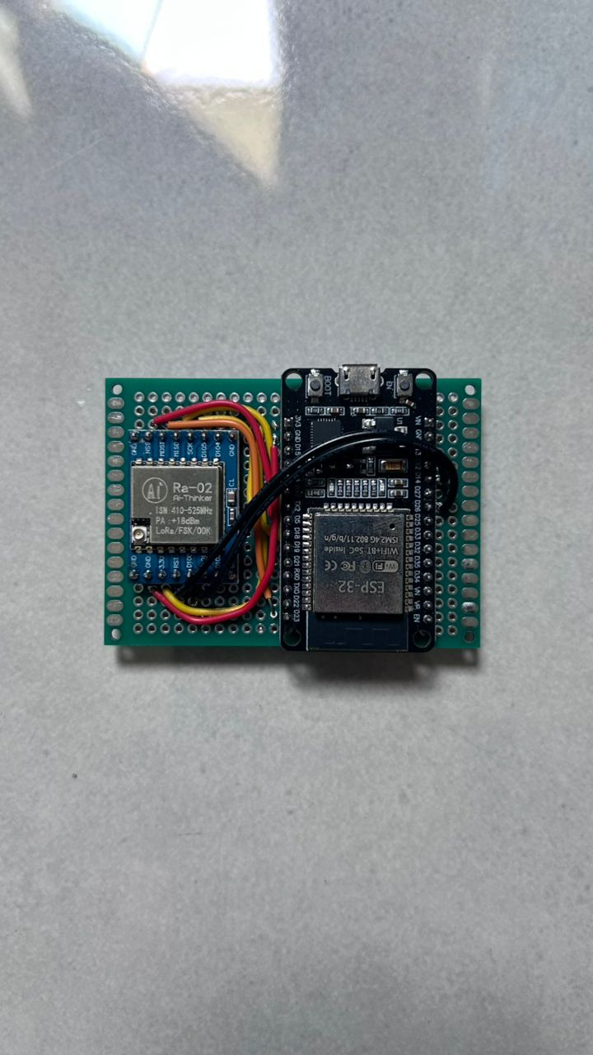
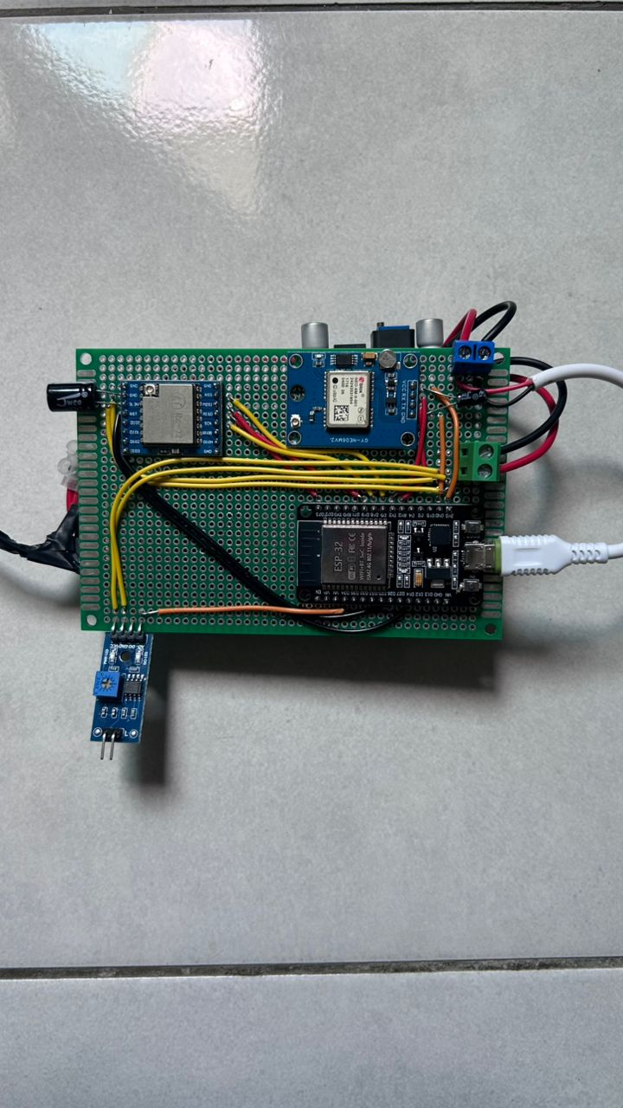

H3. External parts (what you can touch)
You may see:
- Power switch: turns the vest unit on or off. Switch off when not tracking to save battery and reduce heat in bags/vehicles.
- Charging access: recharge the battery pack using the approved charger only (see PowerSafetyNotes.pdf).
- The rain sensor plate may be visible or partially exposed to treat it as a delicate sensing surface, not a button.
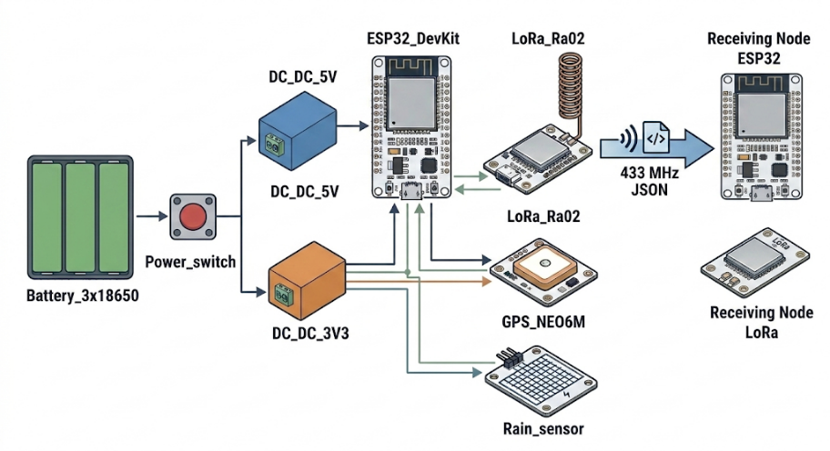
H4. Component explanations (detailed)
ESP32 DevKit V1 (main controller)
What it does: The ESP32 is a small Wi-Fi/BT-capable microcontroller. In the vest, it runs transmitter firmware only (no Wi-Fi in normal use). It reads GPS over UART, talks to LoRa over SPI, and reads the rain sensor on an analog input (GPIO34 in the reference build).
How it behaves in this system: On a fixed schedule (every 60 seconds), it builds a compact JSON packet and transmits it over LoRa. It also sends an extra packet immediately when the rain sensor crosses from dry to wet (after debounce). Over USB Serial (maintainer/debug), it prints a longer JSON diagnostic about every 10 seconds when connected to a PC.
Physical handling: Powered via 5 V from the dedicated 5 V regulator. The module is sensitive to shock, static discharge, and moisture on the circuit board. Do not bend pins or stack heavy objects on the enclosure.

LoRa SX1278 (Ra-02) (long-range communication)
What it does: LoRa (Long Range) is a low-data-rate radio suited to small status messages (coordinates, wet flag, device ID). The Ra-02 module operates at 433 MHz in the repository’s default sketches, a license-free band in many regions, but always follow local regulations for deployment.
How it behaves in this system: The vest transmits, the control tower receives. Payloads are short JSON strings (under 240 bytes). This is not a continuous voice/video link expect roughly one update per minute per vest, plus immediate sends on wet edges. Range is typically hundreds of meters to a few km in open air, but drops sharply with buildings, hills, body blocking, and metal roofs.
Physical handling: Must be powered from the dedicated 3.3 V DC-DC rail, not the ESP32’s 3V3 pin (insufficient/current noisy for reliable RF). A 100 µF capacitor near the module helps stability (see Appendix.pdf). Keep the antenna area clear of metal shielding where the enclosure design allows.

GY-NEO6MV2 GPS module (NEO-6M family)
What it does: Receives signals from GPS satellites and outputs NMEA text at 9600 baud describing position, altitude, speed, and satellite count.
How it behaves in this system: The firmware classifies GPS into three stages: waiting for signal (no data), no satellite lock (data but no valid fix), and locked (valid fix fresh within 2 seconds). LoRa packets include coordinates from the last good lock even if the live stage later drops so the map can show a stale pin indoors while wet status still updates. Cold start outdoors often needs 1–3+ minutes. first fix of the day can take longer under tree cover or near tall buildings.
Physical handling: Powered from 3.3 V rail with a 10 µF capacitor nearby. The ceramic patch antenna needs a view of the sky, orientation matters. In the vest, the antenna should face outward/upward per enclosure design, not buried against the body with no sky path.

Rain / water sensor (FC-37 style analog plate)
What it does: A exposed conductive / sensing plate on a small module reports moisture as an analog voltage read by the ESP32. Lower analog values mean wetter in the shipped firmware (wet when reading below 2500 on the 12-bit ADC, with 80 ms debounce).
How it behaves in this system: The sensor answers: “Is there moisture on this plate?” not “Is the entire vest waterproof?” The cloud and app show `wet=true/false`, the app can fire wet alerts on dry to wet transitions. The firmware sets an important flag while wet (`imp`) for visibility in telemetry.
Physical handling: Keep the plate clean and free of permanent tape unless maintainers applied protective coating. Avoid scraping the sensing surface. Do not submerge unless the whole assembly is rated for it (see PowerSafetyNotes.pdf).

Battery pack + DC-DC regulators (power)
What it does: 3x18650 Li-ion cells in series feed a power switch, then two buck converters: 5 V for ESP32 VIN, 3.3 V for LoRa, GPS, and rain sensor. This split keeps radio and GPS supply clean under ESP32 load spikes.
How it behaves in this system: No sleep mode in reference firmware, the vest draws power continuously while switched on. Expect on the order of 12 hours runtime in prototype builds, but your runtime depends on cell capacity (mAh), temperature, age, and how often LoRa transmits (minute cadence + wet edges).
Physical handling: Charge only with approved charger, never short terminals, replace all cells as a matched set if one is damaged. See PowerSafetyNotes.pdf for transport, storage, and emergency steps.

Control tower / receiver unit
What it is: A separate ESP32 + LoRa receiver (no GPS or rain sensor on the tower). It listens on the same 433 MHz settings and pin map as the vest, then uploads parsed data to Firebase over Wi-Fi.
How it behaves: Must remain powered continuously during operations (USB 5 V typical). When Wi-Fi or Firebase is down, V2 firmware queues up to 30 messages and flushes when connectivity returns (oldest dropped if queue overflows). Adds Malaysia timestamp (`time_my`) when NTP sync succeeds.
Physical handling: Place with clear LoRa line of sight toward the field area, elevate if possible, avoid metal boxes tightly surrounding the antenna. Use a stable USB power supply and not a failing cable.

H5. Known limitations (important)
- GPS needs open sky: Best performance outdoors, poor or absent fixes indoors or under metal roofs.
- LoRa is affected by buildings and terrain: Range decreases with obstacles; body and foliage matter.
- Stale coordinates possible: Last good GPS fix may transmit after lock is lost, do not assume the pin is live position without checking `gsn` / outdoors test.
- Rain sensor ≠ waterproofing: Moisture at the plate only, enclosure may still be vulnerable to heavy rain.
- Battery runtime: Often 12 hours order-of-magnitude in typical builds, plan charging between long field days.

For engineering details (pin maps, wiring tables, schematics, assembly notes) (see Appendix.pdf ).

