Mobile App Guide (Android)
The shipped client is Vest Tracker, a Flutter application under `android-app/vest_tracker/`. Operators receive a release APK (or install from an internal distribution channel). This guide covers installation, startup flow, sign-in, and every major screen and section in the app.

MAG1. Install the app (APK)
- Copy or download the `.apk` file onto your Android phone.
- Open the `.apk` from a file manager or the download notification.
- If Android blocks the install:
  - Tap Settings on the install warning screen.
  - Enable Allow from this source (wording varies by manufacturer).
- Return and tap Install.
- Tap Open when installation completes.

Build output (for maintainers): after `flutter build apk`, look under `android-app/vest_tracker/build/app/outputs/flutter-apk/` for `app-release.apk` (exact name may vary with build flavor).

MAG2. Permissions
Permission | Why the app requests it
Notifications | Wet alerts and the Send test notification button in Profile. Android 13+ may show a runtime prompt.
Location | Satisfies Android expectations for map-centric apps. The map centers on vest coordinates from Firebase, not necessarily the phone’s GPS

If notifications are disabled at the OS level, Profile shows that wet alerts cannot be delivered until you allow Vest Tracker in system settings.

MAG3. App startup flow
When you open Vest Tracker, the app passes through these stages before you reach the main tabs:
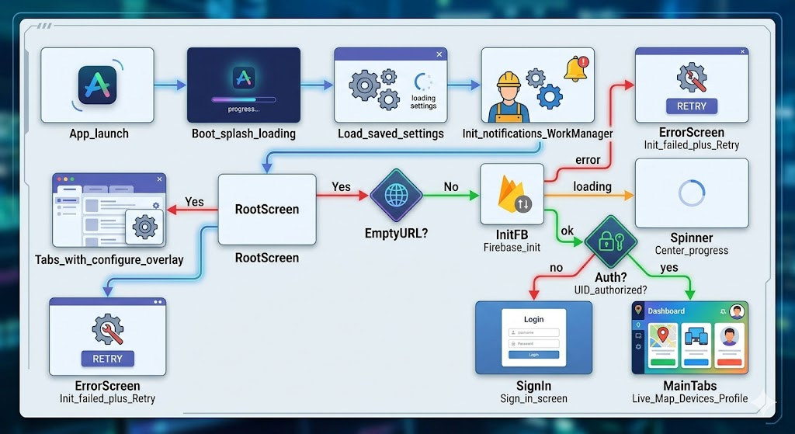

- Boot splash: centered loading indicator while settings load and notification/background services initialize.
- Root screen: decides what you see next:
  - First-run (empty Firebase URL): all three bottom tabs work, but Live Map and Devices show a floating “Configure Firebase in Profile” button that jumps to Profile.
  - Firebase init error: full-screen message “Firebase init failed”, error text, and Retry (use after fixing URL in Profile).
  - Firebase loading: brief centered progress.
  - Not signed in / UID mismatch: Sign in screen replaces tabs.
  - Authorized: bottom navigation with Live Map, Devices, Profile.

There are no separate menu routes, navigation is tabs plus dialogs (e.g. sign-out confirmation).

MAG3. Sign in (Firebase Auth)
The app uses Firebase email + password authentication (not a separate custom username).
- What appears on the sign-in screen
  - App icon (Vest Tracker branding).
  - Title: “Vest Tracker” with subtitle “Sign in to continue”.
  - Email field.
  - Password field with show/hide toggle.
  - UID field helper text explains this must match RTDB rules (same as Allowed UID in Profile).
  - Remember me switch saves email, password, and UID locally on this device (plain storage, use only on trusted phones).
  - Error banner (red-tinted) for wrong password, network errors, or UID mismatch.
  - Sign in button shows a spinner while authenticating.

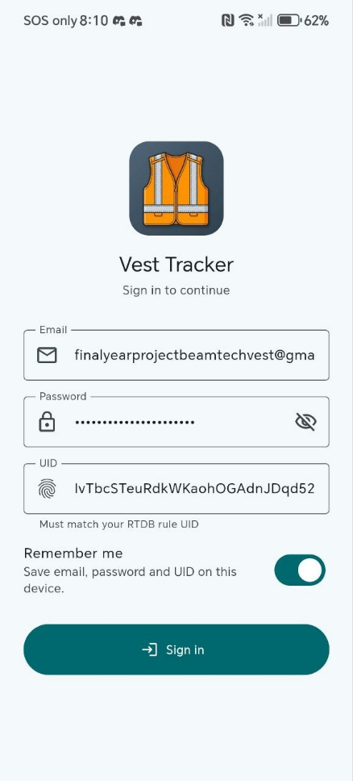
- Sign-in behavior
  - After Firebase URL is saved, the sign-in screen appears if you are not authorized.
  - Enter email, password, and UID. UID must exactly match the Firebase Auth UID for that account and Profile Allowed UID.
  - Optionally enable Remember me to prefill next launch.
  - Tap Sign in.

UID mismatch: If the typed UID does not match the account’s real Firebase UID, the app signs you out automatically and shows Expected vs Actual UID, this prevents silent “empty database” confusion. Successful sign-in also writes Allowed UID into saved app settings.

MAG4. Bottom navigation > Live Map
The Live Map tab is the primary geographic view of all vests you are allowed to read from RTDB.

App bar
- Title: “Live Map”.
- Device focus dropdown (right side): choose `(all)` or a specific device ID (e.g. `device_01`). Filters which markers are emphasized, useful when many vests are deployed.

Map layer
- Base map: OpenStreetMap raster tiles (requires phone internet).
- Markers: One pin per device that has valid `lat` and `lon` in Firebase.
  - Green pin for `wet=false` (dry).
  - Red pin for `wet=true`.
  - Animated ripple around pin when device is considered online (last seen within 5 minutes on the map).
  - Label on marker shows device ID string.

Floating controls
Recenter button (top-left FAB) pans the map to the currently selected / focused device’s coordinates when available. The map does not auto-pan on every new packet so you can explore freely, use recenter to jump back.

Draggable bottom sheet
Pull up from the bottom (~10%–55% of screen height) after tapping a marker:
Field | Source / meaning
Device name | `deviceName` from RTDB if set, else device key
ONLINE / OFFLINE chip | Based on last seen (5 min window on map)
Latitude / Longitude | From RTDB
Altitude | `alt` when present
Speed | `spd` when present
Satellites | `sat` when present
GSN | GPS stage name string (`gsn`)
GS | GPS stage number (`gs`)
Wet | TRUE / FALSE from `wet`

If telemetry has not arrived yet for the selected device, the sheet may show a loading spinner.

Map overlays (empty / error states)
Overlay message | Meaning
No devices found | Nothing under `/vest` you can read, or not signed in correctly
No coordinates | Devices exist but none have valid lat/lon yet (GPS / upload issue)

MAG5. Bottom navigation > Devices
The Devices tab lists every child key under Firebase path `vest/` that your account may read.

App bar
- Title: “Devices”.

Device cards (one per vest)
Each card shows:
UI element | Meaning
Leading avatar | Green check (dry) or red water drop (wet)
Title | Display name from `deviceName` if set, otherwise the RTDB key (e.g. `device_01`)
Subtitle line 1 | Last seen formatted in Malaysia time (UTC+8) (e.g. `h:mm a dd-MM-yyyy`)
Subtitle line 2 | Online if last seen within 10 minutes, else Offline
Trailing Wi‑Fi icon | Visual hint for connectivity context
Red WET chip | Shown when `wet=true`
Check icon | Shown when this card matches Profile > Selected device ID

Interactions
- Tap a card: sets that device as Selected device ID in app settings (snackbar confirmation). Used for notification scoping and map defaults.
- Empty list: text: “No devices found under /vest.”
- Stream error: inline error text (permissions, network, bad path).
Note: Online on Devices uses a 10-minute window, Live Map markers use 5 minutes (see TroubleshootingGuide.pdf).

MAG6. Bottom navigation > Profile
Profile is a scrollable settings hub with a header row (app icon, “Vest Tracker”, short help text) and four expandable sections.

Section 1 Account
(Visible when Firebase client is connected.)
Item | Action
Email | Read-only — current signed-in email
UID | Read-only — current Firebase Auth UID
Clear saved | Removes Remember-me credentials from device
Sign out | Opens confirmation dialog, then signs out of Firebase

Section 2 Notifications
UI element | Meaning
Wet alerts master switch | Enables/disables foreground wet monitor and schedules/cancels background WorkManager task
Foreground monitor status | Label indicating whether stream is active while app is open
Android permission status | Shows if POST_NOTIFICATIONS is granted (Android 13+)
Allow button | Requests notification permission from the system
Send test notification | Fires a local test alert (verify channel works)
Scope line | Text showing whether you watch all devices or only Selected device ID

Permission status refreshes when you return to the app (resume).

Section 3 App settings
Field | Behavior
Firebase RTDB URL | Required `https://…` database URL, empty URL triggers first-run overlay on other tabs
Allowed UID | Must match signed-in user UID for RTDB rules, updated on successful sign-in
Selected device ID | Optional, e.g. `device_01`, empty = watch all devices for wet notifications
Background poll interval | Minutes between background wet checks, clamped 15–240 on save
Upload logs to Firebase | Toggle, when on, app log entries may upload to `appLogs/` in RTDB (saves immediately, no Save button)
Save settings | Validates URL, persists all fields, re-initializes Firebase if URL changed, shows Saved snackbar

Changing Firebase RTDB URL requires Save settings then may require Retry if init had failed.

Section 4 Logs
Item | Action
Add test log | Appends a sample line to the on-device buffer
Clear logs | Empties local log ring buffer
Log list | Up to ~20 recent entries with timestamp, level icon, and message

This is debug/diagnostic history not vest location history.

First launch checklist (Profile before map)
On a fresh install the Firebase Realtime Database URL is empty.
- Open bottom navigation > Profile.
- Expand App settings.
- Enter Firebase RTDB URL and Allowed UID (from your administrator).
- Optionally set Selected device ID or leave blank for all devices.
- Set Background poll interval if needed (default 15 minutes).
- Tap Save settings.
- Sign in with email, password, and matching UID.
- Open Live Map or Devices overlay disappears once URL is valid.
Until URL is saved, Live Map / Devices show the Configure Firebase in Profile shortcut.

MAG7. Wet alerts (behaviour)

Foreground (app open or in memory)
- While signed in and Wet alerts enabled, the app subscribes to RTDB `wet` values.
- Notifies only on false to true transitions (dry to wet).
- First observation after install/load sets baseline, no spam on first read if already wet.
- Last wet state per device stored locally (`vest_tracker.lastWet.{deviceId}`).

Background (app closed / swiped away)
- WorkManager task `vest_tracker_wet_monitor` runs on the Background poll interval (15–240 min, Android may throttle further).
- Uses cached auth session, may attempt anonymous sign-in if configured, open app signed in once after install so rules align.
- Same false to true logic as foreground.

Notification scope
- Selected device ID empty, monitor all devices under `vest/`.
- Selected device ID set, only that device triggers wet alerts.

MAG8. Error and empty states (quick reference)

Situation | What you see | What to do
Empty Firebase URL | Configure overlay on Map/Devices | Profile > enter URL > Save
Firebase init failed | Error screen + Retry | Fix URL/network > Save > Retry
Not signed in | Sign-in screen | Sign in with matching UID
UID mismatch | Error banner, auto sign-out | Fix UID from Firebase console
No devices | Empty list / map overlay | Check receiver, rules, sign-in
No coordinates | Map overlay | Vest outdoors for GPS
RTDB stream error | Inline error text | Network, rules, URL
Notifications blocked | Profile permission warning | System settings > Allow
Test notification fails | SnackBar error | Check permission channel

If something goes wrong
See TroubleshootingGuide.pdf for GPS, LoRa, Wi‑Fi, Firebase, login, wet alerts, and power issues.
See UserGuide.pdf for day-to-day operation steps.

