User Guide
Use this guide the first time you set up the system and for daily operation.

UG1. Before you start (quick checklist)
- Vest unit battery is charged
- Receiver and base station are powered and has Wi‑Fi to reach Firebase
- Phone has the Vest Tracker APK installed and internet access
- You have Firebase RTDB URL, account email/password, and the account UID

UG2. Getting started (first-time setup)
STEP 1) Charge the vest unit
- Use the approved charger for your battery pack.
- Disconnect when fully charged per charger instructions.
- Reinstall the pack in the vest if you removed it for charging.

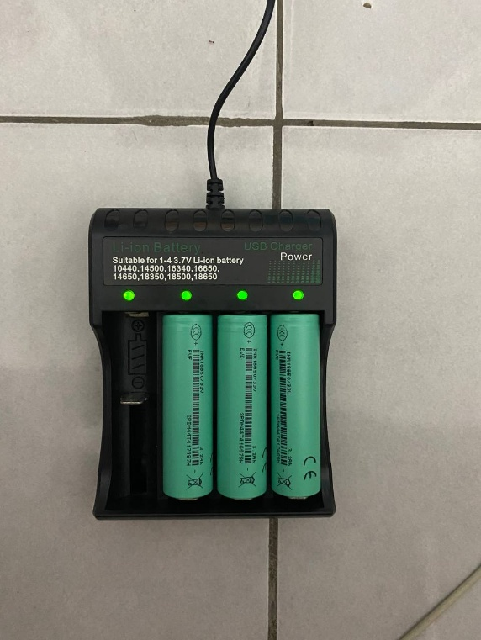
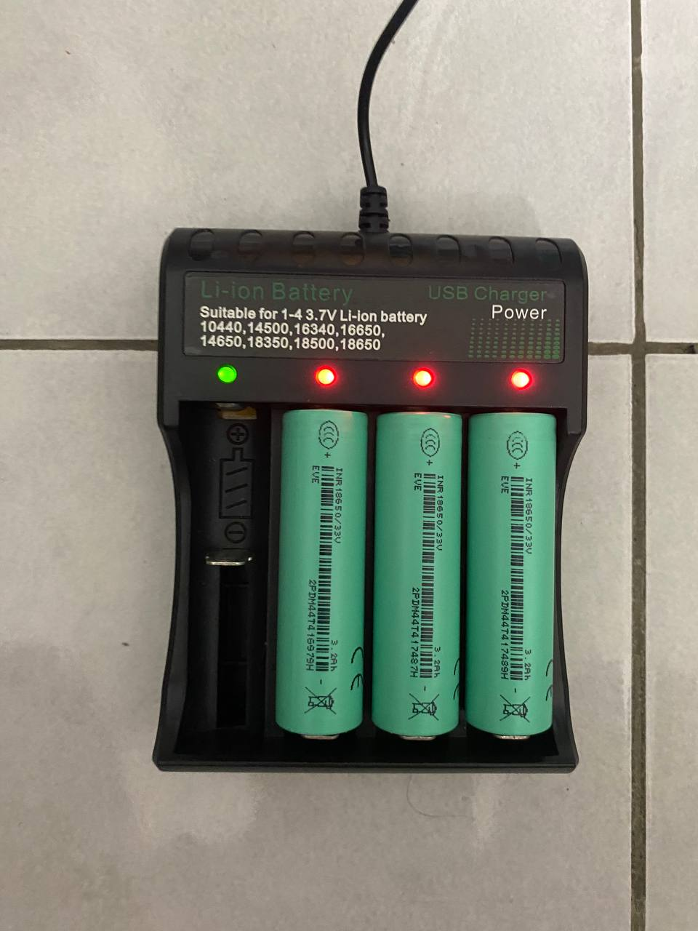
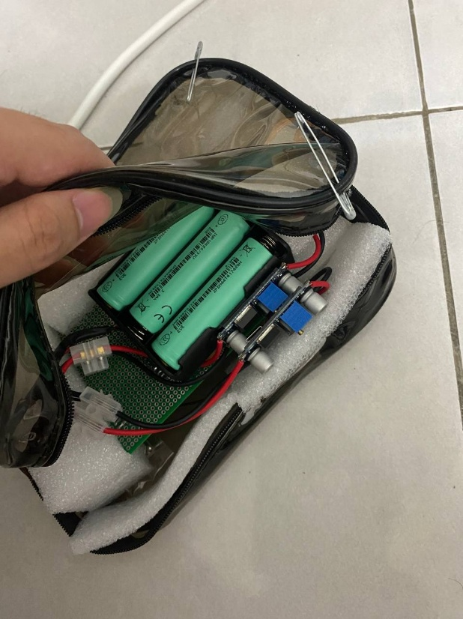

STEP 2) Sign in
- Open Vest Tracker app.
- Enter email, password, and UID on the sign-in screen (UID must match Firebase Auth and your Allowed UID field).
- Enable Remember me only on devices you trust.
- Tap Sign in.

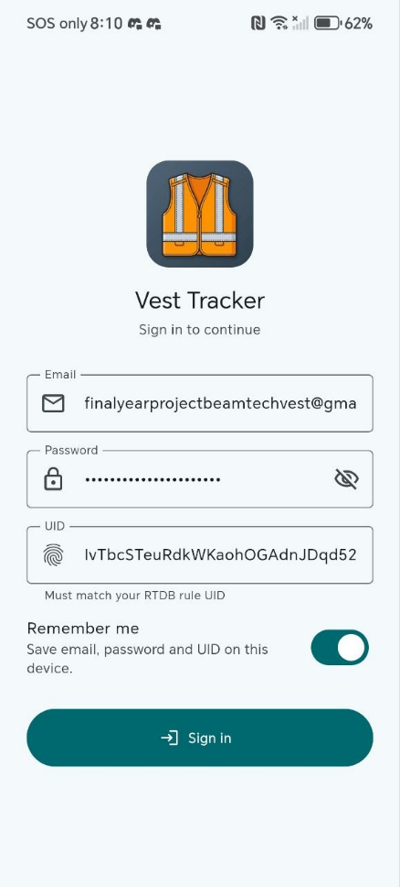
STEP 3) Configure the mobile app

- Tap Profile in the bottom navigation.
- Under App settings, enter your Firebase RTDB URL and Allowed UID
- Optionally set Selected device ID (e.g. device_01) or leave blank to watch all vests.
- Tap Save settings.

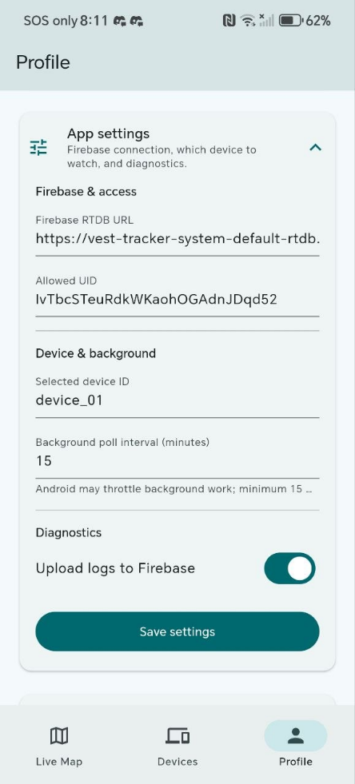
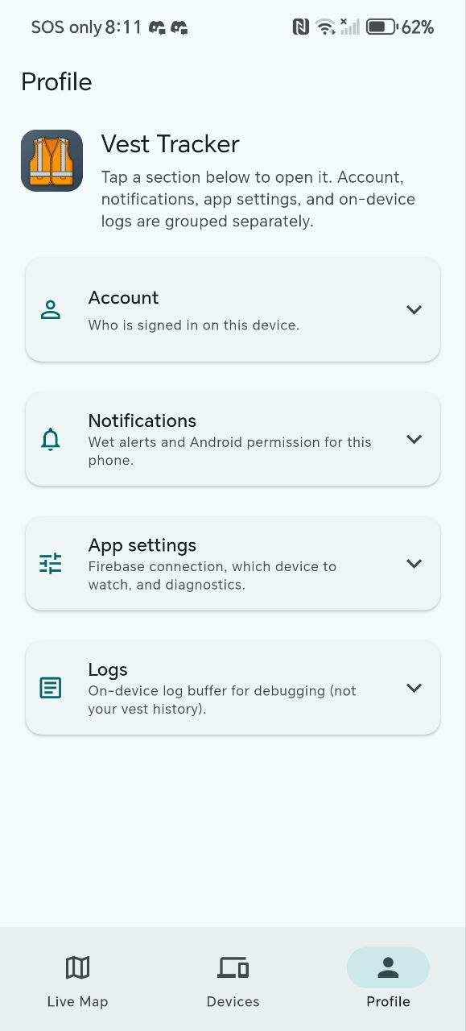

STEP 4) Turn on the vest unit

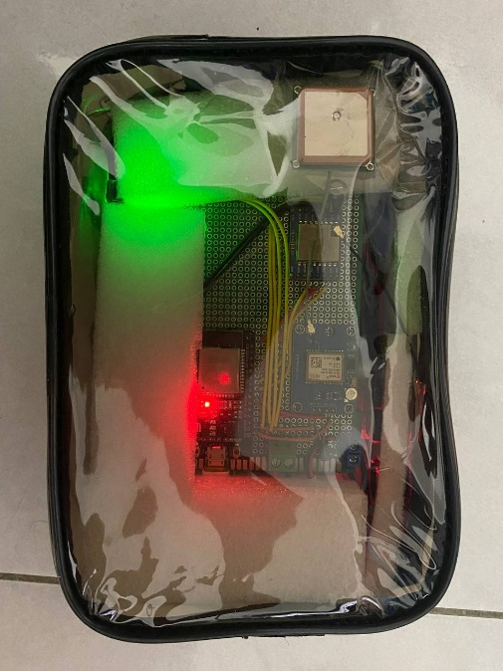
- Use the vest power switch.

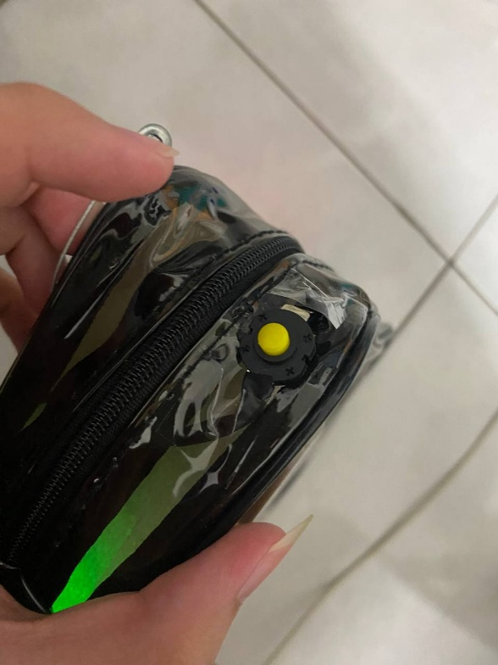

- Allow 1–2 minutes outdoors for a first GPS lock (cold starts can take several minutes in difficult sky conditions). When its locked, the GPS will start blinking.

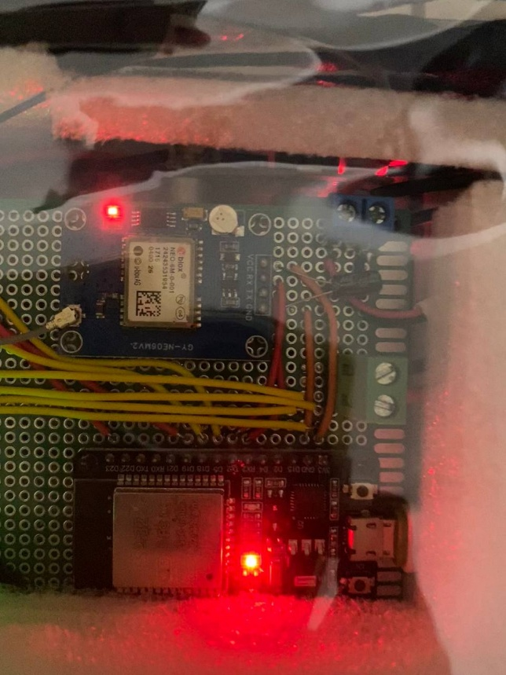
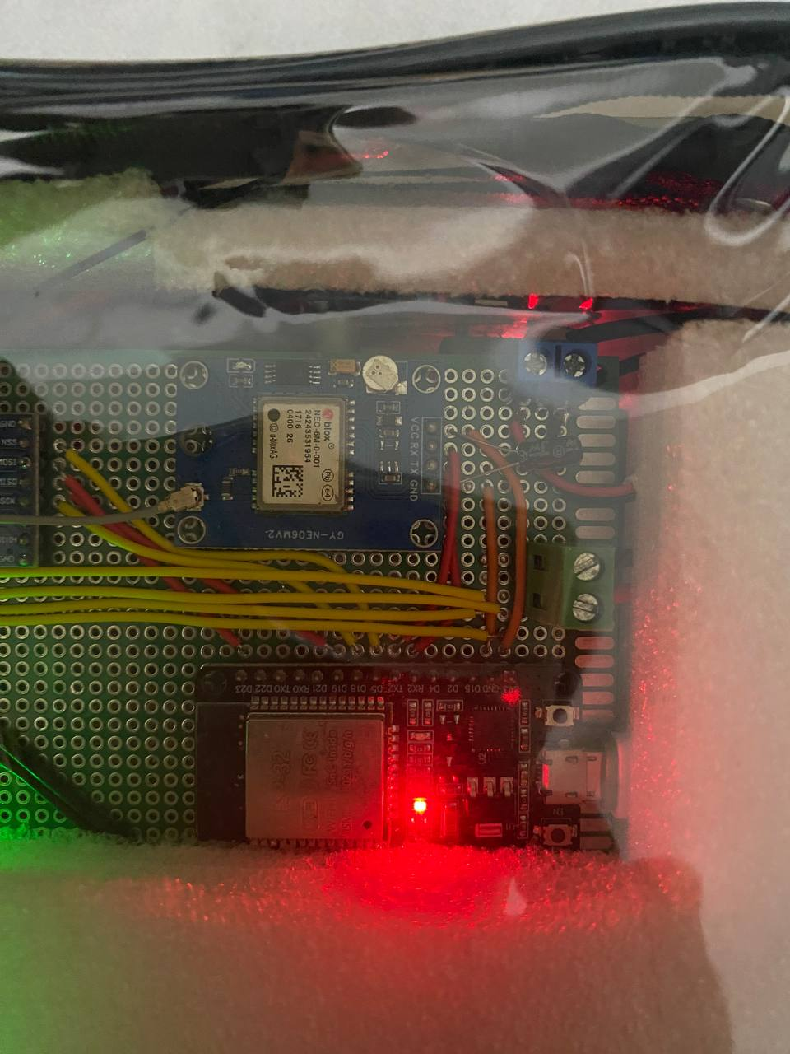

STEP 5) Turn on the receiver / base station

- Apply power (USB adapter or approved supply).
- Leave it on during tracking sessions.

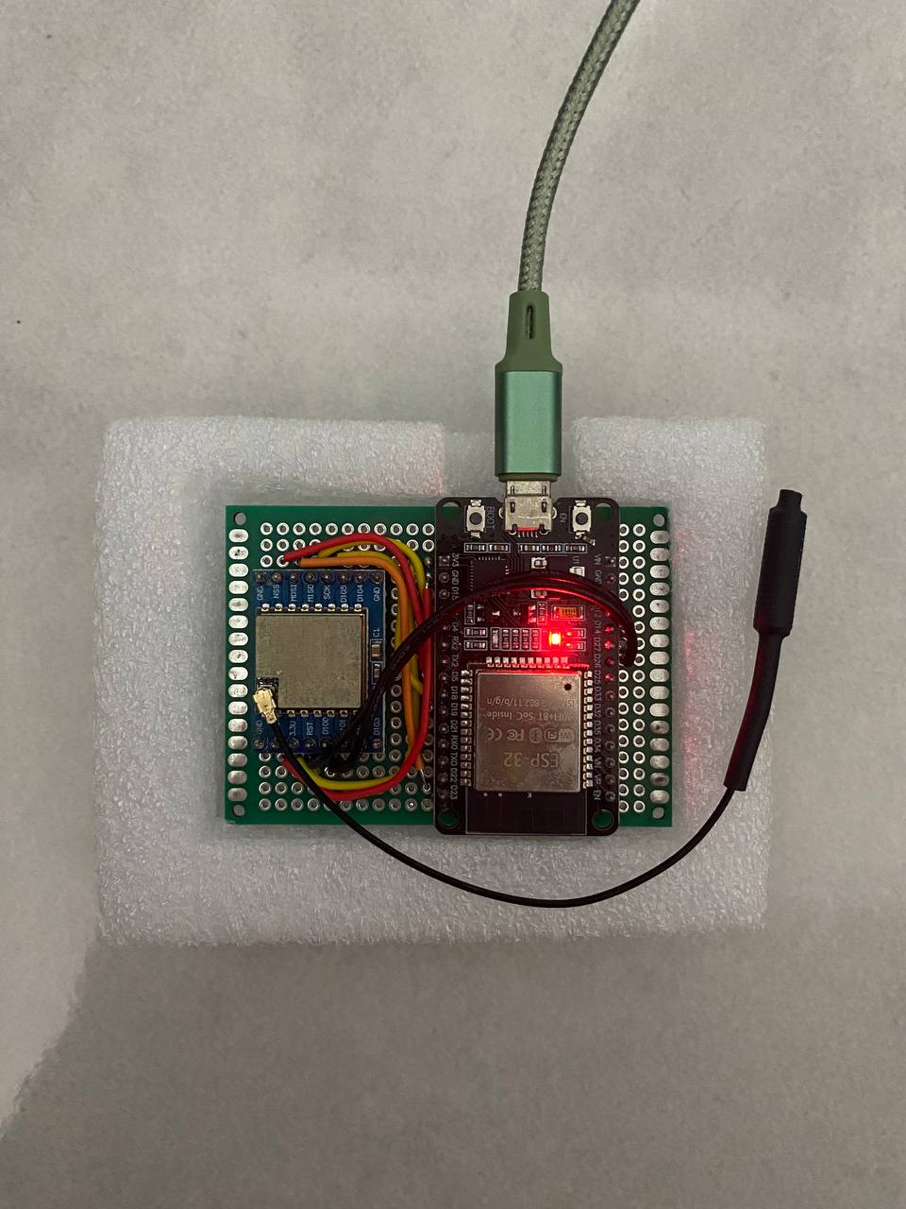

- Make sure to enable Hotspot nearby with predetermined Hotspot ID and Password

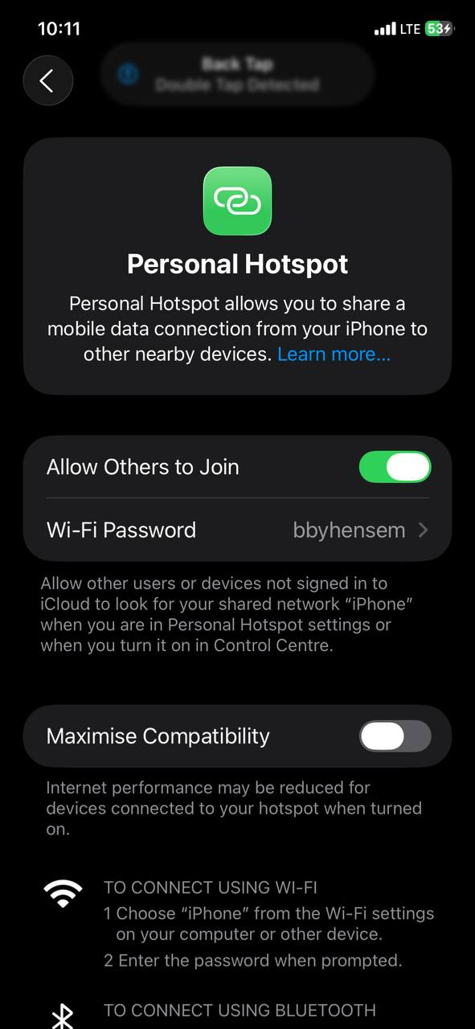
STEP 6) Verify in the app

- Open Live Map. You should see markers when vests report `lat`/`lon`.

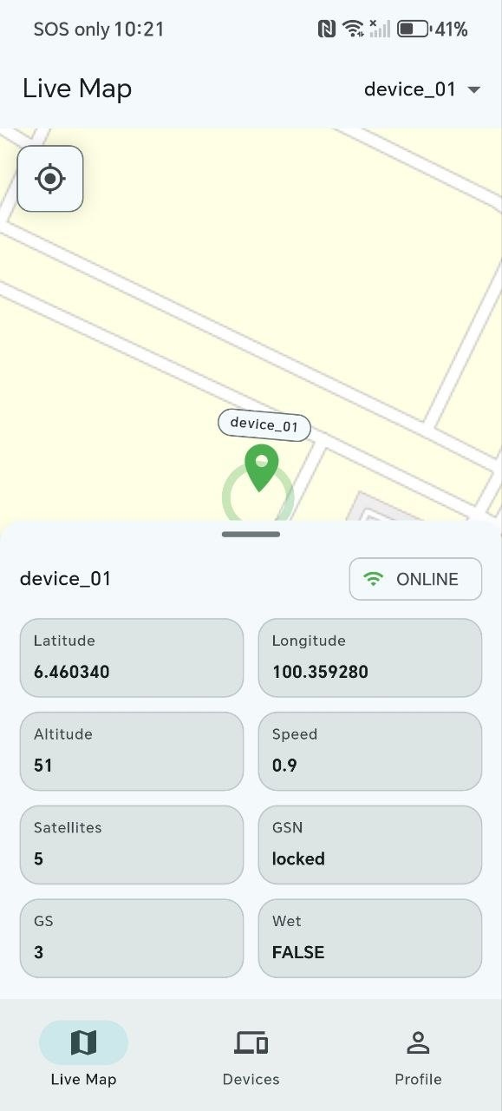
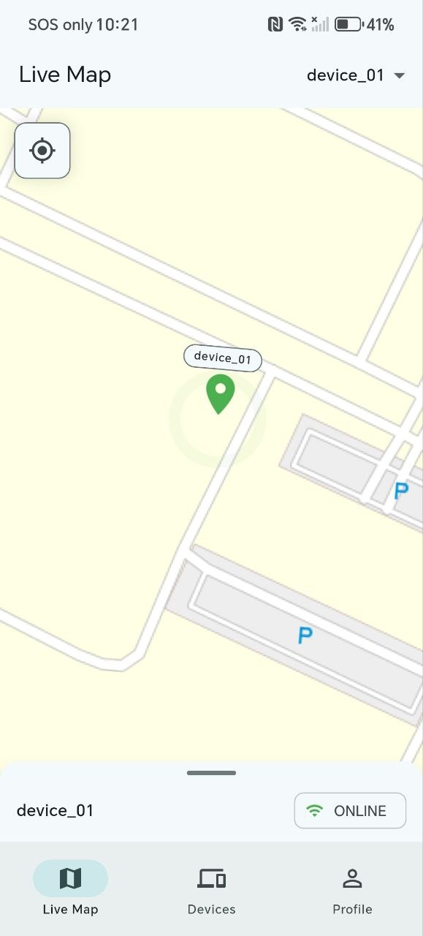

- Open Devices to confirm each `device_XX` row updates last seen over time.
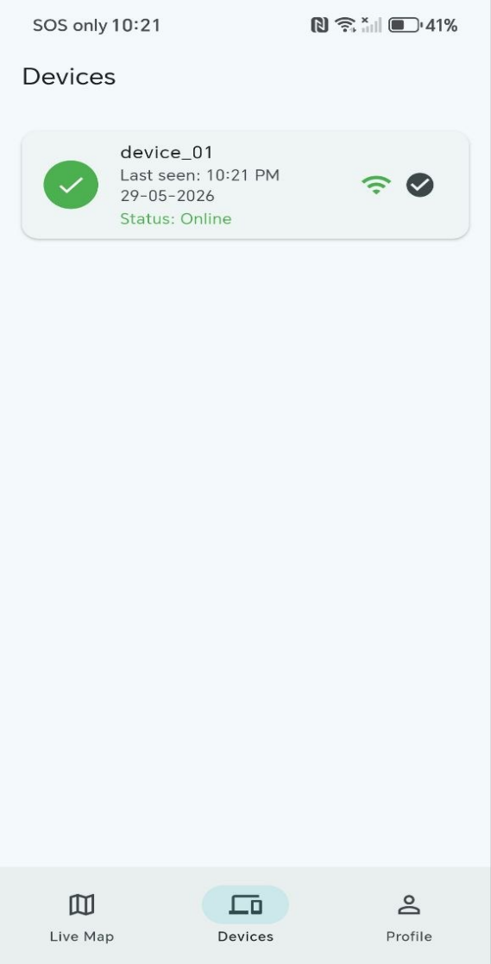

- Under Profile > Notifications, confirm Android notification permission if you want wet alerts.

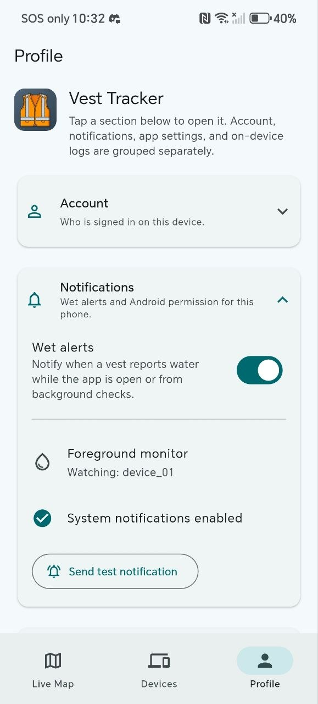

UG3. Normal operation (daily use)
- Check vest location
- Open Live Map.
- Use the device filter in the app bar if you have multiple vests.
- Tap a marker to open the detail sheet. use recenter if you panned away. If the marker is missing or stale, see TroubleshootingGuide.pdf.

UG4. Read device stats
- Open Devices:
  - Online (green) means a telemetry timestamp arrived within roughly the last 10 minutes (app-side heuristic).
  - Offline (red) means no recent timestamp, check receiver power, LoRa range, or Wi‑Fi on the base.
  - WET chip means the latest `wet` flag is true.
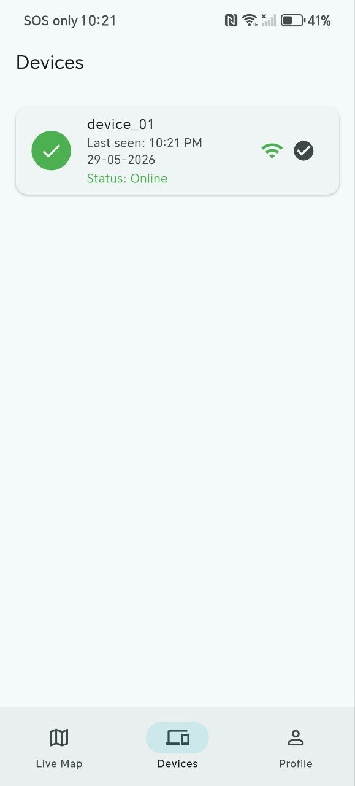
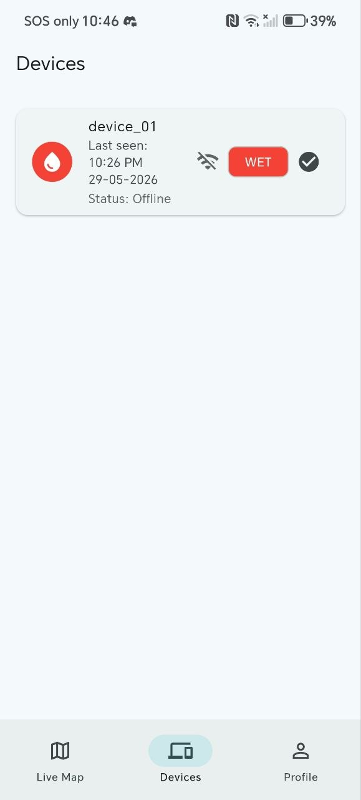

UG5. Understand GPS from the map
- Markers require valid coordinates in Firebase. No marker often means no GPS fix yet, not necessarily a dead radio link.
- Take the vest to open sky and wait several minutes (~5 mins) before assuming a hardware fault.

UG6. Wet / rain alerts
- When notifications are enabled, the app alerts on a new wet detection (dry to wet). Dry the sensor area if the alert persists.
- To make sure notifications works, use send test notification in Profile > Notifications first.



- To ensure notifications are always delivered promptly, keep the app running in the background. Notifications can still be received when the app is not running, but the response time will depend on the polling interval, which may take at least 15 minutes.

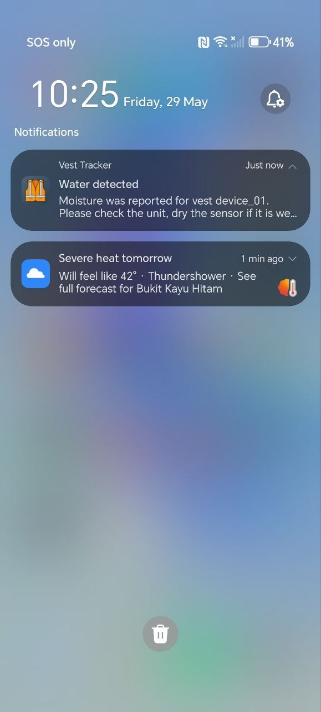
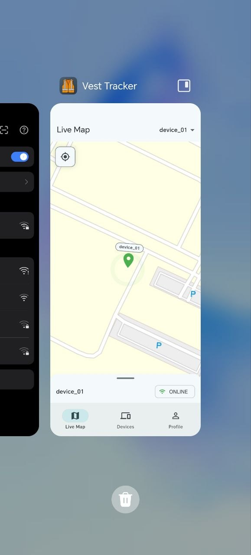

UG7. Daily usage tips (best results)
- Vest placement
  - For reliable GPS, keep the vest outside or under open sky.
  - Avoid covering the GPS antenna area with metal or thick wet fabric for long periods.

- Receiver placement
  - Keep it powered continuously during use.
  - Elevate the receiver and keep a clearer path toward the operating area (range depends on terrain and buildings).

- Battery discipline
  - Charge regularly. Low battery can cause brownouts or reboot loops on the vest.

UG8. Where to read more
- MobileApp.pdf: permissions, tabs, sign-in details
- Hardware.pdf: what each module does (non-wiring)
- PowerSafetyNotes.pdf: charging and lithium safety
- SystemArchitecture.pdf: data path vest to Firebase to app
- Appendix.pdf: BOM and wiring for maintainers

