

|  |
| --- |
| Neo4J Teamwork  Documentation  2020 |
|  |
| Due date: 15th of january, 2020  Information Repositories – UniOvi 19-20  Written by: Óscar Sánchez Campo (UO265078)  Daniel Finca Martínez (UO264469) |

Preface

## GraphGist

As a complementary resource to this documentation, a GraphGist document has been created to serve as a self-explanatory and interactive documentary of some parts of this project’s development.

This documentation can be found in the site linked down below. It has been submitted for approval in the GraphGist portal so when checked out there exists the possibility that it doesn’t work anymore:

<https://portal.graphgist.org/graph_gist_candidates/neo4j_teamwork_graphgist_docs-candidate>

In any case, this GraphGist interactive guide can be run from the Neo4j browser’s console issuing the following command:

***:play*** [***https://portal.graphgist.org/graph_gists/neo4j_teamwork_graphgist_docs/graph_guide***](https://portal.graphgist.org/graph_gists/neo4j_teamwork_graphgist_docs/graph_guide)

## Delivered folder structure and GitHub repository

GitHub version control system has been used throughout the whole development process, just in case there is any need to check any extra files, here is the link to the public repository that holds the project files:

<https://github.com/fincamd/RI_Teamworks> (Disclaimer: I have both Information Repositories team works held there for the sake of easy file manipulation with my colleague. Files for this concrete project are inside “NEO4J” folder).

Only the relevant and requested files have been included, but some files that are not requested might be checked for further correspondence. These files are included in the “extra_files” folder. The folder named as “workspace” contains a project with the optional application to develop on top of the query tasks. Folder named “task_txt_files” contains files used to take notes during the process. Notes such as the statement of the exercise, looked-up references, developed queries and the graph DB creation script.

Contents

# 1.Motivation

Domain: Transport systems across cities, villages and valleys.

This graph database has been created based on the insight of a map. This “map” would display cities, villages and valleys which are interconnected by some conveyance means. These are: buslines, railways, highways and boats.

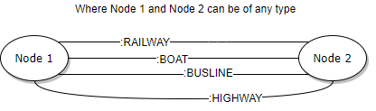

As it can be seen from above schema, our domain allows nodes to be interrelated using three types of relationships: Railway, Boat, Highway and Busline. Although they are not represented with an arrow in the schema, they will be represented using a directed arrow in our graph. This is no problem, as they can be traversed both ways when querying. (Image included in repository path: “RI_Teamworks/NEO4J/extra_files”)

Each relationship has a different set of attributes. Distributed as follows:

1. Railway:
   1. Line: Indicates the line of the linking railway.
   2. Average ride time: The arbitrarily “estimated” time to go through such relationship.
   3. Price: The arbitrarily chosen price to go through this railway relationship.
2. Busline and Boat:
   1. Average ride time: The arbitrarily “estimated” time to go through such relationships.
   2. Price: The arbitrarily chosen price to go through these relationships.
3. Highway:
   1. Average ride time: The arbitrarily “estimated” time to go through such relationship.
   2. Price: The arbitrarily chosen price to go through this highway relationship.

Moreover, nodes also have a defined set of attributes. No discrimination has been applied to different class nodes. In the sense that all of them contain the same attributes. These mentioned classes are: Valley, City and Village.

To continue, the set of attributes set for all the nodes in the domain is this:

1. City, Village and Valley:
   1. Name: Indicates the name of the place the node represents.
   2. Inhabitants: Stores the number of inhabitants populating the place. (Data taken from the internet. Disclaimer: Could be outdated).

Nodes in our domain might have one class among these: City, Village and Valley. Though our model allows it, some connections would be logically and physically impossible. Not all places represented have a dock. In addition, only some of the possible links have been represented for the sake of simplicity of the database instance.

To conclude this summary of the graph database domain, the names and data have been selected using Asturias’s geography. Not every single location of the Principality has been represented because of the same reasons as stated beforehand (Not necessary to be exhaustive).

# 2.Database instance

This database is neither big nor small, but it is still huge when thinking about drawing it by hand. As stated in the task, a subgraph representation is allowed. However, Neo4J provides us with the tools to generate a high-quality image of the complete graph, which will be included down below just in case hand-drawn instance is not clear enough.

All the images taken for this part are included in the repository files under this path:

“RI_Teamworks/NEO4J/extra_files/*”

This database instance features a total of:

1. 26 nodes.
2. 59 relationships.
3. 4 types of relation: Railway, Highway, Busline and Boat.
4. 180 properties.

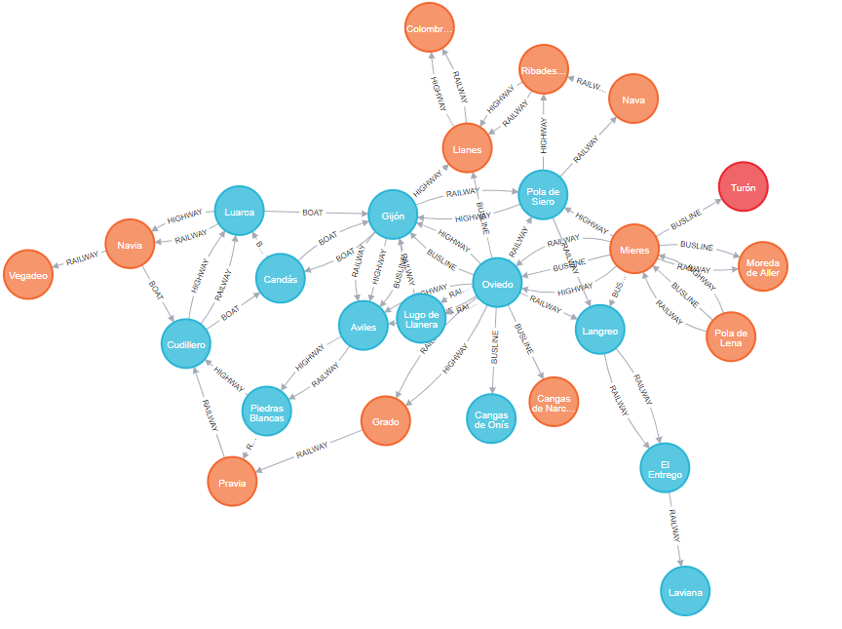

Above we saw the complete graph database instance obtained from Neo4J export system. Now we can see the hand-drawn subgraph:

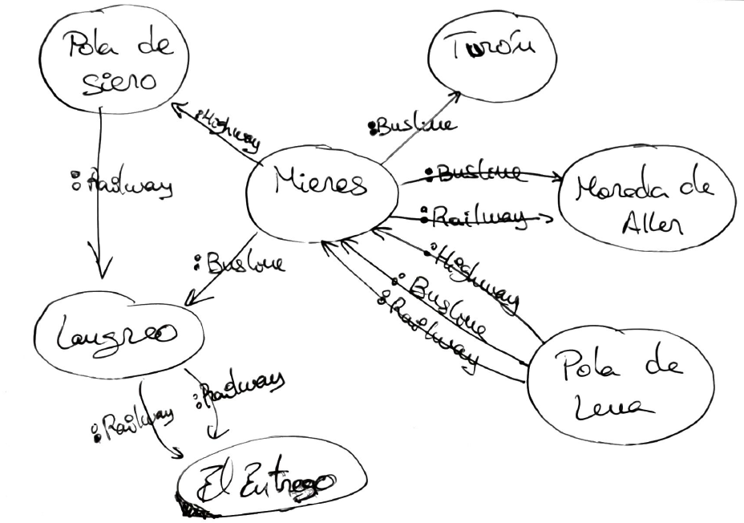

Result obtained after executing the creation script included in the delivery files. Taken from Neo4J browser:

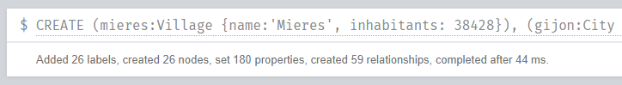

# 3.Database creation script

The script used to create the database can be found among the repository files under this path: “RI_Teamworks/NEO4J/task_txt_files/neo4jDBScript.txt”

It can also be read and executed using Neo4J Browser’s console issuing the command specified at the preface of this document:

***:play*** [***https://portal.graphgist.org/graph_gists/neo4j_teamwork_graphgist_docs/graph_guide***](https://portal.graphgist.org/graph_gists/neo4j_teamwork_graphgist_docs/graph_guide)

Image taken from the browser itself:

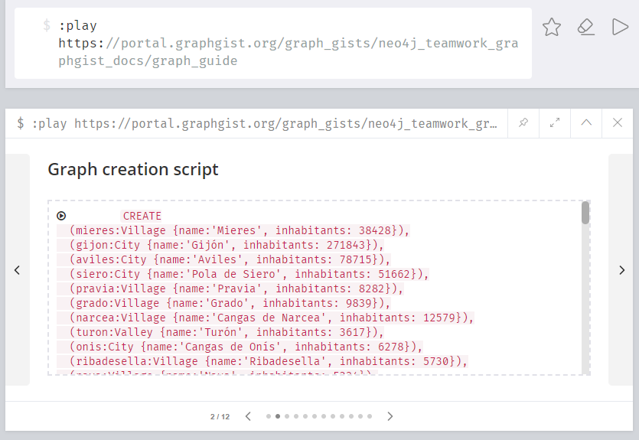

Additionally, under “RI_Teamworks/NEO4J/extra_files”, the graph database folder can be found named as: “graph.db”.